### Connect Profiles

Since version 3.1.2008.0, JDBC/FTP/SSH connect profiles have been integrated into the Connect Profiles.

You can register and manage the information required to access servers such as external databases, FTP, SSH, etc, as a Connect Profile under **Settings > Connect Profiles** menu. A connect profile is a set of data required when running a query that interfaces with an external system, or when a logger retrieves and collects data from an external server.

From the list of connect profiles, you can find the following information:

* **Name**: Name of the connect profile
* **Identifier**: Unique identifier of the connect profile
* **Type**: Type of the the connect profile
* **Detailed Settings**: Configuration information

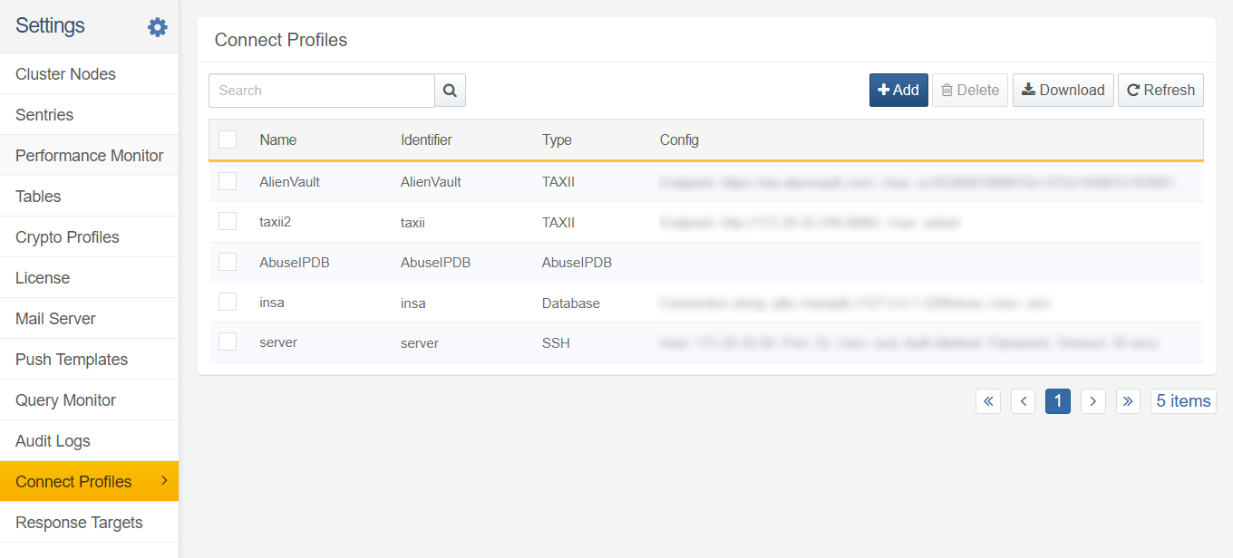

#### Add Connect Profile

To add a new connect profile, go to **Settings > Connect Profiles** and click **+ Add** in the toolbar. You will then asked to enter the basic information for the connect profile, such as name, identifier, description, type, and granted users.

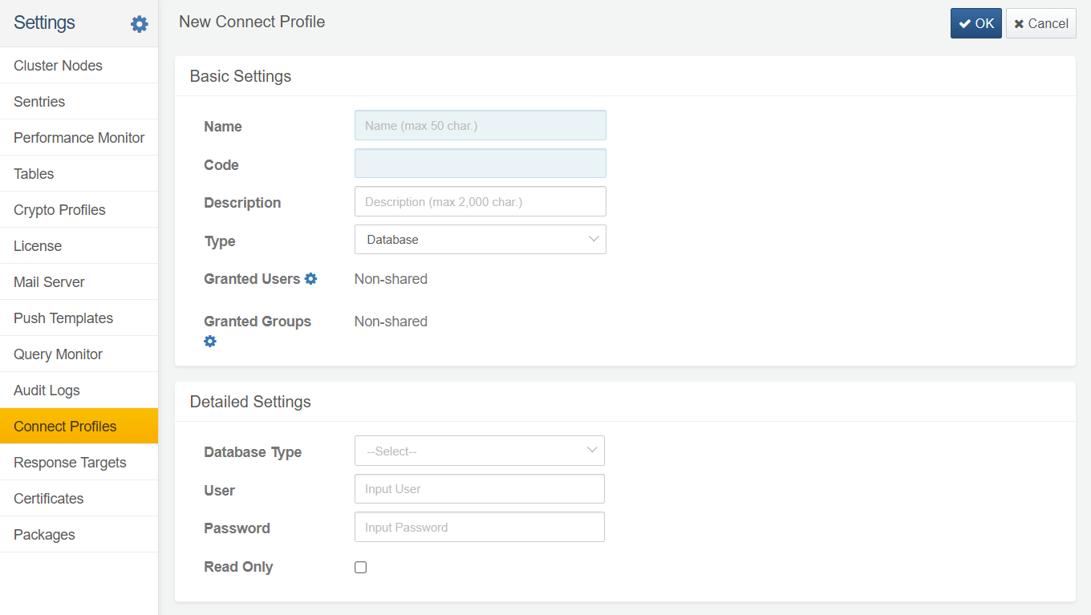

Basic Settings

**Name**

Name of the connect profile. The name can consist of letters (English/Korean), numbers, or special characters, and can be duplicated with other profile names.

**Code**

Unique identifier to identify the profile. The code can consist of letters, numbers, or the underscore character _. This code is used when querying the profile or setting up collection configurations.

**Description**

Description

**Type**

Type of connect profile, e.g. **Database**, **FTP**, **SSH**, etc.

**Granted Users, Granted Groups**

Users or groups with whom the created profile will be shared

Detailed Settings

Database

A database profile identifier can consist of letters, numbers, or the underscore character. However, you cannot use "sonar" as the database profile identifier.

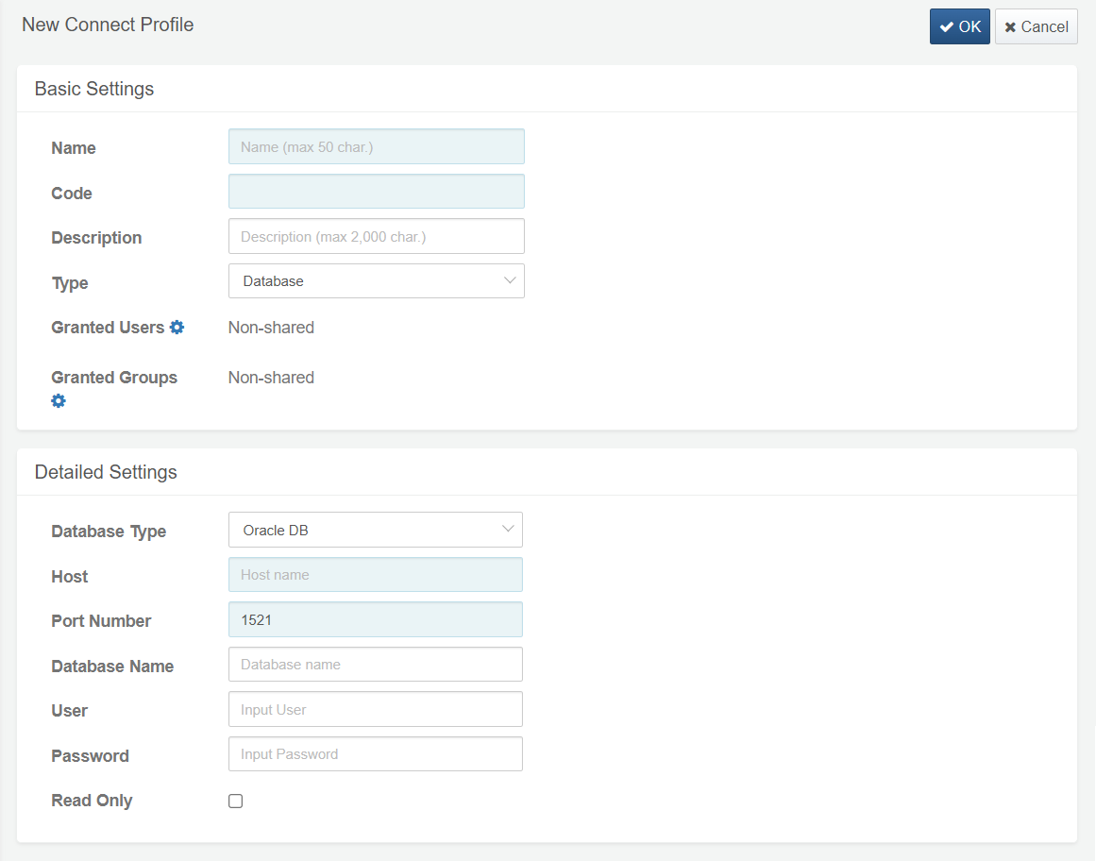

**Database Type**

Type of the database. Currently supported database types include **Oracle DB**, **Microsoft SQL Server**, **MariaDB**, **MySQL**, **Teradata ASTER**, **Tibero**, **Apache Hive**, **HyperSQL**. If you want to enter the JDBC connection string directly, select **User-Defined**. Depending on the type selected, the configuration values to be entered vary. Also the port number is set to the default for each RDBMS.

**Host**

IP address or hostname of the database server

**Port**

Port number used to access the database server. The default value is already set based on the selected database type, and you can change it if necessary.

**Name**

Name of the database to connect to. Leave it blank to target all databases.

**User**

Database account.

**Password**

Password to connect to the database.

**Read Only**

Whether to provide read-only access to users

FTP

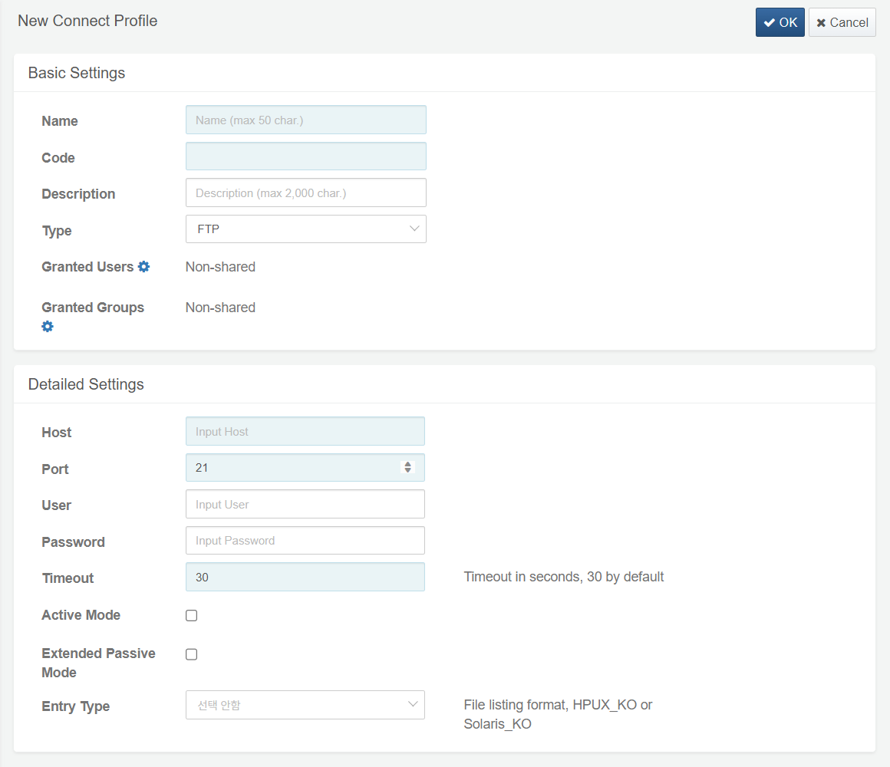

**Host**

IP address or hostname of the FTP server

**Port**

Port number used to access the FTP server (default: 21)

**User**

FTP server login account. Skip this if using anonymous login.

**Password**

FTP server login password. Skip this if using anonymous login.

**Timeout (Required)**

Amount of time after which the FTP session will timeout (default: 30 seconds)

**Mode**

**Active mode** if there are no firewall/access controls between Logpresso node and FTP server. **Extended Passive Mode** if the FTP server is running on an IPv6 network. If you checked neither of them, the default is **passive** mode.

**Entry Type**

Operating system and locale of the FTP server. For example, if the FTP server is running on HP-UX and the locale is set to Korean, select **HPUX_KO**; if it is running on Solaris with a Korean locale, select **Solaris_KO**.

Logpresso CTI

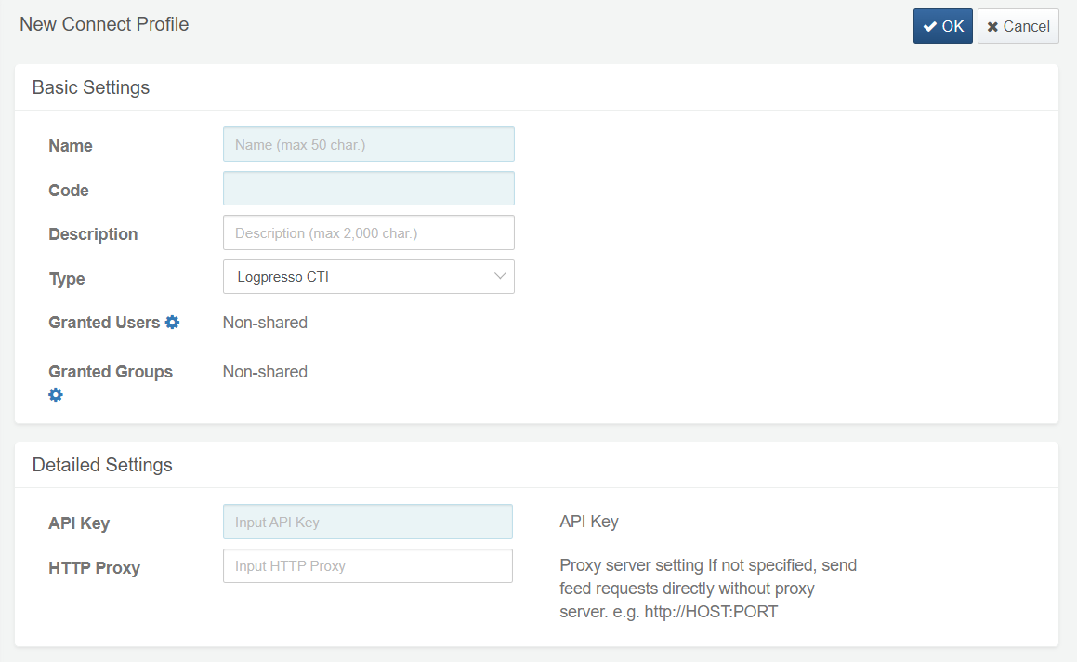

**API Key**

API key to access Logpresso CTI service

**HTTP Proxy**

IP address and port of the HTTP proxy server (IP:PORT format)

MongoDB

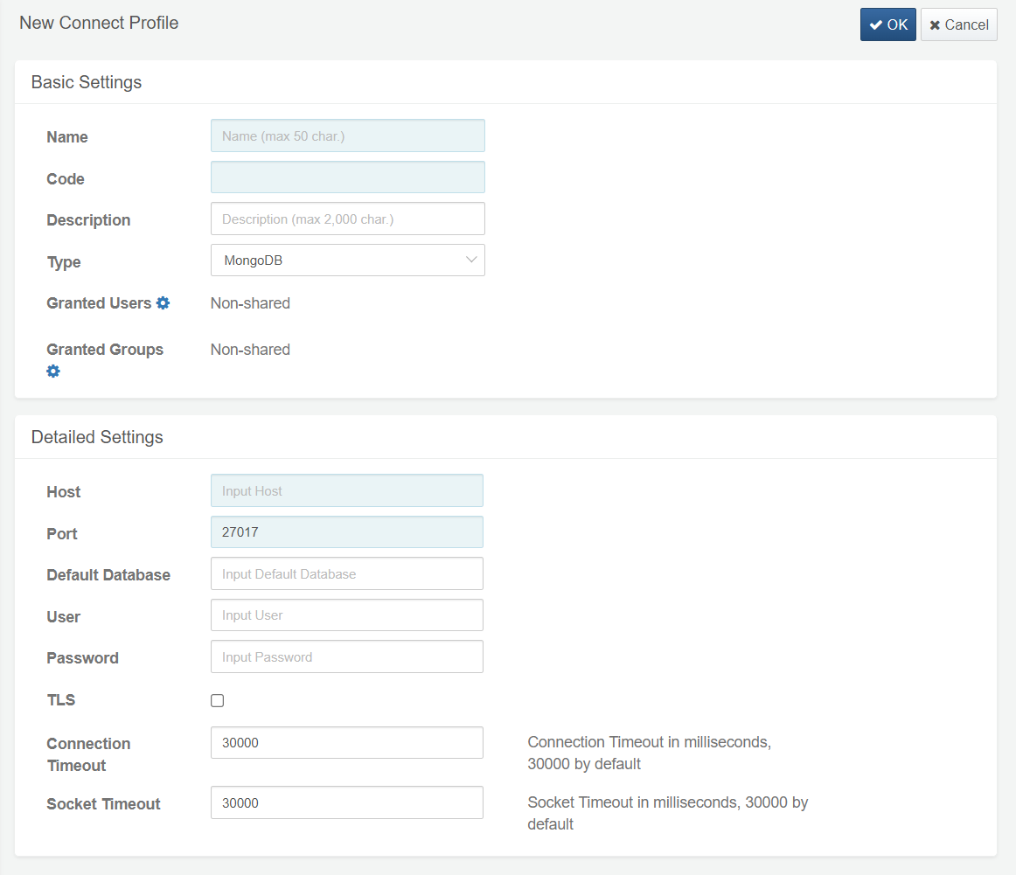

**Host**

IP address or hostname of the remote host

**Port**

Port number used to access the MongoDB server on the remote host (default: 27017)

**User**

MongoDB login account (user name)

**Password**

MongoDB login password

**TLS**

Whether to use TLS communication encryption

Connection timeout:Amount of time after which the MongoDB session will timeout (default: 30,000 milliseconds)

Socket Timeout:Socket timeout duration (default: 30,000 milliseconds)

SSH

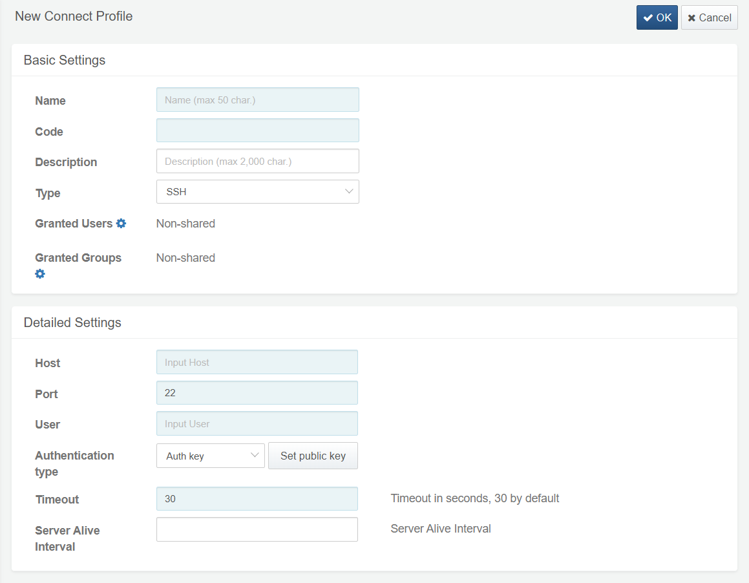

**Host**

IP address or hostname of the SSH server

**Port**

Port number used to access the SSH server (default: 22)

**User**

SSH server login account.

**Authentication Method**

Authentication method for the SSH connect profile. Select either **Auth key**(default) or **Password**. If you select **Password**, enter the password you want to use.

**Password**

SSH server login password.

**Timeout**

Amount of time after which the SSH session will timeout (default: 30 seconds)

**Keep-Alive Interval**

Sets the interval to send a keep-alive message. If zero is specified, any keep-alive message must not be sent. (default: 0 seconds)

#### Edit Connect Profile

Click the name of the connect profile on the list; then you will be directed to the **Edit Connect Profile** where you can modify the settings of the connect profile. Make sure to click Save to save all changes you made.

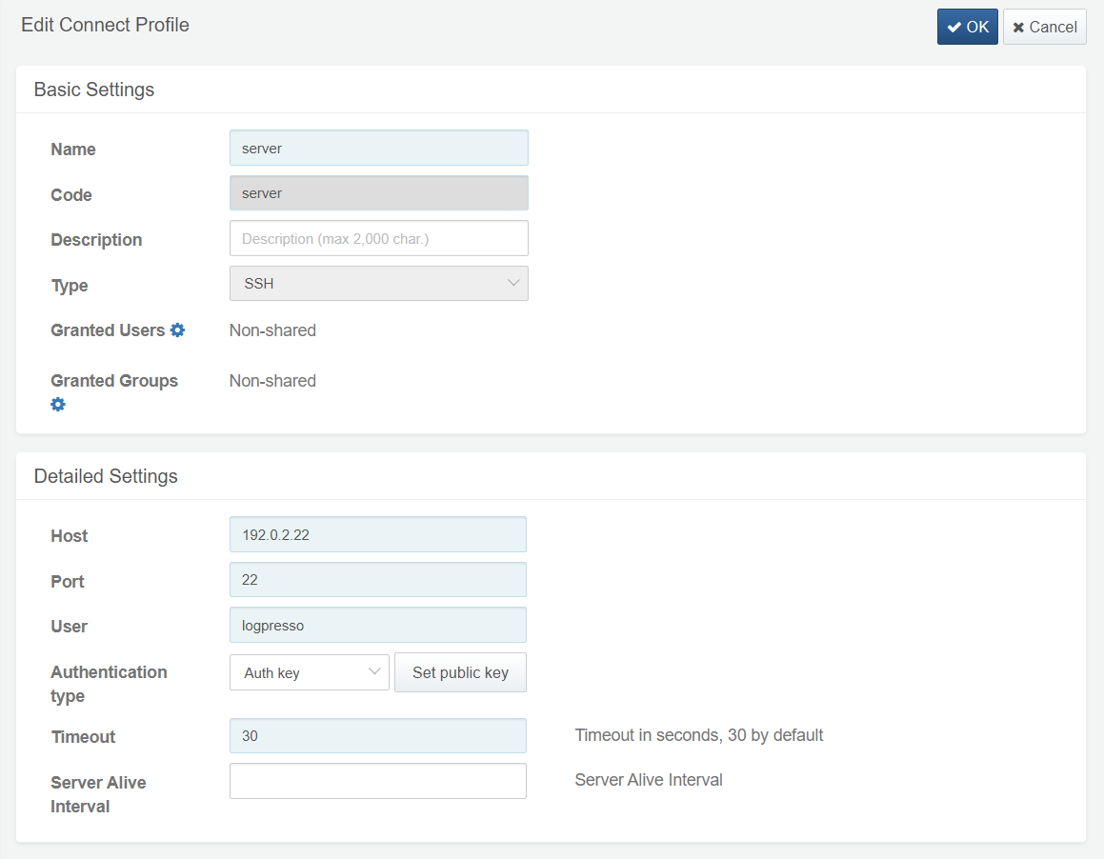

#### Remove Connect Profile

From the profile list, tick the checkbox of the connect profile you want to remove and click **Remove**; **Remove Connect Profile** dialog box will then appear. Click **Remove** to confirm removing the selected connect profile.

