### Crypto Profiles

#### Overview

Crypto profiles are used to encrypt data stored in tables and apply integrity verification. When creating a table, specifying an Crypto profile will encrypt the data according to the encryption algorithm defined in the profile and generate an HMAC for integrity verification using the specified digest algorithm.

#### List of Crypto Profiles

You can view the list of Crypto profiles in **System > Crypto Profiles**.

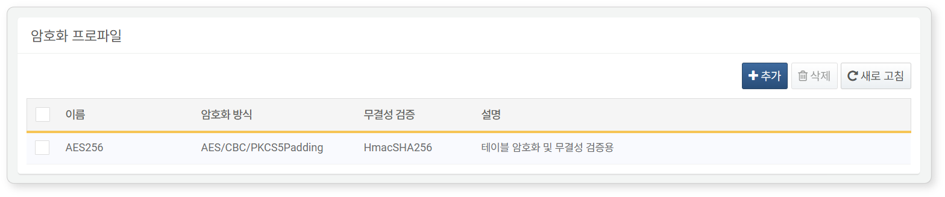

1. **Name**: The unique name of the Crypto profile
2. **Encryption Method**: The configuration of the encryption algorithm to be used for encrypting table data blocks
3. **Integrity Verification**: The integrity verification algorithm to be used for generating the HMAC of table data blocks
4. **Description**: A description of the Crypto profile

#### Adding an Crypto Profile

Logpresso Sonar provides a default Crypto profile named **AES256**. If the default Crypto profile has been deleted, you can add it back using the following method:

To add an Crypto profile:

Click **Add** in the toolbar at the top of the [Crypto Profile List](https://docs.logpresso.comnull).

In the **Add Crypto Profile** screen, enter or select the properties (**Name**, **Encryption Method**, **Integrity Verification**, **Description**) and then click **OK**.

#### Modifying an Crypto Profile

Added Crypto profiles cannot be modified.

#### Deleting an Crypto Profile

To delete an Crypto profile:

Select the Crypto profile you wish to delete from the [Crypto Profile List](https://docs.logpresso.comnull), and then click **Delete** in the toolbar.

In the **Delete Crypto Profile** dialog, click **Delete** to remove the Crypto profile.