### Employees

#### Overview

When a security event detected by Logpresso Sonar is related to members of the organization, and it is necessary to investigate the circumstances surrounding the security event with those members, explanations can be requested via email, SMS, etc. The functions used for this purpose are "[Explanations](https://docs.logpresso.comnull)" and the employee information management feature.

When installing Logpresso Sonar, you can integrate the employee management feature with your organization's Human Resource Management System to automatically update employee information. The method of integration with the Human Resource Management System is beyond the scope of the user interface documentation, so it will not be explained here.

Organizations typically have a tree structure centered around a representative, which is why the employee feature consists of department management and employee management for those departments.

#### Viewing Employees and Departments

The list of employees and departments can be viewed under **Accounts > Employees**.

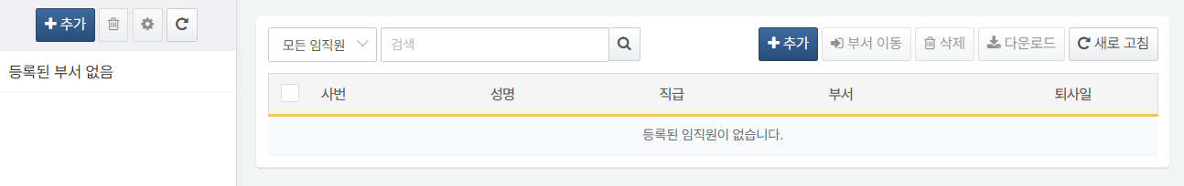

Initially, there may be no departments or employee information configured in the system.

#### Department Management

Adding a Department

To add a department to the department list:

Click **Add** above the department list in **Accounts > Employees**.

In the **Add Department** dialog, enter the department information and click **OK**. Click **Cancel** if you do not wish to add a department.

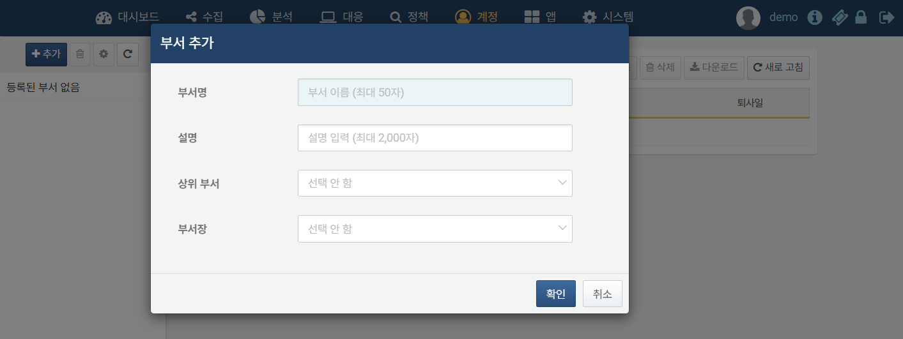

* **Department Name** (Required): The name of the department
* **Description**: A description of the department
* **Parent Department**: If no parent department is specified, the added department will become the top-level department of the organization. There can be more than one top-level department.
* **Department Head**: The manager of the department. The department head will be the primary reviewer for explanation requests related to employees in that department. For more details, refer to [Explanations](https://docs.logpresso.comnull).

Modifying a Department

To modify a department that has been added to the department list:

Click on the department you wish to modify in the department list under **Accounts > Employees**.

Click the gear icon above the department list.

In the **Modify Department** dialog, make the necessary changes and click **OK**. Click **Cancel** if you do not wish to modify the department.

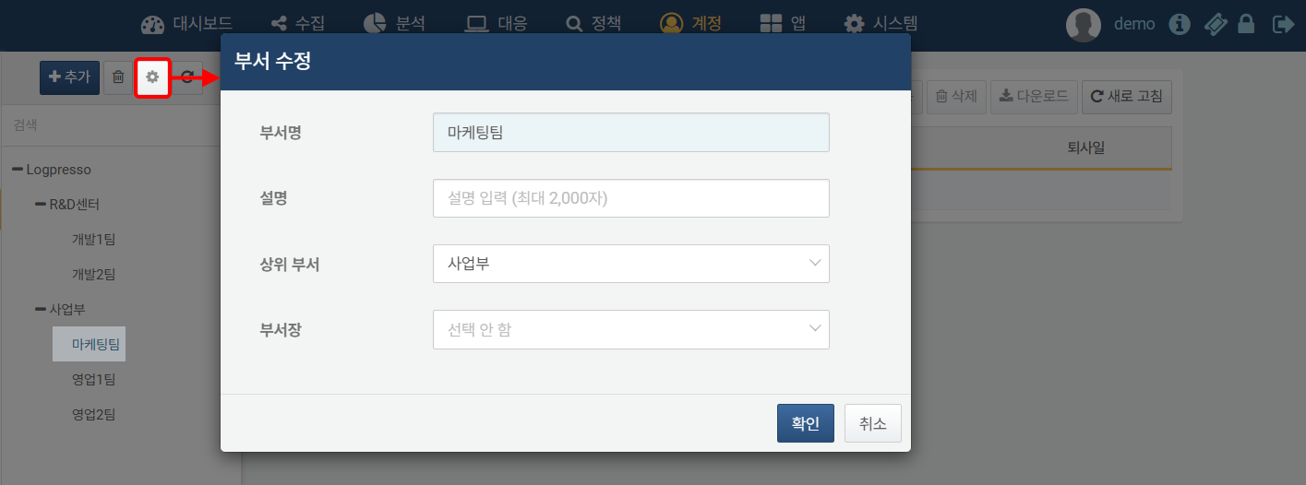

Deleting a Department

To delete a department from the department list:

Click on the department you wish to delete in the department list under **Accounts > Employees**.

Click the trash can icon above the department list.

In the **Delete Department** dialog, confirm that you wish to delete the selected department and click **OK**. Click **Cancel** if you do not wish to delete the department.

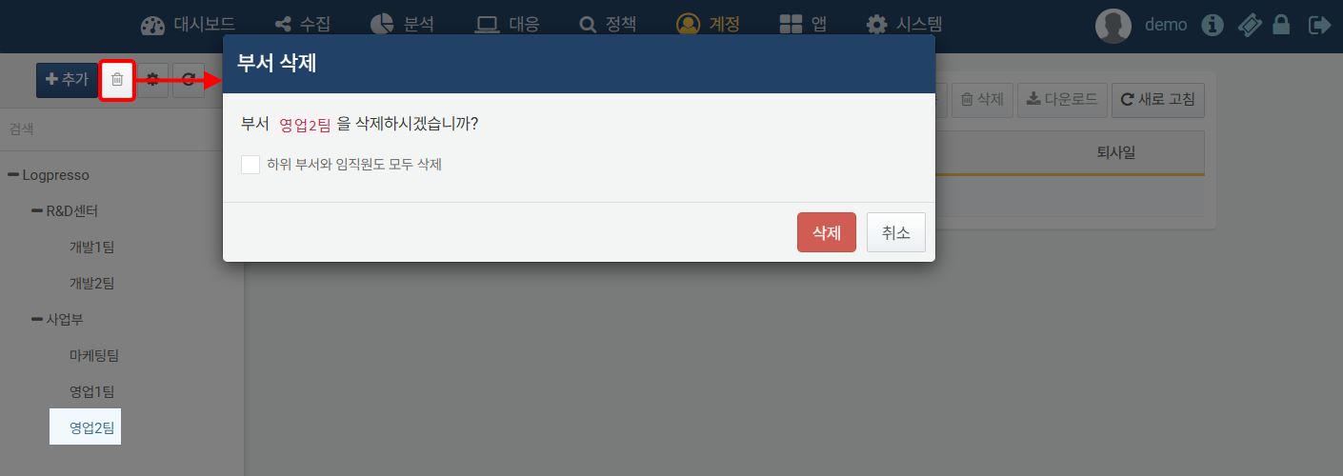

* Checking **Also delete all sub-departments and employees** will delete all sub-departments and employee information as well.
* If you delete a department without checking **Also delete all sub-departments and employees**, all sub-departments and employee information will be moved to the parent department.

#### Employee Management

Searching for Employees

To find a specific employee in the list, use the search tool in the toolbar. You can distinguish between all employees and those who are about to leave. The search tool will find and display employees whose **Employee ID** or **Name** contains the entered words. The search tool is case-insensitive.

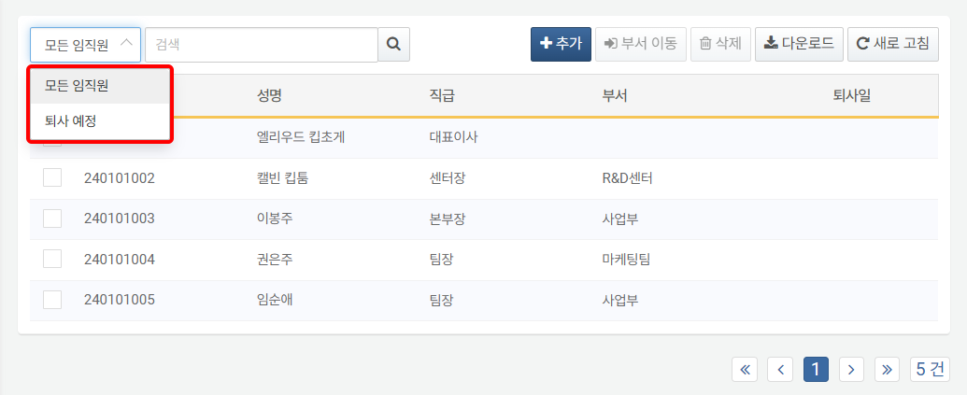

Adding an Employee

To add an employee:

Click on the department in the department list under **Accounts > Employees** where you want to add the employee. If you do not select a department, the employee will be added without an associated department.

Click **Add** in the toolbar.

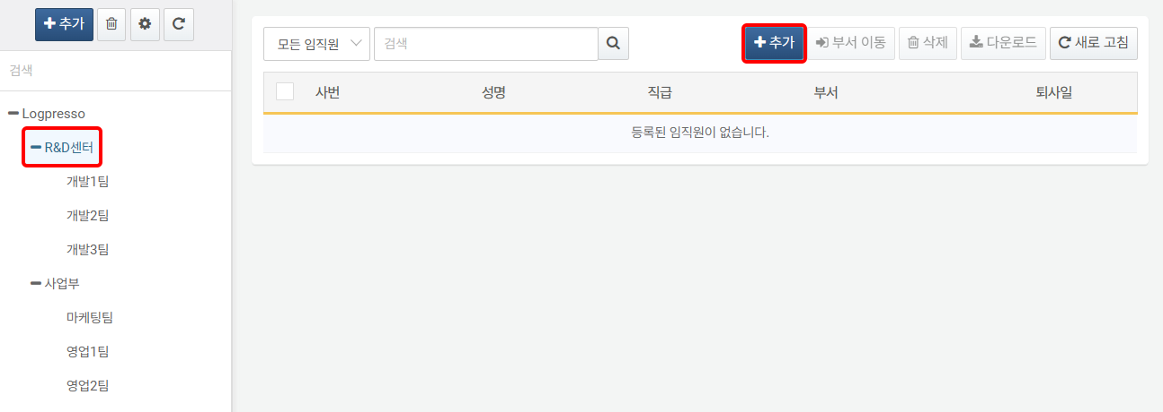

In the **Add Employee** screen, select or enter the employee information. Properties marked in sky blue are required fields.

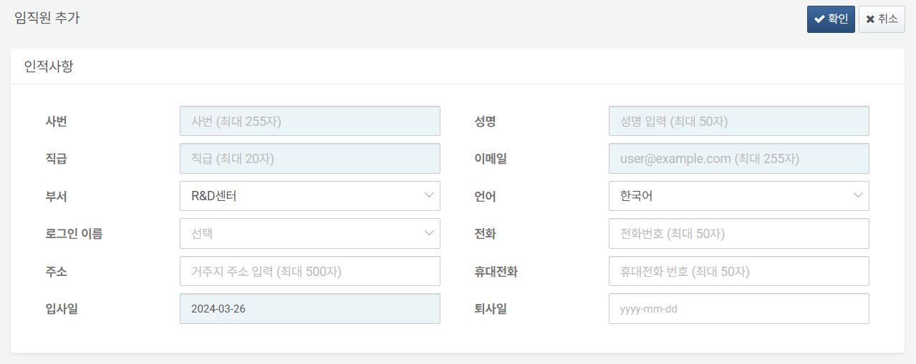

* **Employee ID**: The employee's ID
* **Name**: The employee's actual name
* **Position**: The employee's position
* **Email**: The employee's email address. This will be used to send explanation request emails to the employee.
* **Department**: The employee's associated department. If a department has already been selected, it will be pre-selected. Changing to another department will add the employee to that department.
* **Language**: The language to be used for explanation requests and other communications sent by Logpresso Sonar. Choose from **Korean**, **English**, or **Chinese**.
* **Login Name**: Used to link the employee information with [Accounts](https://docs.logpresso.comnull) (default: not selected). Select the login name of the account to link from the list.
* **Phone**: The employee's phone number
* **Address**: The employee's residential address
* **Mobile Phone**: The employee's mobile phone number. This will be used to send SMS explanation requests to the employee.
* **Date of Joining**: The employee's date of joining. The current date will be entered by default.
* **Date of Leaving**: The employee's date of leaving or expected leaving date. If a leaving date is entered, the employee will be classified as a departing employee.

If the entered information is correct, click **OK**. Click **Cancel** if you do not wish to add the employee.

Modifying an Employee

To modify employee information:

Click on the **Employee ID** or **Name** of the employee you wish to modify in **Accounts > Employees**.

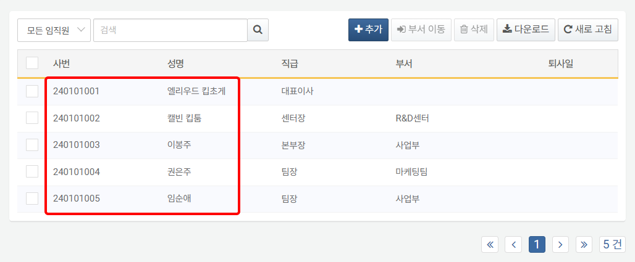

In the **Modify Employee** screen, select or enter the employee information.

If the modified information is correct, click **OK**. Click **Cancel** if you do not wish to modify the employee information.

Deleting an Employee

To delete an employee from the list:

Select the checkbox of the row containing the employee information you wish to delete in **Accounts > Employees**.

Click delete in the toolbar.

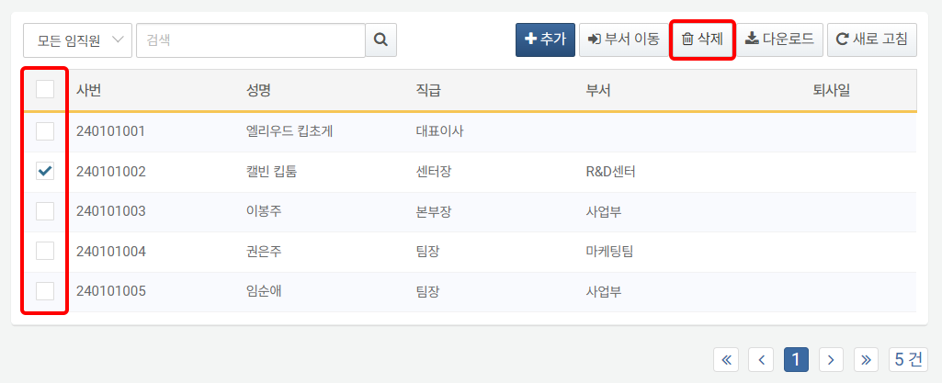

In the **Delete Employee** dialog, review the list of accounts to be deleted and click **Delete**. Click **Cancel** if you do not wish to delete.

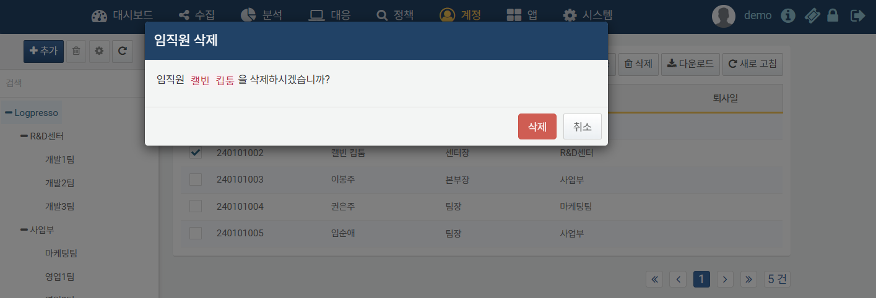

Even if an employee is deleted, related information remains intact. For example, the history of explanation requests assigned to the employee will still be preserved.

Transferring an Employee

To change an employee's department, you can either modify the [employee information](https://docs.logpresso.comnull) or use the toolbar in the employee list.

To change the department of a specific employee in the employee list:

Select the checkbox of the row containing the employee information whose department you wish to change.

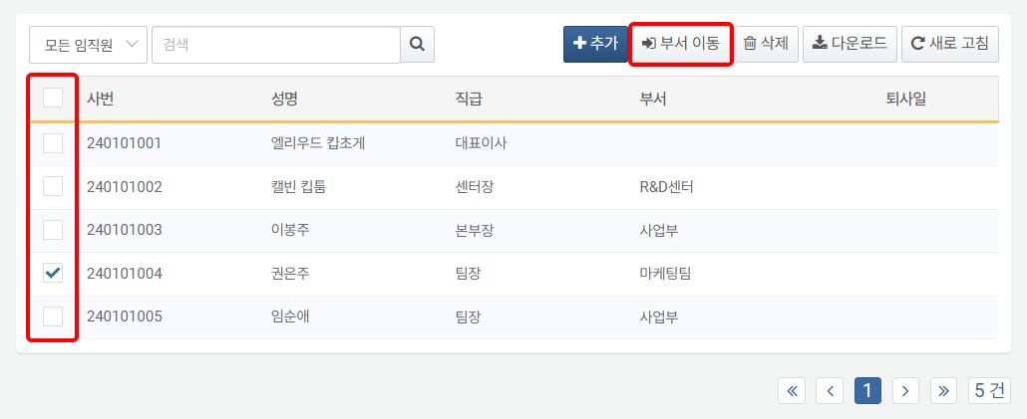

In the **Transfer Department** dialog, select the **Department** to which the employee will be moved and click **OK**. Click **Cancel** if you do not wish to transfer.

