### Events

Enter the target period in the format yyyy-MM-dd and click the Query button to retrieve events that match the range [start, end). This means that the start date is inclusive while the end date is exclusive. Due to the result limit filter, a maximum of 10,000 records will be retrieved during the initial query.

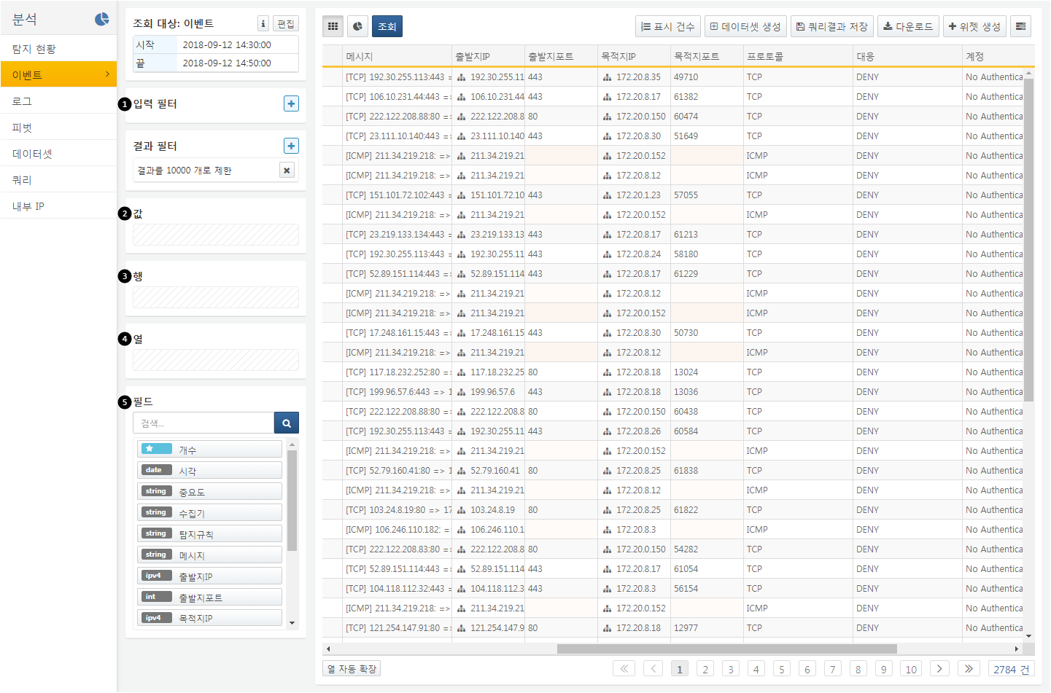

**Filters**: These are divided into input filters and result filters. Input filters perform data transformation and filtering on the original data before the pivot execution. Result filters perform data transformation and filtering on the statistical results after the pivot execution.

**Aggregation Values**: Drag and drop fields into this area to set aggregation functions for the respective fields. Once an aggregation function is set, the pivot will execute immediately.

**Aggregation Row Criteria**: Drag and drop fields into this area to use the respective fields as the row grouping criteria for the pivot.

**Aggregation Column Criteria**: Drag and drop fields into this area to use the respective fields as the column grouping criteria for the pivot.

**Fields**: Displays a list of fields available after querying events.

Clicking on any item in the aggregation values, aggregation row criteria, or aggregation column criteria will invoke a context menu, allowing you to delete the item or change the aggregation function.

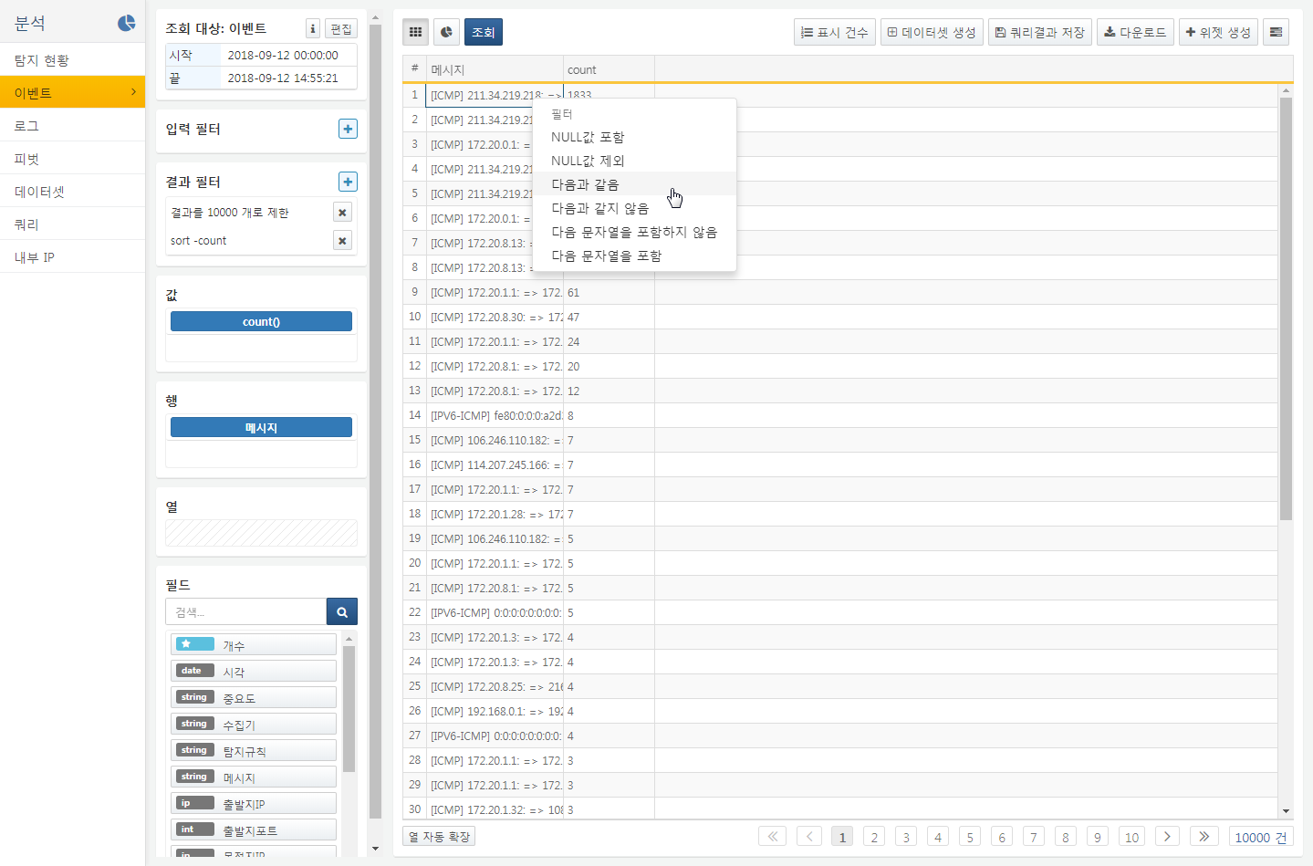

This screen example shows the pivot execution results when the aggregation value is set to count and the aggregation row is set to the message field. You can add filters to the pivot results by right-clicking. Clicking the filter icon in the grid header allows you to add filters with arbitrary input values for specific fields.

You can perform the following functions on the event pivot results:

* **Set Display Count**: Configure how many records to display per page.
* **Create Dataset**: Generate a dataset to reuse the current pivot analysis conditions. You can later query this dataset from the dataset menu or reference it in the dashboard to create widgets.
* **Save Query Results**: Save the query result data on the server for future retrieval. Enter a name for the query result in the dialog box, and it will be saved under that name on the server. Saved queries can be retrieved in a new query window.
* **Download Query Results**: Download the query result data to the PC running the web browser. Specify the file name, format, and download range to download the query results.
* **Create Widget**: Generate a widget available on the dashboard based on the current pivot analysis conditions and chart settings.
* **Query Execution Plan**: Display the SQL query corresponding to the current pivot analysis conditions, the number of records processed at each step, the query start time, and the duration.