### License

#### Overview

To use Logpresso Sonar, you must register a license through the web console. The daily volume of original logs that Logpresso Sonar can collect is defined by the given license, and the features available may also vary depending on the license.

When the license validity period expires, certain features will be disabled, but log collection will continue.

License Types

The licenses for Logpresso Sonar are divided into four types (the identifiers used in the license screen are in parentheses):

1. Logpresso Sonar Light: Standalone Integrated Log Management Server (LMS) License (STD)
2. Logpresso Sonar Light HA: Redundant Integrated Log Management Server (LMS) License (ENT)
3. Logpresso Sonar: SIEM Operation License (SNR)
4. Logpresso Sonar Maestro: Security Operations Automation (SOAR) License (MAE)

STD and ENT have the same features except for redundancy configuration and DBMS.

For the features available based on the license, please refer to the appendix [License Functional Scope](https://docs.logpresso.comnull).

License Application

To apply for or renew a license, you will need the hardware key information of the analysis node. If the analysis node is configured in a redundant setup, the hardware keys for both nodes are required. Please request the issuance of the license from the Logpresso technical support team along with the hardware key information. The hardware key can be found on the [License Screen](https://docs.logpresso.comnull).

Actions on License Exceedance

The license consists of a hardware key, validity period, maintenance period, daily original log collection capacity, and available features. If the daily original log collection capacity granted by the license is exceeded, the following actions will occur:

1. If no license is installed, the maximum daily original log collection is 500MB.
2. If the daily original log collection capacity is exceeded, a license exceedance alert will be triggered once per day.
3. If five license exceedance alerts accumulate within the last 30 days, the license will be deactivated, and the execution of queries to retrieve stored data will stop.

#### Viewing License and Exceedance Alerts

The license status can be viewed under **System > License**.

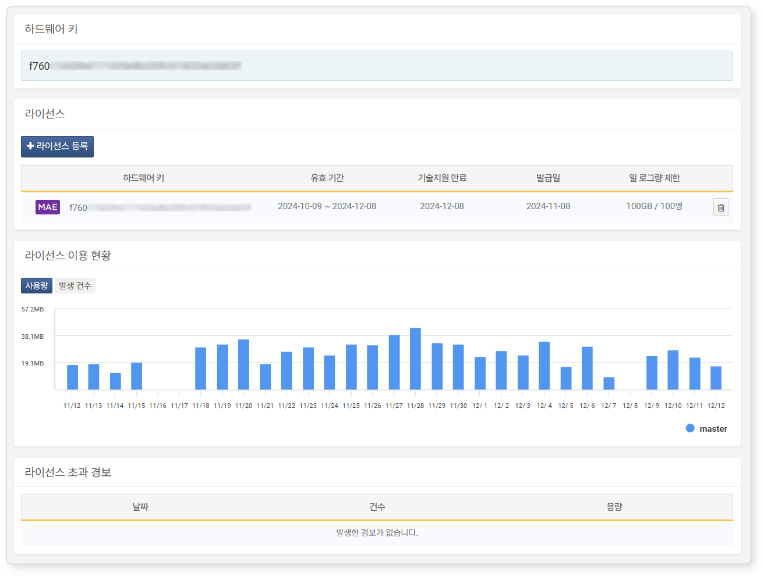

The information available in **License** includes:

1. **Hardware Key**: The hardware key of the analysis node
2. **Validity Period**: The validity period of the license
3. **Support Expiration**: The expiration date of technical support
4. **Issuance Date**: The date the license was issued
5. **Daily Log Volume Limit**: The maximum daily volume of original logs that can be collected. You can configure the logger's [Filter Settings](https://docs.logpresso.comnull) to avoid collecting unnecessary original logs.

**License Usage Status** shows the usage status of the license over the last 30 days. If a cluster is configured with multiple nodes, it will display colors distinguishing each node.

**License Exceedance Alerts** show alerts that have occurred in the last 30 days.

#### Registering a License

To register or renew a license:

Click **License Registration** under **System > License**.

Enter the license information in the **License Input** window and click **OK**.

#### Deleting a License

To delete a license:

Click the  button on the license screen.

In the **License Deletion** dialog, click **Delete**. To cancel the deletion, click **Cancel**.