### Login

Logpresso Sonar (hereinafter referred to as "the server") provides a web service-based user interface for easy access. For convenience, we will refer to this web service-based user interface as the "web console."

#### Accessing the Web Console

The web console complies with HTML5 standards and supports most web browsers. Open your web browser and enter the server's web console address in the format "https://IP address:port number" to access the server's web console. If the server is configured to use the default HTTPS communication port, 443, you can omit the port number (e.g., https://192.0.2.1, https://sonar.example.com, https://sonar).

Since the web console connection uses a private certificate, your web browser will display a security warning. Please verify that the entered address is correct, then ignore the security warning and proceed to connect.

#### Allowing Notification Messages

When a user accesses the web console, a message appears in the lower right corner of the screen indicating that the web browser has blocked notifications.

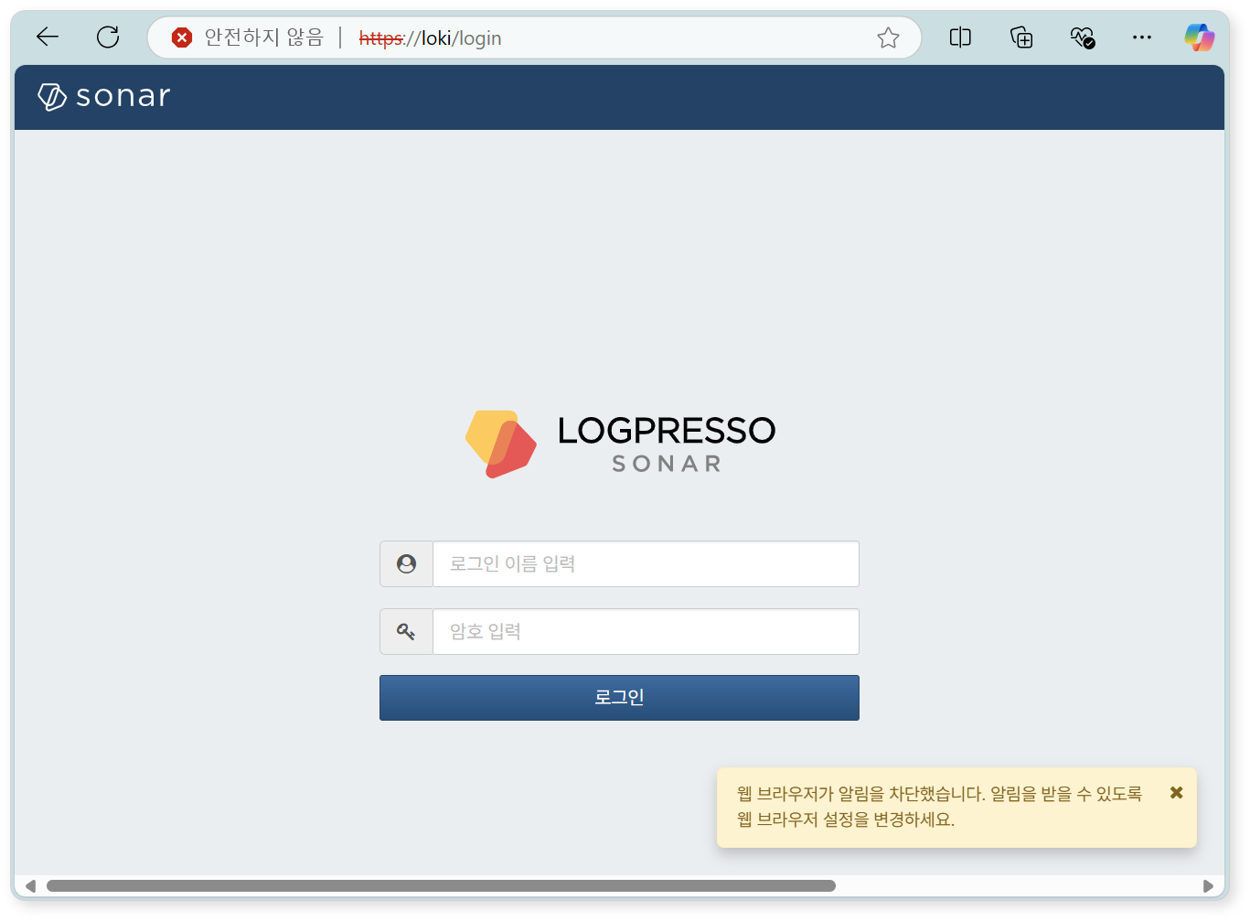

Please change the settings to allow the web console to display popup messages.

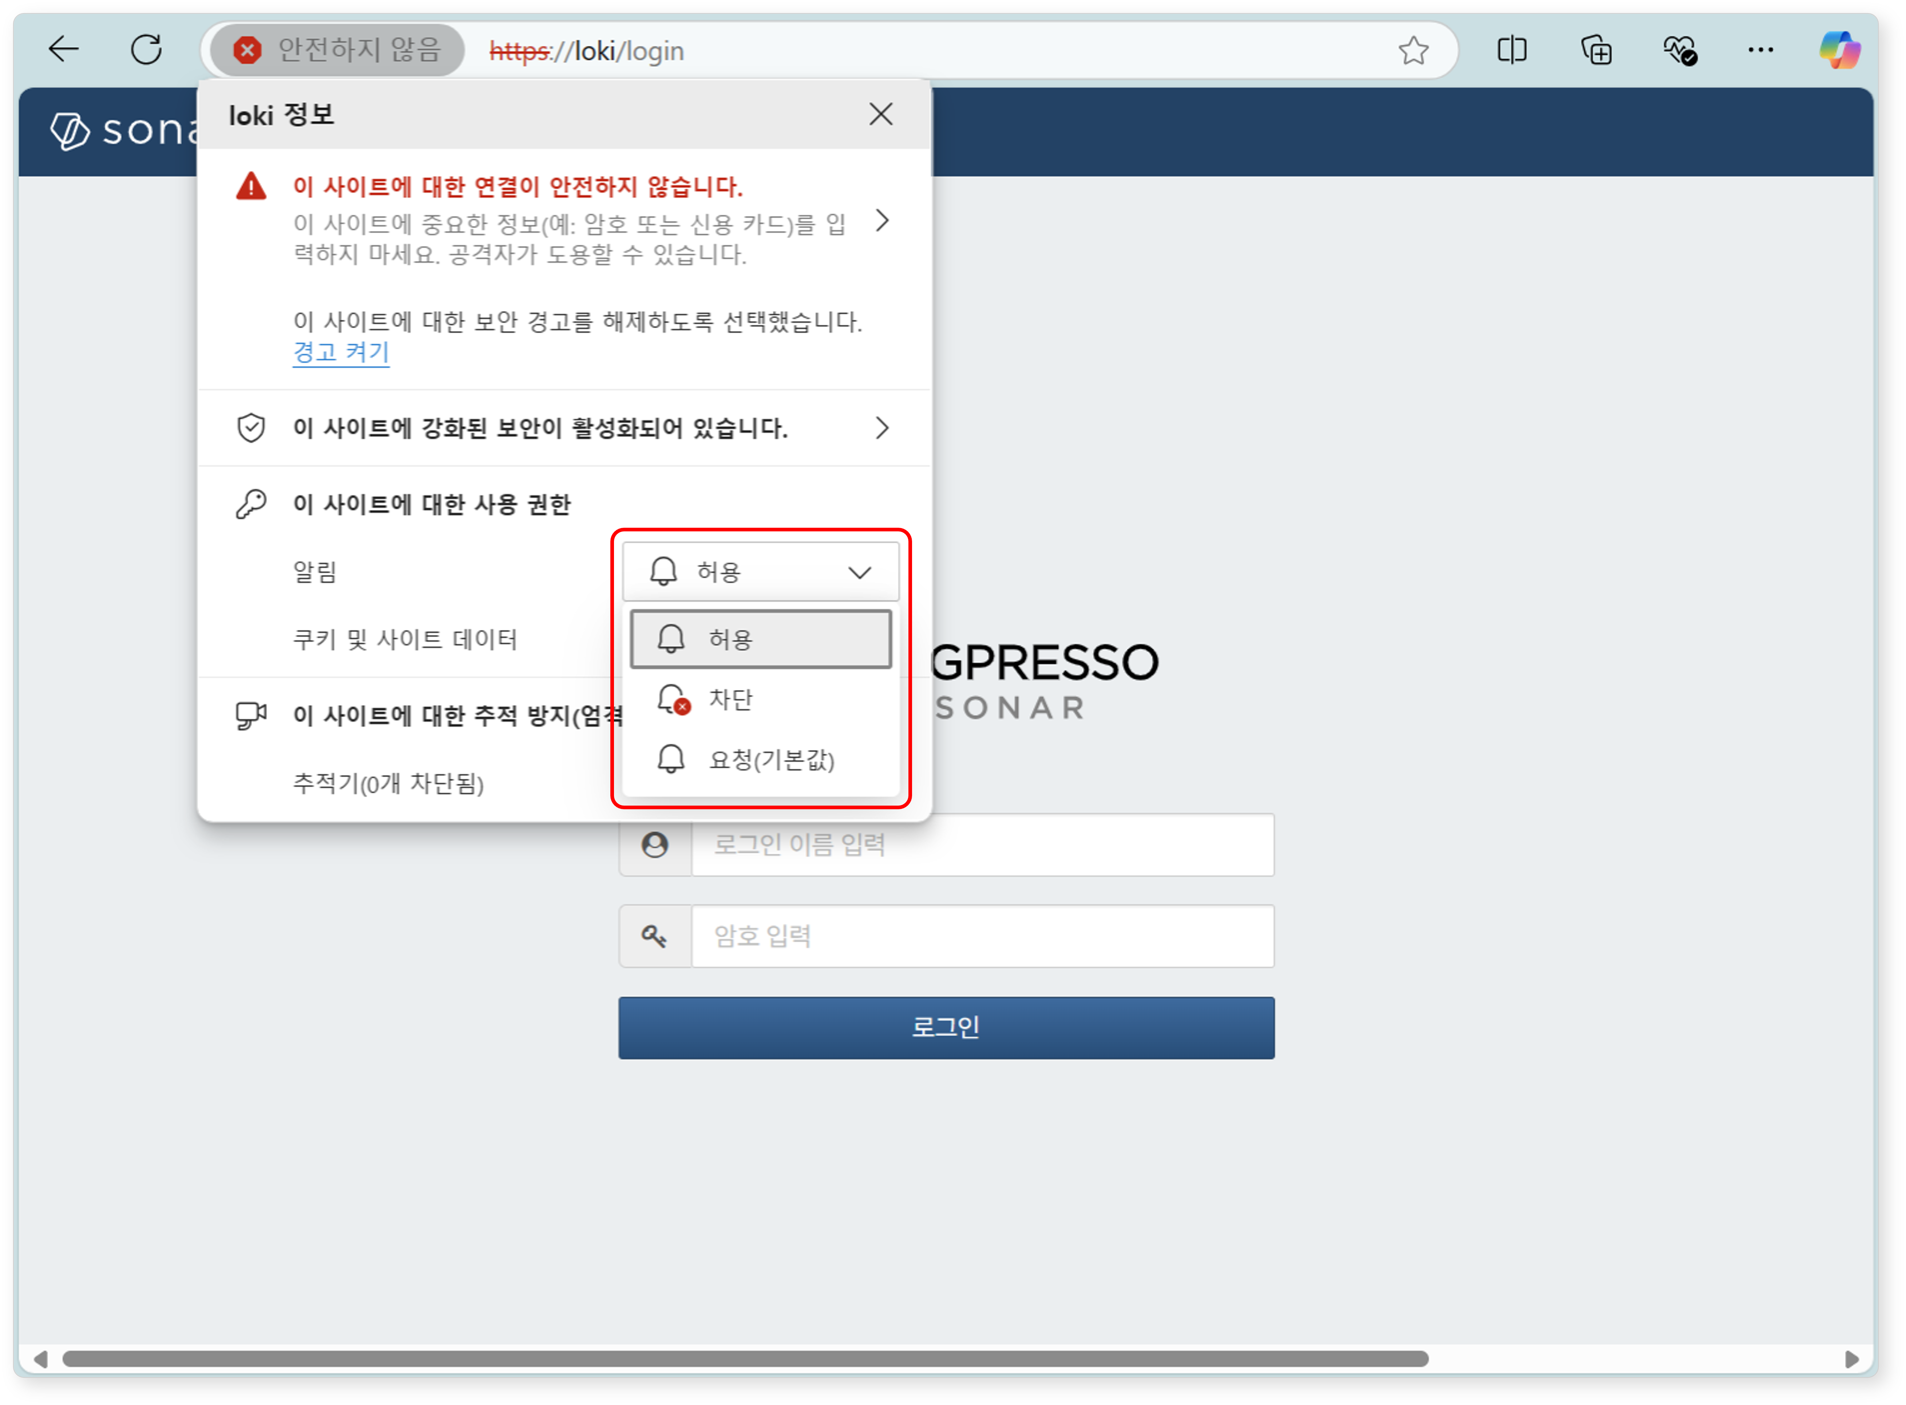

#### Login

To use the web console, users must first authenticate their identity through password authentication or 2FA.

Password Authentication

Enter the **login name** and **password** assigned to your account, then click on the login button.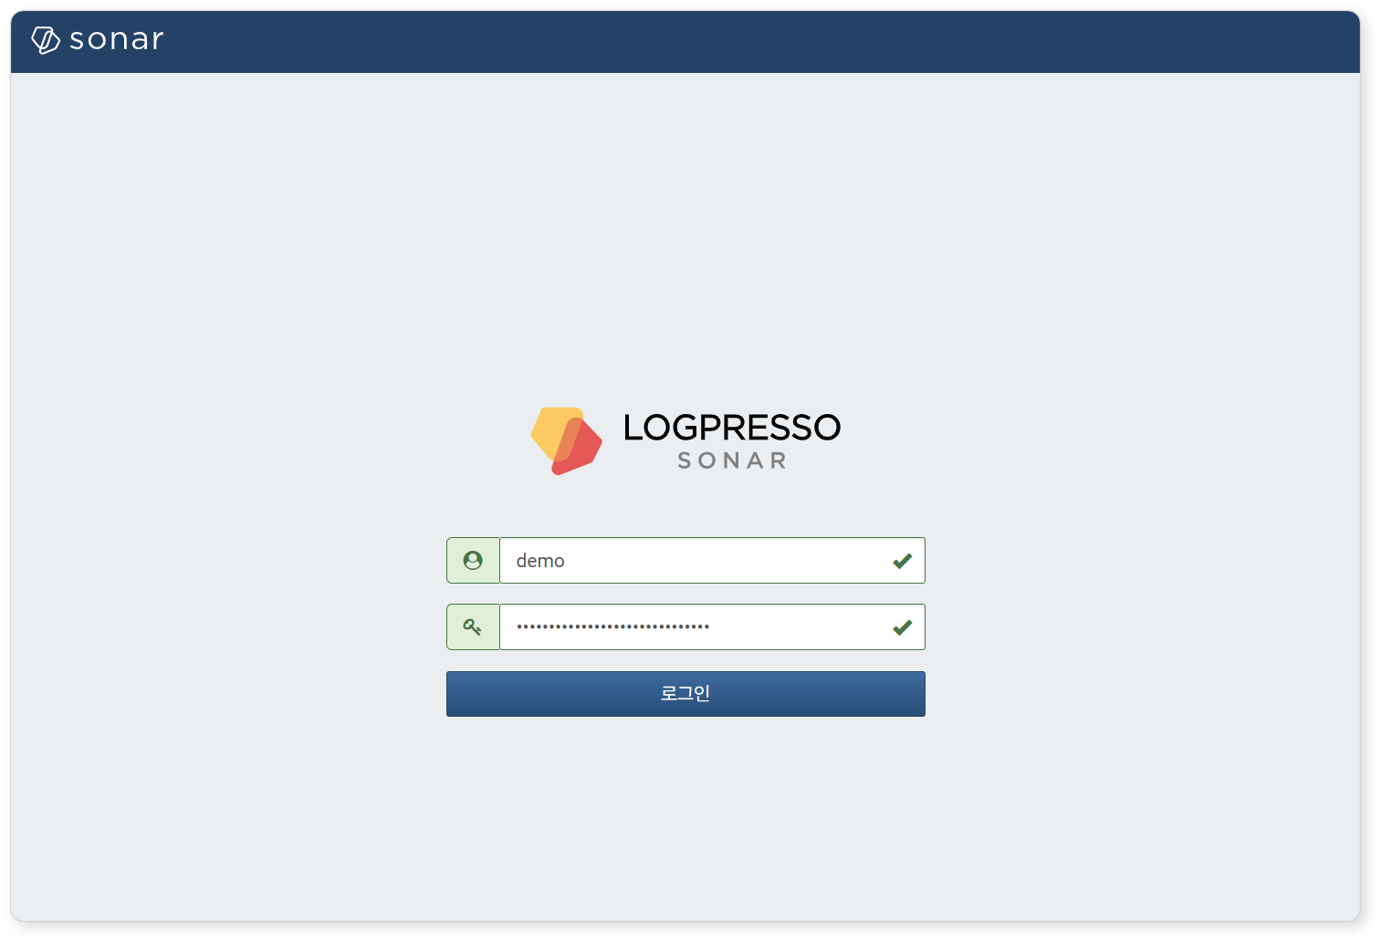

Be cautious, as entering the login name or password incorrectly multiple times will result in your account being locked for a certain period. The number of failed authentication attempts and the account lock duration may vary by system. To unlock your account or change your password, please contact the server administrator.

OTP Setup and Authentication

**Registering Authentication Method**

When a user with a 2FA-enabled account performs password authentication for the first time, they will be directed to a page to set up their authentication method. The currently supported 2FA authentication method is OTP. For instructions on setting up 2FA for your account, please refer to [here](https://docs.logpresso.comnull).

Install an OTP app on your mobile device. Select the appropriate **mobile operating system** for your device, and a QR code will be displayed containing the download page information for Google Authenticator. You may use any OTP app that complies with [RFC 6238](https://datatracker.ietf.org/doc/html/rfc6238) in addition to Google Authenticator. Once the OTP app is installed, click **Next**.

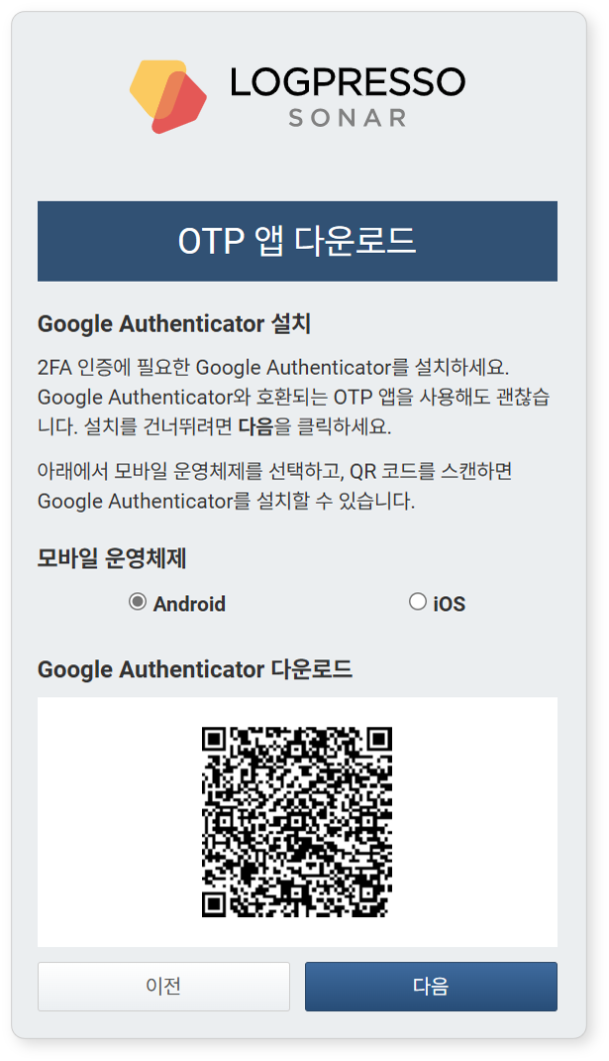

Open the OTP app on your mobile device and use the displayed QR code to set up OTP in the app. If you cannot use the camera on your mobile device due to security policies, click **View Setup Key** and use the displayed setup key to configure OTP. After completing the setup, click **Done**.

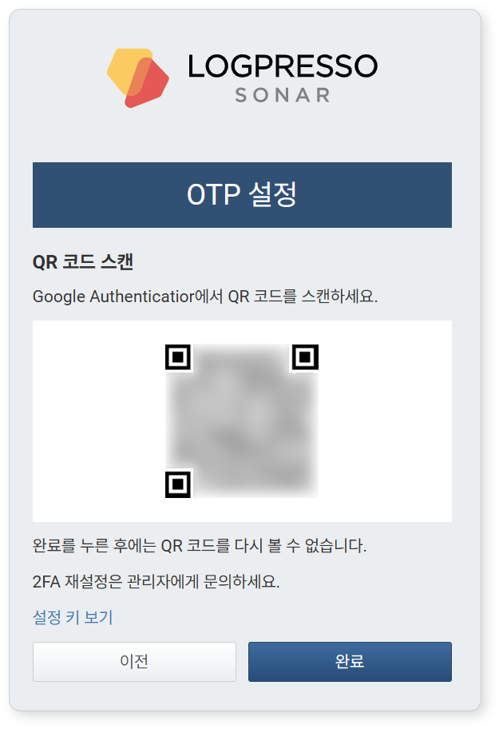

**Entering OTP Code**

When you switch to the **2-Step Verification** screen, enter the 6-digit OTP code displayed in the OTP app and click **Login**.

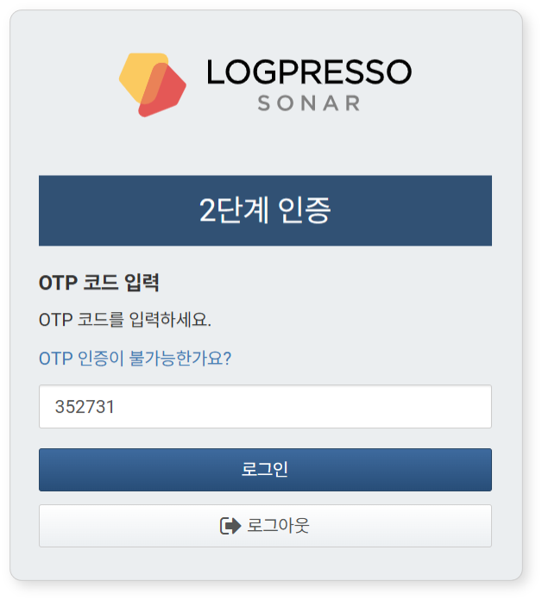

If there are issues with 2FA authentication, click "**Can't authenticate with OTP?**" and then click **Send** to request 2FA reset from the administrator.

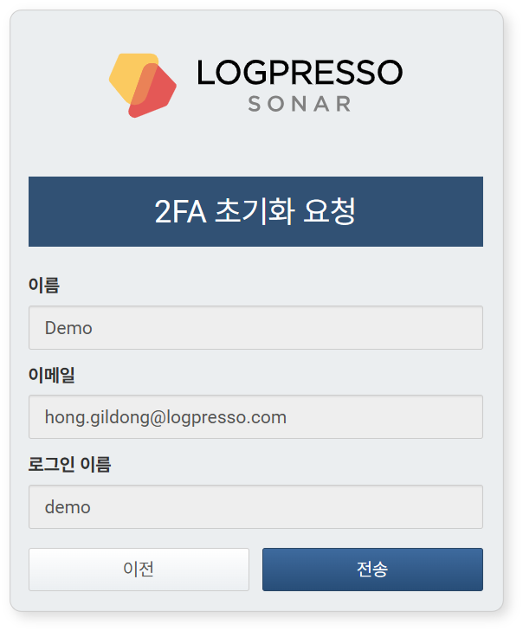

#### Changing Password

To change your password:

Click on your account name in the upper right corner of the web console.

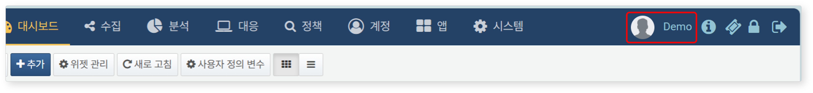

In the **Edit Account** screen, enter the new password in both the **Password** and **Confirm Password** fields, then click **Confirm**.

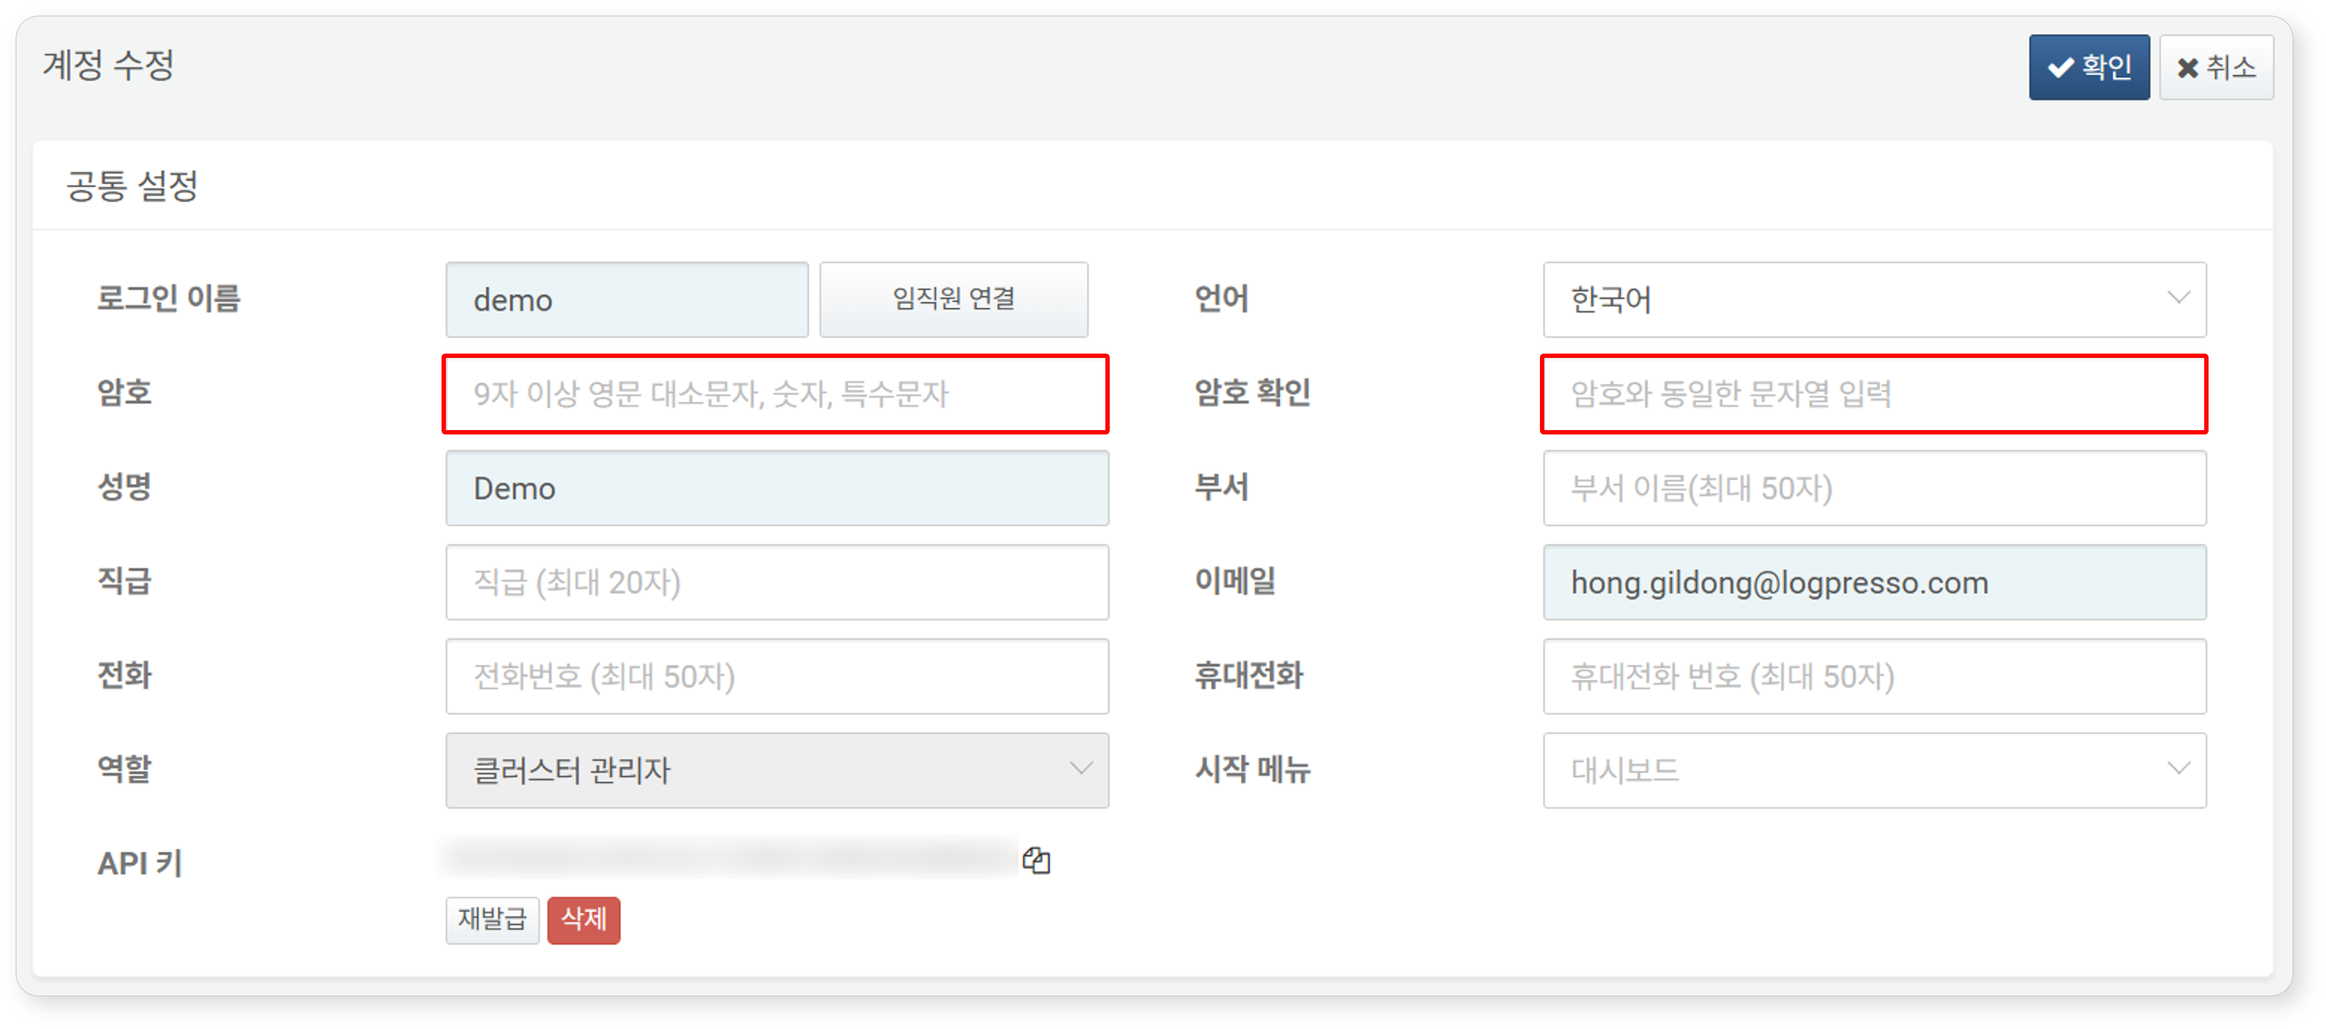

#### Locking and Unlocking the Screen

After logging into the web console, if you do not use it for a certain period or click the lock icon in the upper right corner of the web console screen, the screen will be locked.

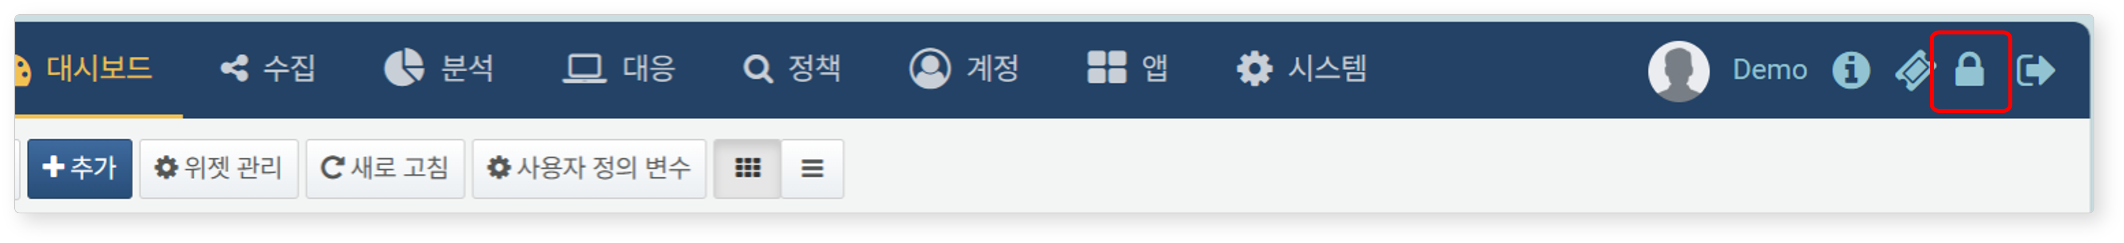

When the web console is locked, user authentication is required to regain access. Depending on your account settings, you may need to perform password authentication only, or enter the OTP code and then click login to unlock the screen.

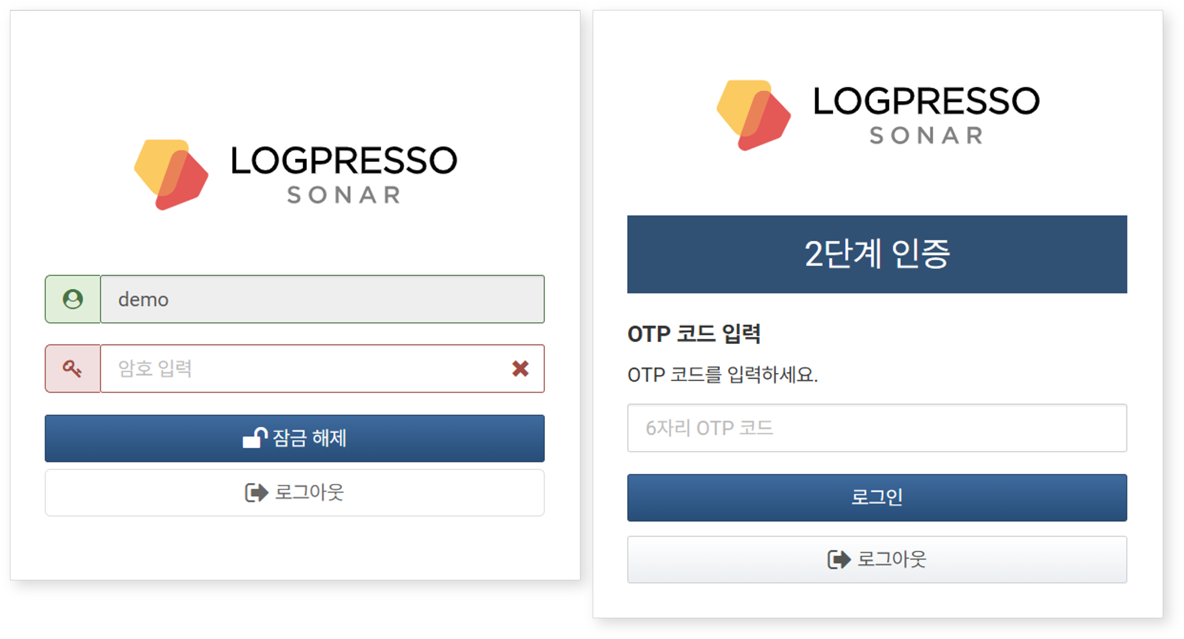

#### Logging Out

To log out of the web console, click on the logout option in the upper right corner of the web console.

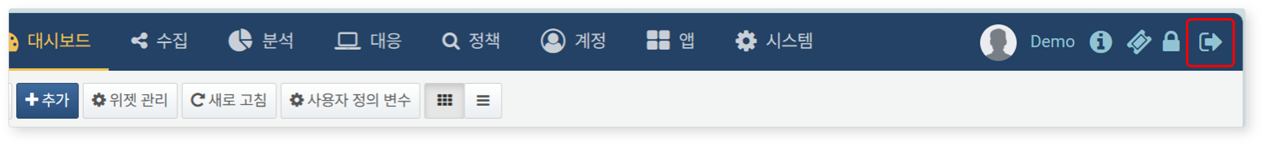

#### Viewing Version Information

To check the version information, click on the version information icon in the upper right corner of the web console.

