### Logs

View or search logs collected from the Loggers. Click the ... button to select a target from the Logger tree, enter the target period in the yyyy-MM-dd format, and then click the Search button. Logs matching the range [start, end) will be retrieved, meaning the start date is inclusive while the end date is exclusive.

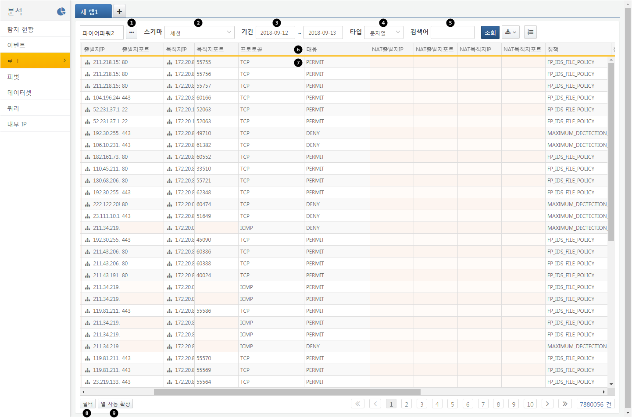

**Logger**: Select the list of Loggers from which to view logs.

**Schema**: Choose the original format to view all logs from the selected Logger, or select a schema to retrieve logs that match the defined field structure.

**Period**: Select the time period for log retrieval. The start date is included in the search range, while the end date is not.

**Type**: Specify the type of the search term as one of the following: string, IP address, IP range, or integer. The search results may vary based on the indexed type, even for the same search term.

**Search Term**: Enter the keyword to search within the logs.

**Column Header**: Clicking on the column header allows for automatic column expansion and sorting in ascending/descending order.

**Field Cell**: Right-clicking will display a filter list, allowing you to apply the desired filter to the log retrieval results.

**Filter**: Displays the list of applied filters.

**Automatic Column Expansion**: Automatically adjusts the width of all columns.

Clicking the download button will allow you to execute the following functions through the context menu:

**Save Query Results**

Saves the query result data on the server for future retrieval. Enter a name for the query result in the dialog box, and it will be saved under that name on the server. Saved query results can be selected and retrieved in a new query window.

**Download Query Results**

Downloads the query result data to the PC running the web browser. Specify the file name, format, and download range to download the query results.

**Create Dataset**

Generates a dataset to re-execute the current pivot analysis conditions. The dataset can later be viewed in the dataset menu or referenced in a dashboard to create widgets.