## Lookups

Lookups are tables that allow you to easily manage data that is frequently looked up while a query is running in Logpresso Sonar. For example, you can register data such as employee IDs, zip codes, and country codes that frequently requested in queries as a lookup.

Administrator privileges are required to view, add, update, or delete lookups. Users without privileges can retrieve lookup records only by using a lookup record retrieval procedure created by an administrator.

### Manage Lookups

#### View Lookup List

You can view the lookup list in **Analysis > Lookups**.

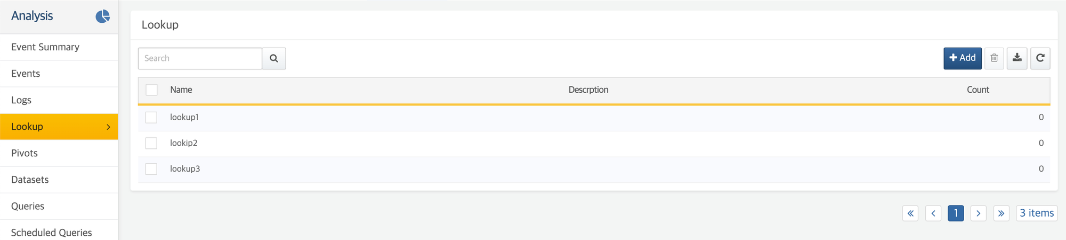

View Lookup Records

To view lookup records, click on the **name** of the lookup. In the above example, clicking **users** in the list brings up the **users** lookup panel.

The lookup panel shows the records in the lookup. A lookup record consists of multiple fields, like a database record, and has a minimum of two fields. The first field is used as a key field.

The top row of the lookup (table header row) is used as the field names. Each field name denotes (1) the name of the field as defined in the lookup schema, (2) the maximum length of the value that can be entered in the field, and (3) whether the field allows empty values. The name of a field that does not allow empty values is prefixed with an asterisk (*). For instance, a field name * ID (10) indicates that the field named "ID" must have a value (doesn't allow empty values) and can contain a maximum of 10 characters.

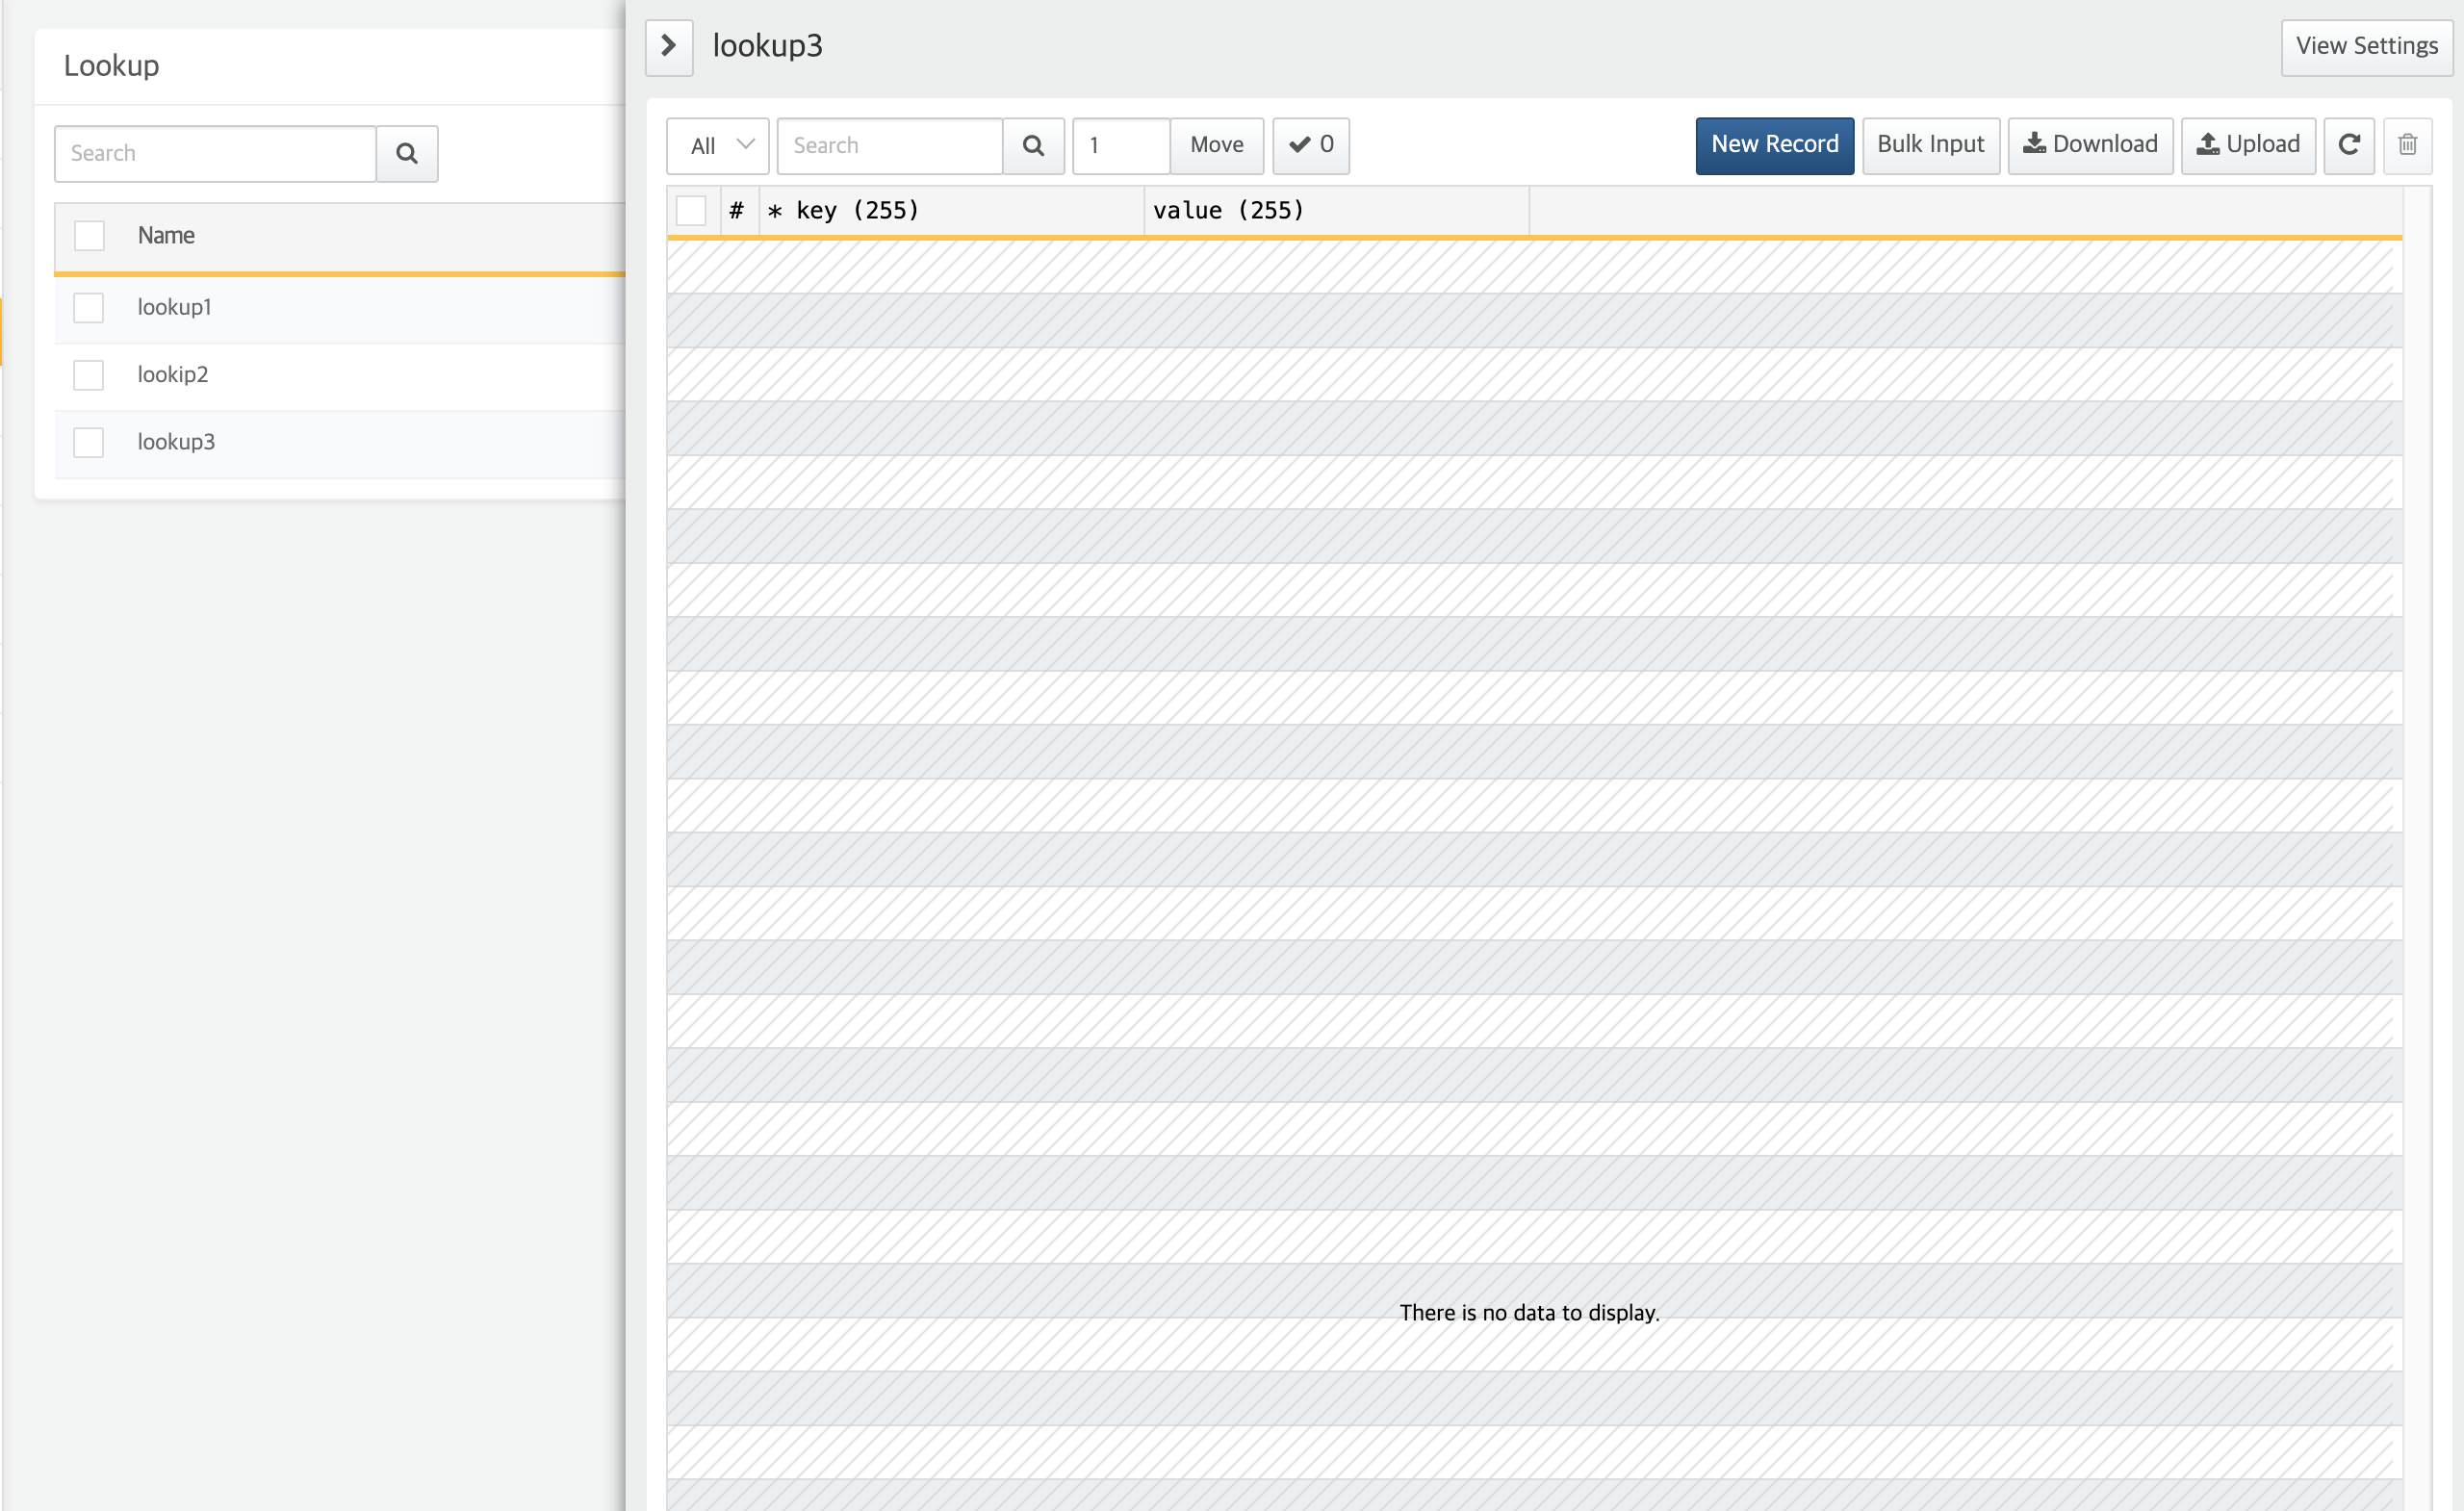

View Lookup Schema

To see the lookup schema, click **Lookup Schema** in the upper right corner of the lookup panel.



On the Lookup Schema view, you can see the **Basic information** and the **Schema** of the lookup, as shown below. The **Schema** defines the properties that appears in the lookup: field name, length, and whether empty values are allowed.

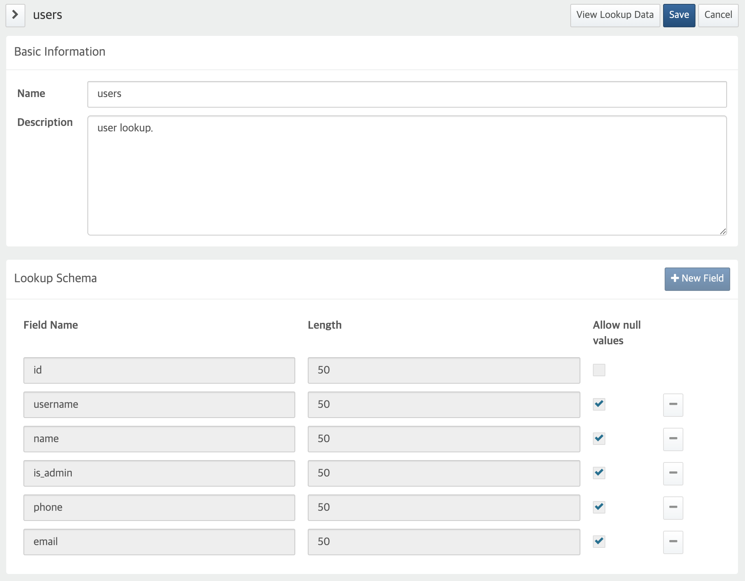

* On the Lookup Schema view, the **New Field** and **"**-**" (delete field icon)** buttons are disabled. You can define the lookup schema when you add a [new lookup](https://docs.logpresso.comnull), and you cannot modify the schema once it is defined.
* On the Lookup Schema view, click **Lookup Data** in the upper right corner to return to the lookup panel (Lookup record view).

Lookup Queries

You can use the [lookup](https://docs.logpresso.comnull) query command to retrieve lookup data. To enumerate the contents of a lookup, you can use [lookuptable](https://docs.logpresso.comnull) query command.

#### Add Lookups

To add a new lookup,

From the **Lookups** page, click **Add** in the upper right corner to go to the **New Lookup** page.

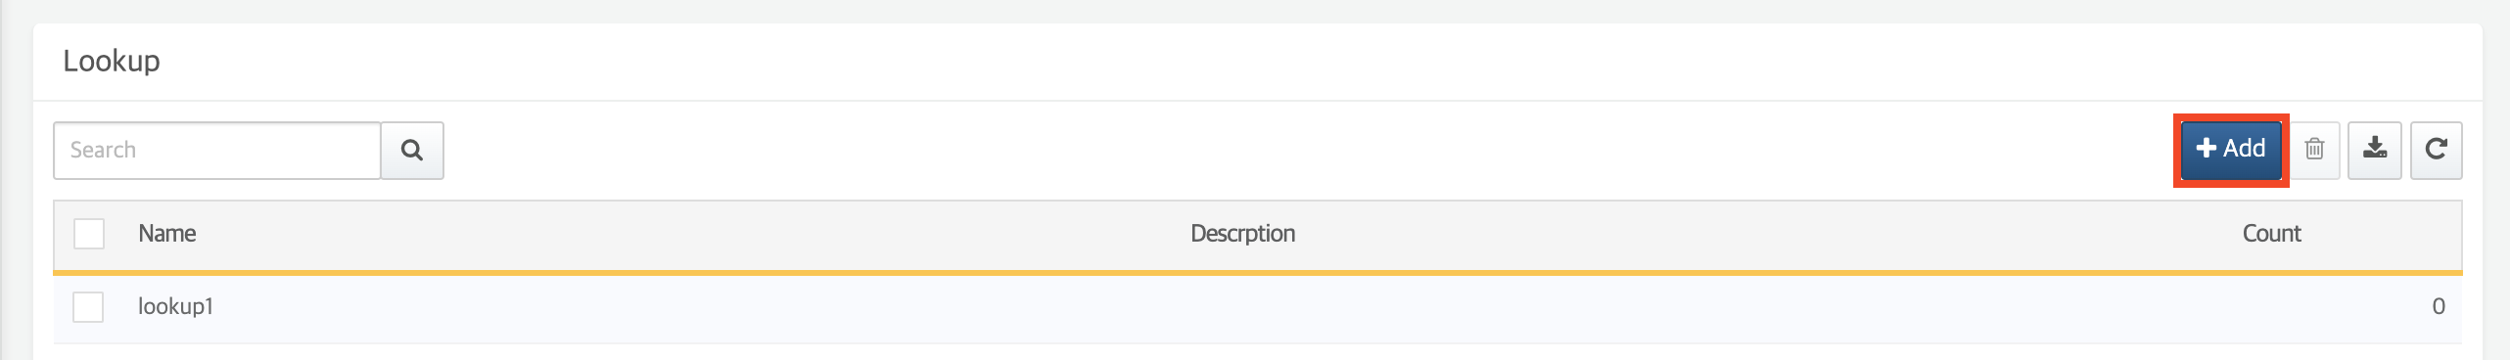

Enter the **Basic Information**: **Name** and **Description**.

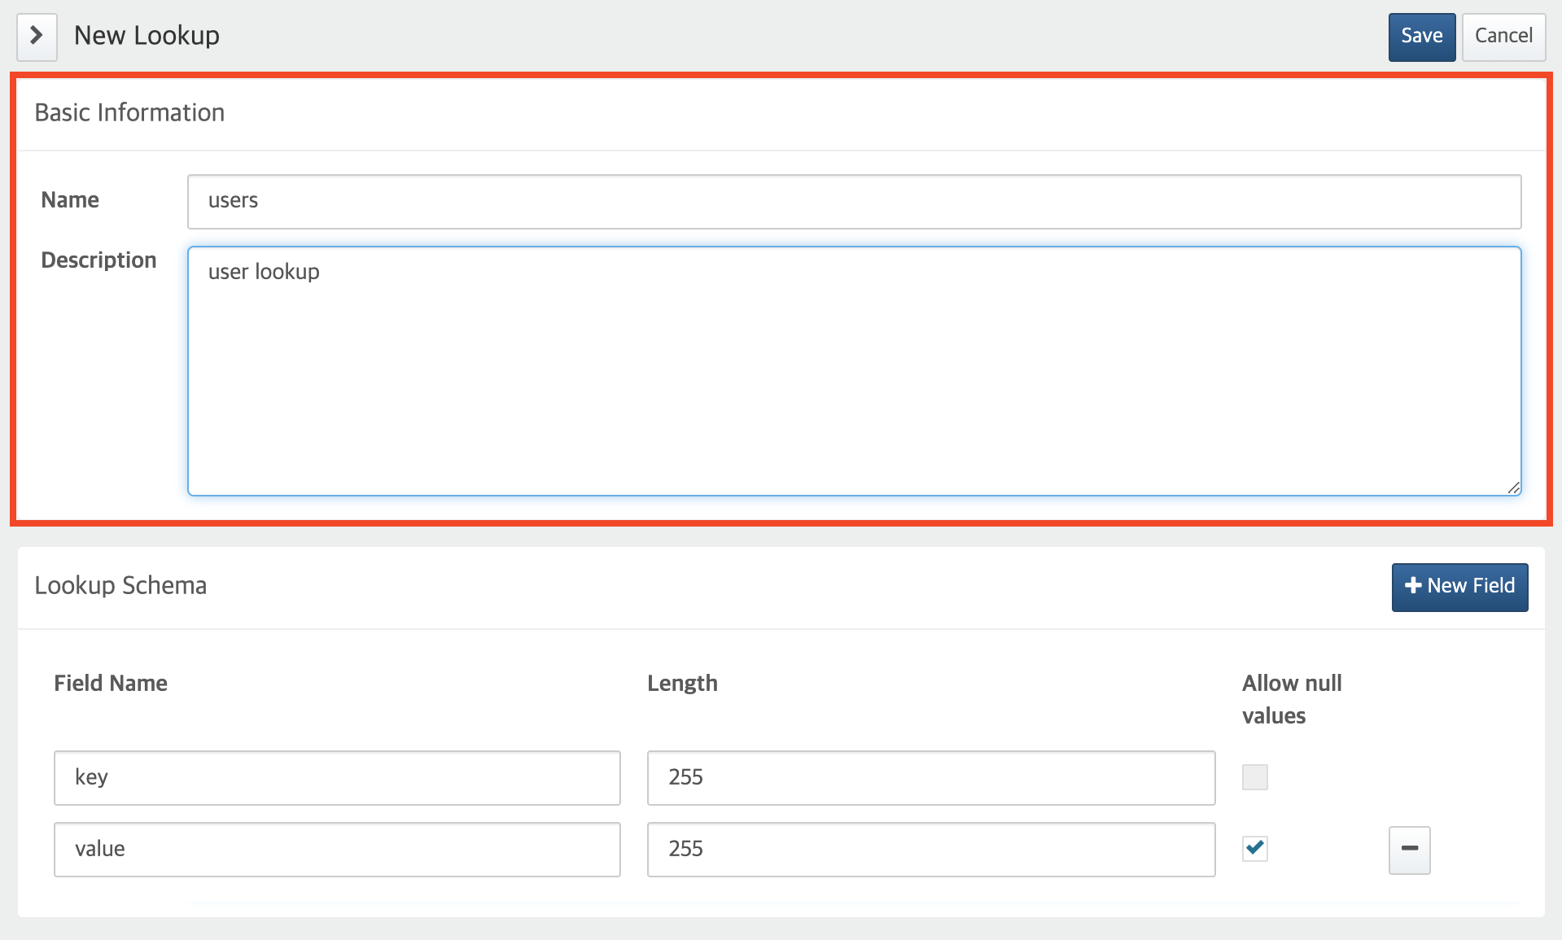

* **Name**: Lookup name as an identifier
* **Description**: Description

Define **Schema**. A lookup schema can consist of up to 10 fields. You can add a field by clicking **New Field**, or remove a field by clicking **"**-**" (delete icon)** to the right of the record.

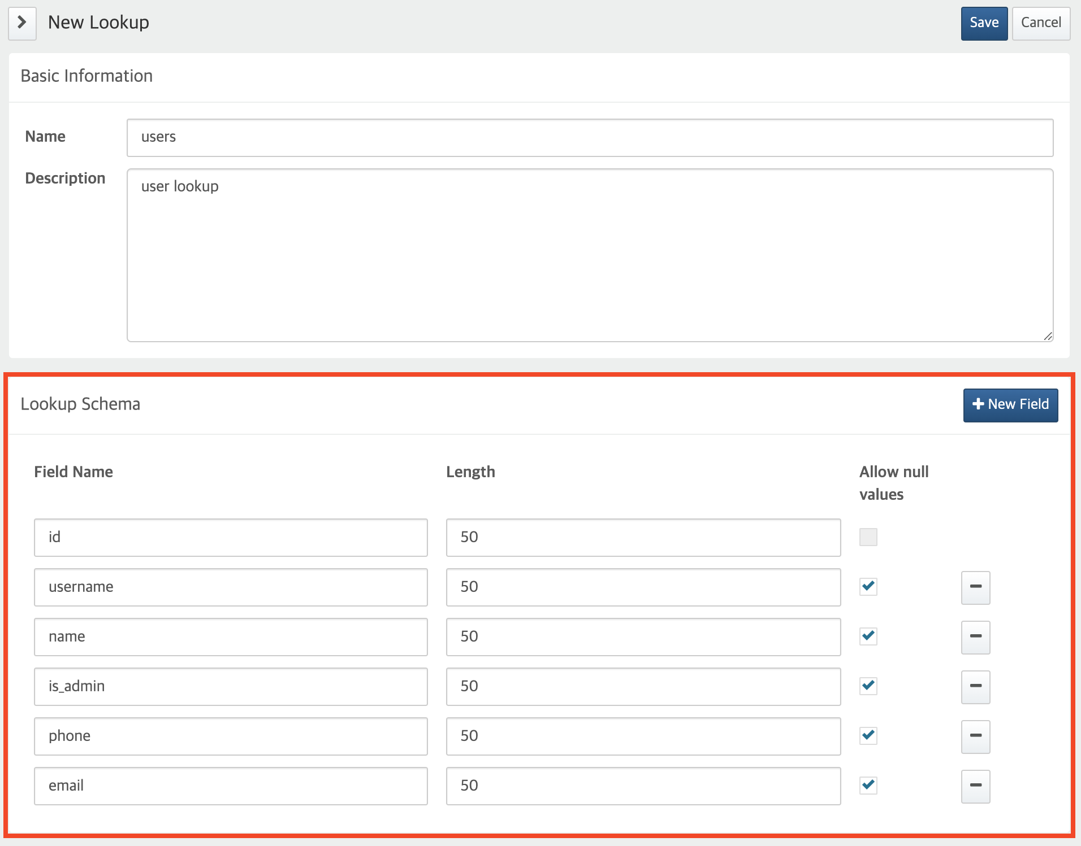

* **Field Name**: Unique field name. The first field is used as the key field. Note that created, created_at, updated, and updated_at are reserved keywords so cannot be used as field names.
* **Length**: The maximum length of a field value. The maximum is 255 characters.
* **Allow null values**: Whether the field allows null value. Note that the key field do not allow an empty value.

Check that the lookup schema is error-free. You cannot change the lookup schema once it has been created. Once you have entered both the **Basic Information** and **Schema** correctly, click **Save** to create the lookup.

#### Edit a Lookup

To change the name and description of a lookup,

Click **Lookup Schema** to go to the [Lookup Schema](https://docs.logpresso.comnull) page.



Edit the **Name** and **Description**. Click **Save** to apply the changes to the lookup.

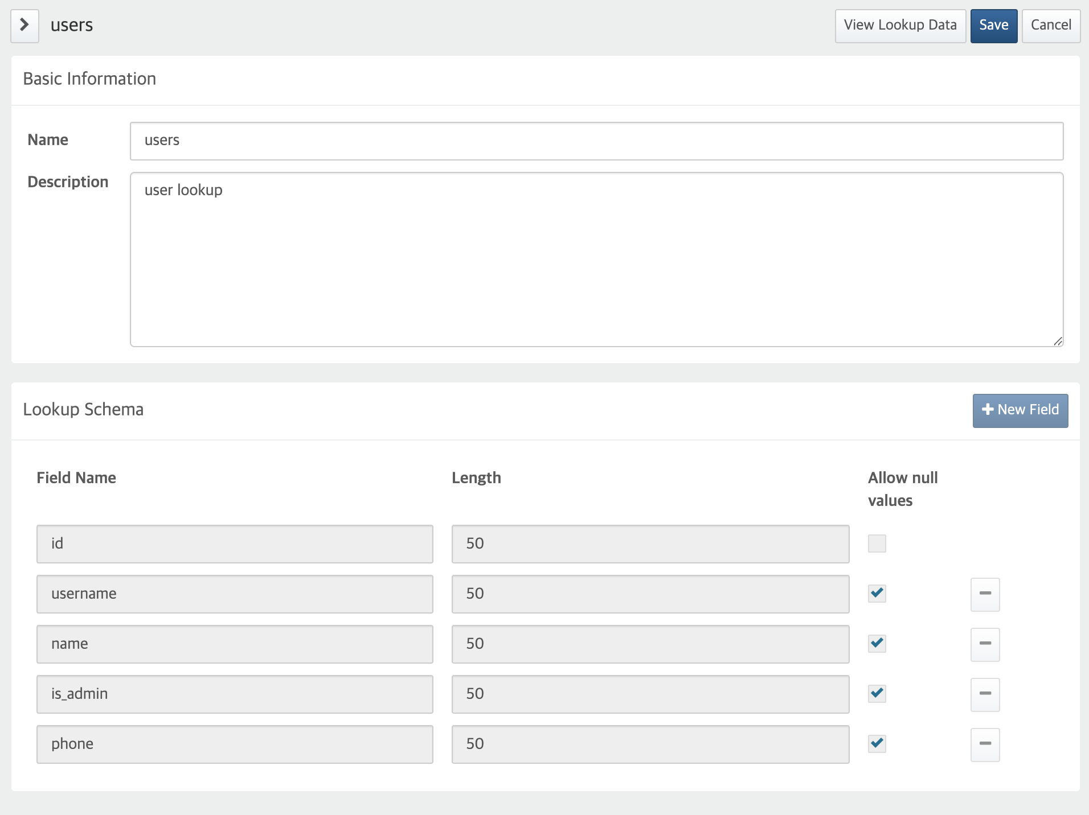

You can only define the lookup schema when you create a lookup, and you cannot modify it after that. If you need to change the lookup schema, create a new lookup.

#### Delete Lookups

To delete a lookup,

From the lookup list, tick the checkbox to the left of the lookup to delete, then click the **trash can (icon)** in the toolbar.

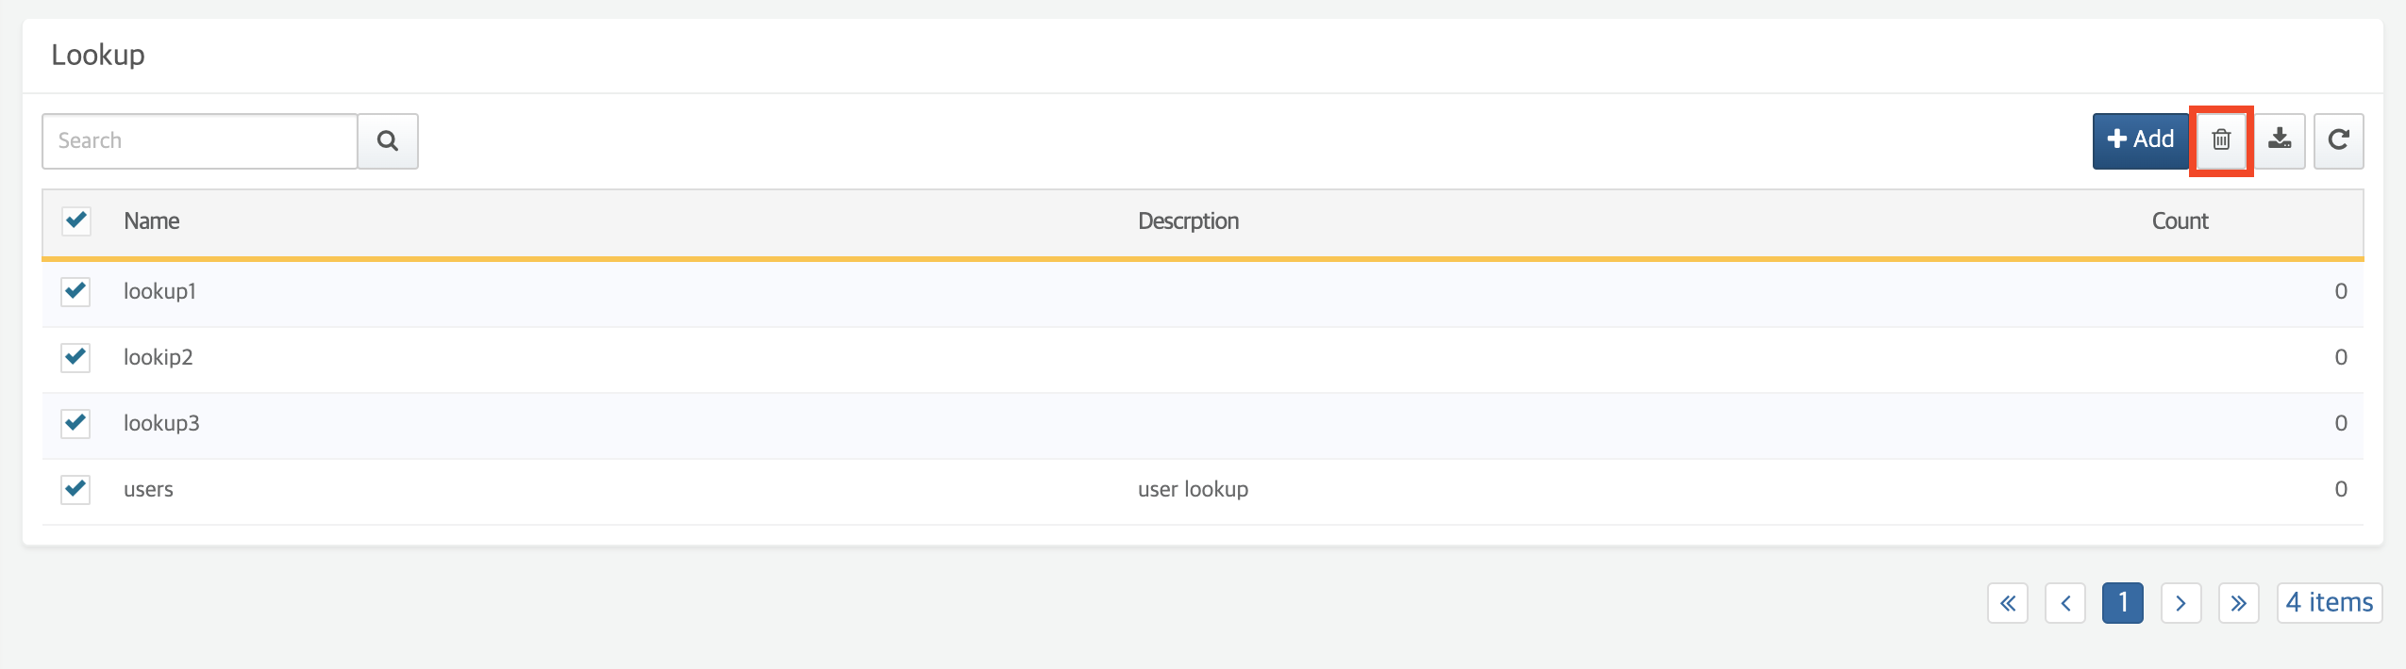

When prompted to delete lookup, ensure you correctly selected the the lookup to delete. Click **Delete** to delete the lookup. To cancel the delete action, click **Cancel**.

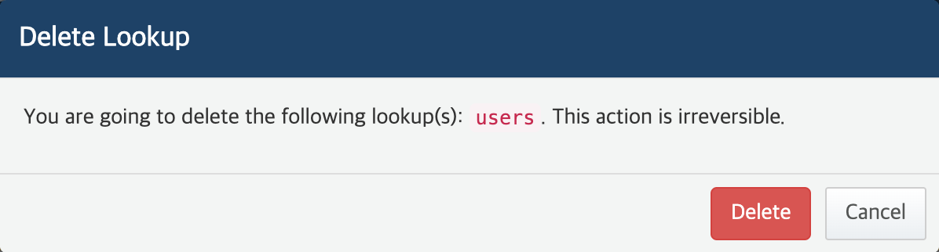

Confirm that the lookup is successfully deleted from the lookup list.

#### Download Lookup List

On the [Lookups](https://docs.logpresso.comnull) page, click **Download** in the upper right corner to download the full list of lookups.

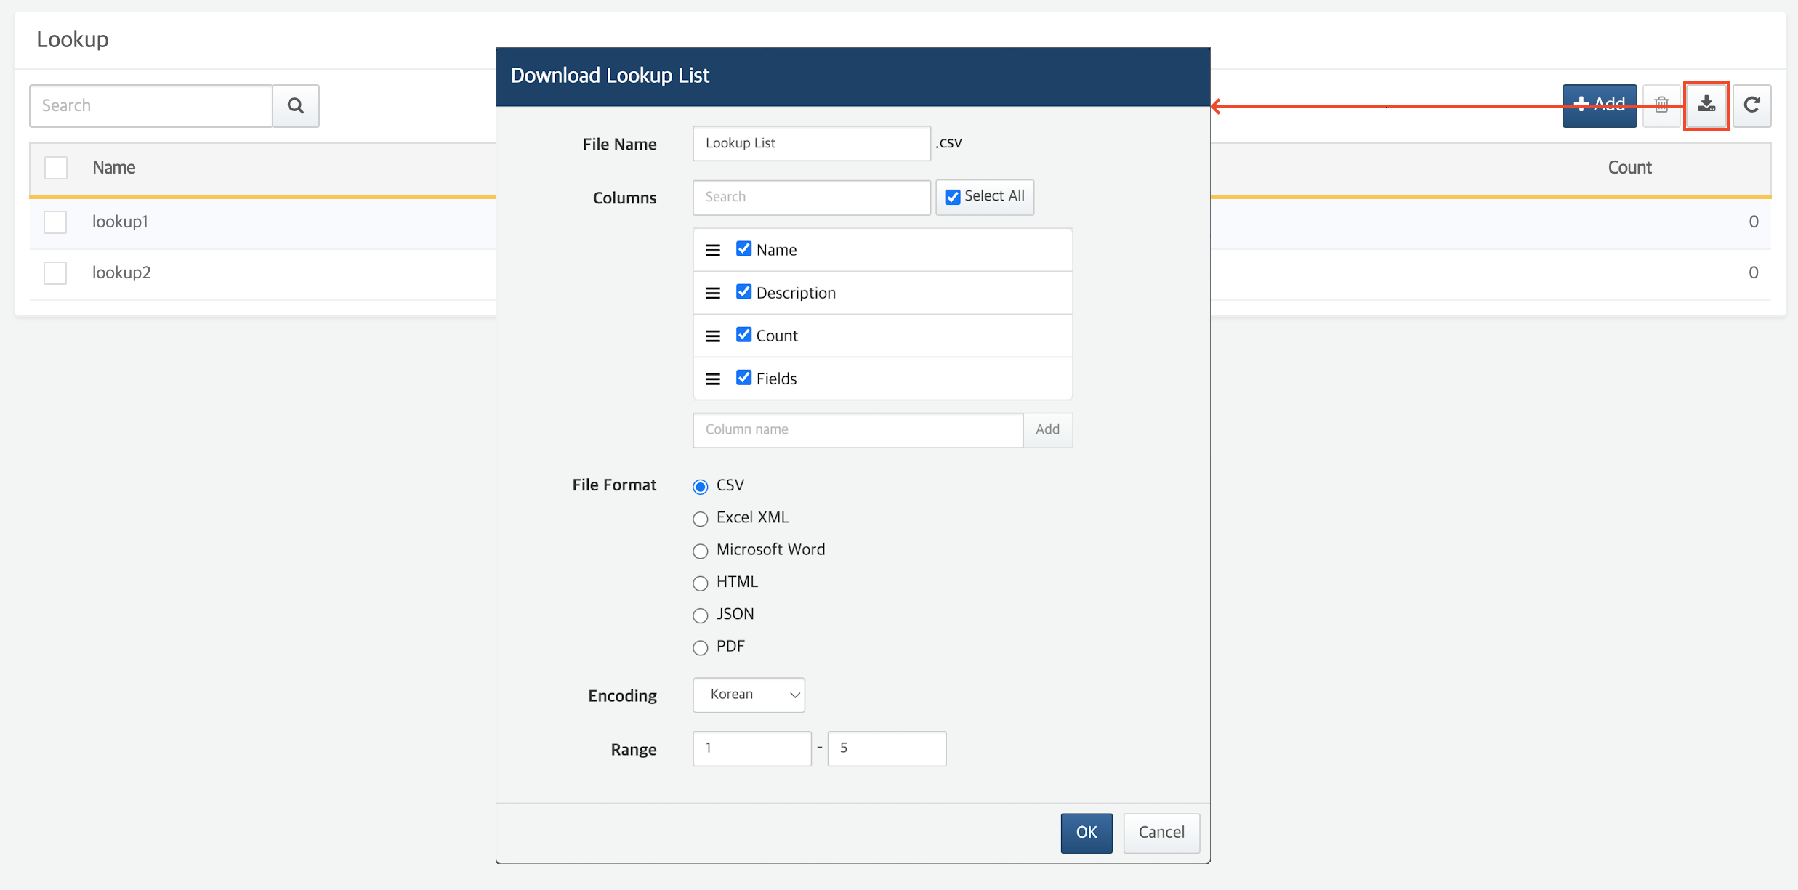

### Manage Lookup Records

Lookups are like database tables. Just as an empty table is worthless; a lookup is only valuable if it has a record, data refined according to the schema. In this section, you'll learn how to add, edit, and delete lookup records, and how to back up your lookups to a file.

#### Lookup Record Toolbar

You can manage lookup records on the [Lookup panel](https://docs.logpresso.comnull). Lookup record management tools are as follows:

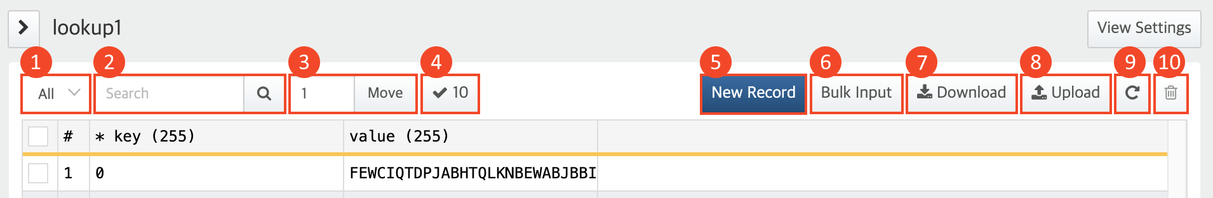

**(1) Record filter**

You can filter and view records based on whether the first field (checkbox) is checked (**All**, **Selected**).

**(2) Search**

Enter a keyword and click **Mgnifying Glass (icon)**. You can search and view only records that contain the keyword. The checkbox status or information in the **#** field will not be retrieved.

**(3) Go to**

Enter a number and click the **Go To** to jump to the record identified by that number in the **#** field.

**(4) Status**

Number of records currently being retrieved.

**(5) New Record**

Click [New Record](https://docs.logpresso.comnull) to add a single record.

**(6) Bulk Input**

Click [Bulk Input](https://docs.logpresso.comnull) to add multiple record at once.

**(7) Download**

Click [Download](https://docs.logpresso.comnull) to download lookup records as a CSV file.

**(8) Upload**

Click [Upload](https://docs.logpresso.comnull) to add lookup records by uploading a CSV file.

**(9) Refresh (icon)**

You can refresh the lookup panel page.

**(10) Trash Can (icon)**

Click [trash can (icon)](https://docs.logpresso.comnull) to delete the selected records by checkbox.

#### Add Lookup Records

You can add lookup records in three ways:

**Single input**

To add a single record, use the single input feature that a user can enter the record directly. If the record does not conform to the lookup schema, an error message will appear.

**Bulk input**

You can enter multiple records to the lookup on a excel-like panel. Users can enter records directly as they would with Excel, or they can simply copy and paste record data from a file created in Microsoft Excel or Google Sheets.

You can add up to 1,000 lookup records using the batch input feature. To add more than 1,000 records to a lookup at once, use the **Upload CSV file** feature.

Records must be structured according to the lookup schema:

* The key fields must contain values.
* Field values must be sorted in the order of the fields defined in the lookup schema.
* Each record field must conform to field constraints: length, whether empty values are allowed.

If any record fails to conform to the lookup schema, an error message appears. You should check the cell with the error and correct the data accordingly.

**File upload**

You can add lookup records by uploading a CSV file with records that conform to the lookup schema. This feature is useful when you need to upload a large number of records at once.

The data in the CSV file you upload to the Logpresso server must be structured according to the lookup schema.

* The first row must contain all the field names you defined in the lookup schema (regardless of order)
* The key fields must contain values.
* Each record field must conform to field constraints: length, whether empty values are allowed.

The Logpresso server checks records for compliance with the lookup schema before adding them to the lookup. When all records conform to the lookup schema, they will be included in the lookup; if any of them are in error, none of the records will be included.

Add Single Record

To add a lookup record using the single input feature,

Click **New Record** on the lookup panel.

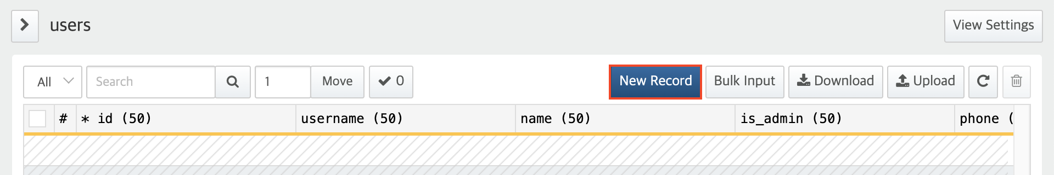

Fill in each field with a value and click **Add**.

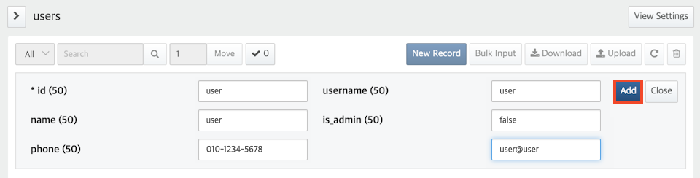

If any record fails to conform to the lookup schema, an error message appears. You should check the cell with the error and correct the data accordingly.

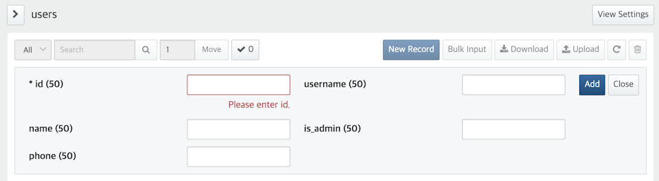

Add Multiple Records

To add a lookup record using the bulk input feature,

Click **Bulk Input** on the lookup panel.

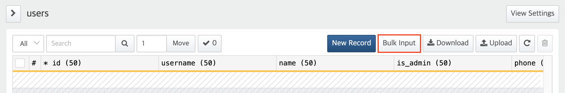

When the lookup panel switches to edit mode, enter records and click **Save**.

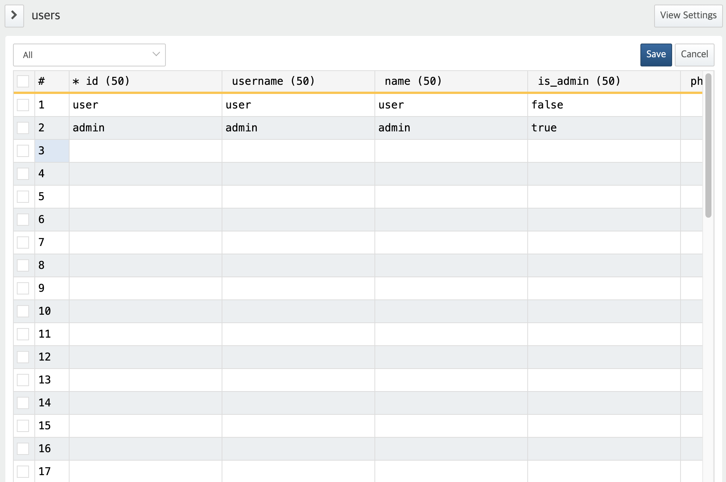

* You can enter records directly, like entering data into cells in Microsoft Excel.
* You can copy & paste data from a file stored in a spreadsheet format, such as an XLS or XLST file.
* If the records you add do not conform to the lookup schema, the borders of the erroneous cells are highlighted in red. To see the error, hover your cursor over the cell. You can see the error message in the bubble help. Check the message and correct the value to conform to the lookup schema.
* 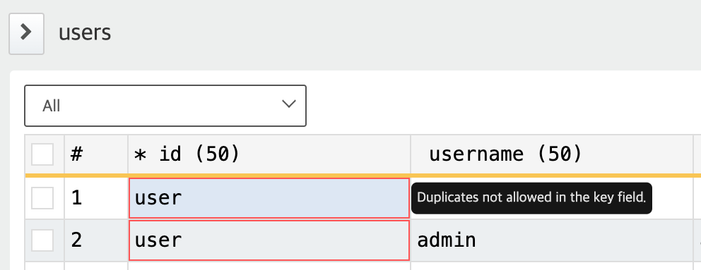
* The error messages that can occur during bulk input are as follows:

**Duplicates not allowed in the key field.**

There are duplicate values in the key field.

**Input exceeds length limit:** XXX characters.

The input is longer than the length defined in the lookup schema.

**Empty value not allowed for this field.**

The field does not allow empty values.

* You can select **Error** in the record filter in the upper left corner to view only lookup records with errors.
* 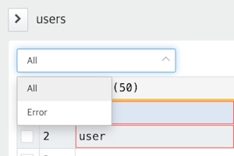

Upload Lookup Table File

To add a lookup record by uploading a CSV file,

Click **Upload** on the lookup panel.

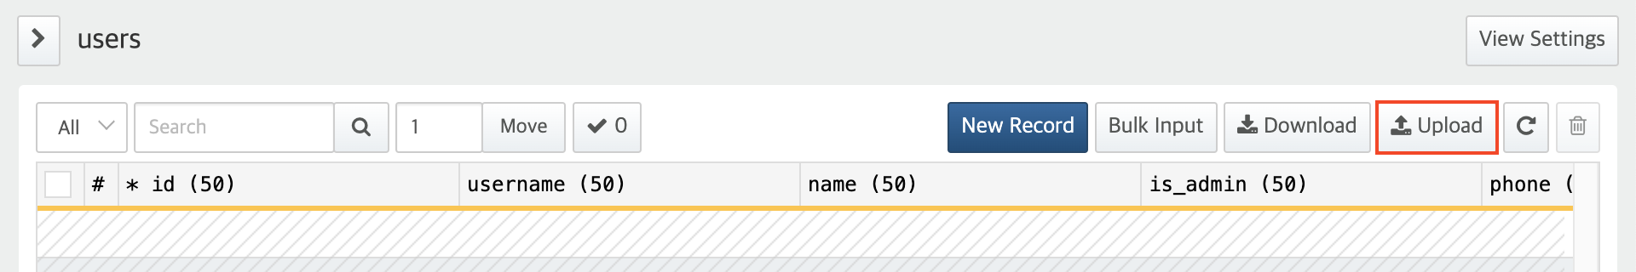

When prompted to upload a lookup file, select the CSV file to upload and the encoding of the file, then click **Upload**.

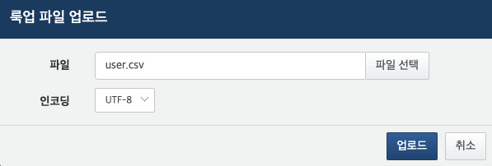

* **File**: Path to the CSV file to upload.
* **Encoding**: Encoding of the CSV file. You can select one of the following encodings: **UTF-8**, **UTF-16 BE**, **MS949**.

The Logpresso server checks records for compliance with the lookup schema before adding them to the lookup. If any record fails to conform to the lookup schema, an error message appears.

* If the first row of the uploaded file does not contain a schema field name, a **Lookup File Upload failure** message appears, as shown in the following screenshot.
* 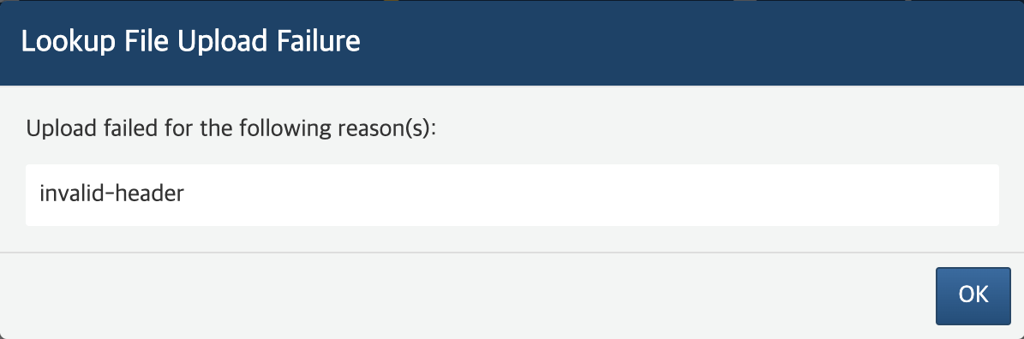
* If any record in the uploaded file fails to conform to the field conditions defined in the lookup schema (key fields, empty values allowed, character length limit), a **Lookup File Upload Failure** message appeard, as shown in the following screenshot.
* 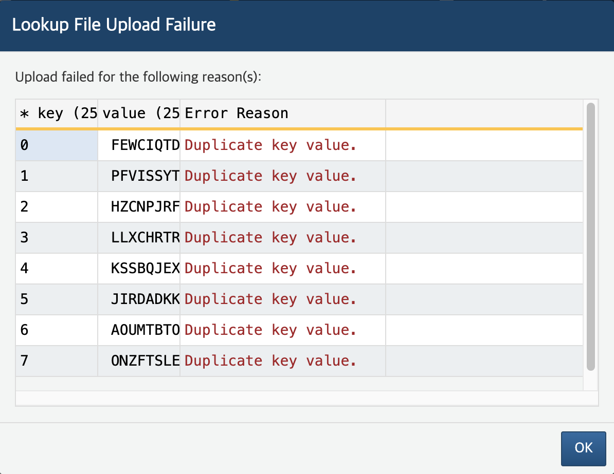

If all the records in the CSV file conform to the lookup schema, the file will be uploaded to the server. Click **Confirm** to close the **Lookup File Upload Success** message window.

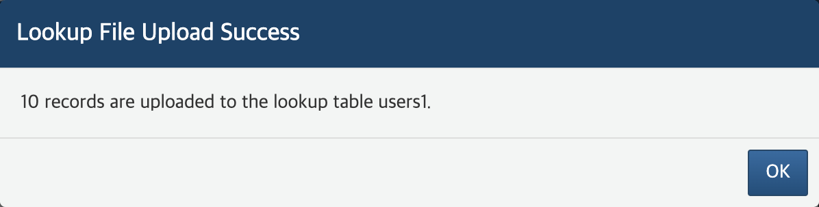

If an server communicayion error occurs while uploading the file, a **Lookup File Upload Failure** message appears, as shown below.

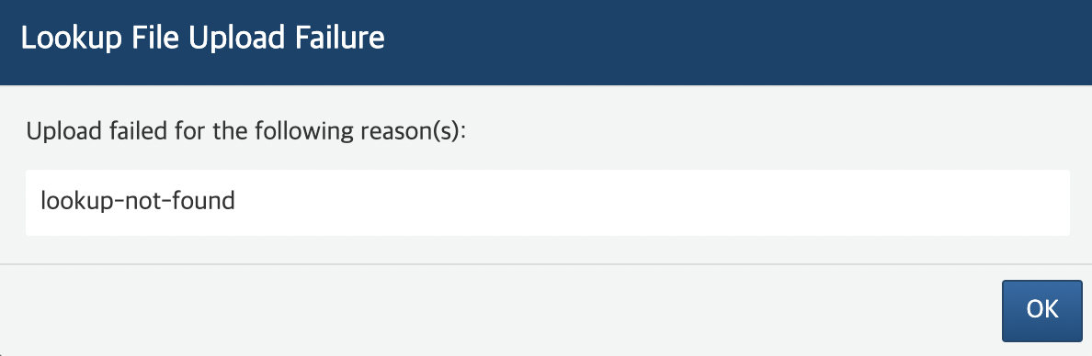

#### Update Lookup Records

To edit lookup records,

Double-click the record cell you want to edit on the lookup panel or use the **arrow key** to navigate to the cell and press **Enter** key.

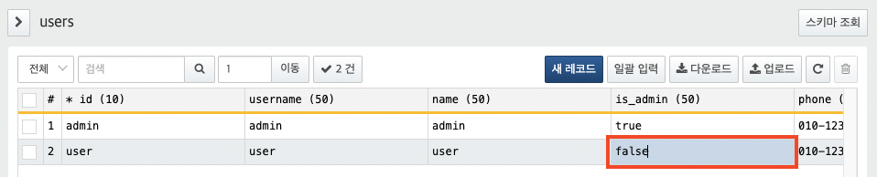

Edit the value in the cell (in edit mode), then press the **Enter** key to save the change. To cancel editing the record, press the **Esc** key.

#### Delete Lookup Records

To delete lookup records,

Select the record you want to delete from the lookup panel screen, and click **trash can (icon)** in the toolbar.

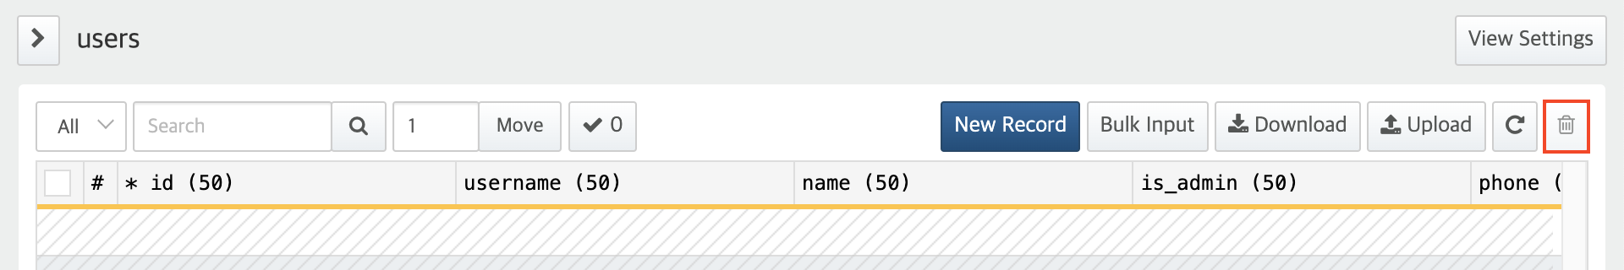

When prompted to remove lookup record, confirm the number of lookups you want to delete. Click **Delete** to delete the records. Click **Cancel** to cancel the delete action.

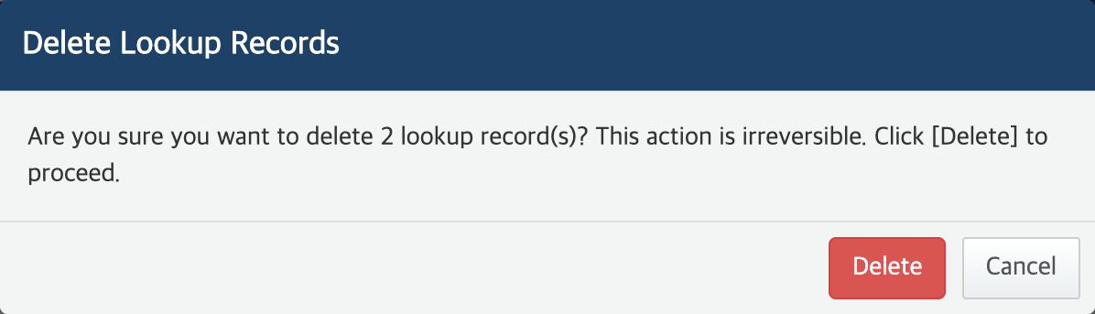

Confirm that the record is successfully deleted from the lookup.

#### Download Lookup Records

To back up lookup records to a CSV file,

Click **Download** in the upper right corner of the Lookup panel. If you select only specific records and click **Download**, you can backup only those records.

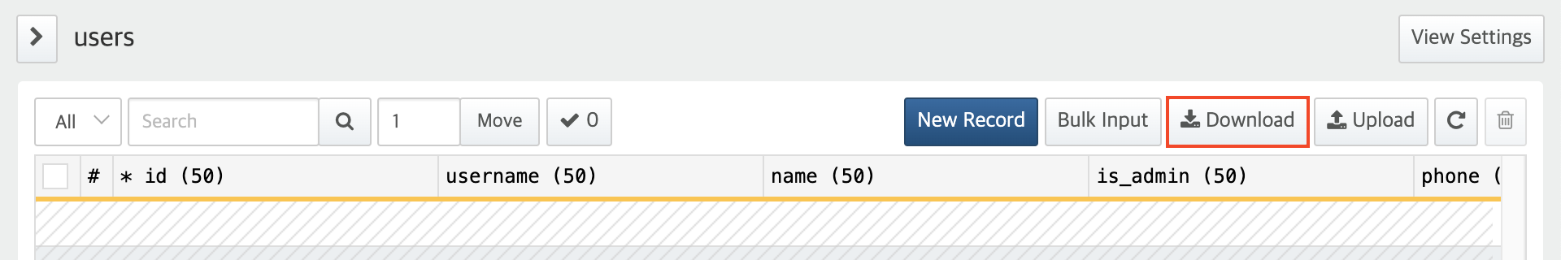

When prompted to download lookup file, specify the properties of the file to download and click **OK**.

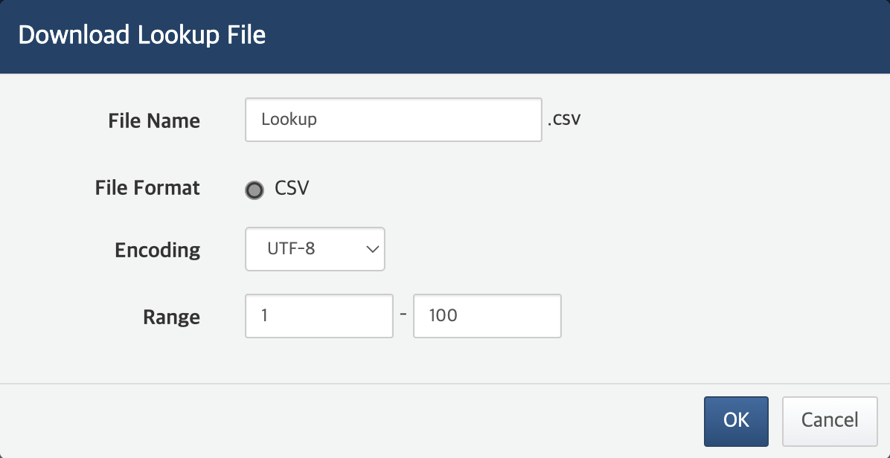

* **File Name**: Name of the file to downlaod. If not specified, **lookup** is assigned.
* **Format**: Only CSV format is currently available.
* **Encoding**: Encoding of the CSV file. You can select one of the following encodings: **UTF-8**, **UTF-16 BE**, **MS949**.
* **Range**: The range of lookup records to save to the file. The first row in the lookup record view (lookup panel veiw) is numbered 1. This property is not available when selecting only specific records.