### Packages

#### Overview

Logpresso version 4.0.2312.0 introduces a new feature, Package, which allows users to register and manage [Sentry](https://docs.logpresso.com/en/sonar/4.0/ui/section-sentries) installation packages on the Logpresso server.

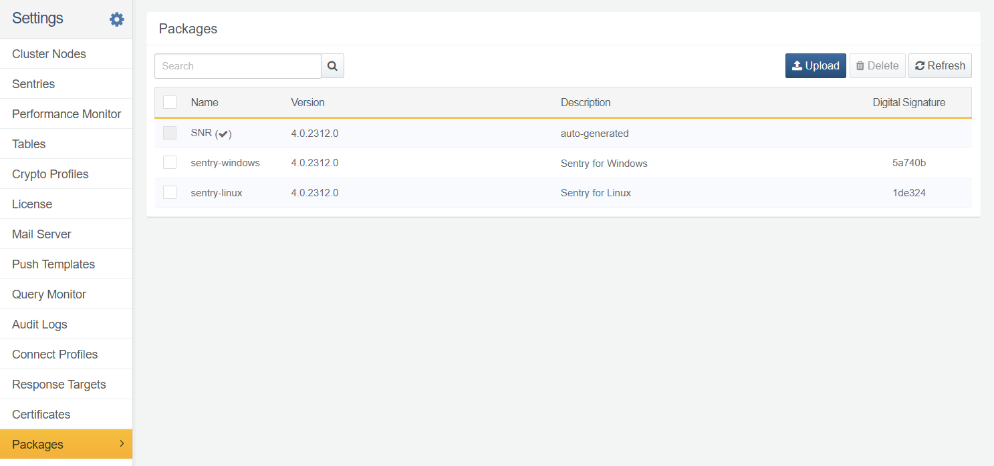

Ensure that you are using Logpresso version 4.0.2312.0 or higher to be able to utilize the package feature. Earlier versions only support manual deployment.

#### Deploy Package

To deploy a Sentry, ensure you have the Sentry installation package and digital signature information.

Log in to the [Logpresso Store](https://logpresso.store/en/packages).

Go to **Packages > Linux Sentry** or **Packages > Windows Sentry**. As of now, package feature is only available on Linux and Windows.

Click **Download** at the bottom of the version information to download the installation package.

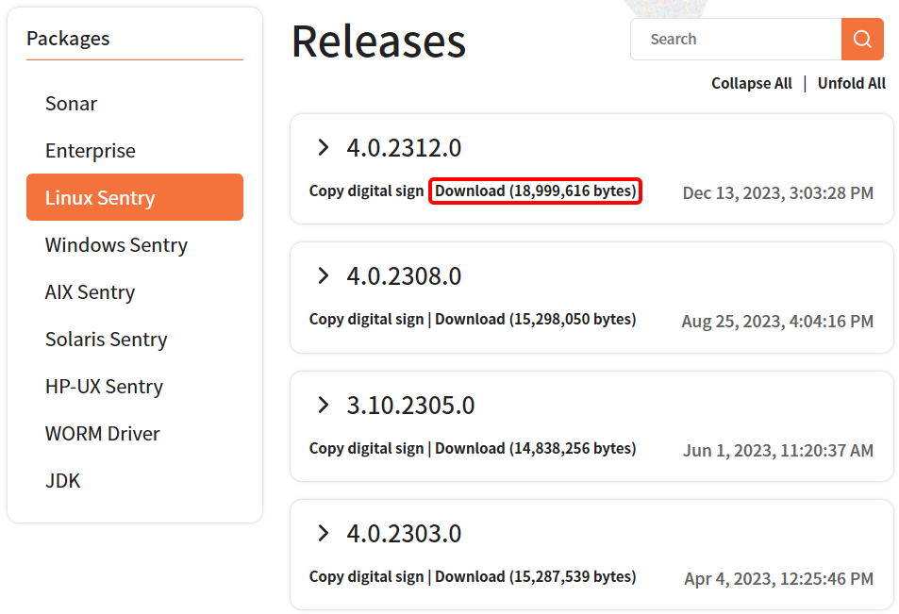

Click **Copy Digital Signature** to copy the digital signature information to the clipboard. You will need the digital signature when uploading the package to the Logpresso server.

#### Upload Package

To upload the package file to **Logpresso Sonar** or **Logpresso Maestro**:

Click **Upload** in the toolbar under **System > Packages**.

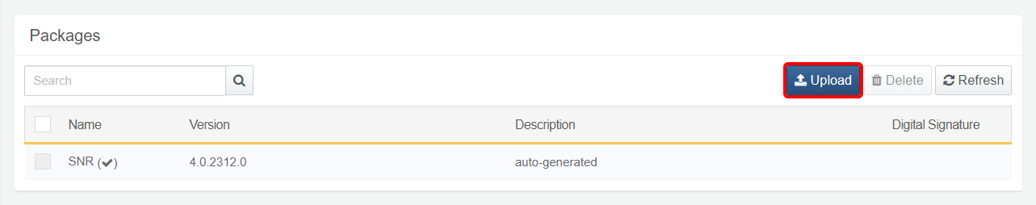

In the **Upload Package** dialog, select the Sentry package file and enter a **Digital signature** and **Description**. Once you're done, click **OK** to upload the file to the Logpresso server.

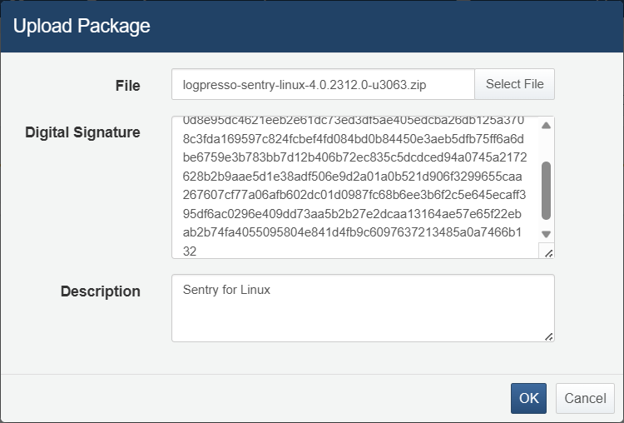

* **Select File**: Sentry installation file (package) to upload
* **Digital Signature**: Digital signature string you copied to the clipboard in **Deploy Package**.
* **Description**: Description

Once uploading is completed, it will appear in the package list.

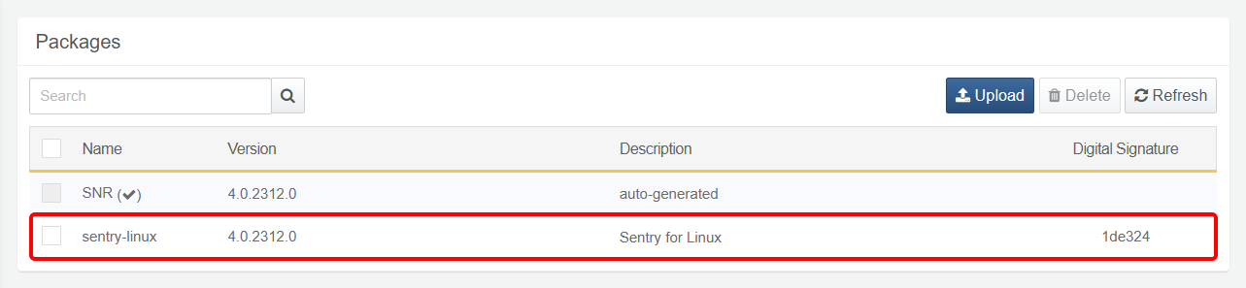

#### Remove Package

To remove an uploaded package:

Go to **System > Packages** and then tick the checkbox of the check the package file you want to delete.

Click **Remove** on the toolbar.

Click **OK** on the **Remove Package** dialog box to confirm the deletion. If you do not want to delete, click **Cancel**.

