### Performance Monitor

#### Overview

The Performance Monitor is a tool for viewing the performance of server nodes that make up the Logpresso platform. Users can check the performance status of all nodes registered in the cluster or view performance metrics for specific nodes.

#### Overall Status View

You can view the status of all nodes in the Logpresso platform by navigating to **System > Performance Monitor**. All information is updated every 5 seconds.

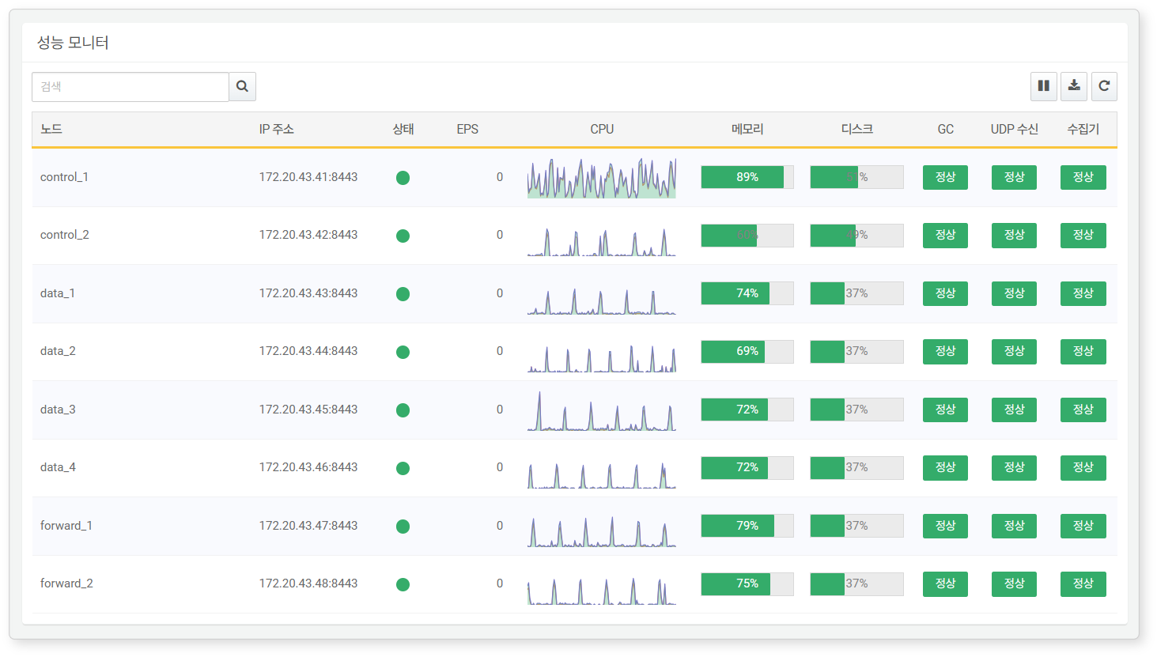

* **Node**: Node ID that can be queried from the cluster node
* **IP Address**: IP address of the cluster node
* **Status**: Connection status of the node. Changes to red if not connected for 60 seconds.
* **EPS**: Number of events collected per second (events per second)
* **CPU**: CPU usage over the last 10 minutes displayed in 10-second intervals (unit: %).
* **Memory**: Physical memory usage excluding filesystem cache (unit: %). Above 95% is critical (red), above 90% is caution (yellow), below 90% is normal (green).
* **Disk**: Maximum usage of the disk partition where Logpresso tables are located (unit: %). Above 90% is critical (red), above 80% is caution (yellow), below 80% is normal (green).
* **GC**: Number of Full GC occurrences that took more than 1 second in the last 10 minutes. More than 5 occurrences is a failure (red), more than 1 occurrence (yellow), none is normal (green).
* **UDP Reception**: Packet loss status for UDP packets over the last hour. Loss of more than 10,000 packets (red), loss of 10,000 packets or less (yellow), no loss is normal (green).
* **Logger**: Operational status of activated loggers. If there is one or more errors, it shows as an error (yellow), no errors is normal (green).

View Specific Node List Only

To view only specific nodes, enter the name of the node in the toolbar and press the **Enter** key.

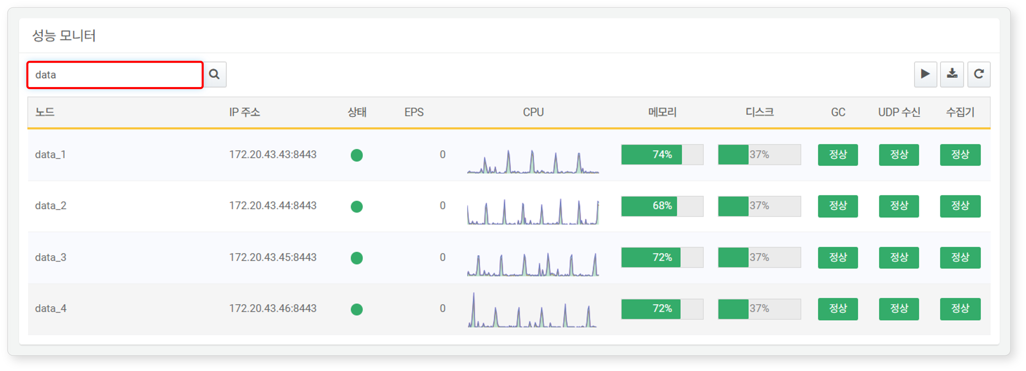

Start/Pause Refresh

The Performance Monitor refreshes every 5 seconds. To pause the refresh, click the  button in the toolbar.

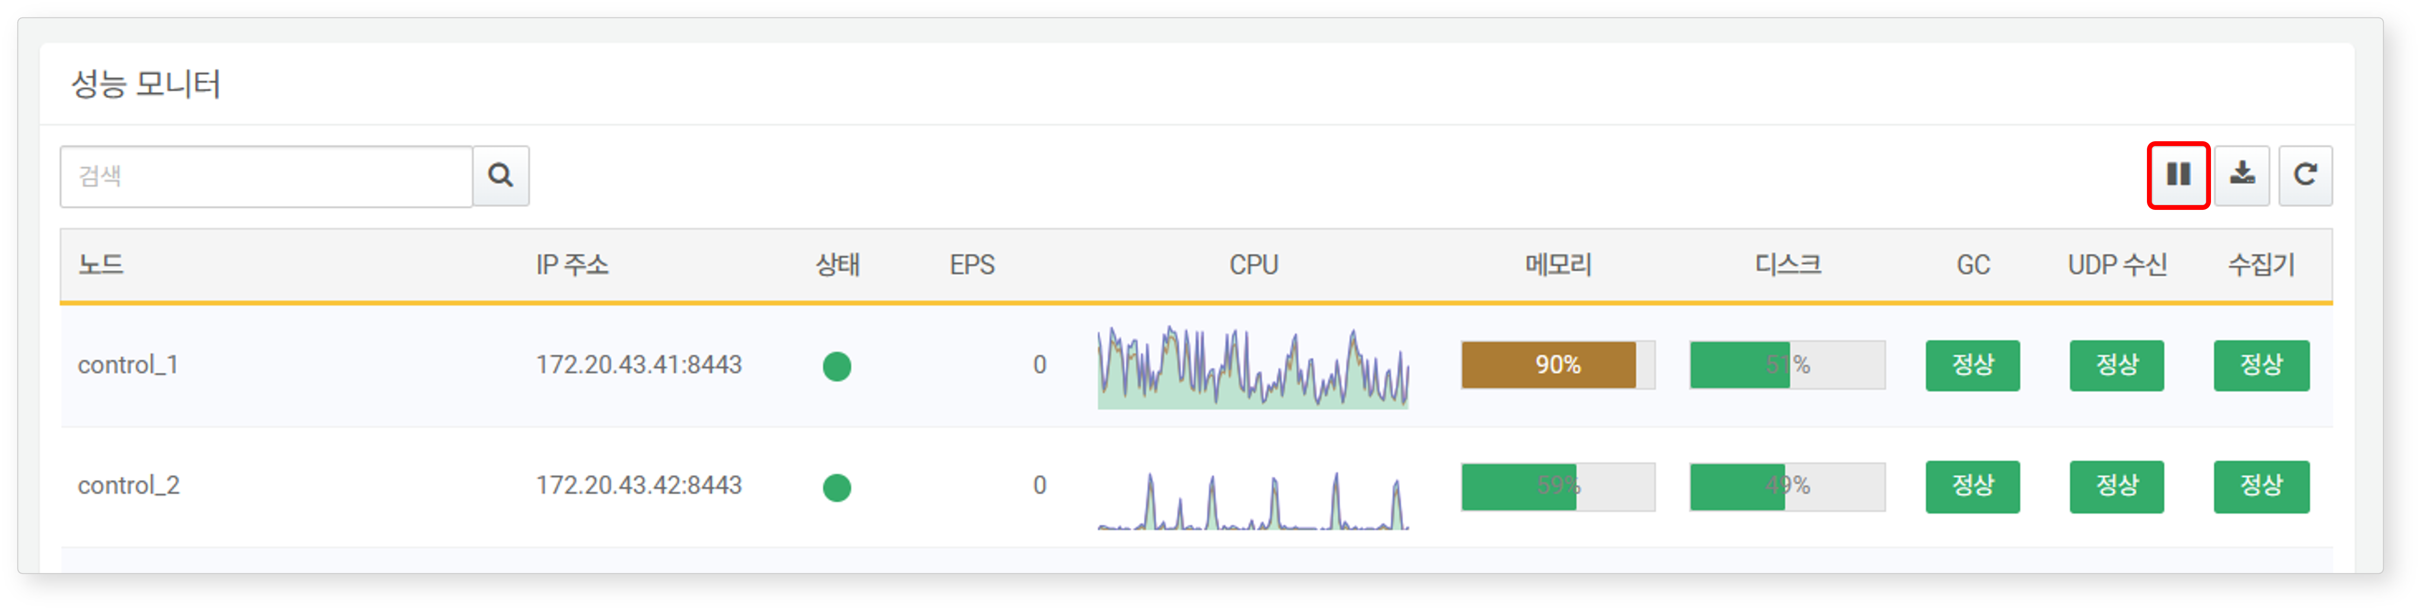

To resume periodic refreshing of the Performance Monitor, click the  button.

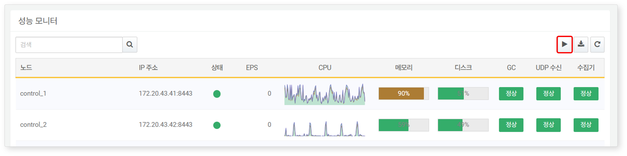

Immediate Refresh

To refresh the Performance Monitor at any time, click the  button.

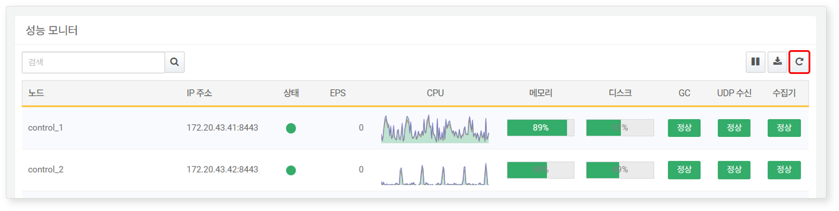

Download Performance Monitor Status

To download the status of the Performance Monitor as a file, click the  button in the toolbar.

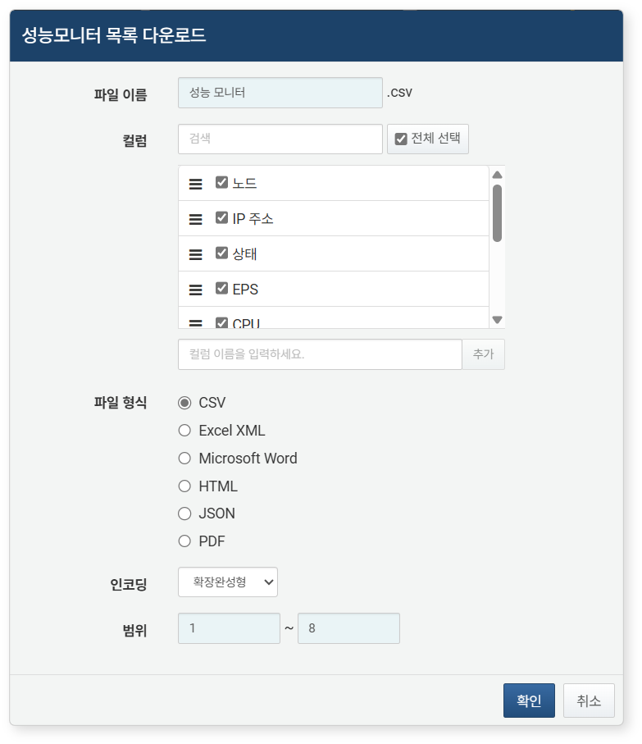

* **File Name**: Name of the file to be downloaded (default: Performance Monitor)
* **Columns**: Fields to be recorded in the download list (default: Select All)
* **File Format**: Choose from **CSV**, **Excel XML**, **Microsoft Word**, **HTML**, **JSON** (default: CSV)
* **Encoding**: Choose the string encoding format for the file from Extended Completion, UTF-8, UTF-16 BE (default: Extended Completion)
* **Scope**: Select the range of nodes to be recorded in the list. The default includes all nodes, starting from node at the top of the Performance Monitor page as number 1.

#### View Detailed Performance Metrics of a Node

Clicking on a specific node row in the Performance Monitor opens a side panel where you can view detailed performance metrics for that node. To close the panel, press the **Esc** key or click the  button. All metrics are updated every 5 seconds.

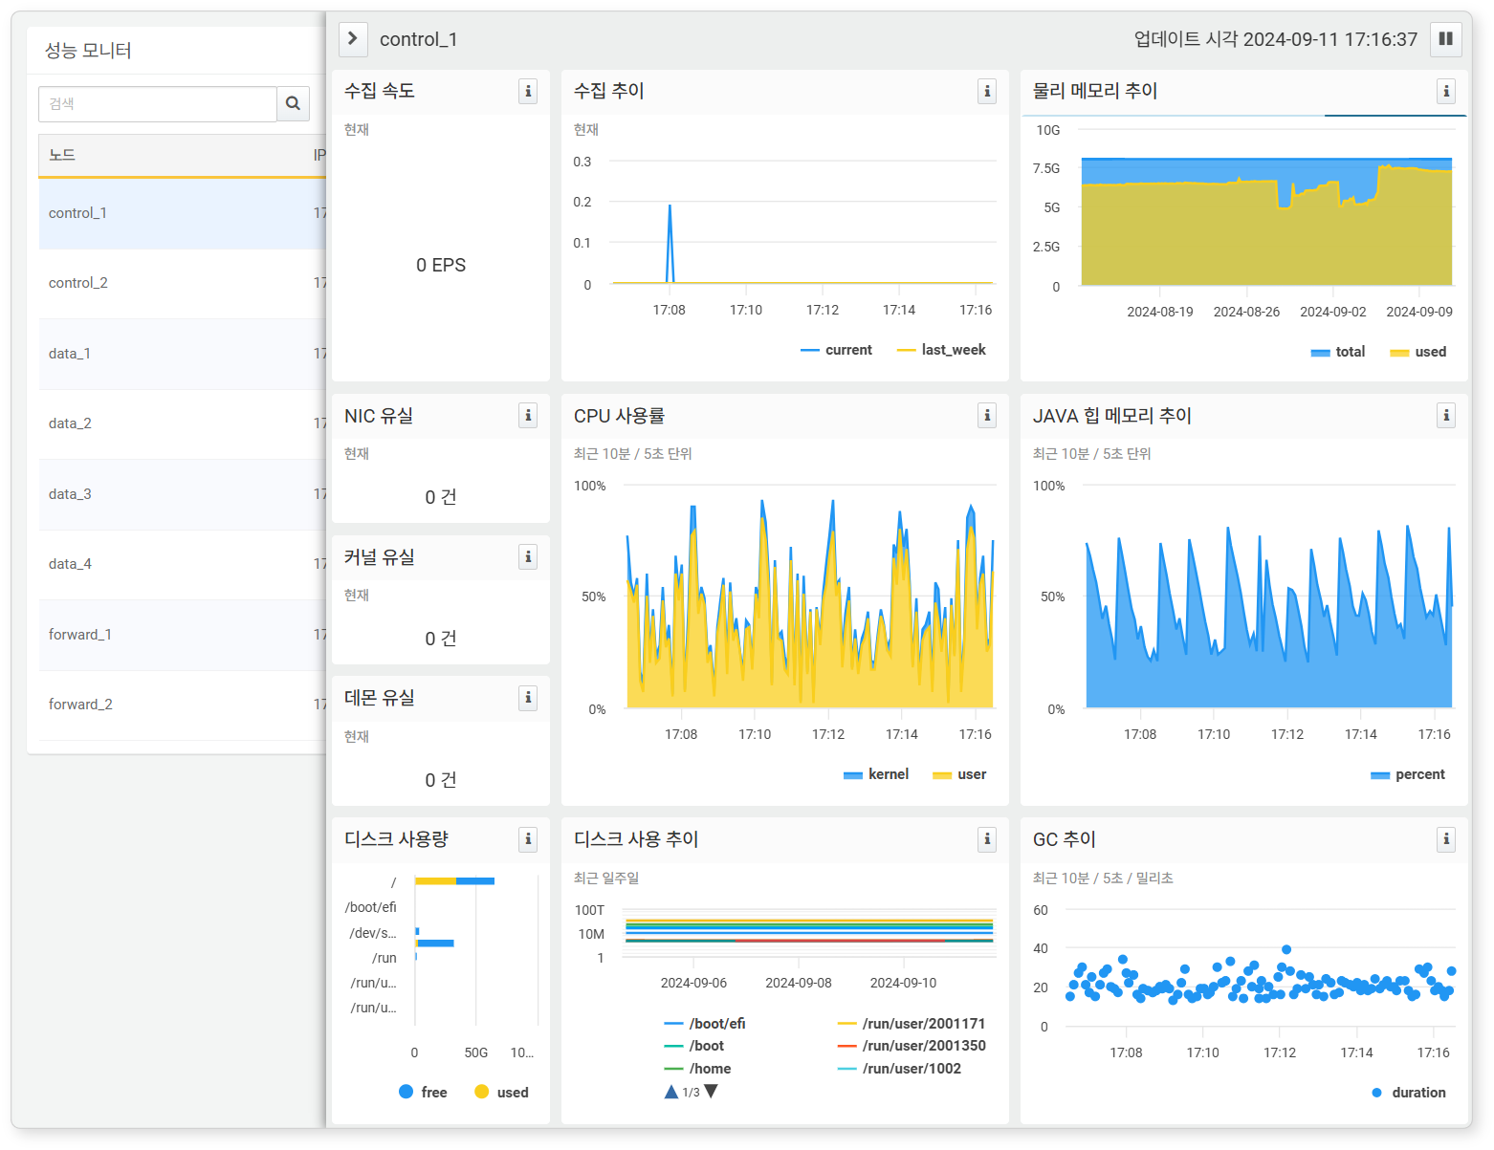

* **Collection Rate**: Number of events collected per second (events per second)
* **Collection Trend**: Displays the number of events collected over the last 10 minutes and the collection status over the last 7 days.
* **NIC Loss**: Number of packets lost at the network interface card level. Loss may occur if the number of packets exceeds what the NIC can handle, causing the buffer to overflow.
* **Kernel Loss**: Number of packets lost at the kernel-level UDP stack.
* **Daemon Loss**: Number of packets that the syslog daemon failed to process.
* **CPU Usage**: Displays updated CPU usage over the last 10 minutes (unit: %).
* **Physical Memory Trend**: Displays memory usage over the last 30 days as maximum values every 3 hours (unit: memory capacity).
* **JAVA Heap Memory Trend**: Displays JAVA heap memory usage over the last 10 minutes (unit: %).
* **GC Trend**: Displays GC duration over the last 10 minutes in milliseconds (unit: milliseconds).
* **Disk Usage**: Usage by disk partition (unit: memory capacity).
* **Disk Usage Trend**: Displays disk usage by partition over the last 7 days (unit: memory capacity).

Start/Pause Refresh

Detailed performance metrics are updated every 5 seconds. To pause the refresh, click the  button in the toolbar. To resume periodic refreshing of the detailed performance metrics, click the  button.

View Metrics in a New Window

Clicking the  button in the widget displaying performance metrics allows you to view the Logpresso query that outputs the data shown in the widget. Below is an example of a query opened from the CPU usage widget.

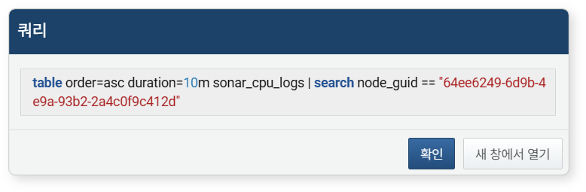

In this window, clicking "Open in New Window" will allow you to check the data source shown by the widget in a new window.

