### Pivot

In the pivot screen, users can perform pivot analysis on previously collected data or created datasets. There is no need for users to write query statements; complex analyses can be conducted simply through clicks and drag-and-drop actions.

Most collected data is likely structured in a way where each record contains information about events that occurred at specific times in sequence. While this format is suitable for logging, it is not ideal for data analysis. By summarizing only the necessary data and displaying the relationships between desired items, users can achieve a much higher level of analysis. With the pivot feature of Logpresso Sonar, users can easily conduct high-level data analysis without the need to write complex queries or learn a programming language.

The process of conducting data analysis using the pivot feature is as follows: First, select the data to be analyzed (Load Pivot), apply filters to narrow down to the desired data (Data Filter), and then use the pivot feature to summarize and display the relationships between the desired items (Data Aggregation). If necessary, further data can be refined or additional information can be derived through association analysis. The organized data can then be saved as a dataset for future reuse or used to create widgets in a dashboard.

#### Data Type Selection

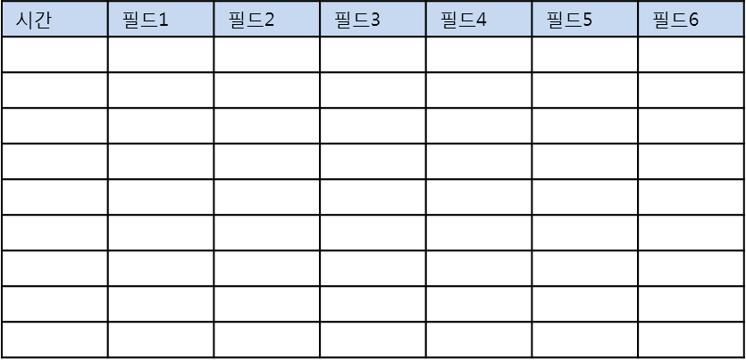

#### Data Filter

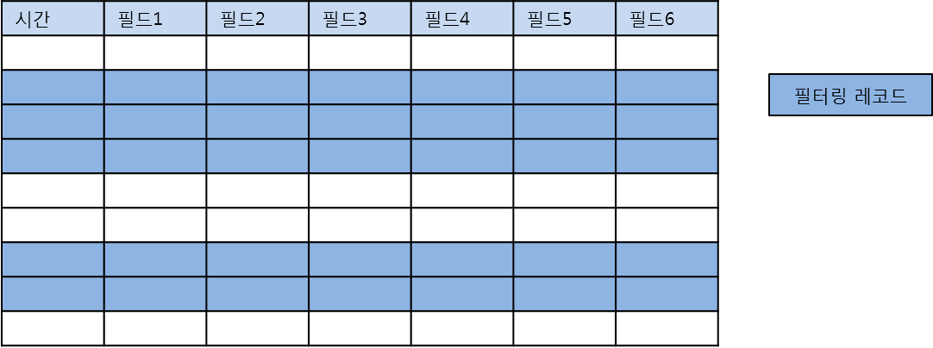

#### Pivot

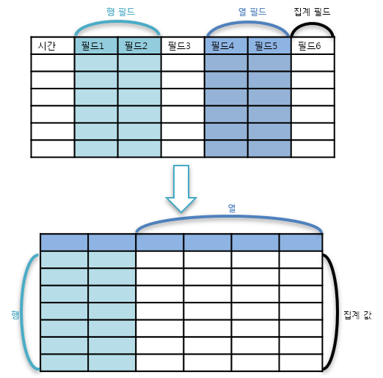

#### Association Analysis

