### Playbook History

The Playbook History menu provides access to the execution history of playbooks and daily statistics.

#### Playbook History List

At the top, daily statistics of playbook executions are displayed, while the bottom shows the list of playbook execution records.

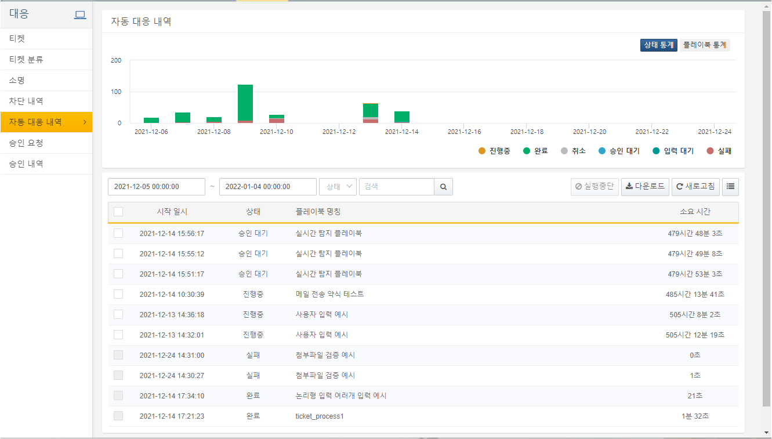

Statistics Overview

The trend graph at the top of the Playbook History displays status statistics by default, categorized into In Progress/Completed/Cancelled/Pending Approval/Waiting for Input/Failed.

Hovering the mouse cursor over a specific date allows users to view statistics for that date.

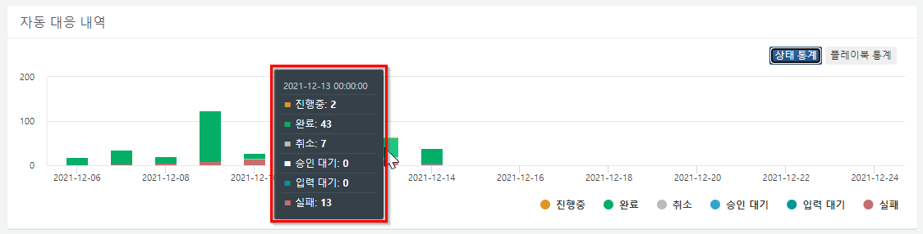

Users can click on the legend displayed in the chart to show or hide specific bars. The example below shows only the In Progress and Completed statuses.

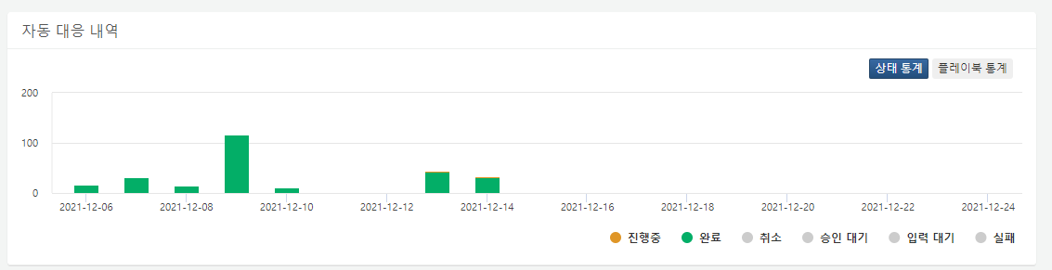

Clicking on the playbook statistics in the trend graph at the top will output the execution trend aggregated by Playbook Name.

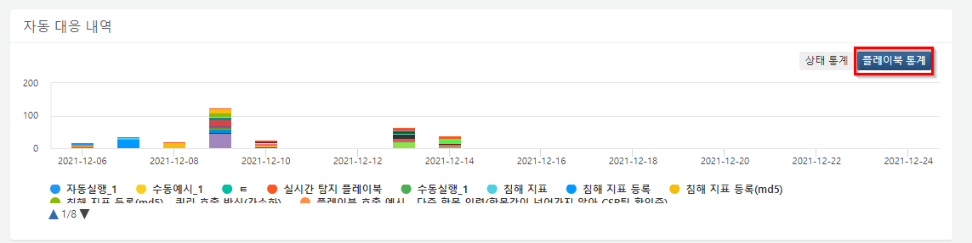

Similar to the status statistics, users can click on the legend to show or hide specific bars. The example below shows only the Real-Time Detection Playbook and Indicators Registration.

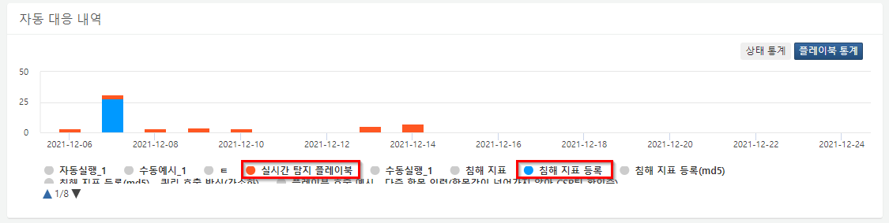

Searching Execution Records

Users can search for playbook execution records by entering filters for date, status, and keywords. The search results will also be reflected in the trend chart. The example below shows the results of searching for completed records from December 6, 2021, to December 10, 2021.

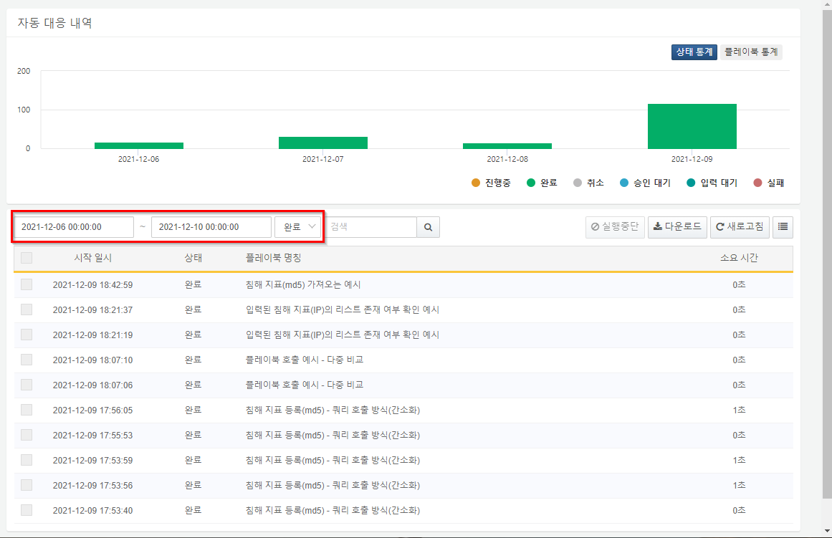

Downloading the List

By clicking the Download button, users can download the playbook history list in CSV, Excel XML, MS Word, HTML, or JSON file formats.

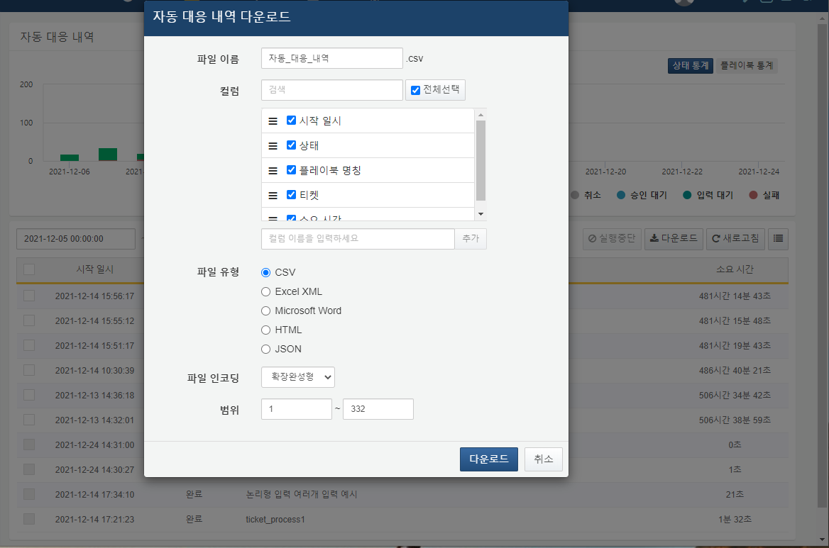

**File Name**

Enter the desired file name for saving.

**Column Search**

Search for the desired column name in the list of columns to be saved.

**Column List**

Select the columns to be saved in the file.

**File Type**

Choose the file format type.

**File Encoding**

Select the file encoding.

**Range**

Select the range of automatic history to save. The first page's top playbook name is considered as number 1.

Stopping Execution

The checkboxes in the execution history list are activated for playbooks that are either in progress or require approval. Completed playbooks cannot be selected.

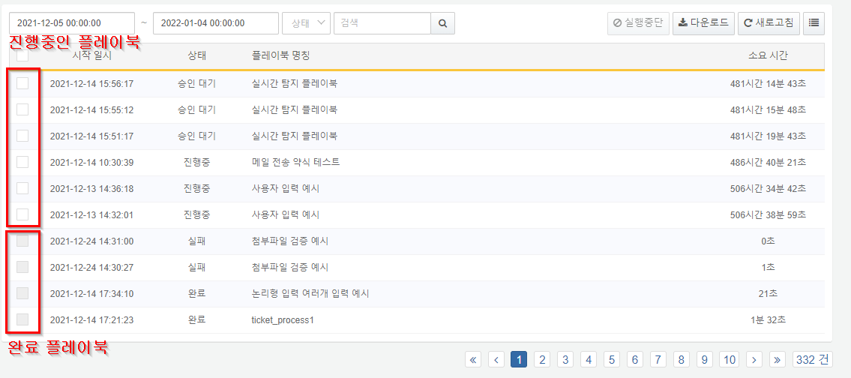

By selecting a playbook and clicking the Stop Execution button, users can forcibly stop the execution of the playbook.

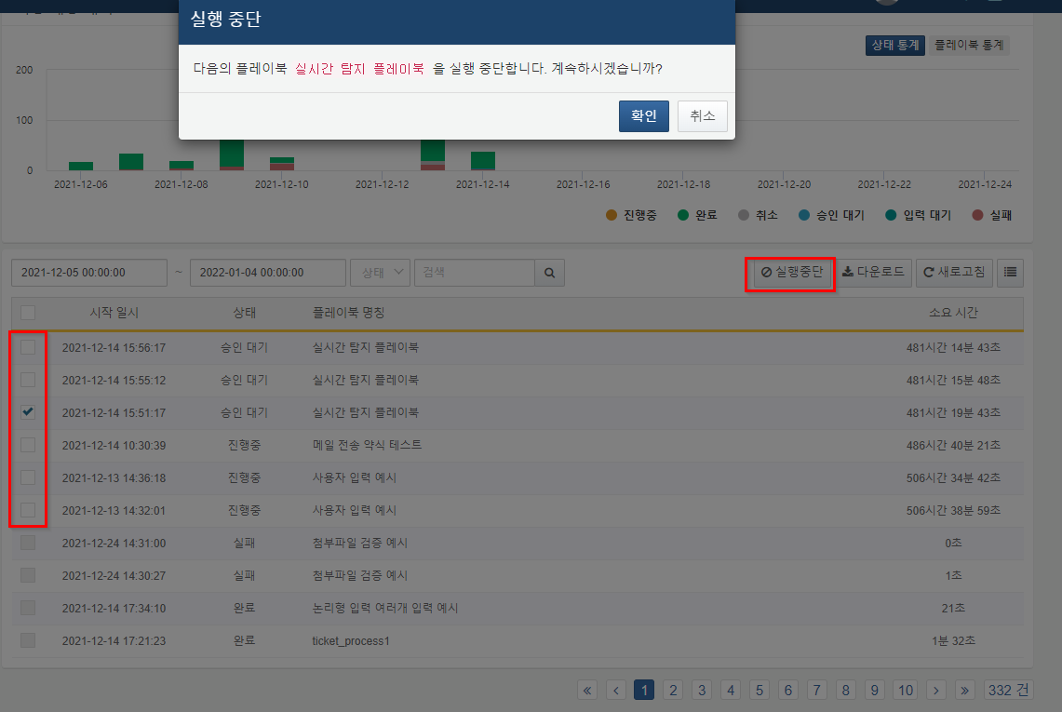

#### Detailed Playbook History

Clicking on a specific playbook name in the execution history list at the bottom of the Playbook History screen will display the execution history of that playbook instance.

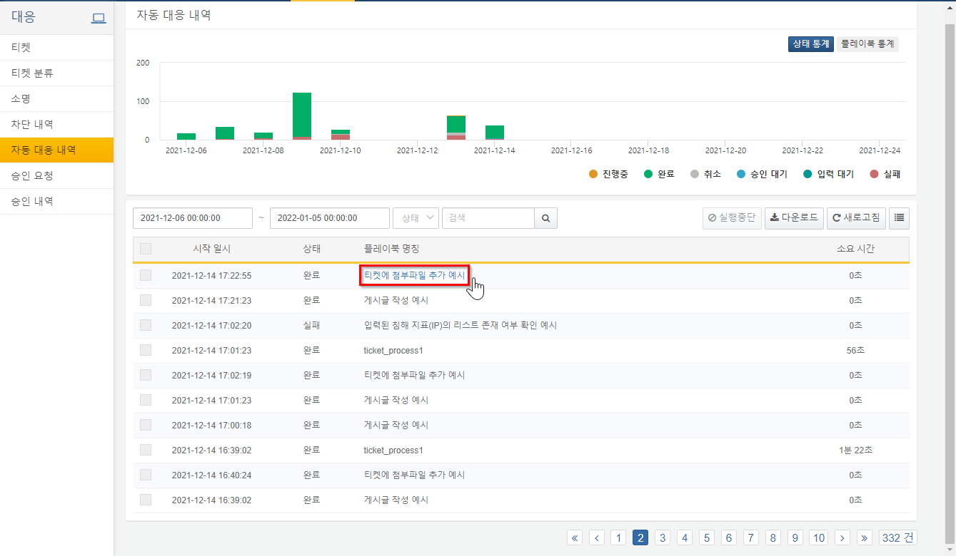

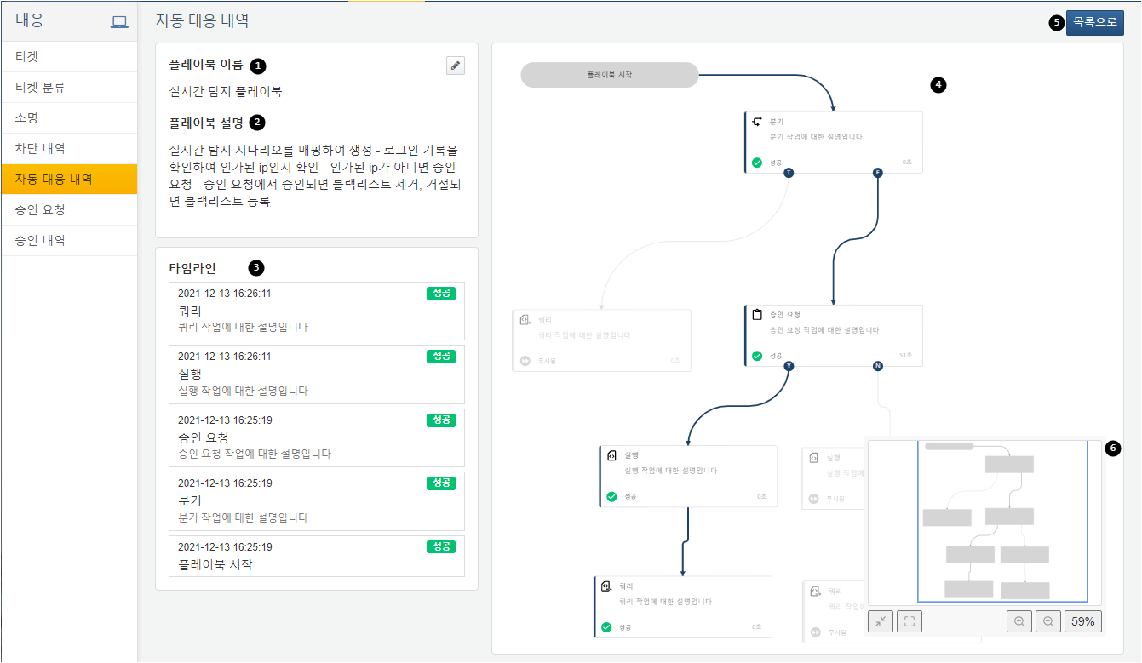

Playbook Name: Displays the name of the executed playbook. Clicking the pencil icon next to the playbook name will navigate to that playbook.

Playbook Description: Displays the description of the executed playbook.

Timeline: Shows the tasks executed in the playbook in the order of recent execution.

Task Progress History: Displays the tasks that were executed in the playbook. Completed tasks are shown in bold, while unexecuted tasks are displayed in a lighter shade.

Mini Map: Provides a brief overview of the entire playbook.

Back to List: Clicking the back to list button returns to the Playbook History list.

**Mini Map**

The description of the Mini Map is as follows.

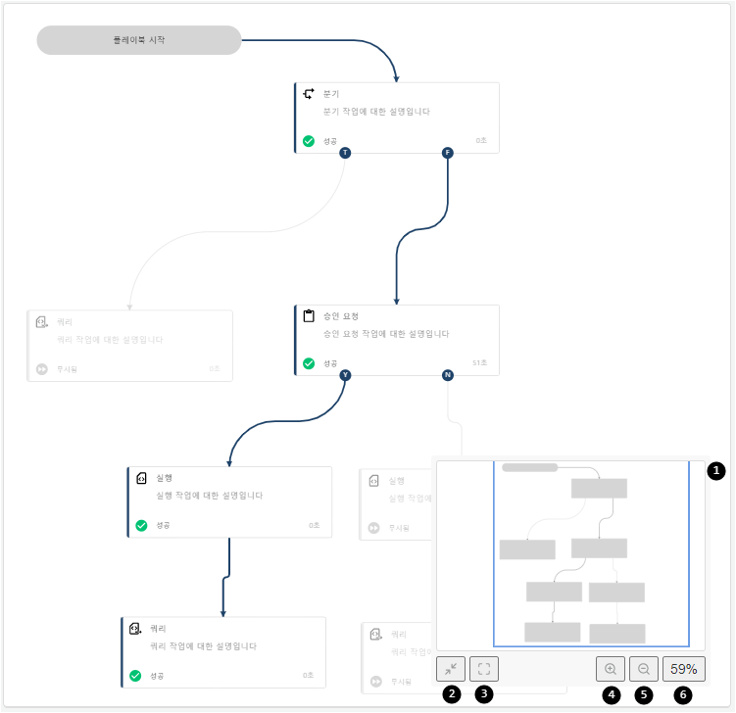

Screen: A screen that briefly displays the contents of the playbook.

Toggle: Can be toggled on and off, showing or hiding the mini map with each click.

Change Position: Changes the position of the mini map to the center of the playbook.

Zoom In: Increases the size of the mini map with each click.

Zoom Out: Decreases the size of the mini map with each click.

Restore Scale: Restores the mini map size to 100%.