### Assets IP

#### Overview

You can register and manage assets to be protected from threats as Assets IP. After registering the Assets IP, you can configure it in the Loggers, allowing for the identification of data related to those assets. The Loggers will add asset information in separate fields (_device_ip, _device_name) and store it in the tables.

#### Viewing/Search Assets IP List

You can view or search the list of Assets IP addresses under **Policies > Assets IP**.

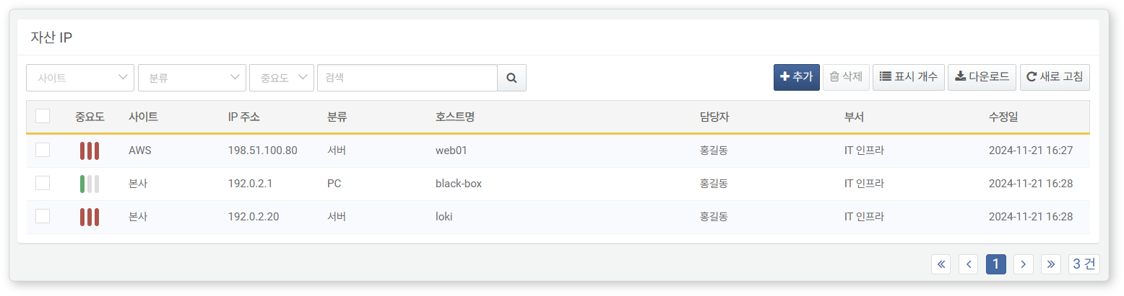

* **Importance**: The importance level of the Assets IP (High, Medium, Low)
* **Site**: The site to which the Assets IP belongs
* **IP Address**: The Assets IP address
* **Classification**: Classification information of the Assets IP
* **Hostname**: The hostname of the Assets IP
* **Person in Charge**: The person responsible for the Assets IP (Primary)
* **Department**: The department of the person in charge of the Assets IP (Primary)
* **Modification Date**: The date the Assets IP was created or last modified

To find a specific Assets IP in the list, use the search tool in the toolbar. The search tool will display Assets IPs that contain the entered term in **Name**, **Hostname**, **Workgroup**, or **Description**. The search tool is case-insensitive.

Downloading the List

To download the Assets IP list as a file to your local PC, click **Download** in the toolbar.

Refreshing the List

To refresh the Assets IP list with the latest information, click **Refresh** in the toolbar.

Changing the Number of Displayed Items

To set the number of Assets IPs displayed in the list, click **Display Count** in the toolbar and select your desired number. (Range: 10, 20, 50, 100, 150, 200 items)

#### Adding Assets IP

To add an Assets IP, click **Add** at the top of the Assets IP list.

In the **Add Assets IP** screen, enter or select the required values and then click **OK**.

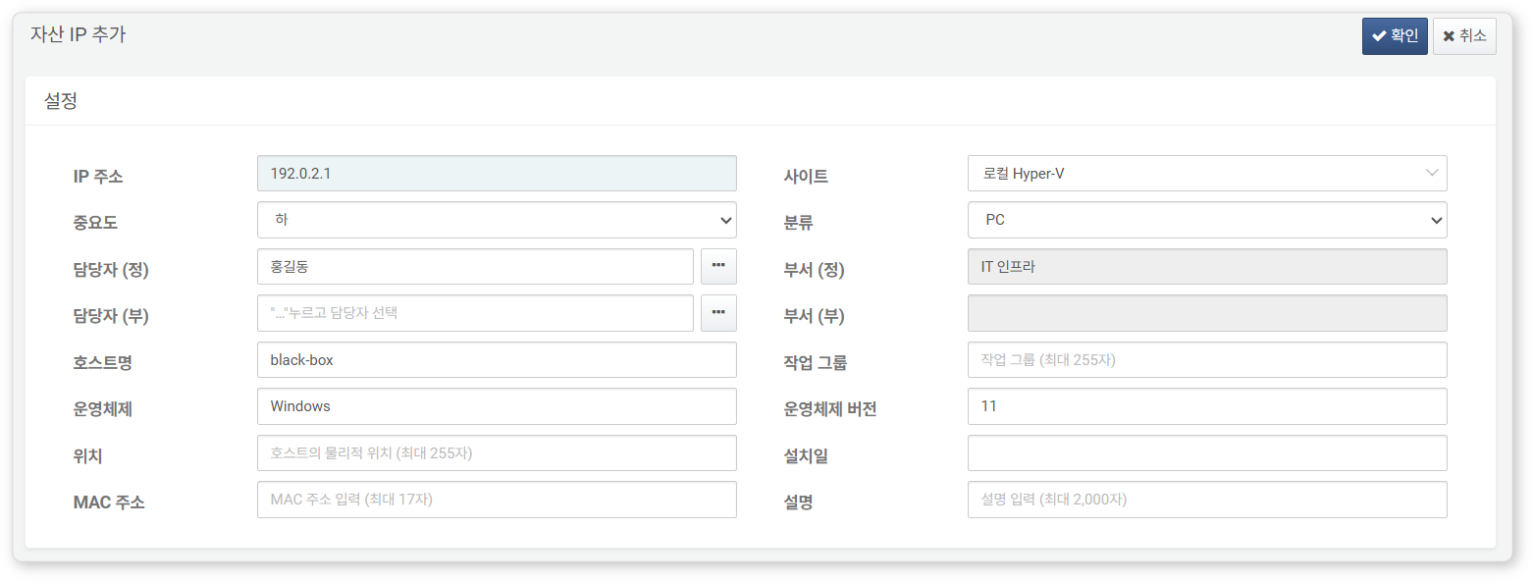

* **IP Address**: The IPv4 address of the asset
* **Site**: Select from the [Sites](https://docs.logpresso.comnull) list
* **Importance**: The importance level of the asset (Range: High, Medium, Low; Default: Low)
* **Classification**: Classification of the asset (Range: Unclassified, PC, Server, Mobile, Network Equipment, Security Equipment, Printer, VOIP; Default: Unclassified)
* **Person in Charge (Primary)**: Select the primary person in charge from the [Employees](https://docs.logpresso.comnull) list
* **Department (Primary)**: The department of the primary person in charge. This will be automatically filled when the primary person is designated.
* **Person in Charge (Secondary)**: Select the secondary person in charge from the [Employees](https://docs.logpresso.comnull) list
* **Department (Secondary)**: The department of the secondary person in charge. This will be automatically filled when the secondary person is designated.
* **Hostname**: The hostname of the asset (up to 255 characters)
* **Workgroup**: The workgroup of the asset (up to 255 characters)
* **Operating System**: The operating system information of the asset (up to 20 characters)
* **Operating System Version**: The version information of the asset's operating system (up to 50 characters)
* **Location**: The location of the asset (up to 255 characters)
* **Installation Date**: Select the installation date of the asset from the calendar
* **MAC Address**: The MAC address of the asset (up to 17 characters)
* **Description**: A description of the asset (up to 2,000 characters)

After completing the settings in the **Add Assets IP** screen, click **OK**.

#### Modifying Assets IP

To modify an Assets IP:

Click the IP address of the Assets IP you wish to modify in the Assets IP list.

In the **Modify Assets IP** screen, update the information and click **OK**.

#### Utilizing Assets IP

Loggers

Assets IP information is used as data source information when adding or modifying Loggers under **Collection > Loggers** along with [Sites](https://docs.logpresso.comnull).

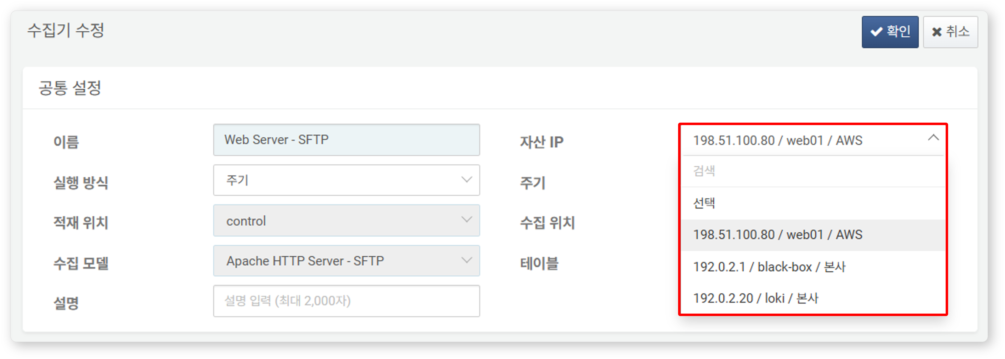

Query

You can use the [iplookup](https://docs.logpresso.comnull) command to check the asset management contact information if the IP address in the input field is an internal asset.

#### Deleting Assets IP

To delete an Assets IP:

Select the checkbox for the Assets IP row you wish to delete in the Assets IP list.

Click **Delete** in the toolbar.

In the **Delete Assets IP** dialog, review the list of Assets IPs to be deleted and click **Delete**. Click **Cancel** if you do not wish to delete.

When an Assets IP is deleted, the Assets IP settings in the configured Loggers will be removed. There will be no issues with data collection, but the values in the _device_ip and _device_name fields will be filled with null.