### Explanation Template

#### Overview

The Explanation Template is a feature that manages email and SMS templates sent to [Employees](https://docs.logpresso.comnull) when events detected by real-time/batch detection scenarios are related to them. It also manages email/SMS templates sent to explanation reviewers ([Users](https://docs.logpresso.comnull)).

When an employee clicks on the hyperlink included in the email/SMS, they are directed to the explanation submission page defined in the Explanation Template, where they can write and submit their explanations. Explanation reviewers can also check and review the explanation content through the hyperlink included in the email/SMS.

The Explanation Template supports internationalization, currently available in three languages: Korean, English, and Chinese.

Text Macros for Templates

The template supports text macros that allow predefined content to be inserted into the email subject, body, or SMS body. Below are the macros available for use in the template.

|  |  |
| --- | --- |
| Macro | Description |
| $category | Classification name |
| $emp_key | Employee ID of the explainer |
| $emp_name | Name of the explainer |
| $emp_title | Title of the explainer |
| $url | Unique address of the explanation page in URI format, including the web access address |
| $expire_date | Deadline for explanation submission (yyyy-MM-dd format) |
| $expire_time | Deadline time for explanation submission (HH:mm:ss format) |
| $user_note | Content entered in the **Remarks** property of the [Real-time](https://docs.logpresso.comnull)/[Batch](https://docs.logpresso.comnull) detection scenarios |

Separation of Communication Ports for Explanations

In versions prior to 4.0.2404.0, the web console and the explanation submission/review page used the same communication port. Starting from version 4.0.2404.0, the communication ports for the web console and the explanation submission/review page have been separated (Refer to: [SNR#2286](https://docs.logpresso.comnull)). Consequently, the communication port for the explanation submission/review page will be assigned differently based on the upgrade/installation method.

**Upgrading from a previous version to 4.0.2404.0:**

The previously configured web access page address and port number will be retained (maintaining backward compatibility).

The explanation reception function of the existing web port will be maintained, but it is recommended to separate the web port to enhance security.

**Fresh installation of version 4.0.2404.0:**

The port number specified using the logpresso.sonar.explanation_port system switch will be used (default value if unspecified: **18443**).

# Use port 12345 for the explanation request/review page communication port -Dlogpresso.sonar.explanation_port=12345

#### Web Access Address

The web access address is used for the hyperlinks provided in the explanation request email/SMS and review request email/SMS, linking to the explanation submission/review page.

The web access address can be set by entering it in the format "https://IP address:port number" and clicking **Save**.

* **IP Address**: The IP address of the Logpresso server. In a cluster configuration, specify the **virtual IP address of the analysis server**.
* **Port Number**: The port number specified by the logpresso.sonar.explanation_port system switch.

Below is an example of setting the web access address in an environment where the hostname can be resolved to an IP address.

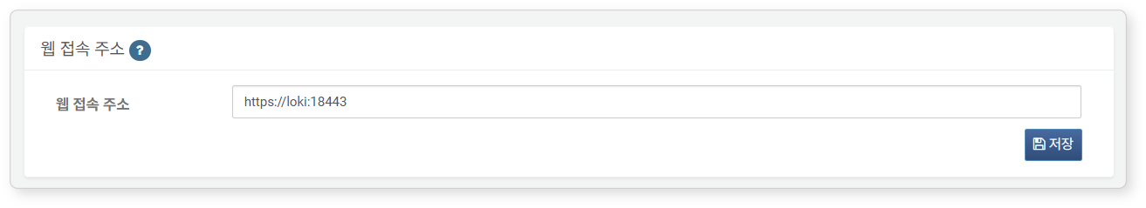

If DNS services are provided in the network, you can use a hostname or FQDN instead of an IP address.

#### Email Template

In the **Email Template**'s **Creation** tab, you can create templates to be applied to explanation requests and review requests.

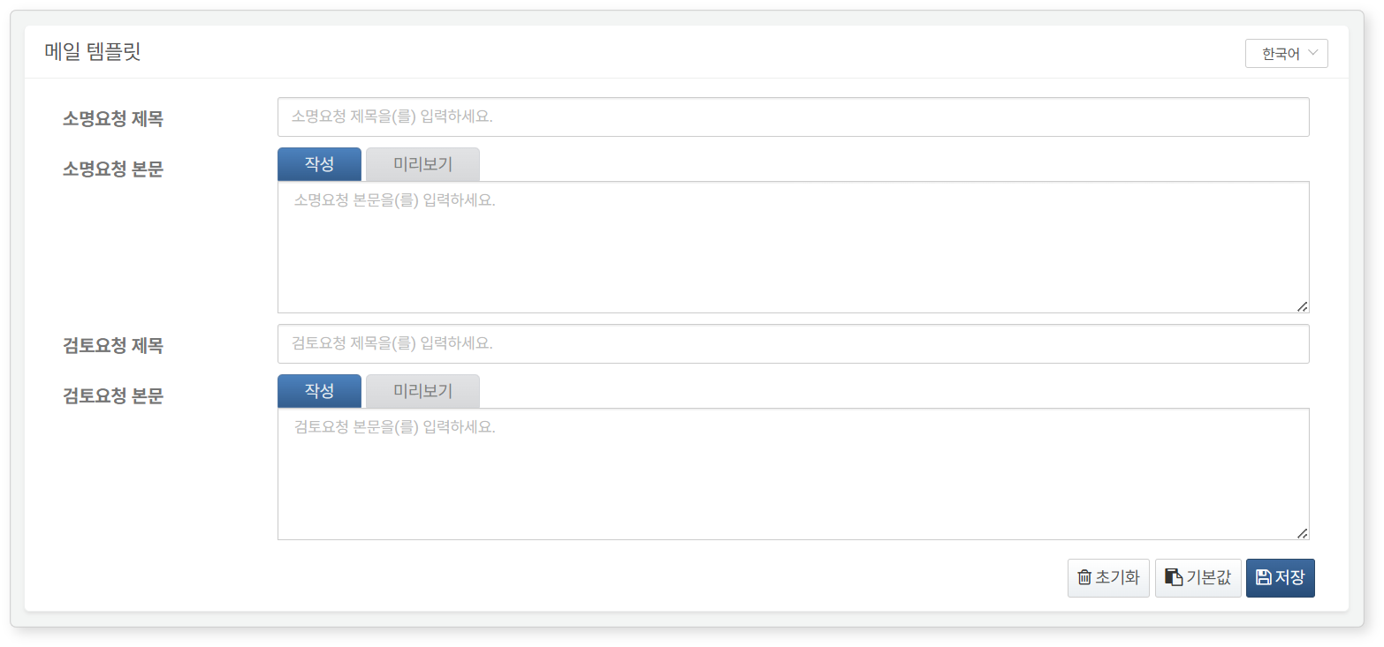

* First, select the language (Korean, English, Chinese) from the top right corner, then create the template (default: Korean).
* Clicking **Reset** will clear the entered content.
* Clicking **Default** will populate the template with the built-in default template, provided for each specified language.
* Clicking **Save** will save the created content.
* The macro strings will be replaced with actual strings at the time of email transmission.

In the **Preview** tab, you can view the email template rendered in HTML format based on the entered content.

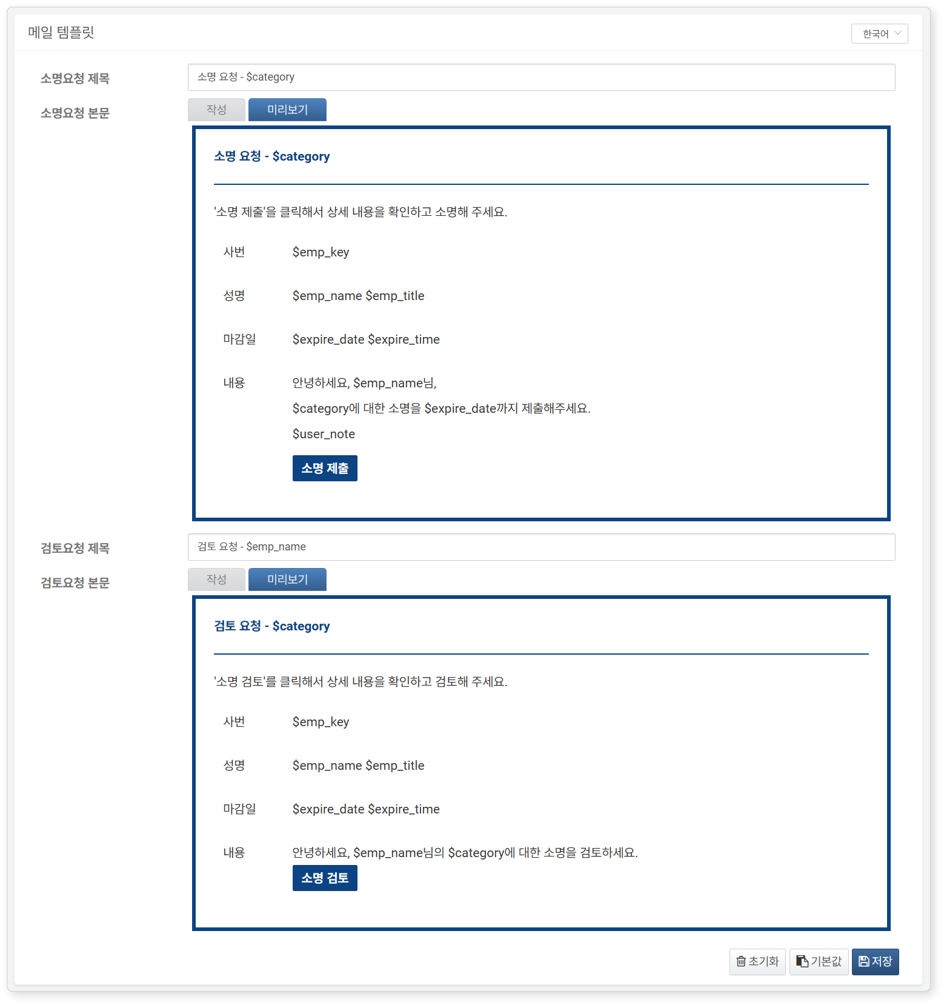

#### SMS Template

In the **SMS Template**, you can create templates to be applied to explanation requests and review requests via SMS.

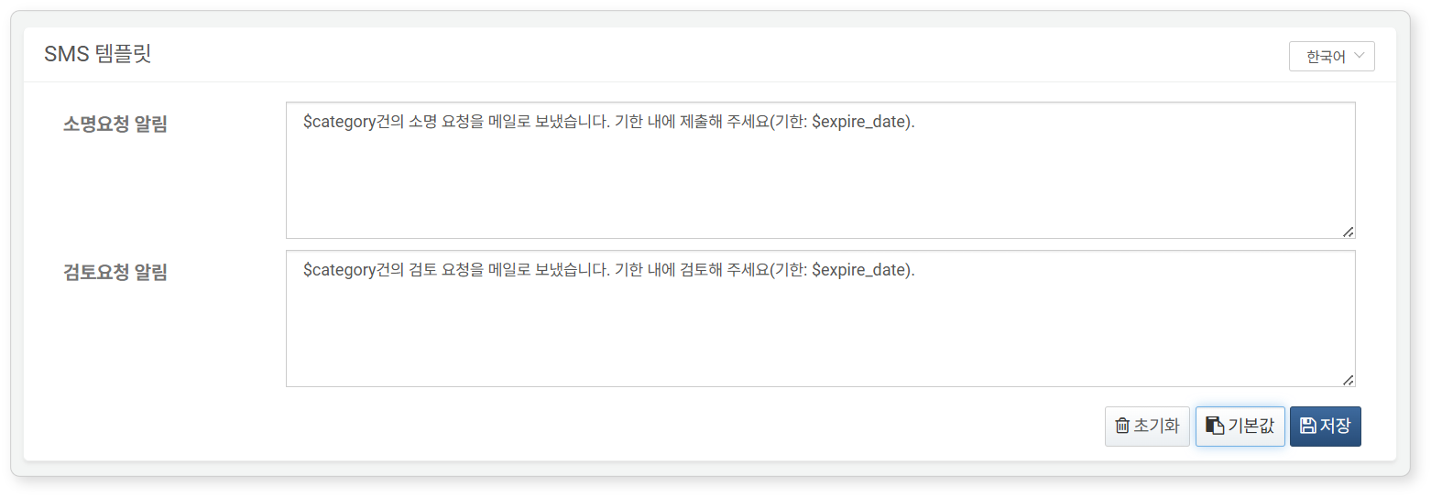

* First, select the language (Korean, English, Chinese) from the top right corner, then create the template (default: Korean).
* Clicking **Reset** will clear the entered content.
* Clicking **Default** will populate the template with the built-in default template, provided for each specified language.
* Clicking **Save** will save the created content.
* The macro strings will be replaced with actual strings at the time of SMS transmission.