### Query Monitor

You can view the status of queries running in Logpresso Sonar. The items displayed in the Query Monitor menu are as follows:

* **Type**: Displays the query type.
* **Node**: Displays the node where the query was executed.
* **Query ID**: Displays the ID of the query.
* **Status**: Displays the status of the query.
* **Author**: Displays the account that executed the query.
* **Remote IP**: Displays the IP address from which the query was executed.
* **Elapsed Time**: Displays the time taken for the query.
* **Result Count**: Displays the number of results returned by the query.
* **Execution Date and Time**: Displays the date and time when the query was executed.
* **Query**: Displays the query statement.

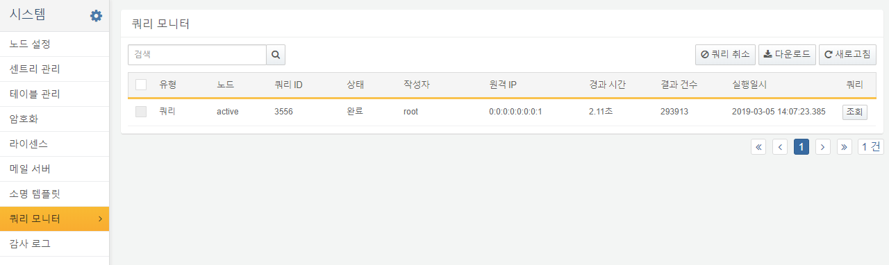

By clicking the View button, you can see the executed query statement. Clicking Clipboard Copy allows you to copy the query content directly.

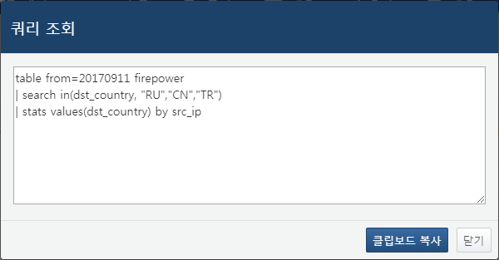

You can select a query and press the Cancel Query button to stop the selected query.

