### Query

You can execute arbitrary searches and analyses using Logpresso queries. When you open a new query tab, you will see a list of recently executed queries, saved query results, and datasets displayed together. By clicking the + button on the right side of the tab, you can open a new tab to run multiple queries simultaneously. Clicking the x button on the tab will cancel any running queries and close the tab.

For detailed query syntax and commands, please refer to the Logpresso Query Documentation.

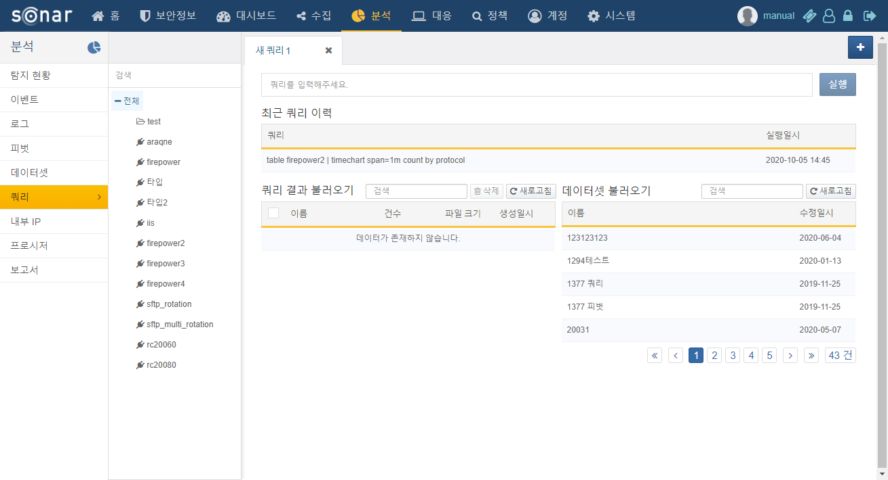

When you execute a query, the following screen will be displayed.

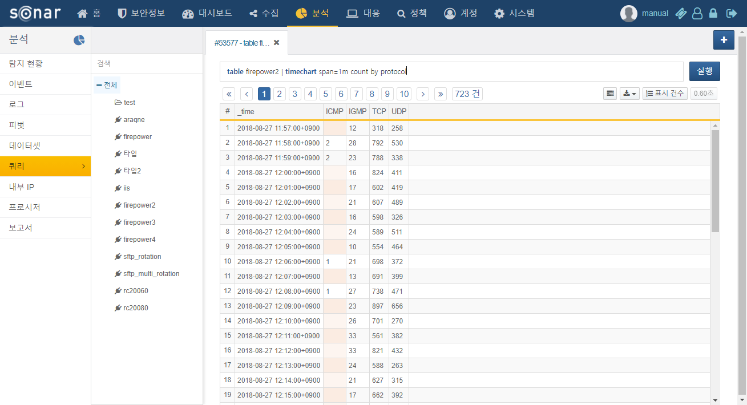

By clicking the download button, you can execute the following functions through the context menu:

**Save Query Results**

This option saves the query result data on the server for future retrieval. When prompted, enter a name for the query result, and it will be saved on the server under that name. You can reload the saved query results in a new query window.

**Download Query Results**

This option downloads the query result data to the PC running the web browser. You can specify the file name, format, and download range before downloading the query results.

**Create Dataset**

This option creates a dataset from the current query for reuse. You can later view the dataset in the dataset menu or reference it in a dashboard to create widgets.

If a query fails, the following screen will be displayed.

