### Reports

Using Logpresso query statements, you can process data into the desired format and create reports. Since report templates can be pre-defined and reports can be generated based on data from specified dates, this feature is particularly useful for periodic reporting.

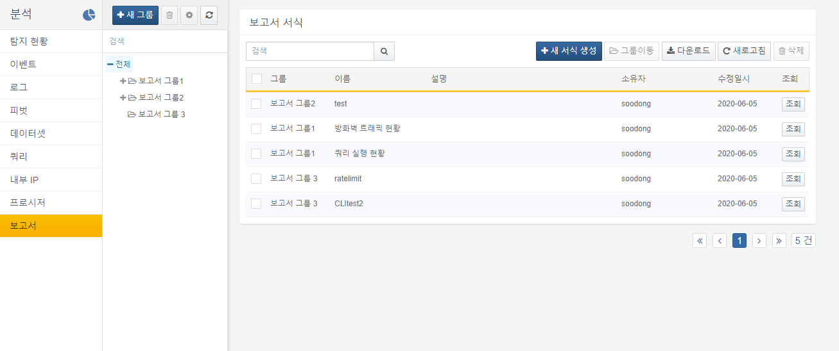

Each item in the report template list includes the following:

* **Group**: Indicates the group to which the report belongs. Report groups can be created on the left side of the report template list.
* **Name**: Displays the name of the report. This can be specified and edited when creating the report template.
* **Description**: Provides a description of the report.
* **Owner**: Displays the account that created the report template.
* **Last Modified Date**: Indicates the last time the report was modified.
* **View**: Navigates to the report viewing screen.