### Response Logs

In the System > Response Logs menu, you can view the integration history when Address Groups and security devices are linked.

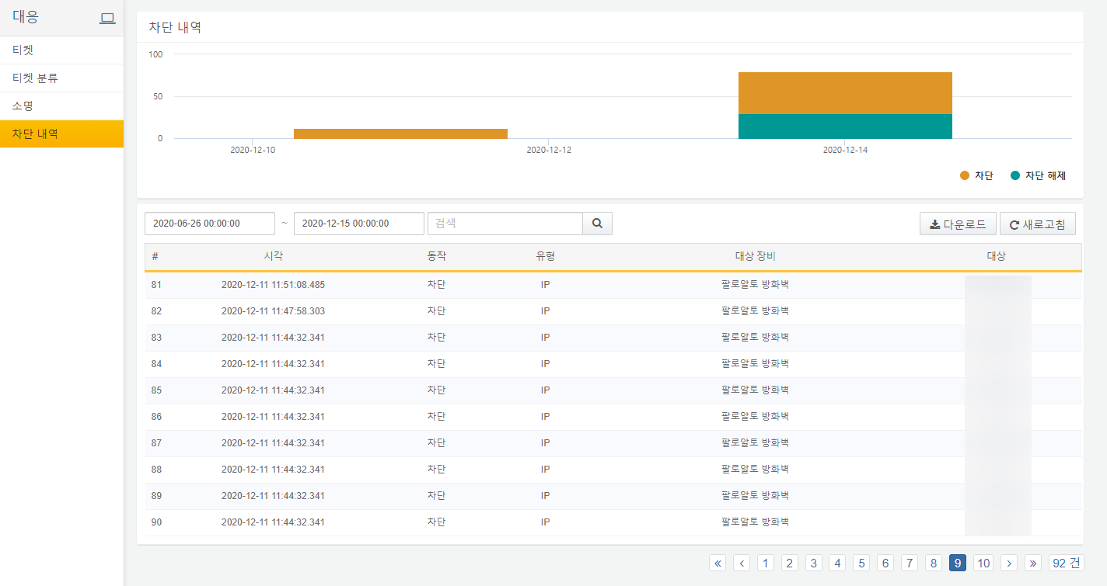

The descriptions for the list are as follows:

**Time**

Displays the time when an IP address was added to or removed from the Address Group, triggering the integration command to the security device.

**Action**

Indicates the type of action. When an IP address is added, it is marked as "block," and when removed, it is marked as "unblock."

**Type**

Displays the type of object synchronized through the integration. Currently, only IP type is supported.

**Target Device**

Displays the name of the block integration setting.

**Target**

Displays the IP addresses synchronized through the block integration.