### Response Targets

#### Overview

Response targets are a feature used to block the IP addresses of detected attackers through integrated devices such as firewalls during [real-time](https://docs.logpresso.comnull) or [batch](https://docs.logpresso.comnull) detection scenarios.

When response targets are configured, IP addresses can also be blocked by registering them in the [Address Groups](https://docs.logpresso.comnull) referenced by the response targets through the [Add to Blacklist](https://docs.logpresso.comnull) action in the playbook.

To configure response targets, a connect profile must first be defined to establish a connection with the target device.

#### Viewing/Search Response Targets List

You can view or search the list of response targets in **System > Response Targets**.

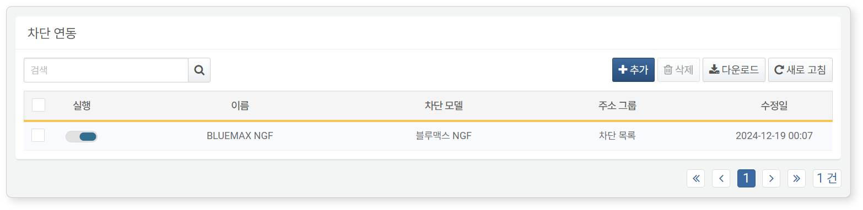

* **Status**: Toggle button for activating the response target (: enabled, : disabled)
* **Name**: Unique name of the response target
* **Response Model**: A model that defines the communication method with the integrated device. This is automatically installed when an app that supports response targets is installed, and can be selected when configuring the response target.
* **Address Group**: The [Address Group](https://docs.logpresso.comnull) containing the IP addresses to be blocked at the target device
* **Last Modified**: The date when the response target was last modified or added

To find a specific response target item in the list, use the search tool in the toolbar. The search tool will display results if the entered term is included in the **Name** of the response target. The search tool is case-insensitive.

Downloading the List

To save the response targets list to your local PC, click **Download** in the toolbar and select the desired file format for download.

Refreshing the List

To refresh the response targets list with the latest information, click **Refresh** in the toolbar.

#### Adding a Response Target

To add a real-time detection scenario:

Click **Add** in the toolbar under **System > Response Targets**.

In the **Add Response Target** screen, enter or select the configuration items.

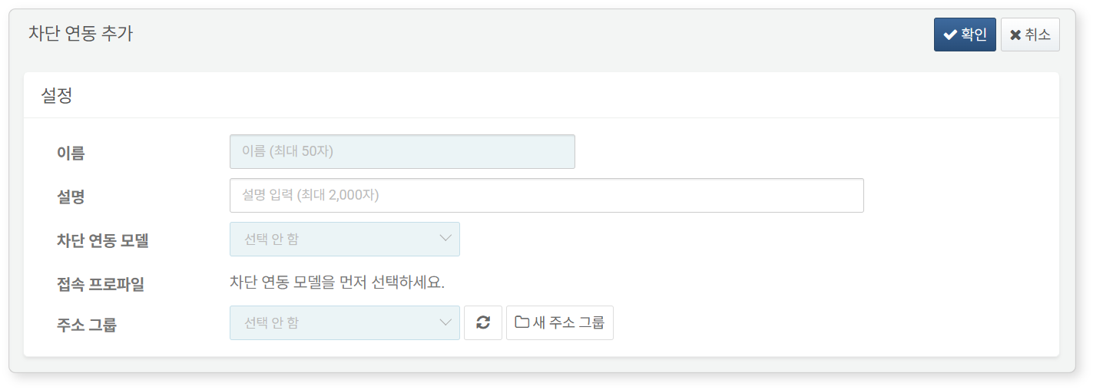

* **Name**: A unique name to identify the response target (up to 50 characters)
* **Description**: A description of the response target configuration (up to 2,000 characters)
* **Response Model**: Select a model from the list that defines the communication method with the integrated device. You can select from the list once an app that supports response targets is installed.
* **Connect Profile**: Select from the list. Only connect profiles that match the selected response model will be displayed.
* **Address Group**: A list of addresses containing the IP addresses to be blocked at the target device. You can add a new address group for use.

Once you select the response model, additional **Detailed Settings** items will appear according to the model. Configure these items and click **OK**.

#### Modifying a Response Target

To modify a response target:

Click the name of the item you wish to modify in the [Response Targets List](https://docs.logpresso.comnull).

In the **Change Response Target Settings** screen, modify the information and click **OK**. The following image shows an example of modifying the response target settings for BlueMax NGF.

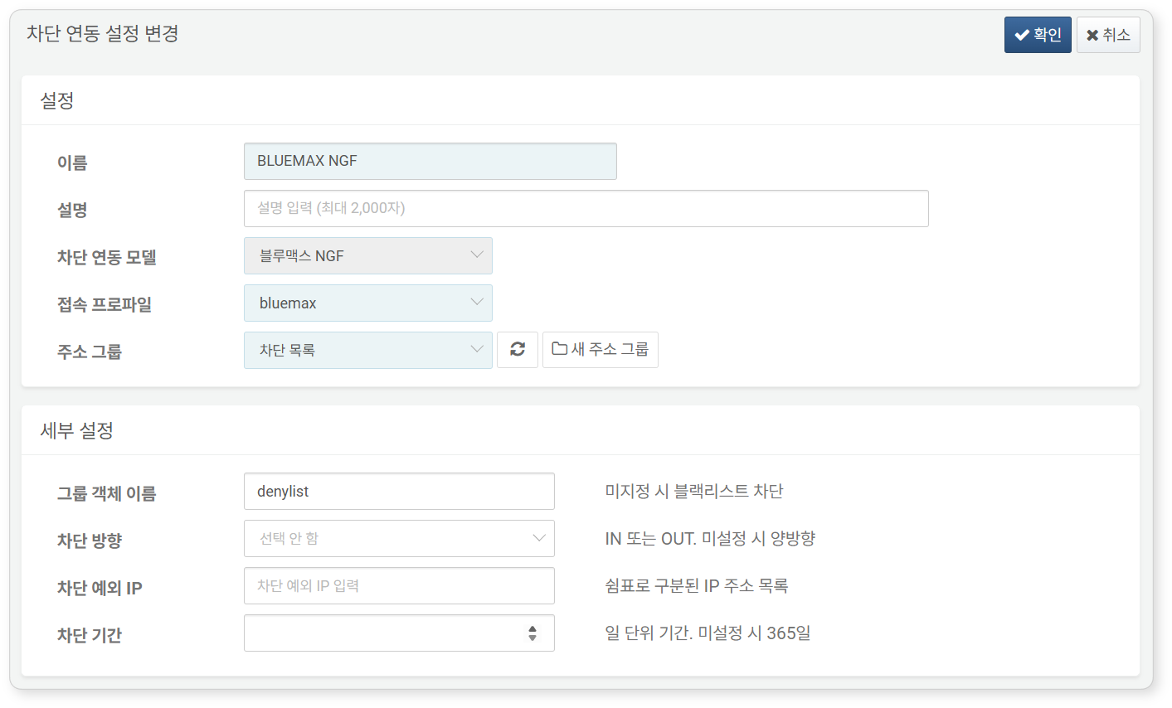

#### Deleting a Response Target

To delete a response target:

Select the checkbox of the response target row you wish to delete in the [Response Targets List](https://docs.logpresso.comnull).

Click **Delete** in the toolbar.

In the **Delete Response Target** dialog, review the list of response targets to be deleted and click delete. Click cancel if you do not wish to delete.