## Scheduled Queries

Scheduled queries refer to queries that are executed periodically according to a schedule or at a specific time, or that are executed based on the results of other scheduled queries. In a cluster environment, scheduled queries are typically executed on the analysis server, but can be designated to run on the logger server if necessary.

All functions related to viewing, adding, modifying, deleting, and executing scheduled queries require administrative permissions.

### Scheduled Query List

You can view the list of scheduled queries under **Analysis > Scheduled Queries**. If there are many scheduled queries, the list will be divided into multiple pages. A maximum of 15 scheduled queries can be displayed on one page.

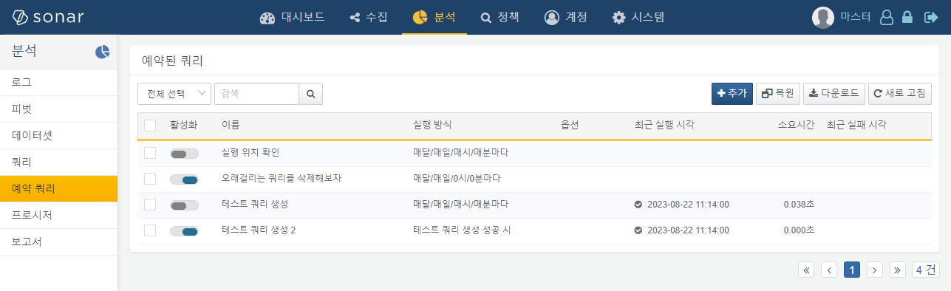

The information available in the scheduled query list includes the following:

* **Checkbox**: Used to select scheduled queries for management tasks. Clicking the checkbox will display a list of available actions, as shown in the following image.
* 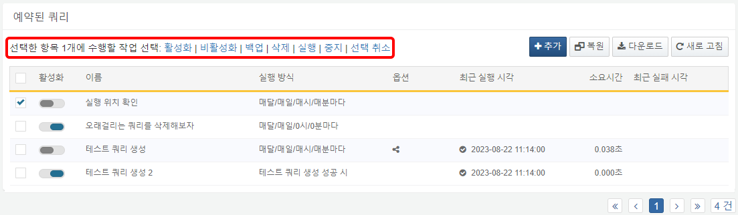
* **Activation**: A switch to activate or deactivate the scheduled query. An activated scheduled query is displayed in blue (), while a deactivated one is displayed in gray (). You can click the switch to activate or deactivate the scheduled query.
* **Name**: The name used to identify the scheduled query.
* **Execution Method**: The method of execution for the query. This displays the schedule or the name and execution results of another scheduled query that serves as the execution condition. If no execution method is specified, it is displayed as **Manual**.
* **Options**: Indicates whether output control settings are enabled. Output control is an option that determines whether the last row of the query output is passed as input to the next query. Scheduled queries with output control enabled will display the output control icon ().
* **Recent Execution Time**: The most recent execution time and status information of the scheduled query.
* 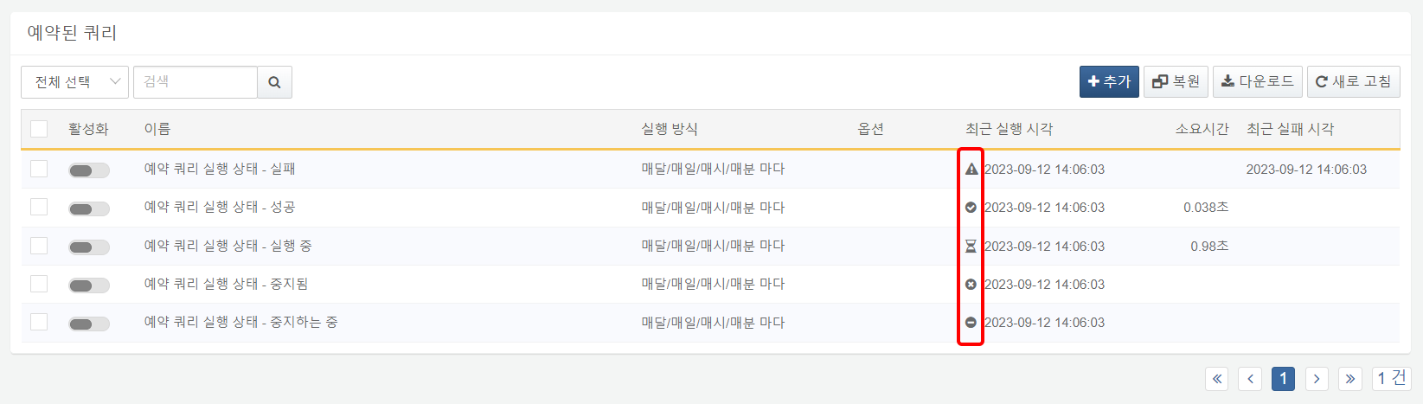
* The execution status of the query is indicated by the following icons:
* : Success
* : Failure
* : Stopped
* : Running
* : Stopping
* Hovering over the status icon in the **Recent Execution Time** field or the **Recent Failure Time** will display a tooltip with the reason for failure.
* 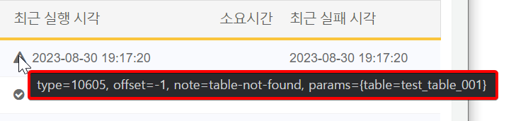
* **Duration**: The time taken for the query execution. For queries that are currently running, it displays the time elapsed since execution began.
* **Recent Failure Time**: The most recent time the query was executed but failed.

### Downloading the Scheduled Query List

You can download the list of scheduled queries. The steps to download the list are as follows:

Click **Download** in the toolbar.

In the **Download Scheduled Query List** dialog, specify the properties of the file to be downloaded and click **OK**.

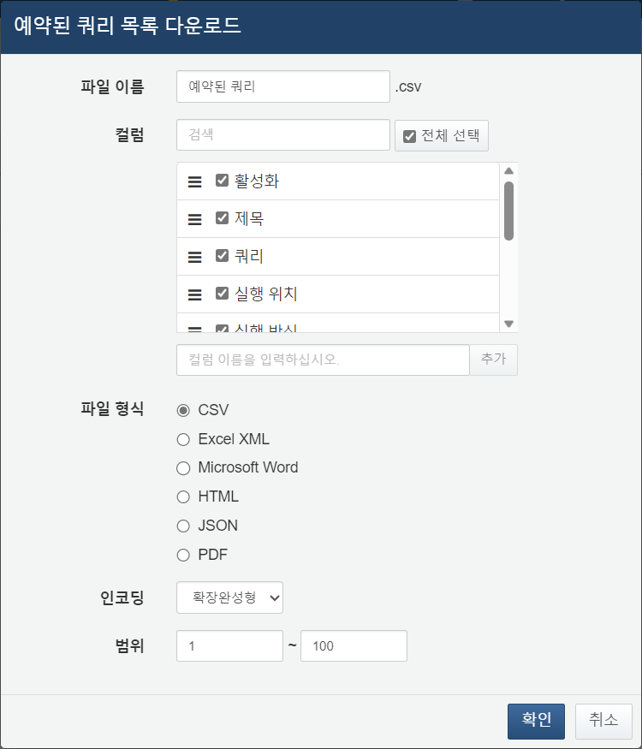

* **File Name**: The name of the file to be downloaded.
* **Columns**: Select the fields to be recorded in the download list. The default is to select all.
* **File Format**: Choose one from CSV, JSON, HTML, Excel XML, or Microsoft Word (default: CSV).
* **Encoding**: Select the string encoding format for the file.
* **Scope**: Select the range of scheduled queries to be recorded in the download list. The default is to include all scheduled queries. The numbering starts from the topmost scheduled query on the first page of the scheduled query list.

Once the server sends the file to your web browser, save the file and check the scheduled query list in the downloaded file.

### Adding a Scheduled Query

To add a scheduled query, follow these steps:

Click **Add** in the toolbar.

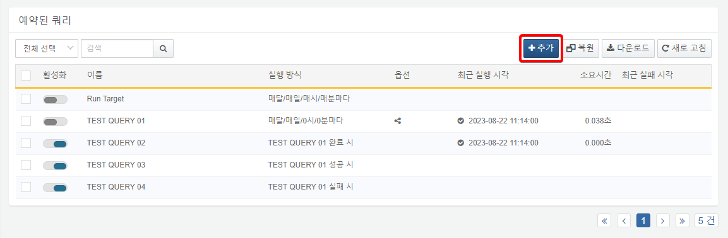

In the scheduled query panel, specify the properties of the query to be scheduled.

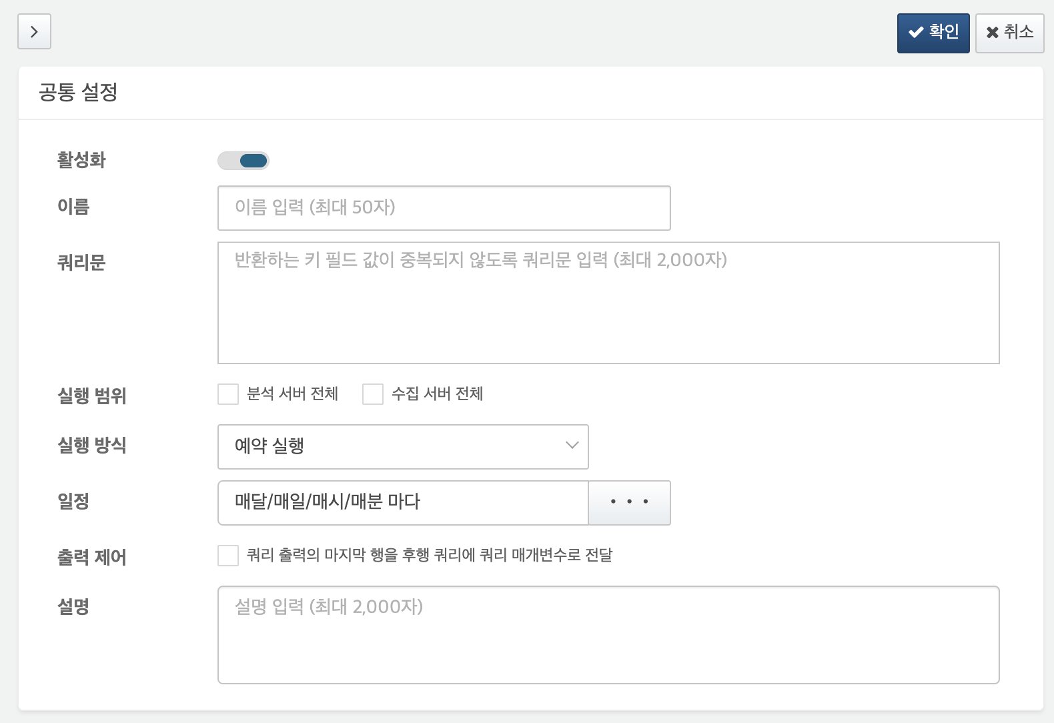

* **Activation**: Whether the query is activated.
* **Name**: The name to be displayed in the list. You can enter Korean characters, special characters, etc., but duplicate names with other scheduled queries are not allowed.
* **Query Statement**: The Logpresso query statement you wish to execute.
* **Execution Scope**: The cluster server on which to execute the query. Choose between **Entire Analysis Server** or **Entire Logger Server**. If not selected, it will execute on the active analysis server.
* **Execution Method**: Choose the execution method for the scheduled query.
* **Scheduled Execution**: Executes periodically according to the execution cycle.
* **Execute Based on Results of Another Query**: Executes based on the completion, success, or failure of another scheduled query.
* **Schedule**: An option used when the **Execution Method** is set to **Scheduled Execution**. The input format is the same as the cron settings of Unix-based operating systems. You can check it using the command "man 5 crontab" on Linux systems. You can either input the settings directly or use the scrollbar to specify them. If the execution cycle is already running, it will not execute again.
* 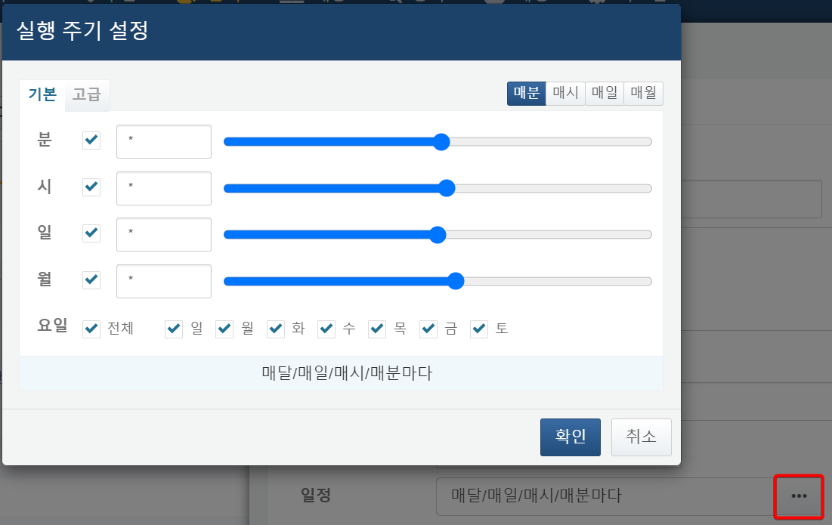
* **Condition**: An option used when the **Execution Method** is set to **Execute Based on Results of Another Query**. Choose from **On Completion**, **On Success**, or **On Failure**, and specify the preceding query from the scheduled query list.
* 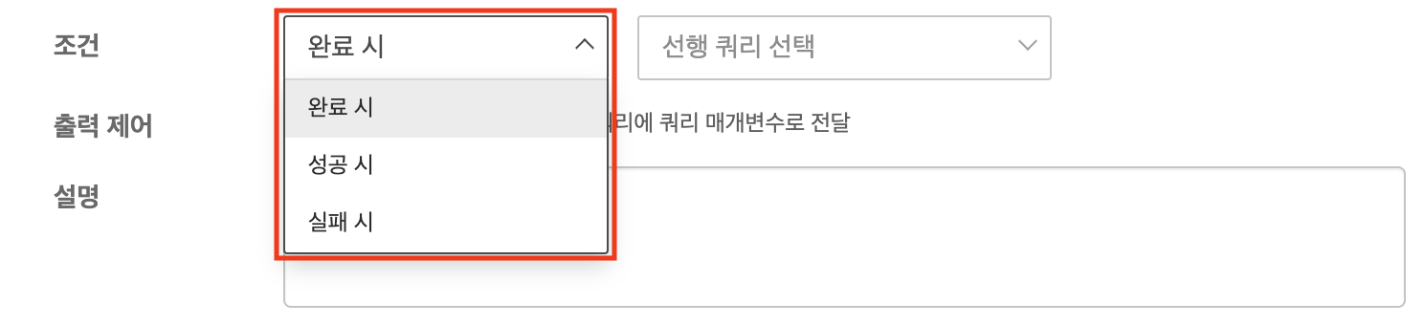
* **On Completion**: Executes the scheduled query regardless of the execution result (success or failure) of the preceding query.
* **On Success**: Executes the scheduled query only if the preceding query is successful.
* **On Failure**: Executes the scheduled query only if the preceding query fails.
* The list of preceding queries will be displayed in batches of 100 from the scheduled query list. You can search to select the desired scheduled query.
* 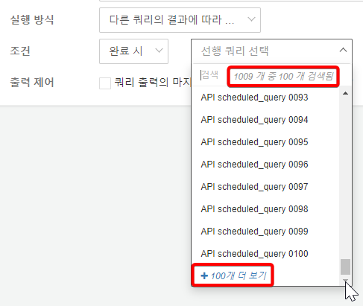
* **Output Control**: Use this option when the execution result of the scheduled query being added needs to be passed as a parameter to another scheduled query. To use output control correctly, the query output must consist of one row, and the subsequent scheduled query must use the same name for the query parameter as the preceding query that stores the value.
* **Description**: A description of the scheduled query.

Verify that the settings entered in the scheduled query panel are correct.

* To save the scheduled query, click **Save** in the upper right corner of the panel.
* To discard the scheduled query, click the "**>**" (close button) in the upper left corner of the panel.

### Modifying a Scheduled Query

To modify a scheduled query, follow these steps:

Click the name of the scheduled query you wish to modify in the [Scheduled Query List](https://docs.logpresso.comnull).

In the scheduled query panel, click **Edit**.

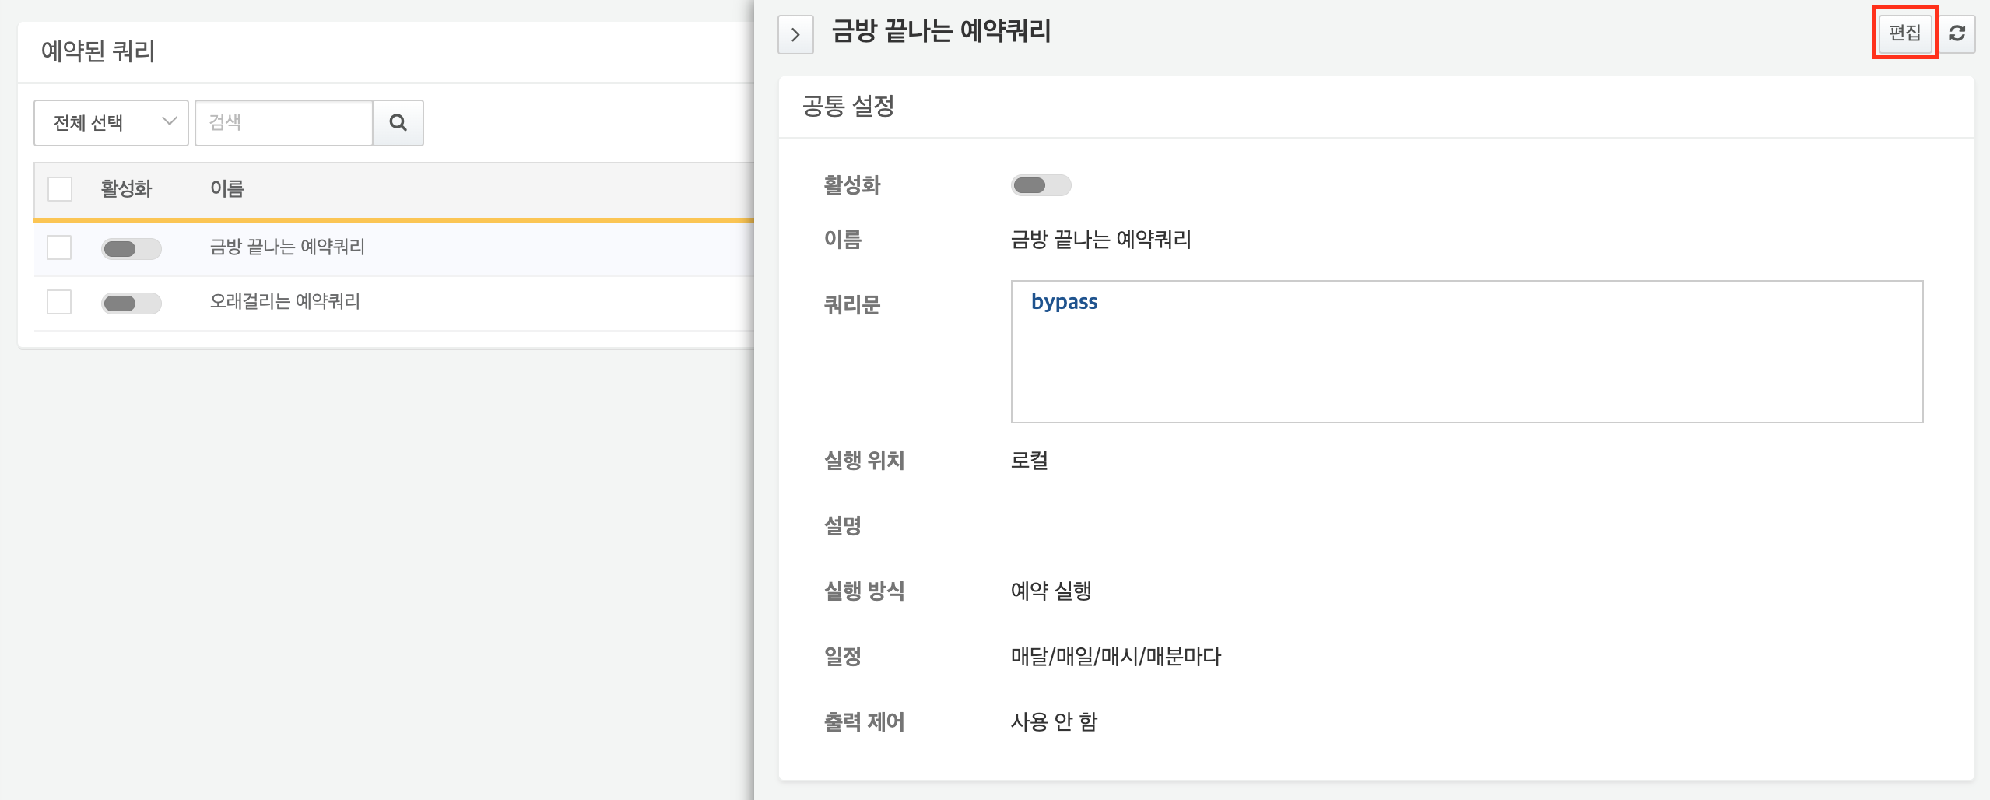

Modify the properties of the scheduled query. The properties are the same as those listed in [Adding a Scheduled Query](https://docs.logpresso.comnull).

Review the modifications.

* To save the changes, click **Save** in the upper right corner of the panel.
* 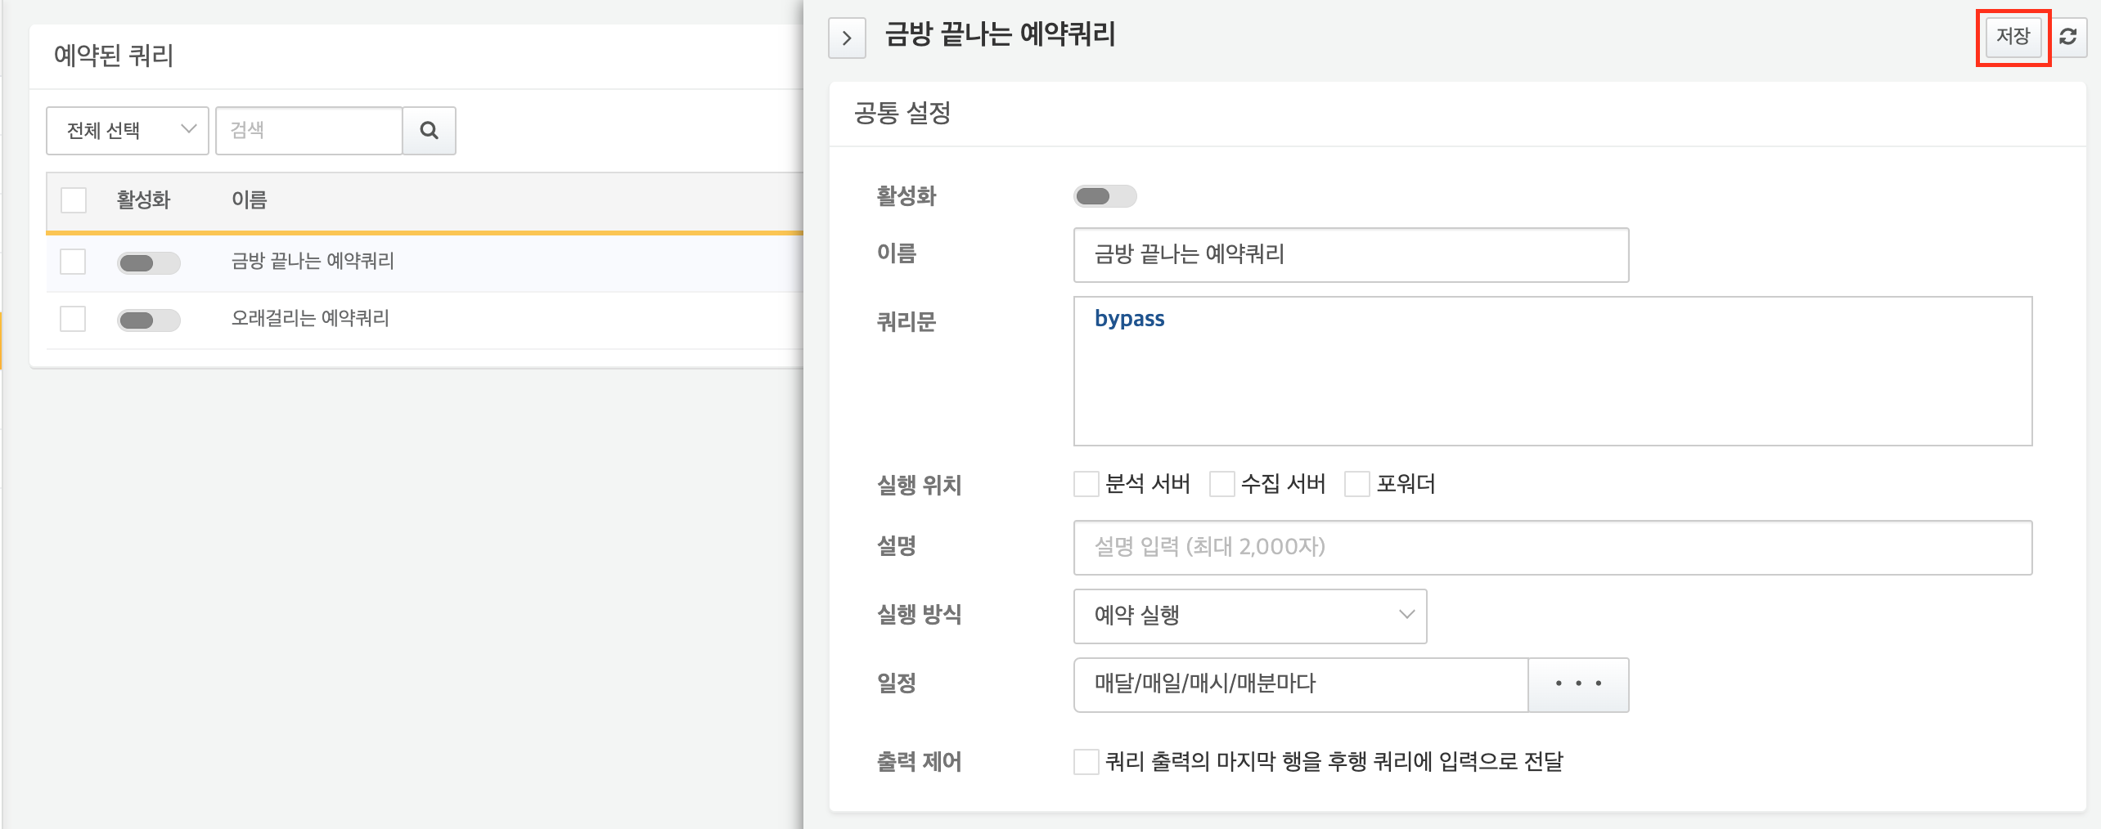
* To cancel the modifications, click the "**>**" (close button) in the upper left corner of the panel.

### Activating/Deactivating a Scheduled Query

The activation status of a scheduled query can be checked by the color of the switch in the **Activation** field. Activated scheduled queries are displayed in blue (), while deactivated ones are displayed in gray ().

To activate/deactivate a single scheduled query:

* Click the **Activation** switch of the scheduled query you wish to activate/deactivate in the [Scheduled Query List](https://docs.logpresso.comnull).

To activate/deactivate multiple scheduled queries at once:

Click the checkbox of the scheduled queries you wish to activate/deactivate in the [Scheduled Query List](https://docs.logpresso.comnull).

Click **Activate** or **Deactivate** from the action list.

Deactivating a running scheduled query will stop the query that is currently executing.

### Executing/Stoppng a Scheduled Query

You can manually execute a scheduled query or stop a running scheduled query, regardless of the execution method.

When a scheduled query is manually executed, the following characteristics apply:

* It can be executed manually even if the scheduled query is deactivated.
* If the execution result of the scheduled query (preceding query) is specified as the execution condition for another scheduled query (subsequent query), and the subsequent query is activated, the subsequent query will also be executed.

To manually execute/stop a scheduled query, follow these steps:

Click the checkbox of the scheduled query you wish to execute/stop in the [Scheduled Query List](https://docs.logpresso.comnull). Clicking the checkbox in the field name list at the top of the list will select all scheduled queries on the current page.

Click **Start** or **Stop** from the action list.

* If you attempt to execute a query that is already running, a dialog will appear asking how to proceed. Choose an option and click **OK**.
* 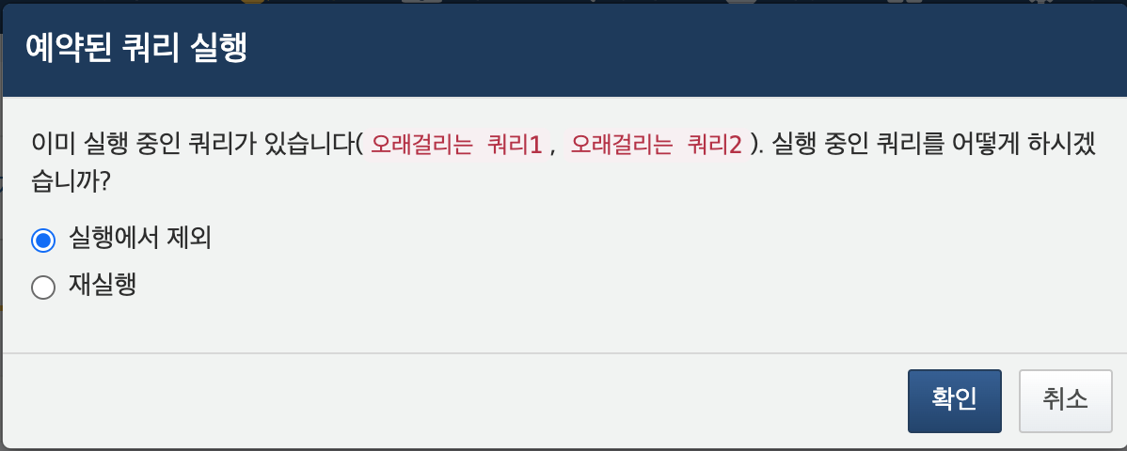
* **Exclude from execution**: Excludes the already running query from the execution list and executes only the remaining queries.
* **Re-execute**: Stops the already running query and re-executes it along with the other queries.
* Clicking **Cancel** will abort the execution task.

Check the icon indicating the query execution status in the **Recent Execution Time** field.

### Backing Up Scheduled Queries

To back up scheduled queries, follow these steps:

Click the checkbox of the scheduled query you wish to back up in the [Scheduled Query List](https://docs.logpresso.comnull). Clicking the checkbox in the field name list at the top of the list will select all scheduled queries on the current page.

Click **Backup** from the action list. The server will send the backup file to your web browser.

Verify that the file sent by the server has been downloaded. The file name will be assigned in the format scheduled-query-yyyymmdd-hhMMss.zip.

### Restoring Scheduled Queries

You can restore scheduled queries using a backup file or import scheduled query files backed up from another server.

To restore a scheduled query:

Click **Restore** in the toolbar.

In the **Restore Scheduled Query** dialog, specify the path of the backup file and click **Restore**.

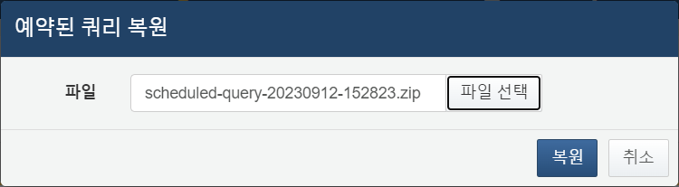

Check the [Scheduled Query List](https://docs.logpresso.comnull) to confirm that the scheduled query has been restored.

Be cautious, as restoring a scheduled query with the same name will replace the existing scheduled query.

### Deleting Scheduled Queries

To delete a scheduled query, follow these steps:

Click the checkbox of the scheduled query you wish to delete in the [Scheduled Query List](https://docs.logpresso.comnull). Clicking the checkbox in the field name list at the top of the list will select all scheduled queries on the current page.

Click **Delete** in the toolbar.

In the **Delete Scheduled Query** confirmation dialog, verify the name of the scheduled query to be deleted.

* Click **Yes** to proceed with the deletion, or **No** to cancel.
* 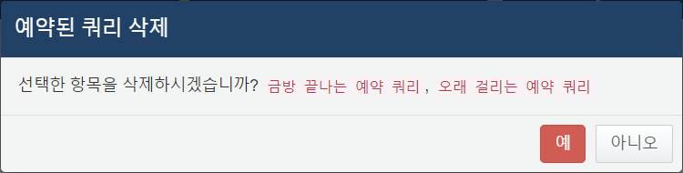
* If the scheduled query to be deleted is currently running, the following question will appear. Choose how to proceed and click **Delete**.
* 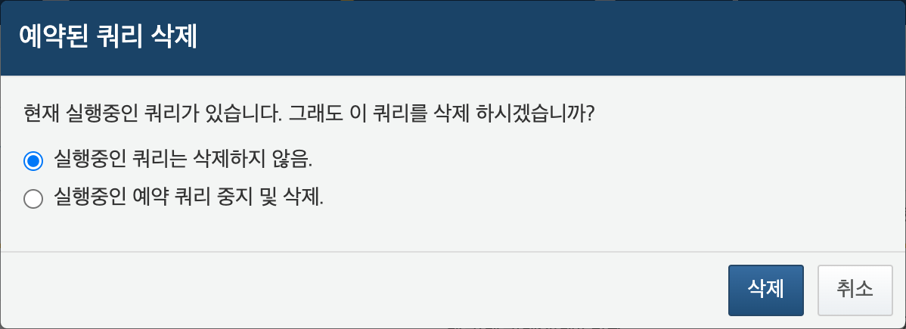
* **Do not delete the running query**: Deletes only the remaining queries, excluding the running query.
* **Stop the running query and delete**: Stops the running query and deletes it along with the other queries.