### Sites

#### Overview

Assets that need protection in the network are identified by their IP addresses. When private IP address networks are distributed across multiple locations, situations may arise where the same IP address is used despite differing physical or geographical locations. This can lead to difficulties in accurately identifying locations when querying tickets.

By using the site functionality, you can identify which site an asset operates from. The site object serves as a container to logically separate assets with IP addresses.

After registering the IP addresses of protected assets by site, specify the asset IP as the data source when configuring the logger. Subsequently, the collected data will be stored in the table with additional fields for device information (_device_ip, _device_name) and site information (_site).

#### Viewing/Search Site List

You can view or search the site list under **Policy > Sites**.

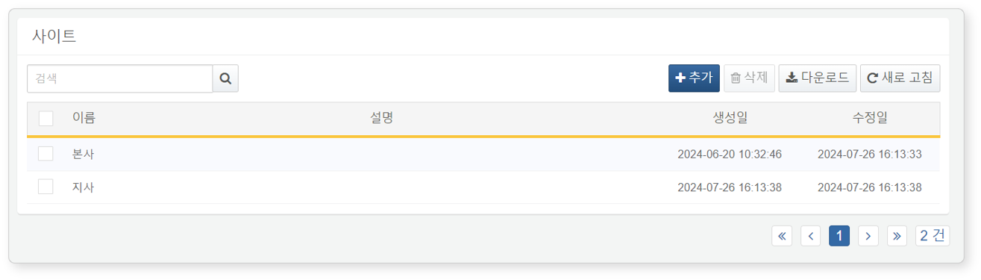

* **Name**: Site name
* **Description**: Description of the site
* **Creation Date**: Date the site was created
* **Modification Date**: Date the site was last modified

To find a specific site in the site list, use the search tool in the toolbar. The search tool will display sites that contain the entered word in the **Name** or **Description** fields. The search tool is case-insensitive.

Downloading the List

To download the site list as a file to your local PC, click **Download** in the toolbar.

Refreshing the List

To refresh the site list with the latest information, click **Refresh** in the toolbar.

#### Adding a Site

To add a site:

Click **Add** in the toolbar under **Policy > Sites**.

In the **Add Site** screen, enter the required values and click **OK**.

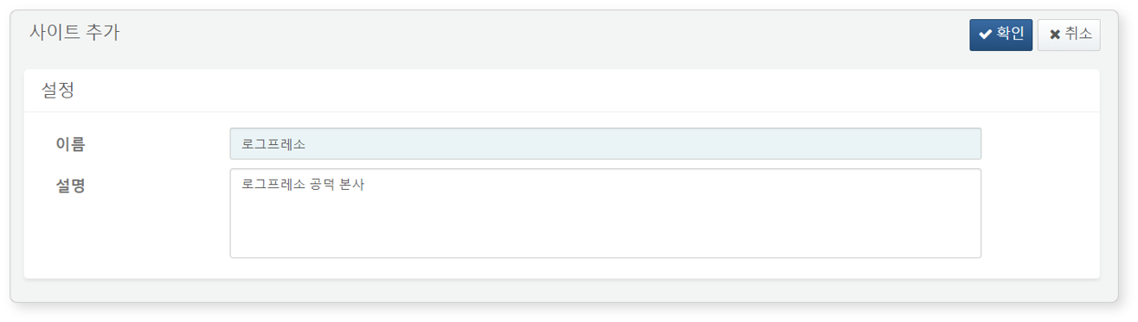

* **Name**: The name of the site. This information will be used to identify site information for each asset (maximum 50 characters).
* **Description**: Detailed description of the site (maximum 2,000 characters).

Sites with duplicate names cannot be added.

#### Modifying a Site

To modify a site:

Click the name of the site you wish to modify in the site list.

In the **Modify Site** screen, update the information and click **OK**.

#### Utilizing Sites

Asset IP

Sites are used when registering [Asset IP](https://docs.logpresso.comnull) under **Policy > Asset IP**.

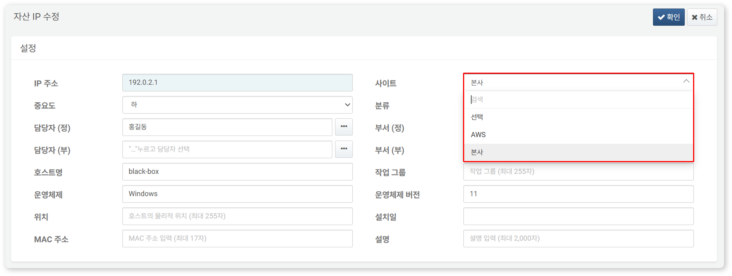

Logger

Site information is used as data source information when adding or modifying loggers under **Collection > Loggers**, along with [Asset IP](https://docs.logpresso.comnull).

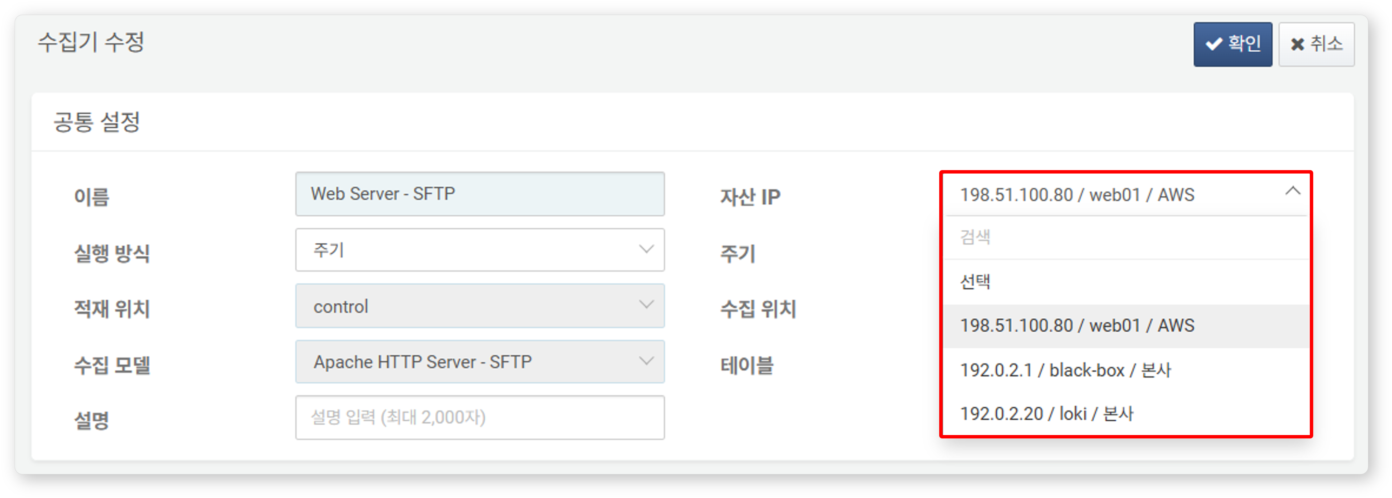

When data is collected through the logger, the site name is recorded in the meta field **_site**.

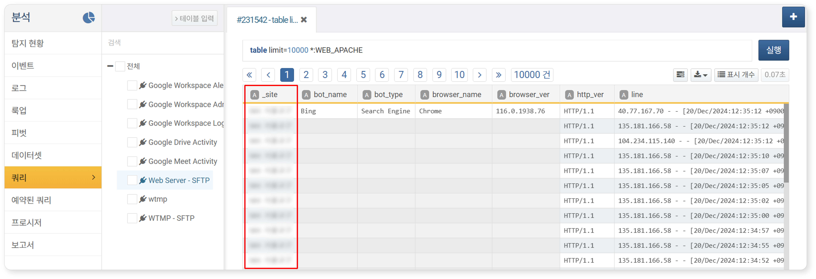

#### Deleting a Site

To delete a site:

Select the checkbox for the row of the site you wish to delete in the site list.

Click **Delete** in the toolbar.

In the **Delete Site** dialog, review the list of sites to be deleted and click **Delete**. Click **Cancel** if you do not wish to delete.

Deleting a site will also delete all asset IPs associated with that site.