### Mail Server

#### Overview

In **System > Mail Server**, you can register and manage the SMTP server that Logpresso Sonar will use to send emails.

Features Requiring Mail Server Configuration

The mail server must be configured to utilize the following features:

* [Send Explanation Request Emails](https://docs.logpresso.comnull)
* Send notification emails for [Approval Requests](https://docs.logpresso.comnull)
* [Notify Ticket Status](https://docs.logpresso.comnull)
* Send emails designated in the [Alarm Groups](https://docs.logpresso.comnull)
* (Playbook) [Send Report File via Email](https://docs.logpresso.comnull)
* (Playbook) [Send Email](https://docs.logpresso.comnull)
* (Login Screen) [Request 2FA Reset for Admin](https://docs.logpresso.comnull)
* [sendmail](https://docs.logpresso.comnull) query command

#### SMTP Server Configuration

In **Common Settings**, specify the following properties and click **Save**.

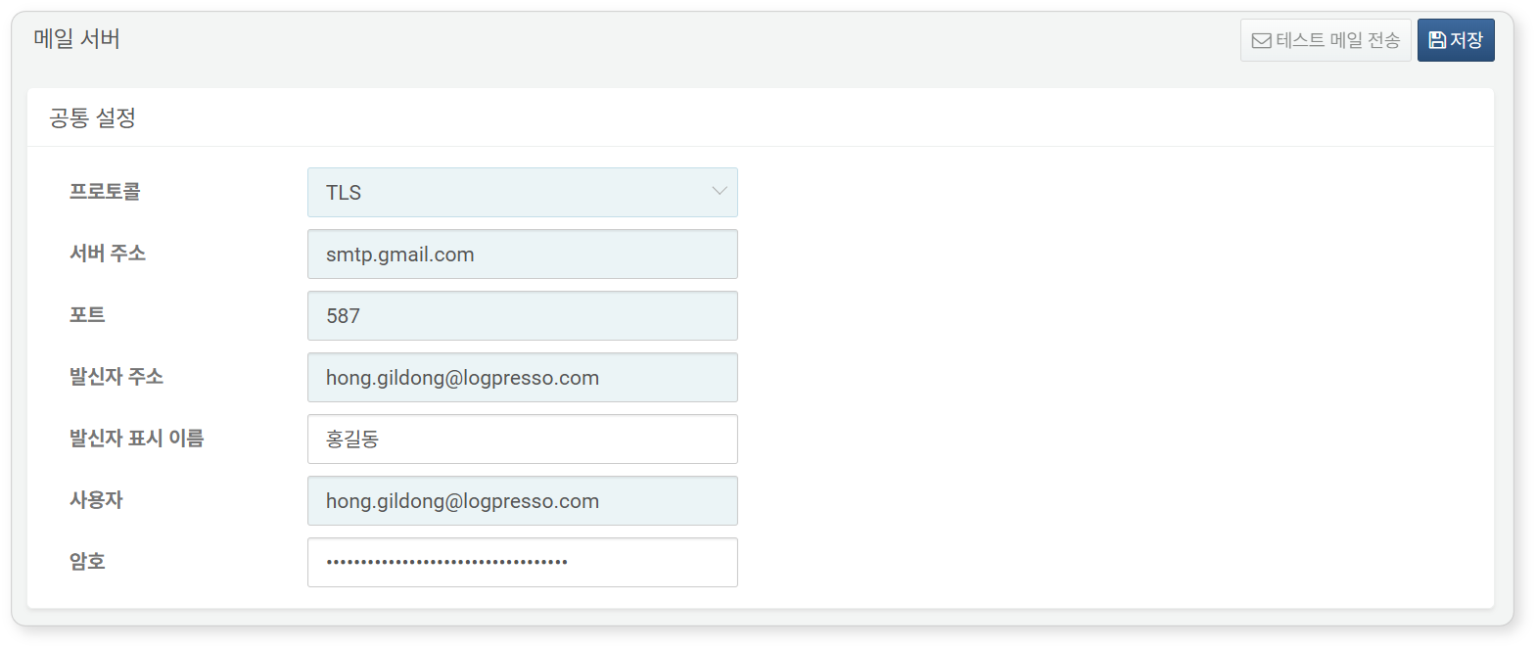

* **Protocol**: Email transmission protocol (default: TLS). Choose one of the following:
* **PLAIN**: Unencrypted SMTP communication
* **SSL**: SMTPS communication. The default communication port is 465/tcp.
* **TLS**: SMTP over TLS (STARTTLS) communication. The default communication port is 587/tcp.
* **Server Address**: Address of the SMTP server
* **Port**: TCP port for SMTP communication (default: 587)
* **Sender Address**: Email address of the sender
* **Sender Display Name**: Display name of the sender
* **User**: ID of the user logging into the SMTP server
* **Password**: Password for the SMTP server login

When the protocol is SSL, 465/tcp is typically used, and when it is TLS, 587/tcp is commonly used for SMTP communication. If using GMAIL, enter the same value for both the sender address and user.

#### Test Email Sending

Once you have entered and saved the **Common Settings**, the **Send Test Email** button will be activated. Click this button to send a test email. Use this feature to verify that the mail server configuration is set up correctly.

