System Logs

Overview
System logs are records of significant system events generated by nodes that comprise the Logpresso platform while they are running.

Viewing/Search System Logs
You can view or search system logs under System > System Logs. The default search period is the last 30 days.
- In the toolbar, you can specify the range of logs to view by selecting the period, node, and level.
- By entering a keyword, you can filter the logs to display only those that contain the specified keyword.

Downloading System Logs
To download system logs:
Click Download in the toolbar.
In the System Log Download dialog, specify the properties of the file to be downloaded and click OK.
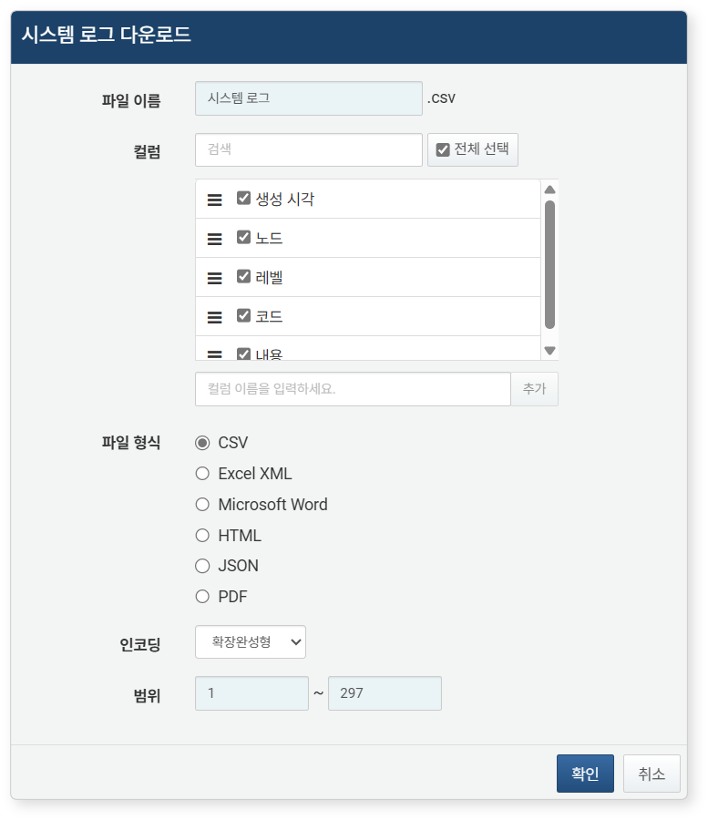
- File Name: The name of the file to be downloaded (default: System Logs)
- Columns: The fields to be included in the download list (default: Select All)
- File Format: Choose from CSV, Excel XML, Microsoft Word, HTML, or JSON (default: CSV)
- Encoding: Select the string encoding format for the file from Extended Completion Type, UTF-8, or UTF-16 BE (default: Extended Completion Type)
- Range: Select the range of system logs to be recorded in the list. The default is set to include all system logs, starting from the first page as number 1.
Once the server transmits the file to your web browser, save the file and check the downloaded system log file.

