### Table Management

#### Overview

A table is a storage space for the data and indexes collected by Logpresso Sonar. All data collected from data sources through loggers undergoes a normalization process according to the logger models, and both the original data and the data generated based on normalization rules, along with indexes, are stored in tables.

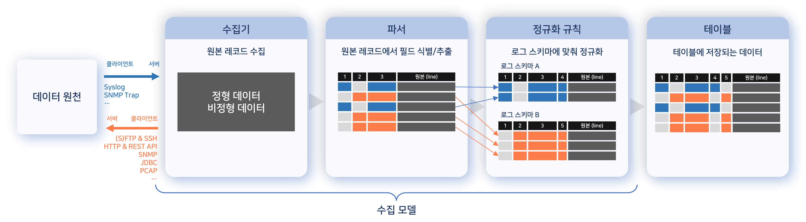

If an encryption profile is specified for a table, the data will be stored in an encrypted format. The stored data is retained for the specified retention period, and data that exceeds the retention period will be deleted. Administrators can grant access permissions to users or user groups, and regular user accounts can access tables within the scope of their granted permissions.

#### Viewing/Search Table List

You can view the table list under **System > Tables**. The left side displays the table tree, while the right side shows the information of the selected organization or table from the tree.

The table list displayed when clicking on an organization name includes the following:

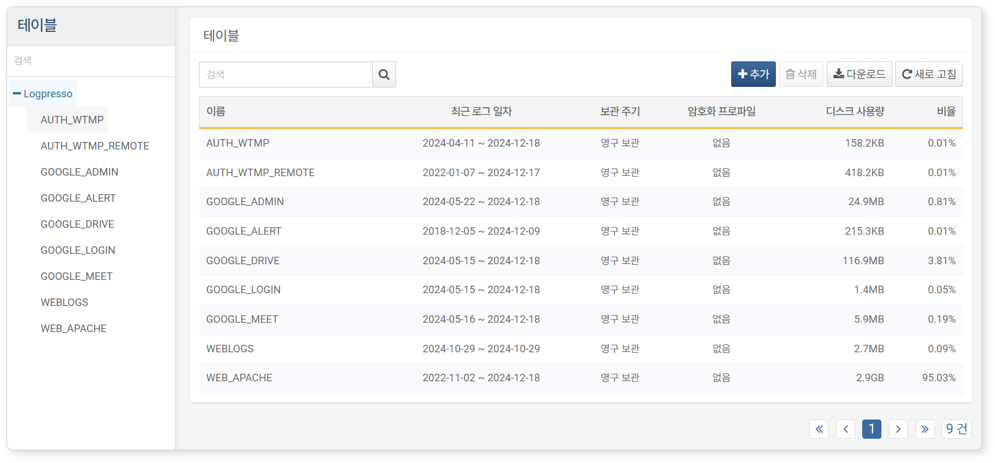

* **Name**: The unique name assigned to the table.
* **Recent Log Date**: The retention period of the data stored in the table.
* **Retention Period**: The retention period for the data recorded in the table. Data that exceeds the retention period based on the time the data was recorded will be deleted.
* **Encryption Profile**: The applied [encryption profile](https://docs.logpresso.comnull). If no encryption profile is applied, it will be displayed as **None**.
* **Disk Usage**: The size of the stored data.
* **Ratio**: The ratio of the stored size compared to the total capacity of all tables.

Both the table tree and the table list support search functionality. Both search features perform searches based on the table name and are case-insensitive.

Downloading the Table List

To save the table list to your local PC, click **Download** in the toolbar and select the desired file format for download.

Refreshing the Table List

To view the table list with the latest information, click **Refresh** in the toolbar.

#### Creating a Table

There are two methods to create a table:

Create a table from the [Table List](https://docs.logpresso.comnull).

Create a table when adding a logger.

When creating a table from the table list, data encryption can be applied; however, when creating a table while adding a logger, data encryption is not supported.

To create a new table from the [Table List](https://docs.logpresso.comnull), click **Add** in the toolbar, then specify the table's **Name**, **Encryption Profile**, and **Retention Period** in the **Add Table** dialog, and click **OK**.

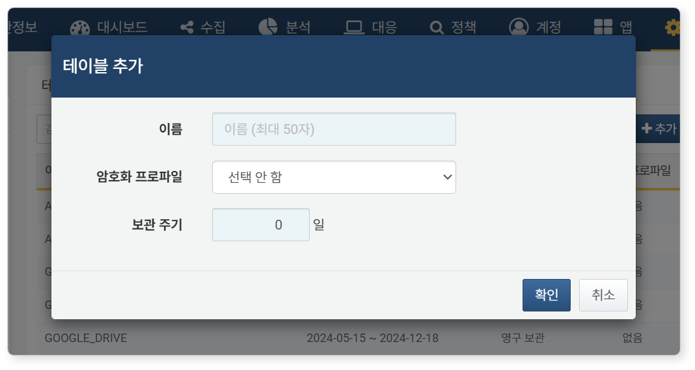

* **Name**: The unique name of the table (up to 50 characters). Only English letters, numbers, and underscores (_) are allowed. The name cannot be changed after the table is created.
* **Encryption Profile**: Select an encryption profile from the list if you want to encrypt the data stored in the table. This setting cannot be changed after the table is created.
* **Retention Period**: The duration for which logs will be retained in the table (default: 0. When set to "0", logs are retained permanently).

#### Viewing a Table

To view table information, click on the table name in the table tree on the left side of the [Table List](https://docs.logpresso.comnull).

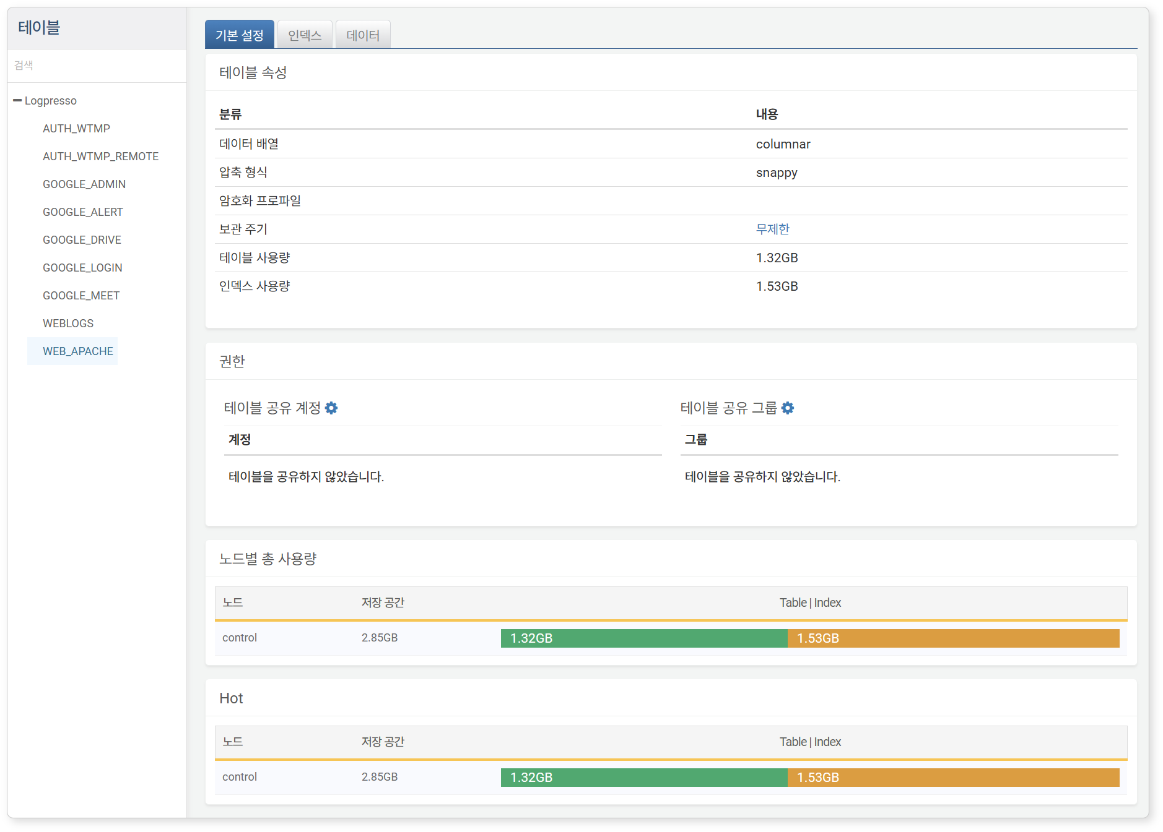

The table properties screen consists of three tabs.

**Basic Settings**

Displays table properties, table access permissions, and total usage per node.

* In **Table Properties**, you can change the **Retention Period**. The unit is in days.
* In the **Permissions** section, you can grant table read permissions to accounts or account groups through **Table Shared Accounts** and **Table Shared Groups**.
* **Total Usage per Node** shows the capacity of tables and indexes on a node basis within the Logpresso Sonar cluster.

**Indexes**

Displays information related to table indexes.

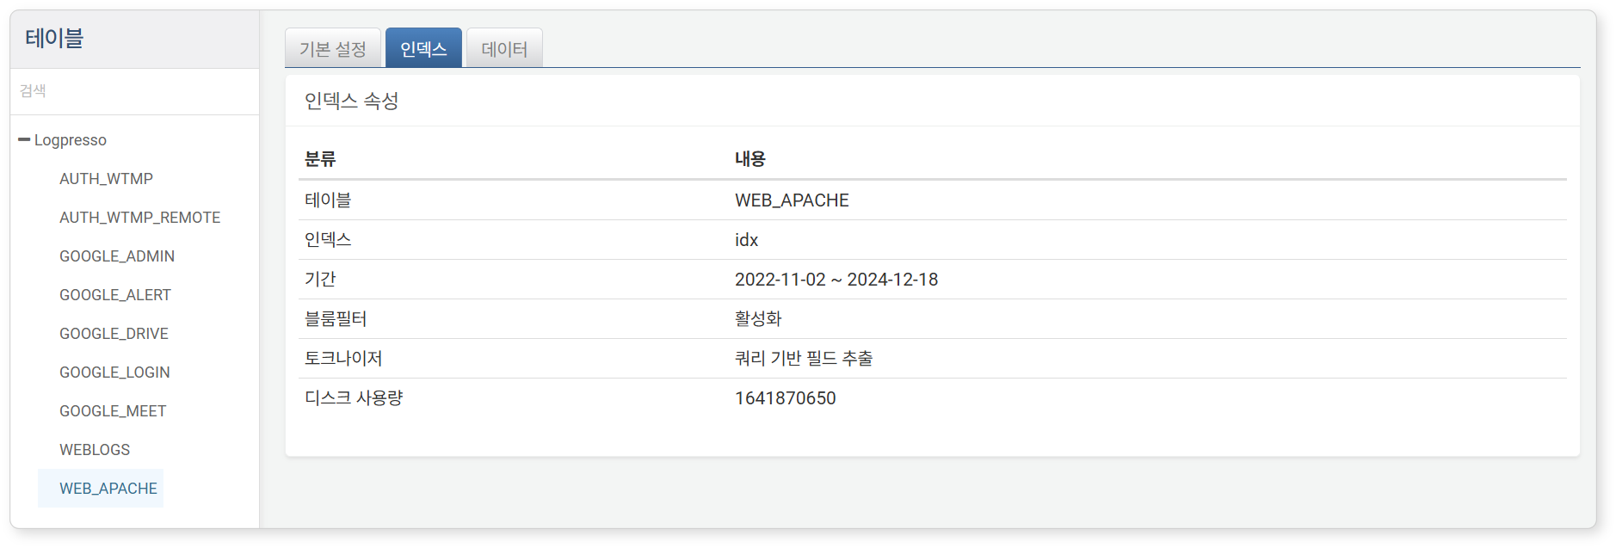

**Data**

Displays the most recent 10,000 entries of data.

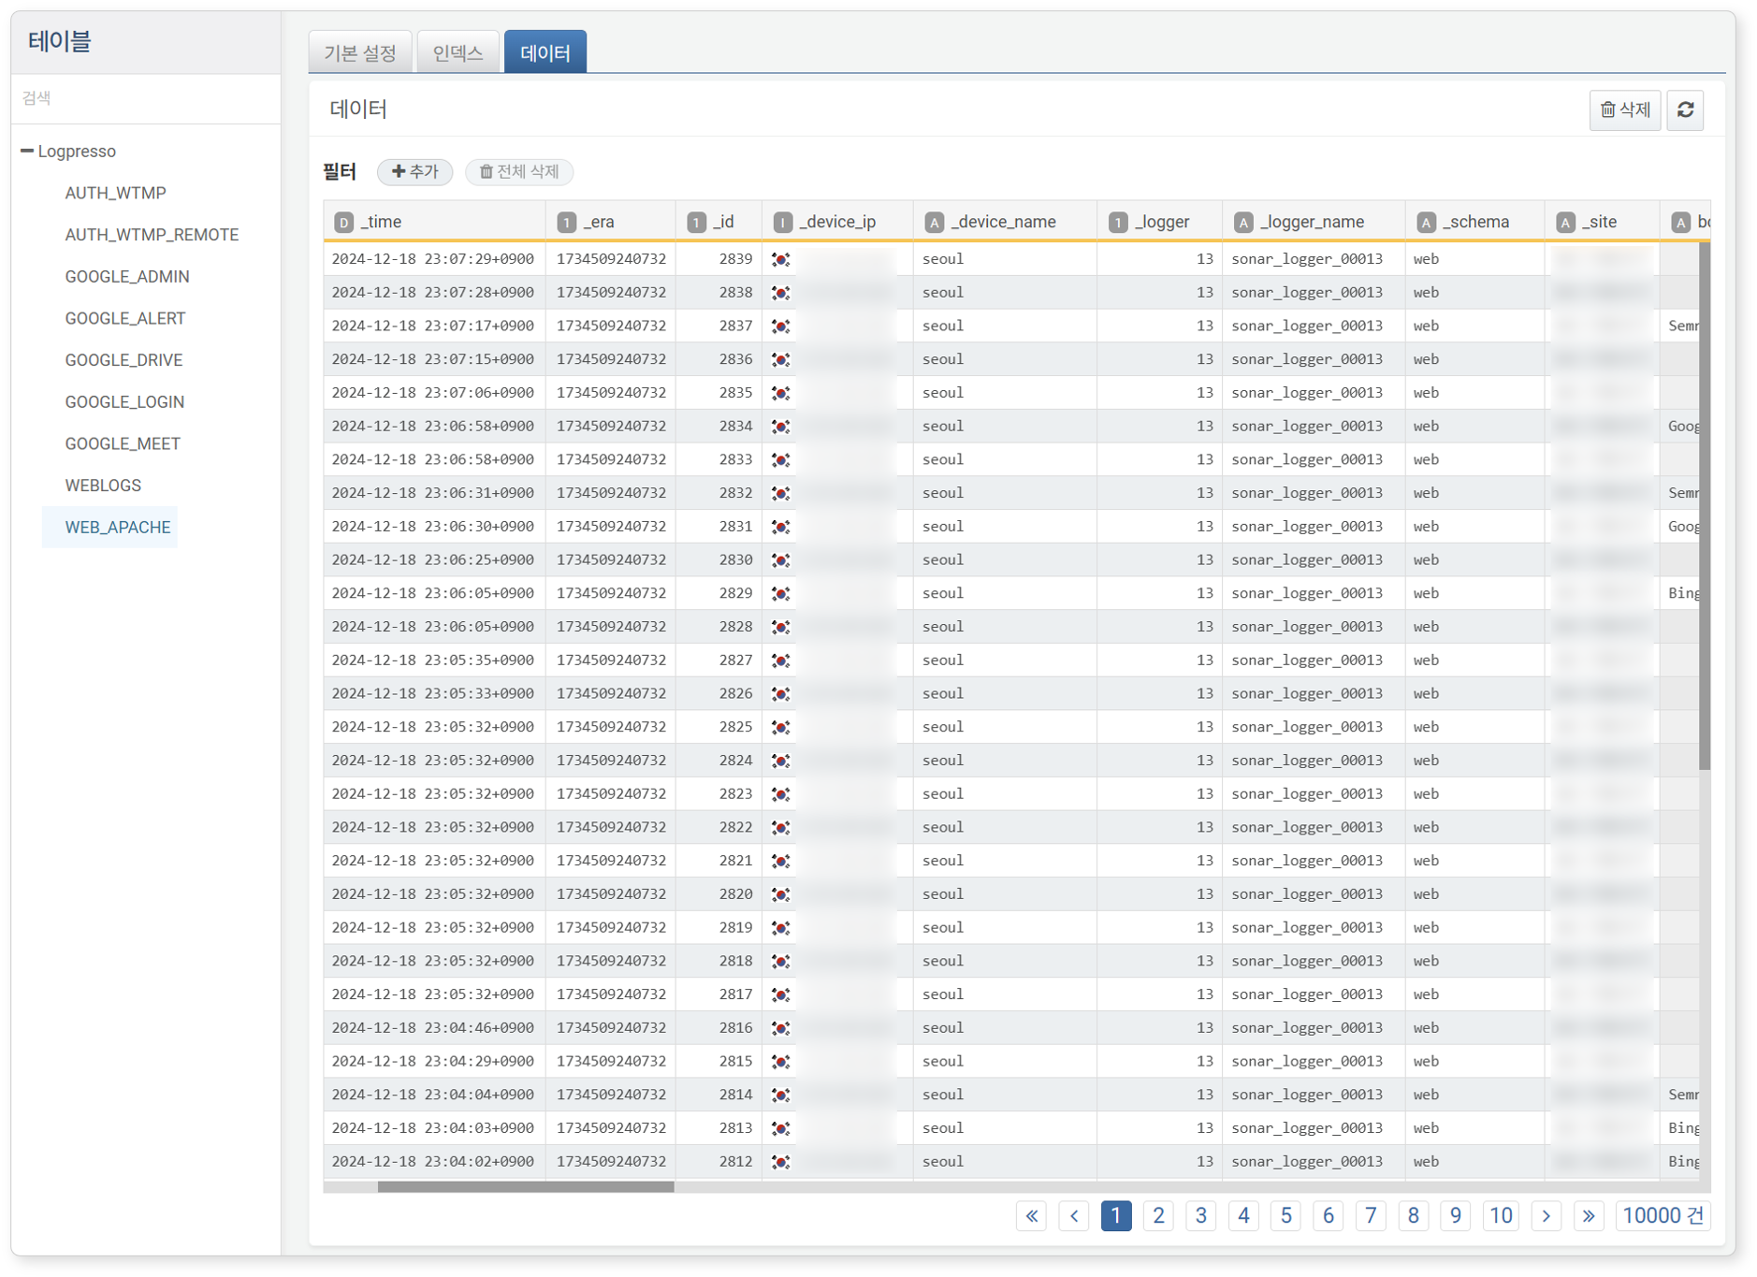

Changing the Retention Period

In the **Basic Settings** tab of the [Table View](https://docs.logpresso.comnull), you can click the value of the **Retention Period** and change the data retention period in the **Set Retention Period** dialog.

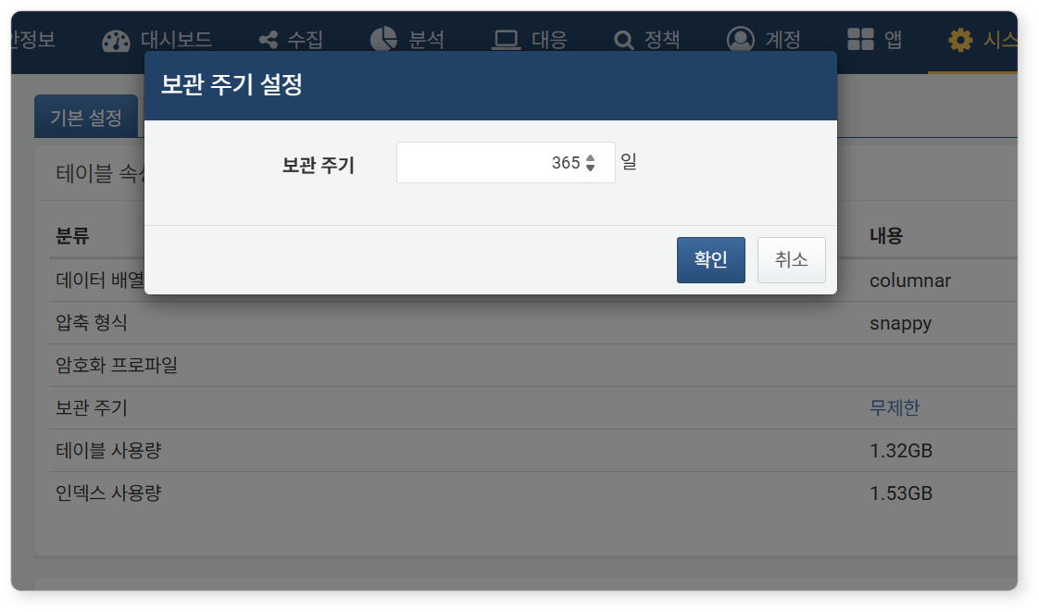

Table Access Control

In the **Basic Settings** tab of the [Table View](https://docs.logpresso.comnull), you can specify the accounts or account groups to grant table read permissions by clicking the gear button next to **Table Shared Accounts** or **Table Shared Groups**.

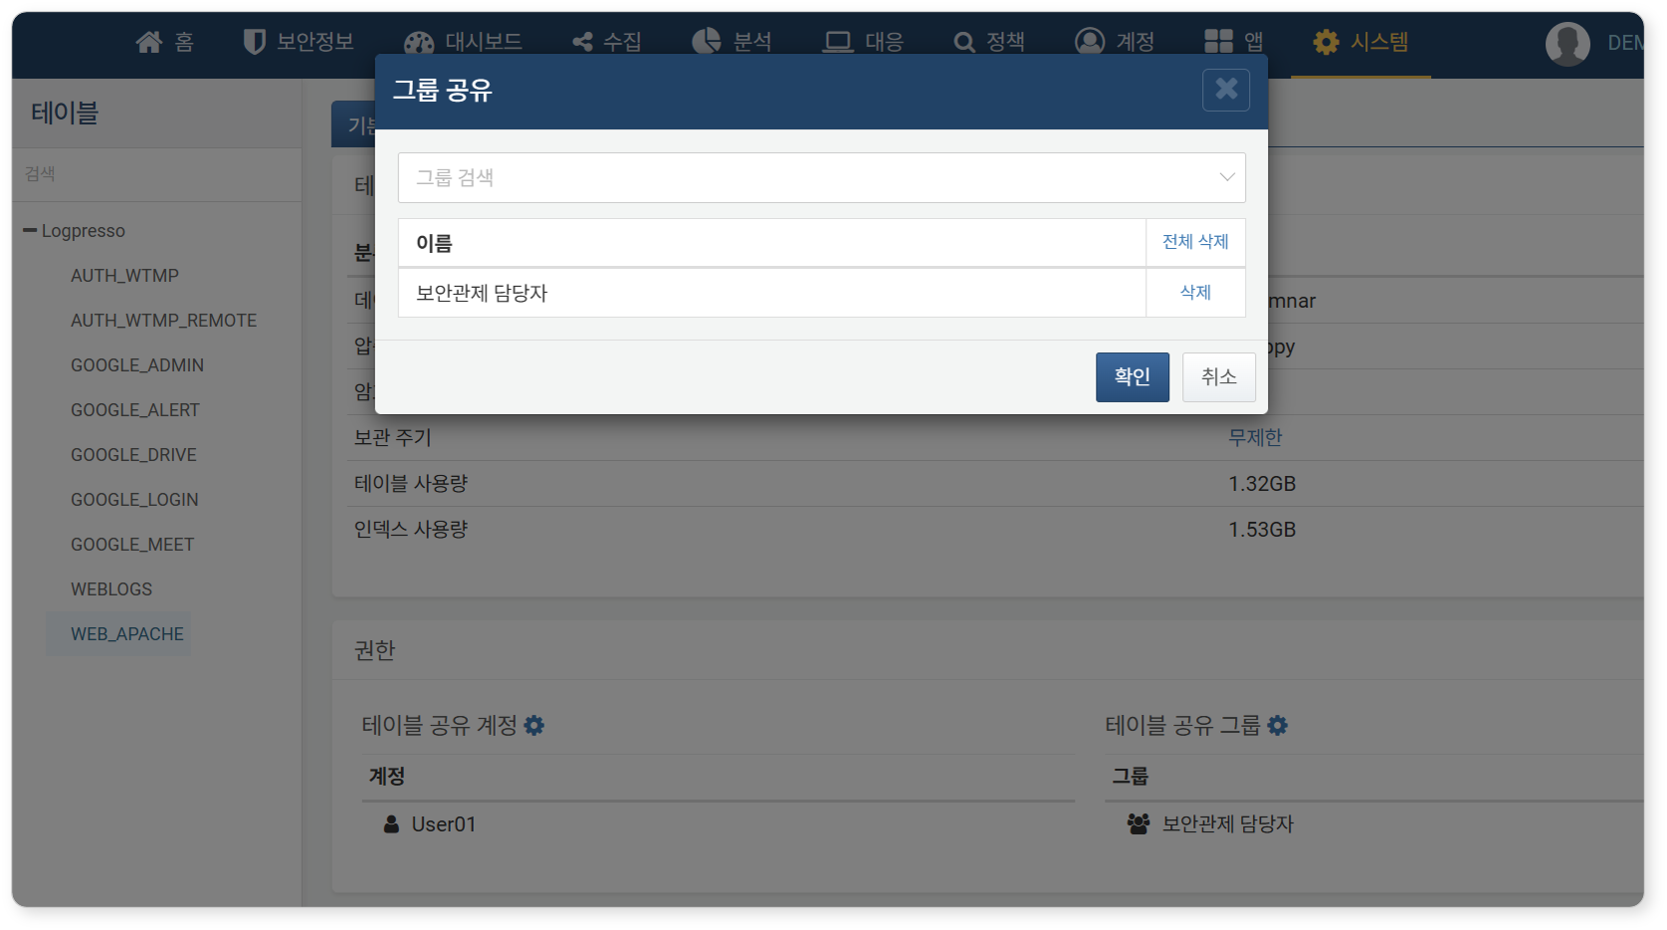

Cluster administrators and admin accounts have access to all tables. This feature is intended to grant access permissions to regular user accounts.

Deleting Data

In the **Data** tab of the [Table View](https://docs.logpresso.comnull), you can click the trash can button to specify a period and delete data from that period.

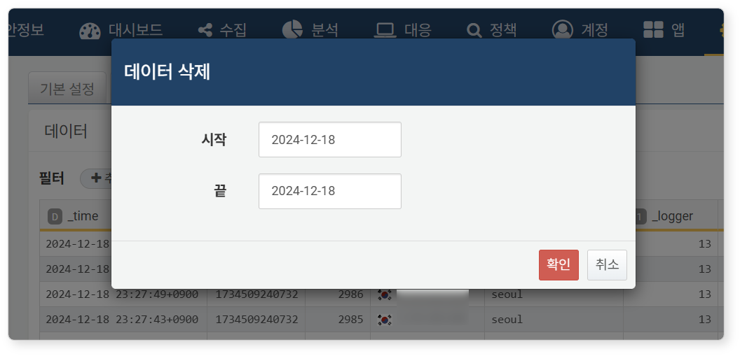

Deleting data is irreversible, so caution is required when deleting data. Never delete data in a production environment.

#### Deleting a Table

To delete a table, select the table you wish to delete from the [Table List](https://docs.logpresso.comnull), then click **Delete** in the toolbar. Clicking **Delete** in the **Delete Table** dialog will remove the table along with all logs and indexes contained within it.

