### Threat Intelligence Feeds

You can manage the threat intelligence feeds provided by Logpresso CTI and Watchade ISAC under **Policies /> Threat Intelligence**. To receive specific feeds, activate each feed item. Only cluster administrator can activate/deactivate threat intelligence feeds, while administrators or users can only view the threat intelligence feed list.

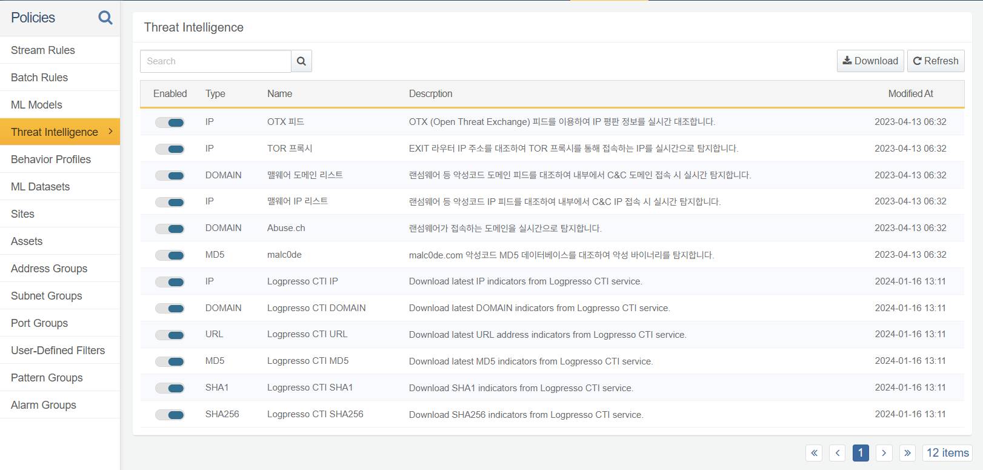

The scenario builder of [Stream Rule](https://docs.logpresso.com/en/sonar/4.0/ui/create-stream-rule), the [matchfeed](https://docs.logpresso.com/en/query/matchfeed-command) query command, and the [matchfeed()](https://docs.logpresso.com/en/query/matchfeed-function) function match specific IP addresses, domain addresses, URLs, MD5 hashes, SHA1 hashes, or sHA256 hashes against the threat intelligence feeds to detect threats.

To use Logpresso CTI feeds, create a Logpresso CTI connect profile from the [Connect Profiles](https://docs.logpresso.com/en/sonar/4.0/ui/section-connect-profile). Customers with a paid Logpresso CTI subscription will receive real-time information; while free subscribers receive threat intelligence information with a 90-day delay.