### Tickets

You can configure the system to generate tickets when a security threat event is suspected in the monitored system. When setting up **Stream Rules** or **Batch Rules**, if you specify a **Ticket Assignee/Recipient**, a ticket will be automatically created when the corresponding event occurs.

Once a ticket is generated, it may already have an assignee, or an administrator can assign a responsible person directly. The assignee will proceed with the response actions based on the ticket details and supporting materials, document the response history, and then submit an approval request. The approver can review the ticket details and response history before approving or rejecting the request. If rejected, the assignee must perform additional work and resubmit the approval request.

The process can be illustrated as follows:

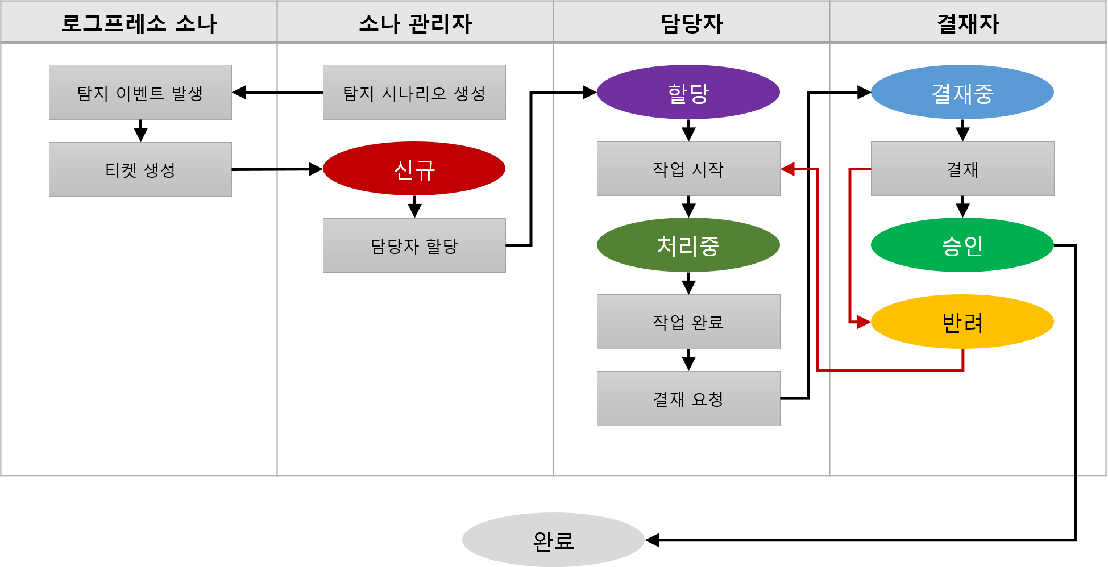

The statuses of tickets are categorized as follows:

* **New**: The ticket has been created but is not assigned to anyone.
* **Assigned**: A ticket assignee has been designated.
* **In Progress**: The ticket assignee is currently working on the task.
* **Under Approval**: The ticket assignee has completed the task and submitted an approval request.
* **Approved**: The approver has approved the ticket.
* **Rejected**: The approver has rejected the ticket. The assignee must perform additional work.
* **Completed**: The ticket has been finalized.

While the ticket processing workflow indicates that a ticket can only be marked as completed when the processing by the assignee is approved by the approver, in practice, a ticket can be converted to **Completed** status regardless of whether it is in New, Assigned, In Progress, or any other state. Tickets that are duplicates or have already been processed through other means, and do not require the Logpresso Sonar ticket processing workflow, can be marked as completed immediately. Conversely, even completed tickets can be transitioned back to a **Rework** state for further action if necessary. In this case, the ticket will revert from Completed status back to New or Assigned status.