### Account Groups

#### Overview

Account groups are a feature that allows for the simplification of repetitive permission management tasks by categorizing accounts into groups and managing permissions at the group level. Representative functionalities that can be performed using account groups include [Connect Profiles](https://docs.logpresso.comnull), [Tables](https://docs.logpresso.comnull), and [Alarm Groups](https://docs.logpresso.comnull).

#### Viewing/Search Account Group List

Cluster administrators and managers can view the list of account groups on the **Accounts > Account Groups** screen. User accounts cannot view account groups.

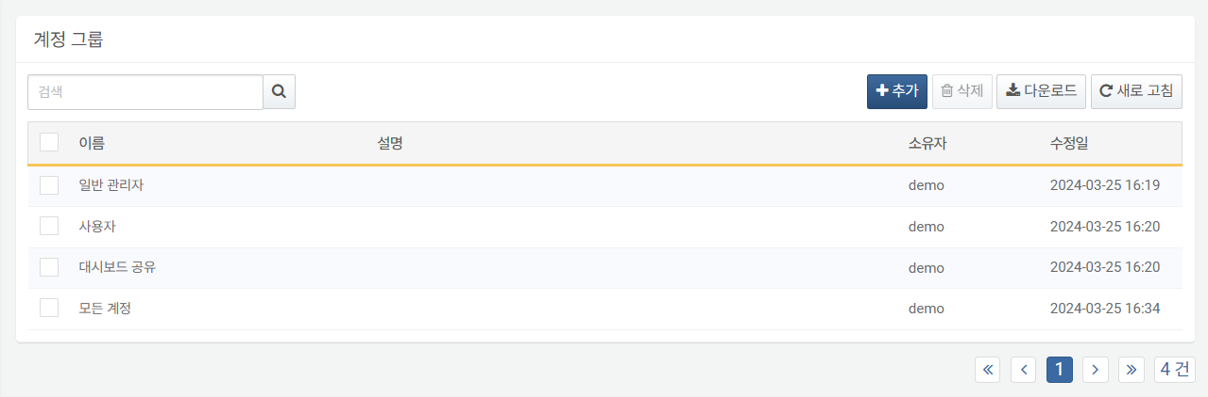

To find a specific account group in the list, use the search tool in the toolbar. The search tool displays account groups that contain the entered words in their name or description. The search tool is case-insensitive.

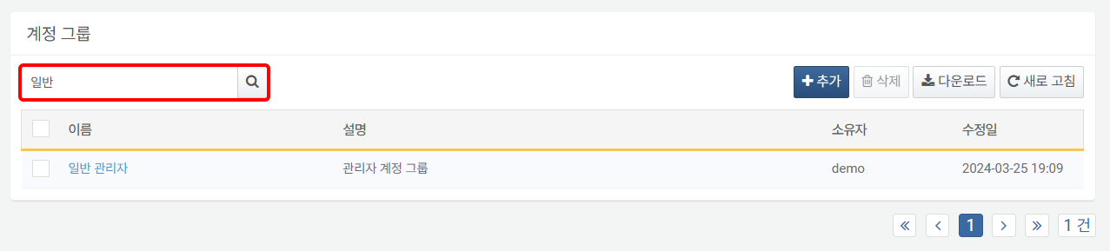

#### Adding an Account Group

To add an account group:

Click **Add** in the toolbar on the **Accounts > Account Groups** screen.

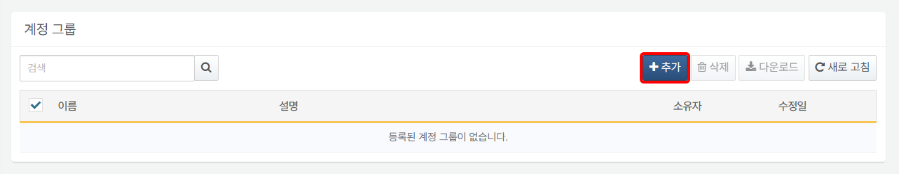

In the **Add Account Group** dialog, enter the **Name** (up to 50 characters) and **Description** (up to 2,000 characters) for the account group, and click **OK**. Click **Cancel** if you do not wish to add the group.

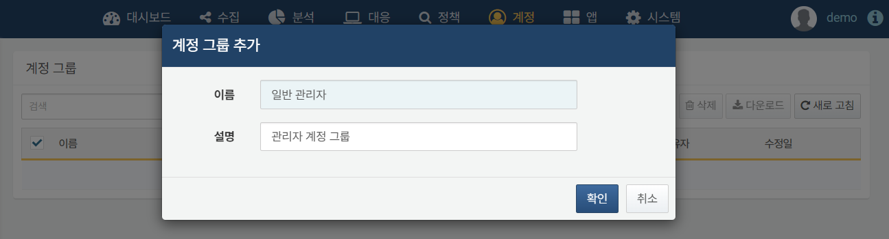

#### Configuring Account Groups

Modifying Account Group Name/Description

To modify the name or description of an account group:

Click the **Name** of the account group you wish to modify in the **Accounts > Account Groups** screen.

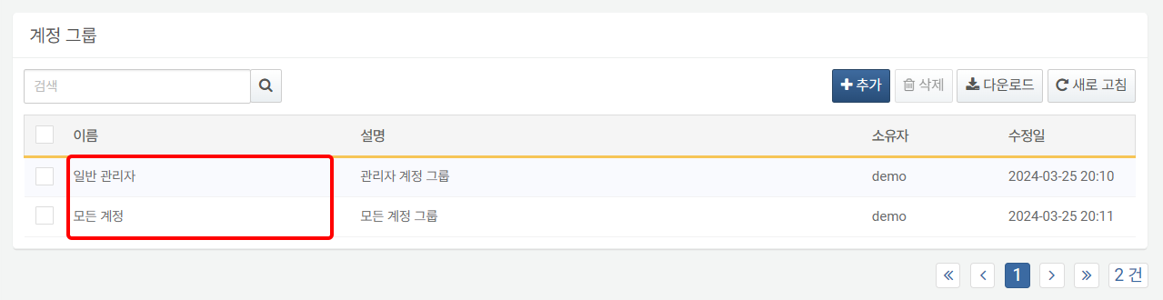

In the **Modify Account Group** screen, edit the name and properties, then click **Save**.

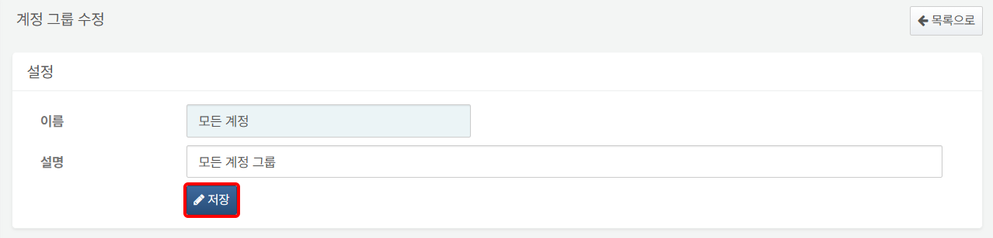

To return to the account list after completing all settings, click **Back to List**.

Adding Accounts to an Account Group

To add accounts as members to an account group:

Click the **Name** of the account group to which you want to add accounts in the **Accounts > Account Groups** screen.



In the **Modify Account Group** screen, click **Add**.

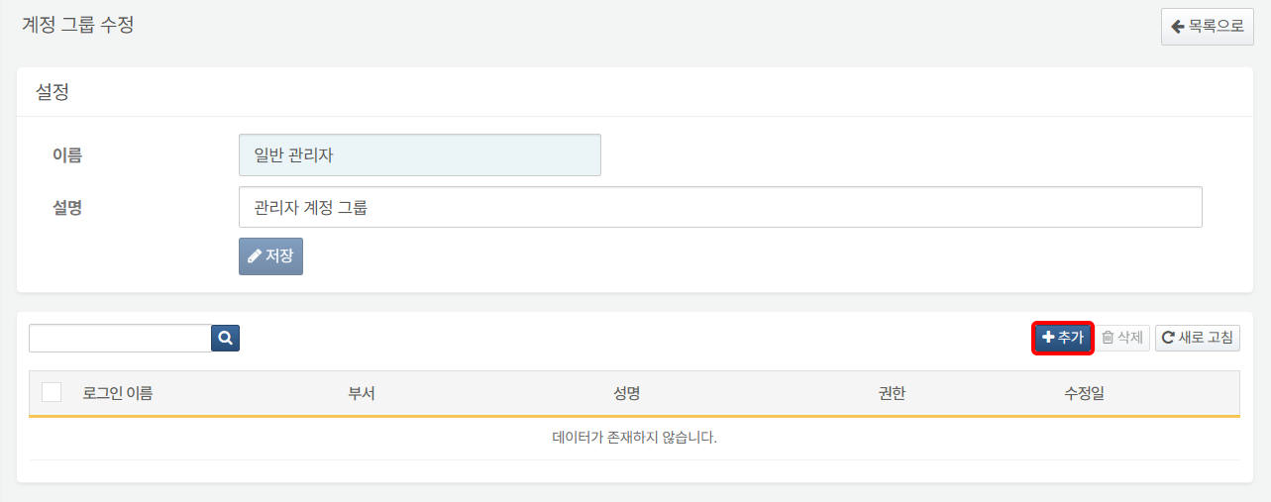

In the **Account Assignment** toolbar, enter the login name of the account you wish to add to the account group. A list of accounts containing the entered string will appear; click the account you wish to add.

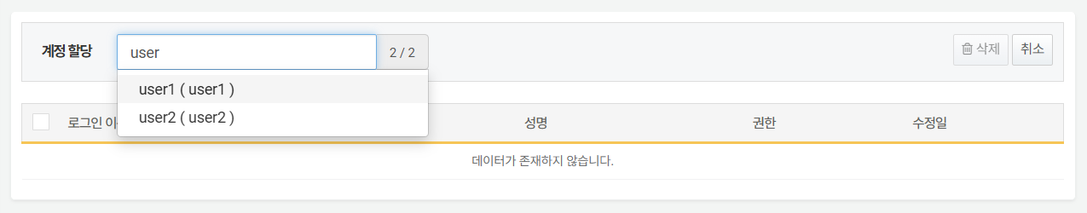

Searching for Accounts in an Account Group

To find a specific account in the account list, use the search tool in the toolbar. The search tool displays accounts that contain the entered words in the **Login Name**, **Department**, or **Full Name**. The search tool is case-sensitive.

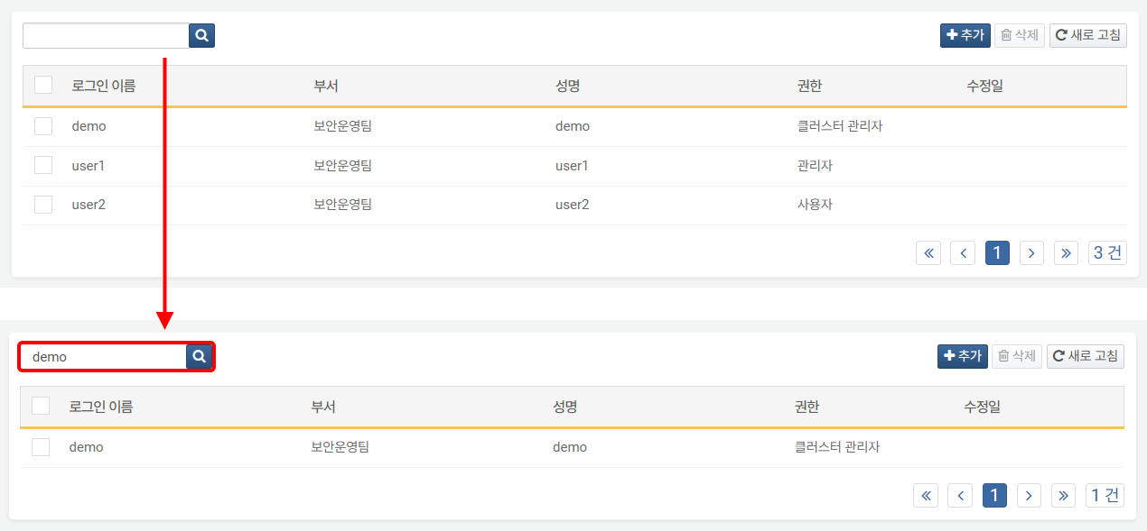

Deleting Accounts from an Account Group

To exclude a specific account from the account group members:

Click the **Name** of the account group from which you want to delete an account in the **Accounts > Account Groups** screen.



In the **Modify Account Group** screen, select the account you wish to delete and click **Delete**.

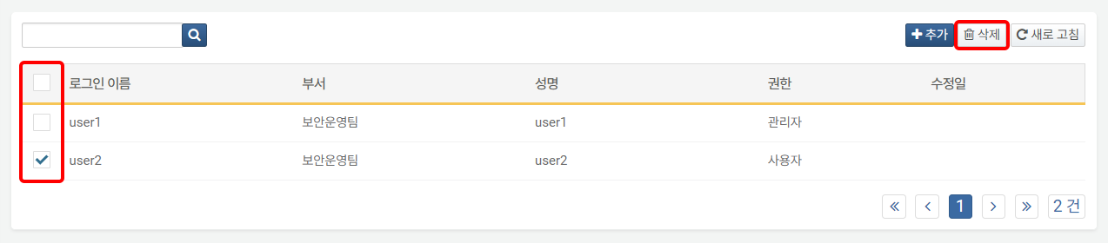

In the **Confirm Account Group Deletion** screen, verify the account information to be deleted and click **Delete**. Click **Close** if you do not wish to delete.

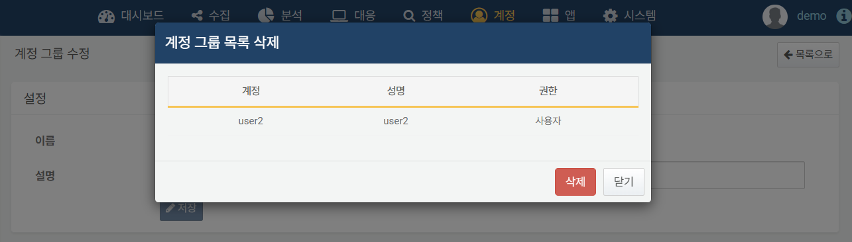

#### Deleting an Account Group

To delete an account group:

Select the account group you wish to delete in the **Accounts > Account Groups** screen and click **Delete** in the toolbar.

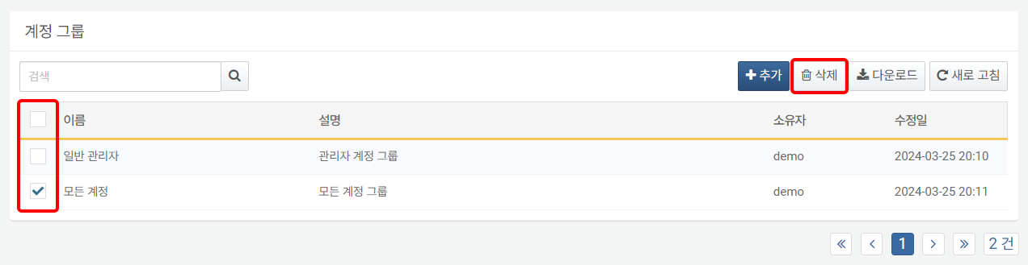

In the **Delete Account Group** dialog, confirm the account group to be deleted and click **Delete**. Click **Cancel** if you do not wish to delete.

