Widget Settings
By clicking on the Widget Management option in the context menu of the dashboard's Manage button, you will be directed to the management screen where you can create, edit, and delete widgets. This screen displays a list of widgets currently available for use.
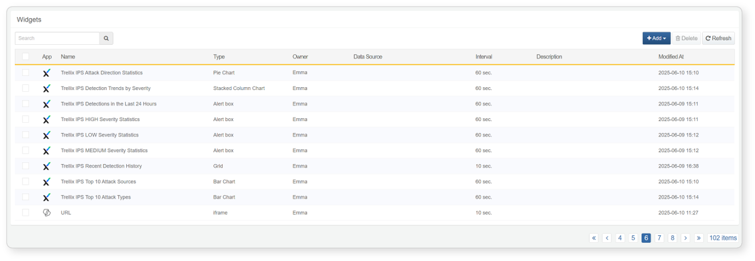

Create Widget
On the widget management screen, click the Add New Widget button and select the desired widget type to create the corresponding widget.
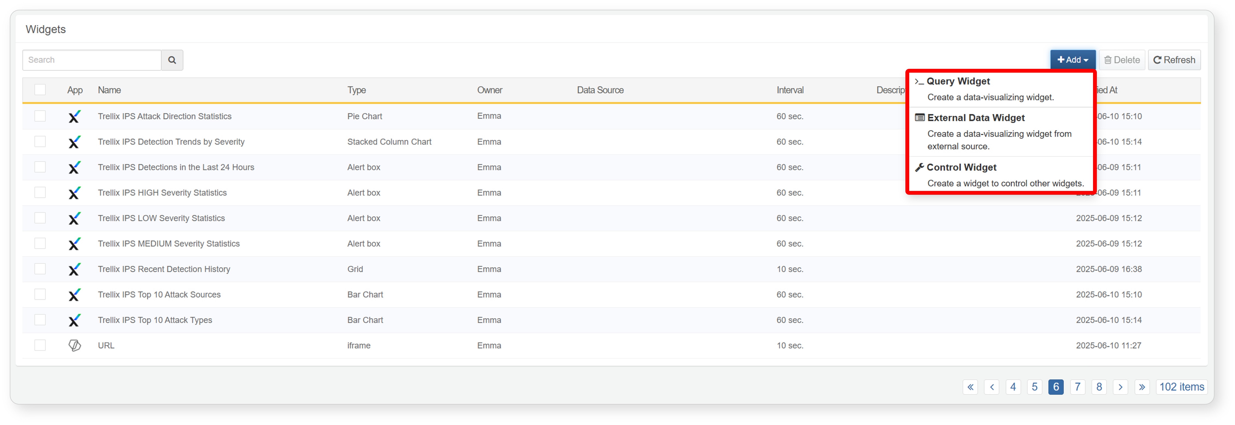
Create Query Widget
The query widget visualizes data in a grid or chart format after processing it based on user-defined conditions and query filters. To create a query widget, click the Add button on the widget management screen and select Query Widget. This will take you to the widget editor screen.
Create Grid Widget
The grid widget displays data in a tabular format based on the configured conditions and queries.You can create a grid widget as follows:
Enter the name, description, and execution interval in the widget editor screen.
- To restrict access to the widget by user account, set Account Sharing or Group Sharing.
- If sharing is configured, check that the underlying data (e.g., tables, datasets, behavior profiles, etc.) is also shared accordingly.
Widget access permissions are applied to users with account-level permissions based on account or account group settings.
In the Data Type field, select the data source to monitor. A condition configuration screen will appear based on the selection.
- Collector: Use to query data from a collector. Available collectors are those configured under the Collection menu.
- Table: Use to query data stored in specific tables.
- Dataset: Use to query datasets. Select from those configured under Analysis > Dataset.
- Behavior Profile: Use to query behavior profile data. Select from profiles under Policy > Behavior Profile.
- Event: Use to view threat events detected based on detection scenarios in the Policy menu.
- Query: Use to input and execute a custom query to retrieve events.
After entering the details for each data type, click the [Apply] button in the Data Type section to fetch the data.
- The data is displayed in a grid format based on the defined conditions.For more information, refer to Analysis > Pivot > Select Data Type.
To create a widget for real-time monitoring, set the time range to "Recent Period" or "All Period".
If you use "Date Range", the widget will only show data within the selected date range.
Configure filters and sort settings to analyze the data easily.You can rearrange rows and columns to build a pivot table for multi-dimensional data views.Refer to Analysis > Pivot > Data Filter and Analysis > Pivot > Data Aggregation for setup guides.Note: Correlation analysis is not supported in grid widgets.
In a grid widget, you can configure actions when a cell is clicked.
Alerts can also be triggered based on threshold values in specific fields.
See Analysis > Pivot > Data Filter > Column Filter > Event Settings for more details.
To complete widget creation, click the [Add] button on the left panel of the widget editor.
- Once the grid widget is added to the dashboard, you can apply filters to monitor data under specific conditions.
- Clicking on a particular column value will automatically add it to the global filter in the filter management section.
Create Chart Widget
The Chart Widget visualizes processed data results as charts based on specified conditions and queries after retrieving the data.
Retrieve the data to monitorRefer to steps 1–3 of the Grid Widget Creation Procedure to retrieve the data you want to monitor.
Process the data using filters or pivot functionsIf you want to refine the data using filters or pivot functions, configure the Filter or Field items.For more details, refer to "Analysis > Events".
Generate a chart from the retrieved dataClick [Chart] → [Settings] in sequence to generate a chart from the retrieved data.
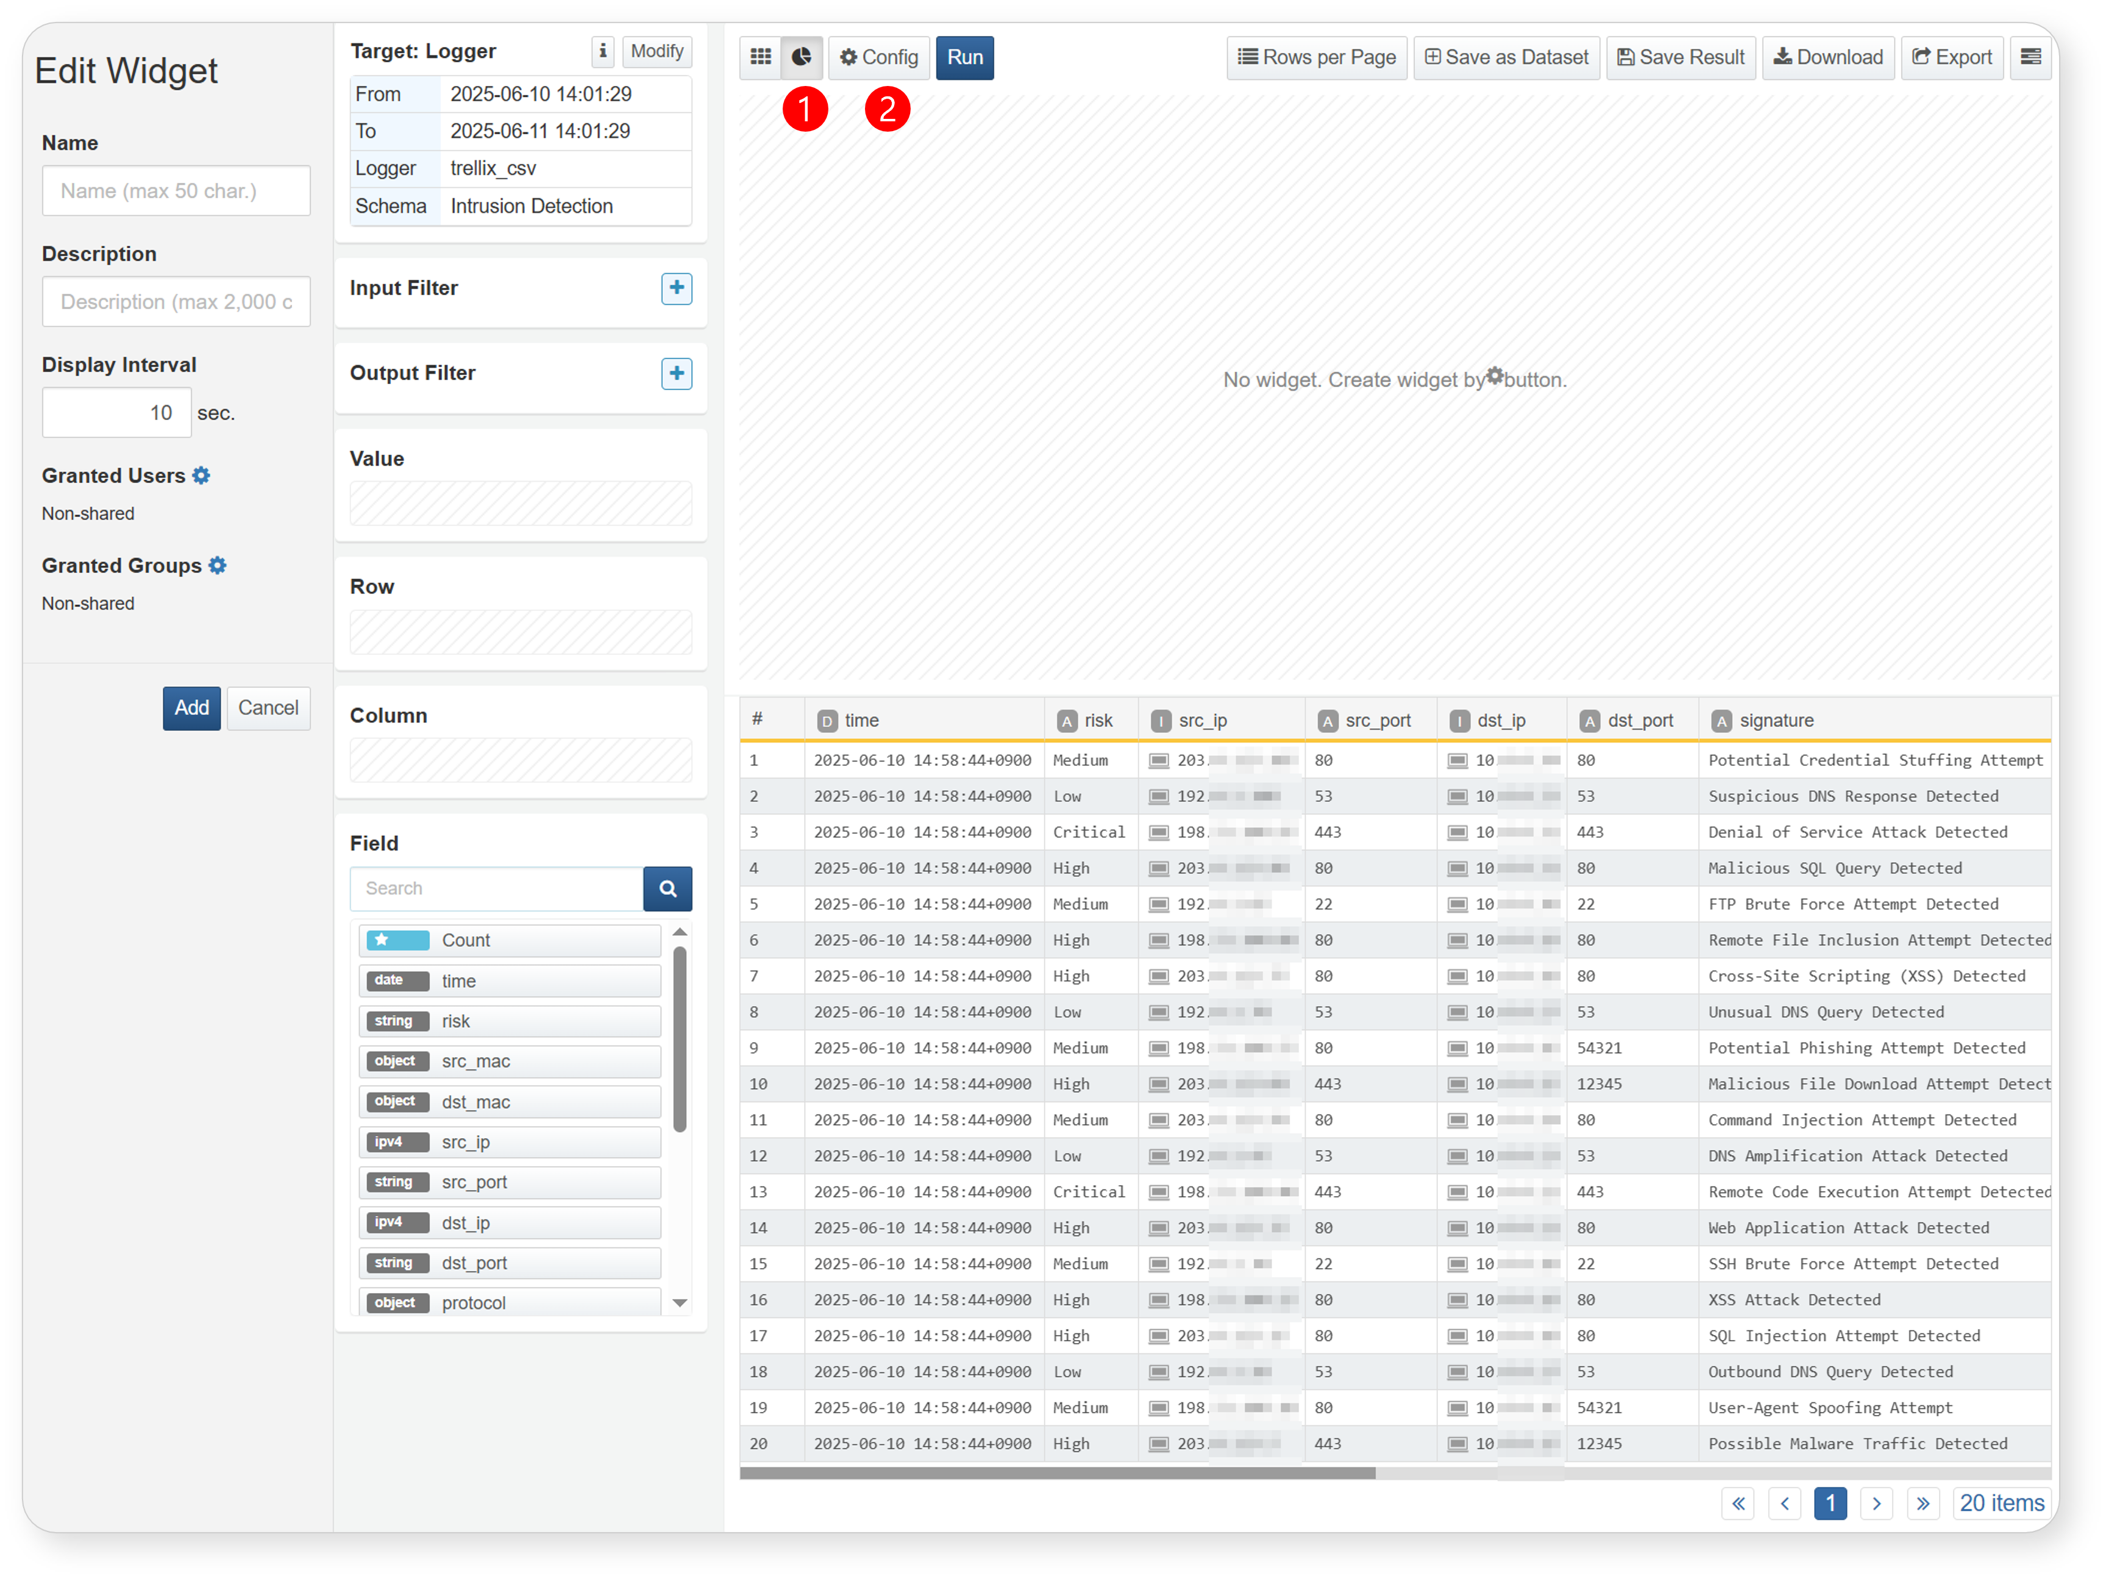
Select the chart typeIn the chart options screen, select the chart type from the Type field.
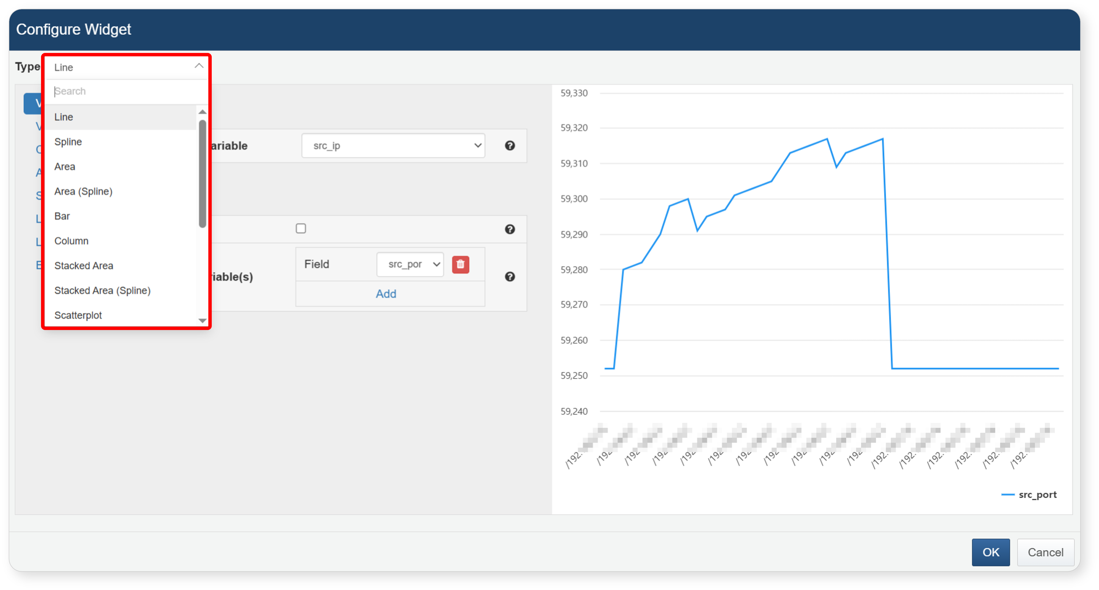
Available chart types include:
- Line
- Spline
- Area
- Area (Spline)
- Horizontal Bar
- Vertical Bar
- Stacked Area
- Stacked Area (Spline)
- Scatter
- Pie
- Stacked Horizontal Bar
- Stacked Vertical Bar
Configure chart settingsEnter the detailed settings in order on the chart options screen. Start with the Variables section to set the independent and dependent variables.
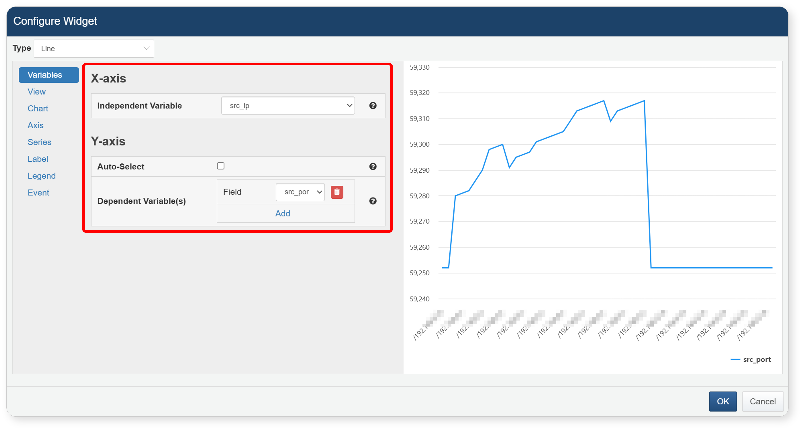
X-Axis – Independent Variable
Set the field to use as the independent variable, which is not affected by other variables.This variable serves as the baseline for the chart, and the dependent variables will be displayed relative to it.
Y-Axis – Auto-select Dependent Variables
To automatically set dependent variables, check the checkbox. All numeric fields (excluding reserved fields like _id, _table, _time, _era and the selected independent variable) will be automatically added as dependent variables. To manually set dependent variables, uncheck the box and add them manually.
Y-Axis – Dependent Variables
If Auto-select is not enabled, choose the numeric fields that vary according to the independent variable.Only numeric fields can be used as dependent variables.
Here are some examples of the available chart types. The following are examples of supported visualization chart types.
Available chart types include:
Line
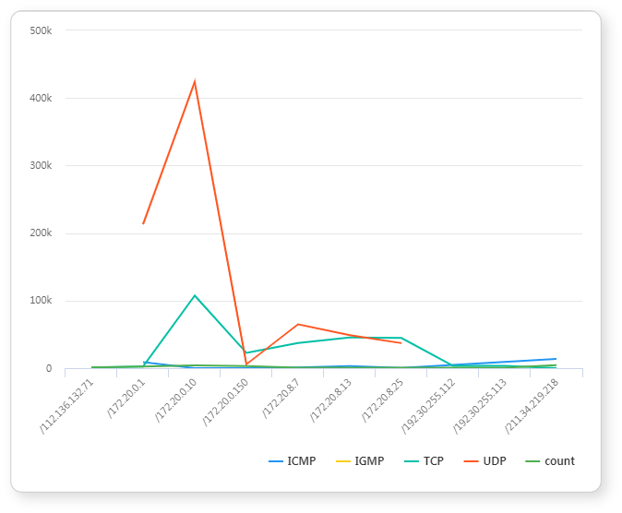
Spline
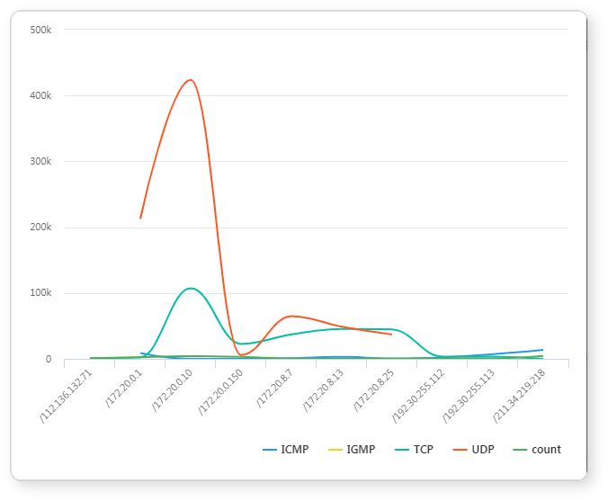
Area
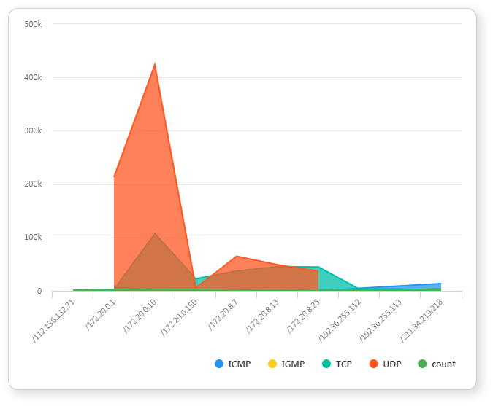
Stacked Area
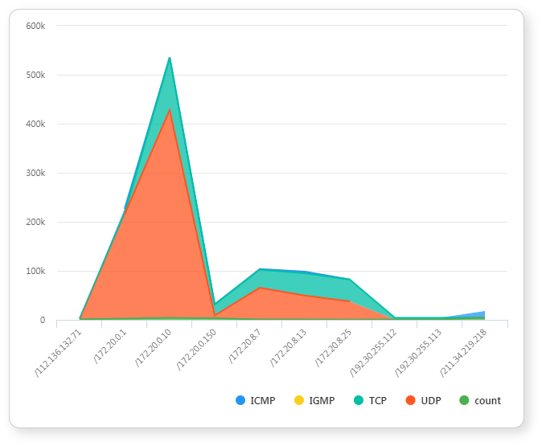
Area (Spline)
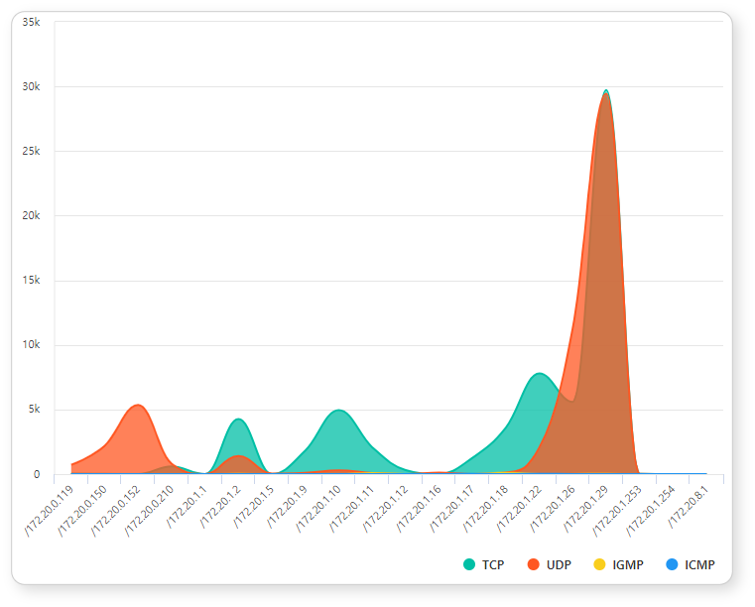
Stacked Area (Spline)
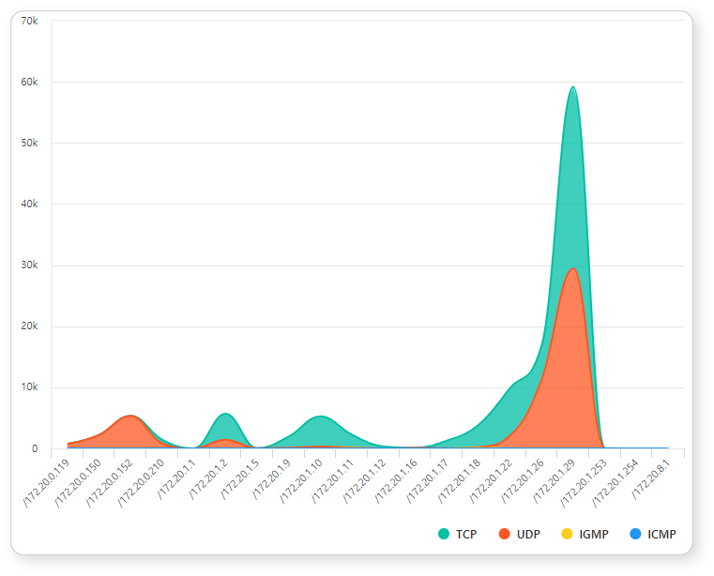
Bar
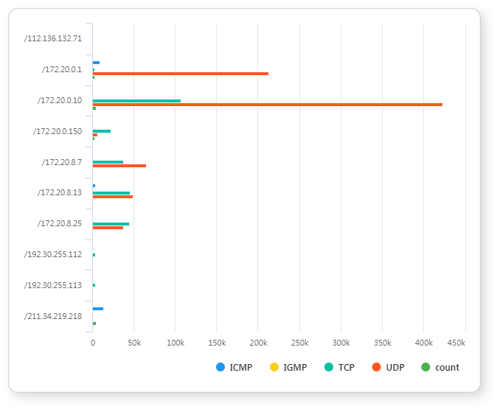
Stacked Bar
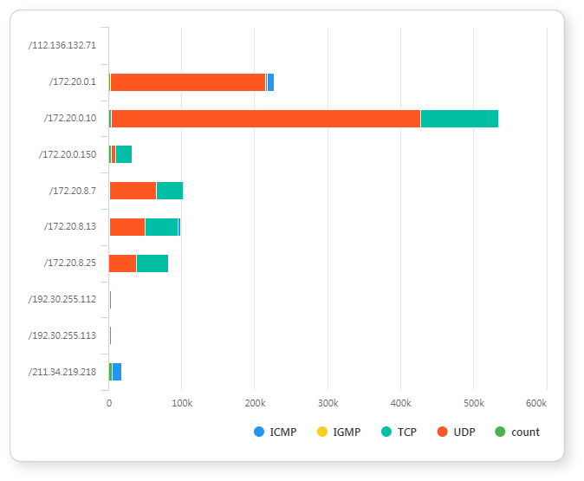
Column
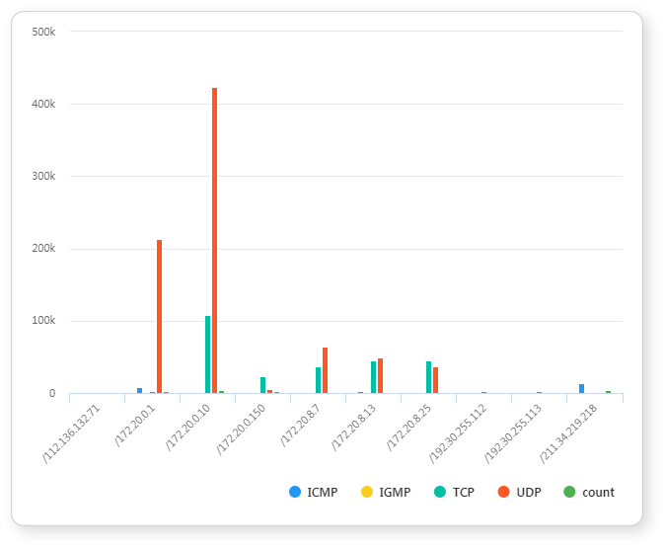
Stacked Column
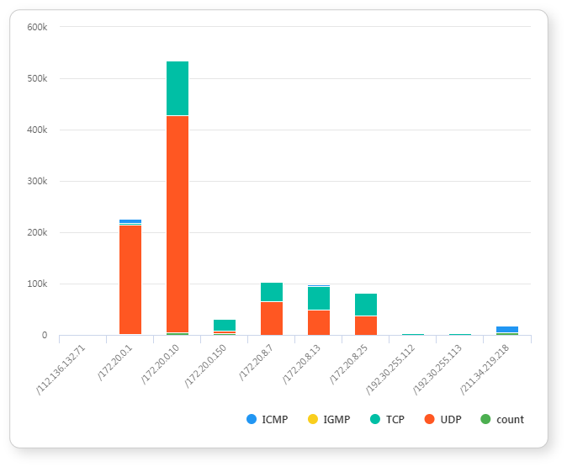
Scatter Plot
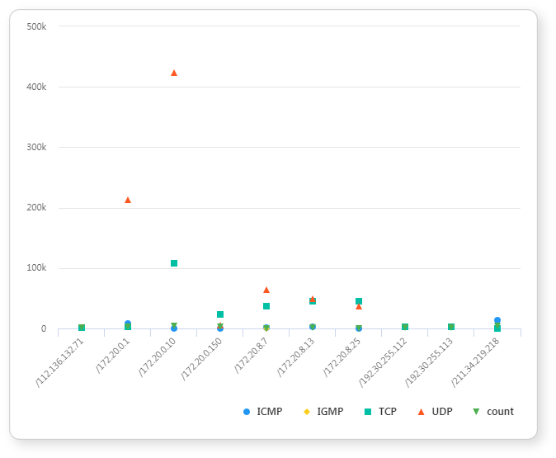
Pie
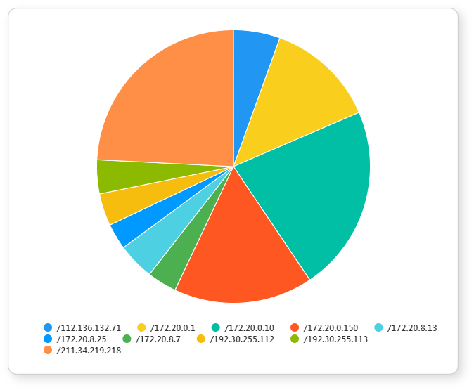
To configure chart display settings, click View
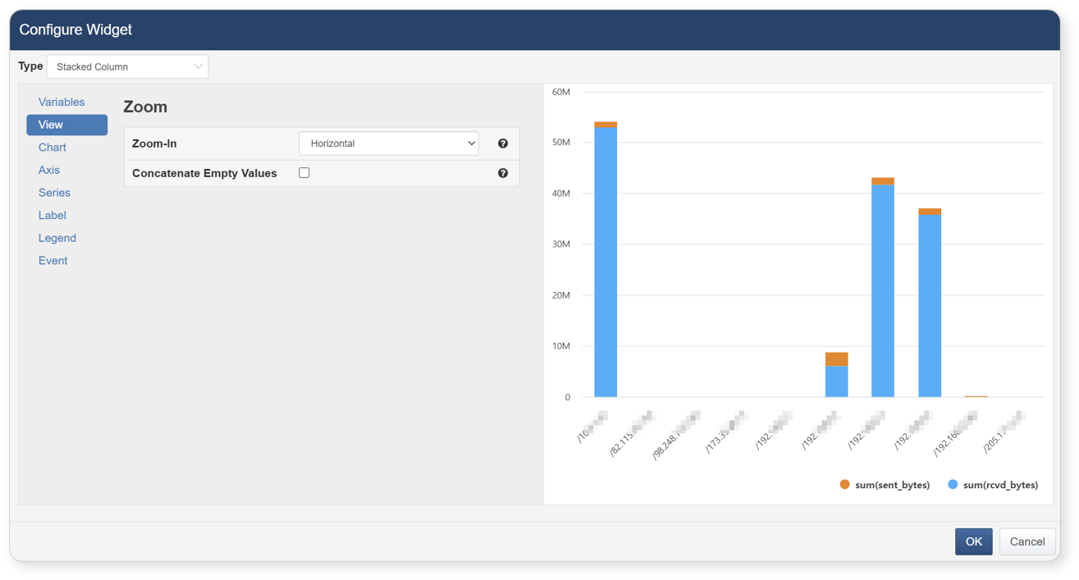
- Zoom DirectionSet the zoom direction to zoom in on a specific part of the chart by dragging. You can choose from horizontal, vertical, or selection zoom.
- Connect Missing ValuesFor line-type charts (line, area, stacked area), check this box to connect points even if a value is missing for a specific independent variable.
To set the chart title and appearance, click Chart Style
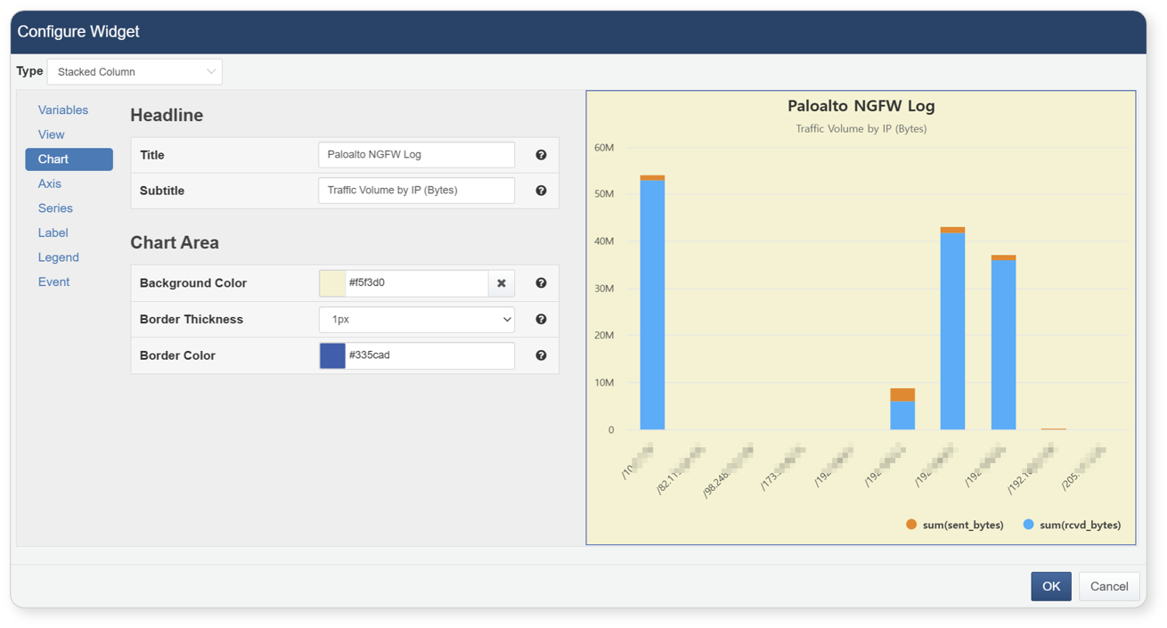
- TitleEnter the chart's main title to display it at the top.
- SubtitleEnter a subtitle to display under the main title.
- Background ColorSet the background color for the entire chart.
- Border ThicknessSet the border thickness to display a border around the entire chart area.
- Border ColorSet the border color if a border is applied to the chart.
To configure axis titles and types, click Axis Style
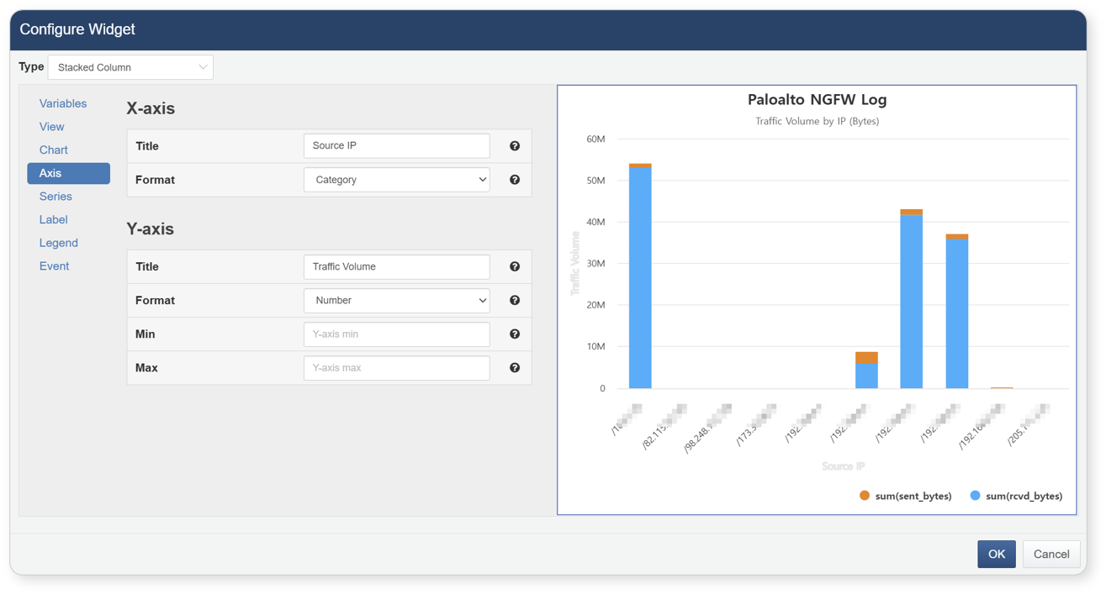
- The independent variable set in the Variable section is displayed on the X-axis, and the dependent variable on the Y-axis.
- TitleEnter titles for the X and Y axes.
- Display FormatThe axis types are automatically set based on the data types of the variables. To change the axis type, select a format from the dropdown:
- Number: Display as numeric values
- Log: Apply logarithmic scale
- Date: Display as date format
- Category: For strings such as IP addresses or text labels
Axis type changes may not be allowed depending on the variable type.
To set chart types and styles by series (dependent variable), click Series Style
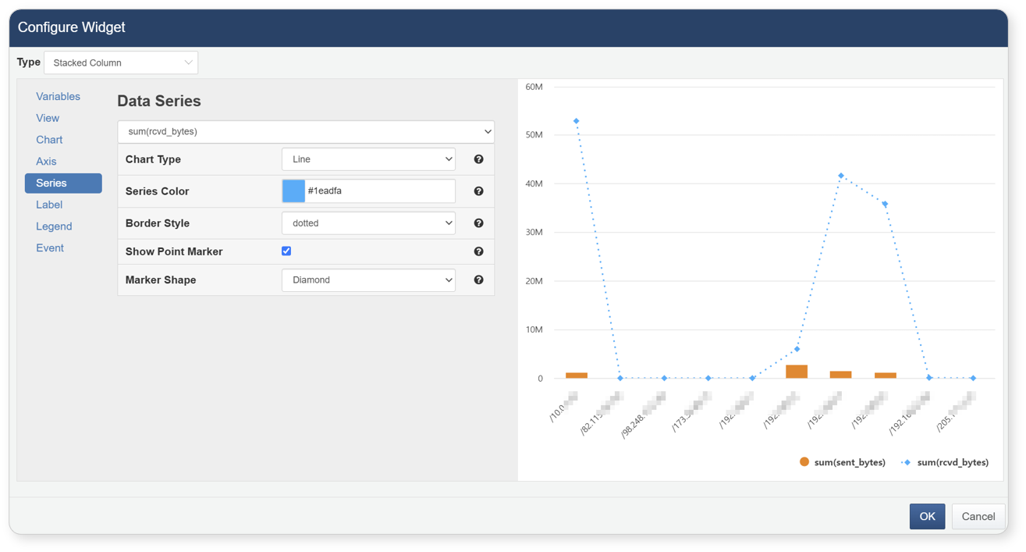
- SeriesSelect the dependent variable to configure from the dropdown list.
- Chart TypeSet the chart type for the selected series. If set to auto, it follows the chart type selected in the Type section.
- Series ColorSet the chart color for the selected series.
- Border StyleChoose a border style. This changes the line style for line/spline charts or the border for bar charts. (Not shown for scatter plots.)
- Show Point MarkerCheck this box to display markers for each data point.(Not applicable for bar charts.)
- Marker TypeIf point markers are enabled, select the marker shape: circle, square, diamond, triangle, or inverted triangle. When set to auto, the system assigns a non-conflicting shape automatically.
To display value labels on all series, click Label
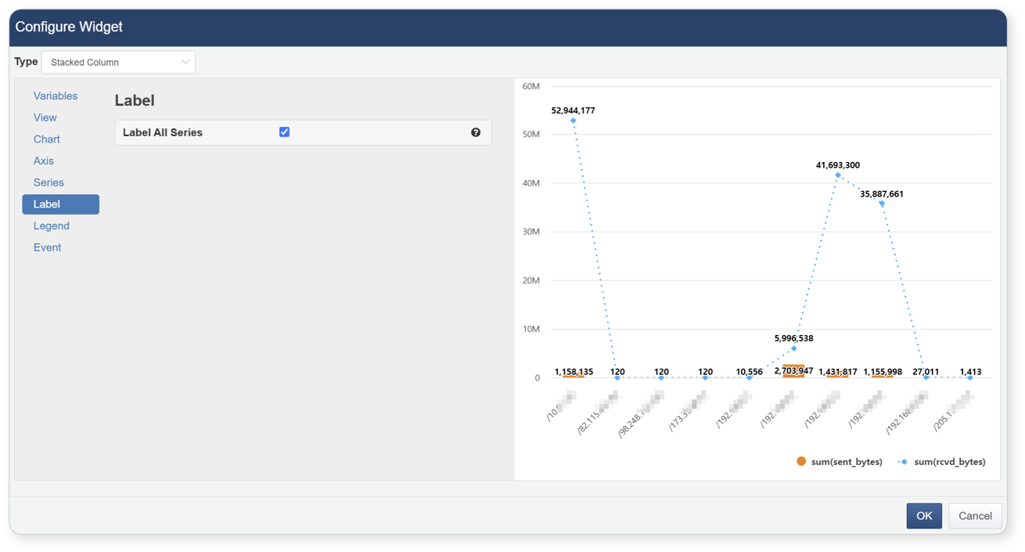
- Show Labels on All SeriesCheck this box to display value labels for all chart series.
To change the legend (dependent variable) properties, click Legend
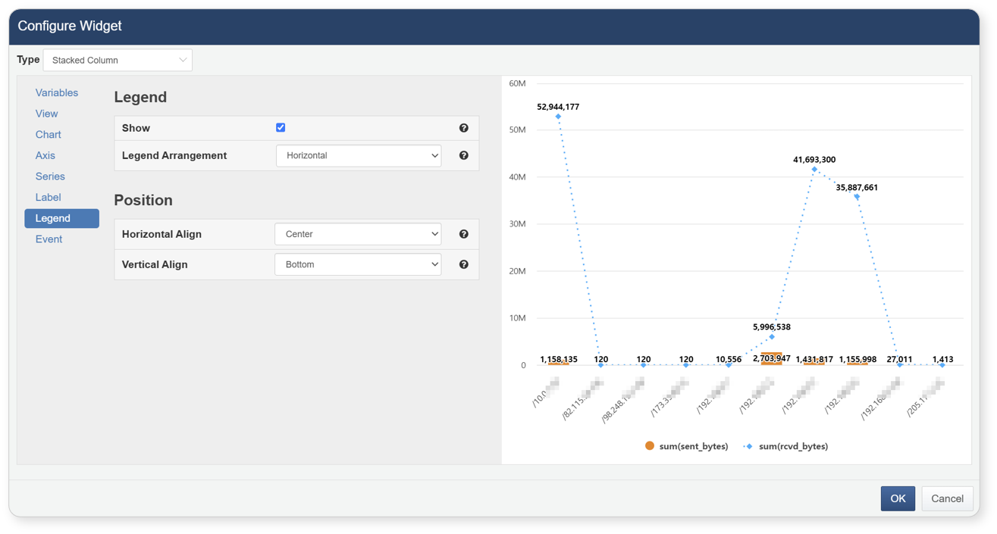
- DisplayCheck this box to display the legend on the chart.
- Item ArrangementChoose the arrangement direction for the legend items.
- Horizontal AlignSelect from left, center, or right alignment.
- Vertical AlignSelect from top, middle, or bottom alignment.
To define actions when clicking or dragging on the chart, click Event
- Drag events can only be set when a time field (e.g., collection time or log event time) is selected as the independent variable.
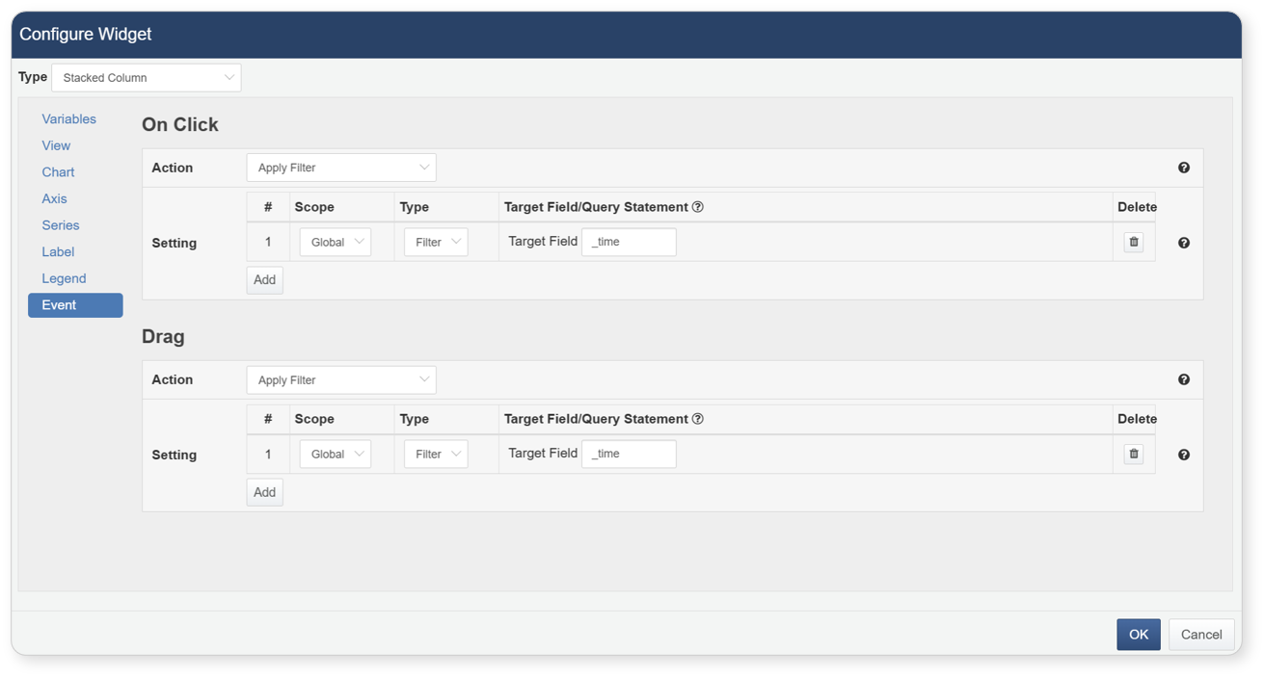
- Action Types
- Apply FilterWhen the user clicks or drags a value on the chart, a corresponding filter is automatically added to the global or dataset filter.Select Apply Filter, then set the scope, type, and target field/query. Click [Add] to add multiple filters (duplicates not allowed).Filters added will apply to all widgets or datasets upon the event trigger.
- Filter Options:
- Scope
- Global: Applies to all widgets in the dashboard.
- Dataset: (Only available for widgets using datasets) Applies to widgets using the same dataset.
- Type
- Filter: Filters data by matching field values.
- Query: Directly write queries to show values within certain ranges or matching conditions.
- Target Field/Query
- For Filter type: enter the target field name.
- For Query type: enter a custom query.
- For click events, use the field set as the independent variable.
- For drag events, use the time field or related query.
- Supported Macros:
- $x$: Value of the clicked field
- $xfield$: Name of the clicked field
- Setting the filter type and field automatically applies filtering when an event occurs.
Example global filters generated from click events:
* `search(field A == clicked value B)`
* If using a time field:
`search(datediff(timeField, date("clickedValue", "yyyy-MM-dd HH:mm:ss"), "sec") == 0)`
For drag events, only queries based on time fields are generated. Using other fields may result in incorrect behavior.
- DeleteClick Delete button to delete a filter.
- 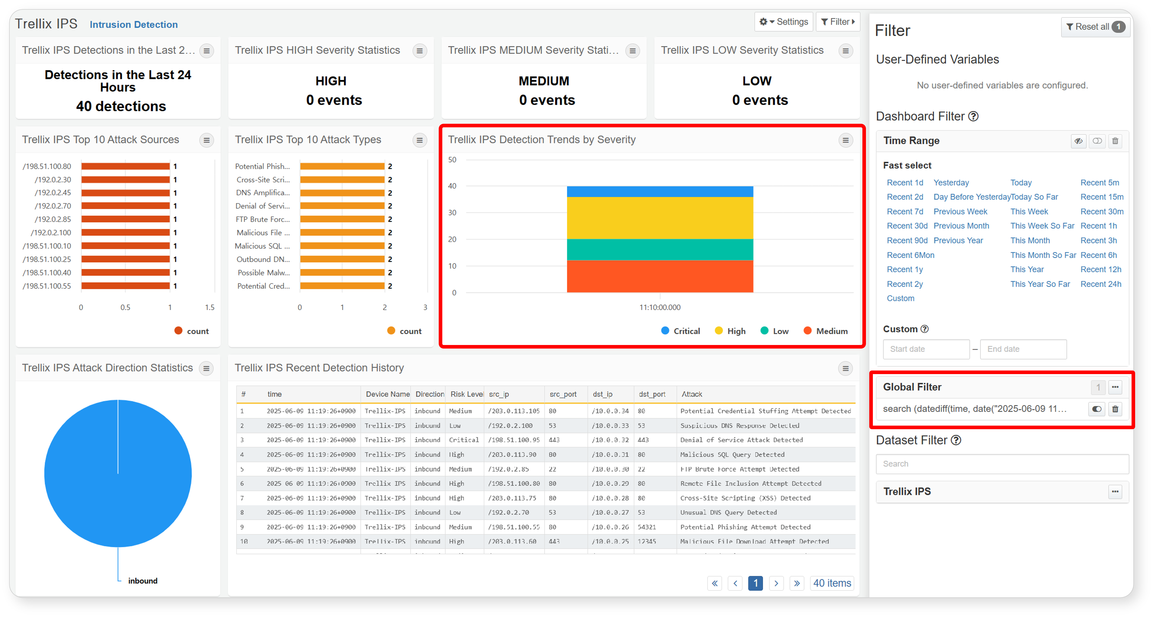
- Execute QueryRun a query using the clicked or dragged value and display results in a new window.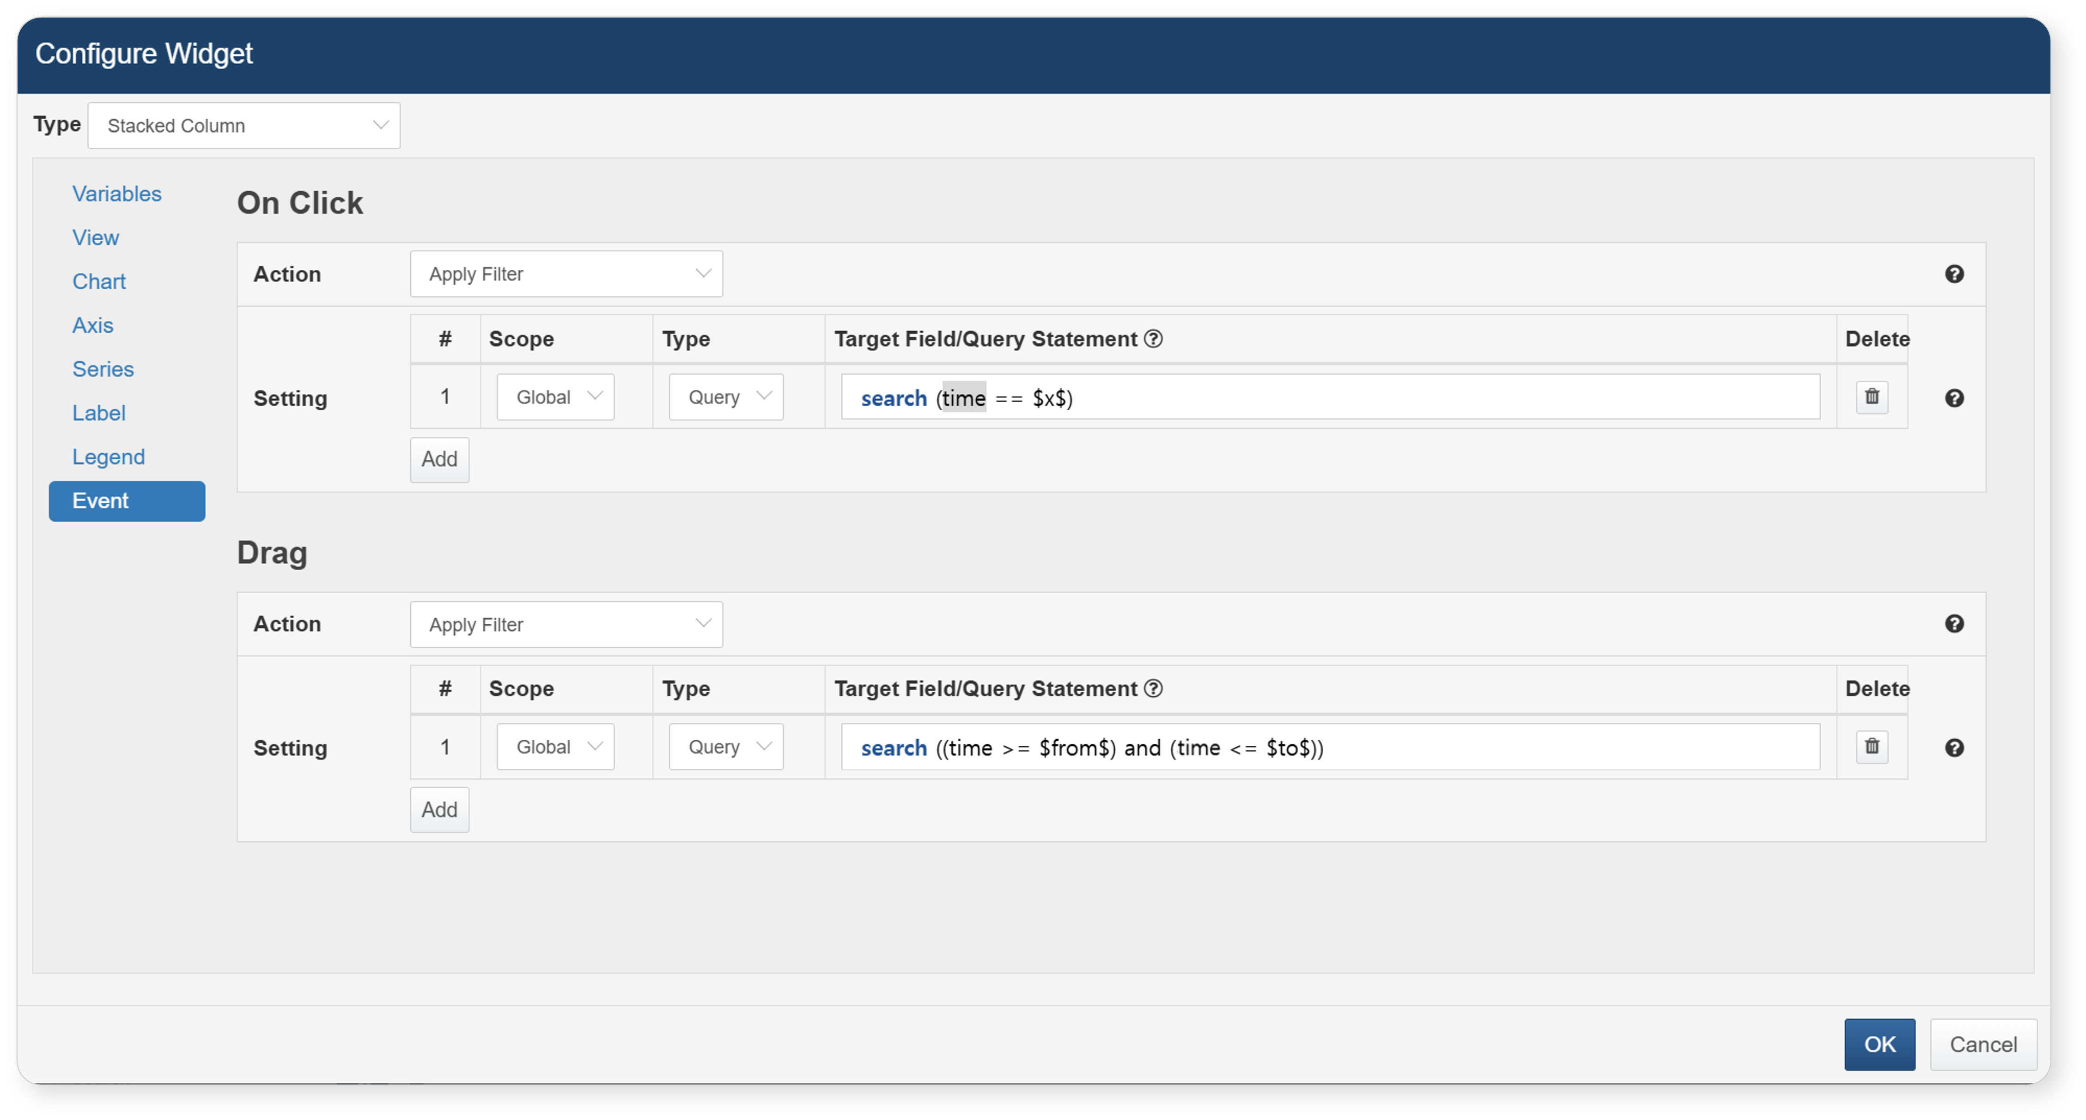
- Macros:
- Click event:
- $series$: Name of the series field
- $fieldName$: Value displayed in the field named fieldName
- Drag event:
- $xfield$: Name of the X field
- $from$: Start time of the drag
- $to$: End time of the drag
- Open Web Browser(Click events only) Open the URL in a new browser window based on the selected field.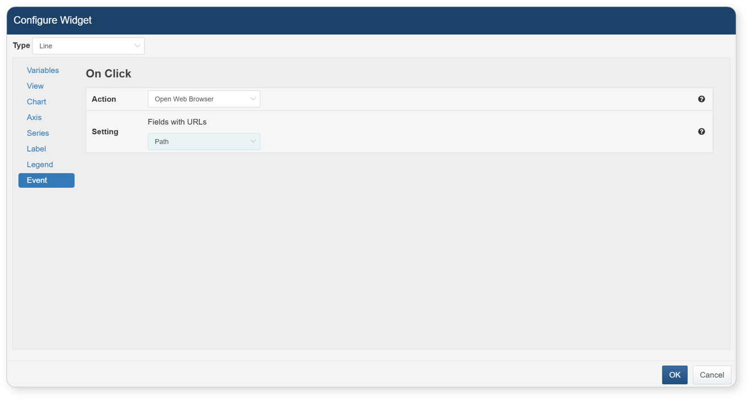
- Navigate to Page(Click events only) Navigate to a specified URL. Useful for linking to analysis, response, or policy-related pages.
- Supported Macros:
- $series$: Field name
- $fieldName$: Value displayed in the field named fieldName
To save the widget settings, click the [OK] button.
To finish editing, click the [Add] button at the bottom-left of the widget editor screen.
Share Query Widget
You can select accounts and groups to share the widget with all accounts within the selected group. If you grant edit permissions to shared accounts, they will be able to edit or delete the shared widget. After specifying the shared accounts, when saving the widget, the system will check the sharing status of the data source being used. If the shared accounts do not have permissions for the data source, a modal will appear to allow for bulk sharing of the data source.
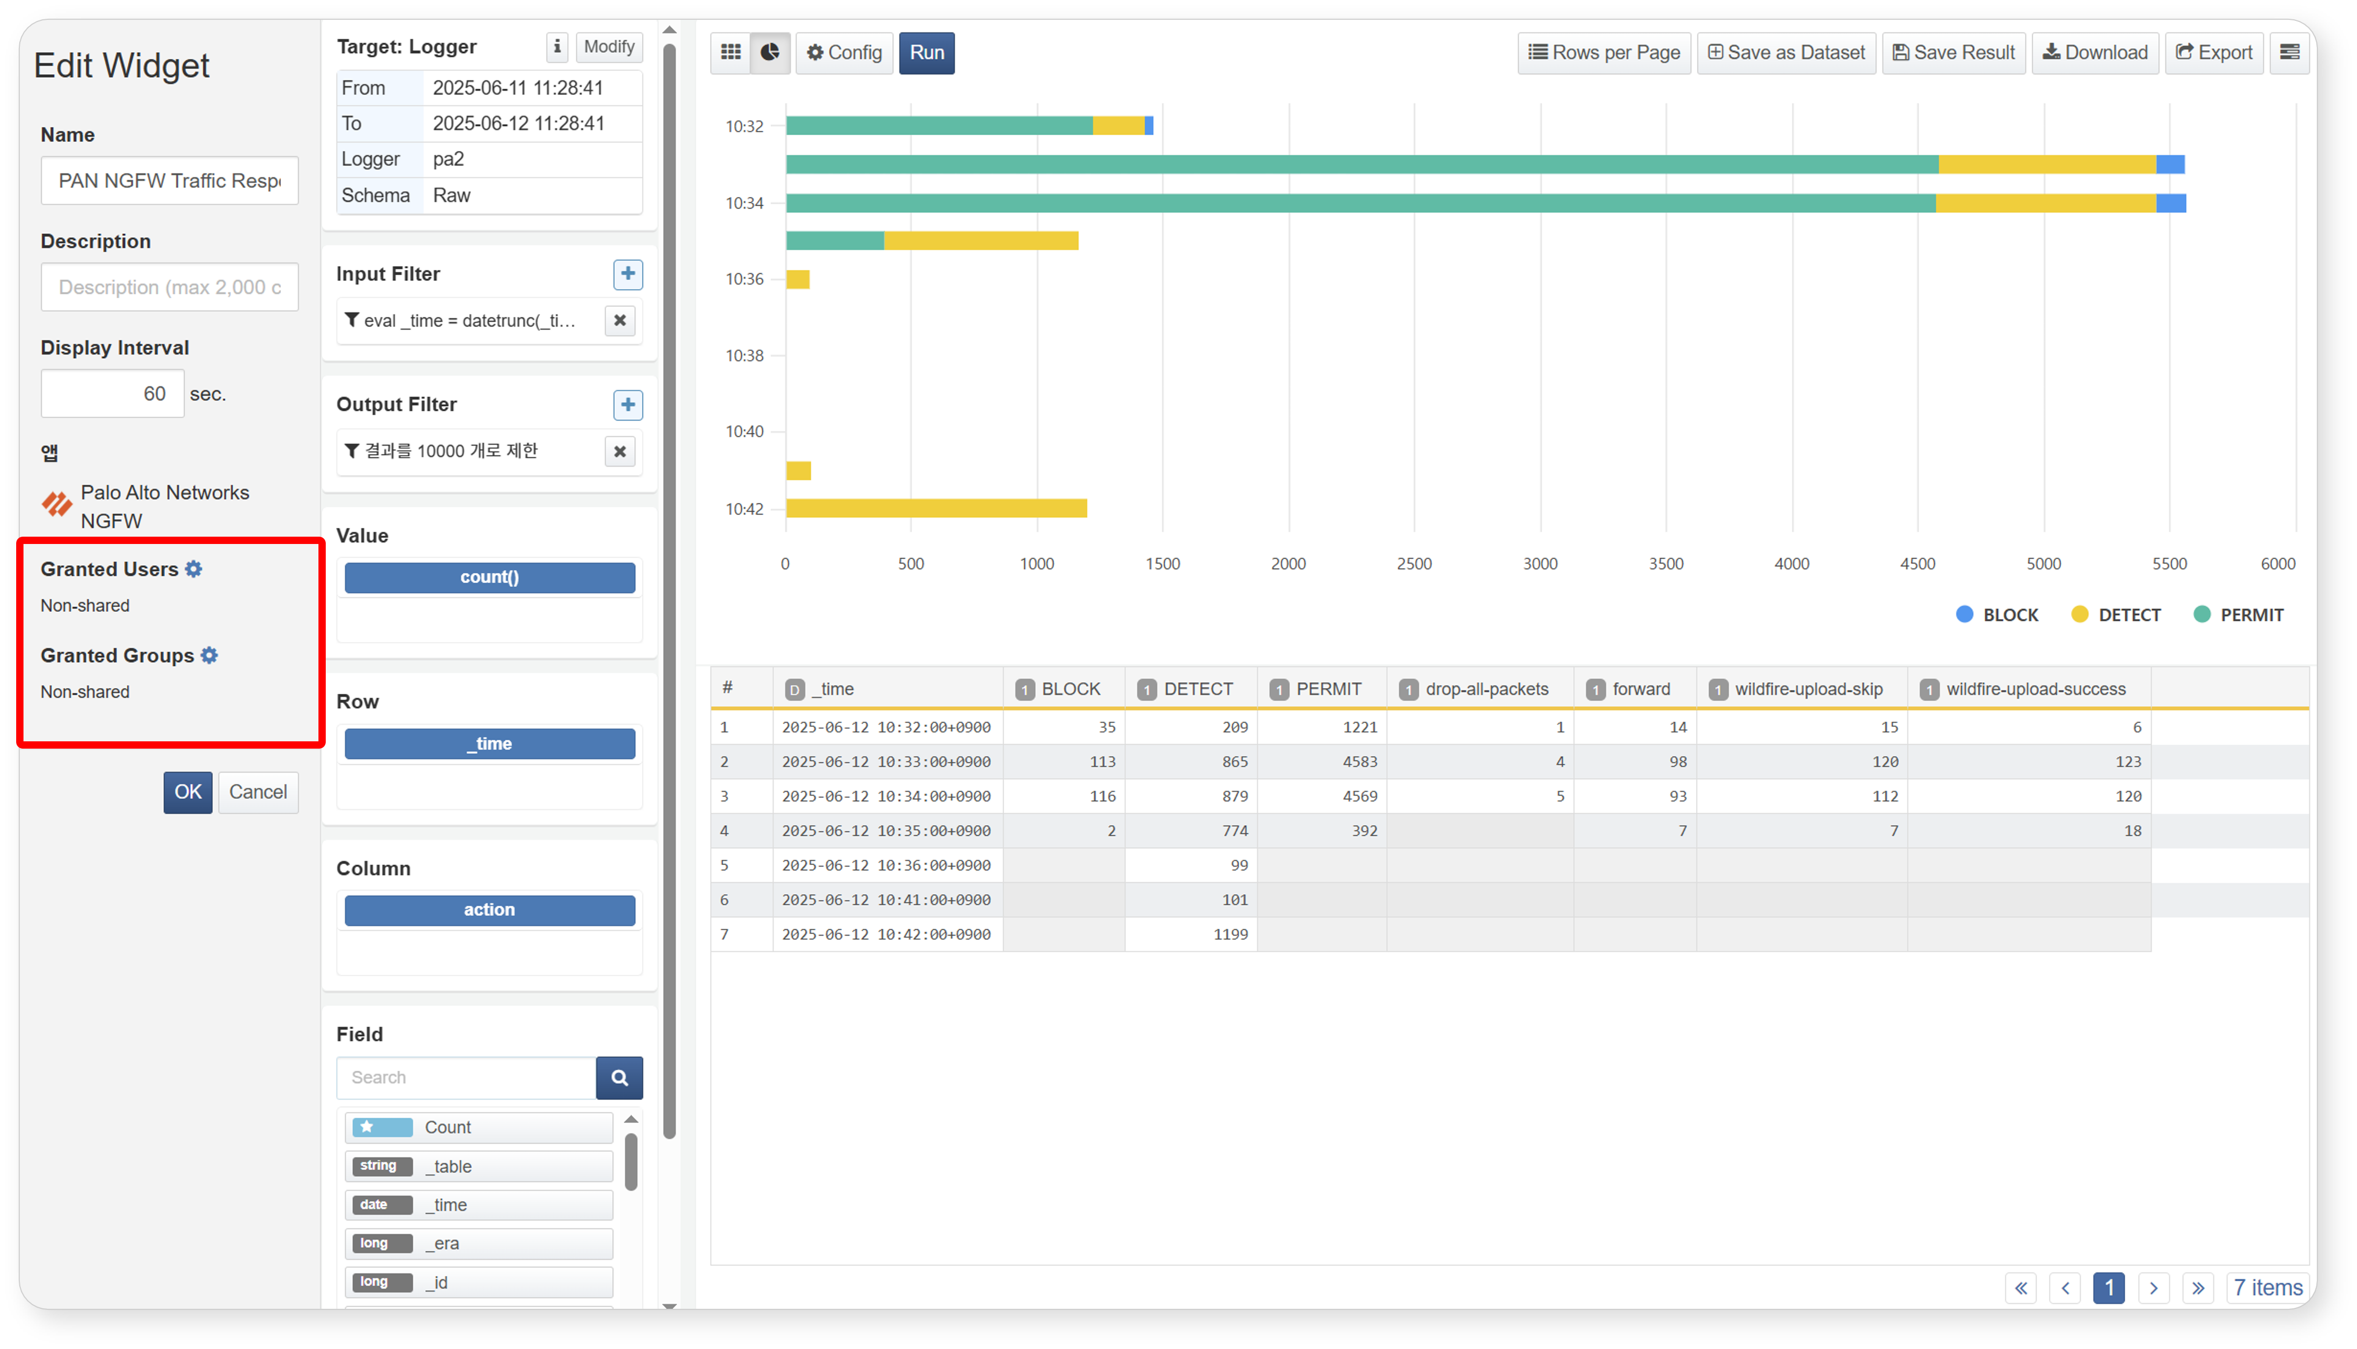
The method for sharing accounts is as follows. The method for sharing groups is the same as that for accounts and is therefore omitted.
Step 1
Select Shared Accounts
Click the gear icon next to account sharing to open the sharing modal and select the accounts you wish to share with.
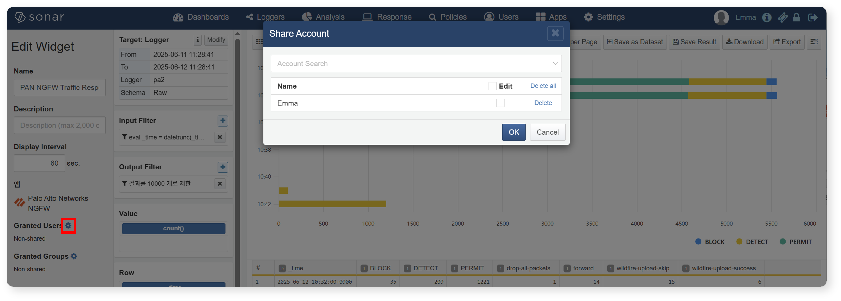
Step 2
Grant Edit Permissions to Shared Accounts
Check the checkbox next to the account you wish to grant edit permissions to. Users with edit permissions can edit or delete the widget, so this should be done with caution.
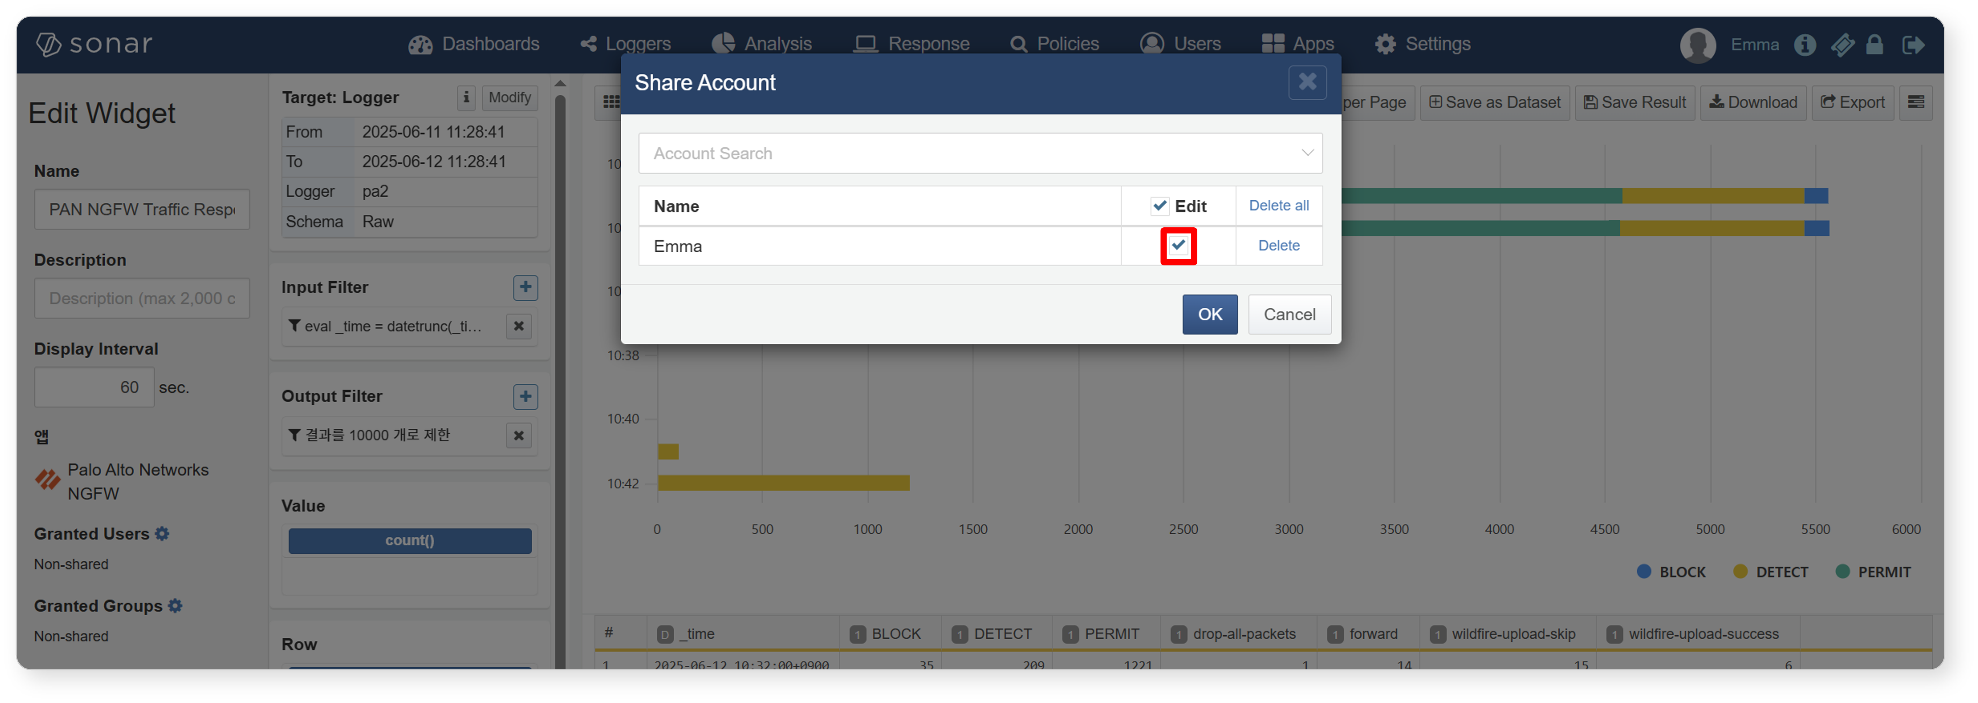
Step 3
Complete Account Sharing and Save Widget
After specifying the shared accounts and saving the widget, the system will check the sharing status of the data source being used in the widget. If the shared accounts only have access to the widget but not to the data source, the widget will not be displayed. Therefore, if the shared accounts do not have permissions for the data source, a modal will appear to allow for sharing of the data source as well.
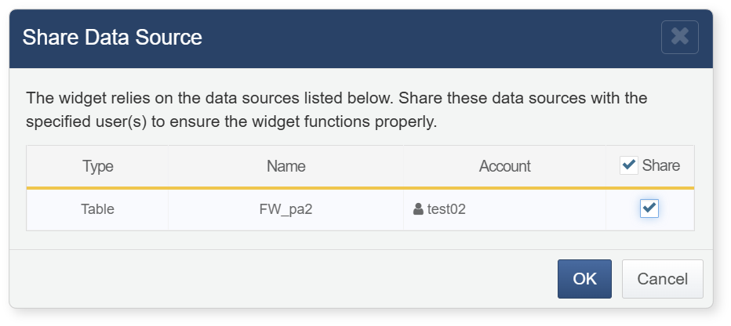
Create External Data Widget
Click the Add New Widget button from the list and select Create External Site Widget to open a popup window for creating an external site widget.
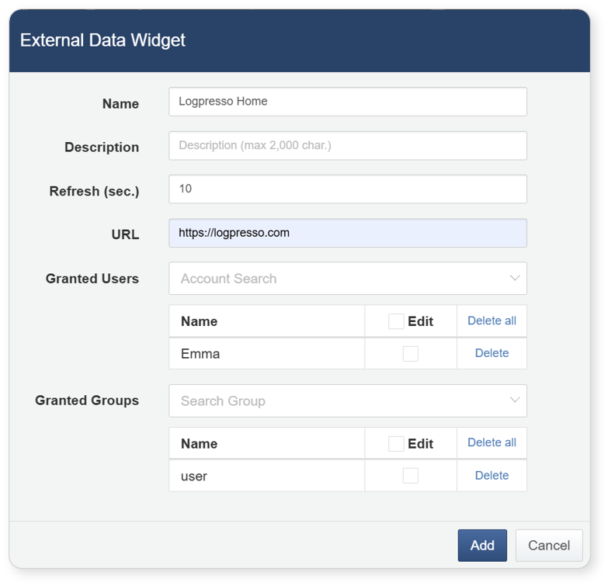
When creating an external site widget, the following fields must be filled out:
Name
Enter the name of the widget to be created.
Description
Enter a description for the widget.
Refresh Interval
Set the refresh interval. Entering '0' will disable the refresh.
Address
Enter the address of the external site to connect. Note that some sites may not display properly depending on the URL (e.g., Naver, Facebook, etc.).
Account Sharing
Select the accounts with which to share the widget. If edit permissions are granted to the account, users who receive the shared widget will be able to edit or delete it.
Group Sharing
Select the groups with which to share the widget. If edit permissions are granted to the group, users within the shared group will be able to edit or delete the widget.
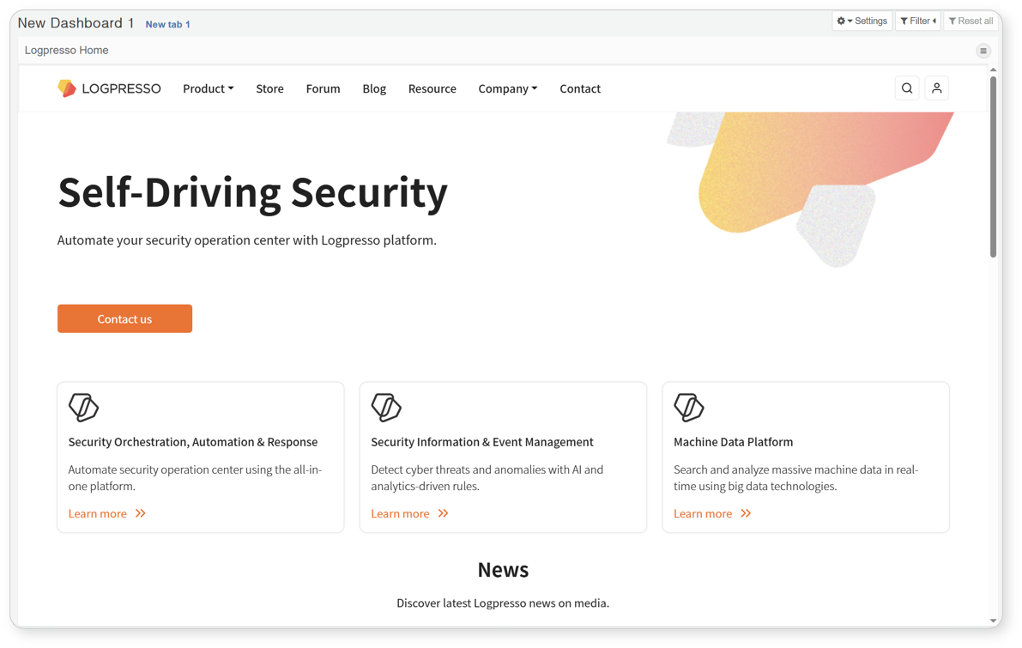
Create Control Widget
To create an input control widget, click the Add New Widget button from the list and select Create Input Control. A popup window will appear for creating the input control widget.
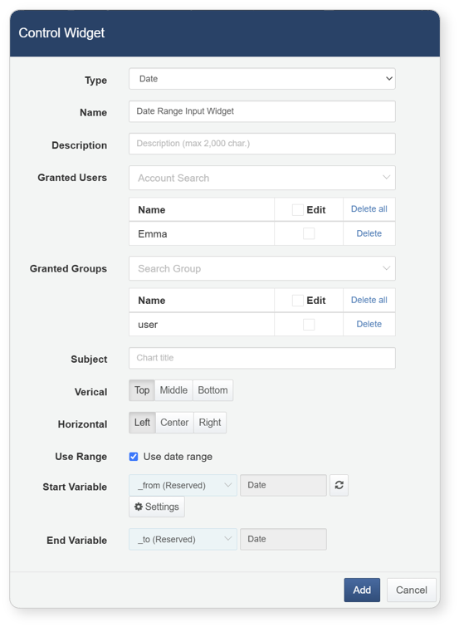
When creating an input control widget, the following items need to be filled out:
Type
Specify the type of the input control widget. You can choose from date, list, or text types.
Name
Enter the name of the input control widget.
Description
Enter a description for the input control widget.
Account Sharing
Select the accounts with which to share the widget. If edit permissions are granted to the accounts, users who receive the shared widget will be able to edit or delete it.
Group Sharing
Select the groups with which to share the widget. If edit permissions are granted to the group, users within the shared group will be able to edit or delete the widget.
Title
Enter the title of the input control widget as it will appear on the dashboard.
Vertical/Horizontal
Specify the vertical or horizontal position of the input field within the widget.
Use Range
This option is only set when creating a date type input control widget. Check this box if you want to use the date range as an input field.
Start Variable/End Variable/Query Parameter
The start variable and end variable are specified when creating a date type input control widget, while the query parameter is used when creating list or text type input control widgets. If there are no custom variables you wish to use, you can create them by clicking the management button.
Select Item List
This item is only set when creating a list type input control widget. Enter the items to be displayed in the list.
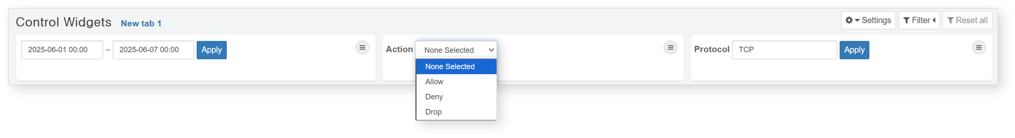

Edit Widget
To edit a widget, click on the title of the widget you wish to modify from the widget list. The layout of the editing screen is the same as that of the widget creation screen.
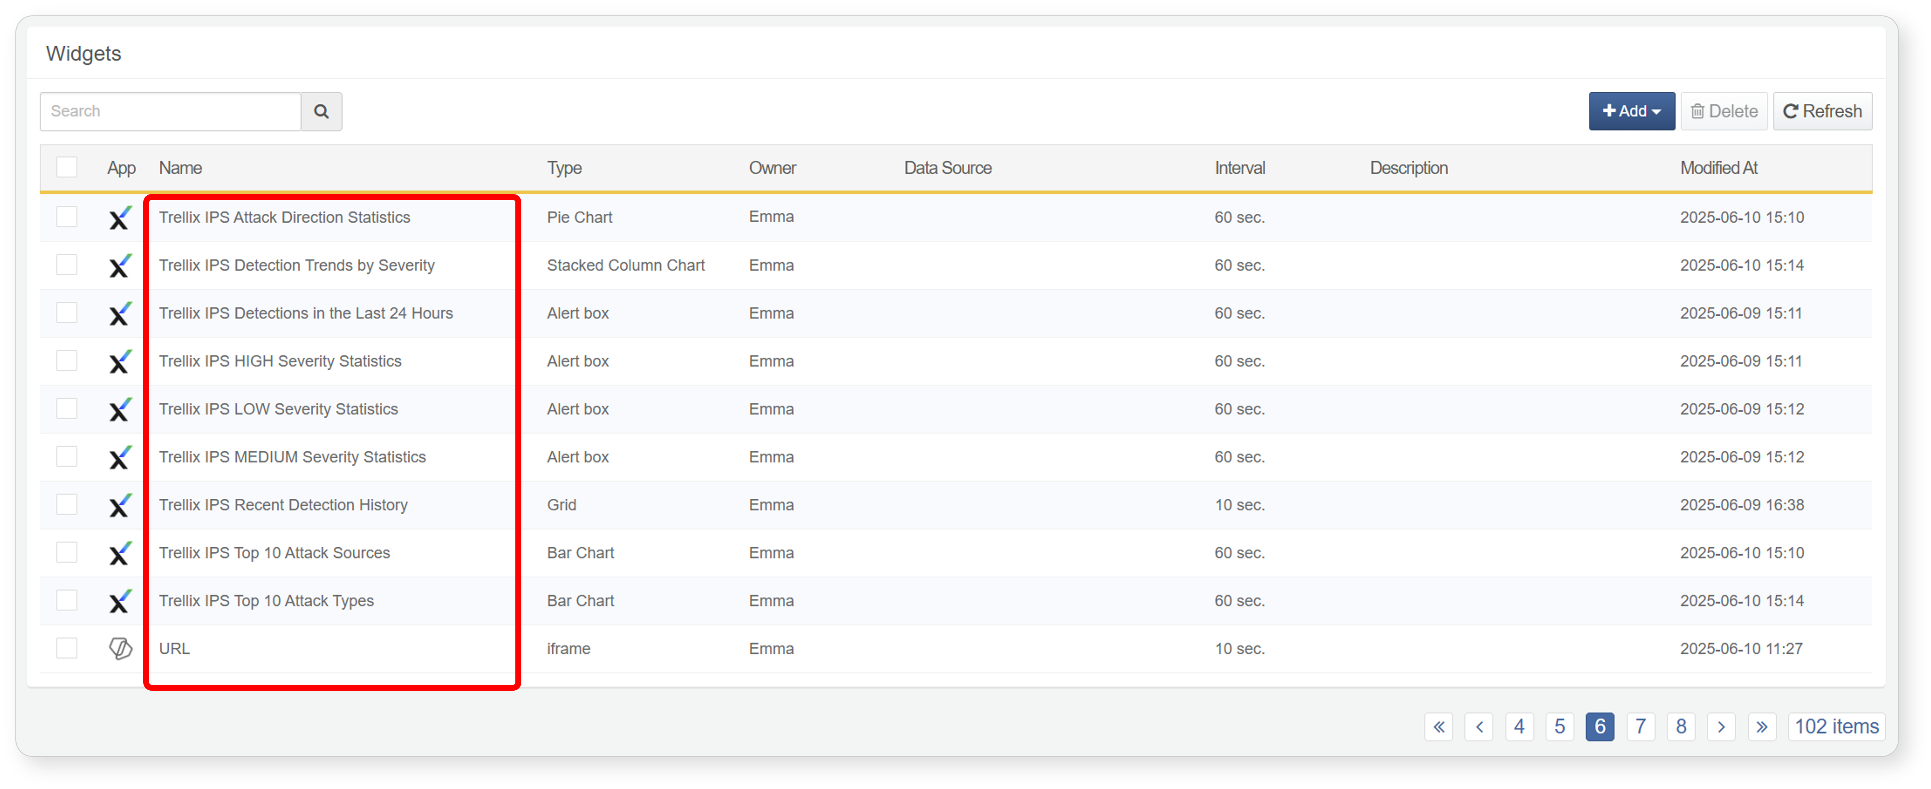

Delete Widget
To delete a widget, select the checkbox next to the desired widget in the widget list and click the Delete button. A confirmation dialog will appear to verify the deletion. Clicking the Delete button in the dialog will remove the selected widget. If a widget currently in use on the dashboard is deleted, the deleted widget will no longer display any information, necessitating a readjustment of the dashboard layout.
