#### Writing the Explanation

When an explanation is automatically requested by the detection policy, or when an explanation request is made from the ticket menu or directly added from the explanation menu, the subject of the explanation will receive an explanation request email at the email address registered in the employee database. The email format can be configured in the explanation template menu.

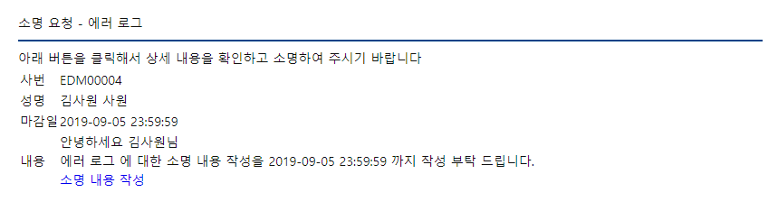

Clicking the link to write the explanation will open the explanation submission menu in a new window. Since a one-time login token is used, it is possible to write the explanation without a Logpresso Sonar account. After composing the content, click the Submit Explanation button to submit. Submissions cannot be made after the deadline.

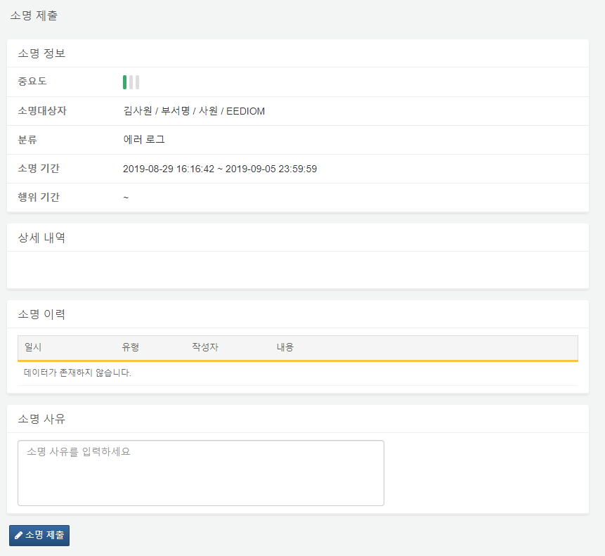

You can set the expiration period for the explanation token using the CLI command 'sonar.setGlobalOption explanation_token_expiry [expiration period in days]'. If the expiration period for the explanation token is set, you can write the explanation as long as the token has not expired, even if the explanation itself has expired after it was created.

Example of Explanation Token Expiration Period

* Explanation Creation Date: 2019-08-21 18:00:00
* Explanation Deadline: 2019-08-27 23:59:59
* Work Date: 2019-08-28 15:00:00
* Explanation Token Expiration Period: 10 days

From the perspective of the work date, the explanation deadline has passed, but since the expiration period for the explanation token is until 2019-08-31 18:00:00, it is still possible to write the explanation.