#### Storage

Overview

Storage is a part of the data lifecycle. For an overview of the data lifecycle, refer to [here](https://docs.logpresso.comnull).

In **Settings > Cluster > Storage**, you can connect to storage services such as AWS S3 and KakaoCloud Object Storage for the **Cold** tier, set rollover schedules and bandwidth limit, and configure maximum capacity for each storage tier.

Object Storage Profile

The **object storage profile** is a dedicated configuration used to connect to object storage services provided by AWS and KakaoCloud. You can set up the object storage profile either during Logpresso Sonar installation or later via the web console.

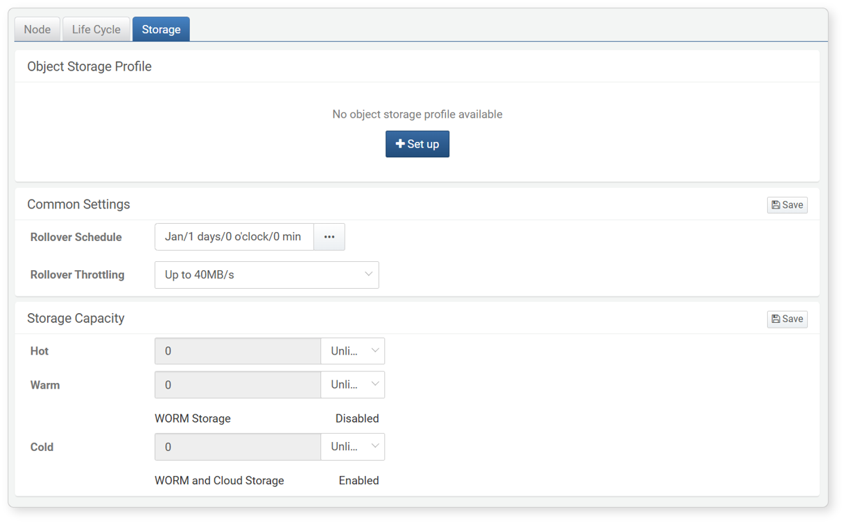

Once configured, the object storage settings cannot be changed. Please pre-configure the object storage environment that Logpresso Sonar will connect to and verify the necessary information.

Web Installer

During the Logpresso Sonar installation, you can configure AWS S3 or Kakao Object Storage in the object storage setup step.

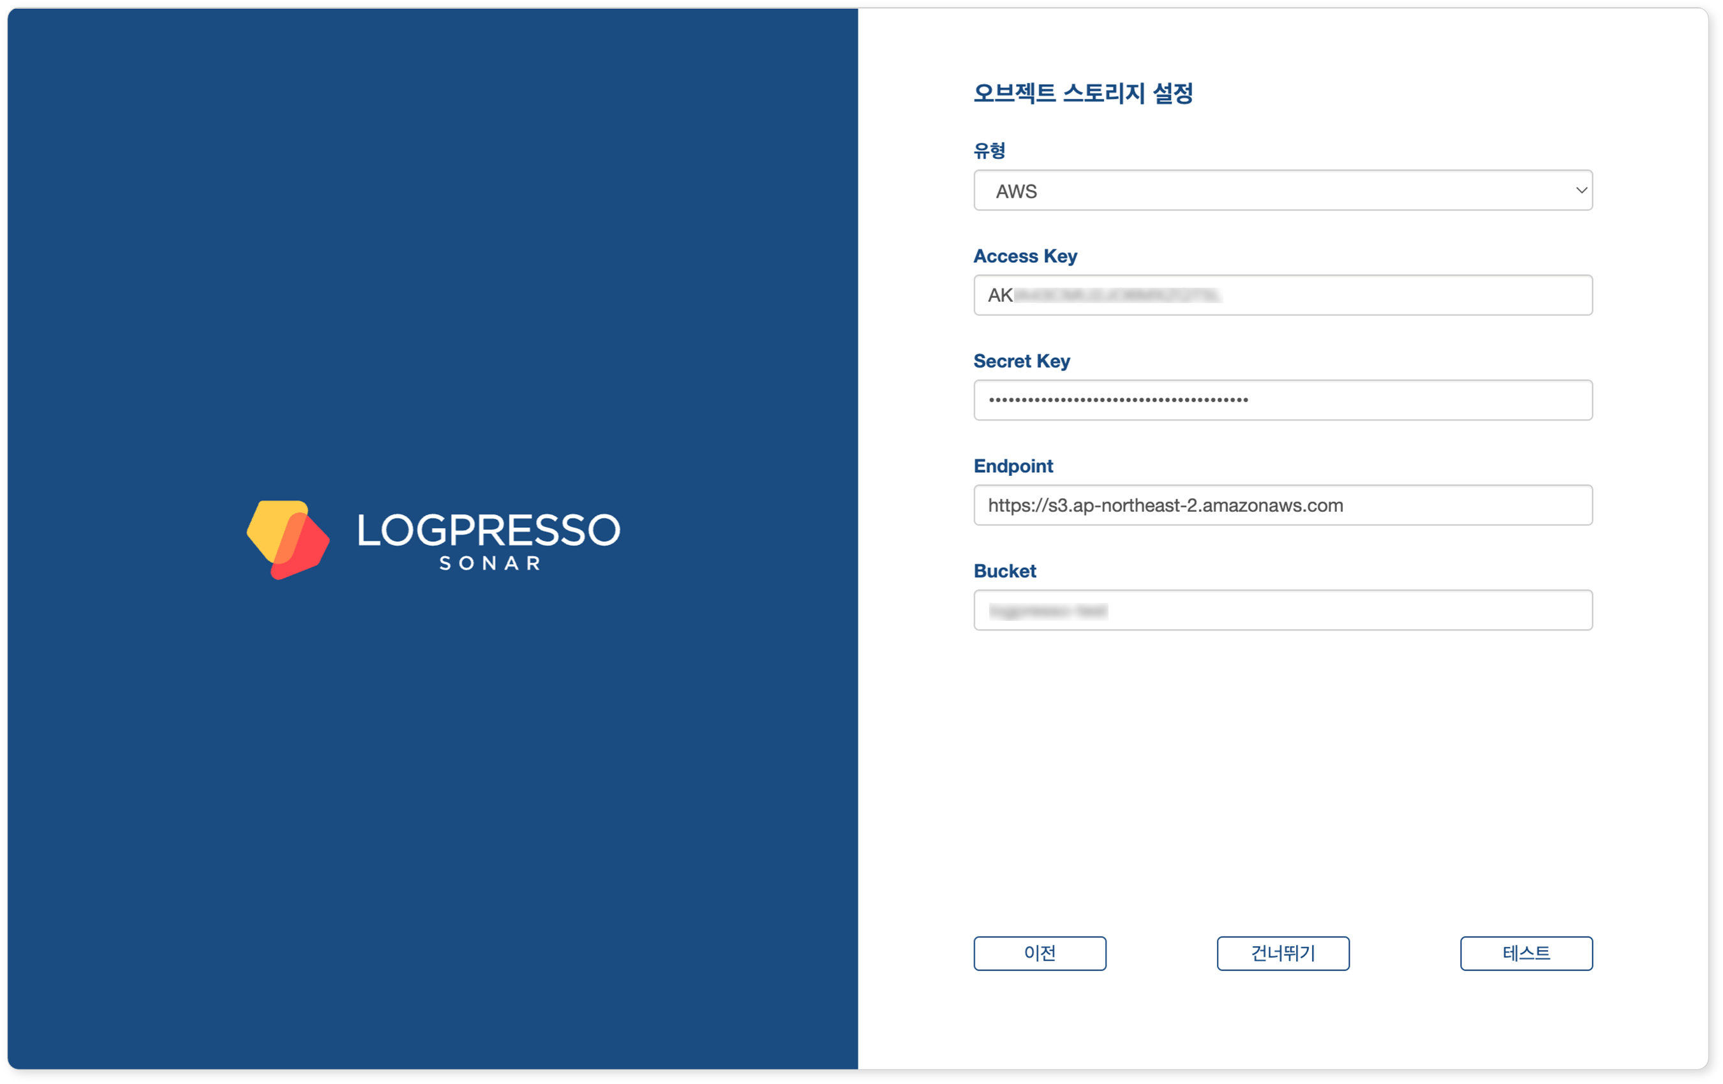

* To skip the object storage setup, click **Skip**.
* To verify if the object storage settings are correct, click **Test**.

Web Console

To set up object storage profile in the web console:

Click **Settings** in **Settings > Cluster > Storage**.

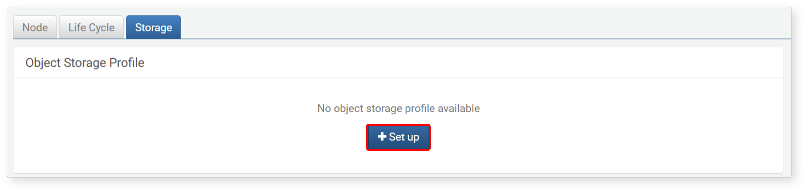

Enter the required information for the object storage connection in the **Object Storage Profile** and click **Test**.

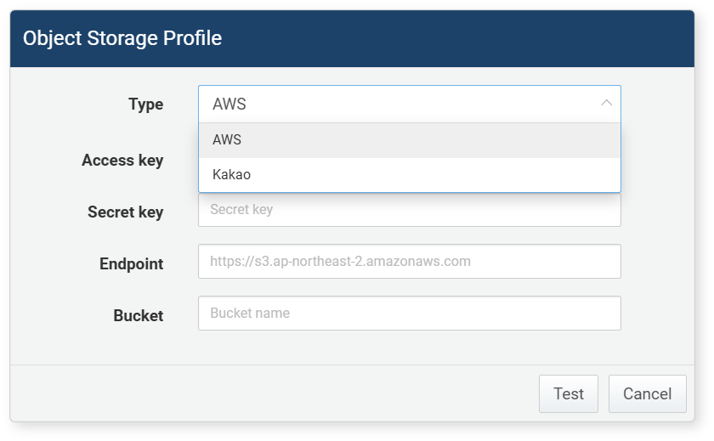

* **Type**: Storage service provider (choose between **AWS** and **Kakao**; default: **AWS**)
* **AWS**: AWS S3
* **Kakao**: KakaoCloud Object Storage
* **Access Key**: Access key for connecting to the storage service
* **Secret Key**: Secret access key for connecting to the storage service
* **Endpoint**: Access address for the storage service
* **Bucket**: Name of the storage bucket
* **User ID**: (when **Type** is **Kakao**) User unique ID that can be found in KakaoCloud Console > User Profile > Account Information
* **Project ID**: (when **Type** is **Kakao**) ID of the KakaoCloud project

If the test result indicates a successful connection to the storage, click **Confirm**.

If the connection to the storage is unsuccessful, check the cause and take corrective action before clicking **Test** again.

* Verify the network connection between the Logpresso Sonar node and the storage service.
* Ensure that the object storage being used is configured correctly.
* Confirm that the object storage connection information, such as the access key and secret access key, is entered correctly.

Common Settings (Rollover Settings)

In the **Rollover Settings**, you can configure the rollover execution schedule and the bandwidth limit to be applied during the rollover. After making changes, click **Save**. If you do not click **Save**, the changes will be lost.

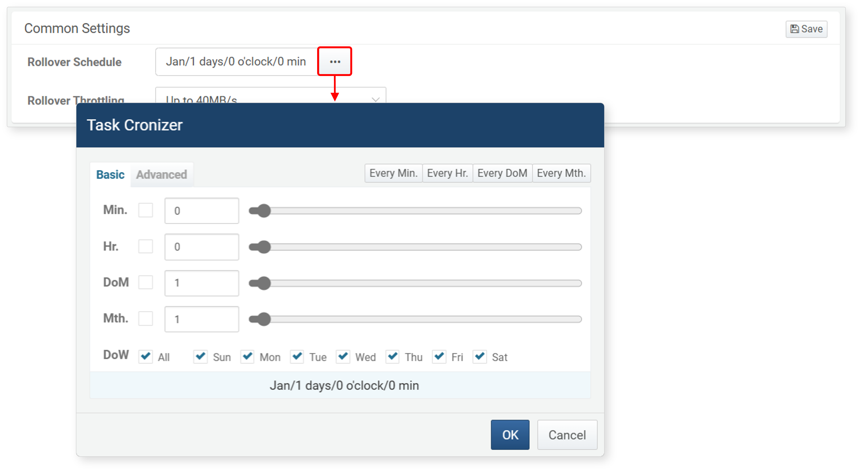

* **Rollover Schedule**: The schedule for executing the rollover. Click "**…**" and specify the execution time according to [CRON syntax](https://www.man7.org/linux/man-pages/man5/crontab.5.html) in the **Task Cronizer** (default: unspecified).
* **Rollover Throttling**: The file transfer speed to be applied during the rollover (choose from **No Throttling**, **Max 320MB/s**, **Max 100MB/s**, **Max 40MB/s**, **Max 16MB/s**; default: **Max 40MB/s**).

It is recommended to schedule the execution during late-night hours when business activities are minimal. Initially, increase the bandwidth limit after introducing the data lifecycle. Once the data is appropriately distributed across the storage tiers, you can reduce the bandwidth limit back to the default level.

Maximum Storage Capacity

The maximum storage capacity is specified for each storage tier. For **Hot** and **Warm** tier storage, it is based on the local storage capacity of each node, while for **Cold** tier storage, it is calculated based on the data volume stored at the specified URI. After making changes, click **Save**. If you do not click **Save**, the changes will be lost.

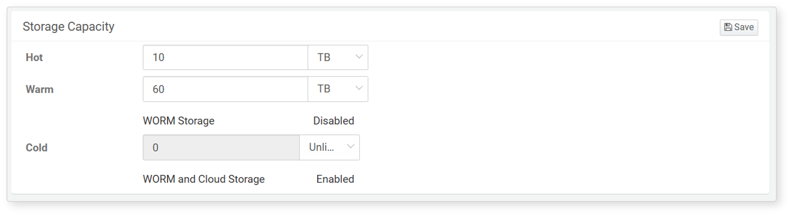

* Specify the capacity for **Hot**, **Warm**, and **Cold** tiers and click **Save**.
* The maximum capacity can be specified in **MB**, **GB**, or **TB**, or you can select **Unlimited**.
* When the maximum capacity is set to **Unlimited**, data will not be deleted even if it exceeds the maximum storage capacity.
* If the storage device mounted in the **Warm** or **Cold** tier is WORM or cloud storage, it can be verified below the maximum capacity.

This setting only displays tiers that have a defined lifecycle. If no lifecycle is defined, the maximum storage capacity settings will not be visible.