Table Data Type

Execute pivot operations on data stored in tables.

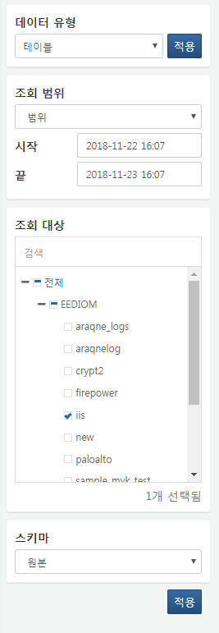

**Query Range**

Set the time range for the data to be queried. When selecting a fixed time range, data within that range will be retrieved. When selecting a duration, data collected within a specific period from the current point in time will be retrieved. Selecting "All" will retrieve data from all periods.

**Query Target**

Select the table to query from the tree.

**Schema**

Choose the schema to apply to the queried data. Since tables do not have separate schema information, any schema type can be selected. When selecting a schema that is not the original schema, the field names will change according to the selected schema, and only the fields used in that schema will be retrieved.

**Field List**

Select the list of fields to be queried.