#### Ticket List

The ticket screen displays the list of tickets. At the top, a trend graph shows the ticket processing status by date. Below, there is a ticket search box and the ticket list.

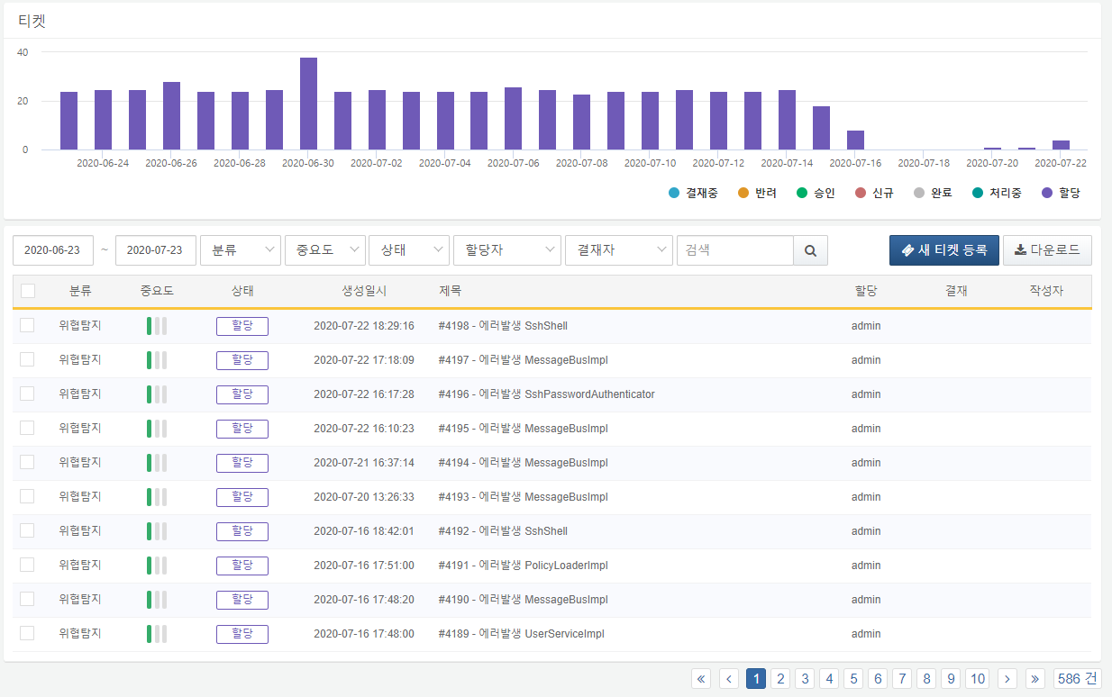

By clicking on the labels in the ticket trend graph at the top of the ticket screen, users can toggle the display of the corresponding status graphs. In the example below, only the statuses of "Pending Approval," "Rejected," and "In Process" are shown, while the other statuses are hidden.

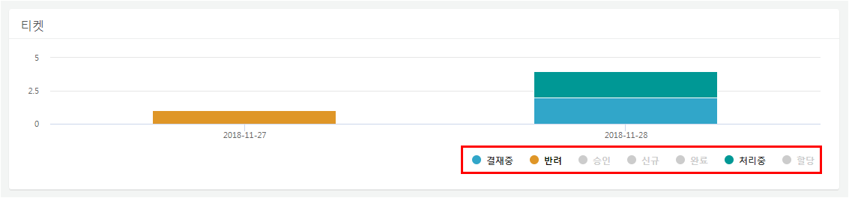

Users can execute searches by entering filter criteria such as date range, priority, status, assignee, approver, and keywords in the search tool at the top of the ticket list. The search results will also be reflected in the ticket trend chart.

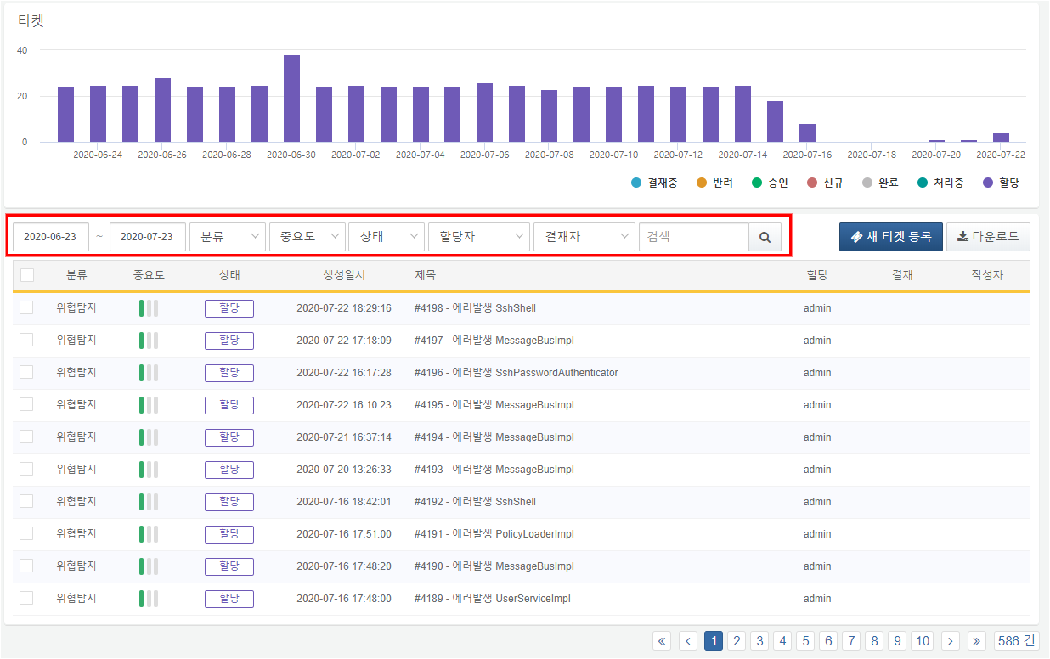

By clicking the Download button, users can download the ticket list in various file formats including CSV, Excel XML, MS Word, HTML, and JSON.

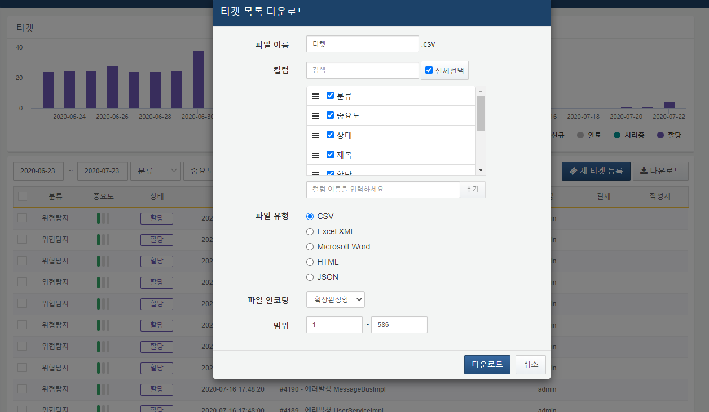

**File Name**

Enter the name for the file to be saved.

**Column Search**

Search for the desired column name in the list of columns to be saved.

**Column List**

Select the columns to be included in the saved file.

**File Type**

Choose the file format type.

**File Encoding**

Select the file encoding.

**Range**

Select the range of tickets to be saved. The first ticket at the top of page 1 is considered as number 1.

Using the checkboxes on the left side of the list, users can perform bulk actions such as deletion, reassignment, approval changes, and status updates on selected tickets.

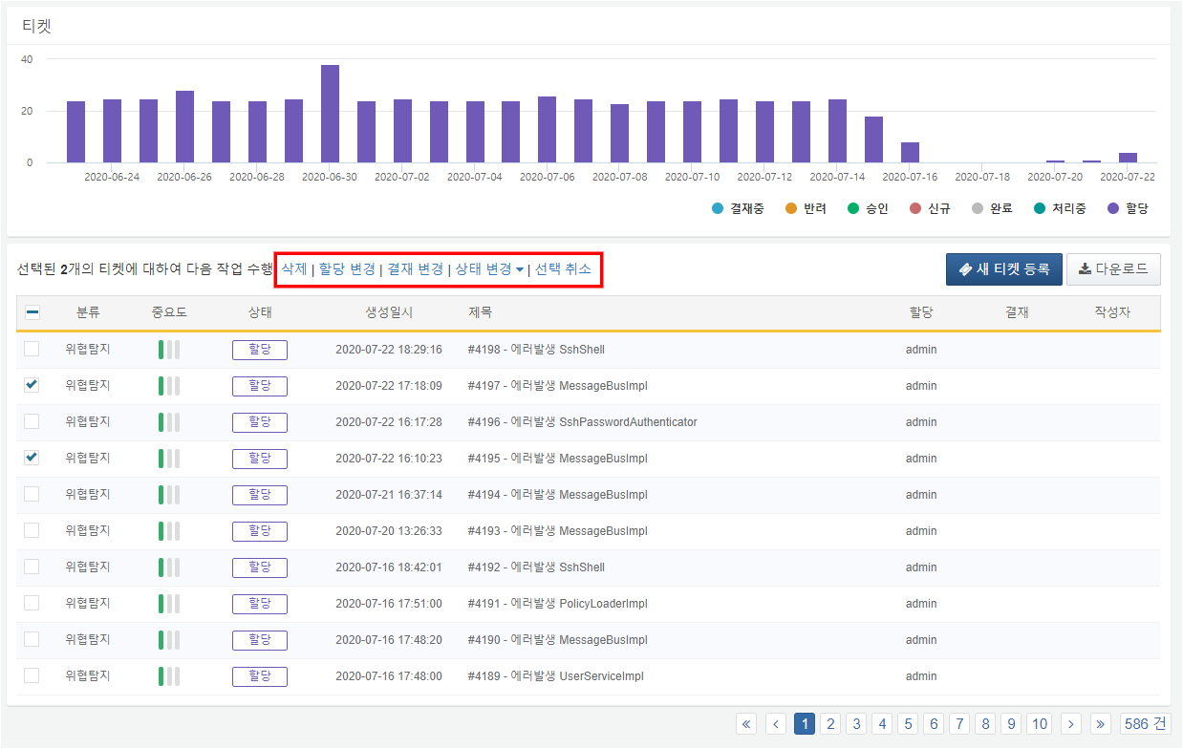

**Delete**

Deletes the selected tickets.

**Reassignment**

Bulk changes the assignee of the selected tickets.

**Approval Change**

Bulk changes the approver of the selected tickets.

**Status Change**

Bulk changes the status of the selected tickets. The status can be changed to "Rework" or "Completed." When changed to "Rework," the ticket status is updated to "New," and when changed to "Completed," the ticket status is updated to "Completed."

**Deselect**

Deselects the selected tickets.