#### Ticket Operations

The assignee must perform the ticket response tasks on the monitored system, record their actions in the ticket, and update the status whenever there is a change in the progress of the work.

If the assignee and approver have not yet been assigned, the Logpresso Sonar administrator will assign them. To assign or approve, click the edit button in the assignment or approval menu, enter the names of the assignee/approver, and then click the Edit button to confirm the assignment.

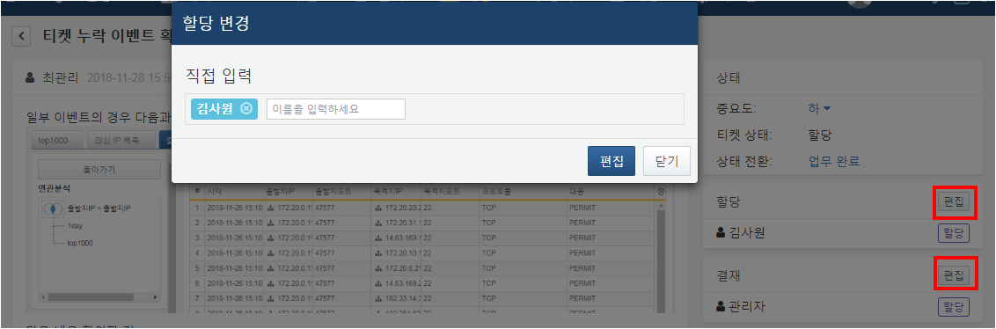

Response logs can be recorded using the "Add Response Log" menu located at the bottom left (highlighted in red). Similar to the ticket body, response logs can be documented using attachments and Markdown syntax. The response logs can be viewed alongside the ticket content.

The ticket status can be changed using the status menu located at the top right of the screen (highlighted in green). The displayed menu options will vary based on your role and the current ticket status. Currently, the ticket assignee account is viewing tickets in the assigned state and can change the ticket status to "In Progress" or "Completed."

All tickets can be changed to "Completed" status regardless of their current state. For tickets that do not require going through the response and approval process, you can directly change the status to "Completed" by clicking **Complete Work** in the status transition menu. Conversely, for tickets that are in "Completed" status, you can revert them to "New/Assigned" status by clicking **Rework**. For more information on status transitions, please refer to the ticket process.

