#### Ticket Repositories List

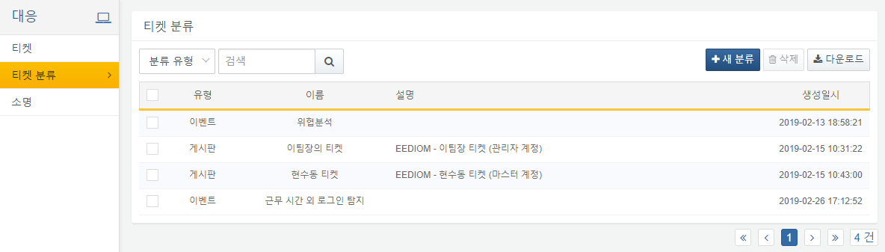

Each item in the list includes the following:

**Type**

Displays the type of ticket classification. Ticket classifications are divided into events and boards.

**Name**

Displays the name of the ticket classification.

**Description**

Displays the description of the ticket classification.

**Creation Timestamp**

Displays the creation timestamp of the ticket classification.

Users can search by classification type, name, or description keywords using the search tool at the top of the list.

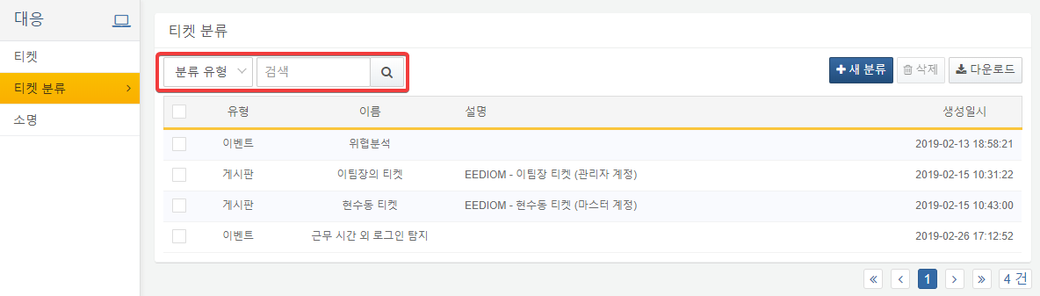

By clicking the Download button, users can download the ticket list in CSV, Excel XML, MS Word, HTML, or JSON format.

