#### Ticket Inquiry

By clicking on the ticket title in the ticket list, users can view the details and assignment status of the corresponding ticket.

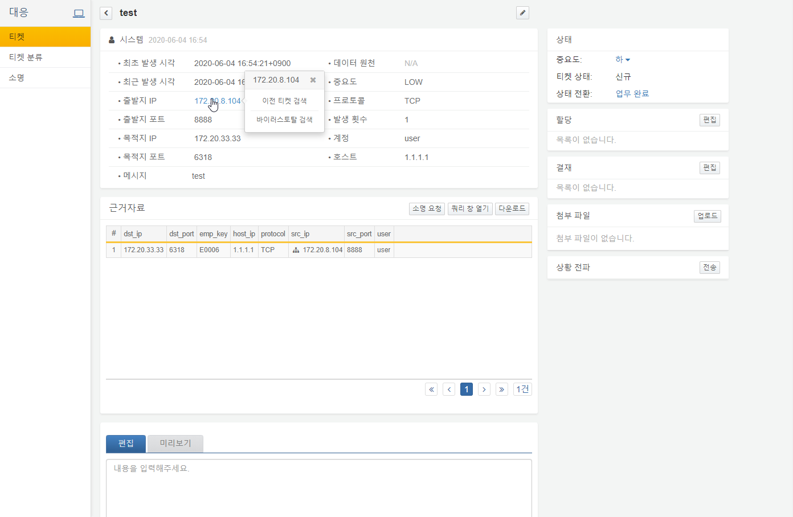

If the ticket was automatically generated by a detection scenario, the ticket body will display the event details as shown above. The supporting evidence at the bottom includes the original logs that triggered the event or data related to the ticket. For example, if a host scan was detected, the supporting evidence may display information such as the destination IP and port that attempted the scan, as illustrated in the example below. If the supporting evidence space is too narrow to view comfortably, clicking the Open Query Window button allows users to review the data in a query screen.

Additionally, users can search for previous ticket history related to the source IP, destination IP, or host, or check for malicious activity on VirusTotal.

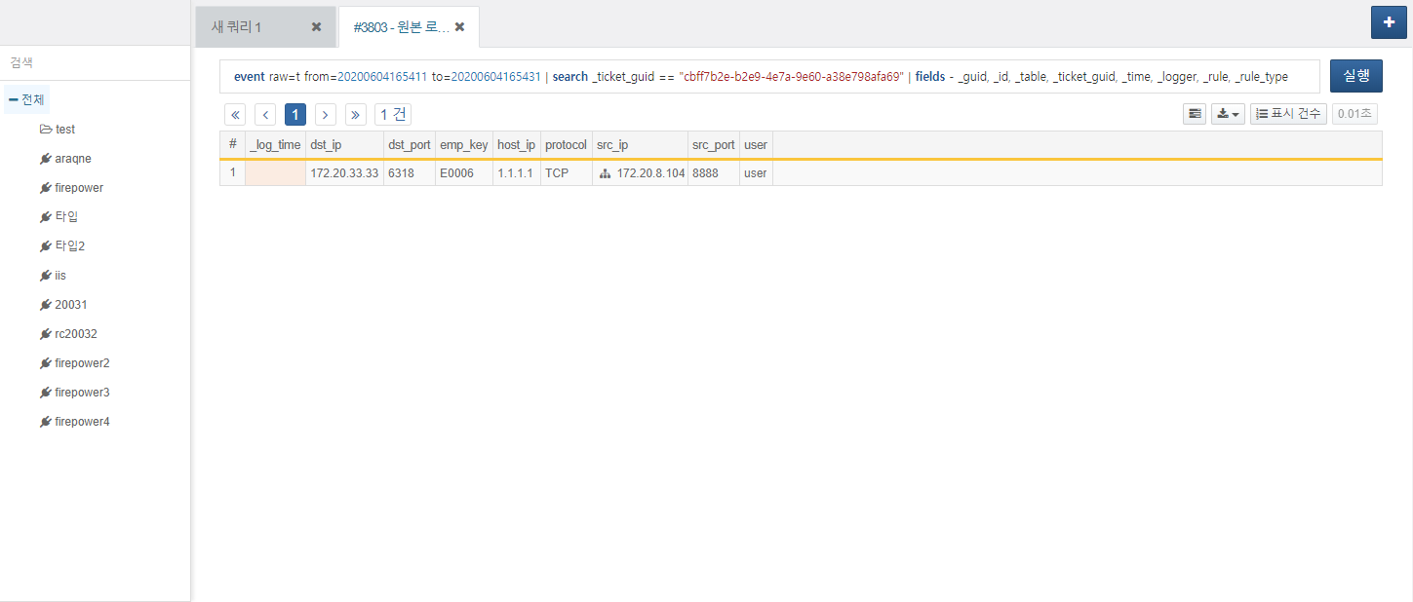

Analysts begin by examining the supporting evidence of the ticket to determine if there are any actual threats or anomalies. They then record the response actions and change the ticket's status to complete it.