Logpresso Sonar Installation Guide

Getting started

Before you start
Document version: 2607.1
Product version: 5.0.2605.1
For a version-by-version list of changes, see Documentation history.

Notice
This document describes how to install Logpresso Sonar and configure a cluster. Read this document before you begin the installation.
Logpresso makes every effort to provide accurate and up-to-date product information, but the product screens and command output may differ from this document. The document is provided as-is. If you find any errors, contact Logpresso.

Notation
User interface elements, commands, and input values are represented as follows.
Format | Meaning
Label | Represents the text of an identifiable UI element (screen, tab, button, and so on) in the web installer or web console.
Menu 1 > Menu 2 | When navigating through multiple menu levels, ">" is used to indicate the menu path.
command, file path | Commands, file paths, and configuration values that you type literally or that appear on screen are shown in monospace.
IP_ADDR, FQDN | Values that you must enter based on your environment are shown in uppercase monospace.

Abbreviations and terms
The following terms are used in this document.
Control Node
A node that provides the web console and analytics features.
Data Node
A node that collects and stores logs.
Forwarder Node
A node that collects logs from remote sites and forwards them to a Data Node.
Node Pair
A configuration unit that groups two nodes (node A and node B) into one for high availability (HA).
Logpresso shell
The command-line interface (CLI) of the Logpresso engine. It uses an account separate from the web console login account.
Web installer
The setup wizard that runs on your first connection to the web console and guides you through the initial configuration for your server environment.
Web console
The web-based user interface provided by Logpresso Sonar.
Galera Cluster
MariaDB's multi-master synchronous replication cluster. It is used to synchronize the database tier of a Control Node pair.
GUID
Abbreviation for Globally Unique Identity, a unique identifier represented in hexadecimal
FQDN
Fully Qualified Domain Name
VIP
Virtual IP address. Used as the representative address of a node pair in a network redundancy configuration.
HA
High Availability
SNR
Logpresso Sonar

Customer support
If you have any inquiries regarding Logpresso products, contact us and we will respond promptly.
- Website: logpresso.com
- Email: support@logpresso.com
- Support portal: support.logpresso.com

Documentation history

2607.1 — based on Sonar 5.0.2605.1
Language support
- Started providing English and Japanese editions
Corrections and enhancements
- Recaptured the web installer screens (cluster administrator registration, system configuration, object storage, database) and replaced an incorrect capture of the object storage configuration screen
- Corrected the node B address example in the Forwarder Node pair configuration to match the body text
- Corrected the node type shown in the Control Node pair configuration screen to Control Node
- Corrected UI labels and wording in the license registration form and deployment topology guidance
- Fixed an appendix chapter title typo and cleaned up unreferenced pages and images
- Improved screenshot rendering quality

2607.0 — based on Sonar 5.0.2605.1
Documentation structure improvements
- Added the "Getting started" chapter — added the Before you start, Customer support, and Documentation history pages
Documentation enhancements
- Recaptured the Control Node, Data Node, and Forwarder Node configuration screenshots to match the Sonar 5.0 web console UI
- Distinguished the access address examples for node A and node B in the web console login instructions
- Split the Control Node pair configuration screen instructions into step-by-step screenshots

Overview

Deployment topology
Logpresso Sonar supports cluster configurations in which multiple nodes (servers) work together as a single system. When you build a cluster, you can apply high availability (HA) settings to each node to improve stability and usability.

Architecture
Cluster architectures can be classified by the tiers that make up the cluster as follows.
- 1-tier: control node (single tier)
- 2-tier: forwarder (first tier) - control (second tier) / data (first tier) - control (second tier)
- 3-tier: forwarder (first tier) - data (second tier) - control (third tier)
Choose the architecture that fits the volume of raw logs collected per day. The architecture recommended by Logpresso is 3-tier.
1-tier: control node
The following diagram illustrates a 1-tier configuration. On the left is a single control node configuration, and on the right is a control node pair configuration. A 1-tier cluster can process up to 250 GB of data per day (250 GB/day).
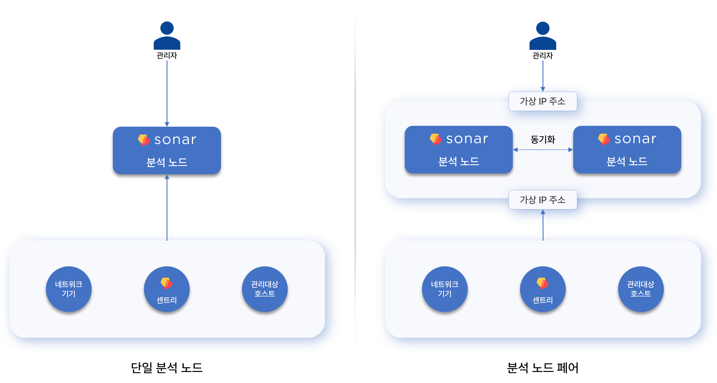
A single control node is the simplest structure, in which the node performs both the data node and control node functions. If the node fails, data loss can occur.
In a control node pair, each node shares a virtual IP address.
- For network load balancing, when data is sent to the IP address of the L4 load balancer/switch placed at the top, one of the two nodes receives the data.
- When network devices, managed hosts, or Sentry send data, the active node of the control node pair receives the data and synchronizes it with the standby node.
- When a user wants to access the web console, connecting to the virtual IP address causes one of the two nodes to provide the service.
When the volume of data to collect grows, you must switch to a 3-tier configuration.
2-tier: forwarder-control / data-control
The following diagram illustrates a 2-tier configuration. On the left is a forwarder-control node configuration, and on the right is a data-control node configuration (legacy).
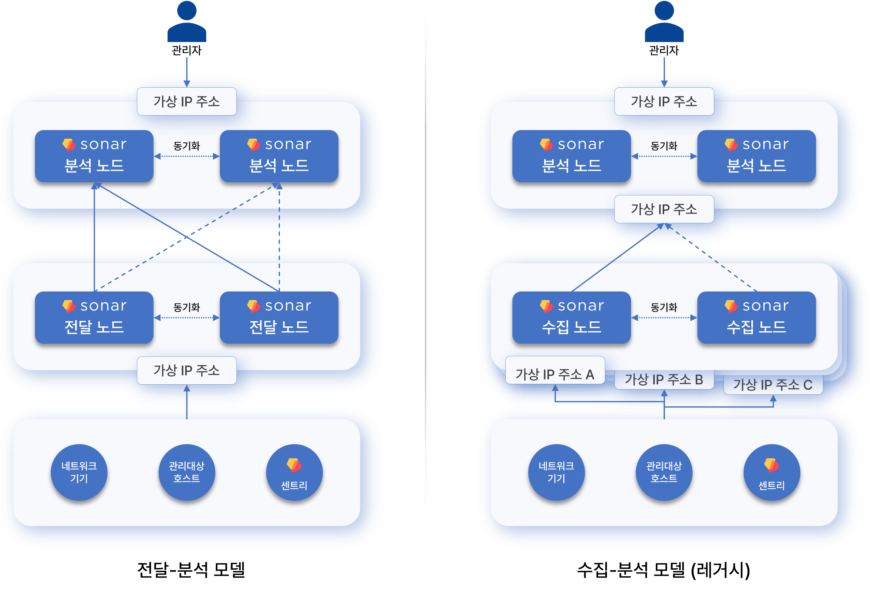
The forwarder-control configuration is the default configuration you can see in [Logpresso Cloud](https://logpresso.cloud/). The forwarder node was introduced in version 4.0.2404.0 and acts as a data gateway and load balancer. (Related document). A forwarder node can be operated as a single node, but redundancy is recommended.
The data-control configuration (legacy) is the architecture used before version 4.0.2404.0. Because each data source (network devices, managed hosts, Sentry) must communicate with its own designated data node pair, the network topology becomes more complex as the number of data node pairs grows, which is a drawback, so it is not recommended.
3-tier: forwarder-data-control
The 3-tier configuration is recommended for large-scale data collection environments.
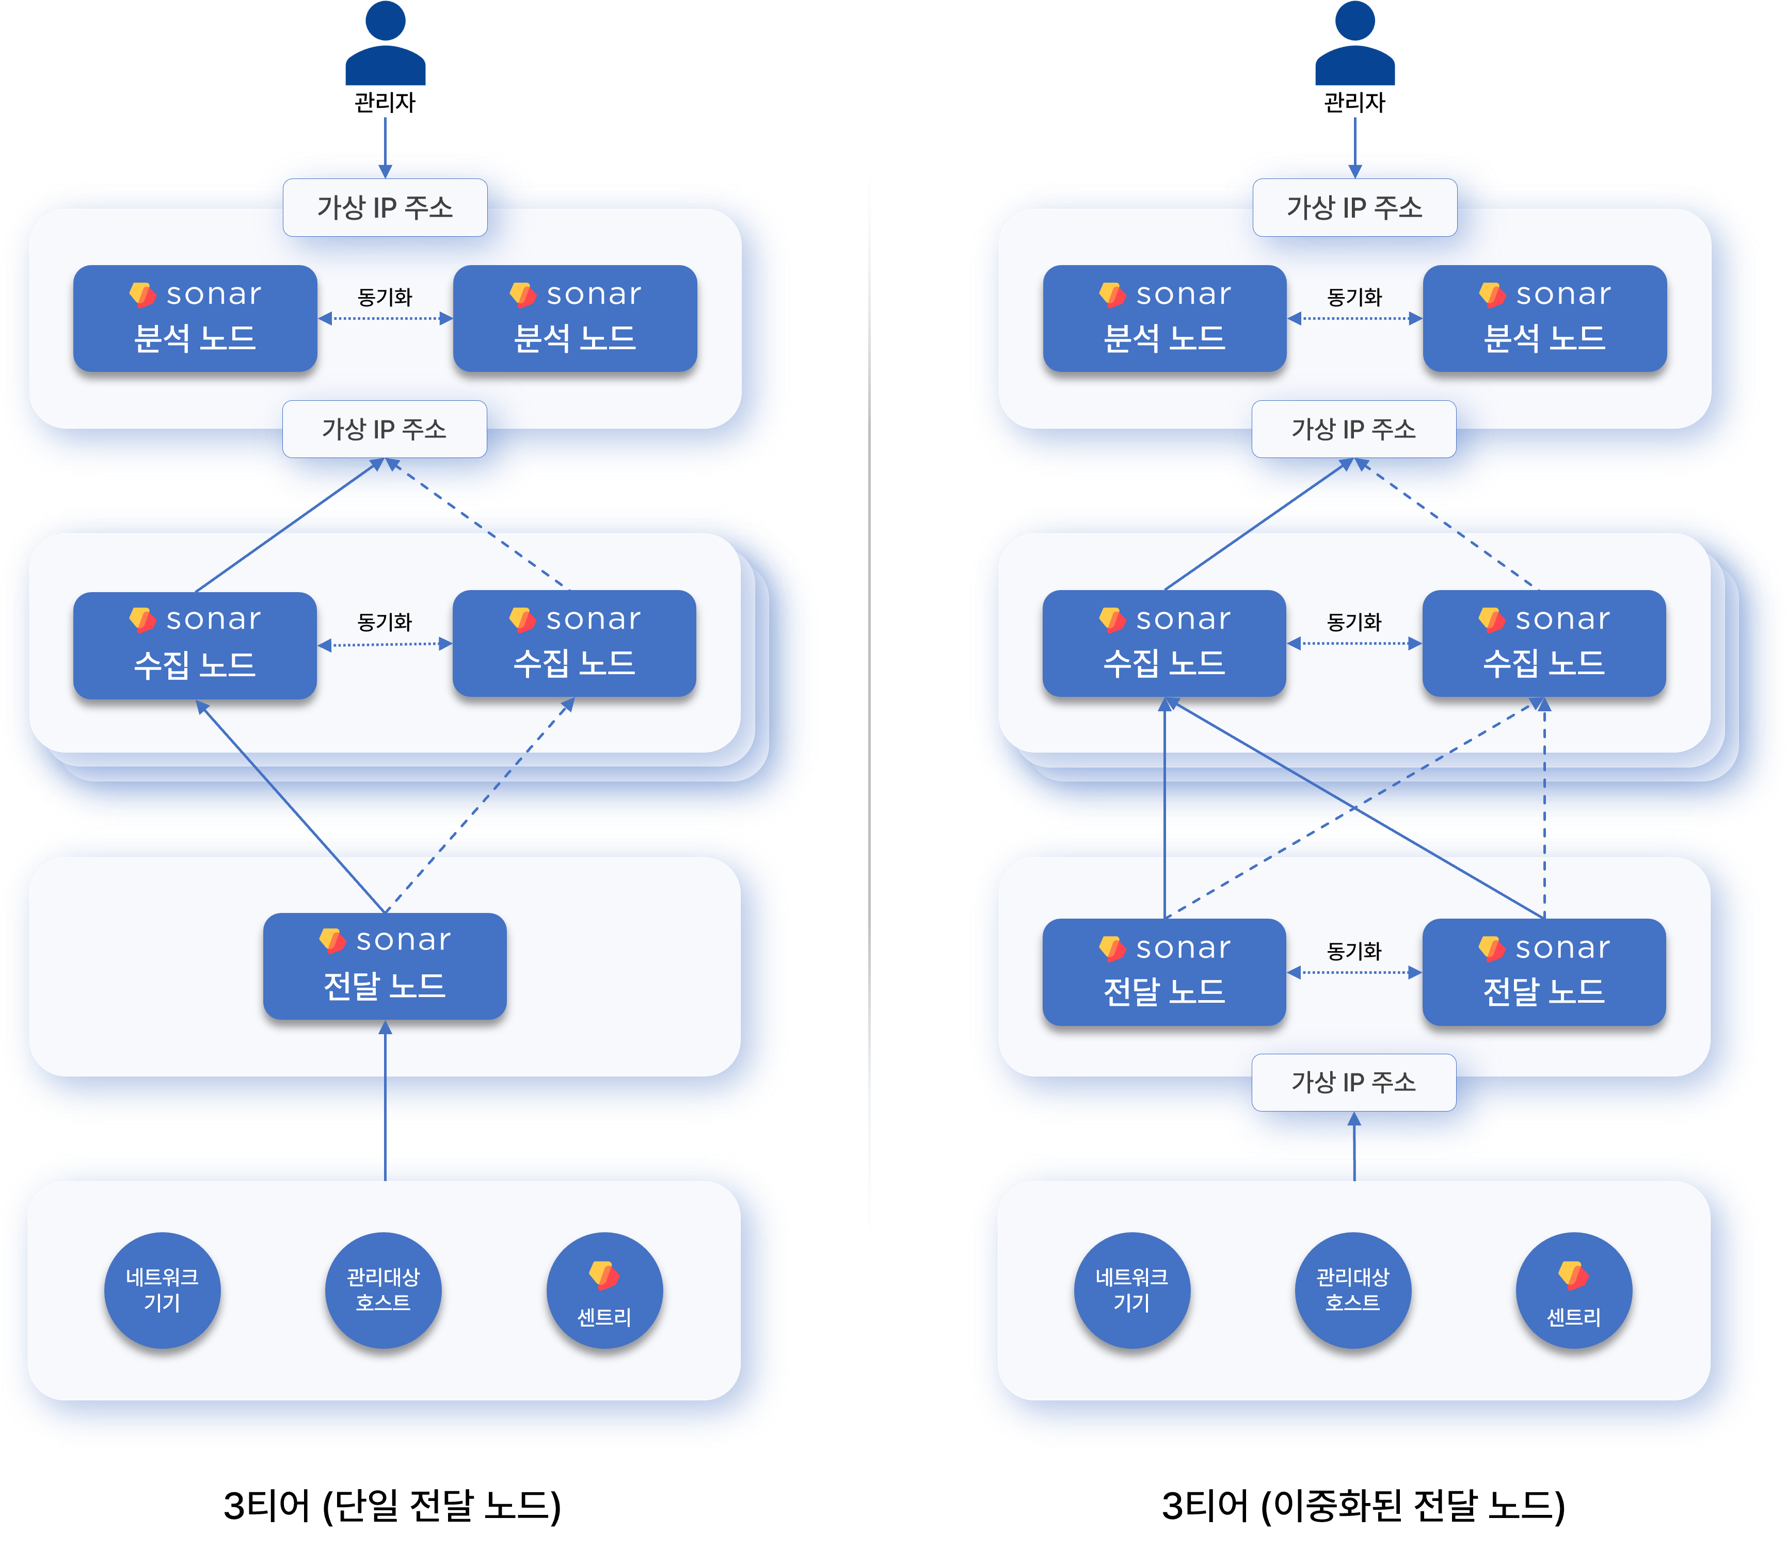
If there are two or more data node pairs, be sure to configure a forwarder node. Adding a forwarder node resolves the topology problem of the 2-tier data-control model.

Functions by node
The nodes (servers) that make up a Logpresso cluster are classified by role into control node, data node, and forwarder node. A standalone Logpresso Sonar server can be regarded as performing both the data node and control node roles.
Control node
The control node controls all nodes in the cluster and provides the web console service to users. Redundant control nodes (a control node pair) share a virtual IP address.
Node control
Nodes in the cluster communicate using polling. When a forwarder node or data node requests configuration and policy synchronization from the control node, the control node sends the changed configuration or policy in response to each node's request.
User web interface
Users can access the web console at the control node's virtual IP or domain address. Explanation requests and review requests that are sent to employees who have received an explanation request for a policy violation and to the approvers who must review them are also delivered through this web address.
Data analysis and detection of security threats and anomalous behavior
Based on the data loaded on the data nodes, the control node performs the following actions according to real-time detection and batch detection scenarios.
- Detecting security threat or anomalous behavior events
- Issuing and managing tickets
- Managing explanations
- Automatically responding to detected threats
The control node establishes and manages the execution plan for Logpresso queries, and it collects the results processed in a distributed manner on each node to process the data. For queries that a user runs directly on the control node or most queries that run periodically in the cluster, the control node reads and processes the data stored on the data nodes.
Data node
The data node parses, normalizes, and indexes the data collected through loggers, then stores and manages it in tables.
Data loading and query execution
Parsing of raw data by parsers and the normalization defined in the collection model both take place on the data node.
Every data node stores raw data and normalized data together in tables that have the same name. When you run a Logpresso query on the control node, data retrieval commands such as table and fulltext are processed in parallel on each data node.
Lifecycle management
The data node manages collected raw log data according to the retention period defined for the table and the data lifecycle.
Forwarder node
The forwarder node was introduced in version 4.0.2404.0 (Related document). Redundant forwarder nodes share a virtual IP address.
- When there are two or more data node pairs, a 3-tier configuration that includes a forwarder node is recommended.
- To operate a forwarder node pair in active-active mode, you need an L4 switch or a network load balancer.
Data gateway
Loggers run on the forwarder node, and the forwarder node becomes the data send/receive gateway of the Logpresso cluster. The forwarder node's virtual IP address or domain address is used as the gateway address.
A data node can also perform the data gateway role, but because each data source (network devices, managed hosts, Sentry) must communicate with its own designated data node pair, the network topology becomes more complex as the number of data node pairs grows, which is a drawback, so it is not recommended.
Load balancing
The data that a forwarder node receives/collects is sent to the data nodes. According to the transmission method defined in the logger, the forwarder node performs load balancing so that data is loaded evenly across multiple data node pairs, or it sends data to a specific node pair.
If the forwarder node detects a failure while communicating with a data node, it temporarily stores the data to be sent in memory and on the local disk, and when the failure is resolved, it resends the stored data to the data node. After the forwarder node completes the transmission, it removes the data remaining locally.
Differences from Sentry
Logpresso Sentry also provides a function to forward data, but because Sentry is intended to be installed on managed servers, it is designed to use minimal system resources and provides only the minimal functions related to collection. In contrast, a forwarder node is configured as an independent machine and provides an app installation feature.
In particular, when a device located in the user's network sends Syslog to a Logpresso Cloud instance, you must install a forwarder node in the user's network to forward the logs, in order to prevent plaintext exposure over the internet segment and to minimize UDP packet loss.
The following table summarizes and compares the features of Sentry and the forwarder node.
Feature | Sentry | Forwarder node
System resources | Minimal usage | Full usage
TLS encrypted communication | Supported | Supported
Real-time compressed transmission | Supported | Supported
Data collection | Supported | Supported
Data parsing | Not supported | Not supported
Data filtering | Supported | Supported
Internal data relay | Not supported | Supported
Forwarding to external systems | Not supported | Supported
Query execution | Not supported | Supported
App installation | Not supported | Supported
High availability configuration | Not supported | Supported
Automatic load balancing | Not supported | Supported

Installation requirements
This document describes the software and hardware requirements for installing Logpresso Sonar.

Software
To run Logpresso Sonar, you need the following operating system and software.
Operating system
The operating system officially supported by Logpresso is Red Hat Enterprise Linux 9.
- You can also use a RHEL 9-compatible operating system such as Rocky Linux.
- We recommend the Server with GUI installation type.
- Depending on the installation type, you may need to install additional packages such as: curl, firewalld, lsof, net-tools, traceroute, unzip, vim, wget
JDK
We recommend OpenJDK 21 (LTS), which is provided by default in the operating system repository. As an alternative, you can bring in and install Eclipse Temurin. Eclipse Temurin is the name of the OpenJDK distribution provided by the Eclipse Foundation.
Database
To install Logpresso Sonar as a single node or to install a control node, you need MariaDB 11.8 (LTS).
Application
You need the Logpresso Sonar package. You can download it from the Logpresso Store.

Hardware
Control node & data node
You can build the cluster architecture based on the volume of raw logs collected per day (daily throughput).
- You can determine the cluster tier configuration based on the daily throughput.
- In a cluster configuration, the control node count is based on one node. The control node can also be made redundant.
- The specifications shown are hardware specifications for one node.
- Available storage assumes a retention period of 1 year and a data compression ratio of 85%.
Node | Item | 10 GB/day | 50 GB/day | 100 GB/day | 250 GB/day | 500 GB/day | 1 TB/day
Control node | CPU | 12 | 12 | 24 | 24 | 24 | 24
 | vCPU | 24 | 24 | 48 | 48 | 48 | 48
 | Memory | 32GB | 64GB | 128GB | 128GB | 128GB | 128GB
 | Disk(OS) | SSD 240GB x 2(RAID 1) | SSD 240GB x 2(RAID 1) | SSD 240GB x 2(RAID 1) | SSD 240GB x 2(RAID 1) | SSD 240GB x 2(RAID 1) | SSD 240GB x 2(RAID 1)
 | Disk(data) | SATA HDD 4TB x 2(RAID 1) | SATA HDD 12TB x 2(RAID 1) | SATA HDD 24TB x 2(RAID 1) | SATA HDD 24TB x 4(RAID 10) | SATA HDD 4TB x 2(RAID 1) | SATA HDD 4TB x 2(RAID 1)
 | Available space | 4TB | 12TB | 24TB | 48TB | 4TB | 4TB
 | NIC | 1Gbps x 2 | 1Gbps x 2 | 1Gbps x 2 | 1Gbps x 2 | 10Gbps x 2 | 10Gbps x 2
Data node | CPU | N/A | N/A | N/A | N/A | 24 | 24
 | vCPU |  |  |  |  | 48 | 48
 | Memory |  |  |  |  | 128GB | 128GB
 | Disk(OS) |  |  |  |  | SSD 240GB x 2(RAID 1) | SSD 240GB x 2(RAID 1)
 | Disk(data) |  |  |  |  | SATA HDD 24TB x 4(RAID 10) | SATA HDD 24TB x 4(RAID 10)
 | Available space |  |  |  |  | 48TB | 48TB
 | NIC |  |  |  |  | 10Gbps x 2 | 10Gbps x 2
Cluster |  | Control/data combined(redundant: 2 nodes) | Control/data combined(redundant: 2 nodes) | Control/data combined(redundant: 2 nodes) | Control/data combined(redundant: 2 nodes) | 1 control node2 data nodes(redundant: 6 nodes) | 1 control node4 data nodes (redundant: 10 nodes)
- CPU means physical cores, and vCPU means logical cores.
Forwarder node
The hardware specifications of a forwarder node are split per node based on the volume of raw logs collected per day (daily throughput) and a Sentry connection count of 500.
- If the daily throughput is 1 TB/day or more, scale out the forwarder nodes horizontally to handle it.
- The specifications shown are hardware specifications for one node.
- Available storage assumes up to one week of retention and 85% compression, taking data node failure into account.
- Sentry is assumed to be up to 500 units.
Network collection-only specification
Item | 1 TB/day
CPU | 4
vCPU | 8
Memory | 16GB
Disk (OS) | SSD 240GB x 2 (RAID 1)
Disk (data) | SATA HDD 4TB x 2 (RAID 1)
Available space | 4TB
NIC | 1Gbps x 2
Sentry management and network collection specification
Item | 1 TB/day
CPU | 12
vCPU | 24
Memory | 64GB
Disk (OS) | SSD 240GB x 2 (RAID 1)
Disk (data) | SATA HDD 4TB x 2 (RAID 1)
Available space | 4TB
NIC | 1Gbps x 2
AWS EC2 | c5.2xlarge

Network
Considering your operating environment and network configuration, prepare IP addresses and an L4 switch (or load balancer).
Node | Single node configuration | Redundant configuration
Control/data combined | 1 IP address | 3 IP addresses, 1 L4 switch/load balancer
Control node | 1 IP address | 3 IP addresses, 1 L4 switch/load balancer
Data node | 1 IP address | (Data-control 2-tier architecture) 3 IP addresses, 1 L4 switch/load balancer(Forwarder-data-control 3-tier architecture) 2 IP addresses
Forwarder node | 1 IP address | 3 IP addresses, 1 L4 switch/load balancer
- For a redundant configuration, node A, node B, and the node pair each need one IP address. The node pair's IP address is used when the L4 switch/load balancer performs load balancing.
- The number of IP addresses required for a data node varies depending on the architecture.
- In environments where an L4 switch cannot be used, you can configure VIP switching with the HA script provided by Logpresso. Request the HA script from the Logpresso technical support team.

Object storage (optional)
Logpresso Sonar provides a data lifecycle management feature. It provides a data lifecycle management feature that divides data storage into three tiers—Hot, Warm, and Cold—according to the data retention period and automatically moves (rolls over) data to a lower tier according to the data retention period.
Cold storage supports object storage services such as AWS S3 and Kakao Cloud Object Storage. To use Cold tier storage, prepare object storage in the cloud in advance.
The data lifecycle management feature can be set up separately after installing Logpresso Sonar.

Prerequisites
Before you begin the actual installation, prepare the following.

Deployment diagram
Referring to Deployment topology, draw a network diagram of the cluster you will build with Logpresso Sonar and review whether it is suitable for your operating environment.

Host names
Decide a unique host name in advance for every server on which you will install Logpresso Sonar.
When a cluster has multiple node pairs, it is a good idea to assign host names by combining the node pair identifier and the node identifier, such as c1a/c1b, d1a/d1b, d2a/d2b, f1a/f1b. For example, for a cluster made up of one control node pair (c1), two data node pairs (d1, d2), and one forwarder node pair (f1), you can use host names as follows.
Node pair | Host name | Description
c1 | c1a | Node A of control node pair c1
c1 | c1b | Node B of control node pair c1
d1 | d1a | Node A of data node pair d1
d1 | d1b | Node B of data node pair d1
d2 | d2a | Node A of data node pair d2
d2 | d2b | Node B of data node pair d2
f1 | f1a | Node A of forwarder node pair f1
f1 | f1b | Node B of forwarder node pair f1

IP address assignment
Assign the IP addresses and subnets to use for each node and node pair in advance.

L4 switch/load balancer configuration
For a high availability configuration, on the L4 switch (or router)/load balancer to be placed at the top of the control node pair or forwarder node pair, configure it to distribute the load using the source IP address hash method for communication whose destination ports are 514/udp, 123/udp, and 8514/udp.

Firewall policy configuration
It is a good idea to isolate the Logpresso Sonar cluster by configuring a subnet so that it cannot be arbitrarily accessed from the internal network, or to control the network communication.
Inbound
Configure firewall policies to allow communication coming into each node.
Control node
The receiving ports of the control node are as follows.
Source | Communication port | Purpose
Administrator terminal | 22/tcp | SSH access
Operator terminal | 443/tcp | Web console access (destination: control node virtual IP address)
Forwarder/data node | 443/tcp | Sonar federation (destination: control node virtual IP address)
Operator terminal | 8443/tcp | ENT web console access
Employee terminal | 18443/tcp | Writing and reviewing explanations (destination: control node virtual IP address)
127.0.0.1 | 3306/tcp | MariaDB access (can be replaced with a Unix socket)
Peer node | 4444/tcp, 4567-4568/tcp | MariaDB Galera access
Peer node | 443/tcp | Mutual status check between control nodes A and B
Forwarder/data node | 7140/tcp | RPC and collected log transmission
All nodes, Sentry | 44300/tcp | Certificate renewal, Sentry installation (destination: control node virtual IP address)
- If you configure MariaDB to connect using a Unix socket, you do not need to open port 3306/tcp on the firewall. If you configure MariaDB to connect using a TCP port, you must open port 3306/tcp on the firewall.
- A peer node means the counterpart node that makes up the control node pair together. The peer of node A is node B, and the peer of node B is node A.
- "Forwarder/data node" means the forwarder node or the data node, depending on the Logpresso cluster configuration.
Data node
The receiving ports of the data node are as follows.
Source | Communication port | Purpose
Administrator terminal | 22/tcp | SSH access
Operator terminal | 8443/tcp | Web management console and API inspection
Control node | 8443/tcp | Sonar federation
Peer node | 8443/tcp | Mutual status check between data nodes A and B
Forwarder node | 7140/tcp | RPC and collected log transmission
Sentry | 7140/tcp | (When there is no forwarder node) RPC and collected log transmission
Log collection target | 514/udp | (When there is no forwarder node) Syslog reception
Log collection target | 8514/udp | (When there is no forwarder node) Syslog over DTLS reception (port is variable)
Log collection target | 162/udp | (When there is no forwarder node) SNMP TRAP
- A peer node means the counterpart that makes up the data node pair together. From node A's perspective, node B is the peer node, and from node B's perspective, node A is the peer node.
Forwarder node
The receiving ports of the forwarder node are as follows.
Source | Communication port | Purpose
Administrator terminal | 22/tcp | SSH access
Operator terminal | 8443/tcp | Web management console and API inspection
Control node | 8443/tcp | Sonar federation
Peer node | 8443/tcp | Mutual status check between forwarder nodes A and B
Sentry | 7140/tcp | RPC and collected log transmission
Log collection target | 514/udp | Syslog reception
Log collection target | 8514/udp | Syslog over DTLS reception (port is variable)
Log collection target | 162/udp | SNMP TRAP
- A peer node means the counterpart that makes up the forwarder node pair together. From node A's perspective, node B is the peer node, and from node B's perspective, node A is the peer node.
Outbound
Configure firewall policies to allow communication going out from each node.
Source | Destination | Communication port | Purpose
All nodes | NTP server | 123/udp | NTP time synchronization
Control node | cti.logpresso.com | 443/tcp | Logpresso CTI service
Forwarder node | Log collection target host | 22/tcp | SFTP log collection
Forwarder node | Log collection target host | 161/udp | SNMP
Forwarder node | Log collection target MySQL | 3306/tcp | JDBC log collection
Forwarder node | Log collection target PostgreSQL | 5432/tcp | JDBC log collection
Forwarder node | Log collection target Oracle | 1521/tcp | JDBC log collection
- Depending on the log collection method of the loggers configured on the forwarder node, additional outbound communication may be required.

Server delivery
Referring to Installation requirements, deliver the bare-metal or virtual machines you prepared to their planned locations and install them.
- If the delivery environment is an air-gapped network, download the operating system and database RPM packages in advance and bring them into the air-gapped network.
- To enable immediate power redundancy in an emergency response, it is a good idea to install an uninterruptible power supply (UPS).

JDK download
Download Temurin JDK 21 from Adoptium and bring it to the server. You can also use OpenJDK 21 (LTS), which is provided by default in the operating system.

Logpresso Sonar package download
Download the latest version of the Logpresso Sonar package from the Logpresso Store. All nodes must use the same version.

Control Node

Operating system
This document describes the items required when installing and configuring the operating system.
- Permissions required for installation: Describes the permissions required to install Logpresso Sonar.
- Operating system and JDK installation: Describes how to install the operating system, configure partitions, and install the required packages and JDK.
- Operating system configuration: Configures JDK permissions, SELinux, the host name, NTP, the firewall, kernel parameters, and more.
- Creating the Logpresso directory: Creates the Logpresso installation directory.

Permissions required for installation
To install Logpresso Sonar, you need root privileges on the target server, or the privileges of a user who can run administrative commands with the sudo command (a user who belongs to the wheel group).

Operating system and JDK installation
The officially supported operating system for Logpresso is Red Hat Enterprise Linux 9.
- You can also use a RHEL 9-compatible operating system such as Rocky Linux.
- The Server with GUI installation type is recommended.
- Separate the operating system partition from the data partition.
- Mount the data partition at /data.
- Configure the data partition with LVM so that you can expand its capacity when needed.
Installing the required packages
On a network with internet access, run the following command to install the required packages.
sudo dnf -y install curl firewalld java-21-openjdk-devel \
lsof net-tools traceroute unzip
Package | Purpose
curl | Used to test APIs
firewalld | Host firewall configuration
java-21-openjdk-devel | JDK required to run Logpresso Sonar
lsof | Diagnostic tool used to check open files and ports
net-tools | Network diagnostic tools such as netstat and ifconfig
traceroute | Diagnostic tool used to trace network paths
unzip | Extracts the Logpresso Sonar installation package
- Install the java-21-openjdk-devel package instead of java-21-openjdk so that you can debug with the jmap and jstack commands when a failure occurs.
- If installing debugging tools is not allowed in your environment, install the java-21-openjdk-headless package.
For convenience, we recommend installing the following packages.
sudo dnf -y install vim wget
Package | Purpose
vim | Editing configuration files
wget | Used to run the Sentry installation script on the host where you install Sentry
Downloading packages (for air-gapped environments)
If you need to install in an air-gapped environment, follow the steps below to prepare the package files to bring into the air-gapped environment.
Identify the operating system and version used in the air-gapped environment, and on a network with internet access, prepare a Linux host that runs the same version as the Linux server that will operate in the air-gapped environment.
Run the following command to download the packages to install and all of their dependency packages to the specified path.
# Downloading packages does not require sudo privileges.
mkdir $HOME/rpm && cd $HOME/rpm && \
dnf download --resolve curl firewalld java-21-openjdk-devel \
lsof net-tools traceroute unzip vim wget && \
tar czvf rpm.tgz *.rpm
Create a file that records the hash value of the compressed file. You need this hash value to verify the integrity of the file brought into the air-gapped environment.
sha256sum rpm.tgz > rpm.tgz.sha256
Keep the rpm.tgz and rpm.tgz.sha256 files in a safe place (read-only media recommended).
To install the required packages in the air-gapped environment, follow these steps.
Create a new directory (for example, $HOME/rpm) and copy the rpm.tgz and rpm.tgz.sha256 files into it.
In the new directory, run the following command to compare the computed hash value against the hash value recorded in the rpm.tgz.sha256 file.
sha256 sum rpm.tgz
Extract the rpm.tgz file and install the packages.
tar xzvf rpm.tgz && sudo dnf install -y *.rpm

Operating system configuration
Configuring JDK permissions
Check the installed JDK version and grant the permissions required to run Logpresso Sonar. You must perform this configuration on every node.
Check the installed JDK version.
java -version
You should see version information like the following.
openjdk version "21.0.10" 2026-01-20 LTS
OpenJDK Runtime Environment (Red_Hat-21.0.10.0.7-1) (build 21.0.10+7-LTS)
OpenJDK 64-Bit Server VM (Red_Hat-21.0.10.0.7-1) (build 21.0.10+7-LTS, mixed mode, sharing)
Grant the required permissions to the java executable.
sudo setcap cap_net_bind_service,cap_sys_time,cap_net_raw=+ep $(readlink /etc/alternatives/java)
The permissions that setcap grants to the java executable are as follows.
Option | Description | Note
cap_net_bind_service | Permission to use ports 1024 and below | Regular user privileges cannot use ports 1024 and below
cap_sys_time | Permission to change the system time | Required for time synchronization and timestamp adjustment
cap_net_raw | Permission to use raw sockets and packet sockets | Used for direct pcap collection, sendsyslog, and the ping app
+ep | +: add the permissione: apply the permissionp: keep the permission permanently
Verify that the permissions were applied correctly.
getcap $(readlink /etc/alternatives/java)
You should see a result like the following.
/usr/lib/jvm/java-21-openjdk-21.0.10.0.7-1.el9.x86_64/bin/java cap_net_bind_service,cap_net_raw,cap_sys_time=ep
Configuring SELinux
SELinux (Security-Enhanced Linux) is a module that applies security policies at the Linux kernel level. By default, in enforcing mode it blocks any action that violates a security policy. Because access to certain directories can be restricted when Logpresso Sonar runs, you must change SELinux to permissive.
We plan to improve this document after verifying the stability of Logpresso Sonar in SELinux enforcing mode. For now, the documentation describes proceeding with the installation after changing SELinux to Permissive.
Open the /etc/selinux/config file and set it as follows. The changed setting takes effect immediately when you restart the system or run the setenforce 0 command.
# This file controls the state of SELinux on the system.
# SELINUX= can take one of these three values:
# enforcing - SELinux security policy is enforced.
# permissive - SELinux prints warnings instead of enforcing.
# disabled - No SELinux policy is loaded.
SELINUX=permissive
To apply the Permissive SELinux setting immediately, run the following command.
sudo setenforce 0
Run the getenforce command and verify that the current SELinux mode is printed as Permissive.
Changing the host name
To make it easy to identify Logpresso Sonar nodes, change the server's host name with the following command.
sudo hostnamectl set-hostname HOSTNAME
- HOSTNAME: The host name.
If you have multiple node pairs, we recommend assigning host names that combine node pair identifiers and node identifiers, such as c1a/c1b, d1a/d1b, d2a/d2b, and f1a/f1b. For example, in a cluster composed of one control node pair, two data node pairs, and one forwarder node pair, you can use the following host names.
Node pair | Host name | Description
c1 | c1a | Node A of control node pair c1
c1 | c1b | Node B of control node pair c1
d1 | d1a | Node A of data node pair d1
d1 | d1b | Node B of data node pair d1
d2 | d2a | Node A of data node pair d2
d2 | d2b | Node B of data node pair d2
f1 | f1a | Node A of forwarder node pair f1
f1 | f1b | Node B of forwarder node pair f1
Configuring NTP
Synchronize the time with the same NTP server so that all nodes use accurate time information.
Identify in advance the IP address or FQDN of an NTP server that provides the network standard time (for example, time.kriss.re.kr).
Set the same NTP server or server pool in the /etc/chrony.conf file so that all servers synchronize the network standard time with the same NTP server.
# Use public servers from the pool.ntp.org project.
# Please consider joining the pool (https://www.pool.ntp.org/join.html).
# pool 2.rocky.pool.ntp.org iburst # comment out the pool line
server time.kriss.re.kr iburst prefer # KRISS NTP server
server 192.0.2.1 iburst # NTP server in the internal 192.0.2.0/24 network (example)
⚠️ When you add a server line, delete or comment out the pool line. Use only one of them.
Run the following command to restart the chronyd service.
sudo systemctl restart chronyd
Run the following command to check the synchronization status of the currently registered NTP server. If chronyd is working correctly, the synchronization status is displayed.
chronyc sources -v
Run the command below to synchronize the time immediately.
sudo chronyc -a makestep
Configuring the host firewall
Configure the inbound firewall policy so that the communication required to run Logpresso Sonar is possible. The following are example commands for configuring the firewall policy on a control node server according to the firewall policy configuration described in the prerequisites document.
sudo firewall-cmd --permanent --add-port={22,443,8443,18443,7140,44300,4444,4567,4568}/tcp
sudo firewall-cmd --permanent --add-port={8514}/tcp -add-port={514,8514,162}/udp # set this for a single-tier control node configuration
sudo firewall-cmd --reload
sudo firewall-cmd --list-all
- If you configured connections to the MariaDB database through a Unix socket, remote connections are not possible, so you do not need to open the 3306/tcp port in the firewall.
The firewall configuration above has the problem of not restricting the source IP addresses. To restrict the source IP addresses in the host firewall, you must run advanced firewall policy commands that use the --add-rich-rule option, as shown below. Change the IP address ranges to match your actual environment.
# 1. Management network: 192.0.2.0/24
# SSH (22/tcp), web console (443/tcp), ENT web console (8443/tcp)
sudo firewall-cmd --permanent --add-rich-rule='rule family="ipv4" source address="192.0.2.0/24" port port="22" protocol="tcp" accept'
sudo firewall-cmd --permanent --add-rich-rule='rule family="ipv4" source address="192.0.2.0/24" port port="443" protocol="tcp" accept'
sudo firewall-cmd --permanent --add-rich-rule='rule family="ipv4" source address="192.0.2.0/24" port port="8443" protocol="tcp" accept'
# 2. Business network: 198.51.100.0/24
# Explanation writing and review (18443)
sudo firewall-cmd --permanent --add-rich-rule='rule family="ipv4" source address="198.51.100.0/24" port port="18443" protocol="tcp" accept'
# 3. Data node range: 203.0.113.128/27 (203.0.113.129 - 203.0.113.159)
# Sonar federation (443/tcp), RPC and log transfer (7140/tcp)
# Note: allow only traffic that comes from the data node group
sudo firewall-cmd --permanent --add-rich-rule='rule family="ipv4" source address="203.0.113.128/27" port port="443" protocol="tcp" accept'
sudo firewall-cmd --permanent --add-rich-rule='rule family="ipv4" source address="203.0.113.128/27" port port="7140" protocol="tcp" accept'
# 4. Forwarder node range: 203.0.113.160/27 (203.0.113.161 - 203.0.113.190)
# Sonar federation (443/tcp), RPC and log transfer (7140/tcp)
# Note: allow only traffic that comes from the forwarder node group
sudo firewall-cmd --permanent --add-rich-rule='rule family="ipv4" source address="203.0.113.160/27" port port="443" protocol="tcp" accept'
sudo firewall-cmd --permanent --add-rich-rule='rule family="ipv4" source address="203.0.113.160/27" port port="7140" protocol="tcp" accept'
# 5. Control node DB cluster range: 203.0.113.192/27 (203.0.113.193 - 203.0.113.222)
# MariaDB Galera ports (4444/tcp, 4567/tcp, 4568/tcp), mutual status checks between control nodes A and B (7140/tcp)
sudo firewall-cmd --permanent --add-rich-rule='rule family="ipv4" source address="203.0.113.192/27" port port="4444" protocol="tcp" accept'
sudo firewall-cmd --permanent --add-rich-rule='rule family="ipv4" source address="203.0.113.192/27" port port="4567" protocol="tcp" accept'
sudo firewall-cmd --permanent --add-rich-rule='rule family="ipv4" source address="203.0.113.192/27" port port="4568" protocol="tcp" accept'
sudo firewall-cmd --permanent --add-rich-rule='rule family="ipv4" source address="203.0.113.192/27" port port="7140" protocol="tcp" accept'
# 6. Sentry (general server range): 203.0.113.0/25 (203.0.113.1 - 203.0.113.126)
# Sentry certificate renewal and Sentry package installation (44300/tcp)
# Allow access from the wide range of servers on which agents are installed
sudo firewall-cmd --permanent --add-rich-rule='rule family="ipv4" source address="203.0.113.0/25" port port="44300" protocol="tcp" accept'
# 7. Service network: 203.0.113.0/25 (203.0.113.1 - 203.0.113.126)
# Sentry: RPC and log reception (7140/tcp)
# set this for a single-tier control node configuration
sudo firewall-cmd --permanent --add-rich-rule='rule family="ipv4" source address="203.0.113.0/25" port port="7140" protocol="tcp" accept'
# 8. Syslog reception (514/udp)
# set this for a single-tier control node configuration
sudo firewall-cmd --permanent --add-rich-rule='rule family="ipv4" source address="203.0.113.0/25" port port="514" protocol="udp" accept'
# 9. Syslog over DTLS reception (8514/tcp, 8514/udp)
# set this for a single-tier control node configuration
sudo firewall-cmd --permanent --add-rich-rule='rule family="ipv4" source address="203.0.113.0/25" port port="8514" protocol="tcp" accept'
sudo firewall-cmd --permanent --add-rich-rule='rule family="ipv4" source address="203.0.113.0/25" port port="8514" protocol="udp" accept'
# 10. SNMP TRAP reception (162/udp)
# set this for a single-tier control node configuration
sudo firewall-cmd --permanent --add-rich-rule='rule family="ipv4" source address="203.0.113.0/25" port port="162" protocol="udp" accept'
# 7. Apply and verify the configuration
sudo firewall-cmd --reload
sudo firewall-cmd --list-rich-rules
Configuring socket buffers and memory maps
When receiving Syslog, Syslog over DTLS, or SNMP TRAP messages, if the kernel's socket buffer or memory buffer is insufficient, log packets can be dropped and logs can be lost. To prevent this, change the socket buffer and memory map settings. Perform this task on every node.
Create the 50-logpresso.conf file in the /etc/sysctl.d directory and add the following content to it.
net.core.rmem_default = 52428800
net.core.rmem_max = 52428800
net.ipv4.udp_rmem_min = 8192
net.ipv4.ipfrag_high_thresh = 16777216
vm.max_map_count = 10000000
vm.swappiness = 1
The meaning of each item is as follows:
Variable | Description | Default | Value
net.core.rmem_default | Default receive buffer size for sockets | 212992 | 52428800
net.core.rmem_max | Maximum receive buffer size for sockets | 212992 | 52428800
net.ipv4.udp_rmem_min | Minimum receive buffer size for UDP sockets | 4096 | 8192
net.ipv4.ipfrag_high_thresh | Maximum size of the IP packet reassembly buffer | 4194304 | 16777216
vm.max_map_count | Maximum allowed number of virtual memory mappings | 65530 | 10000000
vm.swappiness | Minimizes swap usage | 60 | 1
Run the following command to apply the changed kernel settings immediately.
sudo sysctl -p
Run the following command to verify the changed values.
sudo sysctl -a | grep -E "rmem_default|rmem_max|udp_rmem_min|ipfrag_high_thresh|max_map_count"
Relaxing resource limits
Create the 50-logpresso.conf file in the /etc/security/limits.d directory and add the following content to it.
logpresso soft nofile 126488
logpresso hard nofile 126488
logpresso soft nproc 126488
logpresso hard nproc 126488
- nofile: The maximum number of files that can be open at the same time.
- nproc: The maximum number of processes (and threads) that can run at the same time.
Run the following command to verify the changed values.
ulimit -n # check the file open limit (nofile)
ulimit -u # check the process count limit (nproc)
Granting permissions for diagnostic tools
Run the following command to identify the exact paths of the jstack and jmap executables.
readlink /etc/alternatives/jstack
readlink /etc/alternatives/jmap
You should see a result like the following.
/usr/lib/jvm/java-21-openjdk/bin/jstack
/usr/lib/jvm/java-21-openjdk/bin/jmap
Run the sudo visudo /etc/sudoers.d/logpresso command and edit it as shown below. Grant permission for the logpresso account to run the jstack and jmap executables at the paths identified in step 1.
# Adjust the paths to match the output of the readlink command.
%logpresso ALL=(ALL) NOPASSWD: /usr/lib/jvm/java-21-openjdk/bin/jstack
%logpresso ALL=(ALL) NOPASSWD: /usr/lib/jvm/java-21-openjdk/bin/jmap
%logpresso ALL=(ALL) NOPASSWD: /usr/bin/arping
%logpresso ALL=(ALL) NOPASSWD: /usr/bin/netstat
%logpresso ALL=(ALL) NOPASSWD: /usr/sbin/ifconfig
%logpresso ALL=(ALL) NOPASSWD: /usr/sbin/tcpdump
Defaults:logpresso !requiretty
The logpresso account is created when you install Logpresso Sonar. Here, the documentation describes granting the diagnostic tool permissions in advance.
The arping, netstat, ifconfig, and tcpdump commands are used by Logpresso Sonar to check the status of Sentry or to collect pcap files.
Run the following command to verify that the permissions were applied correctly.
sudo visudo -c

Creating the Logpresso directory
Run the following command to create the directory where you will install Logpresso. You can change the Logpresso directory to match your operating environment. This document uses /opt/logpresso.
sudo mkdir -p /opt/logpresso

MariaDB
This document describes how to install MariaDB on a control node and synchronize at the database layer. Logpresso Sonar uses MariaDB to store data and configuration, and MariaDB Galera Cluster is required for control nodes A and B to synchronize data with each other.
- Installing the MariaDB package: Installs the MariaDB server package.
- Changing the data directory: Changes the MariaDB data directory (optional).
- Work on node A: Starts the MariaDB service, applies security settings, and configures the Galera Cluster on node A.
- Work on node B: Joins the Galera Cluster and starts the service on node B.
- Verifying Galera Cluster operation: Verifies that the Galera Cluster works correctly.
- Creating the account and database: Creates the database and account for Logpresso Sonar.

Installing the MariaDB package
When internet access is available
On the official MariaDB mirror server, identify the repository path that matches the MariaDB version and Linux distribution you want to install. For example, the repository path for the latest MariaDB 11.8.x version for Red Hat Enterprise Linux 9 is http://mirror.mariadb.org/yum/11.8/rhel9-amd64.
Based on the path you identified, create the /etc/yum.repos.d/MariaDB.repo file. Creating the file requires the privileges of an account in the wheel group.
[mariadb]
name = MariaDB
baseurl = http://mirror.mariadb.org/yum/11.8/rhel9-amd64
gpgkey=https://yum.mariadb.org/RPM-GPG-KEY-MariaDB
gpgcheck=1
In an arbitrary directory (for example, $HOME), run the following command to install the MariaDB package.
sudo dnf update && \
sudo dnf install -y MariaDB-server MariaDB-backup
In an air-gapped environment
In an air-gapped environment you cannot access external repositories, so you must download the packages required for installation in an environment with internet access, then bring them into the air-gapped environment and install them.
In an environment with internet access, perform installation steps 1 and 2.
In an arbitrary directory (for example, $HOME), run the following command to download the packages required to install MariaDB.
sudo dnf update && \
sudo dnf install -y \
--downloadonly \
--downloaddir=$HOME \
--resolve \
MariaDB-server MariaDB-backup
- --downloadonly: Downloads only, without installing.
- --downloaddir: Specifies the save path.
- --resolve: Downloads dependency packages together.
After verifying that the RPM files are prepared correctly, compress them all. The following is an example list of downloaded RPM files (the actual file list may differ from the example).
MariaDB-backup-11.8.6-1.el9.x86_64.rpm
MariaDB-client-11.8.6-1.el9.x86_64.rpm
MariaDB-common-11.8.6-1.el9.x86_64.rpm
MariaDB-server-11.8.6-1.el9.x86_64.rpm
MariaDB-shared-11.8.6-1.el9.x86_64.rpm
MariaDB-client-compat-11.8.6-1.el9.noarch.rpm
MariaDB-server-compat-11.8.6-1.el9.noarch.rpm
liburing-2.12-1.el9.x86_64.rpm
galera-4-26.4.24-1.el9.x86_64.rpm
socat-1.7.4.1-8.el9_6.1.x86_64.rpm
tar -czvf mariadb11_rpms.tar.gz *.rpm
Upload the created archive file to the working directory on the server where you will install MariaDB, using a USB drive or an internal transfer network.
Now, on the server where you will install MariaDB, extract and install with the following command.
# Run the command in the directory that contains the mariadb11_rpms.tar.gz file
tar -xzvf mariadb11_rpms.tar.gz && sudo dnf localinstall -y *.rpm

Changing the data directory (optional)
The default MariaDB data directory is /var/lib/mysql. To store data on a separate partition, you must change the data directory before starting the service. Apply this configuration to both node A and node B.
Logpresso Sonar stores tickets, audit logs, event metadata, configuration, and more in MariaDB. Because data accumulates continuously in a production environment, we recommend using a separate partition, taking disk capacity into account.
Create the directory to store the data and set its permissions.
sudo mkdir -p /data/mysql
sudo chown mysql:mysql /data/mysql
sudo chmod 750 /data/mysql
Open the /etc/my.cnf.d/server.cnf file and add the following content to the [mysqld] section.
[mysqld]
datadir=/data/mysql

Work on node A
Changing the character encoding
Change the MariaDB character encoding to utf8. Open the /etc/my.cnf.d/server.cnf file and add the following content to the [mysqld] section.
[mysqld]
character-set-server=utf8
skip-character-set-client-handshake
Starting the service
Start the MariaDB service and verify that it works correctly.
sudo systemctl start mariadb && systemctl status mariadb
If it works correctly, you can see content like the following.
● mariadb.service - MariaDB 11.8.3 database server
Loaded: loaded (/usr/lib/systemd/system/mariadb.service; disabled; preset: disabled)
Drop-In: /etc/systemd/system/mariadb.service.d
└─migrated-from-my.cnf-settings.conf
Active: active (running) since Wed 2025-06-18 14:44:00 KST; 5s ago
Docs: man:mariadbd(8)
https://mariadb.com/kb/en/library/systemd/
Applying security settings
Run the following command to perform the basic security configuration. During command execution, you are prompted with questions about the items to configure. Enter an appropriate answer to each question and press the Enter key.
sudo mariadb-secure-installation
1. Enter the root password
The initial root password is not set, so press the Enter key at the first question.
NOTE: RUNNING ALL PARTS OF THIS SCRIPT IS RECOMMENDED FOR ALL MariaDB
SERVERS IN PRODUCTION USE! PLEASE READ EACH STEP CAREFULLY!
In order to log into MariaDB to secure it, we'll need the current
password for the root user. If you've just installed MariaDB, and
haven't set the root password yet, you should just press enter here.
Enter current password for root (enter for none):
2. Choose whether to use unix_socket authentication
Choose whether to use unix_socket authentication for the root account. If you use unix_socket authentication, every user in the wheel group can log into the database with root privileges after logging in to the system.
- If there are no unnecessary accounts in the wheel group, press the Enter key.
- If there are other accounts in the wheel group, enter n and press the Enter key. In this case, you must restrict MariaDB connections through the firewall policy.
Setting the root password or using the unix_socket ensures that nobody
can log into the MariaDB root user without the proper authorisation.
You already have your root account protected, so you can safely answer 'n'.
Switch to unix_socket authentication [Y/n]
3. Choose whether to change the root password
When the following prompt appears, decide whether to change the root account password.
... (content omitted) ...
Change the root password? [Y/n]
- If you do not want to make the control node redundant, press the Enter key and proceed with setting the password.
- To configure redundant control nodes, enter n and press the Enter key. You change the root account password during the Galera Cluster configuration step.
4. Remove the `anonymous` account
Remove the automatically created anonymous account. Press the Enter key.
By default, a MariaDB installation has an anonymous user, allowing anyone
to log into MariaDB without having to have a user account created for
them. This is intended only for testing, and to make the installation
go a bit smoother. You should remove them before moving into a
production environment.
Remove anonymous users? [Y/n]
5. Restrict remote root access
Restrict remote access for the root account. Press the Enter key.
Normally, root should only be allowed to connect from 'localhost'. This
ensures that someone cannot guess at the root password from the network.
Disallow root login remotely? [Y/n]
6. Remove the test database
Remove the automatically created test database. Press the Enter key.
By default, MariaDB comes with a database named 'test' that anyone can
access. This is also intended only for testing, and should be removed
before moving into a production environment.
Remove test database and access to it? [Y/n]
7. Apply the changes
Apply the changes to the system. Press the Enter key.
Reloading the privilege tables will ensure that all changes made so far
will take effect immediately.
Reload privilege tables now? [Y/n]
Configuring the Galera Cluster
To make the Logpresso Sonar control node redundant, you need MariaDB Galera Cluster. When you perform both analysis and collection on a single node, skip this part.
Setting up the account
Identify the IP address ranges of nodes A and B, then use the shell script below to set up the cluster synchronization account.
#!/usr/bin/env bash
set -euo pipefail
# Description
# - Run this script locally with sudo mysql or root privileges.
# - It disables the MariaDB history for the current session only.
# - SST_HOST pattern examples: '10.0.0.%', '192.168.1.%'
# - Run it identically on all Galera nodes.
# Disable MariaDB history
export MYSQL_HISTFILE=/dev/null
# Function to read and confirm a password
read_password() {
local prompt_msg=$1
local password_var=$2
local pass1 pass2
while true; do
read -s -p "${prompt_msg}: " pass1
echo
read -s -p "Re-enter ${prompt_msg}: " pass2
echo
if [[ "$pass1" == "$pass2" && -n "$pass1" ]]; then
printf -v "$password_var" "%s" "$pass1"
break
else
echo "The passwords do not match or are empty. Enter them again."
fi
done
}
# Enter passwords and host pattern
ROOT_PW=""
SST_PW=""
read_password "Password to assign to the root account" ROOT_PW
read_password "Password to assign to the sst account" SST_PW
# Validate the SST_HOST input
while true; do
read -p "Enter the host pattern for the database network (for example, '192.168.1.%'): " SST_HOST
# 0. First remove single quotes (') and double quotes (") from the input (to prevent user mistakes)
SST_HOST="${SST_HOST//[\'\"]/}"
# 1. Check whether the value is empty
if [[ -z "$SST_HOST" ]]; then
echo "Error: you must enter a host pattern."
continue
fi
# 2. Validate (check after the quotes have been removed)
if [[ "$SST_HOST" =~ ^[0-9a-zA-Z\.\%\-_]+$ ]]; then
break
else
echo "Error: invalid host pattern. (Only IP, %, and domain formats are allowed)"
fi
done
# Escape the passwords to prevent SQL injection
# In SQL, a single quote (') must be written as ('') to be recognized as a string
ROOT_PW_SQL="${ROOT_PW//\'/\'\'}"
SST_PW_SQL="${SST_PW//\'/\'\'}"
# 5. Connect to MariaDB and run the configuration
# REPLICA MONITOR is available in MariaDB 10.5+; use REPLICATION CLIENT on older versions
sudo mysql -u root <<SQL
-- Set the local root password
ALTER USER 'root'@'localhost' IDENTIFIED BY '${ROOT_PW_SQL}';
-- Create the SST user
CREATE USER IF NOT EXISTS 'sst'@'${SST_HOST}' IDENTIFIED BY '${SST_PW_SQL}';
-- Grant privileges (for MariaDB 10.5 or later)
GRANT RELOAD, PROCESS, LOCK TABLES, BINLOG MONITOR, REPLICA MONITOR ON *.* TO 'sst'@'${SST_HOST}';
FLUSH PRIVILEGES;
SQL
# Remove the password information from memory
unset ROOT_PW SST_PW ROOT_PW_SQL SST_PW_SQL
echo "---"
echo "Done: setup of the SST account ('sst'@'${SST_HOST}') is complete."
This script is used to create the root account and the sst account so that passwords are not recorded and exposed in the SQL operation history.
Configuring the Galera Cluster
To configure the Galera Cluster on the server that will run node A, follow these steps.
Stop MariaDB and check its status.
sudo systemctl stop mariadb && systemctl status mariadb
Identify the path of the libgalera_smm.so file.
sudo find / -name libgalera_smm.so
The following is an example of the identified file path.
/usr/lib64/galera-4/libgalera_smm.so
Change the permissions of the /etc/my.cnf.d/server.cnf file to 600.
sudo chmod 600 /etc/my.cnf.d/server.cnf
Open the /etc/my.cnf.d/server.cnf file and configure the [galera] section as follows.
[galera]
wsrep_on=ON
wsrep_provider=/usr/lib64/galera-4/libgalera_smm.so
wsrep_node_address=NODE_A_ADDR
wsrep_node_name=c1
wsrep_cluster_address="gcomm://NODE_B_ADDR,NODE_A_ADDR"
wsrep_cluster_name=galera
wsrep_sst_auth=sst:SST_PW
wsrep_sst_method=mariabackup
binlog_format=row
default_storage_engine=InnoDB
innodb_autoinc_lock_mode=2
wsrep_provider_options="pc.bootstrap=YES;pc.weight=2;pc.recovery=TRUE"
- NODE_A_ADDR: The IP address of node A. It must be an address that belongs to the SST_HOST network range you entered when setting up the Galera Cluster account.
- NODE_B_ADDR: The IP address of node B. It must be an address that belongs to the SST_HOST network range you entered when setting up the Galera Cluster account.
- SST_PW: Enter the SST_PW value you entered when setting up the Galera Cluster account.
The description of each option is as follows.
Option | Description | Note
wsrep_on | Whether Galera Cluster operates (ON, OFF)
wsrep_provider | Galera library path | Path of the libgalera_smm.so file
wsrep_node_address | Address of the current server
wsrep_node_name | Node identifier | A name that does not duplicate other nodes; the host name is recommended
wsrep_cluster_address | Addresses of the other nodes in the cluster | Enter in the order node B, node A
wsrep_cluster_name | Cluster name | Enter the same name on node A and node B
wsrep_sst_auth | Galera Cluster synchronization account
wsrep_sst_method | Data synchronization method when a new node joins | Uses mariabackup
binlog_format | Binary log format | row is required in Galera
default_storage_engine | MariaDB storage engine | Uses InnoDB
innodb_autoinc_lock_mode | How InnoDB manages autoincrement values | 0: traditional, 1: consecutive, 2: interleaved
wsrep_provider_options | Galera cluster internal communication and replication settings
Starting the Galera Cluster
Run the following command to start MariaDB Galera Cluster and check the wsrep_start_position value.
sudo galera_new_cluster && \
ps -ef | grep mysql
When you run this command, you can see a result similar to the following.
mysql 3785680 1 2 10:46 ? 00:00:00 /usr/sbin/mariadbd --wsrep-new-cluster --wsrep_start_position=c6609d0e-091a-11f0-86bb-3e7cc9ee21e7:1
Run the galera_new_cluster command only on the very first node started in the cluster. If you also run the galera_new_cluster command on other nodes, the cluster does not work correctly.
If the wsrep_start_position value is "00000000-0000-0000-0000-000000000000", stop MariaDB with the systemctl stop mariadb command and then run the galera_new_cluster command again.

Work on node B
When you perform both analysis and collection on a single node, skip this part.
Changing the character encoding
On the server that will run node A, change the MariaDB character encoding to utf8. Open the /etc/my.cnf.d/server.cnf file and add the following content to the [mysqld] section.
[mysqld]
character-set-server=utf8
skip-character-set-client-handshake
Configuring the Galera Cluster
To configure the Galera Cluster on the server that will run node B, follow these steps. When node B joins the Galera Cluster, it replicates node A's database through SST (State Snapshot Transfer). Therefore, the root account and the sst account configured on node A are synchronized automatically, so no separate account setup is required.
Identify the path of the libgalera_smm.so file.
sudo find / -name libgalera_smm.so
The following is an example of the identified file path.
/usr/lib64/galera-4/libgalera_smm.so
Open the /etc/my.cnf.d/server.cnf file and configure the [galera] section as follows.
[galera]
wsrep_on=ON
wsrep_provider=/usr/lib64/galera-4/libgalera_smm.so
wsrep_node_address=NODE_B_ADDR
wsrep_node_name=c2
wsrep_cluster_address="gcomm://NODE_A_ADDR,NODE_B_ADDR"
wsrep_cluster_name=galera
wsrep_sst_auth=sst:SST_PW
wsrep_sst_method=mariabackup
binlog_format=row
default_storage_engine=InnoDB
innodb_autoinc_lock_mode=2
wsrep_provider_options="pc.weight=1;pc.recovery=TRUE"
- Enter the following items according to the values you entered in the script during the account setup step.
- NODE_A_ADDR: The IP address of node A that belongs to the SST_HOST network range.
- NODE_B_ADDR: The IP address of node B that belongs to the SST_HOST network range.
- SST_PW: The value you entered for SST_PW.
Starting the service
Run the following command to start MariaDB and verify that wsrep_start_position has the same value as on node A.
sudo systemctl start mariadb && \
ps -ef | grep mysql
When you run this command, you can see a result similar to the following.
mysql 1141195 1 1 Apr15 ? 22:50:53 /usr/sbin/mariadbd --wsrep_start_position=c6609d0e-091a-11f0-86bb-3e7cc9ee21e7:40512
Because node B joins a Galera Cluster that has already been started, you must not run the galera_new_cluster command. Run the galera_new_cluster command only on the very first node started in the cluster. If you also run the galera_new_cluster command on other nodes, the cluster does not work correctly.
If the wsrep_start_position value is "00000000-0000-0000-0000-000000000000", run the systemctl restart mariadb command.

Verifying Galera Cluster operation
This task is about the redundant configuration of control nodes. When you perform both analysis and collection on a single node, the Galera Cluster is not used, so skip this part.
If the Galera Cluster works correctly, you should be able to connect to MariaDB on node B with the database account you configured on node A.
On node A and node B, connect to MariaDB with the database root account.
mysql -u root -p
When you run the command, the following prompt appears. Enter the root account password you set on node A and press the Enter key.
Enter password:
In the MariaDB shell of node A and node B, run the following query to check the Galera Cluster operation status.
show status like 'wsrep_%';
When you run this command, you can see a result like the following.
... (content omitted) ...
wsrep_local_state_comment : Synced
wsrep_cluster_size : 2
wsrep_connected : ON
wsrep_ready : ON
... (content omitted) ...

Creating the account and database
To create the database and account required to install Logpresso Sonar, follow these steps. Here, you disable history so that the new account's password is not left in the SQL history, and then run the MariaDB shell.
On one of control nodes A and B, run the following command to disable SQL history and run the MariaDB shell.
export MYSQL_HISTFILE=/dev/null && mysql -u root -p
When you run the command, the following prompt appears. Enter the password and press the Enter key.
Enter password:
Run the following SQL statements to create the sonar database and the sonar account. In these SQL statements, you must replace `SONAR_PASSWORD` with a sufficiently strong password.
CREATE DATABASE IF NOT EXISTS `sonar` /*!40100 DEFAULT CHARACTER SET utf8 COLLATE utf8_general_ci */;
CREATE USER IF NOT EXISTS 'sonar'@'localhost' IDENTIFIED BY 'SONAR_PASSWORD';
GRANT
SELECT, EXECUTE, SHOW VIEW, ALTER, ALTER ROUTINE, CREATE, CREATE ROUTINE,
CREATE TEMPORARY TABLES, CREATE VIEW, DELETE, DROP, EVENT, INDEX, INSERT,
REFERENCES, TRIGGER, UPDATE, LOCK TABLES
ON `sonar`.*
TO 'sonar'@'localhost' WITH GRANT OPTION;
EXIT
You can change the database and account names to match your operating environment.
Use the following command to restore the MYSQL_HISTFILE environment variable to its original state.
unset MYSQL_HISTFILE
On the other control node, connect to the MariaDB shell and run the following command to verify that the sonar database was created automatically.
SHOW DATABASES;
When you run this command, you can see a result like the following.
+--------------------+
| Database |
+--------------------+
| information_schema |
| mysql |
| performance_schema |
| sonar |
+--------------------+
4 rows in set (0.001 sec)

Package installation
This document describes how to install the Logpresso Sonar package. The control node, data node, and forwarder node all use the same package. Perform every step described here on each of control nodes A and B.
- Extracting the package file: Downloads the Logpresso Sonar package and extracts it.
- Creating the logpresso.conf file: Creates the basic configuration file required to run the node.
- Environment configuration: Configures the JVM and node settings to match your operating environment.
- Running the control node: Registers and runs the service.

Extracting the package file
First, download and prepare the Logpresso Sonar package, then extract the package on all Logpresso Sonar nodes.
On a PC with internet access, download the latest version package from the Logpresso Store. This document assumes the version 4.0.2511.1 package.
Copy the downloaded package file to the Logpresso directory of the Logpresso Sonar node, and extract it as follows.
# Assumptions
# Logpresso Sonar package file path: $HOME/logpresso-SNR-4.0.2511.1-u3116.zip
# Logpresso directory: /opt/logpresso
sudo unzip logpresso-SNR-4.0.2511.1-u3116.zip -d /opt/logpresso

Creating the logpresso.conf file
First, create the logpresso.conf file, which records the basic configuration required to run the node.
sudo /opt/logpresso/logpresso install config
When the logpresso.conf file is created, the following message is printed.
configuration file is created: /opt/logpresso/etc/logpresso.conf
File structure and behavior
The logpresso.conf file stores the JVM settings and server settings required to run Logpresso Sonar.
The characteristics of this file are as follows.
- Each setting uses a key-value format, either KEY=VALUE or KEY="VALUE".
- You can use bash-style comments. A line that starts with "#" is treated as a comment.
- It supports bash-style variable references such as $VAR, ${VAR}, and $(command).
- The value of JAVA_OPTS is passed as a string to the parameters of the java command, as JVM options for the Logpresso core (araqne-core).
- It supports the accumulation append operator in the form JAVA_OPTS+="-Doption=value" (for example, JAVA_OPTS="$JAVA_OPTS -XX:ActiveProcessorCount=30").
- You can add options for the java command to the JAVA_OPTS property using the accumulation append operator.
When systemd runs the Logpresso Sonar service, the launcher (logpresso) converts all settings recorded in the logpresso.conf file into parameters for the java command and passes them.
- Some items are mapped to JVM system properties (-D...).
- Not all items are mapped to -D. Some items are used only in the execution script (such as JVM heap and GC), or an internal default value is applied.
The following is the actual command line referenced while writing this document, wrapped for readability (the details may vary depending on the Sonar version and the system). All of the parameters in this command line are properties defined in the logpresso.conf file.
/opt/logpresso/jre/bin/java
-Xms1G -Xmx2G \
-XX:MaxDirectMemorySize=2G \
-XX:-OmitStackTraceInFastThrow \
-XX:-UseCompressedOops \
-XX:+UnlockExperimentalVMOptions \
-XX:+UseZGC \
-XX:+ZGenerational \
-XX:MaxGCPauseMillis=200 \
-XX:ParallelGCThreads=6 \
-XX:StringTableSize=10000019 \
-Xlog:gc=trace:file="/opt/logpresso/log/gc.log":time,level:filecount=10,filesize=10240K
-XX:TrimNativeHeapInterval=300000 \
--add-opens java.base/jdk.internal.ref=ALL-UNNAMED \
--add-opens java.base/java.lang=ALL-UNNAMED \
--add-opens java.base/java.net=ALL-UNNAMED \
--add-opens java.base/java.security=ALL-UNNAMED \
--add-opens java.base/java.util.concurrent.atomic=ALL-UNNAMED \
--add-modules jdk.jfr \
--add-exports=java.base/sun.net.www.protocol.http=ALL-UNNAMED \
-Dipojo.proxy=disabled \
-Djava.awt.headless=true \
-Daraqne.dir=/opt/logpresso \
-Daraqne.log.dir=/opt/logpresso/log \
-Daraqne.core.pid_file=/var/run/logpresso/logpresso.pid \
-Daraqne.ssh.server=enabled \
-Daraqne.ssh.address=127.0.0.1 \
-Daraqne.ssh.port=7022 \
-Daraqne.ssh.timeout=600000 \
-Daraqne.dom.block_concurrent_admin=disabled \
-Daraqne.dom.block_concurrent_login=disabled \
-Daraqne.sso.timeout=3600000 \
-Daraqne.log.keepdays=7 \
-Daraqne.core.watchdog=enabled \
-Daraqne.logdb.cepengine=mem \
-DINSTANCE_ID=logpresso \
-jar /opt/logpresso/araqne-core-4.0.5-package.jar

Environment configuration
Now, edit the logpresso.conf file to match the environment where you will operate Logpresso Sonar. Open the /opt/logpresso/etc/logpresso.conf file and edit the settings to match your operating environment. For settings other than the environment settings described here, see (Appendix) logpresso.conf file properties.
JVM configuration variables
The JVM configuration variables defined in the logpresso.conf file are JAVA_HOME, MIN_HEAP_SIZE, MAX_HEAP_SIZE, and MAX_DIRECT_MEM_SIZE. Refer to the following table to set appropriate values.
Daily throughput | Physical cores | vCPU | RAM | APC | HEAP | DM
10 GB/day | 12 | 24 | 32 GB | 8 | 8 GB | 11 GB
50 GB/day | 12 | 24 | 64 GB | 17 | 17 GB | 30 GB
100 GB/day or more | 24 | 48 | 128 GB | 34 | 34 GB | 68 GB
- APC: The value to apply to -XX:ActiveProcessorCount=N.
- HEAP: The value to apply to MIN_HEAP_SIZE and MAX_HEAP_SIZE (set both values to the same).
- DM: The value to apply to MAX_DIRECT_MEM_SIZE.
The JVM configuration items are as follows.
JAVA_HOME
The JDK directory path (for example, /opt/logpresso/jre; default: none). When you run Logpresso Sonar, the Logpresso launcher (logpresso) looks for the value defined in JAVA_HOME in the logpresso.conf file. If the logpresso.conf file does not exist, or if no value is assigned to JAVA_HOME, it searches for the java file in the paths specified by the operating system's PATH environment variable and runs it.
-XX:ActiveProcessorCount=N
The number of CPU logical processors the JVM uses (N is the number of logical processors). This option is a JDK option that is not explicitly defined in the logpresso.conf file. Enter it directly in the logpresso.conf file as follows.
JAVA_OPTS="$JAVA_OPTS -XX:ActiveProcessorCount=30"
JDK 21 recognizes the number of CPU cores and cgroup limits by default. Use this when you need to prevent the creation of too many threads. If you specify an individual flag (for example, -XX:ParallelGCThreads), that value takes precedence.
MIN_HEAP_SIZE
The minimum heap memory size. This value is applied to the -Xms flag parameter. We recommend the same value as MAX_HEAP_SIZE.
MAX_HEAP_SIZE
The maximum heap memory size. This value is applied to the -Xmx flag parameter. We recommend the same value as MIN_HEAP_SIZE.
-XX:SoftMaxHeapSize
The soft maximum heap size. This option is a JDK option that is not explicitly defined in the logpresso.conf file. Enter it directly in the logpresso.conf file as follows.
JAVA_OPTS="$JAVA_OPTS -XX:SoftMaxHeapSize=4g"
- At 10 GB/day, we recommend 4g for the -XX:SoftMaxHeapSize value.
- At 50 GB/day, we recommend 8g for the -XX:SoftMaxHeapSize value.
- At 100 GB/day or more, we recommend 17g for the -XX:SoftMaxHeapSize value.
MAX_DIRECT_MEM_SIZE
The maximum direct memory size. This value is applied to the -XX:MaxDirectMemorySize flag parameter.
Node configuration variables
The main configuration items for a Logpresso Sonar node are as follows.
BASEDIR
The Logpresso directory path. The value is assigned automatically when the logpresso.conf file is created, so you do not need to change it. This setting becomes the default value for other path variables such as LOGDIR.
DATADIR
The path of the directory for collected data (default: $BASEDIR/data). Because you mount the data partition at /data, change it to /data/logpresso-data.
LOGDIR
The log directory path (default: $BASEDIR/log).
SSH_OPEN
Whether Logpresso shell connections are allowed (default: disabled). To connect to the Logpresso shell, change it to enabled.
SSH_ADDR
The Logpresso shell connection address (default: 127.0.0.1).
SSH_PORT
The Logpresso shell connection port (default: 7022).
SSH_TIMEOUT
The Logpresso shell connection timeout (default: 600000 milliseconds = 10 minutes).
LOGKEEPDAY
The retention period of the araqne.log file (default: 7 days). This file records the execution of major tasks, system errors, and exceptions. Each log record has an ERROR, WARNING, INFO, DEBUG, or TRACE level.
LOGDB_PURGE
Whether the purge command is allowed in Logpresso queries (default: disabled). For the behavior of the command, see the purge command documentation. To enable this feature, change it to enabled.
ALLOWED_FILE_SCAN_PATHS
The list of directories to which access is allowed when running query commands (for example, textfile and csvfile) (default: $DATADIR/araqne-logdb/scan,$LOGDIR; related content: 4.0.2511.0 migration guide).
For example, if you set ALLOWED_FILE_SCAN_PATHS="/opt/logpresso/data/araqne-logdb/scan,/opt/logpresso/log", query commands that access local files can access only files under the /opt/logpresso/data/araqne-logdb/scan and /opt/logpresso/log directories.

Running the control node
After you finish editing the environment configuration file, register and run the service unit (logpresso.service).
Registering and running the service
To install the Logpresso Sonar server, run the following command.
sudo /opt/logpresso/logpresso install server && \
sudo systemctl enable --now logpresso
The following happens during the Logpresso installation process.
The logpresso user is created, and the owner and owning group of all files and directories in the Logpresso directory are changed to logpresso.
# logpresso account added to /etc/passwd
logpresso:x:1001:1001::/opt/logpresso:/sbin/nologin
The /etc/ld.so.conf.d/logpresso.conf file is created, and the directory path where the libjli.so file is located is saved.
# /etc/ld.so.conf.d/logpresso.conf
# The file content may vary depending on the system.
/opt/logpresso/jdk-21.0.8+9/lib/jli
If the jli directory path was not added correctly to the /etc/ld.so.conf.d/logpresso.conf file in this process, the following error can occur when the Logpresso Sonar service starts.
/opt/logpresso/jre/bin/java: error while loading shared libraries: libjli.so: cannot open shared object file: No such file or directory
If the error occurs, run the following command to identify the actual directory path of the libjli.so file.
sudo find /opt/logpresso -type f -name libjli.so -exec dirname {} \;
If the content of the /etc/ld.so.conf.d/logpresso.conf file differs from the actual directory path, edit the /etc/ld.so.conf.d/logpresso.conf file to match the actual directory path and run the sudo ldconfig command.
The logpresso.service service unit file is added to the /usr/lib/systemd/system directory, and systemd is configured to manage the service. The content of the logpresso.service file is as follows (it may vary depending on the version). Edit it if necessary.
[Unit]
Description=Logpresso daemon
After=multi-user.target network.target mariadb.service
Requires=mariadb.service
Wants=network-online.target
Documentation=https://docs.logpresso.com
[Service]
User=logpresso
Group=logpresso
Type=forking
PIDFile=/opt/logpresso/logpresso.pid
Environment=PKGDIR=/opt/logpresso
ExecStart=/opt/logpresso/logpresso start
ExecStop=/opt/logpresso/logpresso stop
StartLimitBurst=0
TimeoutStopSec=1200
LimitNOFILE=65535
Restart=on-failure
[Install]
WantedBy=multi-user.target
- After, Requires, and Wants are additional settings because the database service must run before the Logpresso service runs. If the created logpresso.service file does not have these items, add them.
- If the LimitNOFILE line exists, the value set in the service unit overrides the setting in the /etc/security/limits.d/50-logpresso.conf file. If this line exists, delete it.
If you edited the service unit file, run the following command to restart the service.
sudo systemctl daemon-reload && sudo systemctl restart logpresso
Checking the service status
Run the following command to verify that the Logpresso service is running correctly.
systemctl status logpresso
If it is running correctly, a result like the following is printed. Note the value of the Main PID field (1682 here).
● logpresso.service - Logpresso daemon
Loaded: loaded (/usr/lib/systemd/system/logpresso.service; enabled; preset: disabled)
Active: active (running) since Wed 2025-10-15 10:56:58 KST; 6 days ago
Docs: https://ko.logpresso.com/documents
Main PID: 1682 (java)
Tasks: 229 (limit: 23116)
Memory: 4.1G
CPU: 4d 40min 56.229s
CGroup: /system.slice/logpresso.service
└─1682 /usr/lib/jvm/java/bin/java ...(omitted)... -jar /opt/logpresso/sonar/araqne-core-4.0.5-package.jar
(rest omitted)
Run the following command to check the list of ports that the java and mariadbd processes have open.
sudo ss -tuanlp | grep -E '^Netid|java|mariadbd'
If the service is running correctly, you can see the list of ports bound to the java and mariadbd processes in the command output, as follows.
Netid State Recv-Q Send-Q Local Address:Port Peer Address:PortProcess
udp UNCONN 0 0 0.0.0.0:162 0.0.0.0:* users:(("java",pid=2783806,fd=421))
udp UNCONN 0 0 0.0.0.0:514 0.0.0.0:* users:(("java",pid=2783806,fd=419))
tcp LISTEN 0 1 0.0.0.0:8787 0.0.0.0:* users:(("java",pid=2783806,fd=6))
tcp LISTEN 0 4096 *:44300 *:* users:(("java",pid=2783806,fd=252))
tcp LISTEN 0 80 *:3306 *:* users:(("mariadbd",pid=843,fd=19))
tcp LISTEN 0 50 [::ffff:127.0.0.1]:7022 *:* users:(("java",pid=2783806,fd=163))
tcp LISTEN 0 512 *:7140 *:* users:(("java",pid=2783806,fd=529))
tcp LISTEN 0 80 [::]:3306 [::]:* users:(("mariadbd",pid=843,fd=23))
tcp LISTEN 0 4096 *:443 *:* users:(("java",pid=2783806,fd=274))
tcp LISTEN 0 4096 *:8443 *:* users:(("java",pid=2783806,fd=241))
tcp LISTEN 0 4096 *:18443 *:* users:(("java",pid=2783806,fd=263))
- The ports used by the mariadbd process are observed only on the control node.
For the control node, verify in the output that port 443 is open. If you see port 4443 instead of 443, the java file does not have permission to use ports 1024 and below. For details, see JDK installation.

Control Node configuration
This document describes the tasks to perform after completing package installation on a Control Node.
- Node A initial setup: Configure the basic settings of Node A using the web installer.
- Federation communication account setup: Set up the federation account used for communication between nodes.
- Node B initial setup: Configure the basic settings of Node B to match the settings of Node A.
- Web console login: Log in to the web console on Node A and Node B.
- License registration: Register a license on each node.
- Control Node pair setup: Configure Node A and Node B as a single pair and set the unique identifier of the Node Pair.
- Network redundancy: Configure network high availability (HA) using a virtual IP address (VIP).
- Access the web console via the virtual IP address: Access the web console using the virtual IP address.

Node A initial setup
A Control Node provides a user interface in the form of a web service (the web console). When an administrator accesses the web console for the first time, the web installer runs and guides you through the initial setup tailored to the server operating environment.
Run the web installer on Node A.
Access the web console
Open a web browser and access the IP address or FQDN address of Control Node A (for example, https://192.0.2.1, https://c1a.example.com, https://c1a).
Because a private SSL certificate is used, the web browser displays a security warning message. If there is no issue, ignore the security warning and proceed with the connection.
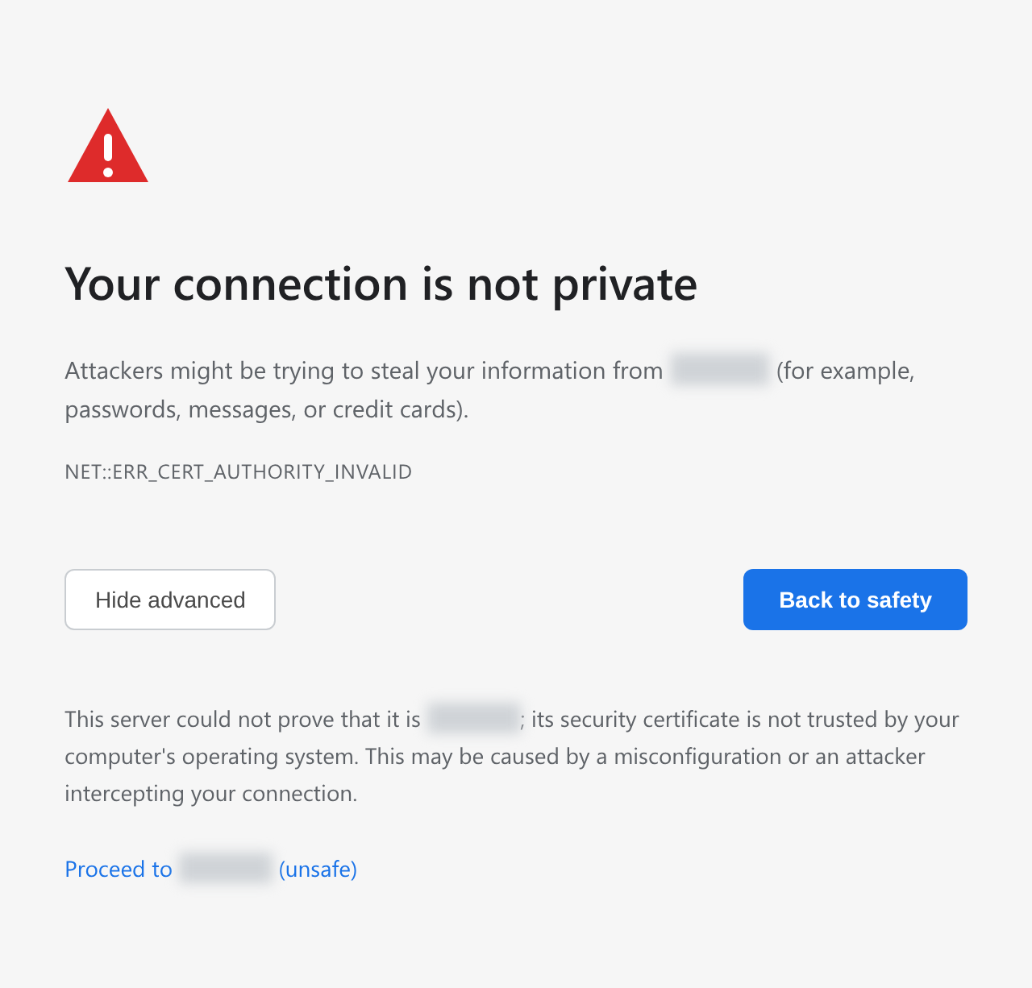
Register the cluster administrator
Register the cluster administrator, the top-level administrator of Logpresso Sonar.
When the Registering Cluster Administrator screen appears, enter the information required to register the cluster administrator.
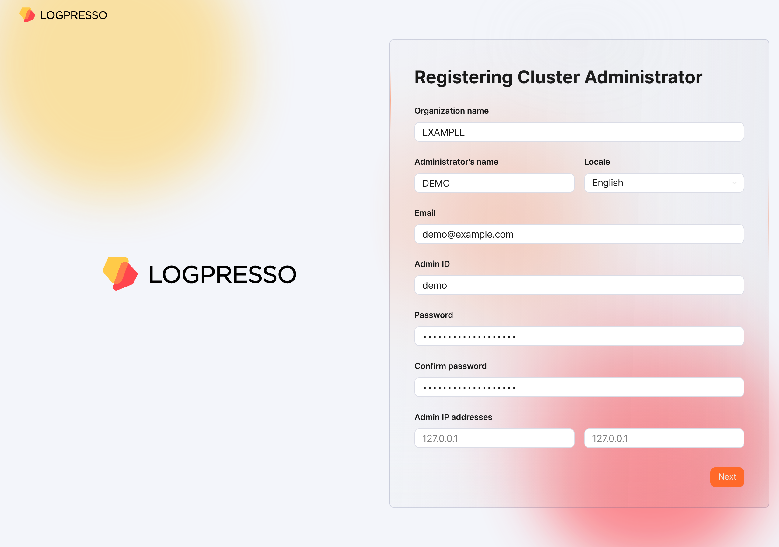
- Organization name: The name of the company or organization that will operate Logpresso Sonar
- Administrator's name: The name of the cluster administrator. When the cluster administrator logs in, the administrator's name is displayed in the upper-right corner of the web console.
- Locale: The language of the cluster administrator. Either Korean or English is selected according to the language of the web browser you access from.
- Email: The email address of the cluster administrator
- Admin ID: The login name of the cluster administrator. Do not use well-known login names such as root, system, admin, administrator, logpresso, or sonar.
- Password/Confirm password: The login password of the cluster administrator
- Admin IP addresses: Used to restrict cluster administrator access to specific IP addresses. You can specify up to two IP addresses.
Click the Next button to proceed to the next step.
Configure the certificates and web endpoint
Replace the certificates and configure the web endpoint. The web endpoint is the address that employees access when writing or reviewing explanations for security events.
When the System Configuration screen appears, enter the information required for the system configuration.
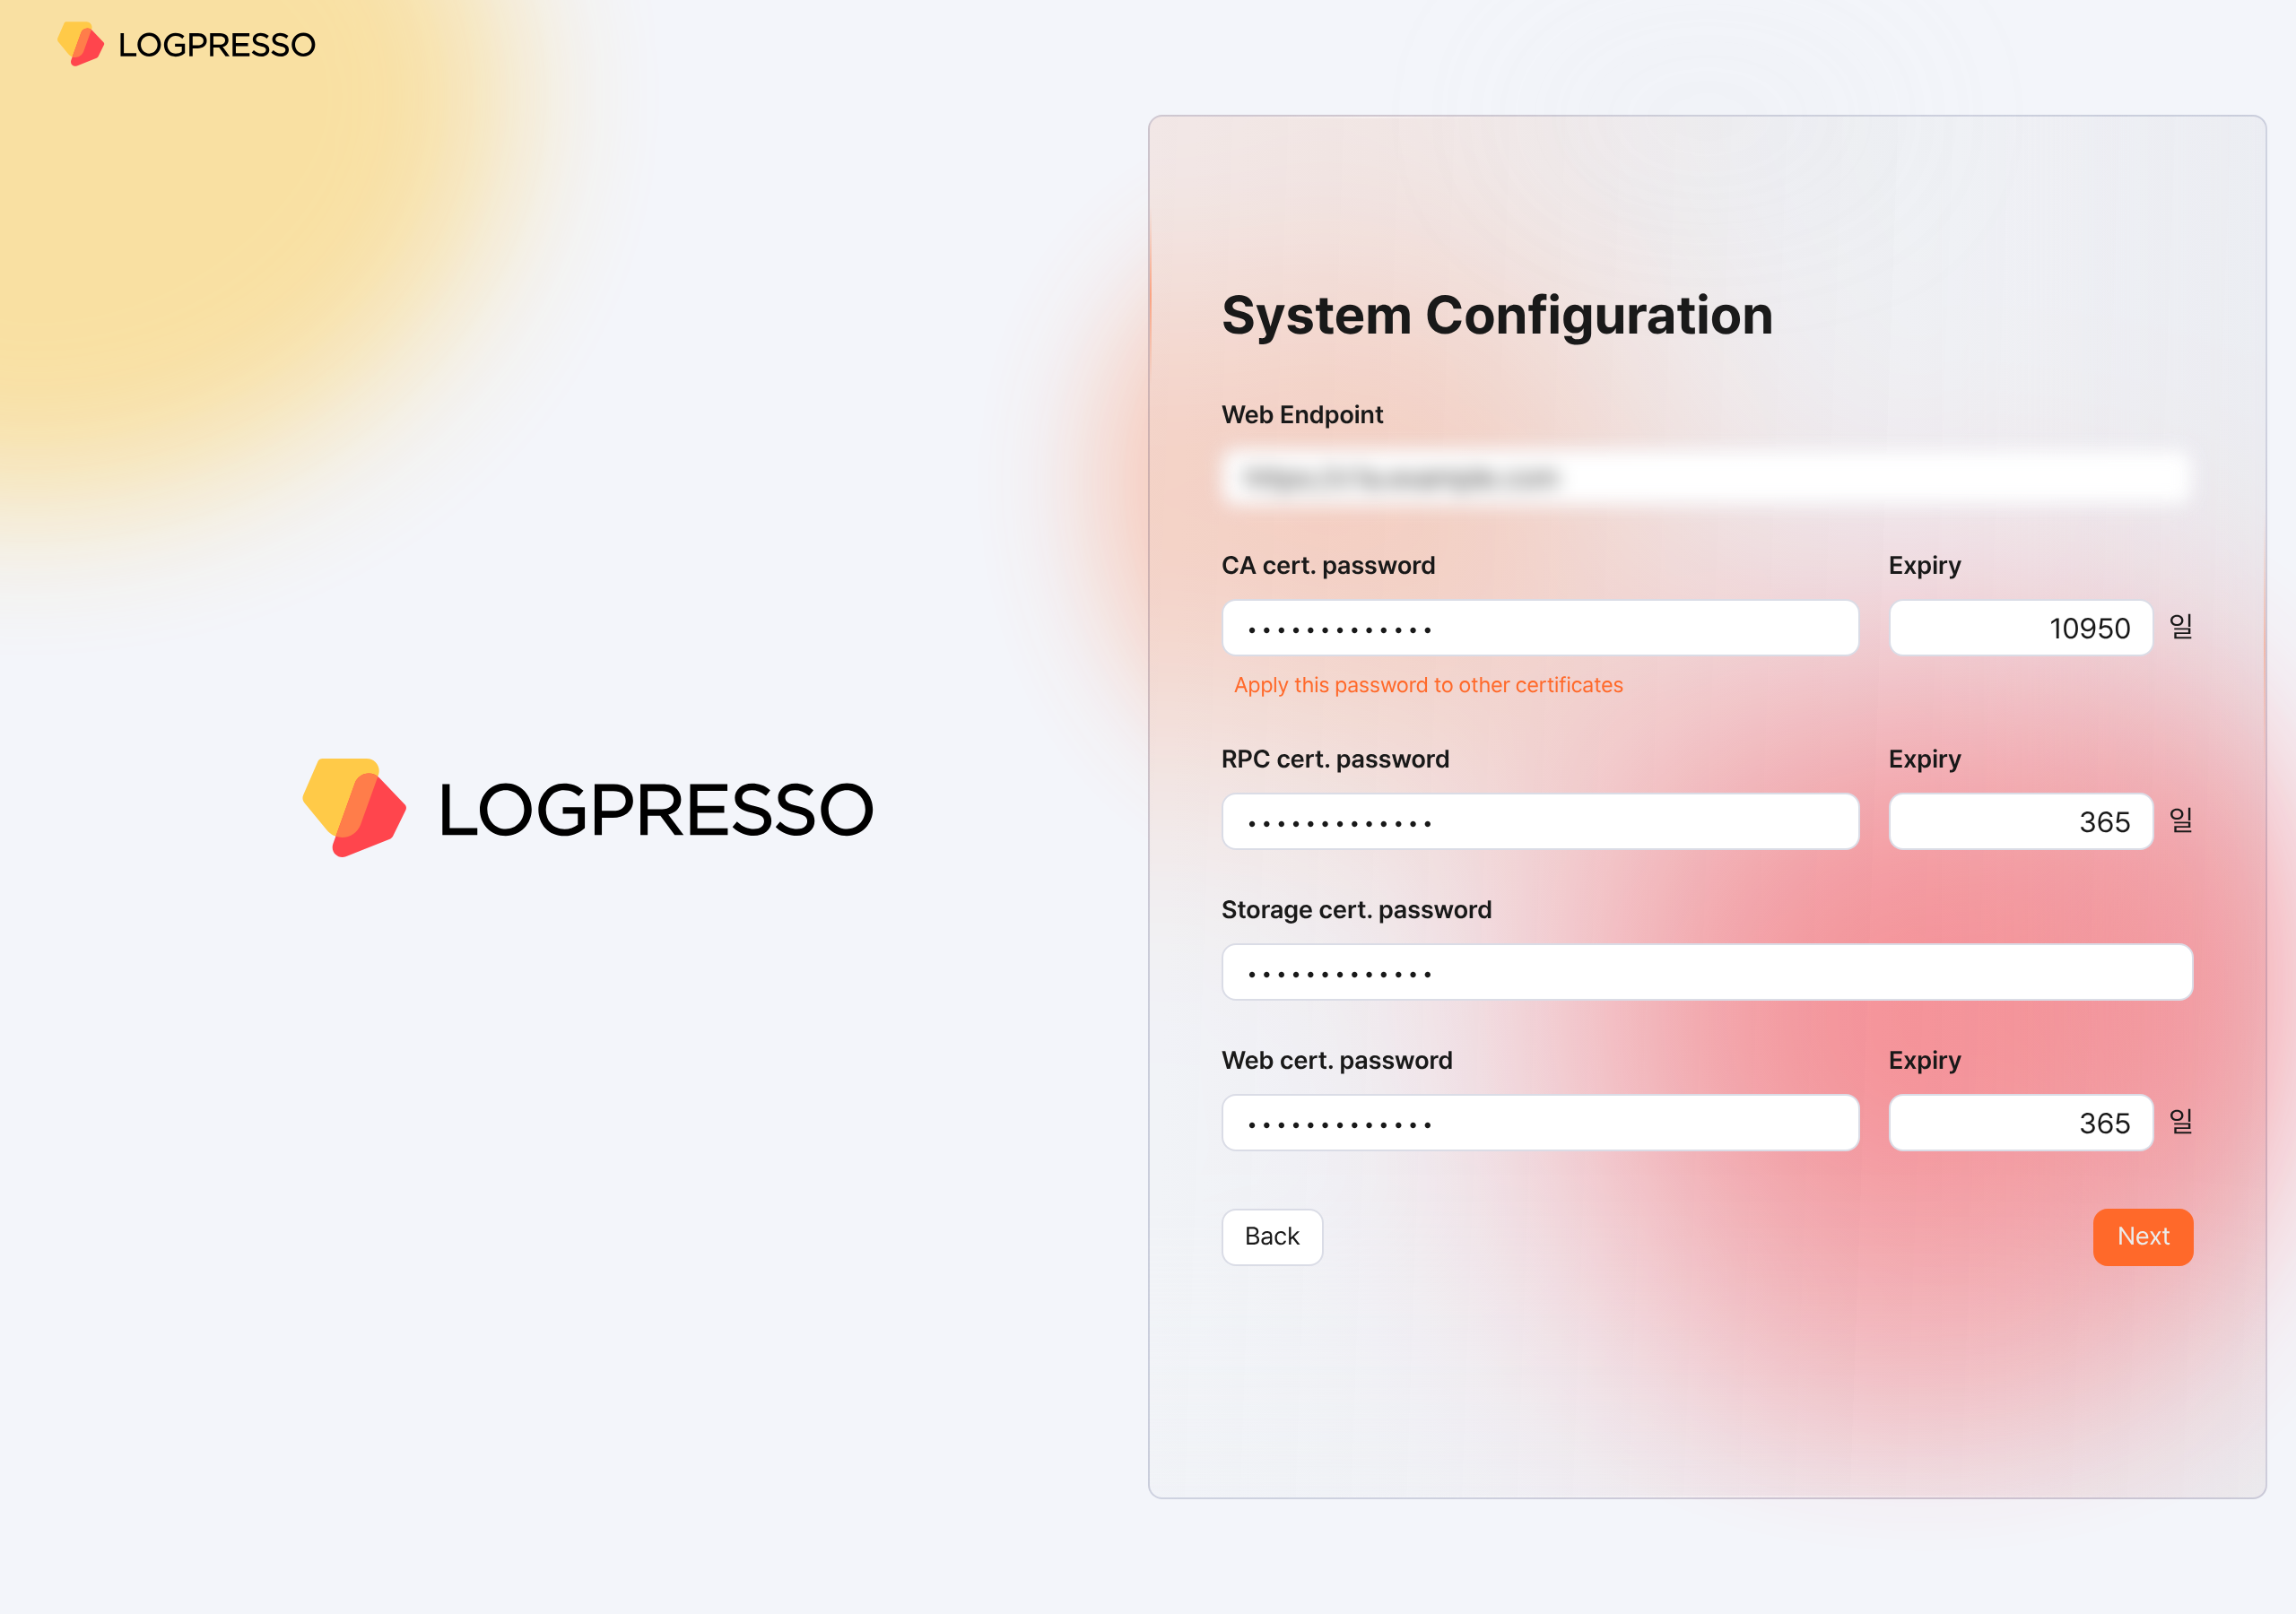
- Web Endpoint: The web console address. Use the virtual IP address or FQDN address of the Control Node pair, as shown below.
- # Virtual IP address of the Control Node: 192.0.2.24
# FQDN: sonar.example.com
https://192.0.2.24 or https://sonar.example.com
- CA cert. password: The CA certificate password (default/maximum validity period: 10950 days). After you enter the password, click Apply this password to other certificates to enter the same password for the other certificates.
- RPC cert. password: The certificate password used when communicating with Sentry (default/maximum validity period: 365 days)
- Storage cert. password: The password used for the certificate that stores the table encryption key. This certificate has no validity period.
- Web cert. password: The password of the web server certificate used when accessing the Logpresso Sonar web console (default/maximum validity period: 365 days)
Click the Next button to proceed to the next step.
Also keep the following in mind.
- You can change the Web Endpoint on the web console [Push Templates](/en/sonar/5.0/ui/section-push-template) screen.
- On the web console [Certificates](/en/sonar/5.0/ui/section-certificates) screen, you can view certificate information, reissue certificates, and more.
Calculate the expiration date of every certificate, set a reminder in advance in Google Calendar or a similar tool, and reissue each certificate before it expires.
After the web server certificate is replaced, the web browser reconnects to the web console. A security warning message may appear during the connection, but ignore it and proceed with the connection.
Configure object storage
Configure the object storage to use as Cold tier storage in the data lifecycle feature. If you do not use object storage or want to configure it later, click the Skip button.
Once you configure object storage, you cannot change it from the web console, so review your entire operating environment thoroughly before configuring it.
When the Object Storage Configuration screen appears, enter the information required for the object storage configuration.
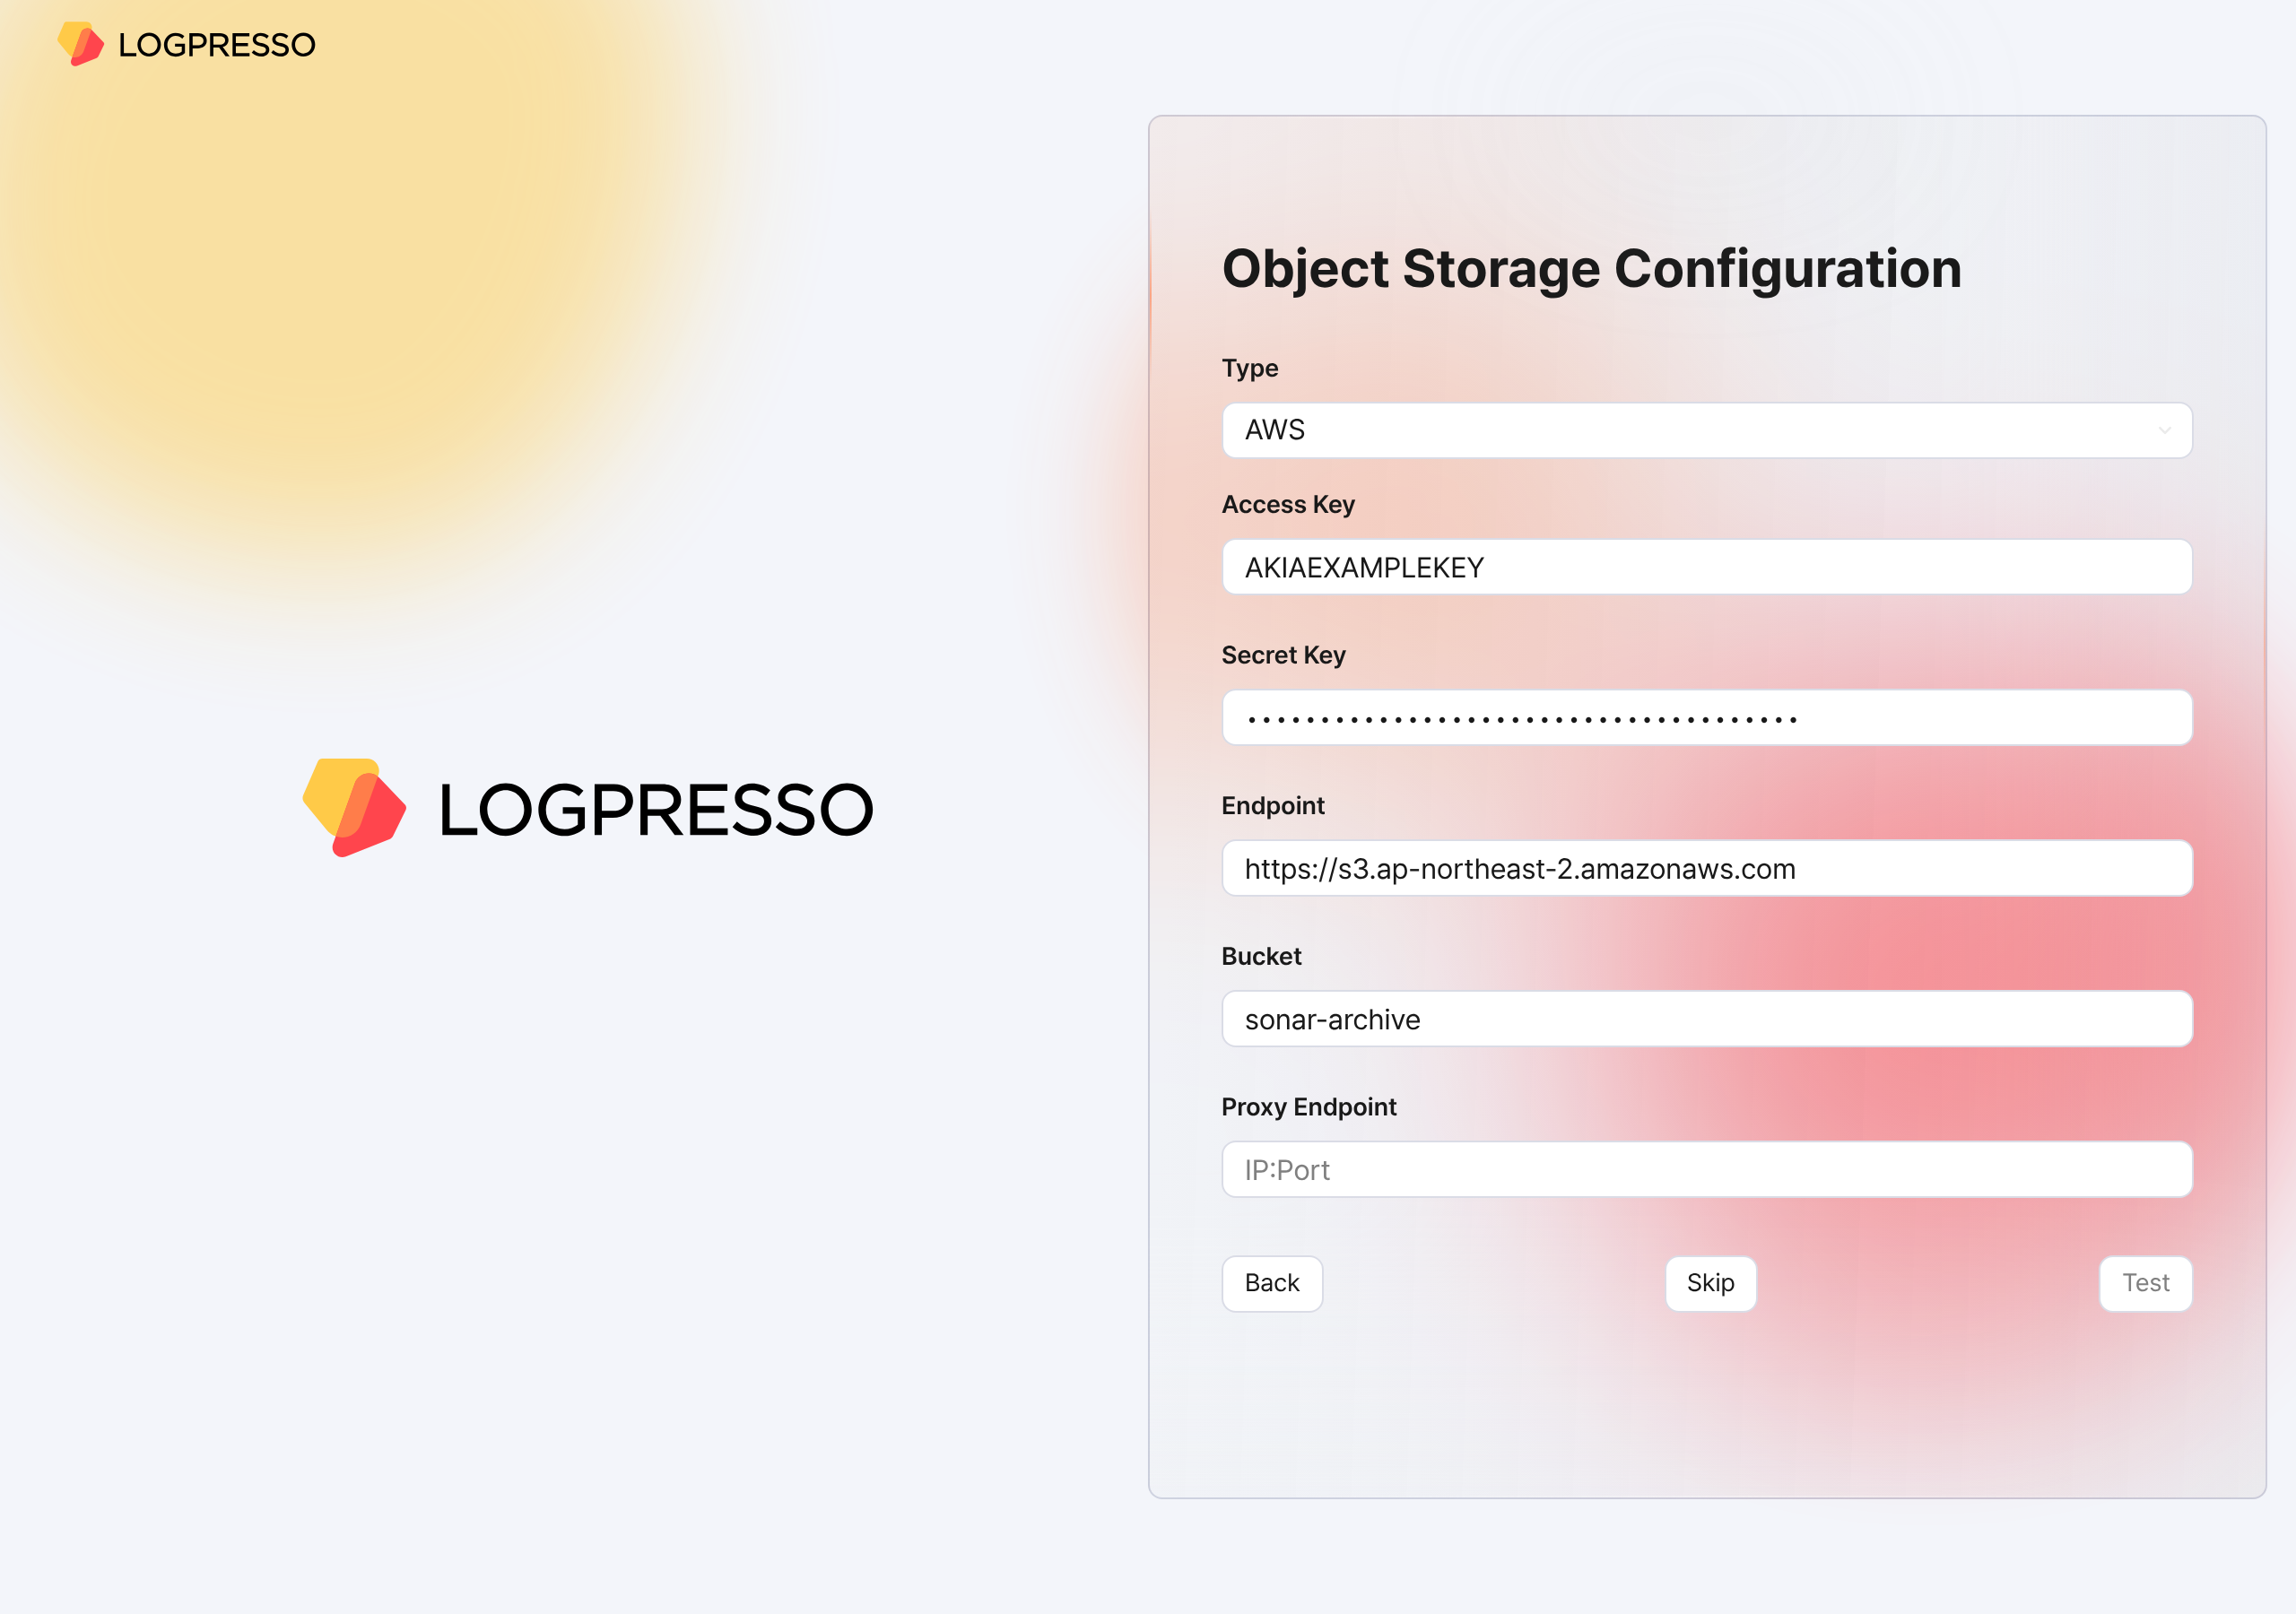
- Type: The storage service provider (select one of AWS, S3 Compatible Storage, or kakaocloud; default: AWS)
- Access Key or Authentication Key: The access key for connecting to the storage service
- Secret Key or Secret access Key: The secret access key for connecting to the storage service
- Endpoint: The connection address of the storage service
- Bucket: The name of the storage bucket
After entering all properties, click the Test button. The test must succeed before you can proceed to the next step.
Also keep the following in mind.
- On the [Lifecycle](/en/sonar/5.0/ui/subsection-lifecycle) tab of the web console [Clusters](/en/sonar/5.0/ui/section-node-config) screen, set the retention period for each storage tier, and on the [Storage](/en/sonar/5.0/ui/subsection-storage) tab, set the rollover. Only then can you manage data according to the data lifecycle.
Configure the database
Now connect the MariaDB database to Logpresso Sonar.
When the Database Configuration screen appears, enter the database configuration. Once you enter all the configuration values, a database connection is attempted automatically. If the connection succeeds, the message Successfully connected to database. is displayed and the Next button becomes active. Click the activated Next button.
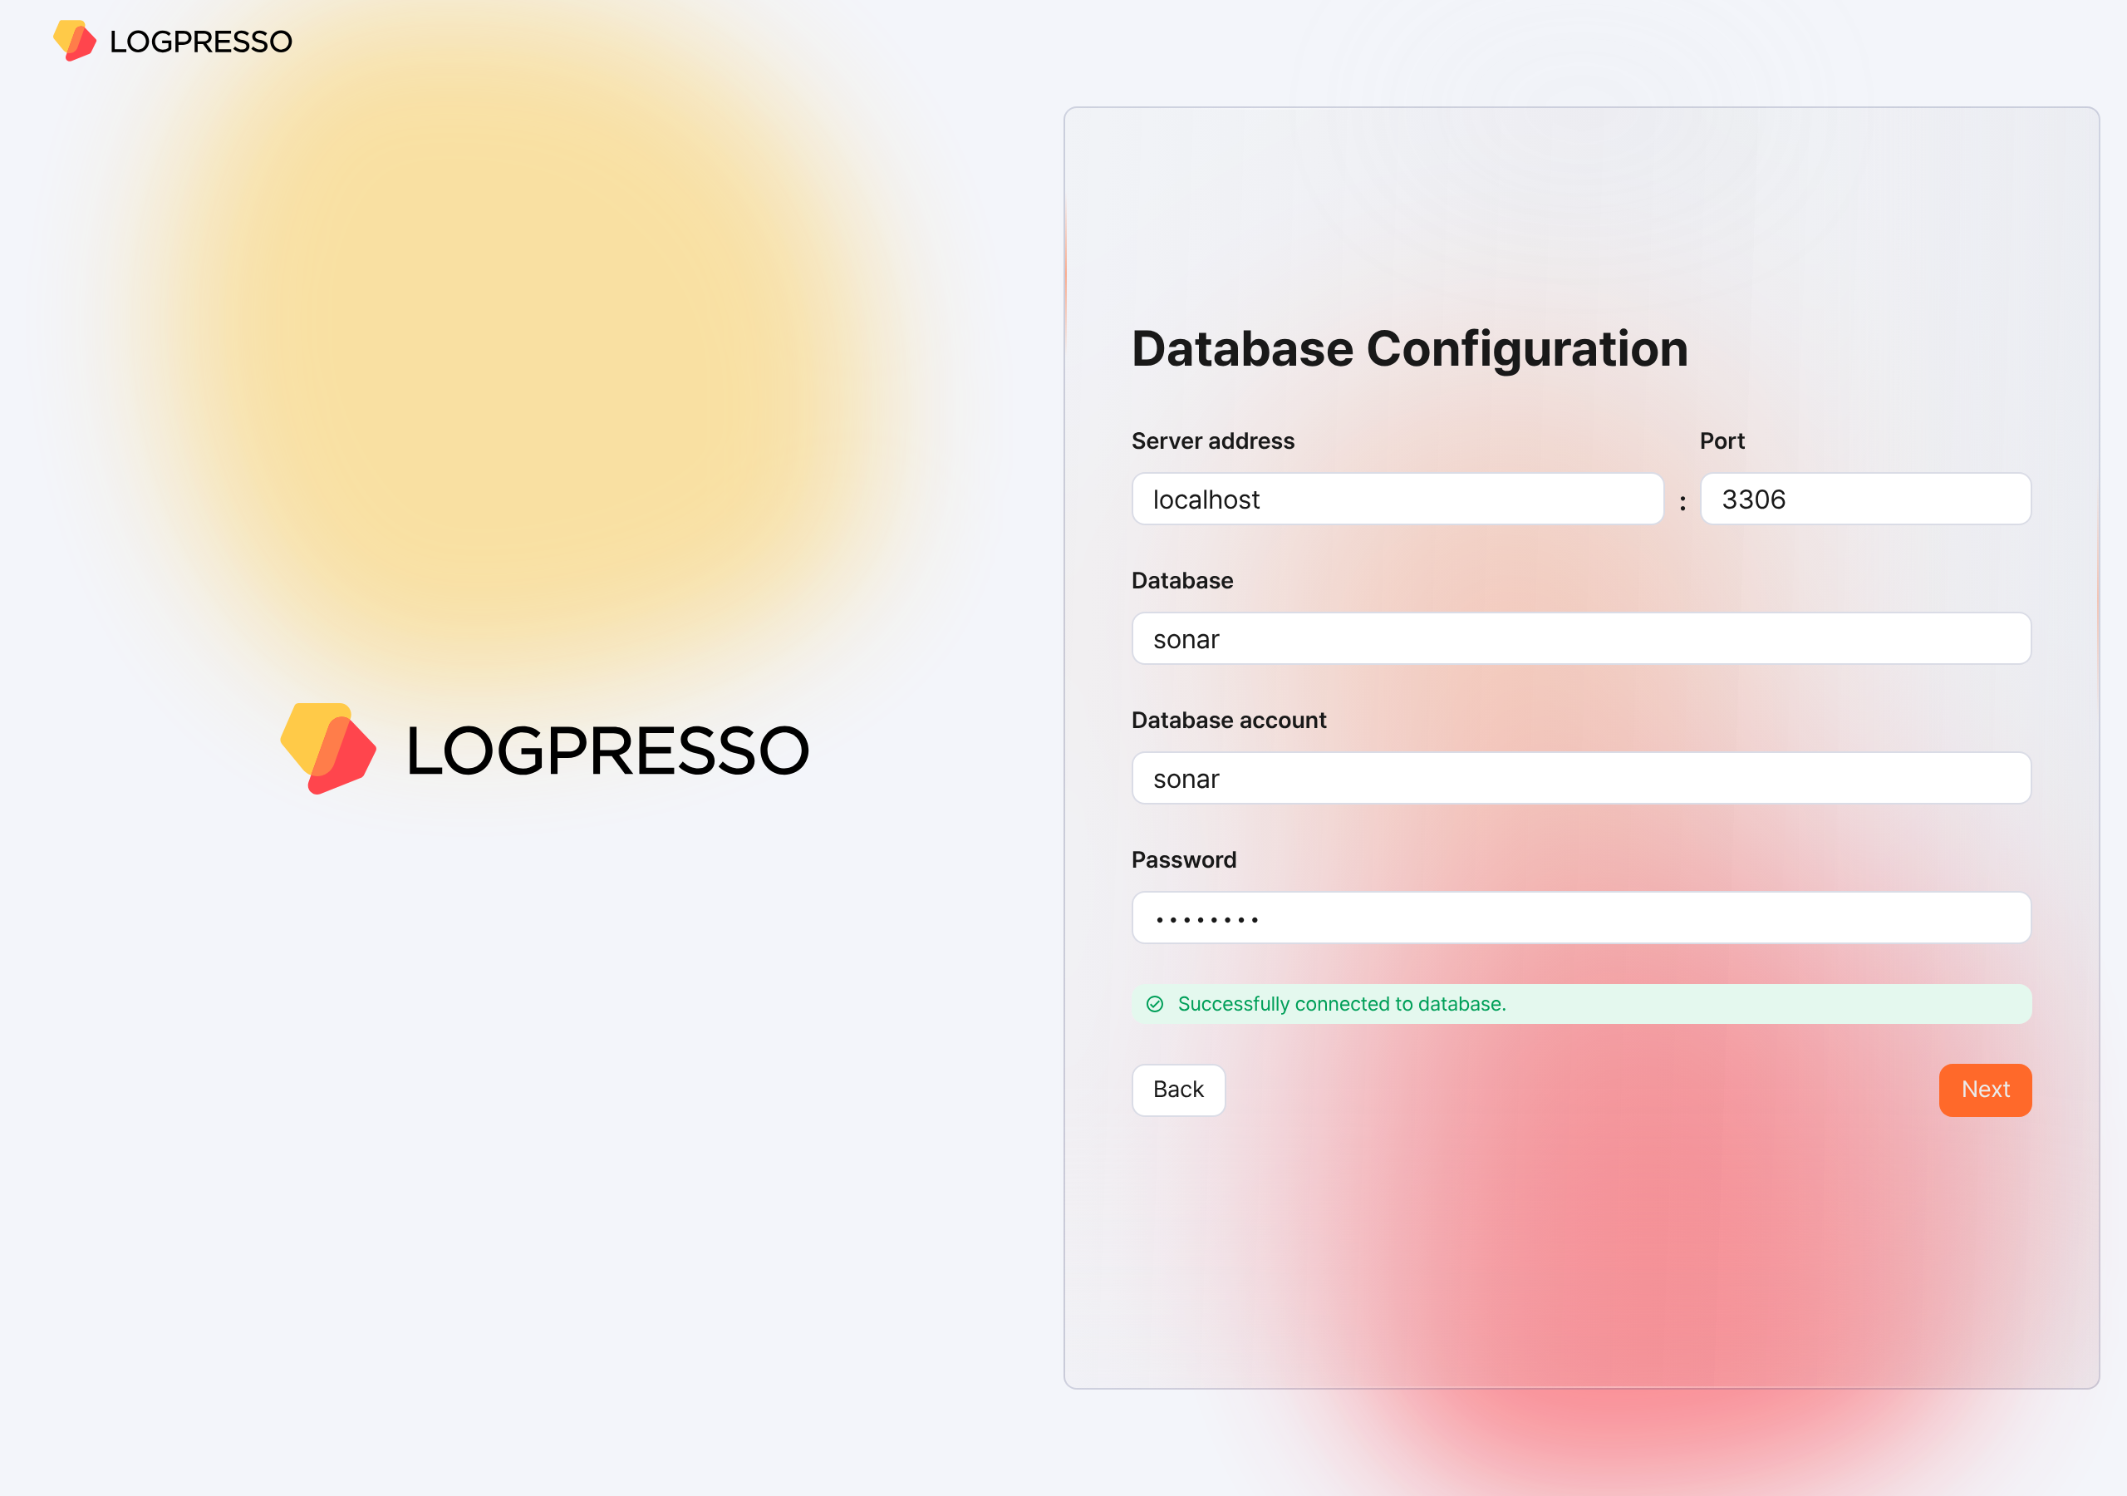
- Server address: The address of the MariaDB server (default: localhost)
- Port: The port number of the MariaDB server (default: 3306)
- Database: The database name of the MariaDB server (default: sonar)
- Database account: The dedicated database account for Logpresso Sonar (default: sonar)
- Password: The password of the dedicated database account for Logpresso Sonar
- If the connection fails, an error message appears. Review the error, correct the configuration values, and then click the Retry button.
- 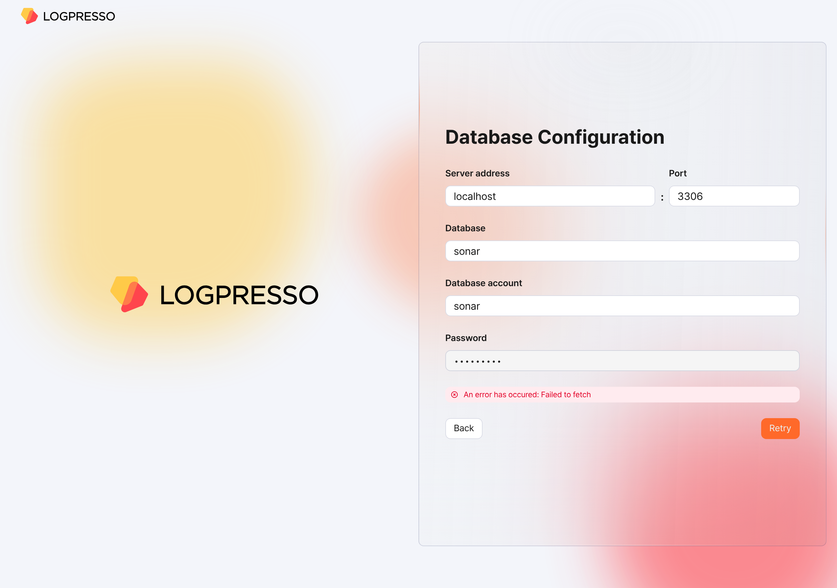
When the database configuration is complete, the settings required to run Logpresso Sonar are applied automatically. All settings configured in the web installer are synchronized with Node B through the Galera Cluster.
When the settings have been applied, the certificates are replaced and the browser reconnects to the web console login screen. Because a renewed self-signed server certificate is used, a security warning may appear. Ignore the warning and proceed.
Summary
After you complete the steps up to this point, the following tasks have been performed on Node A.
- A database and tables are created in MariaDB, and default data is injected
- The database layer is synchronized with Node B by the Galera Cluster
- The application layer is configured
- A JDBC profile required to connect to the database is created
- The authentication service required for the cluster administrator to access the web console is configured
The basic setup of Node A is complete, but the application layer configuration of Node B still remains. You will proceed with this configuration in the next step.
If you operate as a standalone deployment without configuring a cluster, skip to the License registration step.

Federation communication account setup
For federation communication between nodes, you must set the passwords of the Logpresso Shell account and the federation account on both Node A and Node B. This process is performed in the Logpresso Shell. The Logpresso Shell is the CLI of the Logpresso engine and uses an account that is separate from the web console access account (for example, the cluster administrator).
Access the Logpresso Shell
Access the Logpresso Shell on each of Control Node A and B, and change the default password. We recommend registering an SSH key in case you lose the password.
Change the default password
In the terminal, run the following command to access the Logpresso Shell. The port number may differ depending on the SSH_PORT setting in the logpresso.conf file (default: 7022).
ssh -p 7022 root@localhost
When prompted for a password, enter the Logpresso Shell default password.
When the new password prompt appears, enter a new password and press the Enter key. The Logpresso Shell account is used only for SSH access to each node, so you can set a different password for each node.
Please change the default password.
New password: # Enter a new password, then press Enter
Retype password: # Re-enter the new password, then press Enter
Password changed successfully.
Logpresso SNR-4.0.2511.1 (build 20250805) on Araqne Core 4.0.5
logpresso> # Logpresso Shell prompt
The Logpresso Shell rejects reuse of the default password. Never reuse the default password on any account. If a problem occurs due to using the default password, Logpresso is not responsible for it.
Depending on the operating system, the connection may fail during SSH key exchange and encryption algorithm negotiation when connecting to the Logpresso Shell. Add the following content to the ~/.ssh/config file of Control Nodes A and B, and connect using the ssh sonar command.
Host sonar
HostName 127.0.0.1
Port 7022
User root
HostKeyAlgorithms +ssh-rsa
PubkeyAcceptedAlgorithms +ssh-rsa
KexAlgorithms +diffie-hellman-group14-sha1
Ciphers +aes256-cbc
PreferredAuthentications publickey # SSH key login
IdentityOnly yes # SSH key login
IdentityFile ~/.ssh/logpresso_rsa # SSH key login
Register an SSH key (optional)
You can access the Logpresso Shell using SSH key authentication. Because you can access it even if you lose the password, we recommend registering an SSH key.
If you do not have an RSA key, run the following command to generate a key pair.
ssh-keygen -t rsa -b 2048 -f ~/.ssh/logpresso_rsa
The Logpresso Shell supports only ssh-rsa keys.
In the Logpresso Shell, run the following command to register the SSH public key.
account.addSshKey root
When the prompt appears, enter the SSH public key. The public key is in the ~/.ssh/logpresso_rsa.pub file.
SSH public key? ssh-rsa AAAAB3NzaC1yc2EAAAADAQABAAACAQ... # Enter the entire public key
root password: # Enter the current password
added
You can also specify the absolute path of the public key file directly: account.addSshKey root /home/logpresso/.ssh/logpresso_rsa.pub
Run the following command to check the list of registered SSH keys.
account.sshKeys root
When you run the command, you can check the registered SSH keys as follows.
Authorized SSH keys
---------------------
1: ssh-rsa AAAAB3NzaC1yc2EAAAADAQABAAACAQ...
You can now access the Logpresso Shell with the SSH key without a password.
ssh -p 7022 -i ~/.ssh/logpresso_rsa root@localhost
Set the federation account password
The federation account is the account used for communication between all nodes that make up the cluster, and all Control, Data, and Forwarder Nodes must use the same federation account password. The federation account password set in this step is used not only in Control Node pair registration, but also in the Data Node pair and the Forwarder Node pair.
In the Logpresso Shell of Node A and Node B, run the following command to change the password of the federation account.
dom.resetPassword localhost root
When the new password prompt appears, enter a new password and press the Enter key.
New Password: # Enter a new password, then press Enter
- You can enter the password only once. If you enter the password incorrectly, run the dom.resetPassword localhost root command again.
The federation account root belongs to a different authentication domain than the Logpresso Shell account root, even though they have the same name. During the federation password change process, ERROR logs may be temporarily recorded in araqne.log, but they are resolved after the change is complete.
Refer to this document to change the Password Expiration of the federation account to Unlimited.
Open a web browser, access https://<Control Node A IP address>:8443, and then log in with the federation account.
In the left menu of the web console, go to the System > Users screen.
In the federation account list, click root.
In the Passwd. Expiration field, select Unlimited and click the Save button.
Perform the same task on Node B as well.

Node B initial setup
On Node A, the web installer automatically configures the authentication service and the database connection. On Node B, you must perform this configuration manually. Because Node A and Node B share the same MariaDB, once you complete this configuration, the cluster administrator can log in to the Node B web console with the same account.
Configure the sonar authentication service
The sonar authentication service is used for web console user authentication. You must complete this configuration for the cluster administrator to log in to the Node B web console.
In the Logpresso Shell of Node B, run the following command to enable the sonar authentication service.
logdb.useAuthService sonar dom
Run the following command to check whether the sonar authentication service is enabled.
logdb.authServices
In the External Auth Services list, if dom and sonar are marked with an asterisk (*) and the order is sonar - dom, it is normal.
External Auth Services
------------------------
[*] dom - araqne-dom authentication provider for araqne logdb
[*] sonar - com.logpresso.sonar.dom.impl.SonarAuthServiceImpl@5d7b80f7
order: sonar - dom
Create a JDBC profile
For Logpresso Sonar to connect to MariaDB on Node B, you must create a JDBC profile.
Run the following command to create a JDBC profile.
logpresso.createConnectProfile jdbc sonar
When the profile creation prompt appears, enter the values as follows.
Connection String (required)? jdbc:mariadb://localhost:3306/sonar # Database connection string
User (optional)? sonar # The database account created with the web installer on Node A (default: sonar)
Password (optional)? # The password of the database account created with the web installer on Node A
Read Only (optional)? false # Be sure to enter false
Granted users (csv)? # Press the Enter key to skip
Granted groups (csv)? # Press the Enter key to skip
Run the following command to check the GUID of the created JDBC profile.
logpresso> logpresso.connectProfiles
Connect Profiles
------------------
guid=59f4788b-75df-4297-afbd-579eed9cb086, type=jdbc, name=sonar, description=null, source=ENT
Run the following command with the GUID you checked to verify that the profile was created correctly.
logpresso> logpresso.connectProfile 59f4788b-75df-4297-afbd-579eed9cb086
Connect Profile
-----------------
Type: jdbc
Name: sonar
Description: null
Configs
* Connection String: jdbc:mariadb://localhost:3306/sonar
* User: sonar
* Password: ********
* Read Only: false
Restart the Logpresso service
To apply the profile settings, you must restart the Logpresso service.
On Node B, run the following command to restart the Logpresso service.
sudo systemctl restart logpresso
Run the following command to verify that the service is running normally.
sudo systemctl status logpresso
If the status is Active: active (running) as shown below, it is normal.
logpresso.service - Logpresso daemon
Loaded: loaded (/usr/lib/systemd/system/logpresso.service; enabled; preset: disabled)
Active: active (running) since Sat 2025-12-13 10:56:58 KST; 6 days ago
Docs: https://ko.logpresso.com/documents
Main PID: 1682 (java)
Tasks: 229 (limit: 23116)
Memory: 4.1G
CPU: 4d 40min 56.229s
CGroup: /system.slice/logpresso.service
└─1682 /opt/logpresso/jre/bin/java ...(omitted)... -jar /opt/logpresso/sonar/araqne-core-4.0.5-package.jar

Web console login
Log in to the web console on Node A and Node B respectively. Log in with the cluster administrator account.
On Node A, after running the web installer, verify that the login screen is displayed. If you closed the web browser window, access the https://NODE_A_IP_ADDR or https://FQDN address (for example, https://203.0.113.194, https://c1a.example.com).
On Node B as well, access the https://NODE_B_IP_ADDR or https://FQDN address (for example, https://203.0.113.195, https://c1b.example.com).
When you access the web console, a notification blocking message may appear in the lower-right corner of the screen.

Change the notification setting of the web browser to Allow so that you can check server notifications in the web console.

Enter the Username and Password of the cluster administrator and click the Login button.
If you fail to log in several times, the account is locked for a certain period. If you need to unlock the account or change the password, contact the server administrator.

License registration
After logging in, register a license first.
Request a license
On the web console System > Licenses screen of Node A and Node B, check the Hardware Key and record it in a safe place.
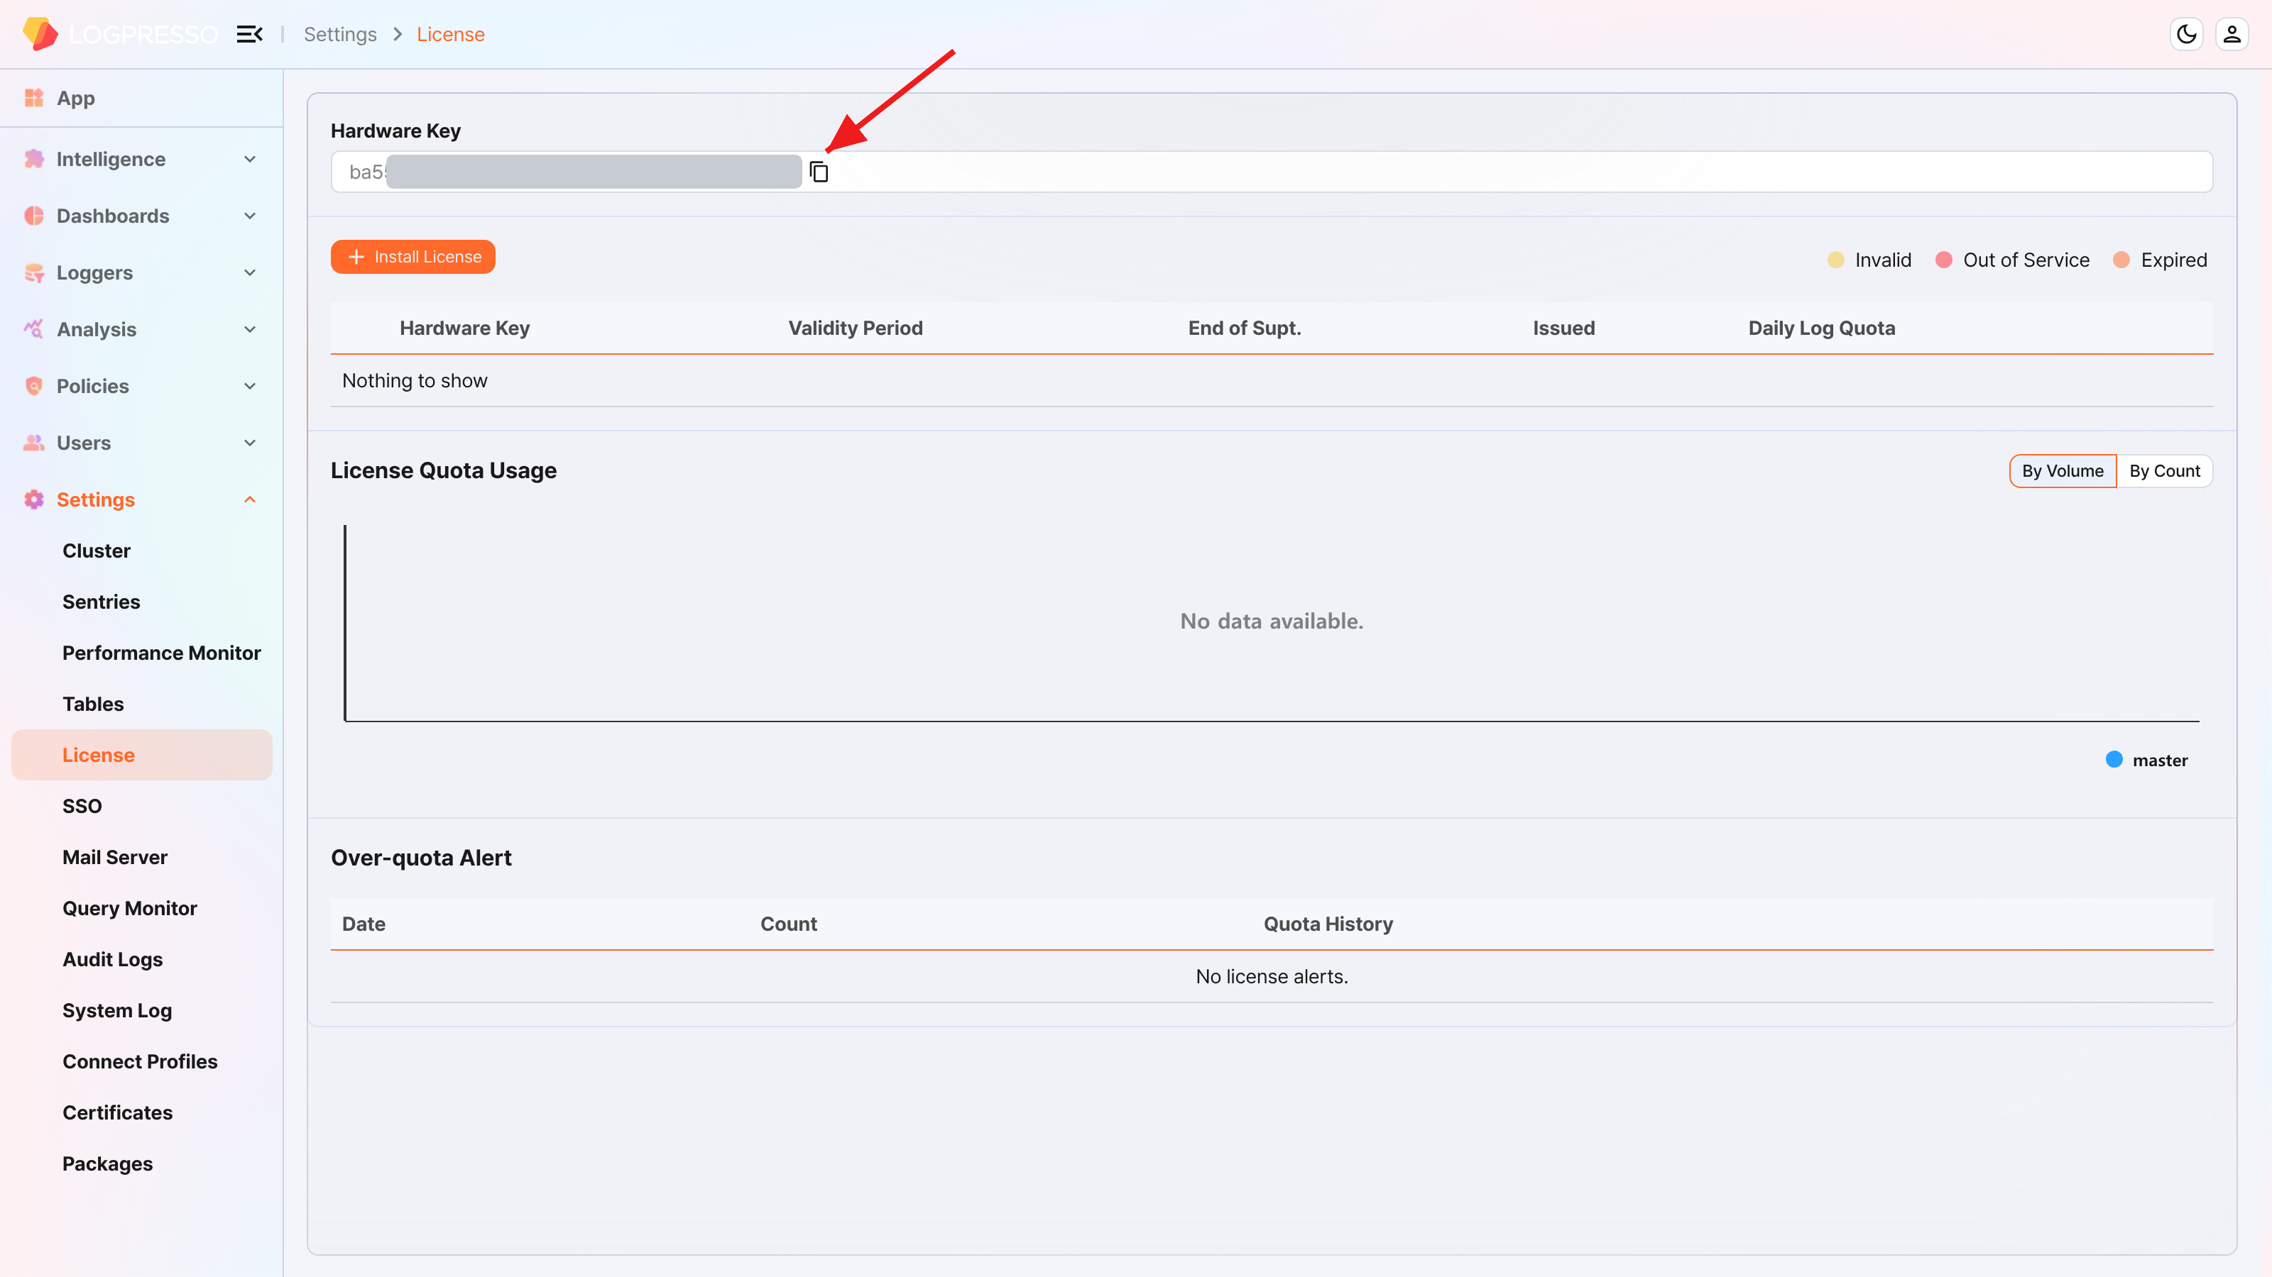
On the Logpresso support portal, request license issuance for the hardware keys of Node A and Node B.
You must perform the subsequent tasks after the license has been issued.
Enter the license
On the web console System > Licenses screen of Node A and Node B, click the Install License button.
Paste the issued license information into the input window and click the OK button.
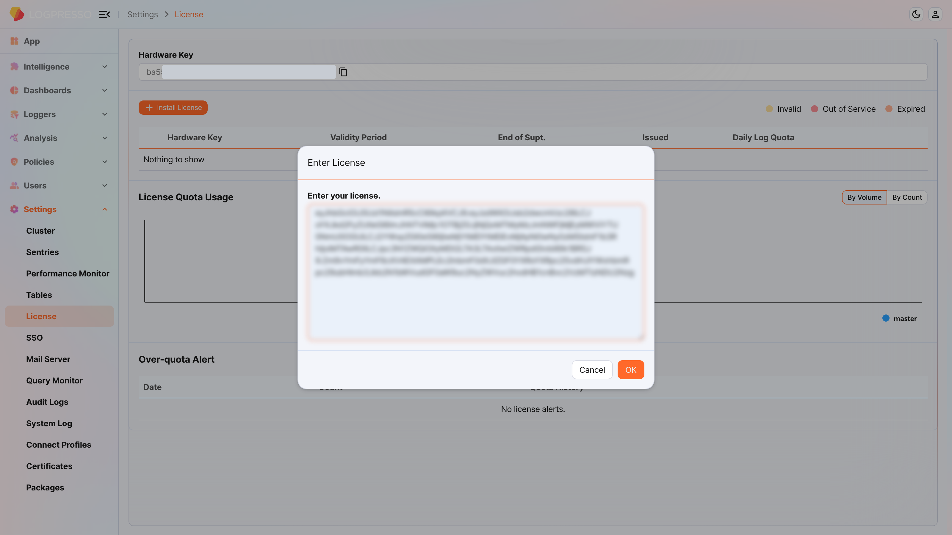
Verify that the license is registered correctly.
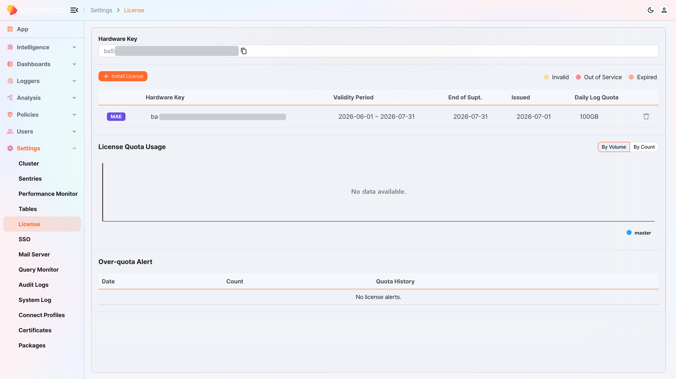

Control Node pair setup
Register the Control Node pair
Register the Node Pair on the web console System > Clusters > Node screen of Node A. Here, we explain the method of deleting and reconfiguring the existing Node Pair.
The name of the default Node Pair is 'control' and cannot be changed. To change the name, you must delete the default Node Pair and register a new one.
On the web console of Node A, go to the System > Clusters menu.
Select the existing control node and click the Delete button.
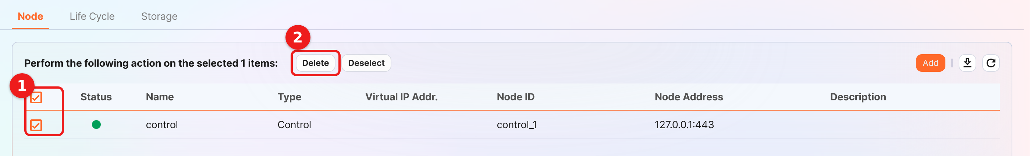
In the upper-right corner of the cluster node list, click the Add button and configure the Control Node pair. For a detailed description of each property, refer to Add a Node Pair in the user guide.
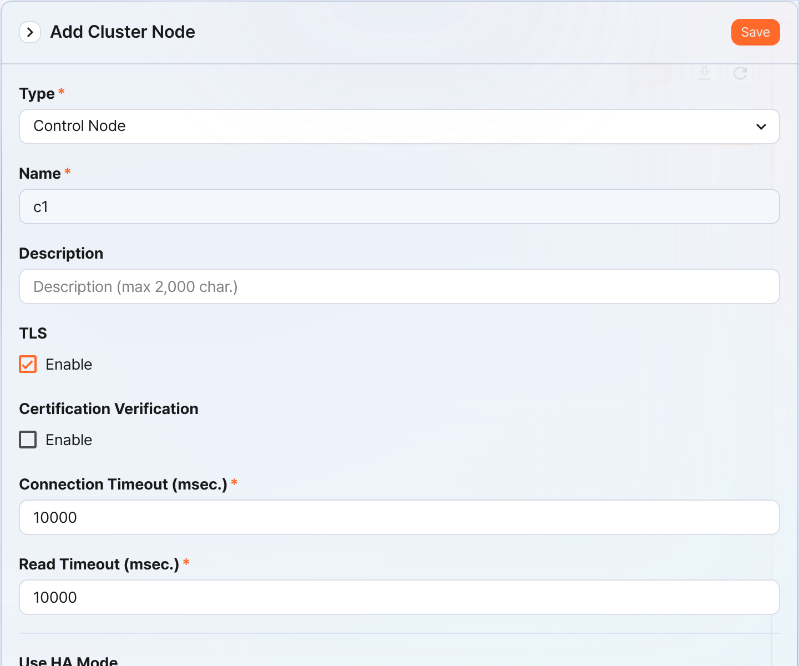
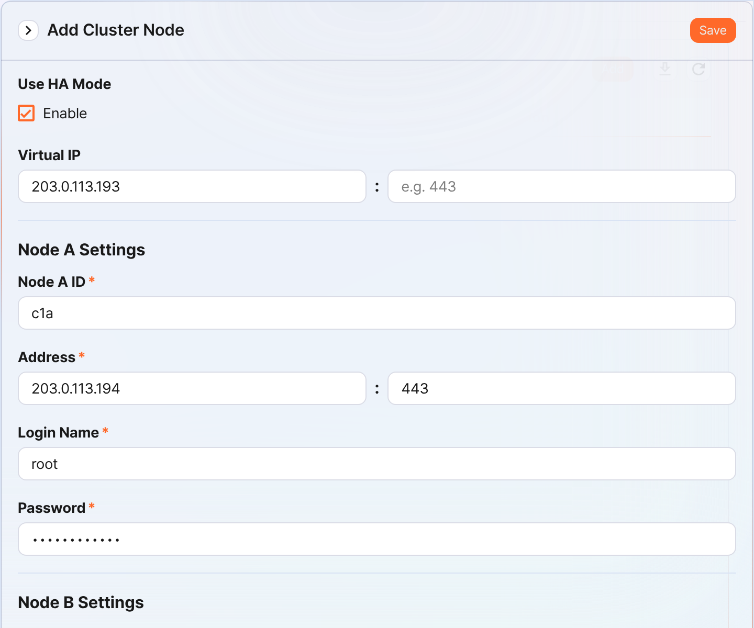
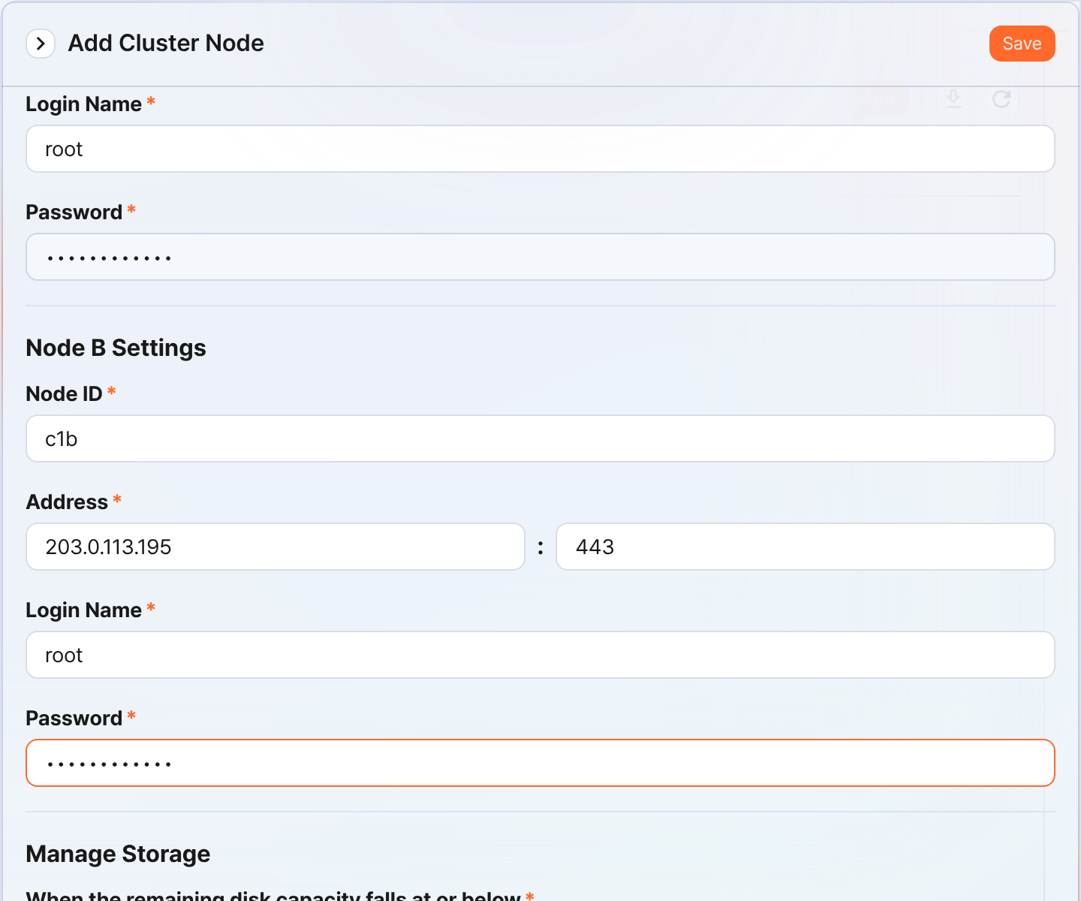
- Type: Select Control Node
- Name: Enter the Control Node pair identifier (for example, c1)
- You cannot change it after clicking the Save button.
- Description: A description of the Node Pair (can be omitted)
- TLS: Selected
- Certification Verification: Not selected
- Connection Timeout: Use the default value
- Read Timeout: Use the default value
- Use HA Mode: Selected
- Virtual IP: The IP address of the Control Node pair (for example, 203.0.113.193)
- This IP address is used as the VIP in the HA script.
- Node A Settings
- Node A ID: Enter the Node A identifier (for example, c1a)
- Address: The actual IP address and communication port of Node A (for example, 203.0.113.194:443)
- The port number of the Control Node is 443.
- Login Name: Enter root
- Password: Enter the Sonar federation account password
- Node B Settings
- Node ID: The Node B identifier (for example, c1b)
- Address: The actual IP address and communication port of Node B (for example, 203.0.113.195:443)
- Login Name: Enter root
- Password: Enter the Sonar federation account password
After completing the input, click the Save button. Verify that the Control Node pair has been added as shown below.
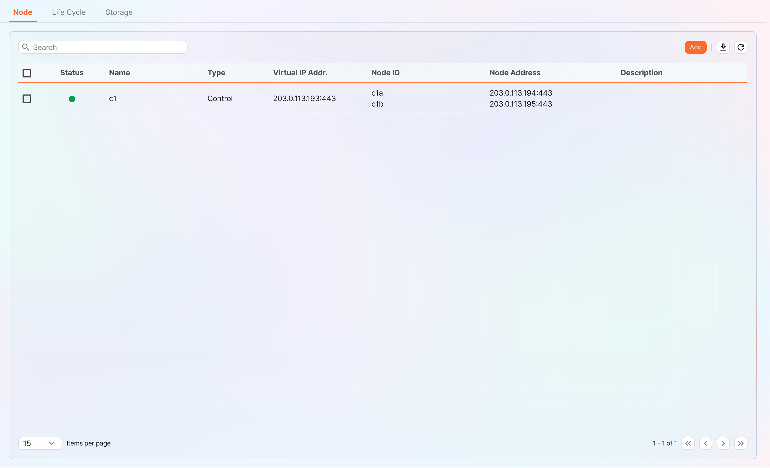
Click the Name of the added Control Node and check the GUIDs of Node A and Node B. If you specified the Name or Node ID incorrectly, you must delete the Node Pair and reconfigure it.
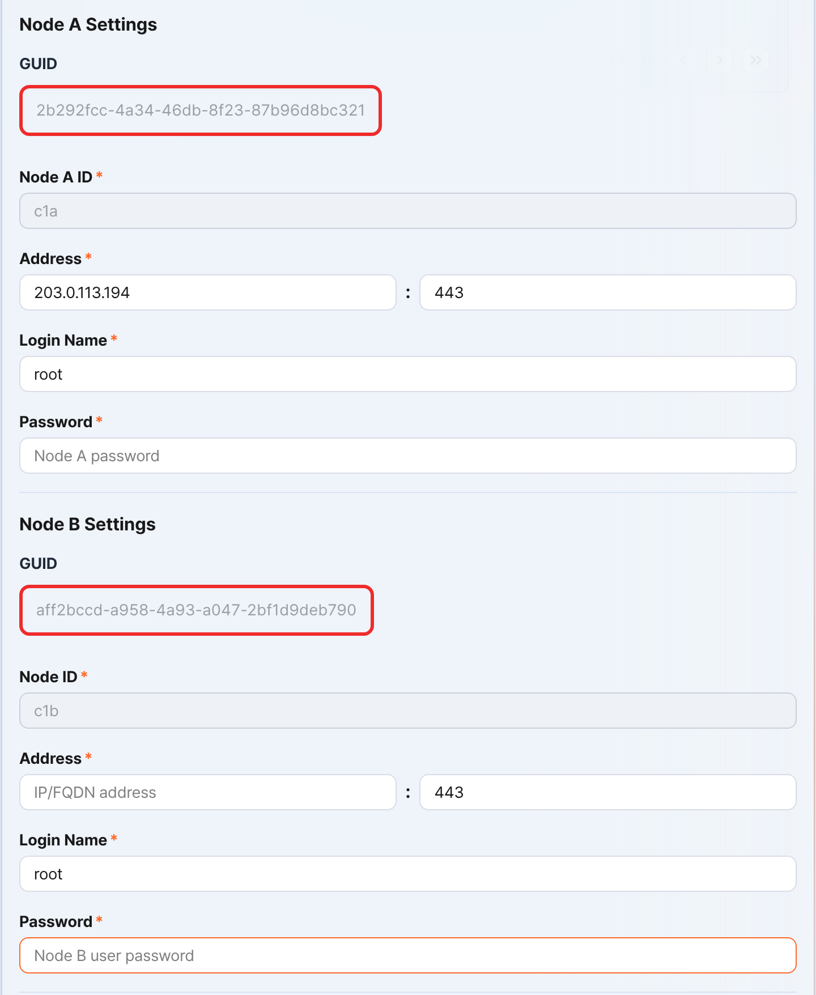
Record the GUIDs of Node A and Node B in a safe place. These values are used in Node GUID configuration.
Copy the key encryption key
Set the same key encryption key (KEK, Key Encryption Key) of Node A on Node B. Because the key encryption key does not allow replication between nodes, the administrator must copy it directly.
After completing this configuration, never change the key encryption key. All nodes that make up the cluster must use the same key encryption key. If they use different keys, encrypted data cannot be decrypted, so synchronization between nodes cannot be performed.
In the Logpresso Shell of Node A, run the following command and record the encryption key string in a safe place.
sonar.cipherKey
Copy the encryption key string of Node A, and then in the Logpresso Shell of Node B, run the following command to configure the same encryption key. KEY_STRING is the encryption key string of Node A.
sonar.setCipherKey KEY_STRING
Node GUID configuration
Set the GUID of Node A that was changed in the Control Node pair registration step and the newly created GUID of Node B identically in the Logpresso Shell.
In the Logpresso Shell of Node A and Node B, run the following command to set the GUID for policy synchronization of each node in the Logpresso engine. GUID_STRING is the GUID string of each node.
sonar.setGuid GUID_STRING # Enter the GUID that matches each node
You can check the GUID for policy synchronization of each node with the following command.
sonar.nodeConfig
In the Logpresso Shell of Node A and Node B, run the following command to set the GUID for cluster control in the Logpresso engine.
sonar.setControlGuid GUID_STRING # Enter the GUID that matches each node
You can check the GUID for cluster control of each node with the following command.
sonar.controlNodeGuid
In each of steps 1 and 2, Node A must set the GUID of Node A, and Node B must set the GUID of Node B.
Configure the master node connection
Configure the master node connection information used to synchronize policies and settings within the cluster. In the case of a Control Node, specify itself (127.0.0.1) as the master to load policies from MariaDB.
This configuration is separate from the Node Pair registration information you performed earlier in the web console. The node pair information is used when other nodes connect to this node. The master node connection information configured here is used when this node connects to the master, and is stored in the confdb of the Logpresso engine. Because a Control Node is its own master, specify 127.0.0.1.
In the Logpresso Shell of Node A and Node B, run the following command.
sonar.setMaster
The following describes the prompts output after running the command and the values to enter. The account used here is the federation account.
host? 127.0.0.1 # Specify itself as the master
port? 443 # Enter 443
account? root # Enter root, the federation account
password? # Enter the federation account password
connect timeout? 10000 # Press the Enter key to use the default value
read timeout? 10000 # Press the Enter key to use the default value
secure? true # Enter true (the default is false)
skip cert check? true # Enter true (the default is false)
Option | Description | Example
host | Control Node address | 127.0.0.1
port | Port to communicate with the Control Node | 443
account | Federation account login name | root
password | Federation account password
connect timeout | Server connection wait time | 10000 (ms)
read timeout | Response wait time | 10000 (ms)
secure | Whether to apply TLS communication | true
skip cert check | Whether to skip TLS certificate validation | true
Run the following command to verify that the node configuration has been applied.
sonar.nodeConfig
The following is an example output that you can check when the configuration is applied correctly.
guid: 7bdb297d-1d2a-400b-8efc-ce8d98580a13
host=127.0.0.1, port=443, account=root, connectTimeout=10000, readTimeout=10000, secure=true, skipCertCheck=true
crypto_file_path: /opt/logpresso/data/logpresso-ca/certs/storage.pfx
On the web console System > Clusters screen of Node A, verify that the Status is displayed in green.
Configure the data replication mode
When you configure a Node Pair, you can replicate table data between the two nodes. Here, "table" does not mean a database table, but a file-based table where the Logpresso engine stores data.
If the same data exists on both nodes, duplicate searches may occur during distributed query execution. To prevent this, you must set one of the data replication modes, ACTIVE or STANDBY, on each node.
- Active Node: Stores the original log tables and becomes the search target during distributed queries.
- Standby Node: Receives the log table data of the Active Node in real time through replication. The replicated tables use the same table ID as the original, and are excluded from searches during distributed queries, so duplicate searches do not occur.
The logpresso.setStandbyNode command designates the peer node as standby and sets itself as active.
The logpresso.setActiveNode command designates the peer node as active and sets itself as standby.
Node A configuration (active)
In the Logpresso Shell of Node A, run the following command to check the name of the pair node (Node B).
logpresso.nodeStatuses
The following is an example output. In the Federation Nodes section, [c1b] is the name of Node B.
Local
------------------
Node GUID: ffdade37-6d96-4d13-9843-88569d64db6a
Instance GUID: 93e9d502-276f-468a-9311-019e1fed8a79
Federation Nodes
------------------
[c1b] node_guid=92eab23d-83e1-4ba2-91d6-48f5408b12a6, instance_guid=1a2eb7aa-85e2-4d73-a23e-9d8d1421605e, repl_mode=null, pair_guid=null, invalid_guid=false, alive=true, paired=true, failure=false, last connect=2025-06-09 13:51:39, last alive=2025-06-10 11:18:44, created=2025-06-09 13:48:37
The Node GUID and Instance GUID displayed in the logpresso.nodeStatuses command output are identifiers that the Logpresso engine uses for log table replication and distributed queries. The Node GUID is used to identify the database and is recorded in the DB_GUID file for permanent storage. The Instance GUID is the identifier of the currently running process and changes each time the node process is started.
Run the following command to designate Node B as the standby node, which makes Node A the active node. In the command example, c1b is the name of Node B that you checked above.
logpresso.setStandbyNode c1b
When you run the logpresso.nodeStatuses command again, you can see that Replication Mode is set to ACTIVE in the Local section.
Local
------------------
Node GUID: ffdade37-6d96-4d13-9843-88569d64db6a
Instance GUID: 93e9d502-276f-468a-9311-019e1fed8a79
Replication Mode: ACTIVE
Pair Node: c1b
Federation Nodes
------------------
[c1b] node_guid=92eab23d-83e1-4ba2-91d6-48f5408b12a6, instance_guid=1a2eb7aa-85e2-4d73-a23e-9d8d1421605e, repl_mode=null, pair_guid=null, invalid_guid=false, alive=true, paired=true, failure=false, last connect=2025-06-09 16:56:24, last alive=2025-03-27 13:35:12, created=2025-06-09 16:56:24
Node B configuration (standby)
In the Logpresso Shell of Node B, run the following command to designate Node A as active, which makes Node B the standby node. c1a is the name of Node A that you checked from the result of the logpresso.nodeStatuses command.
logpresso.setActiveNode c1a
When you run the logpresso.nodeStatuses command, you can see that Replication Mode is set to STANDBY in the Local section.
Local
------------------
Node GUID: ef5a8e0d-e80d-4b93-80a2-c8fec4b764ad
Instance GUID: c1fb7d52-229b-464b-be06-4f7784001c17
Replication Mode: STANDBY
Pair Node: c1a
Federation Nodes
------------------
[c1a] node_guid=ffdade37-6d96-4d13-9843-88569d64db6a, instance_guid=93e9d502-276f-468a-9311-019e1fed8a79, repl_mode=ACTIVE, pair_guid=ef5a8e0d-e80d-4b93-80a2-c8fec4b764ad, invalid_guid=false, alive=true, paired=true, failure=false, last connect=2025-06-09 16:56:58, last alive=2025-03-27 13:37:34, created=2025-06-09 15:54:59
Configure license sharing between nodes
Configure all nodes in the cluster environment to be covered by the same license. The license registered on the Control Node is also applied to the Data Nodes and Forwarder Nodes. Here, we explain how to propagate the license registered on the Control Node to the other nodes.
In the Logpresso Shell of Node A and Node B, run the following command to set the license master. Both nodes must become license masters.
logpresso.setLicenseMode master
Run the following command to check the license master status.
logpresso.licenseMode
When set correctly, the output is as follows.
MASTER
Enable distributed query
Distributed Query is a feature that queries table data distributed across multiple nodes as a single unified query. When you run a query on a Control Node, the Control Node distributes the necessary query to the Data Node pair and the query is executed on the Data Nodes. The Control Node aggregates the execution results of each Data Node and returns the final result. Distributed query must be enabled on all nodes.
In the Logpresso Shell of Node A and Node B, run the following command respectively to enable distributed query.
logpresso.enablePlanner
Run the following command to check the distributed query status.
logpresso.plannerStatus
When enabled correctly, the output is as follows.
Running: true
Configure the WebSocket frame
If the distributed query result is large or there is a lot of data to send to the web browser, transmission may fail with the default WebSocket frame size.
When you operate a Control Node as a combined control/data node, changing the WebSocket frame is optional, but when you configure a Control Node pair, be sure to configure it.
In the Logpresso Shell of Node A and Node B, run the following command to check the current setting value.
webconsole.maxFrameSize
The default value is 8MB, and the command execution result is as follows.
8,388,608 bytes
Run the following command to change the frame size. The value set in the example is 84MB.
webconsole.setMaxFrameSize 83886080
Run the webconsole.maxFrameSize command again to check the changed value.
83,886,080 bytes
Configure the query cache
To optimize query performance, table metadata, inverted indexes, and bloom filters are cached in memory. The role of each cache is as follows.
- Table cache: Caches log data read from disk during queries so that when the same data is re-queried, it is returned directly from memory without disk I/O.
- Inverted index cache: Caches the list of document IDs that contain a specific search term for full-text search.
- Bloom filter 0/1 cache: A bloom filter is a probabilistic data structure that quickly determines whether a specific search term exists in a given segment. Bloom filter 0 is used for fast determination, and bloom filter 1 is used for precise determination.
When you run a search query, the caches are queried in the order of bloom filter 0, bloom filter 1, inverted index cache, and table cache. If the desired data is not found in the caches, it is queried from disk.
In the Logpresso Shell of Node A and Node B, run the following commands to set the cache sizes.
logpresso.tableCacheConfig max_weight CACHE_SIZE # Table cache
logpresso.indexCacheConfig inverted max_weight CACHE_SIZE # Inverted index cache
logpresso.indexCacheConfig bloomfilter0 max_weight CACHE_SIZE # Bloom filter 0 cache
logpresso.indexCacheConfig bloomfilter1 max_weight CACHE_SIZE # Bloom filter 1 cache
For CACHE_SIZE, enter the values in the following table considering the daily throughput and memory capacity. The input unit of the cache is bytes.
Daily throughput | RAM | HEAP | DM | max_weight | inverted | bloomfilter0 | bloomfilter1
10GB/day | 32GB | 8GB | 9GB | 643,825,664 | 6,442,450,944 | 1,073,741,824 | 213,909,504
50GB/day | 64GB | 16GB | 26GB | 1,073,741,824 | 19,327,352,832 | 4,294,967,296 | 613,416,960
100GB/day or more | 128GB | 34GB | 68GB | 3,221,225,472 | 46,170,898,432 | 10,737,418,240 | 1,073,741,824
- max_weight: Table cache
- inverted: Inverted index cache
- bloomfilter0: Bloom filter 0 cache
- bloomfilter1: Bloom filter 1 cache
- When entering values, do not use commas (,). The commas are shown to separate units for readability.
Converting the caches to GB units results in the following table.
Daily throughput | RAM | HEAP | DM | max_weight | inverted | bloomfilter0 | bloomfilter1
10GB/day | 32GB | 8GB | 9GB | 614MB | 6GB | 1GB | 204MB
50GB/day | 64GB | 16GB | 26GB | 1GB | 18GB | 4GB | 585MB
100GB/day or more | 128GB | 34GB | 68GB | 3GB | 43GB | 10GB | 1GB
Restart the service
To apply the changed settings, you must restart the Logpresso service. The order of operations is as follows.
Stop order: standby → active
Start order: active → standby
By default, Node A is active and Node B is standby. When you start the active node first during system operation, you can quickly restore the original data service, and the standby node can establish a replication connection immediately when it starts. In an environment where a virtual IP address (VIP) is configured (explained later), if you do not follow this order, an unnecessary VIP switchover may occur.
To stop a node,
On the standby node (Node B), run the following command to stop the Logpresso service.
sudo systemctl stop logpresso
Once Node B is stopped, run the same command on active Node A to stop the service.
To start a node,
On Node A, run the following command to start the Logpresso service.
sudo systemctl start logpresso
Once Node A starts normally, run the same command on Node B to start the Logpresso service.
After logging in to the web console of Node A, go to the System > Performance Monitor menu and verify that the status of each Control Node is displayed in green.
Do not use the sudo systemctl restart logpresso command during operation. If you do not follow the start order of Node A and Node B, an unnecessary VIP switchover may occur.
If the status of a Control Node is not green, you can check the cause in the /opt/logpresso/log/araqne.log file.

Network redundancy
A Control Node pair has the two nodes share a single virtual IP address (VIP, Virtual IP Address) as the representative address, distributing load at the network level and automatically switching the connection in case of a failure. Because external clients such as Data Nodes, Forwarder Nodes, and web browsers access the Control Node through the VIP, service continuity can be maintained regardless of whether an individual node fails.
You can configure network redundancy in the following two ways.
Load balancer (recommended)
Use a load balancer such as an L4 switch to distribute traffic coming into the VIP to Control Node A and Control Node B. Refer to the following when configuring the load balancer.
- Health check: Configure the load balancer to periodically health-check port 443 (TCP) of each Control Node to determine whether the node is alive.
- Failover: Configure the load balancer to automatically exclude a node that fails the health check from traffic distribution and to forward traffic only to healthy nodes.
HA script
In an environment where you cannot use a load balancer, you can configure VIP switchover with the HA script provided by Logpresso. Request the HA script from the Logpresso technical support team.

Access the web console via the virtual IP address
Once the setup is complete, you can access the web console via the virtual IP address in a web browser (for example, https://203.0.113.193).

Data Node

Operating system
This document describes the items you need for operating system installation and configuration.
- Permissions required for installation: Describes the permissions required to install Logpresso Sonar.
- Operating system & JDK installation: Describes how to install the operating system, configure partitions, and install required packages and the JDK.
- Operating system configuration: Configures JDK permissions, SELinux, host name, NTP, firewall, kernel parameters, and more.
- Creating the Logpresso directory: Creates the Logpresso installation directory.

Permissions required for installation
To install Logpresso Sonar, you need root permission on the target server, or a user account that can run administrator commands with the sudo command (a user in the wheel group).

Operating system & JDK installation
The operating system officially supported by Logpresso is Red Hat Enterprise Linux 9.
- You can also use an RHEL 9-compatible operating system such as Rocky Linux.
- We recommend the Server with GUI installation type.
- Configure the operating system partition and the data partition separately.
- Mount the data partition on /data.
- Configure the data partition with LVM so that you can expand its capacity when needed.
Installing required packages
On a network with internet access, run the following command to install the required packages.
sudo dnf -y install curl firewalld java-21-openjdk-devel \
lsof net-tools traceroute unzip
Package | Purpose
curl | Used to test the API
firewalld | Configures the host firewall
java-21-openjdk-devel | JDK required to run Logpresso Sonar
lsof | Diagnostic tool used to check open files and ports
net-tools | Network diagnostic tools such as netstat and ifconfig
traceroute | Diagnostic tool used to trace network paths
unzip | Extracts the Logpresso Sonar installation package
- Install the java-21-openjdk-devel package instead of java-21-openjdk so that you can use the jmap and jstack commands to debug when a failure occurs.
- If installing debugging tools is not allowed in your environment, install the java-21-openjdk-headless package.
For convenience, we recommend installing the following packages.
sudo dnf -y install curl vim wget
Package | Purpose
vim | Edits configuration files
wget | Used to run the Sentry installation script on the host where Sentry is installed
Downloading packages (for air-gapped environments)
If you need to install in an air-gapped environment, prepare the package files to bring into the air-gapped environment by following the steps below.
Check the operating system and version to use in the air-gapped environment, and on a network with internet access, prepare a Linux host with the same version as the Linux server that will run in the air-gapped environment.
Run the following command to download the packages to install and all of their dependency packages to the specified path.
# Downloading packages does not require sudo permission.
mkdir $HOME/rpm && cd $HOME/rpm && \
dnf download --resolve curl firewalld java-21-openjdk-devel \
lsof net-tools traceroute unzip vim wget && \
tar czvf rpm.tgz *.rpm
Create a file that records the hash value of the archived file. You need the hash value to verify the integrity of the file brought into the air-gapped environment.
sha256sum rpm.tgz > rpm.tgz.sha256
Store the rpm.tgz and rpm.tgz.sha256 files in a safe place (read-only media recommended).
To install the required packages in the air-gapped environment, follow the steps below.
Create a new directory (for example, $HOME/rpm) and copy the rpm.tgz and rpm.tgz.sha256 files to the new directory.
In the new directory, run the following command to compare the computed hash value with the hash value recorded in the rpm.tgz.sha256 file.
sha256sum rpm.tgz
Extract the rpm.tgz file and install the packages.
tar xzvf rpm.tgz && sudo dnf install -y *.rpm

Operating system configuration
Configuring JDK permissions
Check the installed JDK version and grant the permissions required to run Logpresso Sonar. You must perform this configuration on all nodes.
Check the installed JDK version.
java -version
You should see version information like the following.
openjdk version "21.0.10" 2026-01-20 LTS
OpenJDK Runtime Environment (Red_Hat-21.0.10.0.7-1) (build 21.0.10+7-LTS)
OpenJDK 64-Bit Server VM (Red_Hat-21.0.10.0.7-1) (build 21.0.10+7-LTS, mixed mode, sharing)
Grant the required permissions to the java executable.
sudo setcap cap_net_bind_service,cap_sys_time,cap_net_raw=+ep $(readlink /etc/alternatives/java)
The permissions that setcap grants to the java executable are as follows.
Option | Description | Note
cap_net_bind_service | Permission to use ports 1024 and below | Regular user accounts cannot use ports 1024 and below
cap_sys_time | Permission to change the system time | Required for time synchronization and timestamp adjustment
cap_net_raw | Permission to use raw sockets and packet sockets | Used for direct pcap collection, sendsyslog, and the ping app
+ep | +: add permissione: apply permissionp: keep the permission permanently
Verify that the permissions were applied correctly.
getcap $(readlink /etc/alternatives/java)
You should see a result like the following.
/usr/lib/jvm/java-21-openjdk-21.0.10.0.7-1.el9.x86_64/bin/java cap_net_bind_service,cap_net_raw,cap_sys_time=ep
Configuring SELinux
SELinux (Security-Enhanced Linux) is a module that applies security policies at the Linux kernel level. By default, in enforcing mode it blocks any action that violates the security policy. Because access to certain directories may be restricted when running Logpresso Sonar, you must change SELinux to permissive.
We plan to improve this document after we verify the stability of Logpresso Sonar in SELinux enforcing mode. For now, this document describes performing the installation with SELinux set to Permissive.
Open the /etc/selinux/config file and configure it as follows. The changed setting takes effect immediately when you restart the system or run the setenforce 0 command.
# This file controls the state of SELinux on the system.
# SELINUX= can take one of these three values:
# enforcing - SELinux security policy is enforced.
# permissive - SELinux prints warnings instead of enforcing.
# disabled - No SELinux policy is loaded.
SELINUX=permissive
To apply Permissive mode immediately, run the following command.
sudo setenforce 0
Run the getenforce command and verify that the current SELinux mode is displayed as Permissive.
Changing the host name
To make Logpresso Sonar nodes easier to identify, change the server host name with the following command.
sudo hostnamectl set-hostname HOSTNAME
- HOSTNAME: The host name
When you have multiple node pairs, we recommend assigning host names by combining a node pair identifier and a node identifier, such as c1a/c1b, d1a/d1b, d2a/d2b, and f1a/f1b. For example, for a cluster made up of one control node pair, two data node pairs, and one forwarder node pair, you can use the following host names.
Node pair | Host name | Description
c1 | c1a | Node A of control node pair c1
c1 | c1b | Node B of control node pair c1
d1 | d1a | Node A of data node pair d1
d1 | d1b | Node B of data node pair d1
d2 | d2a | Node A of data node pair d2
d2 | d2b | Node B of data node pair d2
f1 | f1a | Node A of forwarder node pair f1
f1 | f1b | Node B of forwarder node pair f1
Configuring NTP
Synchronize the time with the same NTP server on all nodes so that they use accurate time information.
Check the IP address or FQDN of an NTP server that provides standard network time (for example, time.kriss.re.kr) in advance.
Configure the same NTP server or server pool in the /etc/chrony.conf file so that all servers synchronize the standard network time with the same NTP server.
# Use public servers from the pool.ntp.org project.
# Please consider joining the pool (https://www.pool.ntp.org/join.html).
# pool 2.rocky.pool.ntp.org iburst # comment out the pool line
server time.kriss.re.kr iburst prefer # KRISS NTP server
server 192.0.2.1 iburst # NTP server on the internal 192.0.2.0/24 network (example)
⚠️ When you add a server line, delete or comment out the pool line. Use only one of the two.
Run the following command to restart the chronyd service.
sudo systemctl restart chronyd
Run the following command to check whether the currently registered NTP server is synchronized. If chronyd is working correctly, the synchronization status is displayed.
chronyc sources -v
Run the command below to synchronize the time immediately.
sudo chronyc -a makestep
Configuring the host firewall
Configure the inbound firewall policy so that the communication required to run Logpresso Sonar is allowed. The following is an example of the commands to configure the firewall policy on the data node server, following the firewall policy configuration described in the prerequisites document.
When receiving data through a forwarder node
sudo firewall-cmd --permanent --add-port={22,8443,7140}/tcp
sudo firewall-cmd --reload
sudo firewall-cmd --list-all
When the data node receives data directly without a forwarder node
sudo firewall-cmd --permanent --add-port={22,8443,7140,8514}/tcp --add-port={514,8514,162}/udp
sudo firewall-cmd --reload
sudo firewall-cmd --list-all
- Syslog over DTLS (8514/tcp, 8514/udp) has no standard port, so it may differ depending on your operating environment.
The firewall configuration above has the problem that it does not restrict the source IP address. To restrict the source IP address on the host firewall, run advanced firewall policy commands using the --add-rich-rule option as follows. Change the IP address ranges to match your actual environment.
# 1. Management network: 192.0.2.0/24
# SSH (22/tcp), ENT web console (8443/tcp)
sudo firewall-cmd --permanent --add-rich-rule='rule family="ipv4" source address="192.0.2.0/24" port port="22" protocol="tcp" accept'
sudo firewall-cmd --permanent --add-rich-rule='rule family="ipv4" source address="192.0.2.0/24" port port="8443" protocol="tcp" accept'
# 2. Control node: 203.0.113.240/29
# Control node: Sonar federation (8443/tcp)
# Note: Uses the same 8443 port as operators, but access from the control node range is allowed separately
sudo firewall-cmd --permanent --add-rich-rule='rule family="ipv4" source address="203.0.113.240/29" port port="8443" protocol="tcp" accept'
# 3. Data node range: 203.0.113.128/27 (203.0.113.129 - 203.0.113.159)
# Status check between peer nodes (7140/tcp)
# Caution: Allow only traffic coming from the data node group
sudo firewall-cmd --permanent --add-rich-rule='rule family="ipv4" source address="203.0.113.128/27" port port="7140" protocol="tcp" accept'
# 4. Forwarder node range: 203.0.113.160/27 (203.0.113.161 - 203.0.113.190)
# Forwarder node: RPC and log transmission (7140/tcp)
# Description: Configure when transmitting logs to the data node through a forwarder node
# Caution: Allow only traffic coming from the forwarder node group
sudo firewall-cmd --permanent --add-rich-rule='rule family="ipv4" source address="203.0.113.160/27" port port="7140" protocol="tcp" accept'
# 5. Service network: 203.0.113.0/25 (203.0.113.1 - 203.0.113.126)
# Sentry: RPC and log reception (7140/tcp)
# Configure when Sentry connects directly to the data node without a forwarder node
sudo firewall-cmd --permanent --add-rich-rule='rule family="ipv4" source address="203.0.113.0/25" port port="7140" protocol="tcp" accept'
# Syslog reception (514/udp)
# Configure when receiving Syslog data directly without a forwarder node
sudo firewall-cmd --permanent --add-rich-rule='rule family="ipv4" source address="203.0.113.0/25" port port="514" protocol="udp" accept'
# Syslog over DTLS reception (8514/tcp, 8514/udp)
# Configure when receiving Syslog over DTLS data directly without a forwarder node
sudo firewall-cmd --permanent --add-rich-rule='rule family="ipv4" source address="203.0.113.0/25" port port="8514" protocol="tcp" accept'
sudo firewall-cmd --permanent --add-rich-rule='rule family="ipv4" source address="203.0.113.0/25" port port="8514" protocol="udp" accept'
# SNMP TRAP reception (162/udp)
# Configure when receiving SNMP TRAP data directly without a forwarder node
sudo firewall-cmd --permanent --add-rich-rule='rule family="ipv4" source address="203.0.113.0/25" port port="162" protocol="udp" accept'
# 6. Apply and verify the configuration
sudo firewall-cmd --reload
sudo firewall-cmd --list-rich-rules
Configuring socket buffers and memory maps
When receiving Syslog, Syslog over DTLS, and SNMP TRAP, if the kernel socket buffer or the memory buffer is insufficient, log packets can be dropped, resulting in log loss. To prevent this, change the socket buffer and memory map settings. Perform this task on all nodes.
Create a 50-logpresso.conf file in the /etc/sysctl.d directory and add the following content to the file.
net.core.rmem_default = 52428800
net.core.rmem_max = 52428800
net.ipv4.udp_rmem_min = 8192
net.ipv4.ipfrag_high_thresh = 16777216
vm.max_map_count = 10000000
vm.swappiness = 1
The meaning of each item is as follows:
Variable | Description | Default | Value
net.core.rmem_default | Default socket receive buffer size | 212992 | 52428800
net.core.rmem_max | Maximum socket receive buffer size | 212992 | 52428800
net.ipv4.udp_rmem_min | Minimum UDP socket receive buffer size | 4096 | 8192
net.ipv4.ipfrag_high_thresh | Maximum IP packet reassembly buffer size | 4194304 | 16777216
vm.max_map_count | Maximum number of virtual memory mappings allowed | 65530 | 10000000
vm.swappiness | Minimizes swap usage | 60 | 1
Run the following command to apply the changed kernel settings immediately.
sudo sysctl -p
Run the following command to verify the changed values.
sudo sysctl -a | grep -E "rmem_default|rmem_max|udp_rmem_min|ipfrag_high_thresh|max_map_count"
Relaxing resource limits
Create a 50-logpresso.conf file in the /etc/security/limits.d directory and add the following content to the file.
logpresso soft nofile 126488
logpresso hard nofile 126488
logpresso soft nproc 126488
logpresso hard nproc 126488
- nofile: The maximum number of files that can be open at the same time
- nproc: The maximum number of processes (and threads) that can run at the same time
Run the following command to verify the changed values.
ulimit -n # Check the open file limit (nofile)
ulimit -u # Check the process count limit (nproc)
Granting permissions for diagnostic tools
Run the following command to find the exact paths of the jstack and jmap executables.
readlink /etc/alternatives/jstack
readlink /etc/alternatives/jmap
You should see a result like the following.
/usr/lib/jvm/java-21-openjdk/bin/jstack
/usr/lib/jvm/java-21-openjdk/bin/jmap
Run the sudo visudo /etc/sudoers.d/logpresso command and edit it as follows. This grants permission for the logpresso account to run the jstack and jmap executables at the paths found in step 1.
# Adjust the paths to match the output of the readlink command.
%logpresso ALL=(ALL) NOPASSWD: /usr/lib/jvm/java-21-openjdk/bin/jstack
%logpresso ALL=(ALL) NOPASSWD: /usr/lib/jvm/java-21-openjdk/bin/jmap
%logpresso ALL=(ALL) NOPASSWD: /usr/bin/arping
%logpresso ALL=(ALL) NOPASSWD: /usr/bin/netstat
%logpresso ALL=(ALL) NOPASSWD: /usr/sbin/ifconfig
%logpresso ALL=(ALL) NOPASSWD: /usr/sbin/tcpdump
Defaults:logpresso !requiretty
The logpresso account is created when you install Logpresso Sonar. Here, this document describes granting diagnostic tool permissions in advance.
The arping, netstat, ifconfig, and tcpdump commands are used by Logpresso Sonar to check the status of Sentry or to collect pcap files.
Run the following command to verify that the permissions were applied correctly.
sudo visudo -c

Creating the Logpresso directory
Run the following command to create the directory where Logpresso will be installed. You can change the Logpresso directory to match your operating environment. This document uses /opt/logpresso.
sudo mkdir -p /opt/logpresso

Package installation
This document describes how to install the Logpresso Sonar package. The control node, data node, and forwarder node all use the same package. Perform all of the steps described here on both data node A and data node B.
- Extracting the package file: Downloads and extracts the Logpresso Sonar package.
- Creating the logpresso.conf file: Creates the basic configuration file required to run the node.
- Environment configuration: Configures the JVM and node settings to match your operating environment.
- Running the data node: Registers and runs the service.

Extracting the package file
First, download and prepare the Logpresso Sonar package, and extract the package on all Logpresso Sonar nodes.
On a PC with internet access, download the latest version package from the Logpresso Store. This document assumes the version 4.0.2511.1 package.
Copy the downloaded package file to the Logpresso directory on the data node, and extract it as follows.
# Assumptions
# Logpresso Sonar package file path: $HOME/logpresso-SNR-4.0.2511.1-u3116.zip
# Logpresso directory: /opt/logpresso
sudo unzip logpresso-SNR-4.0.2511.1-u3116.zip -d /opt/logpresso

Creating the logpresso.conf file
First, create the logpresso.conf file, which records the basic settings required to run the node.
sudo /opt/logpresso/logpresso install config
When the logpresso.conf file is created, the following message is displayed.
configuration file is created: /opt/logpresso/etc/logpresso.conf
File structure and behavior
The logpresso.conf file stores the JVM settings and server settings required to run Logpresso Sonar.
The characteristics of this file are as follows.
- Each setting uses the key-value format KEY=VALUE or KEY="VALUE".
- You can use bash-style comments. A line that starts with "#" is treated as a comment.
- It supports bash-style variable references such as $VAR, ${VAR}, and $(command).
- The value of JAVA_OPTS is passed verbatim as a parameter of the java command, that is, as a JVM option for the Logpresso core (araqne-core).
- It supports the append operator in the form JAVA_OPTS+="-Doption=value" (for example, JAVA_OPTS="$JAVA_OPTS -XX:ActiveProcessorCount=30").
- You can add options for the java command to the JAVA_OPTS property using the append operator.
When systemd runs the Logpresso Sonar service, the launcher (logpresso) converts all settings recorded in the logpresso.conf file into parameters of the java command and passes them.
- Some items are mapped to JVM system properties (-D...).
- Not all items are mapped to -D. Some items are used only by the execution script (such as JVM heap/GC), or an internal default value is applied.
The following is the actual command line referenced while writing this document, with line breaks added for readability (the details may differ depending on the Sonar version and the system). The parameters in this command line are all properties defined in the logpresso.conf file.
/opt/logpresso/jre/bin/java
-Xms1G -Xmx2G \
-XX:MaxDirectMemorySize=2G \
-XX:-OmitStackTraceInFastThrow \
-XX:-UseCompressedOops \
-XX:+UnlockExperimentalVMOptions \
-XX:+UseZGC \
-XX:+ZGenerational \
-XX:MaxGCPauseMillis=200 \
-XX:ParallelGCThreads=6 \
-XX:StringTableSize=10000019 \
-Xlog:gc=trace:file="/opt/logpresso/log/gc.log":time,level:filecount=10,filesize=10240K
-XX:TrimNativeHeapInterval=300000 \
--add-opens java.base/jdk.internal.ref=ALL-UNNAMED \
--add-opens java.base/java.lang=ALL-UNNAMED \
--add-opens java.base/java.net=ALL-UNNAMED \
--add-opens java.base/java.security=ALL-UNNAMED \
--add-opens java.base/java.util.concurrent.atomic=ALL-UNNAMED \
--add-modules jdk.jfr \
--add-exports=java.base/sun.net.www.protocol.http=ALL-UNNAMED \
-Dipojo.proxy=disabled \
-Djava.awt.headless=true \
-Daraqne.dir=/opt/logpresso \
-Daraqne.log.dir=/opt/logpresso/log \
-Daraqne.core.pid_file=/var/run/logpresso/logpresso.pid \
-Daraqne.ssh.server=enabled \
-Daraqne.ssh.address=127.0.0.1 \
-Daraqne.ssh.port=7022 \
-Daraqne.ssh.timeout=600000 \
-Daraqne.dom.block_concurrent_admin=disabled \
-Daraqne.dom.block_concurrent_login=disabled \
-Daraqne.sso.timeout=3600000 \
-Daraqne.log.keepdays=7 \
-Daraqne.core.watchdog=enabled \
-Daraqne.logdb.cepengine=mem \
-DINSTANCE_ID=logpresso \
-jar /opt/logpresso/araqne-core-4.0.5-package.jar

Environment configuration
Now edit the logpresso.conf file to match the environment where you will run Logpresso Sonar. Open the /opt/logpresso/etc/logpresso.conf file and modify the settings to match your operating environment. For settings other than the ones described here, see (Appendix) logpresso.conf file properties.
JVM configuration variables
The JVM configuration variables defined in the logpresso.conf file are JAVA_HOME, MIN_HEAP_SIZE, MAX_HEAP_SIZE, and MAX_DIRECT_MEM_SIZE. Refer to the following table to set appropriate values.
Daily throughput | Physical cores | vCPU | RAM | APC | HEAP | DM
500 GB/day | 24 | 48 | 128GB | 26 | 26GB | 76GB
- Data nodes are operated in a redundant configuration in environments with a daily throughput of 500 GB/day or more. At 250 GB/day or less, they are configured as an integrated control/data node, so set the values based on the JVM configuration variables of the control node.
- Add a data node each time the daily throughput exceeds 500 GB/day.
- APC: The value to apply to -XX:ActiveProcessorCount=N
- HEAP: The value to apply to MIN_HEAP_SIZE and MAX_HEAP_SIZE (set both values the same)
- DM: The value to apply to MAX_DIRECT_MEM_SIZE
The JVM configuration items are as follows.
JAVA_HOME
The JDK directory path (for example, /opt/logpresso/jre, default: none). When you run Logpresso Sonar, the Logpresso launcher (logpresso) looks for the value defined in JAVA_HOME in the logpresso.conf file. If the logpresso.conf file does not exist, or no value is assigned to JAVA_HOME, it searches for the java file in the paths specified in the operating system environment variable PATH and runs it.
-XX:ActiveProcessorCount=N
The number of logical CPU processors the JVM uses (N is the number of logical processors). This option is not explicitly defined in the logpresso.conf file; it is a JDK option. Enter it directly into the logpresso.conf file as follows.
JAVA_OPTS="$JAVA_OPTS -XX:ActiveProcessorCount=30"
JDK 21 recognizes the number of CPU cores and cgroup limits by default. Use this when you need to prevent creating too many threads. If you specify an individual flag (for example, -XX:ParallelGCThreads), that value takes precedence.
MIN_HEAP_SIZE
The minimum heap memory size. This value is applied to the -Xms flag parameter. We recommend the same value as MAX_HEAP_SIZE.
MAX_HEAP_SIZE
The maximum heap memory size. This value is applied to the -Xmx flag parameter. We recommend the same value as MIN_HEAP_SIZE.
-XX:SoftMaxHeapSize
The soft maximum heap size. This option is not explicitly defined in the logpresso.conf file; it is a JDK option. Enter it directly into the logpresso.conf file as follows.
JAVA_OPTS="$JAVA_OPTS -XX:SoftMaxHeapSize=13g"
- At 500 GB/day, we recommend 13g for the value of -XX:SoftMaxHeapSize.
MAX_DIRECT_MEM_SIZE
The maximum direct memory size. This value is applied to the -XX:MaxDirectMemorySize flag parameter.
Node configuration variables
The main configuration items for a Logpresso Sonar node are as follows.
BASEDIR
The Logpresso directory path. This value is assigned automatically when the logpresso.conf file is created, so you do not need to modify it. This setting becomes the default value for other path variables such as LOGDIR.
DATADIR
The path of the collected data directory (default: $BASEDIR/data). Because the data partition is mounted on /data, change it to /data/logpresso-data.
LOGDIR
The log directory path (default: $BASEDIR/log)
SSH_OPEN
Whether to allow access to the Logpresso shell (default: disabled). To access the Logpresso shell, change it to enabled.
SSH_ADDR
The Logpresso shell access address (default: 127.0.0.1)
SSH_PORT
The Logpresso shell access port (default: 7022)
SSH_TIMEOUT
The Logpresso shell access timeout (default: 600000 milliseconds = 10 minutes)
LOGKEEPDAY
The retention period for the araqne.log file (default: 7 days). This file is used to record the execution of major tasks, system errors, and exceptions. Log records have ERROR, WARNING, INFO, DEBUG, and TRACE levels respectively.
LOGDB_PURGE
Whether to allow the purge command in Logpresso queries (default: disabled). For the behavior of the command, see the purge command documentation. To enable this feature, change it to enabled.
ALLOWED_FILE_SCAN_PATHS
The list of directories to allow access to when running query commands (for example, textfile, csvfile) (default: $DATADIR/araqne-logdb/scan,$LOGDIR, related content: 4.0.2511.0 migration guide).
For example, if you set ALLOWED_FILE_SCAN_PATHS="/opt/logpresso/data/araqne-logdb/scan,/opt/logpresso/log", query commands that access local files can access only the files under the /opt/logpresso/data/araqne-logdb/scan and /opt/logpresso/log directories.

Running the data node
After you finish editing the environment configuration file, register and run the service unit (logpresso.service).
Registering and running the service
To install the Logpresso Sonar server, run the following command.
sudo /opt/logpresso/logpresso install server && \
sudo systemctl enable --now logpresso
The following tasks are performed during the Logpresso installation process.
The logpresso user is created, and the owner and owning group of all files and directories in the Logpresso directory are changed to logpresso.
# logpresso account added to /etc/passwd
logpresso:x:1001:1001::/opt/logpresso:/sbin/nologin
The /etc/ld.so.conf.d/logpresso.conf file is created, and the directory path where the libjli.so file is located is stored.
# /etc/ld.so.conf.d/logpresso.conf
# The file content may differ depending on the system.
/opt/logpresso/jdk-21.0.8+9/lib/jli
If the jli directory path was not added correctly to the /etc/ld.so.conf.d/logpresso.conf file during this process, the following error may occur when the Logpresso Sonar service starts.
/opt/logpresso/jre/bin/java: error while loading shared libraries: libjli.so: cannot open shared object file: No such file or directory
If the error occurs, run the following command to find the actual directory path of the libjli.so file.
sudo find /opt/logpresso -type f -name libjli.so -exec dirname {} \;
If the content of the /etc/ld.so.conf.d/logpresso.conf file differs from the actual directory path, modify the /etc/ld.so.conf.d/logpresso.conf file to match the actual directory path and run the sudo ldconfig command.
A logpresso.service service unit file is added to the /usr/lib/systemd/system directory, and it is configured so that systemd can manage the service. The content of the logpresso.service file is as follows (it may differ depending on the version). Modify it if necessary.
[Unit]
Description=Logpresso daemon
After=multi-user.target network.target
Wants=network-online.target
Documentation=https://docs.logpresso.com
[Service]
User=logpresso
Group=logpresso
Type=forking
PIDFile=/opt/logpresso/logpresso.pid
Environment=PKGDIR=/opt/logpresso
ExecStart=/opt/logpresso/logpresso start
ExecStop=/opt/logpresso/logpresso stop
StartLimitBurst=0
TimeoutStopSec=1200
LimitNOFILE=65535
Restart=on-failure
[Install]
WantedBy=multi-user.target
- Wants is an additional setting. If the generated logpresso.service file does not have this item, add it.
- If a LimitNOFILE line is present, the settings in the /etc/security/limits.d/50-logpresso.conf file are ignored, and the value set in the service unit is applied. If this line is present, delete it.
If you modified the service unit file, run the following command to restart the service.
sudo systemctl daemon-reload && sudo systemctl restart logpresso
Checking the service status
Run the following command to check whether the Logpresso service is running correctly.
systemctl status logpresso
If it is running correctly, the following result is displayed. Note the value of the Main PID field (here it is 1682).
● logpresso.service - Logpresso daemon
Loaded: loaded (/usr/lib/systemd/system/logpresso.service; enabled; preset: disabled)
Active: active (running) since Wed 2025-10-15 10:56:58 KST; 6 days ago
Docs: https://ko.logpresso.com/documents
Main PID: 1682 (java)
Tasks: 229 (limit: 23116)
Memory: 4.1G
CPU: 4d 40min 56.229s
CGroup: /system.slice/logpresso.service
└─1682 /usr/lib/jvm/java/bin/java ...(omitted)... -jar /opt/logpresso/sonar/araqne-core-4.0.5-package.jar
(omitted below)
Run the following command to check the list of ports that the java process has opened.
sudo ss -tuanlp | grep -E '^Netid|java'
If the service is running correctly, you can find the list of ports bound to the java process in the command output as follows.
Netid State Recv-Q Send-Q Local Address:Port Peer Address:Port Process
tcp LISTEN 0 512 *:7140 *:* users:(("java",pid=2981,fd=407))
tcp LISTEN 0 50 [::ffff:127.0.0.1]:7022 *:* users:(("java",pid=2981,fd=144))
tcp LISTEN 0 4096 *:443 *:* users:(("java",pid=2981,fd=257))
tcp LISTEN 0 4096 *:44300 *:* users:(("java",pid=2981,fd=219))
tcp LISTEN 0 4096 *:8443 *:* users:(("java",pid=2981,fd=200))
tcp LISTEN 0 4096 *:18443 *:* users:(("java",pid=2981,fd=238))

Data Node configuration
This document describes the tasks to perform after you finish installing the package on the data node. You can proceed with this task after you finish control node configuration.
- Configuring the federation communication account: Sets the federation account password for the data node.
- Configuring the data node pair: Registers the data node pair in the web console and performs the related configuration.

Configuring the federation communication account
Connecting to the Logpresso shell
On data node A and B respectively, you must connect to the Logpresso shell and change the initial password. We recommend registering an SSH key in case you lose the password.
Changing the default password
In a terminal, run the following command to connect to the Logpresso shell. The port number may differ depending on the SSH_PORT setting in the logpresso.conf file (default: 7022).
ssh -p 7022 root@localhost
When the password prompt appears, enter the Logpresso shell initial password.
When the new password prompt appears, enter a new password and press Enter. Because the Logpresso shell account is used only for SSH access to each node, you can set a different password on each node.
Please change the default password.
New password: # Enter the new password, then Enter
Retype password: # Re-enter the new password, then Enter
Password changed successfully.
Logpresso SNR-4.0.2511.1 (build 20250805) on Araqne Core 4.0.5
logpresso> # Logpresso shell prompt
The Logpresso shell rejects reuse of the default password. Never reuse the default password on any account. If a problem occurs because you used the default password, Logpresso is not responsible for it.
Depending on the operating system, the connection may fail during SSH key exchange and encryption algorithm negotiation when you connect to the Logpresso shell. Add the following content to the ~/.ssh/config file on data node A and B, and connect with the ssh sonar command.
Host sonar
HostName 127.0.0.1
Port 7022
User root
HostKeyAlgorithms +ssh-rsa
PubkeyAcceptedAlgorithms +ssh-rsa
KexAlgorithms +diffie-hellman-group14-sha1
Ciphers +aes256-cbc
PreferredAuthentications publickey # SSH key login
IdentityOnly yes # SSH key login
IdentityFile ~/.ssh/logpresso_rsa # SSH key login
Registering an SSH key (optional)
You can connect to the Logpresso shell with SSH key authentication. Because you can connect even if you lose the password, we recommend registering an SSH key.
If you do not have an RSA key, run the following command to generate a key pair.
ssh-keygen -t rsa -b 2048 -f ~/.ssh/logpresso_rsa
The Logpresso shell supports only ssh-rsa keys.
In the Logpresso shell, run the following command to register the SSH public key.
account.addSshKey root
When the prompt appears, enter the SSH public key. The public key is in the ~/.ssh/logpresso_rsa.pub file.
SSH public key? ssh-rsa AAAAB3NzaC1yc2EAAAADAQABAAACAQ... # Enter the entire public key
root password: # Enter the current password
added
You can also specify the absolute path of the public key file directly: account.addSshKey root /home/logpresso/.ssh/logpresso_rsa.pub
Run the following command to check the list of registered SSH keys.
account.sshKeys root
When you run the command, you can see the registered SSH keys as follows.
Authorized SSH keys
---------------------
1: ssh-rsa AAAAB3NzaC1yc2EAAAADAQABAAACAQ...
Now you can connect to the Logpresso shell with the SSH key, without a password.
ssh -p 7022 -i ~/.ssh/logpresso_rsa root@localhost
Setting the federation account password
The federation account is the account used for communication between all nodes that make up the cluster. Use the same federation account password that is already assigned to the control node pair.
In the Logpresso shell of data node A and B, run the following command to change the federation account password.
dom.resetPassword localhost root
When the new password prompt appears, enter the same federation account password assigned in the control node pair, and press Enter.
New Password: # Enter the password, then Enter
- You can enter the password only once. If you entered the password incorrectly, run the dom.resetPassword localhost root command again.
The federation account root and the Logpresso shell account root have the same name, but they belong to different authentication domains. During the federation password change, ERROR logs may be recorded temporarily in araqne.log, but they are resolved after the change is complete.
Following this document, change the Password Expiration of the federation account to Unlimited.
Open a web browser, go to https://<data node A IP address>:8443, and log in with the federation account.
In the left menu of the web console, go to the System > Users screen.
In the federation account list, click root.
In the Passwd. Expiration field, select Unlimited and click the Save button.
Perform the same task on node B.

Configuring the data node pair
Registering the data node pair
Register the data node pair on the web console System > Clusters > Node screen.
In the top-right corner of the cluster node list, click the Add button and configure the data node pair. For a description of each property, see Adding a node pair in the user guide.
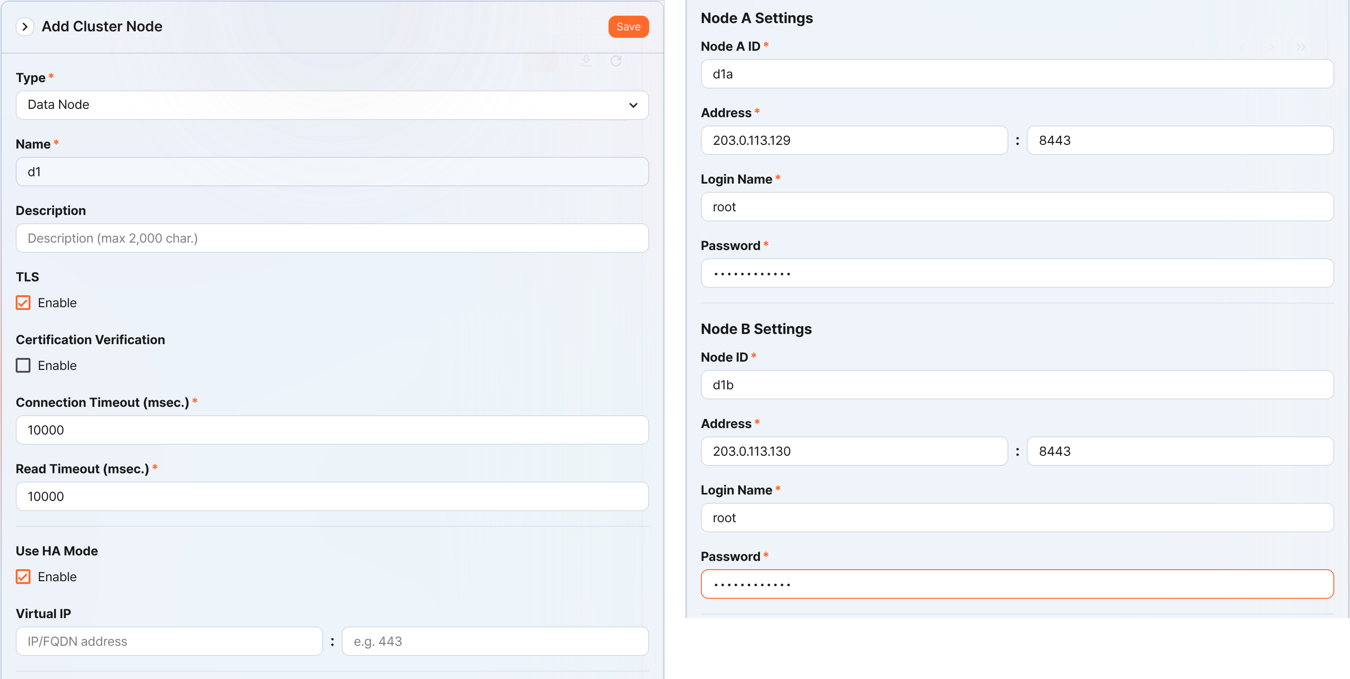
- Type: Select Data Node
- Name: Enter the data node pair identifier (for example, d1)
- You cannot change it after you click the Save button.
- Description: A description of the node pair (optional).
- TLS: Selected
- Certification Verification: Not selected
- Connection Timeout: Use the default value
- Read Timeout: Use the default value
- Use HA Mode: Selected
- Virtual IP: Not selected
- Node A Settings
- Node ID: Enter the node A identifier (for example, d1a)
- Address: The actual IP address and communication port of node A (for example, 203.0.113.129:8443)
- The data node port number is 8443.
- Login Name: Enter root
- Password: Enter the federation account password
- Node B Settings
- Node ID: Enter the node B identifier (for example, d1b)
- Address: The actual IP address and communication port of node B (for example, 203.0.113.130:8443)
- Login Name: Enter root
- Password: Enter the federation account password
After you finish entering the values, click the Save button. Confirm that the data node pair is added as shown below.
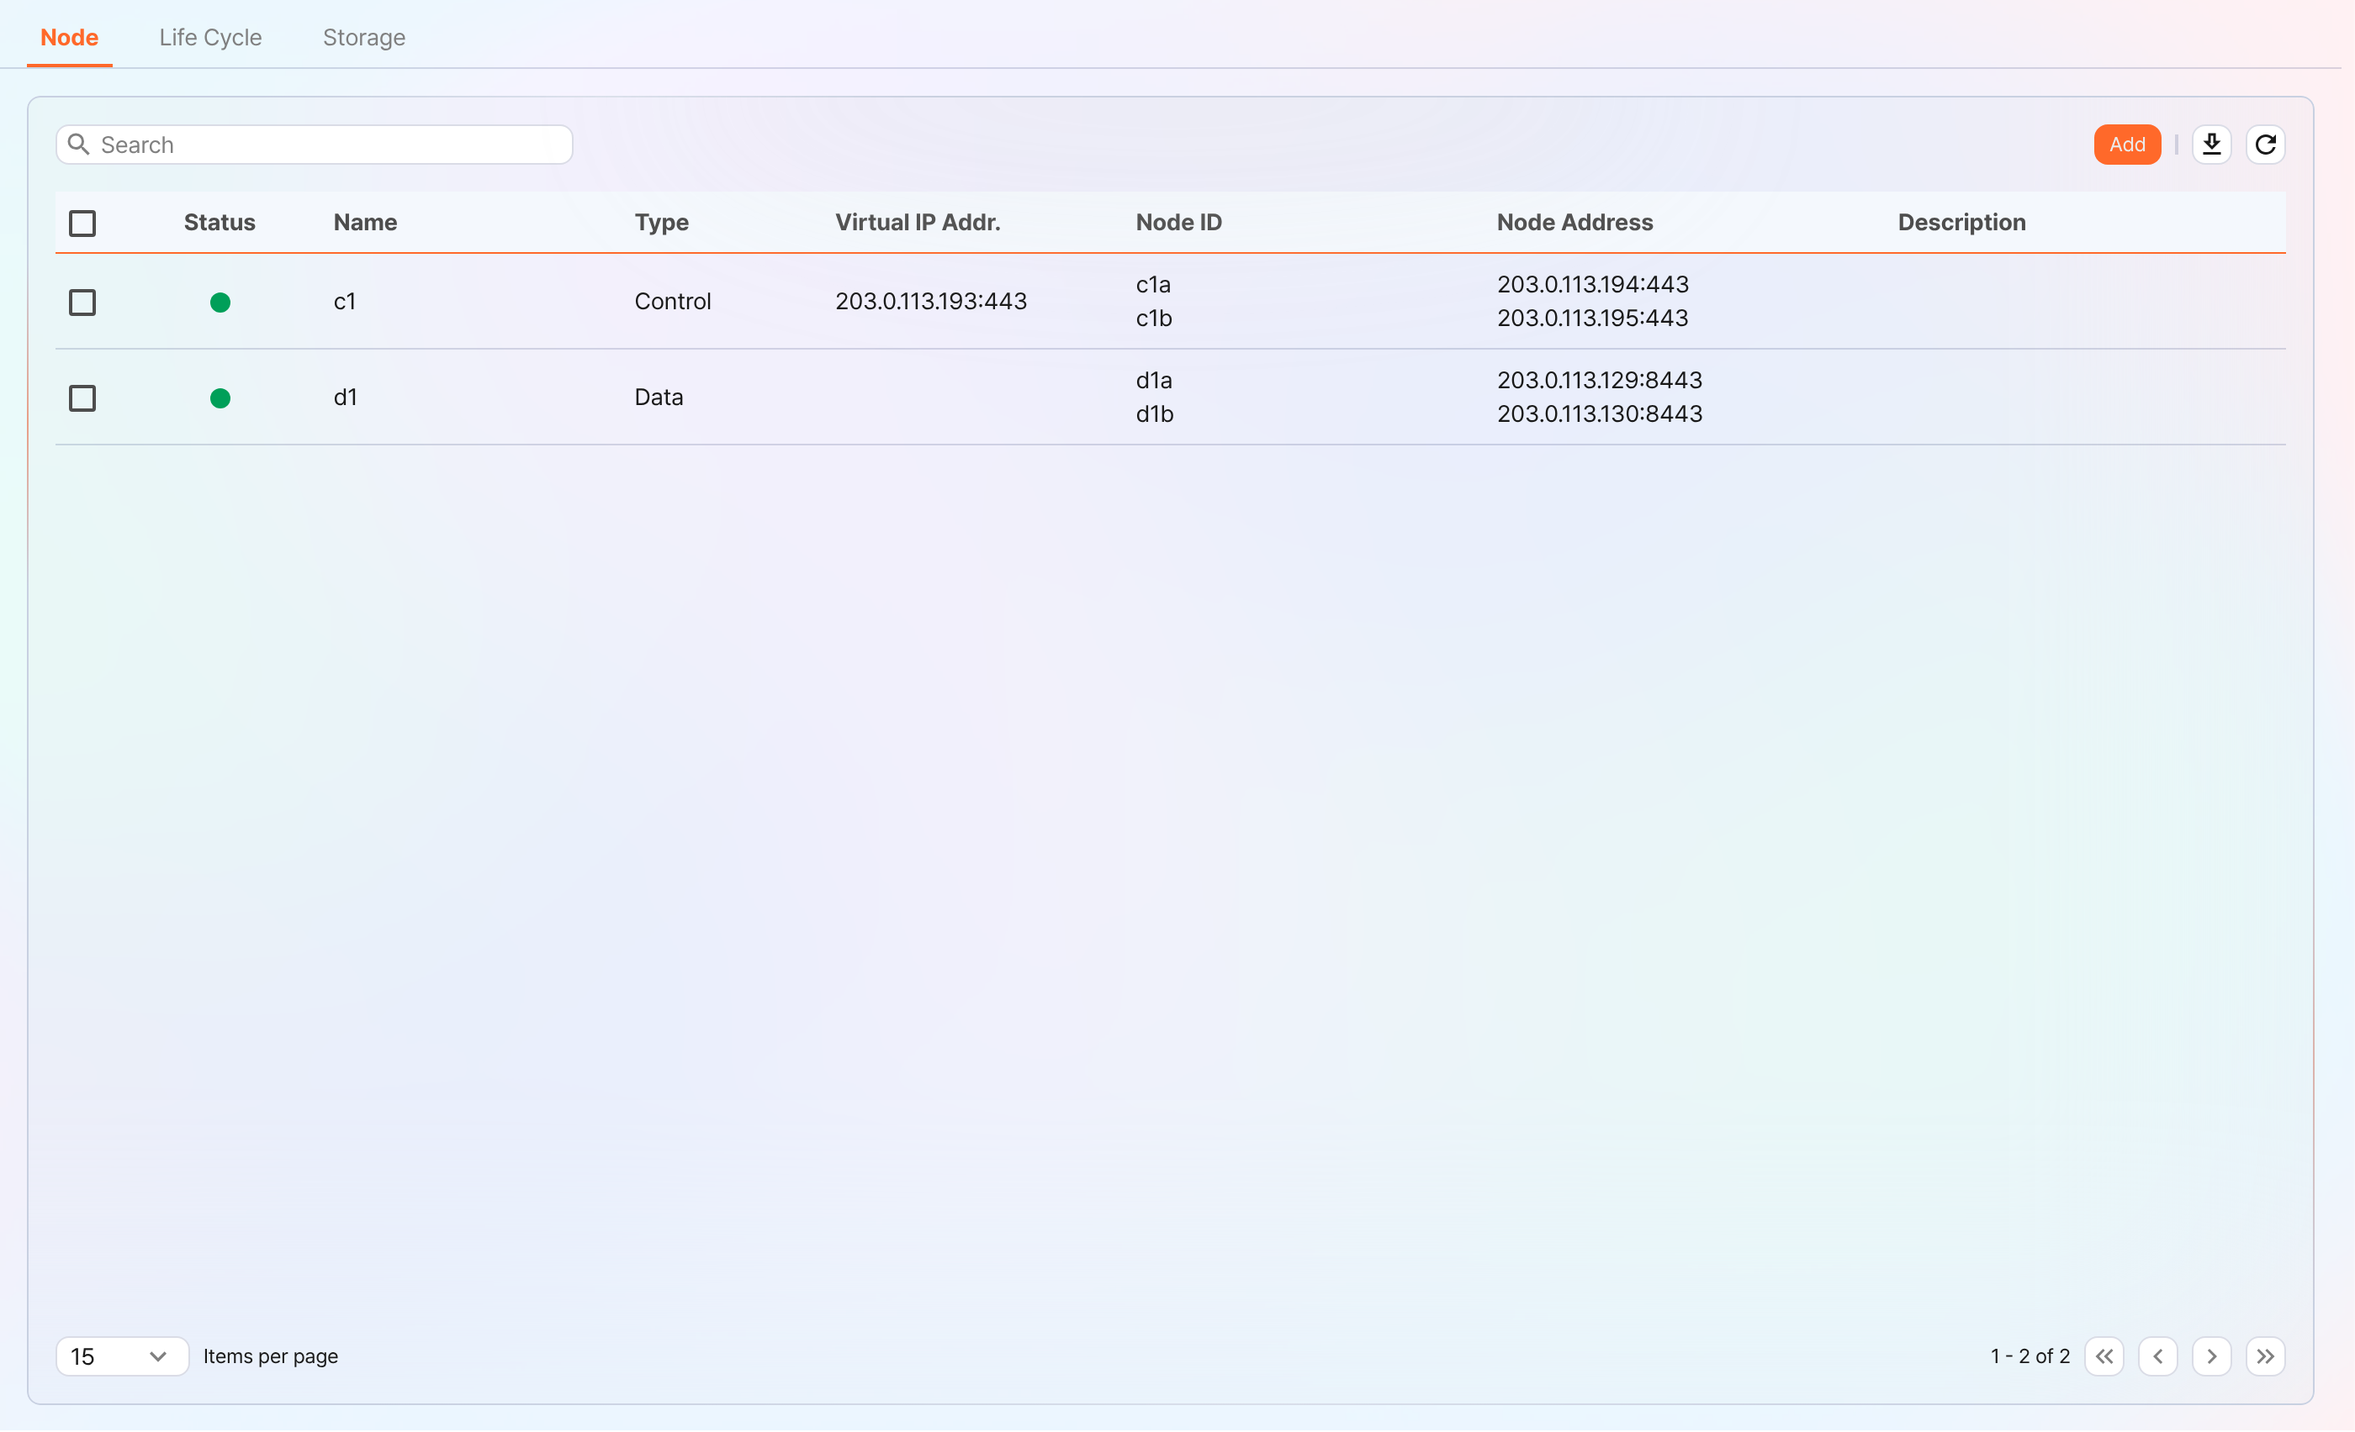
You can click the Name of the added data node to view and modify its properties. If you specified the Name or Node ID incorrectly, you must delete the node pair and reconfigure it.
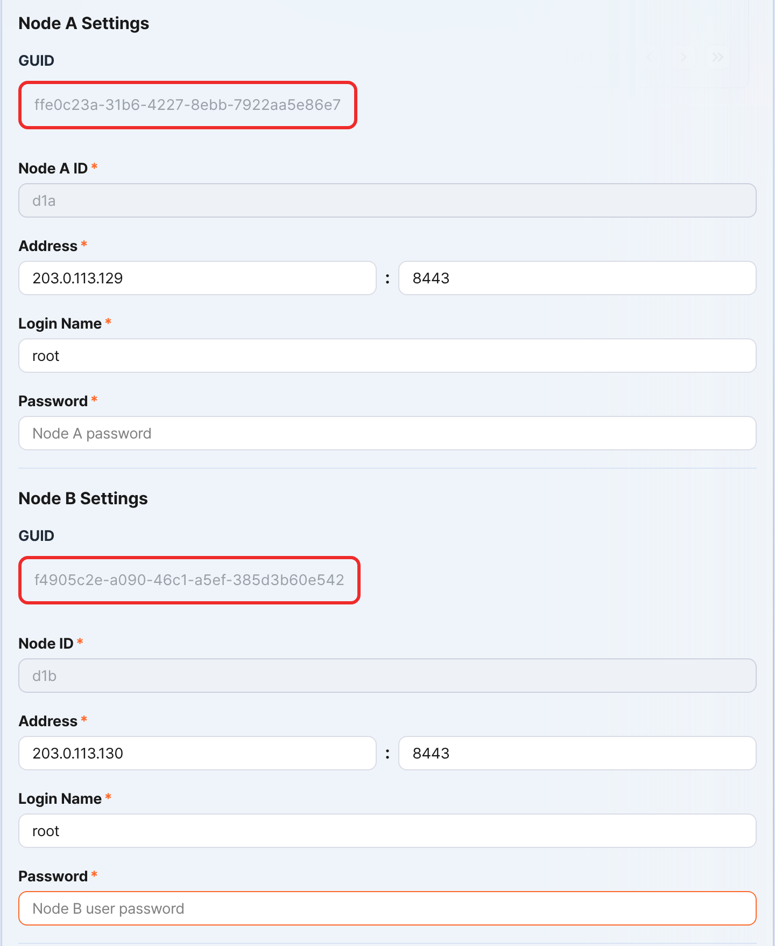
Record the GUIDs of node A and node B in a safe place. These values are used in Configuring the node GUID.
Replicating the key encryption key
Replicate the key encryption key (KEK, Key Encryption Key) of the control node identically to data node A and B.
After you finish this configuration, never change the key encryption key. All nodes that make up the cluster must use the same key encryption key. If they use different keys, encrypted data cannot be decrypted, so synchronization between nodes cannot be performed.
In the Logpresso shell of control node A or B, run the following command to record the encryption key string in a safe place.
sonar.cipherKey
In the Logpresso shell of data node A and B, run the following command respectively to configure the same encryption key. KEY_STRING is the encryption key string of the control node.
sonar.setCipherKey KEY_STRING
Configuring the node GUID
Set the GUIDs of data node A and B, which you checked in the Registering the data node pair step, identically in the Logpresso shell of each node.
In the Logpresso shell of data node A and B, run the following command to set the GUID used for policy synchronization for each node in the Logpresso engine. GUID_STRING is the GUID string of each node.
sonar.setGuid GUID_STRING # Enter the GUID that matches each node
You can check the GUID used for policy synchronization for each node with the following command.
sonar.nodeConfig
Configuring the master node connection
The data node is controlled by the control node. Because communication takes place by the data node connecting to the control node, you must configure the information for the policy master node connection.
In the Logpresso shell of node A and node B, run the following command.
sonar.setMaster
The following describes the prompts displayed after you run the command and the values to enter. The account used here is the federation account.
host? 203.0.113.193 # Virtual IP address of the control node pair
port? 443 # Enter 443
account? root # Enter root, the federation account
password? # Enter the federation account password
connect timeout? 10000 # Press Enter to use the default value
read timeout? 10000 # Press Enter to use the default value
secure? true # Enter true (the default is false)
skip cert check? true # Enter true (the default is false)
Option | Description | Example
host | Virtual IP address of the control node pair | 203.0.113.193
port | Federation communication port of the control node | 443
account | Federation account | root
password | Federation account password
connect timeout | Server connection wait time | 10000 (ms)
read timeout | Response wait time | 10000 (ms)
secure | Whether to apply TLS communication | true
skip cert check | Whether to skip TLS certificate validation | true
Run the following command to check whether the node configuration was applied.
sonar.nodeConfig
The following is an example of the output you can see when it is configured correctly.
guid: ffe0c23a-31b6-4227-8ebb-7922aa5e86e7
host=203.0.113.193, port=443, account=root, connectTimeout=10000, readTimeout=10000, secure=true, skipCertCheck=true
crypto_file_path: null
Configuring the data replication mode
When you configure a node pair, you can replicate table data between the two nodes. Here, "table" does not mean a database table, but a file-based table where the Logpresso engine stores data.
If the same data exists on both nodes, duplicate searches can occur when running a distributed query. To prevent this, you must set the data replication mode of each node to either active (ACTIVE) or standby (STANDBY).
- Active node: Stores the original log tables and is a search target in distributed queries.
- Standby node: Receives real-time replication of the log table data of the active node. The replicated tables use the same table ID as the originals and are excluded from searches in distributed queries, so duplicate searches do not occur.
The logpresso.setStandbyNode command designates the peer node as standby and sets itself as active.
The logpresso.setActiveNode command designates the peer node as active and sets itself as standby.
Configuring node A (active)
In the Logpresso shell of node A, run the following command to check the name of the peer node (node B).
logpresso.nodeStatuses
The following is an example of the output. In the Federation Nodes section, [d1b] is the name of node B.
Local
------------------
Node GUID: b6b014f9-88c2-48c1-96c8-e23d8bdb65bc
Instance GUID: af43a33f-7985-41cb-9c7b-31224e47c35a
Federation Nodes
------------------
[d1b] node_guid=44494d5a-40c7-4e02-93bb-71adb50f3aec, instance_guid=3189e170-dae7-465a-a713-21e3da40cbb7, repl_mode=null, pair_guid=null, invalid_guid=false, alive=true, paired=true, failure=false, last connect=2025-06-09 13:39:20, last alive=2025-06-10 14:08:08, created=2025-06-09 13:39:20
The Node GUID and Instance GUID shown in the logpresso.nodeStatuses command output are identifiers that the Logpresso engine uses for log table replication and distributed queries. The Node GUID is used to identify the database and is recorded in the DB_GUID file for permanent storage. The Instance GUID is the identifier of the currently running process and changes each time the node process starts.
Run the following command to designate node B as the standby node; node A then becomes the active node. In the command example, d1b is the name of node B that you checked above.
logpresso.setStandbyNode d1b
When you run the logpresso.nodeStatuses command again, you can see that Replication Mode is set to ACTIVE in the Local section.
------------------
Node GUID: b6b014f9-88c2-48c1-96c8-e23d8bdb65bc
Instance GUID: af43a33f-7985-41cb-9c7b-31224e47c35a
Replication Mode: ACTIVE
Pair Node: d1b
Federation Nodes
------------------
[d1b] node_guid=44494d5a-40c7-4e02-93bb-71adb50f3aec, instance_guid=3189e170-dae7-465a-a713-21e3da40cbb7, repl_mode=null, pair_guid=null, invalid_guid=false, alive=true, paired=true, failure=false, last connect=2025-06-09 13:49:36, last alive=2025-06-10 14:08:08, created=2025-06-09 13:49:36
Configuring node B (standby)
In the Logpresso shell of node B, run the following command to designate node A as active; node B then becomes the standby node. d1a is the name of node A that you checked in the output of the logpresso.nodeStatuses command.
logpresso.setActiveNode d1a
When you run the logpresso.nodeStatuses command, you can see that Replication Mode is set to STANDBY in the Local section.
Local
------------------
Node GUID: 44494d5a-40c7-4e02-93bb-71adb50f3aec
Instance GUID: 3189e170-dae7-465a-a713-21e3da40cbb7
Replication Mode: STANDBY
Pair Node: d1a
Federation Nodes
------------------
[d1a] node_guid=6b6b014f9-88c2-48c1-96c8-e23d8bdb65bc, instance_guid=af43a33f-7985-41cb-9c7b-31224e47c35a, repl_mode=ACTIVE, pair_guid=44494d5a-40c7-4e02-93bb-71adb50f3aec, invalid_guid=false, alive=true, paired=true, failure=false, last connect=2025-03-26 17:03:11, last alive=2025-03-27 13:40:55, created=2025-03-26 17:03:11
Configuring system log transmission
Configure the data node to collect performance information such as CPU and memory. You can view the collected data on the web console System > Performance Monitor screen.
In the Logpresso shell of data node A and B, run the sentry.setGuid command respectively to set the Sentry GUID. Here, the GUID means the node ID. For example, if the node ID of data node A is d1a, configure it as follows.
sentry.setGuid d1a
On data node A and B, run the following command to set the control node to which logs are transmitted.
# sentry.addBase BASE_NAME IP_ADDR PORT SENTRY_CERT CA_CERT SWAP_SIZE
sentry.addBase c1 203.0.113.193 7140 logpresso-sentry logpresso-ca 1073741824
- BASE_NAME: The name of the control node pair (for example, c1)
- IP_ADDR: The virtual IP address of the control node pair (for example, 203.0.113.193)
- PORT: The Sentry port (for example, 7140)
- SENTRY_CERT: The Sentry certificate (for example, logpresso-sentry)
- CA_CERT: The Logpresso CA certificate (for example, logpresso-ca)
- SWAP_SIZE: The swap size (for example, 1073741824 (=1 GB), unit: bytes)
Run the following command to check the connection.
sentry.connections
The following is an example of the output you can see when it is configured correctly.
Connections
--------------------
[c1] id=2035698886, peer=(1b3fcc3f-61ce-41ae-9c45-d0096b8b7fff, /203.0.113.193:7140), trusted level=Low, ssl=true, props={phase=post_hello, type=command}
Configuring license sharing between nodes
Configure the cluster environment so that all nodes are covered by the same license. The license registered on the control node also applies to the data node and forwarder node. Here, this document describes how to apply the license of the control node to the data node.
In the Logpresso shell of node A and node B, run the following command to enable license sharing.
logpresso.setLicenseMode slave
Run the following command to check the license master status.
logpresso.licenseMode
When it is configured correctly, the following is displayed.
SLAVE
(Control node A and B) Following this document, register the data node as a license slave.
Open a web browser and go to https://<control node A IP address>:8443.
Log in with the federation account, then go to Settings > License Management.
In the All Node List, click Register Node.
Enter the information for the license slave node and click Create.
- Name: A name to identify the data node (for example, d1a, d1b)
- Host Address: The IP address of the data node
- Port: The federation communication port of the data node. Enter 8443.
- User: The federation account ID (root)
- Password: The password of the federation account
- Secure: Select Enable.
- Verify Certification: If Enable is checked, clear it.
- Connection Timeout: Use the default value.
- Read Timeout: Use the default value.
Perform the same task on control node B.
Enabling distributed queries
A distributed query (Distributed Query) is a feature that queries table data distributed across multiple nodes with a single, integrated query. To prevent duplicate searches when running a distributed query and to get correct query results, you must enable distributed queries on all nodes.
In the Logpresso shell of node A and node B, run the following command respectively to enable distributed queries.
logpresso.enablePlanner
Run the following command to check the distributed query status.
logpresso.plannerStatus
When it is enabled correctly, the following is displayed.
Running: true
Configuring the web server
There are web service ports that are open after the package installation. Close the unnecessary ports and open only the ports required to operate the data node.
In the Logpresso shell, run the following command to check the open web service ports.
httpd.bindings
The following is an example of the output you can see after you run the command.
/0.0.0.0:8443 (ssl: key logpresso-web, trust null), opened, default context: webconsole, idle timeout: 0seconds, log file prefix: null, access log: false, error log: false
/0.0.0.0:18443 (ssl: key logpresso-web, trust null), opened, default context: sonar-explanation, idle timeout: 0seconds, log file prefix: null, access log: false, error log: false
/0.0.0.0:443 (ssl: key logpresso-web, trust null), opened, default context: sonar, idle timeout: 0seconds, log file prefix: null, access log: false, error log: false
/0.0.0.0:44300 (ssl: key logpresso-web, trust null), opened, default context: deploy, idle timeout: 0seconds, log file prefix: null, access log: false, error log: false
Run the following commands to close all open web ports, reflect the certificate change, and open only the port used for federation communication.
httpd.close 8443
httpd.close 18443
httpd.close 443
httpd.close 44300
httpd.openSsl 8443 webconsole logpresso-web
The httpd mentioned in the commands does not mean the Apache web server, but the web service of Logpresso Sonar.
Configuring the WebSocket frame (optional)
Because federation communication uses WebSocket, if the distributed query result is large or there is a lot of data to transmit, transmission can fail with the default WebSocket frame size. To process large volumes of data smoothly, you must increase the frame size.
In the Logpresso shell of node A and node B, run the following command to check the current value.
webconsole.maxFrameSize
The default is 8 MB, so the command result is as follows.
8,388,608 bytes
Run the following command to change the frame size. The value set in the example is 84 MB.
webconsole.setMaxFrameSize 83886080
Run the webconsole.maxFrameSize command again to check the changed value.
83,886,080 bytes
Configuring the query cache
To optimize query performance, cache the table metadata, inverted index, and bloom filter in memory. The role of each cache is as follows.
- Table cache: Caches the log data read from disk during a query, so that when the same data is queried again, it is returned directly from memory without disk I/O.
- Inverted index cache: Caches the list of document IDs that contain a specific search term (term) for full-text search.
- Bloom filter 0/1 cache: A bloom filter is a probabilistic data structure that quickly determines whether a specific search term exists in a given segment. Bloom filter 0 is used for fast determination, and bloom filter 1 is used for precise determination.
When you run a search query, the caches are checked in the order of bloom filter 0, bloom filter 1, inverted index cache, and table cache. If the desired data is not found in the cache, it is queried from disk.
In the Logpresso shell of node A and node B, run the following commands to set the cache size.
logpresso.tableCacheConfig max_weight CACHE_SIZE # Table cache
logpresso.indexCacheConfig inverted max_weight CACHE_SIZE # Inverted index cache
logpresso.indexCacheConfig bloomfilter0 max_weight CACHE_SIZE # Bloom filter 0 cache
logpresso.indexCacheConfig bloomfilter1 max_weight CACHE_SIZE # Bloom filter 1 cache
For CACHE_SIZE, enter the values from the following table, considering the daily throughput and memory capacity. The input unit for the cache size is bytes.
Daily throughput | RAM | HEAP | DM | max_weight | inverted | bloomfilter0 | bloomfilter1
500 GB/day | 128GB | 26GB | 76GB | 4,294,967,296 | 53,687,091,200 | 12,884,901,888 | 1,073,741,824
- max_weight: Table cache
- inverted: Inverted index cache
- bloomfilter0: Bloom filter 0 cache
- bloomfilter1: Bloom filter 1 cache
- Do not enter commas (,). The commas are shown to separate the units for readability.
Converted to GB units, the cache is as shown in the following table.
Daily throughput | RAM | HEAP | DM | max_weight | inverted | bloomfilter0 | bloomfilter1
500 GB/day | 128GB | 26GB | 76GB | 4GB | 50GB | 12GB | 1GB
Restarting the service
To apply the changed settings, you must restart the Logpresso service. The order of the tasks is as follows.
Stop order: standby → active
Start order: active → standby
By default, node A is active and node B is standby. During system operation, if you start the active node first, you can quickly recover the original data service, and the standby node can establish a replication connection immediately when it starts.
To stop the nodes,
On the standby node (node B), run the following command to stop the Logpresso service.
sudo systemctl stop logpresso
After node B stops, run the same command on active node A to stop the service.
To start the nodes,
On node A, run the following command to start the Logpresso service.
sudo systemctl start logpresso
After node A starts correctly, run the same command on node B to start the Logpresso service.
After you log in to the web console of node A, check on the System > Performance Monitor screen whether the status of each data node is displayed in green.
If the status of a data node is not green, you can check the cause in the /opt/logpresso/log/araqne.log file.

Connecting stream queries with the control node
Configure a pipeline so that the event data generated by the real-time detection rules on the data node is transmitted to the control node for final event processing (alert). The role of each component is as follows.
- sonar_event_logger (data node): A stream logger that collects the output of the sonar_event stream query on the data node
- sonar_event_data (control node): A stream query that reads data from sonar_event_logger on the data node
- sonar_event (control node): A stream query that takes sonar_event_data as input and runs the alert command to process and store events
Ultimately, the following data flow is configured: (data node A, B) sonar_event_logger → (control node A, B) sonar_event_data → (control node A, B) sonar_event
Creating the sonar_event_logger logger
(Data node A, B) In the Logpresso shell, run the following command to create the sonar_event_logger logger.
# logapi.createLogger LOGGER_FACTORY_NAME NAMESPACE LOGGER_NAME
logapi.createLogger stream local sonar_event_logger
- LOGGER_FACTORY_NAME: The logger factory name. Enter stream.
- NAMESPACE: The logger namespace. Enter local.
- LOGGER_NAME: The name of the logger to create. Enter sonar_event_logger.
The following describes the prompts displayed after you run the command and the values to enter.
Stream query name (required)? sonar_event # Enter sonar_event
transformer (optional, enter to skip)? # Press Enter to skip the input
- Stream query name: The name of the data stream query that will receive the collected logs. Enter sonar_event.
- transformer: Do not enter anything and press Enter.
When you enter all the values in the prompts, the created logger information is displayed as follows.
logger created: name=local\sonar_event_logger, factory=local\stream, status=stopped (passive), log count=0, log volume=0, last start=null, last run=null, last log=null
(Data node A, B) Run the logapi.loggers command to check whether the sonar_event_logger logger was created. The following is an example of the output; the enabled field of the sonar_event_logger logger is displayed as disabled, and the status field as stopped.
Loggers
----------------------
+------------------------------+--------------------+----------+---------+------------+----------+------------+-----------+---------------------------+-------------+-------+
| name | factory | enabled | status | intvl.(ms) | schedule | time range | log count | last log | stop reason | error |
+------------------------------+--------------------+----------+---------+------------+----------+------------+-----------+---------------------------+-------------+-------+
| local\sonar_system_alert | system-alert | enabled | running | 0 | null | null | 17 | 2025-07-09 15:09:59 +0900 | | |
| local\sonar_event_logger | stream | disabled | stopped | 0 | null | null | 0 | null | | |
+------------------------------+--------------------+----------+---------+------------+----------+------------+-----------+---------------------------+-------------+-------+
(Control node A) In the Logpresso shell, run the logapi.loggers command to query the list of loggers currently created. The loggers created on the data node are displayed with the namespace of each data node (d1a, d1b).
Loggers
----------------------
+--------------------------------+--------------------+----------+---------+------------+----------+------------+-----------+---------------------------+-------------+-------+
| name | factory | enabled | status | intvl.(ms) | schedule | time range | log count | last log | stop reason | error |
+--------------------------------+--------------------+----------+---------+------------+----------+------------+-----------+---------------------------+-------------+-------+
| d1a\sonar_event_logger | stream | disabled | stopped | 0 | null | null | 0 | null | | |
| d1a\sonar_system_alert | system-alert | enabled | running | 0 | null | null | 17 | 2025-07-09 15:09:59 +0900 | | |
| d1b\sonar_event_logger | stream | disabled | stopped | 0 | null | null | 0 | null | | |
| d1b\sonar_system_alert | system-alert | enabled | running | 0 | null | null | 23 | 2025-07-09 15:09:59 +0900 | | |
| local\sonar_system_alert | system-alert | enabled | running | 0 | null | null | 72 | 2025-07-09 16:17:10 +0900 | | |
+--------------------------------+--------------------+----------+---------+------------+----------+------------+-----------+---------------------------+-------------+-------+
(Control node A) Run the following command to register the loggers of the data node as managed objects. A logger registered as a managed object starts automatically when the system restarts, and its status is synchronized in an HA environment.
# logpresso.createLogger NAMESPACE\LOGGER_NAME
logpresso.createLogger d1a\sonar_event_logger
logpresso.createLogger d1b\sonar_event_logger
- NAMESPACE\LOGGER_NAME: The full name of the logger. Enter the logger name that you checked in step 3.
(Control node A) Run the following command to enable the loggers.
# logapi.startLogger NAMESPACE\LOGGER_NAME
logapi.startLogger d1a\sonar_event_logger
logapi.startLogger d1b\sonar_event_logger
- NAMESPACE\LOGGER_NAME: The full name of the logger. Enter the logger name that you checked in step 3.
(Control node A) Run the logapi.loggers command and, in the output logger list, check whether the enabled field of the sonar_event_logger logger is displayed as enabled and the status field as running.
Loggers
----------------------
+--------------------------------+--------------------+---------+---------+------------+----------+------------+-----------+---------------------------+-------------+-------+
| name | factory | enabled | status | intvl.(ms) | schedule | time range | log count | last log | stop reason | error |
+--------------------------------+--------------------+---------+---------+------------+----------+------------+-----------+---------------------------+-------------+-------+
| d1a\sonar_event_logger | stream | enabled | running | 0 | null | null | 0 | null | | |
| d1a\sonar_system_alert | system-alert | enabled | running | 0 | null | null | 17 | 2025-07-09 15:09:59 +0900 | | |
| d1b\sonar_event_logger | stream | enabled | running | 0 | null | null | 0 | null | | |
| d1b\sonar_system_alert | system-alert | enabled | running | 0 | null | null | 23 | 2025-07-09 15:09:59 +0900 | | |
| local\sonar_system_alert | system-alert | enabled | running | 0 | null | null | 72 | 2025-07-09 16:17:10 +0900 | | |
+--------------------------------+--------------------+---------+---------+------------+----------+------------+-----------+---------------------------+-------------+-------+
Creating the sonar_event_data stream query
Perform the following steps to transmit the data collected by the logger on the data node to the sonar_event stream query on the control node.
(Control node A) In the Logpresso shell, run the following command to create the stream query.
# logpresso.createStreamQuery NAME SOURCE_TYPE
logpresso.createStreamQuery sonar_event_data logger
- NAME: The name of the stream query. Enter sonar_event_data.
- SOURCE_TYPE: The data source type. Enter logger.
The following describes the prompts displayed after you run the command and the values to enter.
interval? 60 # Enter 60 (seconds)
query? bypass # Enter bypass
loggers? d1a\sonar_event_logger, d1b\sonar_event_logger # Enter the list of logger full names of data node A and B
owner? root # Enter the owner account name
async [y/N]? N # Enter N
- interval: The execution cycle of the stream query. Enter 60.
- query: The query string of the stream query. Enter bypass.
- loggers: The full name of the logger to connect. Enter d1a\sonar_event_logger.
- owner: The owner account name. Enter root.
- async: Whether to run in async mode. Enter N.
Run the logpresso.streamQueries command and check whether the sonar_event_data stream query is listed in the stream query list. The following is an example of the output; the enabled field of the sonar_event_data stream query is displayed as true, and the running field as true.
Stream Queries
----------------
+-----------------------------------------+-------------+--------------+---------------------+---------+---------+-------+-------+
| name | input count | output count | last refresh | running | enabled | async | error |
+-----------------------------------------+-------------+--------------+---------------------+---------+---------+-------+-------+
| sonar_event | 0 | 0 | 2025-07-09 15:14:54 | true | true | false | null |
| sonar_event_data | 0 | 0 | 2025-07-09 15:21:35 | true | true | false | null |
| ..... |
+-----------------------------------------+-------------+--------------+---------------------+---------+---------+-------+-------+
Connecting the sonar_event stream query
Now, on control node A, connect the data source stream query created above to the sonar_event stream query.
On the Logpresso web console Analysis > Queries screen, run the following command to generate a list of stream queries with sonar_event_data added.
system-streams
| search name == "sonar_event"
| eval streams = format("sonar_event_data,%s", strjoin(",", input_streams))
| fields streams
Copy the value in the streams field to a safe place. You need to enter this value at the streams prompt in the next step.
Run the following command to connect the sonar_event stream query with the sonar_event_data stream query.
# logpresso.updateStreamQuery NAME SOURCE_TYPE
logpresso.updateStreamQuery sonar_event STREAM # Enter STREAM in uppercase
- NAME: The name of the stream query. Enter sonar_event.
- SOURCE_TYPE: The data source type. Enter STREAM.
The following describes the prompts displayed after you run the command and the values to enter.
interval? 0 # Enter 0
query? alert # Enter alert
streams? sonar_rule_00001,sonar_rule_00003,sonar_rule_00005, ..., sonar_rule_00051,sonar_event_data # The value copied from the streams field
async [y/N]? N # Enter N
owner? root # Enter the owner account name
The logpresso.updateStreamQuery command overwrites all existing data, so be careful. When you enter the value at the stream prompt, you must enter exactly the stream list queried from the input_streams field and sonar_event_data, separated by commas (,).
Synchronizing the control node pair
The sonar_event_logger logger and the sonar_event_data and sonar_event stream queries that you configured earlier are configurations created manually in the Logpresso shell, so automatic redundancy through synchronization is not supported.
You must stop cluster synchronization, perform the configuration process that you performed on control node A identically on control node B, and restart the cluster.
(Control node A) In a terminal, stop the logpresso service.
sudo systemctl stop logpresso
(Control node B) In the Logpresso shell, run the following command to remove the loggers remaining on control node B from the managed objects and delete the logger instances.
# logapi.removeLogger NAMESPACE\LOGGER_NAME
logapi.removeLogger d1a\sonar_event_logger
logapi.removeLogger d1b\sonar_event_logger
- NAMESPACE\LOGGER_NAME: The full name of the logger
(Data node A, B) Create the loggers on data node A and B.
# Create the sonar_event_logger logger
logapi.createLogger stream local sonar_event_logger
(Control node B) Perform the tasks that you performed on control node A identically on control node B.
# Create the sonar_event_logger logger
logpresso.createLogger d1a\sonar_event_logger
logpresso.createLogger d1b\sonar_event_logger
# Enable the sonar_event_logger logger
logapi.startLogger d1a\sonar_event_logger
logapi.startLogger d1b\sonar_event_logger
# Create the sonar_event_data stream query
logpresso.createStreamQuery sonar_event_data logger
# Check the input_streams field value in the stream query list of control node B for sonar_event_data
system streams
| search name == "sonar_event_data"
| order source_type, name, running, enabled, async, interval, query_string, owner, input_streams
# Connect the sonar_event stream query
logpresso.updateStreamQuery sonar_event STREAM
(Control node B) In a terminal, run the following command to stop the logpresso service.
sudo systemctl stop logpresso
(In the order of control node A, then control node B) In a terminal, run the following command to start the logpresso service. When control node A starts first, the settings of A are synchronized to control node B.
sudo systemctl start logpresso

Forwarder Node

Operating system
This document describes the items you need to configure when installing and setting up the operating system.
- Permissions required for installation: Describes the permissions required to install Logpresso Sonar.
- Operating system & JDK installation: Describes how to install the operating system, configure partitions, and install required packages and the JDK.
- Operating system configuration: Configures JDK permissions, SELinux, host name, NTP, firewall, kernel parameters, and more.
- Creating the Logpresso directory: Creates the Logpresso installation directory.

Permissions required for installation
To install Logpresso Sonar, you need root privileges on the target server or a user account that can run administrative commands with the sudo command (a user that belongs to the wheel group).

Operating system & JDK installation
The operating system officially supported by Logpresso is Red Hat Enterprise Linux 9.
- You can also use an RHEL 9-compatible operating system such as Rocky Linux.
- The recommended installation type is Server with GUI.
- Configure the operating system partition and the data partition separately.
- Mount the data partition at /data.
- Configure the data partition with LVM so that you can expand its capacity when needed.
Installing required packages
On a network with internet access, run the following command to install the required packages.
sudo dnf -y install curl firewalld java-21-openjdk-devel \
lsof net-tools traceroute unzip
Package | Purpose
curl | Used for API testing
firewalld | Host firewall configuration
java-21-openjdk-devel | JDK required to run Logpresso Sonar
lsof | Diagnostic tool for checking open files and ports
net-tools | Network diagnostic tools such as netstat and ifconfig
traceroute | Diagnostic tool for tracing network routes
unzip | Extracts the Logpresso Sonar installation package
- Install the java-21-openjdk-devel package instead of java-21-openjdk so that you can use the jmap and jstack commands to debug failures.
- If installing debugging tools is not allowed in your environment, install the java-21-openjdk-headless package instead.
For convenience, we recommend installing the following packages.
sudo dnf -y install vim wget
Package | Purpose
vim | Editing configuration files
wget | Used when running the Sentry installation script on the host where Sentry is installed
Downloading packages (for air-gapped environments)
If you need to install in an air-gapped environment, prepare the package files to bring into the air-gapped environment by following the steps below.
Identify the operating system and version to use in the air-gapped environment, and on a network with internet access, prepare a Linux host that runs the same version as the Linux server that will operate in the air-gapped environment.
Run the following command to download the packages to install and all of their dependency packages to the specified path.
# Downloading packages does not require sudo privileges.
mkdir $HOME/rpm && cd $HOME/rpm && \
dnf download --resolve curl firewalld java-21-openjdk-devel \
lsof net-tools traceroute unzip vim wget && \
tar czvf rpm.tgz *.rpm
Create a file that records the hash value of the compressed file. You need the hash value to verify the integrity of the file brought into the air-gapped environment.
sha256sum rpm.tgz > rpm.tgz.sha256
Store the rpm.tgz and rpm.tgz.sha256 files in a safe place (read-only media is recommended).
To install the required packages in the air-gapped environment, follow the steps below.
Create a new directory (for example, $HOME/rpm) and copy the rpm.tgz and rpm.tgz.sha256 files into the new directory.
In the new directory, run the following command to compare the computed hash value with the hash value recorded in the rpm.tgz.sha256 file.
sha256sum rpm.tgz
Extract the rpm.tgz file and install the packages.
tar xzvf rpm.tgz && sudo dnf install -y *.rpm

Operating system configuration
Configuring JDK permissions
Check the installed JDK version and grant the permissions required to run Logpresso Sonar. Perform this configuration on all nodes.
Check the installed JDK version.
java -version
You should see version information like the following.
openjdk version "21.0.10" 2026-01-20 LTS
OpenJDK Runtime Environment (Red_Hat-21.0.10.0.7-1) (build 21.0.10+7-LTS)
OpenJDK 64-Bit Server VM (Red_Hat-21.0.10.0.7-1) (build 21.0.10+7-LTS, mixed mode, sharing)
Grant the required permissions to the java executable.
sudo setcap cap_net_bind_service,cap_sys_time,cap_net_raw=+ep $(readlink /etc/alternatives/java)
The permissions that setcap grants to the java executable are as follows.
Option | Description | Note
cap_net_bind_service | Permission to use ports below 1024 | Regular user accounts cannot use ports below 1024
cap_sys_time | Permission to change the system time | Required for time synchronization and timestamp adjustment
cap_net_raw | Permission to use raw sockets and packet sockets | Used for direct pcap collection, sendsyslog, and the ping app
+ep | +: add the permissione: apply the permissionp: keep the permission permanently
Verify that the permissions were applied correctly.
getcap $(readlink /etc/alternatives/java)
You should see a result like the following.
/usr/lib/jvm/java-21-openjdk-21.0.10.0.7-1.el9.x86_64/bin/java cap_net_bind_service,cap_net_raw,cap_sys_time=ep
Configuring SELinux
SELinux (Security-Enhanced Linux) is a module that applies security policies at the Linux kernel level. By default, in enforcing mode it blocks any action that violates a security policy. Because access to certain directories may be restricted when Logpresso Sonar runs, you need to change SELinux to permissive.
We plan to improve this document after verifying the stability of Logpresso Sonar in SELinux enforcing mode. For now, the document describes installing with SELinux changed to Permissive.
Open the /etc/selinux/config file and configure it as follows. The changed setting takes effect immediately after you restart the system or run the setenforce 0 command.
# This file controls the state of SELinux on the system.
# SELINUX= can take one of these three values:
# enforcing - SELinux security policy is enforced.
# permissive - SELinux prints warnings instead of enforcing.
# disabled - No SELinux policy is loaded.
SELINUX=permissive
Run the following command to apply Permissive mode immediately.
sudo setenforce 0
Run the getenforce command and verify that the current SELinux mode is displayed as Permissive.
Changing the host name
Change the server's host name with the following command to make Logpresso Sonar nodes easy to identify.
sudo hostnamectl set-hostname HOSTNAME
- HOSTNAME: The host name
If you have multiple node pairs, we recommend assigning host names that combine a node pair identifier and a node identifier, such as c1a/c1b, d1a/d1b, d2a/d2b, and f1a/f1b. For example, for a cluster consisting of one Control Node pair, two Data Node pairs, and one Forwarder Node pair, you can use the following host names.
Node pair | Host name | Description
c1 | c1a | Node A of Control Node pair c1
c1 | c1b | Node B of Control Node pair c1
d1 | d1a | Node A of Data Node pair d1
d1 | d1b | Node B of Data Node pair d1
d2 | d2a | Node A of Data Node pair d2
d2 | d2b | Node B of Data Node pair d2
f1 | f1a | Node A of Forwarder Node pair f1
f1 | f1b | Node B of Forwarder Node pair f1
Configuring NTP
Synchronize the time with the same NTP server so that all nodes use accurate time information.
Identify the IP address or FQDN of the NTP server that provides the network standard time (for example, time.kriss.re.kr) in advance.
Configure the same NTP server or server pool in the /etc/chrony.conf file so that all servers synchronize the network standard time with the same NTP server.
# Use public servers from the pool.ntp.org project.
# Please consider joining the pool (https://www.pool.ntp.org/join.html).
# pool 2.rocky.pool.ntp.org iburst # comment out the pool line
server time.kriss.re.kr iburst prefer # NTP server of the Korea Research Institute of Standards and Science
server 192.0.2.1 iburst # NTP server in the internal network 192.0.2.0/24 range (example)
⚠️ If you add a server line, delete or comment out the pool line. You must use only one of them.
Run the following command to restart the chronyd service.
sudo systemctl restart chronyd
Run the following command to check whether the currently registered NTP server is synchronized. If chronyd is working correctly, the synchronization status is displayed.
chronyc sources -v
Run the following command to synchronize the time immediately.
sudo chronyc -a makestep
Configuring the host firewall
Configure the inbound firewall policy so that the communication required to run Logpresso Sonar is possible. The following is an example of the commands for configuring the firewall policy on the Forwarder Node server, following the firewall policy configuration described in the prerequisites document.
sudo firewall-cmd --permanent --add-port={22,8443,7140,8514,44300}/tcp --add-port={514,8514,162}/udp
sudo firewall-cmd --reload
sudo firewall-cmd --list-all
- Syslog over DTLS (8514/tcp, 8514/udp) does not have a standard port, so it may vary depending on your operating environment.
The firewall configuration above has the problem that it does not restrict the source IP address. To restrict the source IP address in the host firewall, you need to run advanced firewall policy commands using the --add-rich-rule option as follows. Change the IP address ranges to match your actual environment.
# 1. Management network: 192.0.2.0/24
# Administrator: SSH access (22), web console and API check (8443)
sudo firewall-cmd --permanent --add-rich-rule='rule family="ipv4" source address="192.0.2.0/24" port port="22" protocol="tcp" accept'
sudo firewall-cmd --permanent --add-rich-rule='rule family="ipv4" source address="192.0.2.0/24" port port="8443" protocol="tcp" accept'
# 2. Control Node: 203.0.113.240/29
# Control Node: Sonar federation (8443)
sudo firewall-cmd --permanent --add-rich-rule='rule family="ipv4" source address="203.0.113.240/29" port port="8443" protocol="tcp" accept'
# 3. Forwarder Node range: 203.0.113.160/27 (203.0.113.161 - 203.0.113.190)
# Peer node status check (7140)
# Note: allow only traffic coming from the Forwarder Node group
sudo firewall-cmd --permanent --add-rich-rule='rule family="ipv4" source address="203.0.113.160/27" port port="7140" protocol="tcp" accept'
# 4. Service network: 203.0.113.0/25 (203.0.113.1 - 203.0.113.126)
# Targets: Sentry agents and general log-generating devices (switches, servers, and so on)
# Sentry: RPC and log reception (7140/tcp)
sudo firewall-cmd --permanent --add-rich-rule='rule family="ipv4" source address="203.0.113.0/25" port port="7140" protocol="tcp" accept'
# Log collection target: Syslog (514/udp)
sudo firewall-cmd --permanent --add-rich-rule='rule family="ipv4" source address="203.0.113.0/25" port port="514" protocol="udp" accept'
# Log collection target: Syslog over DTLS (8514/udp)
sudo firewall-cmd --permanent --add-rich-rule='rule family="ipv4" source address="203.0.113.0/25" port port="8514" protocol="tcp" accept'
sudo firewall-cmd --permanent --add-rich-rule='rule family="ipv4" source address="203.0.113.0/25" port port="8514" protocol="udp" accept'
# Log collection target: SNMP TRAP (162/udp)
sudo firewall-cmd --permanent --add-rich-rule='rule family="ipv4" source address="203.0.113.0/25" port port="162" protocol="udp" accept'
# 5. Sentry range: 203.0.113.0/25 (203.0.113.1 - 203.0.113.126)
# Certificate renewal, Sentry installation (44300/tcp)
sudo firewall-cmd --permanent --add-rich-rule='rule family="ipv4" source address="203.0.113.0/25" port port="44300" protocol="tcp" accept'
# 6. Apply and check the configuration
sudo firewall-cmd --reload
sudo firewall-cmd --list-rich-rules
Configuring socket buffers and memory map
When receiving Syslog, Syslog over DTLS, and SNMP TRAP, if the kernel's socket buffer is insufficient or the memory buffer is insufficient, log packets may be dropped, resulting in log loss. To prevent this, change the socket buffer and memory map settings. Perform this task on all nodes.
Create a 50-logpresso.conf file in the /etc/sysctl.d directory and add the following content to the file.
net.core.rmem_default = 52428800
net.core.rmem_max = 52428800
net.ipv4.udp_rmem_min = 8192
net.ipv4.ipfrag_high_thresh = 16777216
vm.max_map_count = 10000000
vm.swappiness = 1
The meaning of each item is as follows:
Variable | Description | Default | Value
net.core.rmem_default | Default receive buffer size of a socket | 212992 | 52428800
net.core.rmem_max | Maximum receive buffer size of a socket | 212992 | 52428800
net.ipv4.udp_rmem_min | Minimum receive buffer size of a UDP socket | 4096 | 8192
net.ipv4.ipfrag_high_thresh | Maximum size of the IP packet reassembly buffer | 4194304 | 16777216
vm.max_map_count | Maximum number of allowed virtual memory mappings | 65530 | 10000000
vm.swappiness | Minimize swap usage | 60 | 1
Run the following command to apply the changed kernel settings immediately.
sudo sysctl -p
Run the following command to check the changed setting values.
sudo sysctl -a | grep -E "rmem_default|rmem_max|udp_rmem_min|ipfrag_high_thresh|max_map_count"
Relaxing resource limits
Create a 50-logpresso.conf file in the /etc/security/limits.d directory and add the following content to the file.
logpresso soft nofile 126488
logpresso hard nofile 126488
logpresso soft nproc 126488
logpresso hard nproc 126488
- nofile: The maximum number of files that can be open at the same time
- nproc: The maximum number of processes (and threads) that can run at the same time
Run the following command to check the changed setting values.
ulimit -n # Check the open file limit (nofile)
ulimit -u # Check the process count limit (nproc)
Granting permissions for diagnostic tools
Run the following command to check the exact paths of the jstack and jmap executables.
readlink /etc/alternatives/jstack
readlink /etc/alternatives/jmap
You should see a result like the following.
/usr/lib/jvm/java-21-openjdk/bin/jstack
/usr/lib/jvm/java-21-openjdk/bin/jmap
Run the sudo visudo /etc/sudoers.d/logpresso command and edit it as follows. This grants permission to run the jstack and jmap executables (whose paths you checked in step 1) with the logpresso account.
# Correct the paths according to the output of the readlink command.
%logpresso ALL=(ALL) NOPASSWD: /usr/lib/jvm/java-21-openjdk/bin/jstack
%logpresso ALL=(ALL) NOPASSWD: /usr/lib/jvm/java-21-openjdk/bin/jmap
%logpresso ALL=(ALL) NOPASSWD: /usr/bin/arping
%logpresso ALL=(ALL) NOPASSWD: /usr/bin/netstat
%logpresso ALL=(ALL) NOPASSWD: /usr/sbin/ifconfig
%logpresso ALL=(ALL) NOPASSWD: /usr/sbin/tcpdump
Defaults:logpresso !requiretty
The logpresso account is created when Logpresso Sonar is installed. Here, the document describes granting the diagnostic tool permissions in advance.
The arping, netstat, ifconfig, and tcpdump commands are used by Logpresso Sonar to check the status of Sentry or to collect pcap files.
Run the following command to verify that the permissions were applied correctly.
sudo visudo -c

Creating the Logpresso directory
Run the following command to create the directory where Logpresso will be installed. You can change the Logpresso directory to match your operating environment. This document uses /opt/logpresso.
sudo mkdir -p /opt/logpresso

Package installation
This document describes how to install the Logpresso Sonar package. The Control Node, Data Node, and Forwarder Node all use the same package. Perform all the steps described here on both Forwarder Node A and Forwarder Node B.
- Extracting the package file: Downloads the Logpresso Sonar package and extracts it.
- Creating the logpresso.conf file: Creates the basic configuration file required to run the node.
- Environment configuration: Configures the JVM and node settings to match your operating environment.
- Running the Forwarder Node: Registers and runs the service.

Extracting the package file
First, download and prepare the Logpresso Sonar package, and extract the package on all Logpresso Sonar nodes.
On a PC with internet access, download the latest version package from the Logpresso Store. This document assumes the version 4.0.2511.1 package.
Copy the downloaded package file to the Logpresso directory on the Forwarder Node, and extract it as follows.
# Assumptions
# Logpresso Sonar package file path: $HOME/logpresso-SNR-4.0.2511.1-u3116.zip
# Logpresso directory: /opt/logpresso
sudo unzip logpresso-SNR-4.0.2511.1-u3116.zip -d /opt/logpresso

Creating the logpresso.conf file
First, create the logpresso.conf file, where the basic settings required to run the node are recorded.
sudo /opt/logpresso/logpresso install config
When the logpresso.conf file is created, the following message is displayed.
configuration file is created: /opt/logpresso/etc/logpresso.conf
File structure and how it works
The logpresso.conf file stores the JVM settings and server settings required to run Logpresso Sonar.
The characteristics of this file are as follows.
- Each setting uses a key-value form, KEY=VALUE or KEY="VALUE".
- You can use bash-style comments. A line that starts with "#" is treated as a comment.
- It supports bash-style variable references such as $VAR, ${VAR}, and $(command).
- The value of JAVA_OPTS is passed verbatim as parameters of the java command and as JVM options for the Logpresso core (araqne-core).
- It supports the accumulate-and-append operator in the form JAVA_OPTS+="-Doption=value" (for example, JAVA_OPTS="$JAVA_OPTS -XX:ActiveProcessorCount=30").
- You can add options of the java command to the JAVA_OPTS property using the accumulate-and-append operator.
When systemd runs the Logpresso Sonar service, the launcher (logpresso) converts all settings recorded in the logpresso.conf file into parameters of the java command and passes them.
- Some items are mapped to JVM system properties (-D...).
- Not all items are mapped to -D. Some items are used only in the execution script (JVM heap/GC and so on) or use internal default values.
The following is the actual command line referenced while writing this document, broken into multiple lines for readability (the details may vary depending on the Sonar version and the system). All of the parameters in this command line are properties defined in the logpresso.conf file.
/opt/logpresso/jre/bin/java
-Xms1G -Xmx2G \
-XX:MaxDirectMemorySize=2G \
-XX:-OmitStackTraceInFastThrow \
-XX:-UseCompressedOops \
-XX:+UnlockExperimentalVMOptions \
-XX:+UseZGC \
-XX:+ZGenerational \
-XX:MaxGCPauseMillis=200 \
-XX:ParallelGCThreads=6 \
-XX:StringTableSize=10000019 \
-Xlog:gc=trace:file="/opt/logpresso/log/gc.log":time,level:filecount=10,filesize=10240K
-XX:TrimNativeHeapInterval=300000 \
--add-opens java.base/jdk.internal.ref=ALL-UNNAMED \
--add-opens java.base/java.lang=ALL-UNNAMED \
--add-opens java.base/java.net=ALL-UNNAMED \
--add-opens java.base/java.security=ALL-UNNAMED \
--add-opens java.base/java.util.concurrent.atomic=ALL-UNNAMED \
--add-modules jdk.jfr \
--add-exports=java.base/sun.net.www.protocol.http=ALL-UNNAMED \
-Dipojo.proxy=disabled \
-Djava.awt.headless=true \
-Daraqne.dir=/opt/logpresso \
-Daraqne.log.dir=/opt/logpresso/log \
-Daraqne.core.pid_file=/var/run/logpresso/logpresso.pid \
-Daraqne.ssh.server=enabled \
-Daraqne.ssh.address=127.0.0.1 \
-Daraqne.ssh.port=7022 \
-Daraqne.ssh.timeout=600000 \
-Daraqne.dom.block_concurrent_admin=disabled \
-Daraqne.dom.block_concurrent_login=disabled \
-Daraqne.sso.timeout=3600000 \
-Daraqne.log.keepdays=7 \
-Daraqne.core.watchdog=enabled \
-Daraqne.logdb.cepengine=mem \
-DINSTANCE_ID=logpresso \
-jar /opt/logpresso/araqne-core-4.0.5-package.jar

Environment configuration
Now edit the logpresso.conf file to match the environment where you will operate Logpresso Sonar. Open the /opt/logpresso/etc/logpresso.conf file and modify the settings to match your operating environment. For settings other than those described here, see (Appendix) logpresso.conf file properties.
JVM configuration variables
The JVM configuration variables defined in the logpresso.conf file are JAVA_HOME, MIN_HEAP_SIZE, MAX_HEAP_SIZE, and MAX_DIRECT_MEM_SIZE. Refer to the following table to set appropriate values.
Network collection only
Daily throughput | Physical cores | vCPU | RAM | APC | HEAP | DM
1 TB/day | 4 | 8 | 16GB | - | 8GB | 4GB
Sentry management and network collection
Daily throughput | Physical cores | vCPU | RAM | APC | HEAP | DM
1 TB/day | 12 | 24 | 64GB | - | 31GB | 20GB
- A Forwarder Node operates in environments with a daily throughput of 1 TB/day or more. If availability is important, consider a redundant configuration.
- Add another Forwarder Node whenever the daily throughput exceeds 1 TB/day.
- APC: The value to apply to -XX:ActiveProcessorCount
- HEAP: The value to apply to MIN_HEAP_SIZE and MAX_HEAP_SIZE (set the two values the same)
- DM: The value to apply to MAX_DIRECT_MEM_SIZE
The JVM configuration items are as follows.
JAVA_HOME
The JDK directory path (for example, /opt/logpresso/jre; default: none). When you run Logpresso Sonar, the Logpresso launcher (logpresso) looks up the value defined in JAVA_HOME in the logpresso.conf file. If there is no logpresso.conf file, or if no value is assigned to JAVA_HOME, the launcher searches for the java file in the paths specified in the operating system's PATH environment variable and runs it.
: By default, JDK 21 recognizes the number of CPU cores and cgroup limits. Use it when you need to prevent excessive thread creation. If you specify an individual flag (for example, -XX:ParallelGCThreads), that value takes precedence.
MIN_HEAP_SIZE
The minimum heap memory size. This setting value is applied to the -Xms flag parameter. We recommend the same value as MAX_HEAP_SIZE.
MAX_HEAP_SIZE
The maximum heap memory size. This setting value is applied to the -Xmx flag parameter. We recommend the same value as MIN_HEAP_SIZE.
-XX:SoftMaxHeapSize
The soft maximum heap size. This option is a JDK option that is not explicitly defined in the logpresso.conf file. Enter it directly in the logpresso.conf file as follows.
JAVA_OPTS="$JAVA_OPTS -XX:SoftMaxHeapSize=1g"
- For network collection only, we recommend a value of 4g for -XX:SoftMaxHeapSize.
- For Sentry management and network collection, we recommend a value of 15g for -XX:SoftMaxHeapSize.
MAX_DIRECT_MEM_SIZE
The maximum direct memory size. This setting value is applied to the -XX:MaxDirectMemorySize flag parameter.
Node configuration variables
The main configuration items for a Forwarder Node are as follows.
BASEDIR
The Logpresso directory path. The value is assigned automatically when the logpresso.conf file is created, so you do not need to modify it. This setting becomes the default value for other path-specifying variables such as LOGDIR.
DATADIR
The path of the collected data directory (default: $BASEDIR/data). Because you mount the data partition at /data, change it to /data/logpresso-data.
LOGDIR
The log directory path (default: $BASEDIR/log)
SSH_OPEN
Whether to allow Logpresso shell access (default: disabled). To access the Logpresso shell, change it to enabled.
SSH_ADDR
The Logpresso shell access address (default: 127.0.0.1)
SSH_PORT
The Logpresso shell access port (default: 7022)
SSH_TIMEOUT
The Logpresso shell access timeout (default: 600000 milliseconds = 10 minutes)
LOGKEEPDAY
The retention period of the araqne.log file (default: 7 days). This file is used to record the execution of major operations, system errors, and exceptional situations. Each log record has one of the ERROR, WARNING, INFO, DEBUG, and TRACE levels.
LOGDB_PURGE
Whether to allow the purge command in Logpresso queries (default: disabled). For the behavior of the command, see the purge command documentation. To enable this feature, change it to enabled.
ALLOWED_FILE_SCAN_PATHS
The list of directories to which access is allowed when running query commands (for example, textfile and csvfile) (default: $DATADIR/araqne-logdb/scan,$LOGDIR; related content: 4.0.2511.0 migration guide).
For example, if you set ALLOWED_FILE_SCAN_PATHS="/opt/logpresso/data/araqne-logdb/scan,/opt/logpresso/log", query commands that access local files can access only files under the /opt/logpresso/data/araqne-logdb/scan and /opt/logpresso/log directories.
-Dsonar.node.ignore_pattern_group=true
Disables pattern group synchronization. This option is a JVM option that is not explicitly defined in the logpresso.conf file. Enter it directly in the logpresso.conf file as follows.
JAVA_OPTS="$JAVA_OPTS -Dsonar.node.ignore_pattern_group=true"
The sonar.node.ignore_pattern_group JVM option is set only on the Forwarder Node.

Running the Forwarder Node
After you finish editing the environment configuration file, register and run the service unit (logpresso.service).
Registering and running the service
To install the Logpresso Sonar server, run the following command.
sudo /opt/logpresso/logpresso install server && \
sudo systemctl enable --now logpresso
The following tasks are performed during the Logpresso installation process.
A logpresso user is created, and the owner and owning group of all files and directories in the Logpresso directory are changed to logpresso.
# logpresso account added to /etc/passwd
logpresso:x:1001:1001::/opt/logpresso:/sbin/nologin
The /etc/ld.so.conf.d/logpresso.conf file is created, and the directory path where the libjli.so file is located is stored in it.
# /etc/ld.so.conf.d/logpresso.conf
# The file content may vary depending on the system.
/opt/logpresso/jdk-21.0.8+9/lib/jli
If the jli directory path is not added correctly to the /etc/ld.so.conf.d/logpresso.conf file during this process, the following error may occur when the Logpresso Sonar service starts.
/opt/logpresso/jre/bin/java: error while loading shared libraries: libjli.so: cannot open shared object file: No such file or directory
If the error occurs, run the following command to check the actual directory path of the libjli.so file.
sudo find /opt/logpresso -type f -name libjli.so -exec dirname {} \;
If the content of the /etc/ld.so.conf.d/logpresso.conf file differs from the actual directory path, modify the /etc/ld.so.conf.d/logpresso.conf file to match the actual directory path and run the sudo ldconfig command.
The logpresso.service service unit file is added to the /usr/lib/systemd/system directory, and systemd is configured to manage the service. The content of the logpresso.service file is as follows (it may vary depending on the version). Modify it if needed.
[Unit]
Description=Logpresso daemon
After=multi-user.target network.target
Wants=network-online.target
Documentation=https://docs.logpresso.com
[Service]
User=logpresso
Group=logpresso
Type=forking
PIDFile=/opt/logpresso/logpresso.pid
Environment=PKGDIR=/opt/logpresso
ExecStart=/opt/logpresso/logpresso start
ExecStop=/opt/logpresso/logpresso stop
StartLimitBurst=0
TimeoutStopSec=1200
LimitNOFILE=65535
Restart=on-failure
[Install]
WantedBy=multi-user.target
- Wants is an additionally configured item. If this item is not in the generated logpresso.service file, add it.
- If the LimitNOFILE line exists, the setting in the service unit is applied instead of the /etc/security/limits.d/50-logpresso.conf file setting. If this line exists, delete it.
If you modified the service unit file, run the following command to restart the service.
sudo systemctl daemon-reload && sudo systemctl restart logpresso
Checking the service status
Run the following command to check whether the Logpresso service is running correctly.
systemctl status logpresso
If it is running correctly, a result like the following is displayed. Note the value of the Main PID field (1682 here).
● logpresso.service - Logpresso daemon
Loaded: loaded (/usr/lib/systemd/system/logpresso.service; enabled; preset: disabled)
Active: active (running) since Wed 2025-10-15 10:56:58 KST; 6 days ago
Docs: https://ko.logpresso.com/documents
Main PID: 1682 (java)
Tasks: 229 (limit: 23116)
Memory: 4.1G
CPU: 4d 40min 56.229s
CGroup: /system.slice/logpresso.service
└─1682 /usr/lib/jvm/java/bin/java ...(omitted)... -jar /opt/logpresso/sonar/araqne-core-4.0.5-package.jar
(the rest is omitted)
Run the following command to check the list of ports that the java process has open.
sudo ss -tuanlp | grep -E '^Netid|java'
If the service is running correctly, you can see the list of ports bound to the java and mariadbd processes in the command output as follows.
Netid State Recv-Q Send-Q Local Address:Port Peer Address:Port Process
udp UNCONN 0 0 0.0.0.0:162 0.0.0.0:* users:(("java",pid=2981,fd=338))
udp UNCONN 0 0 0.0.0.0:514 0.0.0.0:* users:(("java",pid=2981,fd=336))
udp UNCONN 0 0 0.0.0.0:8514 0.0.0.0:* users:(("java",pid=2981,fd=339))
tcp LISTEN 0 512 *:7140 *:* users:(("java",pid=2981,fd=407))
tcp LISTEN 0 50 [::ffff:127.0.0.1]:7022 *:* users:(("java",pid=2981,fd=144))
tcp LISTEN 0 4096 *:44300 *:* users:(("java",pid=2981,fd=219))
tcp LISTEN 0 4096 *:8443 *:* users:(("java",pid=2981,fd=200))
Check the output to verify that ports below 1024 are open. If you do not have permission to use ports below 1024, see JDK installation.

Forwarder Node configuration
This document describes the tasks to perform after you finish installing the package on a Forwarder Node. You can proceed with this task after you finish Data Node configuration.
- Configuring the federation communication account: Sets the federation account password of the Forwarder Node.
- Configuring the Forwarder Node pair: Registers the Forwarder Node pair in the web console and performs related configuration.
- Network redundancy: Configures network high availability (HA) using a virtual IP address (VIP).

Configuring the federation communication account
Accessing the Logpresso shell
Access the Logpresso shell on each of Forwarder Node A and B, and change the initial password. We recommend registering an SSH key in case you lose the password.
Changing the default password
In the terminal, run the following command to access the Logpresso shell. The port number may vary depending on the SSH_PORT setting in the logpresso.conf file (default: 7022).
ssh -p 7022 root@localhost
When the password prompt appears, enter the Logpresso shell initial password.
When the new password prompt appears, enter a new password and press the Enter key. Because the Logpresso shell account is used only for SSH access to each node, it is fine to set a different password for each node.
Please change the default password.
New password: # enter new password, then press Enter
Retype password: # re-enter new password, then press Enter
Password changed successfully.
Logpresso SNR-4.0.2511.1 (build 20250805) on Araqne Core 4.0.5
logpresso> # Logpresso shell prompt
The Logpresso shell refuses reuse of the default password. Never reuse the default password on any account. If a problem occurs because you used the default password, Logpresso is not responsible for it.
Depending on the operating system, the connection may fail during SSH key exchange and encryption algorithm negotiation when you connect to the Logpresso shell. Add the following content to the ~/.ssh/config file on Forwarder Node A and B, and connect with the ssh sonar command.
Host sonar
HostName 127.0.0.1
Port 7022
User root
HostKeyAlgorithms +ssh-rsa
PubkeyAcceptedAlgorithms +ssh-rsa
KexAlgorithms +diffie-hellman-group14-sha1
Ciphers +aes256-cbc
PreferredAuthentications publickey # SSH key login
IdentityOnly yes # SSH key login
IdentityFile ~/.ssh/logpresso_rsa # SSH key login
Registering an SSH key (optional)
You can access the Logpresso shell using SSH key authentication. Because you can still connect even if you lose the password, we recommend registering an SSH key.
If you do not have an RSA key, run the following command to generate a key pair.
ssh-keygen -t rsa -b 2048 -f ~/.ssh/logpresso_rsa
The Logpresso shell supports only ssh-rsa keys.
In the Logpresso shell, run the following command to register the SSH public key.
account.addSshKey root
When the prompt appears, enter the SSH public key. The public key is in the ~/.ssh/logpresso_rsa.pub file.
SSH public key? ssh-rsa AAAAB3NzaC1yc2EAAAADAQABAAACAQ... # enter the entire public key
root password: # enter the current password
added
You can also specify the absolute path of the public key file directly: account.addSshKey root /home/logpresso/.ssh/logpresso_rsa.pub
Run the following command to check the list of registered SSH keys.
account.sshKeys root
When you run the command, you can see the registered SSH keys as follows.
Authorized SSH keys
---------------------
1: ssh-rsa AAAAB3NzaC1yc2EAAAADAQABAAACAQ...
Now you can access the Logpresso shell with the SSH key without a password.
ssh -p 7022 -i ~/.ssh/logpresso_rsa root@localhost
Setting the federation account password
The federation account is the account used for communication between all nodes that make up the cluster. Use the same federation account password that is already set on the Control Node pair.
In the Logpresso shell of Forwarder Node A and B, run the following command to change the password of the federation account.
dom.resetPassword localhost root
When the new password prompt appears, enter the same federation account password that you set on the Control Node pair, and press the Enter key.
New Password: # enter password, then press Enter
- You can enter the password only once. If you enter the password incorrectly, run the dom.resetPassword localhost root command again.
The federation account root and the Logpresso shell account root belong to different authentication domains even though they have the same name. During the federation password change, an ERROR log may be temporarily recorded in araqne.log, but it is resolved after the change is complete.
See this document to change the Password Expiration of the federation account to Unlimited.
Open a web browser, go to https://<Forwarder Node A IP address>:8443, and then log in with the federation account.
In the left menu of the web console, go to the System > Users screen.
In the federation account list, click root.
In the Password Expiration field, select Unlimited and click the Save button.
Perform the same task on Node B.

Configuring the Forwarder Node pair
Registering the Forwarder Node pair
Register the Forwarder Node pair on the web console System > Clusters > Node screen.
In the upper-right corner of the cluster node list, click the Add button and configure the Forwarder Node pair. For a description of each property, see Adding a node pair in the user guide.
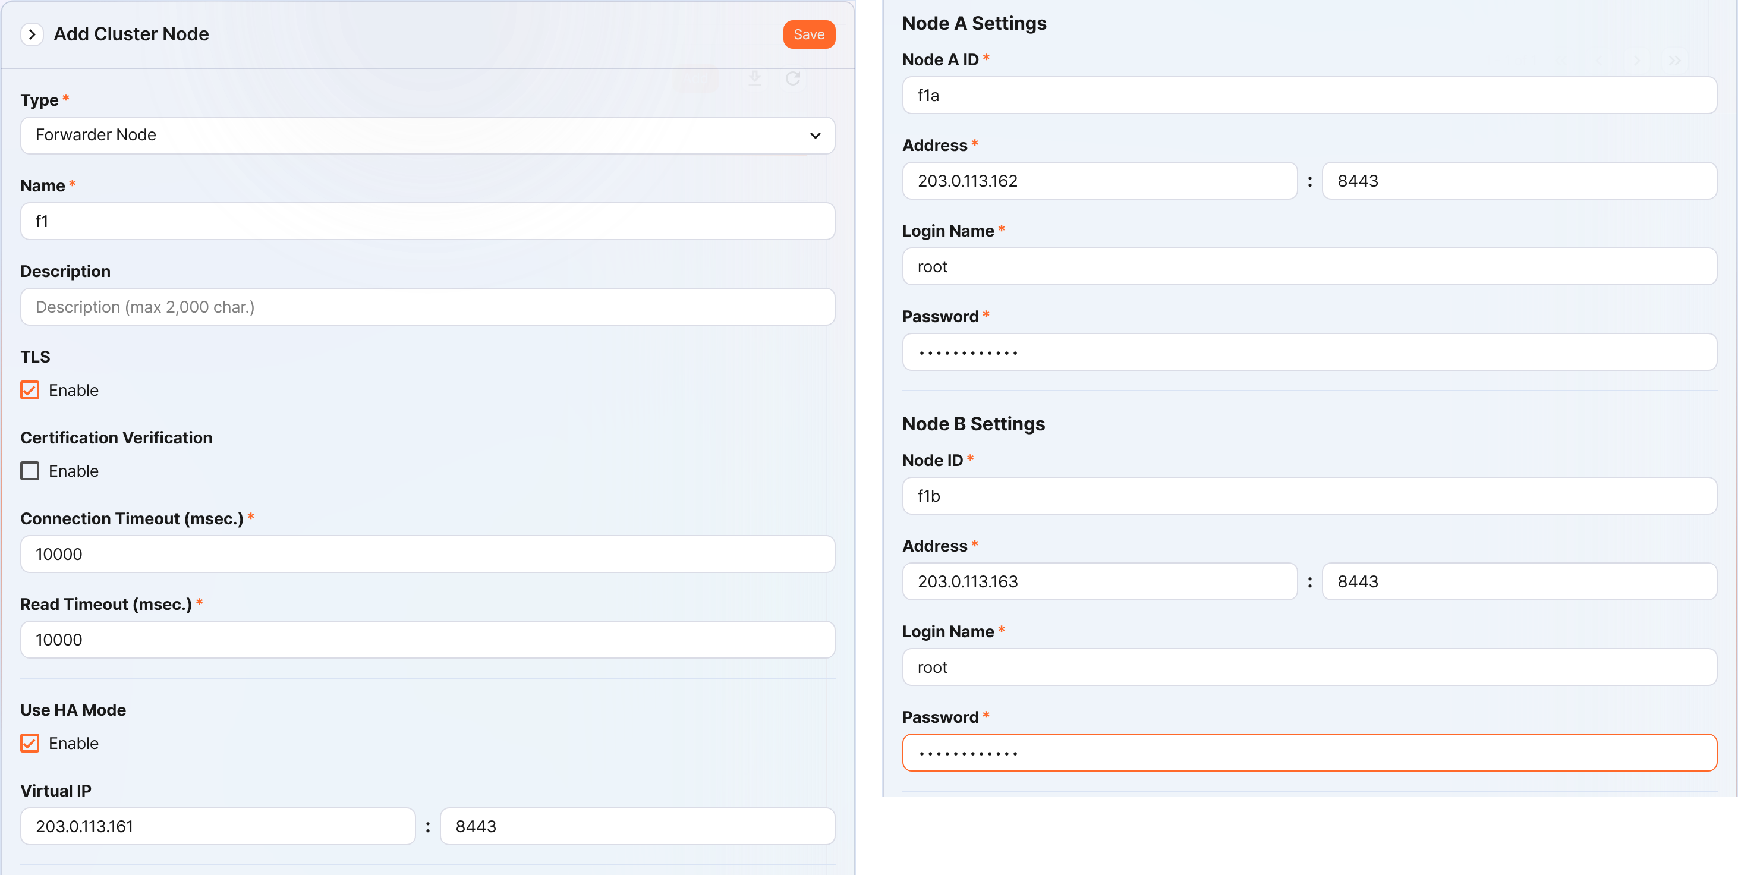
- Type: Select Forwarder Node.
- Name: Enter the Forwarder Node pair identifier (for example, f1).
- You cannot change it after you click the Save button.
- Description: A description of the node pair (optional)
- TLS: Select
- Certification Verification: Not selected
- Connection Timeout: Use the default value
- Read Timeout: Use the default value
- Use HA Mode: Select
- Virtual IP: The IP address of the Forwarder Node pair (for example, 203.0.113.161:8443)
- This IP address is used as the VIP in the HA script.
- Node A Settings
- Node ID: Enter the Node A identifier (for example, f1a).
- Address: The actual IP address and communication port of Node A (for example, 203.0.113.162:8443)
- The port number of the Forwarder Node is 8443.
- Login Name: Enter root.
- Password: Enter the Sonar federation account password.
- Node B Settings
- Node ID: Enter the Node B identifier (for example, f1b).
- Address: The actual IP address and communication port of Node B (for example, 203.0.113.163:8443)
- The port number of the Forwarder Node is 8443.
- Login Name: Enter root.
- Password: Enter the Sonar federation account password.
After you finish entering the information, click the Save button. Verify that the Forwarder Node pair has been added as shown below.
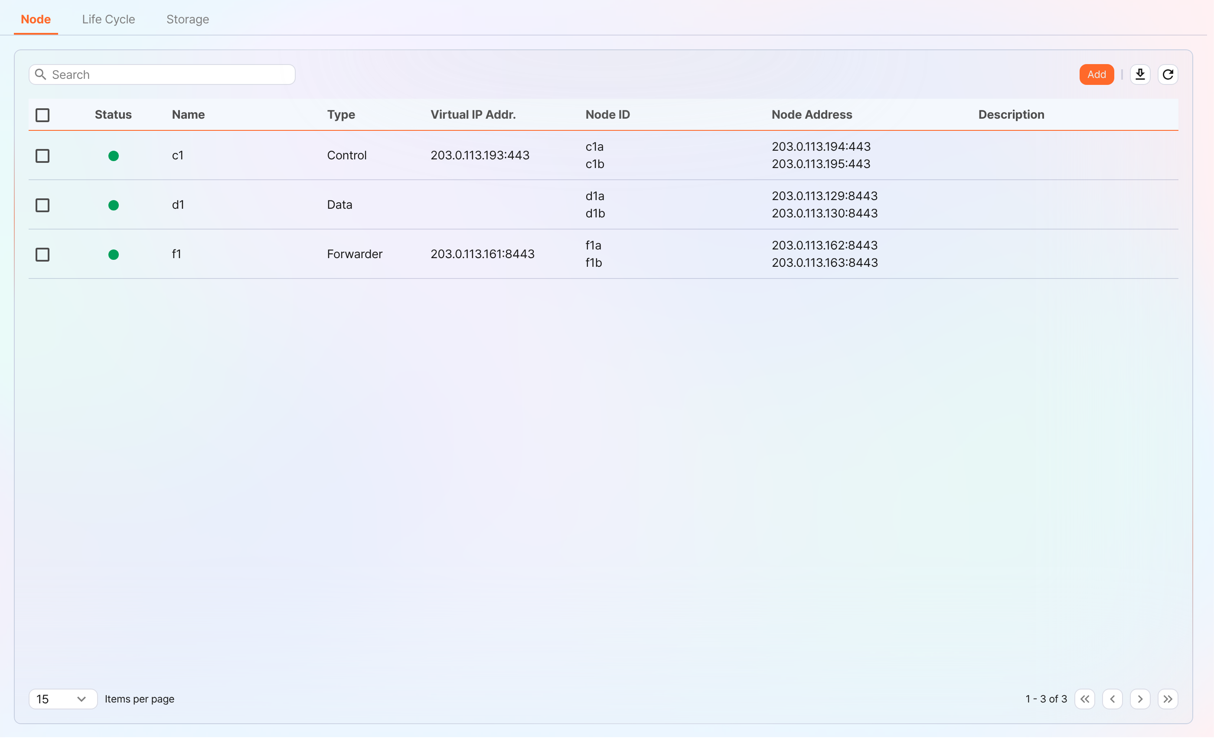
You can click the Name of the added Forwarder Node to check and edit its properties. If you specified the Name or Node ID incorrectly, you must delete the node pair and reconfigure it.
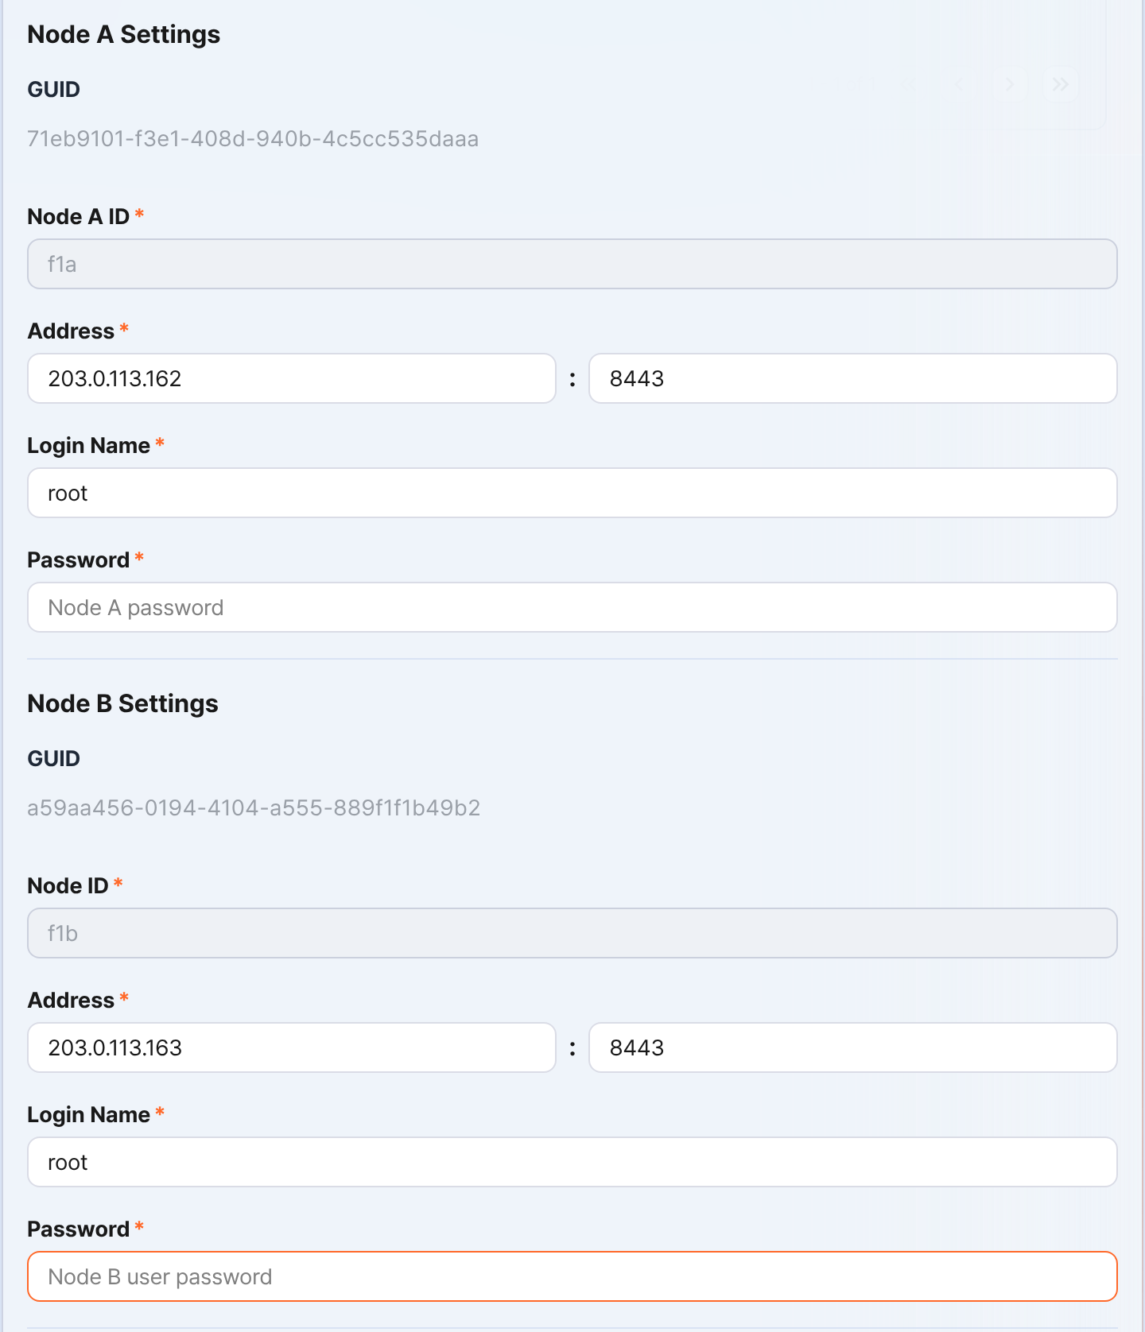
Record the GUIDs of Node A and Node B in a safe place. These values are used in Configuring the node GUID.
Replicating the key encryption key
Replicate the key encryption key (KEK) of the Control Node identically to Forwarder Node A and B.
After you finish this configuration, never change the key encryption key. All nodes that make up the cluster must use the same key encryption key. If they use different keys, encrypted data cannot be decrypted and synchronization between nodes cannot be performed.
In the Logpresso shell of Control Node A or B, run the following command and record the encryption key string in a safe place.
sonar.cipherKey
In the Logpresso shell of Forwarder Node A and B, run the following command on each to configure the same encryption key. KEY_STRING is the encryption key string of the Control Node.
sonar.setCipherKey KEY_STRING
Configuring the node GUID
Set the GUIDs of Forwarder Node A and B, which you checked in the Registering the Forwarder Node pair step, identically in the Logpresso shell of each node.
In the Logpresso shell of Forwarder Node A and B, run the following command to set each node's GUID for policy synchronization in the Logpresso engine.
sonar.setGuid GUID_STRING # enter the GUID for each node
You can check each node's GUID for policy synchronization with the following command.
sonar.nodeConfig
Configuring the master node connection
The Forwarder Node is controlled by the Control Node. Because communication takes place with the Forwarder Node connecting to the Control Node, you must configure the information for the policy master node connection.
In the Logpresso shell of Node A and Node B, run the following command.
sonar.setMaster
The following describes the prompts displayed after you run the command and the values to enter. The account used here is the federation account.
host? 203.0.113.193 # virtual IP address of the Control Node pair
port? 443 # enter 443
account? root # enter root, the federation account
password? # enter the federation account password
connect timeout? 10000 # press Enter to use the default value
read timeout? 10000 # press Enter to use the default value
secure? true # enter true (default is false)
skip cert check? true # enter true (default is false)
Option | Description | Example
host | Virtual IP address of the Control Node pair | 203.0.113.193
port | Federation communication port of the Control Node | 443
account | Federation account | root
password | Federation account password
connect timeout | Server connection wait time | 10000 (ms)
read timeout | Response wait time | 10000 (ms)
secure | Whether to apply TLS communication | true
skip cert check | Whether to skip validation of the TLS certificate | true
Run the following command to verify that the node settings were applied.
sonar.nodeConfig
The following is an example of the output you can see when it is configured correctly.
guid: 7a3241be-c932-4630-8fa5-aefaba773f02
host=203.0.113.193, port=443, account=root, connectTimeout=10000, readTimeout=10000, secure=true, skipCertCheck=true
crypto_file_path: null
Configuring the data replication mode
When you configure a node pair, you can replicate table data between the two nodes. Here, "table" does not mean a database table but a file-based table where the Logpresso engine stores data.
If the same data exists on both nodes, duplicate searching may occur when a distributed query runs. To prevent this, you must set one of the data replication modes, ACTIVE or STANDBY, on each node.
- Active Node: Stores the original log tables and is a search target during distributed queries.
- Standby Node: Replicates the log table data of the Active Node in real time. The replicated tables use the same table ID as the original and are excluded from searches during distributed queries, so duplicate searching does not occur.
The logpresso.setStandbyNode command designates the other node as standby and sets itself as active.
The logpresso.setActiveNode command designates the other node as active and sets itself as standby.
Node A configuration (active)
In the Logpresso shell of Node A, run the following command to check the name of the pair node (Node B).
logpresso.nodeStatuses
The following is an example of the output. In the Federation Nodes section, [f1b] is the name of Node B.
Local
------------------
Node GUID: b6b014f9-88c2-48c1-96c8-e23d8bdb65bc
Instance GUID: af43a33f-7985-41cb-9c7b-31224e47c35a
Federation Nodes
------------------
[f1b] node_guid=44494d5a-40c7-4e02-93bb-71adb50f3aec, instance_guid=3189e170-dae7-465a-a713-21e3da40cbb7, repl_mode=null, pair_guid=null, invalid_guid=false, alive=true, paired=true, failure=false, last connect=2025-06-09 13:39:20, last alive=2025-06-10 14:08:08, created=2025-06-09 13:39:20
The Node GUID and Instance GUID shown in the logpresso.nodeStatuses command output are identifiers that the Logpresso engine uses for log table replication and distributed queries. The Node GUID is used to identify the database and is recorded in the DB_GUID file to be kept permanently. The Instance GUID is the identifier of the currently running process and changes each time you start the node process.
Run the following command to designate Node B as the standby node, which makes Node A the active node. In the command example, f1b is the name of Node B that you checked above.
logpresso.setStandbyNode f1b
If you run the logpresso.nodeStatuses command again, you can see that Replication Mode is set to ACTIVE in the Local section.
------------------
Node GUID: b6b014f9-88c2-48c1-96c8-e23d8bdb65bc
Instance GUID: af43a33f-7985-41cb-9c7b-31224e47c35a
Replication Mode: ACTIVE
Pair Node: f1b
Federation Nodes
------------------
[f1b] node_guid=44494d5a-40c7-4e02-93bb-71adb50f3aec, instance_guid=3189e170-dae7-465a-a713-21e3da40cbb7, repl_mode=null, pair_guid=null, invalid_guid=false, alive=true, paired=true, failure=false, last connect=2025-06-09 13:49:36, last alive=2025-06-10 14:08:08, created=2025-06-09 13:49:36
Node B configuration (standby)
In the Logpresso shell of Node B, run the following command to designate Node A as active, which makes Node B the standby node. f1a is the name of Node A that you checked in the output of the logpresso.nodeStatuses command.
logpresso.setActiveNode f1a
If you run the logpresso.nodeStatuses command, you can see that Replication Mode is set to STANDBY in the Local section.
Local
------------------
Node GUID: 44494d5a-40c7-4e02-93bb-71adb50f3aec
Instance GUID: 3189e170-dae7-465a-a713-21e3da40cbb7
Replication Mode: STANDBY
Pair Node: f1a
Federation Nodes
------------------
[f1a] node_guid=6b6b014f9-88c2-48c1-96c8-e23d8bdb65bc, instance_guid=af43a33f-7985-41cb-9c7b-31224e47c35a, repl_mode=ACTIVE, pair_guid=44494d5a-40c7-4e02-93bb-71adb50f3aec, invalid_guid=false, alive=true, paired=true, failure=false, last connect=2025-03-26 17:03:11, last alive=2025-03-27 13:40:55, created=2025-03-26 17:03:11
Configuring collected log forwarding
To forward the data collected by the Forwarder Node to the base node, you must configure an RPC connection. The RPC connection is encrypted with TLS, and if the connection is temporarily lost, the data is buffered on disk and retransmitted after the connection is restored.
The target to which the Forwarder Node forwards data differs depending on the cluster architecture. The target node to which data is forwarded is called the base node.
- 3-tier architecture: Forwards data to the Data Node
- 2-tier architecture: Forwards data to the Control Node
In the Logpresso shell of Forwarder Node A and B, run the forwarder.setGuid command on each and enter the Node ID of Forwarder Node A/B that you specified in the Registering the Forwarder Node pair step. In the example, this corresponds to f1a.
# forwarder.setGuid NODE_ID
forwarder.setGuid f1a
- NODE_ID: The ID of the Forwarder Node (for example, f1a, f1b)
Add the properties required for the base node connection.
# forwarder.addBase BASE_NAME IP_ADDR PORT SENTRY_CERT CA_CERT SWAP_SIZE
# active base node
forwarder.addBase d1a 203.0.113.129 7140 logpresso-sentry logpresso-ca 1073741824
# standby base node
forwarder.addBase d1b 203.0.113.130 7140 logpresso-sentry logpresso-ca 1073741824
- BASE_NAME: The node ID of the base node (for example, d1a, d1b)
- For a 2-tier architecture (for example, Logpresso Cloud), the name of the Control Node
- For a 3-tier architecture, the name of the Data Node
- IP_ADDR: The IP address of the base node (for example, 203.0.113.129, 203.0.113.130)
- Enter the actual IP address of the base node.
- PORT: The RPC communication port (for example, 7140)
- SENTRY_CERT: The RPC communication certificate (for example, logpresso-sentry)
- CA_CERT: The Logpresso CA certificate (for example, logpresso-ca)
- SWAP_SIZE: The swap size (for example, 1073741824 (=1GB); unit: bytes).
- Specify it considering the size of the /data partition. Swap is a disk swap space that temporarily stores data in case of a Data Node connection failure.
- Specify a size large enough to retain data for your target period.
- When the buffer capacity is exceeded, the oldest data is deleted first.
If the base node is configured as a single server, do not add base node B.
Designate the base node pair as a high-availability unit. The following command designates d1a and d1b as the member nodes of the d1 base node pair.
# forwarder.addBasepair BASE_PAIR_NAME ACTIVE_NODE STANDBY_NODE
forwarder.addBasepair d1 d1a d1b
- BASE_PAIR_NAME: The name of the base node pair (for example, d1)
- ACTIVE_NODE: The active node ID (for example, d1a)
- STANDBY_NODE: The standby node ID (for example, d1b)
If the base node is a single node, enter the same node ID for the active and standby nodes.
Run the following command to check the connection.
forwarder.connections
The following is an example of the output you can see when it is configured correctly.
Connections
--------------------
[d1a] id=1847293650, peer=(a3c7e2f1-8b4d-4a92-9f6e-2d1c8b5a7e3f, /203.0.113.129:7140), trusted level=Low, ssl=true, props={phase=post_hello, type=command}
[d1b] id=1847293651, peer=(b4d8f3g2-9c5e-5b03-0g7f-3e2d9c6b8f4g, /203.0.113.130:7140), trusted level=Low, ssl=true, props={phase=post_hello, type=command}
Configuring system log forwarding
Configure the Forwarder Node to collect performance information such as CPU and memory. You can view the collected data on the web console System > Performance Monitor screen.
In the Logpresso shell of Forwarder Node A and B, run the sentry.setGuid command on each to set the Sentry GUID. Here, the GUID means the node ID. For example, if the node ID of Forwarder Node A is f1a, configure it as follows.
# sentry.setGuid SENTRY_NAME
sentry.setGuid f1a
- SENTRY_NAME: The node ID of the Sentry (for example, f1a, f1b)
On Forwarder Node A and B, run the following command to set the Control Node to which logs are forwarded.
# sentry.addBase BASE_NAME IP_ADDR PORT SENTRY_CERT CA_CERT SWAP_SIZE
sentry.addBase c1 203.0.113.193 7140 logpresso-sentry logpresso-ca 1073741824
- BASE_NAME: The name of the Control Node pair (for example, c1)
- IP_ADDR: The virtual IP address of the Control Node pair (for example, 203.0.113.193). Unlike the RPC connection, you must always enter the virtual IP address of the Control Node.
- PORT: The Sentry port (for example, 7140)
- SENTRY_CERT: The Sentry certificate (for example, logpresso-sentry)
- CA_CERT: The Logpresso CA certificate (for example, logpresso-ca)
- SWAP_SIZE: The swap size (for example, 1073741824 (=1GB); unit: bytes)
Run the following command to check the connection.
sentry.connections
The following is an example of the output you can see when it is configured correctly.
Connections
--------------------
[c1] id=2035698886, peer=(1b3fcc3f-61ce-41ae-9c45-d0096b8b7fff, /203.0.113.193:7140), trusted level=Low, ssl=true, props={phase=post_hello, type=command}
Configuring license sharing between nodes
Configure all nodes in the cluster environment to be subject to the same license. The license registered on the Control Node also applies to the Data Node and the Forwarder Node. Here, the document describes how to apply the Control Node license to the Forwarder Node.
In the Logpresso shell of Node A and Node B, run the following command to enable license sharing.
logpresso.setLicenseMode slave
Run the following command to check the license master status.
logpresso.licenseMode
When it is configured correctly, the following is displayed.
SLAVE
(Control Node A and B) See this document to register the Forwarder Node as a license slave.
Open a web browser and go to https://<Control Node A IP address>:8443.
Log in with the federation account, then go to Settings > License Management.
In the All Node List, click Register Node.
Enter the information of the license slave node and click Create.
- Name: A name to identify the Forwarder Node (for example, f1a, f1b)
- Host Address: The IP address of the Forwarder Node
- Port: The federation communication port of the Forwarder Node. Enter 8443.
- User: The federation account ID (root)
- Password: The password of the federation account
- Secure: Select Enable.
- Verify Certification: If Enable is checked, clear it.
- Connection Timeout: Use the default value.
- Read Timeout: Use the default value.
Perform the same task on Control Node B.
Enabling distributed queries
A distributed query (Distributed Query) is a feature that integrates and queries table data stored across multiple nodes with a single query. To prevent duplicate searching during distributed query execution and to get correct query results, you must enable distributed queries on all nodes.
In the Logpresso shell of Node A and Node B, run the following command on each to enable distributed queries.
logpresso.enablePlanner
Run the following command to check the distributed query status.
logpresso.plannerStatus
When it is enabled correctly, the following is displayed.
Running: true
Because the Forwarder Node forwards collected data to the Data Node and does not keep it in local tables, it does not configure the query cache, unlike the Data Node.
Configuring the web server
There are web service ports that are open after the package installation. Close the unnecessary ports and open only the ports required for Data Node operation.
In the Logpresso shell, run the following command to check the open web service ports.
httpd.bindings
The following is an example of the output you can see after running the command.
/0.0.0.0:8443 (ssl: key logpresso-web, trust null), opened, default context: webconsole, idle timeout: 0seconds, log file prefix: null, access log: false, error log: false
/0.0.0.0:18443 (ssl: key logpresso-web, trust null), opened, default context: sonar-explanation, idle timeout: 0seconds, log file prefix: null, access log: false, error log: false
/0.0.0.0:443 (ssl: key logpresso-web, trust null), opened, default context: sonar, idle timeout: 0seconds, log file prefix: null, access log: false, error log: false
/0.0.0.0:44300 (ssl: key logpresso-web, trust null), opened, default context: deploy, idle timeout: 0seconds, log file prefix: null, access log: false, error log: false
Run the following command to close all open web ports, reflect the certificate change, and open only the port used for federation communication.
httpd.close 8443
httpd.close 18443
httpd.close 443
httpd.close 44300
httpd.openSsl 8443 webconsole logpresso-web
The httpd mentioned in the commands does not mean the Apache web server but the web service of Logpresso Sonar.
Configuring WebSocket frames (optional)
Because federation communication uses WebSocket, if the distributed query result is large or there is a lot of data to transfer, the transfer may fail with the default WebSocket frame size. To process large data smoothly, you need to increase the frame size.
In the Logpresso shell of Node A and Node B, run the following command to check the current setting value.
webconsole.maxFrameSize
The default value is 8MB, and the command output is as follows.
8,388,608 bytes
Run the following command to change the frame size. The value set in the example is 84MB.
webconsole.setMaxFrameSize 83886080
Run the webconsole.maxFrameSize command again to check the changed value.
83,886,080 bytes
Restarting the service
To apply the changed settings, you must restart the Logpresso service. The order of operations is as follows.
Stop order: standby → active
Start order: active → standby
By default, Node A is active and Node B is standby. If you start the active node first during system operation, you can quickly recover the original data service, and the standby node can immediately establish a replication connection when it starts.
To stop the nodes,
On the standby node (Node B), run the following command to stop the Logpresso service.
sudo systemctl stop logpresso
After Node B stops, run the same command on the active Node A to stop the service.
To start the nodes,
On Node A, run the following command to start the Logpresso service.
sudo systemctl start logpresso
After Node A starts correctly, run the same command on Node B to start the Logpresso service.
Log in to the web console of Node A and, on the System > Performance Monitor screen, verify that the status of each Forwarder Node is displayed in green.
If the status of a Forwarder Node is not green, you can check the cause in the /opt/logpresso/log/araqne.log file.

Network redundancy
A Forwarder Node pair shares a single virtual IP address (VIP, Virtual IP Address) as its representative address, so the two nodes distribute the load at the network level and automatically switch the connection during a failure. External clients such as the Data Node, the Control Node, and web browsers connect to the Forwarder Node through the VIP, so service continuity is maintained regardless of whether an individual node fails.
You can configure network redundancy in the following two ways.
Load balancer (recommended)
Use a load balancer such as an L4 switch and configure it to distribute traffic coming into the VIP to Forwarder Node A and Forwarder Node B. Refer to the following when configuring the load balancer.
- Health check: Configure it to periodically health-check the listening port of each Forwarder Node (for example, 7140/tcp) to verify whether the node is alive.
- Failover: Configure it to automatically exclude a node that fails the health check from traffic distribution and forward traffic only to healthy nodes.
HA script
In environments where you cannot use a load balancer, you can configure VIP switching with the HA script provided by Logpresso. Request the HA script from the Logpresso technical support team.

Appendix

Troubleshooting

Connection issues
Data/Forwarder node status shown in gray in the web console
First, check whether the Control Node can reach the web server of the Data/Forwarder node. Sign in to the Logpresso shell on the Control Node, and then enter the IP address of the Data/Forwarder node and the web server port as shown below to check connectivity.
# tcpscan <Data/Forwarder node IP> 8443
tcpscan 203.0.113.161 8443
Diagnosing firewall policy issues
Depending on the command output, there may be a firewall policy issue or a federation communication port issue as described below.
timeout
If timeout is displayed after a certain amount of time when you run the tcpscan command, check every firewall policy on the communication path from the Control Node to the Data/Forwarder node, along with the node's local firewall policy using the firewall-cmd --list-all command.
trying to connect /203.0.113.161:8443
timeout
not opened: Connection refused
If the not opened: Connection refused message is displayed, the federation communication port is not open. Run the httpd.bindings command in the Logpresso shell on the Data/Forwarder node to recheck the port settings. When it is working properly, the output looks like the following.
# httpd.bindings command output
/0.0.0.0:8443 (ssl: key logpresso-web, trust null), opened, default context: webconsole, idle timeout: 0seconds, log file prefix: null, access log: false, error log: false
Run the httpd.openSsl command as shown below to open the federation communication port.
# httpd.openSsl <port> <context> <key alias>
httpd.openSsl 8443 webconsole logpresso-web
Diagnosing web server certificate issues
If the tcpscan <Data/Forwarder node IP> 8443 command shows opened but the Data/Forwarder node connection status is still shown in gray in the web console, the SSL certificate or the policy synchronization password is set incorrectly. To determine the cause, connect to port 8443 of the node from a web browser on your operations terminal. If ERR_SSL_PROTOCOL_ERROR is displayed as shown below, it is a certificate issue.
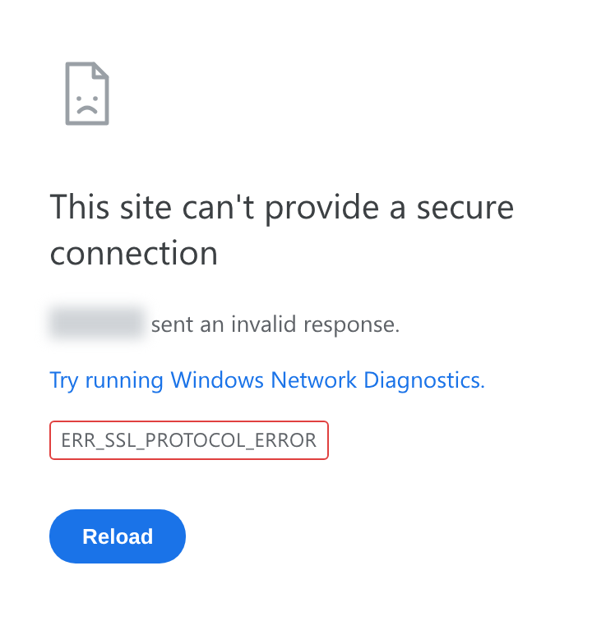
If it is a web server certificate issue on the Data/Forwarder node, run the master node connection setup again with the sonar.setMaster command (this goes through the process of downloading and installing the certificate while communicating with the master node). The following describes the values to enter when you run the sonar.setMaster command.
host? 203.0.113.193 # Virtual IP address of the Control Node pair
port? 8443 # Enter 8443
account? root # Enter the Control Node federation account root
password? # Enter the password of the Control Node federation account
connect timeout? 10000 # Press Enter to use the default value
read timeout? 10000 # Press Enter to use the default value
secure? true # Enter true (the default is false)
skip cert check? true # Enter true (the default is false)
Diagnosing policy synchronization password issues
If the ENT web console screen is displayed properly when you connect to port 8443 of the Data/Forwarder node from a web browser, enter the federation account name and password on this screen to check whether you can sign in successfully. If you cannot sign in, run the dom.resetPassword localhost root command in the Logpresso shell on the Data/Forwarder node to reset the password, and then re-enter the reset password in the Password fields under Node A Settings and Node B Settings on the System > Clusters > Node screen of the web console.
Failure to connect from a Data/Forwarder node to the Control Node RPC
Diagnosing the RPC connection status
Run the following commands in the Logpresso shell on the Data/Forwarder node to check whether the connection to the Control Node RPC port works.
forwarder.connections # For a Forwarder node
sentry.connections # For a Data node. Can also be run on a Forwarder node
The command output should list content like the following.
Connections
--------------------
[c1a] id=1317075310, peer=(39c2dd55-5bb5-4497-a327-ee6f8cae9ad9, /203.0.113.194:7140), trusted level=Low, ssl=true, props={phase=post_hello, ping_failure=0, type=command}
If no RPC connection related to the Control Node IP address is listed as shown above, it may be a firewall policy issue or an issue with the certificate used for TLS mutual authentication.
Diagnosing firewall policy issues
First, in the Logpresso shell on the Data/Forwarder node, enter the Control Node IP address and RPC port as shown below to check connectivity.
# tcpscan <Control Node IP> 7140
tcpscan 203.0.113.193 7140
If timeout is printed after a certain amount of time as shown below, check every firewall policy on the communication path from the Data/Forwarder node to the Control Node.
trying to connect /203.0.113.193:7140
timeout
Diagnosing SSL certificate issues
In the Logpresso shell on the Data/Forwarder node, run the logger.tail command or view the /opt/logpresso/log/araqne.log file to check the daemon log.
Certificate password error
If a keystore password was incorrect error occurs as shown below, the certificate password is incorrect.
[2025-01-30 09:24:10.812] WARN (KeyStoreManagerImpl) - getKeyStore() error:
java.io.IOException: keystore password was incorrect
at java.base/sun.security.pkcs12.PKCS12KeyStore.engineLoad(PKCS12KeyStore.java:2116)
at java.base/sun.security.util.KeyStoreDelegator.engineLoad(KeyStoreDelegator.java:222)
at java.base/java.security.KeyStore.load(KeyStore.java:1479)
at org.araqne.keystore.KeyStoreManagerImpl.getKeyStore(KeyStoreManagerImpl.java:298)
at org.araqne.keystore.KeyStoreManagerImpl.getKeyManagerFactory(KeyStoreManagerImpl.java:414)
at org.araqne.rpc.RpcKeyStoreManagerImpl.__M_getKeyManagerFactory(RpcKeyStoreManagerImpl.java:62)
at org.araqne.rpc.RpcKeyStoreManagerImpl.getKeyManagerFactory(RpcKeyStoreManagerImpl.java)
at org.logpresso.sentry.impl.ConnectionWatchdogImpl.__M_connect(ConnectionWatchdogImpl.java:216)
at org.logpresso.sentry.impl.ConnectionWatchdogImpl.connect(ConnectionWatchdogImpl.java)
at org.logpresso.sentry.impl.ConnectionWatchdogImpl.__M_checkConnections(ConnectionWatchdogImpl.java:171)
at org.logpresso.sentry.impl.ConnectionWatchdogImpl.checkConnections(ConnectionWatchdogImpl.java)
at org.logpresso.sentry.impl.ConnectionWatchdogImpl.__M_checkNow(ConnectionWatchdogImpl.java:149)
at org.logpresso.sentry.impl.ConnectionWatchdogImpl.checkNow(ConnectionWatchdogImpl.java)
at org.logpresso.sentry.impl.ConnectionWatchdogImpl.__M_run(ConnectionWatchdogImpl.java:123)
at org.logpresso.sentry.impl.ConnectionWatchdogImpl.run(ConnectionWatchdogImpl.java)
at java.base/java.lang.Thread.run(Thread.java:829)
Caused by: java.security.UnrecoverableKeyException: failed to decrypt safe contents entry: javax.crypto.BadPaddingException: Given final block not properly padded. Such issues can arise if a bad key is used during decryption.
... 16 more
Untrusted certificate error
If a No trusted certificate found error occurs as shown below, the certificate used is not the one issued by the Control Node but the one automatically generated when the daemon first started.
[2025-01-30 09:28:14.623] ERROR (ConnectionWatchdogImpl) - logpresso-sentry: failed to connect, closing connection (No trusted certificate found)
[2025-01-30 09:28:14.624] ERROR (RpcHandler) - araqne rpc: ssl handshake exception from x.x.x.x:7140, channel 2ca2e90a (No trusted certificate found)
For both errors, run the master node connection setup again with the sonar.setMaster command (this goes through the process of downloading and installing the certificate while communicating with the master node). The following describes the values to enter when you run the sonar.setMaster command.
host? 203.0.113.193 # Virtual IP address of the Control Node pair
port? 8443 # Enter 8443
account? root # Enter the Control Node federation account root
password? # Enter the password of the Control Node federation account
connect timeout? 10000 # Press Enter to use the default value
read timeout? 10000 # Press Enter to use the default value
secure? true # Enter true (the default is false)
skip cert check? true # Enter true (the default is false)

Diagnosing Syslog reception
If Syslog is not collected properly through a Forwarder node even after you configure a collector in the web console, diagnose the issue as described below. The following example assumes that packets are sent from the IP address 172.20.100.100.
Forwarder node trace
Connect to the Forwarder node over SSH, and then run the following command to enter the Logpresso shell.
ssh -p7022 root@localhost
Run the syslog.servers command to list the Syslog server settings.
Syslog Servers
----------------
[logpresso] 0.0.0.0:514 (udp), charset=UTF-8 (override: 0), capacity=20000, rx_buf_size=0, receiver_cpu_id=-1, queue_count=1, buffer_file_path=./, buffer_file_size=10737418240, start from=2024-12-11 13:22:13, received=7
Use the syslog.stats logpresso command to view reception statistics by Syslog client IP address.
Syslog Statistics
-------------------
x.x.x.x => 1 (first seen 2025-01-20 10:58:44, last seen 2025-01-20 10:58:44)
Use the syslog.trace logpresso command to trace the content of incoming Syslog packets in real time. Press Ctrl+C during the trace to stop it.
Checking Syslog packets
You can verify whether packets reach the Logpresso Forwarder node by using the tcpdump command in the terminal as shown below.
# tcpdump -i <interface> host <Forwarder node IP address> port <Forwarder node syslog port> -A
tcpdump -i any host 172.20.100.100 port 514 -A
Checking whether the port is open
Once you confirm that Syslog packets are reaching the Forwarder node, run the netstat -na | grep :514 command to check whether the port is open.
# netstat -na | grep :514
udp 0 0 0.0.0.0:514 0.0.0.0:*
If the port is not open as shown above, you may have skipped the JVM permission granting step during installation and failed to open the port, or the port settings may have changed. Run the following command to check whether cap_net_bind_service is printed.
# getcap <java executable path>
getcap /opt/logpresso/jdk/bin/java
If the permission is not granted, use the setcap command to grant the required permissions to the java executable.
# setcap cap_net_bind_service,cap_sys_time,cap_net_raw=+ep <java executable path>
setcap cap_net_bind_service,cap_sys_time,cap_net_raw=+ep /opt/logpresso/jdk/bin/java
Checking the host firewall policy
If there is no blocked segment on the connection path from the Syslog client to the Forwarder node, but Syslog packets do not reach the Forwarder node at all, run the firewall-cmd --list-ports command to recheck the host firewall policy.
# firewall-cmd --list-ports
Checking the rp_filter setting
If the firewall policy and the port open status are all normal but you cannot confirm reception with the syslog.trace command in the Logpresso shell, the issue may be with the Linux kernel's Reverse Path Filtering setting.
The Linux kernel's Reverse Path Filtering feature checks the source of a packet to block spoofed packets. The default is 1, which drops packets that come in on an invalid path.
If the Forwarder node has multiple network interface cards and packets from a source can be received through multiple network interface cards, change the rp_filter setting.
Checking the current setting
Run the cat /proc/sys/net/ipv4/conf/<interface>/rp_filter command to check the rp_filter setting value.
# cat /proc/sys/net/ipv4/conf/eth2/rp_filter # command output
1
- 0 (disabled): Does not perform Reverse Path Filtering
- 1 (default, strict): Checks the path of the interface based on the packet's source IP address, and drops the packet if it does not match
- 2 (loose): Allows a packet with the same source IP address if it has a valid path through any interface
If the value is 1, add the following setting to the end of the /etc/sysctl.conf file.
net.ipv4.conf.eth2.rp_filter = 2
Run the following command with administrator privileges to apply the kernel setting.
sysctl -p

MariaDB
Galera Cluster cannot be restarted
If you stop all Galera Cluster servers and then restart them, but the cluster does not start and the database does not start even with the systemctl start mariadb command, restart MariaDB in the following order.
(Control Node A) Edit the /var/lib/mysql/grastate.dat file with administrator privileges.
# GALERA saved state
Version: 2.1
Uuid: 5022f7e5-281a-11e8-98c9-9baa762d13e6
Seqno: -1
Safe_to_bootstrap: 1
- Change the Safe_to_bootstrap value from 1 to 0.
(Control Node A) Restart the Galera Cluster server.
sudo galera_new_cluster
(Control Node B) Run the following command to start MariaDB, and check whether wsrep_start_position has the same value as Control Node A.
sudo systemctl start mariadb && \
ps -ef | grep mysql
Running this command produces a result similar to the following.
mysql 1141195 1 1 Apr15 ? 22:50:53 /usr/sbin/mariadbd --wsrep_start_position=c6609d0e-091a-11f0-86bb-3e7cc9ee21e7:40512
Node B joins an already-started Galera Cluster, so you must not run the galera_new_cluster command. The galera_new_cluster command must be run only on the first node to start in the cluster.
If the wsrep_start_position value is "00000000-0000-0000-0000-000000000000", run the systemctl restart mariadb command.

Diagnosing OOM and memory leaks
Generating a heap dump
If an OutOfMemoryError (OOM) occurs on a node and stops the logpresso process, or a memory leak is suspected, you can generate a heap dump to diagnose the cause.
The size of the heap dump file can be similar to the JVM heap size. Make sure there is enough free disk space in the save path.
Add the following lines to the end of the /opt/logpresso/etc/logpresso.conf file.
JAVA_OPTS="$JAVA_OPTS -XX:+HeapDumpOnOutOfMemoryError"
JAVA_OPTS="$JAVA_OPTS -XX:HeapDumpPath=/data/heapdump.hprof"
Restart the logpresso process.
sudo systemctl restart logpresso
When an OOM occurs afterward, a heap dump file is automatically generated at the specified path. Run the following command to check the file.
ls -lh /data/heapdump.hprof

Collecting data for failure analysis
Run the jcmd command to find the PID of the java process running araqne-core. The following is an example of the command output.
3370022 /logpresso/araqne-core-4.0.5-package.jar
2428126 jdk.jcmd/sun.tools.jcmd.JCmd
Generate evidence based on the identified PID.
# Run jcmd based on the PID identified earlier.
# The path where files are saved can be changed.
# Run so that all evidence files are stored in a directory with sufficient free space.
# Generate jmap
jcmd 3370022 GC.class_histogram > /data/histogram_yyMMdd.txt
# Generate JFR -> (the file is created after 60 seconds.)
jcmd 3370022 JFR.start duration=60s settings=profile filename=/data/jfr_yyMMdd.jfr
# Generate jstack
jcmd 3370022 Thread.print > /data/jstack_yyMMdd.txt
# Generate HeapDump
# The file can be created as large as the Java heap memory size. Run this in a directory with ample free space if possible.
jcmd 3370022 GC.heap_dump -all=true /data/heapdump_yyyyMMdd.hprof
Export the generated evidence.
If you use OpenJDK distributed as a ZIP file, the java file path may be registered in the PATH environment variable. Run the 'ps -ef | grep java' command to first check the java file path used to run Logpresso Sonar.
If it is not the path registered in PATH, move to the directory that contains the java file and prefix each command with './' to run the audit evidence generation commands.

logpresso.conf file properties

Overview
This document describes the options defined in logpresso.conf.

Environment variables and launcher options
The following options control the runtime environment, such as JVM memory/GC, ulimit, and paths, and are not mapped to -D system properties (some are used for the JVM flags -X, -XX or for script behavior).
Option | Function summary | Allowed values | Default
ETCDIR | Configuration file directory location | Path | $BASEDIR/etc
LOGDIR | Log directory location | Path | $BASEDIR/log
HOSTNAME | Host name (compatibility) | String | $(hostname)
ARAQNE_CORE_VERSION | Core version (display/compatibility) | String | Undefined
OPEN_FILE_LIMIT | Process open file limit | Integer | 50,240
OPEN_PROC_LIMIT | Process count limit | Integer | 50,240
JAVA_HOME | JDK path | Path | Undefined
MIN_HEAP_SIZE | JVM initial heap size | e.g. 2G | 2G
MAX_HEAP_SIZE | JVM maximum heap size | e.g. 4G | 4G
MAX_PERMGEN_SIZE | PermGen (old JDK) | e.g. 300M | 300M
MAX_DIRECT_MEM_SIZE | Direct memory | e.g. 4G | 4G
GC_LOG_FILECOUNT | Number of GC log files | Integer | 10
GC_LOG_FILESIZE | Maximum size of one GC log | Size (e.g. 10240K) | 10240K
TRIM_NATIVE_HEAP_INTERVAL | Native heap trim interval | Milliseconds | 300,000
PIDFILE | PID file path | Path | /var/run/logpresso/logpresso.pid
Note: TRIM_NATIVE_HEAP_INTERVAL is applied as -XX:TrimNativeHeapInterval on JDK 21 or later. MIN_HEAP_SIZE/MAX_HEAP_SIZE are applied as -Xms/-Xmx, respectively.

System options
The following options are passed by the launcher as system properties (the mapped -D key is noted in parentheses).
Option | Function summary | Allowed values | Default
BASEDIR (-Daraqne.dir) | Default installation path | Path | /opt/logpresso
CERTDIR (-Daraqne.cert.dir) | Certificate/key directory | Path | Undefined
CACHEDIR (-Daraqne.cache.dir) | Cache directory (components) | Path | $BASEDIR/cache (recommended)
DATADIR (-Daraqne.data.dir) | Data directory | Path | $BASEDIR/data
DIAGDIR (-Daraqne.diag.dir) | Abnormal termination/memory dump storage | Path | $BASEDIR/diag
DOWNDIR (-Daraqne.download.dir) | Temporary bundle download directory | Path | $BASEDIR/download
SFTPDIR (-Daraqne.home.dir) | SFTP home directory | Path | $BASEDIR/home
PLGNDIR (-Daraqne.plugin.dir) | Plugin directory | Path | $BASEDIR/plugin
LOGDIR (-Daraqne.log.dir) | Log directory | Path | $BASEDIR/log
INDEXDIR (-Daraqne.index.dir) | Index directory | Path | $DATADIR/logpresso-index/online
LOG_API_STATE_DIR (-Daraqne.logapi.state.dir) | Log API state directory | Path | $DATADIR/araqne-log-api/state
PACKMANDIR (-Daraqne.packman.dir) | Package directory | Path | $BASEDIR/pkg
PIDFILE (-Daraqne.core.pid_file) | PID file path | Path | /var/run/logpresso/logpresso.pid
HTTP_404 (-Daraqne.http.404) | 404 page path | Path | Predefined page
HTTP_500 (-Daraqne.http.500) | 500 page path | Path | Predefined page
HTTPD_AES256 (-Daraqne.httpd.aes256) | Use strong TLS suites | disabled/enabled | disabled
HTTPD_CORS (-Daraqne.httpd.cors) | Enable CORS | disabled/enabled | disabled
HTTPD_LOG_PATH (-Daraqne.httpd.log_path) | HTTP POST logging path | Path | $LOGDIR/httpd
HTTPD_LOG_RETENTION (-Daraqne.httpd.log_days) | HTTP log retention days | Integer (days) | 7
HTTPD_WORKER_POOL (-Daraqne.httpd.max_worker) | Number of web worker threads | 4 - number of CPU cores | Automatic
HTTPD_XSS_PROTECT (-Daraqne.httpd.xss_protection) | XSS protection header | disabled/enabled | enabled
HTTPS_PROTOCOL (-Daraqne.https.protocols) | TLS protocol list | TLSv1.1/1.2/1.3,... | Undefined (null)
SSH_OPEN (-Daraqne.ssh.server) | Enable SSH service | disabled/enabled | disabled
SSH_ADDR (-Daraqne.ssh.address) | SSH bind address | IPv4 | 127.0.0.1
SSH_PORT (-Daraqne.ssh.port) | SSH port | 1–65535 | 7022
SSH_TMOUT (-Daraqne.ssh.timeout) | SSH session timeout (ms) | Integer | 600,000
TEL_OPEN (-Daraqne.telnet.server) | Telnet service | disabled/enabled | disabled
TEL_ADDR (-Daraqne.telnet.address) | Telnet bind address | IPv4 | 127.0.0.1
TEL_PORT (-Daraqne.telnet.port) | Telnet port | 1–65535 | 7004
ADM_IP (-Daraqne.dom.admin_trust_hosts) | Administrator access allow IP | IPv4 (up to 2, comma-separated) | Undefined (unlimited)
BLOCK_CC_ADM (-Daraqne.dom.block_concurrent_admin) | Block concurrent administrator login | disabled/enabled | disabled
BLOCK_CC_LOGIN (-Daraqne.dom.block_concurrent_login) | Block concurrent login | disabled/enabled | disabled
SSO_TMOUT (-Daraqne.sso.timeout) | SSO token timeout (ms) | Integer | 3,600,000
LOGKEEPDAY (-Daraqne.log.keepdays) | Log retention days | Integer (days) | 7
TAIL_LIMIT (-Daraqne.log.last_size) | logger.tail result limit | Integer (<=0 is treated as 0) | 1,000
LOGSTORAGE_REPAIR (-Daraqne.logstorage.repair) | Log storage integrity repair | disabled/enabled | enabled
MSGBUS_DELAY (-Daraqne.msgbus.delay) | Simulate response delay (ms) | Integer | 0
RPC_CLIENT_IOWORKER (-Daraqne.rpc.client.ioworker) | RPC client IO workers | Integer | 2
RPC_CLIENT_OIO (-Daraqne.rpc.client.oio) | RPC OIO mode (blocking I/O) | disabled/enabled | disabled
RPC_WORKER (-Daraqne.rpc.max_worker) | RPC worker thread upper limit | 4–8 | Automatic
REPAIR_FORCECHECK (-Dlogpresso.repair.forcecheck) | Force integrity check on next boot | false/true | false
LOG_EMPTY_LINE (-Daraqne.logapi.collect_empty_line) | Allow empty line collection | disabled/enabled | disabled
LOG_EVICT_MS (-Daraqne.logapi.evict_interval) | Collection buffer eviction interval (ms) | Integer | 3,600,000
LOG_WATCHER_MODE (-Daraqne.logapi.watcher) | File watch mode | naive/null | null
LOG_NIO_POLL_MS (-Daraqne.nio.poll_interval) | NIO polling interval (ms) | Integer | 0
LOG_NIO_POLL_TMOUT (-Daraqne.nio.poll_timeout) | NIO polling timeout (ms) | Integer | 100
HP_FTP_FIX (-Dlogpresso.ftp.rotation.useWuFtpFix) | WuFtpd compatibility fix | false/true | false
JDBC_FETCH (-Dlogpresso.jdbc.fetch_size) | DB fetch size | Integer | 10,000 (collection)/5,000 (query)
SNMP_MAX_REPEAT (-Dlogpresso.snmp.bulk_max_repeat) | SNMP bulk max-repeat | Integer | 20
SSH_BULK_REQ (-Dlogpresso.ssh.bulk_req) | SFTP bulk request count | Integer | 16
ALLOWED_FILE_SCAN_PATHS (-Daraqne.logdb.allowed_file_scan_paths) | Local file access allowed paths | Path (comma-separated) | $DATADIR/araqne-logdb/scan,$LOGDIR
LOGDB_ARRAY_CAP (-Daraqne.logdb.array_capacity) | array() input upper limit | Integer | 100
CEPENGINE (-Daraqne.logdb.cepengine) | CEP storage | mem/offheap | mem
JDK_REGEX_STEP_LIMIT (-Daraqne.logdb.regex.jdk_regex_step_limit) | JDK regex step limit | -1 or integer 0 or greater | 300,000,000
COUNTER_SLOT (-Daraqne.logdb.counter_slot) | Number of slotted counter slots | Integer | CPU/configuration automatic
DISCARD_NULL_COL (-Daraqne.logdb.discard_null_column) | Remove null columns | false/true | false
DISCARD_NULL_GRP (-Daraqne.logdb.discard_null_group) | Remove null groups | false/true | false
EXEC_QUERY (-Daraqne.logdb.exec_query) | Allow exec/execpip | disabled/enabled | disabled
LEGACY_STR_MATCH (-Daraqne.logdb.legacy_string_match) | Legacy IP string matching | disabled/enabled | disabled
COLUMNS_LIMIT (-Daraqne.logdb.max_columns) | CSV column count upper limit | Integer | 10,000
LOGDB_PURGE (-Daraqne.logdb.purge) | Allow purge command | disabled/enabled | disabled
QUERY_POOL_SIZE (-Daraqne.logdb.query_pool_size) | Number of parallel table query cores | Integer | Number of CPUs
SORT_HEAP_SIZE (-Daraqne.logdb.sort_offheap) | sort offheap size | Size (MB/G) | 100MB
SORT_PARTITIONS (-Daraqne.logdb.sort_partitions) | Number of sort partitions | Integer | 32
TABLE_OPTIMIZER (-Daraqne.logdb.table_scan_optimizer) | Scan optimizer | disabled/enabled | enabled
UTF8BOM (-Daraqne.logdb.utf8bom) | Add outputcsv BOM | false/true | false
VALUES_CAP (-Daraqne.logdb.values_capacity) | values() input upper limit | Integer | 100
WGET_SIZE_LIMIT (-Daraqne.logdb.wget_max_size) | wget response maximum size | Bytes | 10,485,760
CUREVFIT_LIMIT (-Dlogpresso.curvefit.limit) | curvefit input upper limit | Integer | 10,000
INSTANT_CACHING (-Dlogpresso.index.instant_caching) | Instant caching | disabled/enabled | enabled
OLD_FULLTEXT (-Dlogpresso.index.old_fulltext_func) | Keep old full-text search function | disabled/enabled | disabled
INVERTED_CACHE_SIZE (-Dlogpresso.inverted_cache_size) | Inverted cache size | Bytes | 104,857,600
KMEANS_LIMIT (-Dlogpresso.kmeans.limit) | kmeans input upper limit | Integer | 10,000
CACHE_RECORD_STATS (-Dlogpresso.log_cache_record_stats) | Table cache statistics | false/true | false
CACHE_SIZE (-Dlogpresso.log_cache_size) | Table cache size | Bytes | 104,857,600
QUERY_RESULT_POOL_SIZE (-Dlogpresso.logstorage.query_result_pool_size) | Temporary result generation threads | 4 - CPU cores | Automatic
FCST_SERIAL (-Dlogpresso.ml.forecast.serial) | forecast serial execution | f/t | f
LOF_OPTIMIZER (-Dlogpresso.ml.lof.optimize) | Use LOF optimization | f/t | t
DETECT_DEADLOCK (-Dlogpresso.query.deadlock_detect) | Deadlock detection | disabled/enabled | enabled
REPAIR_CHECKDAYS (-Dlogpresso.repair.checkdays) | Integrity check window (days) | Integer/-1 | 2
STL_LIMIT (-Dlogpresso.stl.limit) | stl input upper limit | Integer | 1,000
ASYNC_POOL_SIZE (-Dlogpresso.stream.async_pool_size) | Async stream pool size | 1 < integer ≤ 100 | Number of CPUs
STREAMJOIN_BUFFER_SIZE (-Dlogpresso.streamjoin.max_buffer_size) | Stream join buffer | Size (M/G) | 1000M
SENTRY_LINK_SPEED (-Dlogpresso.sentry.default_link_speed) | Sentry link speed | 10m/100m/1g/10g | 0
SENTRY_FLOWCTRL (-Dlogpresso.sentry.disableFlowControl) | Flow control | false/true | false
SENTRY_HOSTNAME (-Dlogpresso.sentry.hostname) | Sentry host name | String | $(hostname)
SENTRY_AWS_PROFILE (-Dlogpresso.sentry.logger_provisioning_profile) | Sentry provisioning profile | String (UUID, etc.) | null
ROOT_ID (-Daraqne.dom.master_account) | Rename root account ID | String | root
HASHJOINTHRESHOLD (-Daraqne.hashjointhreshold) | Hash join threshold | Integer | 10,000,000
VERIFY_SIGN (-Dlogpresso.packman.verify_sign) | Allow unsigned packages | disabled/enabled | enabled
AWT_HEADLESS (-Djava.awt.headless) | Headless mode | false/true | true
Notes:
- SSH_OPEN/TEL_OPEN pass the related properties only when the value is not disabled.
- Some items are commented out in the template and are applied when uncommented.

