Data Catalog

Overview
Data Catalog was introduced in version 4.0.2507.0 to let users without administrator privileges review the relationship between log schemas and tables. You can open it from Analysis > Data Catalog, and the page is available to administrators or to user roles granted the DATA_CATALOG_VIEW permission. Log schemas and tables are closely related, but standard users cannot access log schema details directly, which made query authoring difficult.
You can now review the list of tables that use a specific log schema, or review the log schemas related to tables you are allowed to access. Through Data Catalog you can easily understand structural information such as field types, names, and display names that make up a log schema, which helps you decide what data to process in Logs or Queries to obtain meaningful results.

Screen layout
The Data Catalog screen consists of a navigation panel on the left and a data preview area on the right.
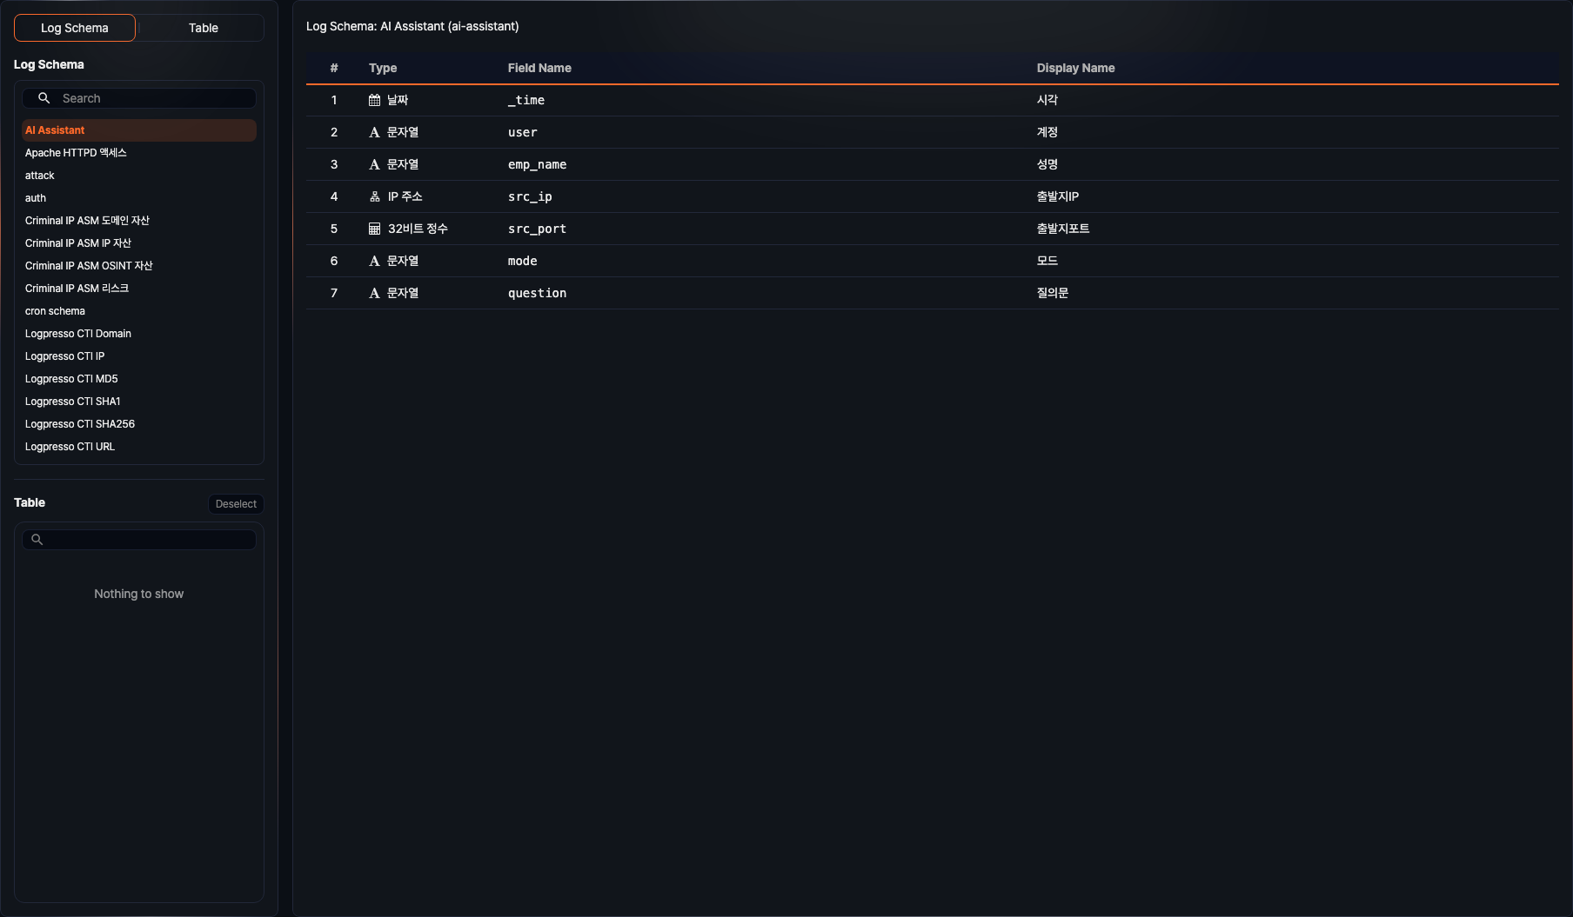
- Switch: Chooses whether to browse by Log Schema or Table.
- Search box: The log schema list provides a text input to filter by name, while the table list provides built-in search on its tree structure.
- Log schema list: Shows the log schemas selectable under the current browsing mode.
- Table list: Shows the tables selectable under the current browsing mode as a group tree.
- Data grid: Shows the data normalized according to the selected log schema and table.
- Filter tools: Add field-based conditions above the data grid to view only the records you want.
- Page size and pagination: Adjust the number of records shown at once and the current page at the bottom.
The data grid shows columns normalized according to the selected log schema. For the same table, the visible fields can change when you switch to a different log schema.

Browse tables by log schema
Select Log Schema in the switch, then pick an item from the log schema list to see the tables related to that schema.
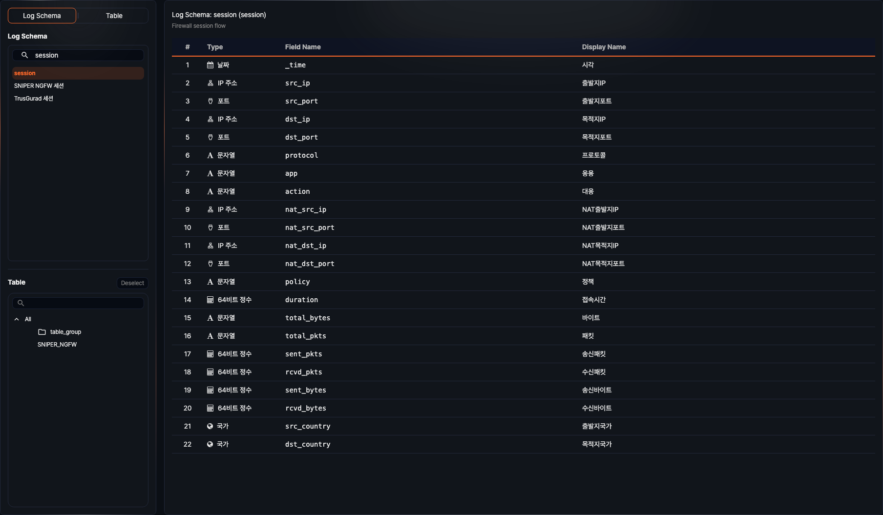
- The log schema name and display name follow the signed-in user's language setting.
- The table list shows only tables that use the selected log schema and that the current user has permission to view.
- When you select a table from the list, you can review the data stored in the table together with the normalized fields of the selected log schema.
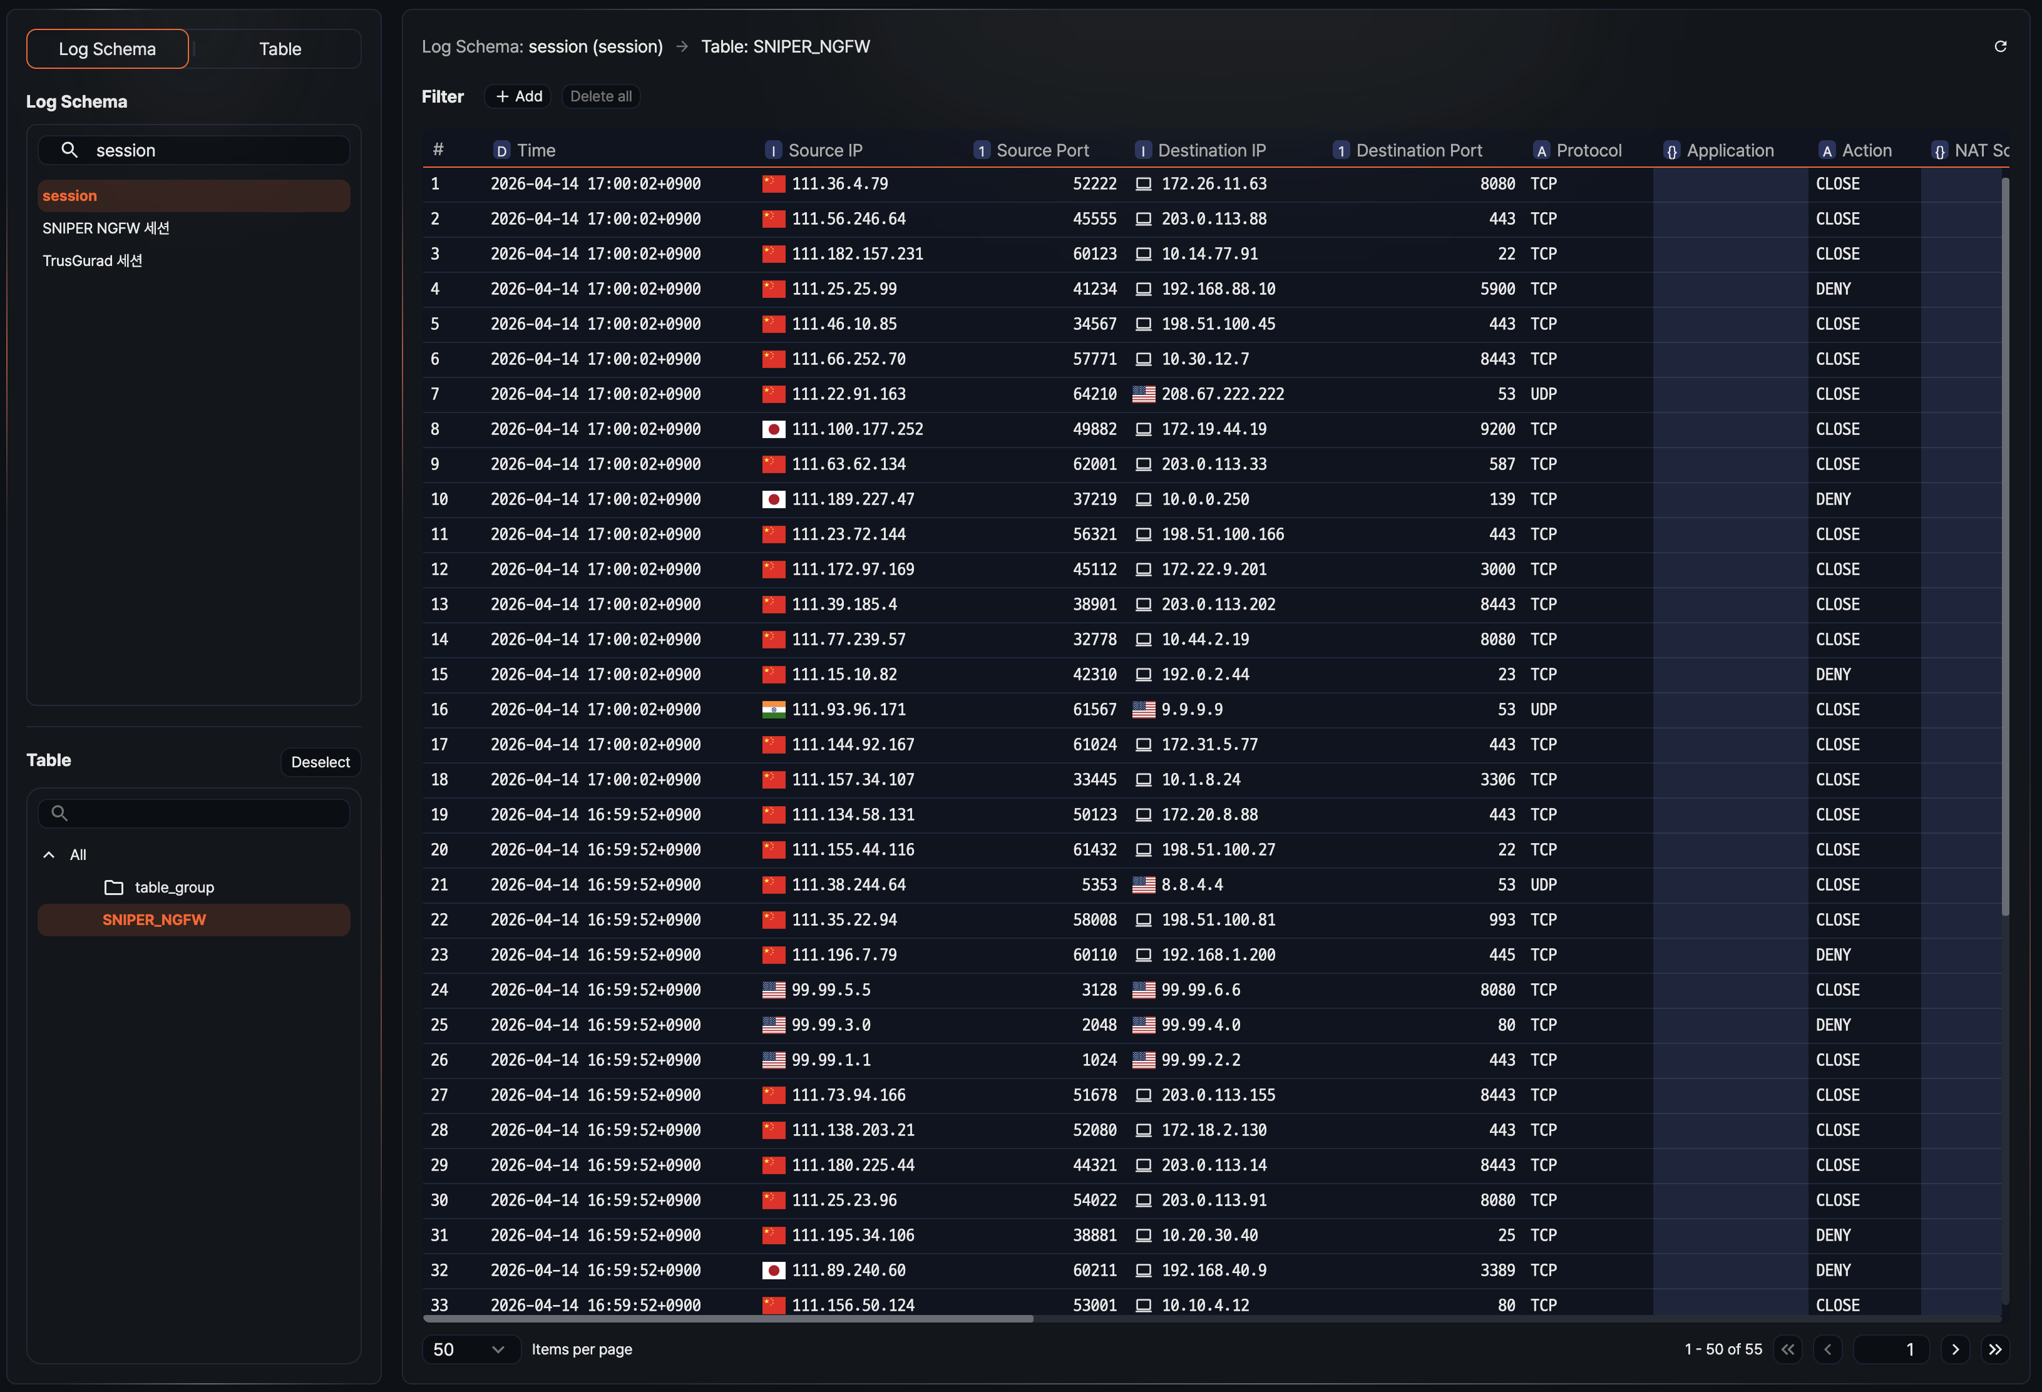
- Data is displayed in normalized form according to the selected log schema.
- Click the icon at the top to reload the data for the selected table.
- Some capabilities provided in Logs are also available on the same screen.
- Use the Filter feature to set conditions based on field values and narrow down to the data you want.
- You can sort the fields of the retrieved data or change how they are displayed while reviewing the information.

Browse log schemas by table
Select Table in the switch to first see the list of tables the current user has permission to view. When you pick one, the main area shows part of the data stored in that table along with the related log schemas.
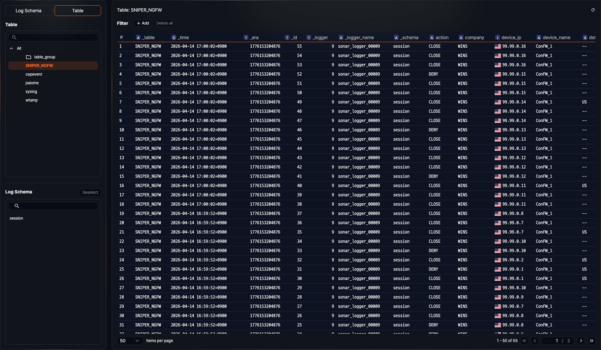
- The log schema list shows the log schemas related to the selected table.
- A single table can be linked to one or more log schemas.
- When you select a log schema from the list, you can review the field structure of that schema.
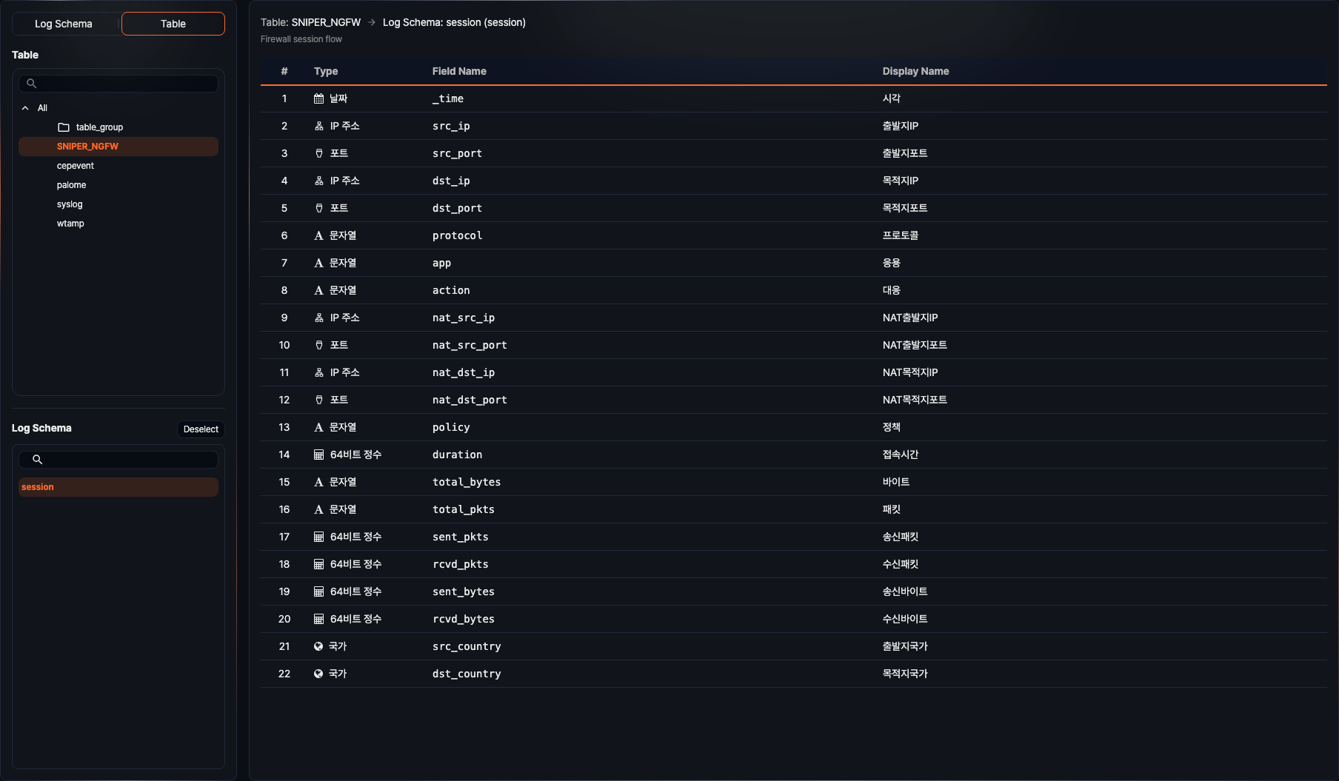

Using Data Catalog
Browse the table list by log schema to see which tables a specific log schema is applied to.
Browse the log schema list by table to review the log schemas applied to a table and the field information of each schema.
Understand data structure and flow in advance to quickly find the information needed for writing queries, reviewing logs, and processing data.

