Explanation categories

Overview
Explanation categories let you manage the categories available when submitting explanation requests. Registering categories in advance lets you assign a category to each explanation request and systematically track explanation types.
Accessing the Explanation Categories menu requires the edit explanation category (EXPLANATION_CATEGORY_EDIT) permission.

Viewing and searching the explanation category list
You can view and search the explanation category list at Response > Explanation Categories.
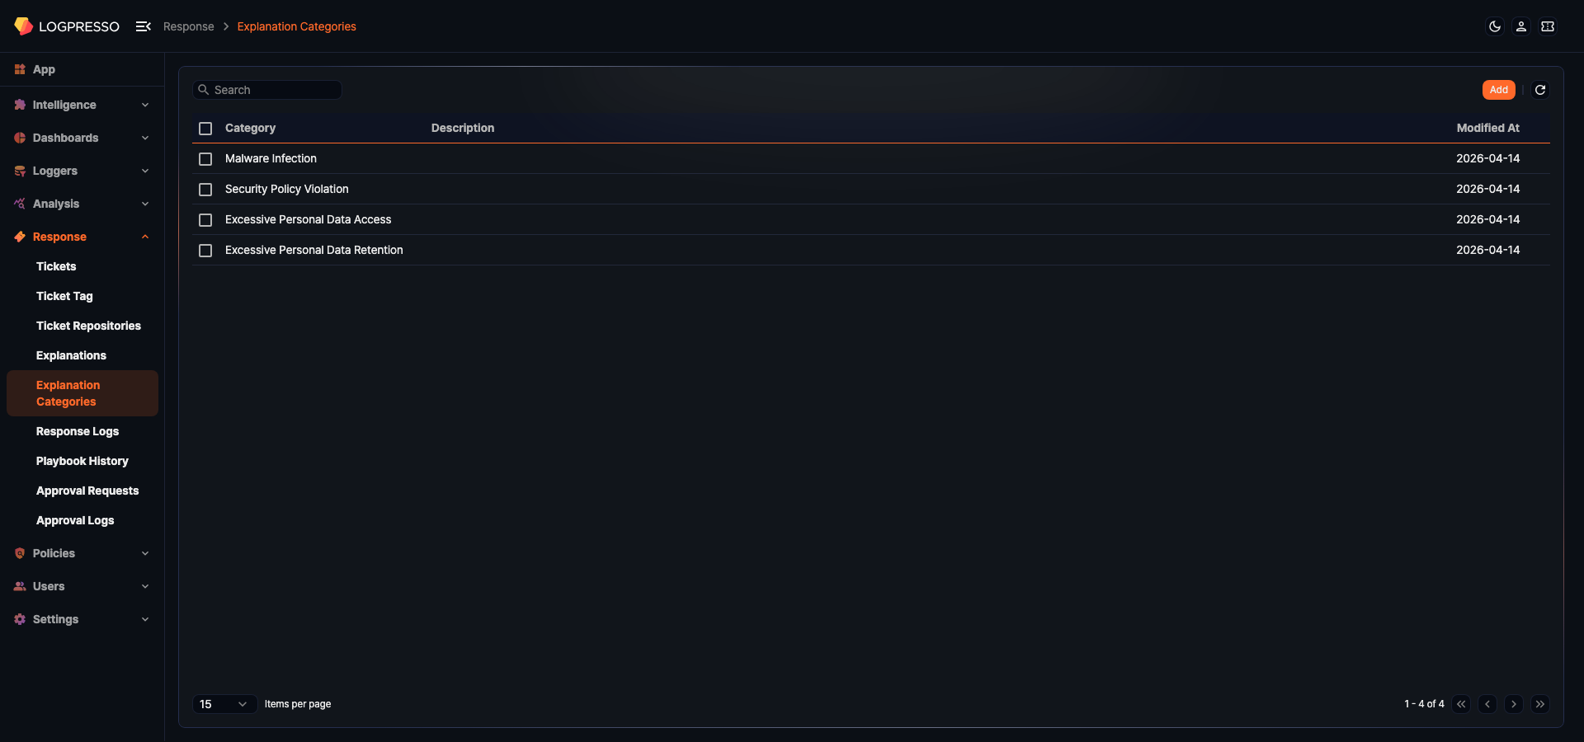
- Category: The explanation category name. If multilingual translations are registered, the name is displayed in the current locale.
- Description: The explanation category description.
- Modified At: The date when the explanation category was last modified.
To find a specific explanation category in the list, use the search tool in the toolbar. The search tool finds explanation categories whose Category name contains the entered keyword.
Refresh
To reload the explanation category list with the latest data, click Refresh in the toolbar.

Add explanation category
To add an explanation category:
Go to Response > Explanation Categories and click Add in the toolbar.
In the New Explanation Category panel, enter the required values and click Save.
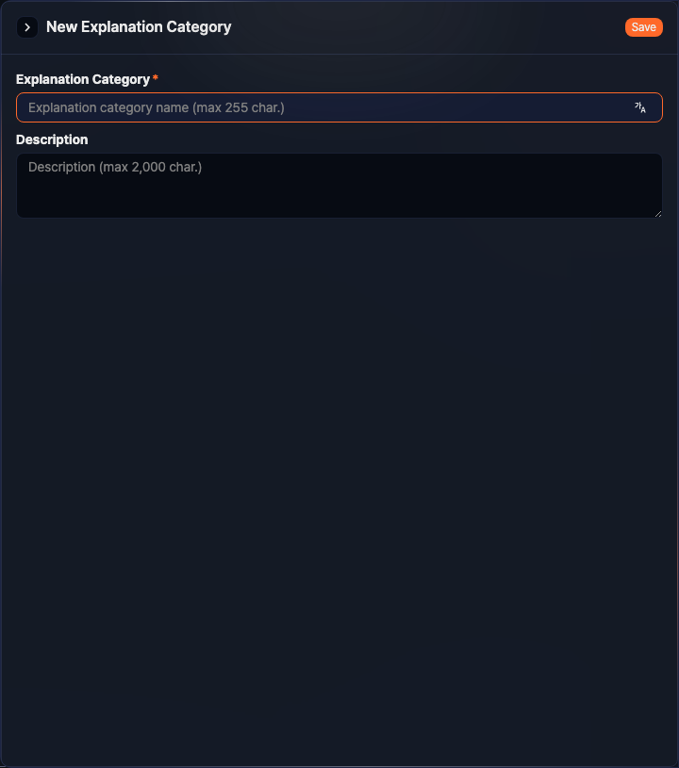
- Explanation Category: The explanation category name (required, up to 255 characters). To add multilingual translations, click the multilingual button next to the input field and enter the name for each language.
- Description: The explanation category description (up to 2,000 characters).

Edit explanation category
To edit an explanation category:
In the explanation category list, click the Category name of the category you want to edit.
In the Edit Explanation Category panel, update the information and click Save.
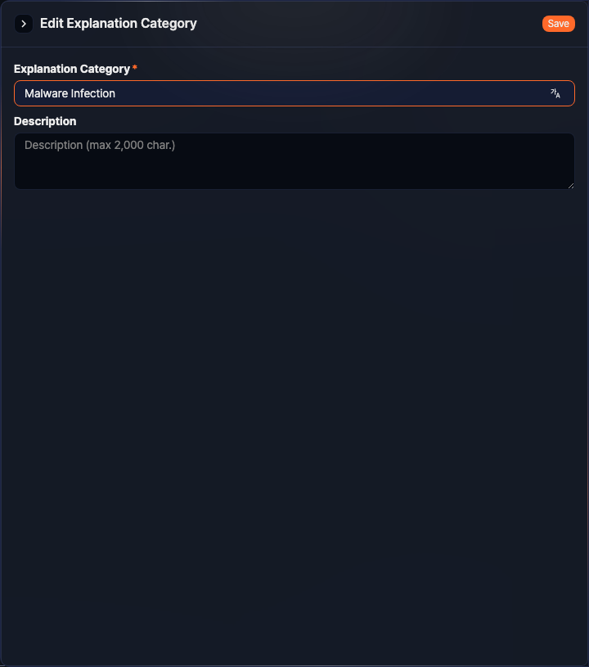

Delete explanation category
To delete an explanation category:
In the explanation category list, select the checkbox to the left of the category you want to delete.
Click Delete in the toolbar.
In the Delete Explanation Category dialog, confirm the category information and click Delete. To cancel, click Cancel.
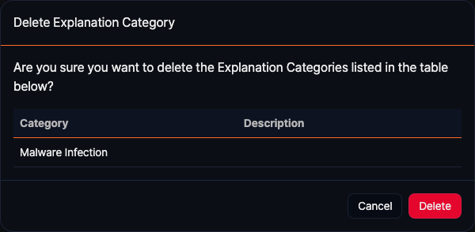
You cannot delete an explanation category that is in use by existing explanations.

