SSO

Overview
SSO (Single Sign-On) is a unified authentication system that allows you to access multiple services with a single authentication process. By integrating Logpresso Sonar with authentication services already in use in your organization, such as SAML 2.0 and OAuth 2.0, users can log in with their existing accounts without a separate Sonar account.
In the Settings > SSO menu, you can register and manage external authentication providers (SSO Providers) to use for SSO integration. When you add and enable an SSO configuration, a login button for that authentication service appears on the login screen.
Administrator privileges are required to view or manage SSO configurations.

Viewing the SSO configuration list
You can view the registered SSO configuration list in the Settings > SSO menu.
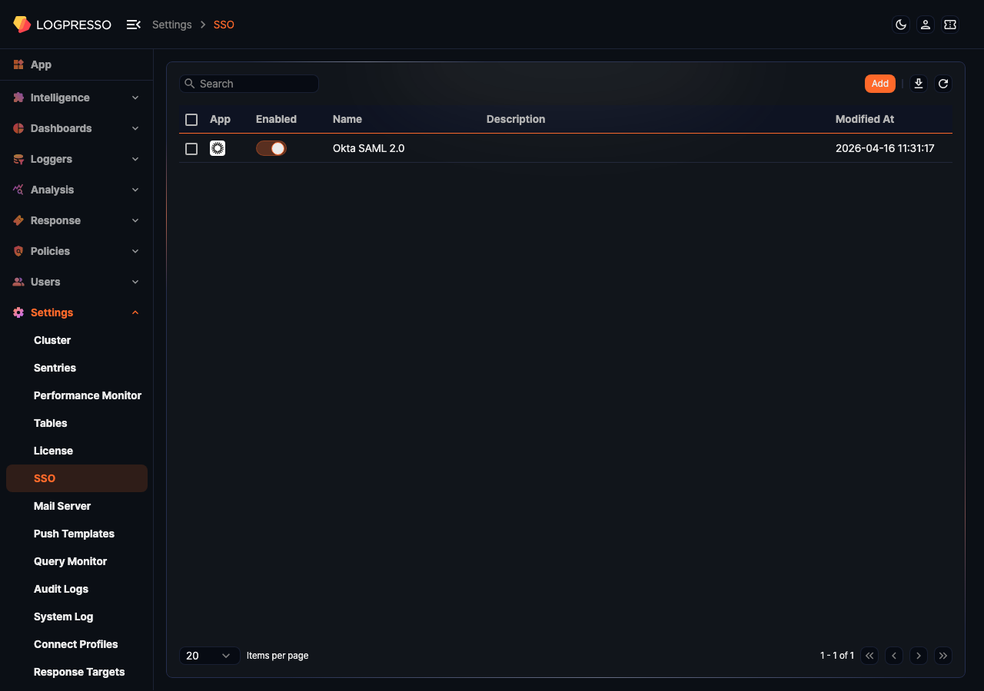
- App: Icon of the SSO provider
- Enabled: Enabled state of the SSO configuration. Click the toggle to enable or disable it. When you enable an SSO configuration, a login button for that provider appears on the login screen.
- Name: Name of the SSO provider
- Description: Description of the SSO configuration
- Modified At: Date and time the SSO configuration was last modified
To find a specific SSO configuration, enter a keyword in the search bar at the upper left of the list.
Downloading the SSO list
To download the SSO configuration list as a file, click at the upper right of the list. In the Download SSO List dialog, specify the File Name, Columns, File Format, Encoding, and Range, then click Confirm.
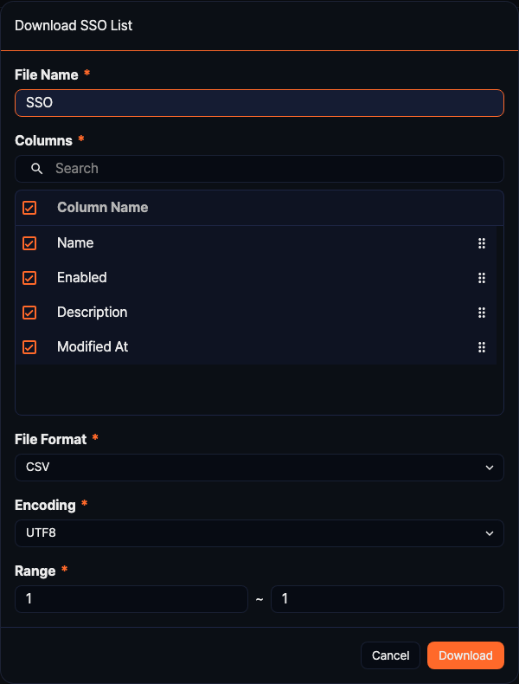
Refreshing the SSO list
Click at the upper right of the list to update the SSO configuration list to the latest state.

Adding an SSO configuration
In the Settings > SSO menu, click Add at the upper right of the list.
In the Add SSO panel, enter the Basic Configuration and Detail Configuration.
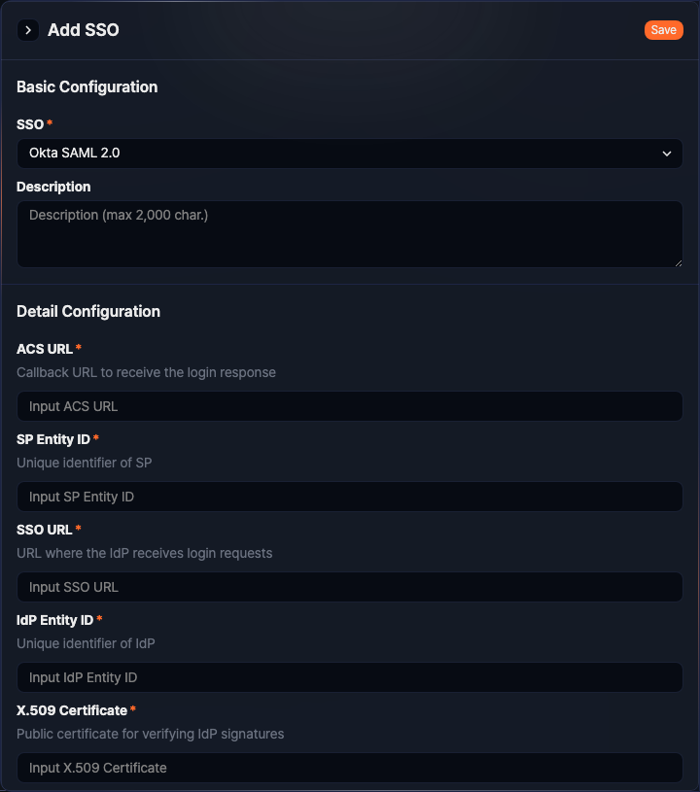
When you finish entering the settings, click Save at the upper right of the panel.
Basic Configuration
- SSO: Select the SSO provider type (required). You can select from the list of SSO providers installed on the system.
- Description: Enter a description for the SSO configuration (up to 2,000 characters).
Detail Configuration
The Detail Configuration fields change dynamically based on the SSO provider type selected in Basic Configuration. The name, required status, and input format of each field are determined by the configuration specification provided by the selected SSO provider. Required fields are marked with an asterisk (*) next to the label.
Depending on the SSO provider, configuration fields such as SAML Endpoint URL, Entity ID, certificate, Client ID, and Client Secret may appear. Refer to the administrator guide of the authentication service you are integrating with for details on each field.

Editing an SSO configuration
In the SSO list, click the row of the SSO configuration you want to edit.
In the Edit SSO panel, modify the necessary fields, then click Save at the upper right of the panel. The SSO provider type cannot be changed.
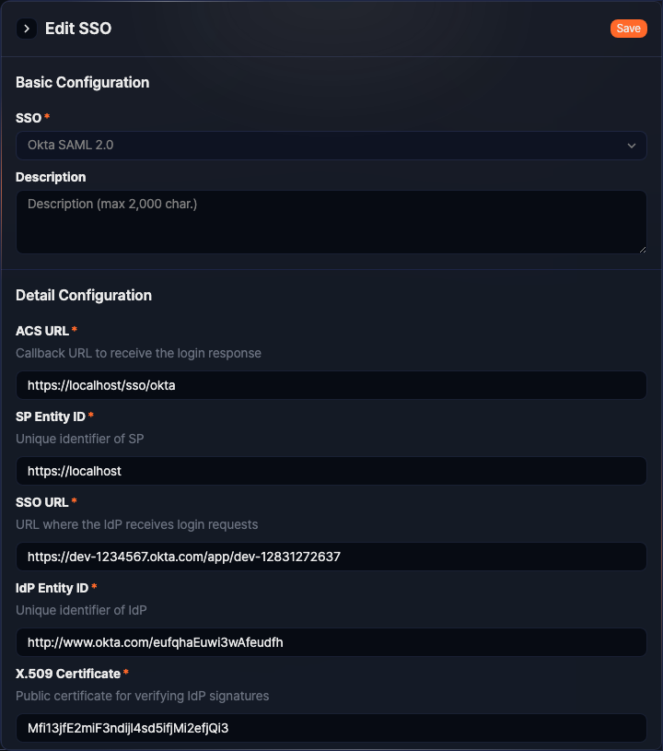

Deleting an SSO configuration
In the SSO list, select the SSO configurations you want to delete. Click the checkbox at the top of the list to select all items on the current page.
Click Delete at the upper right of the list.
In the Delete SSO dialog, confirm the items to delete, then click Delete. To cancel the deletion, click Cancel.
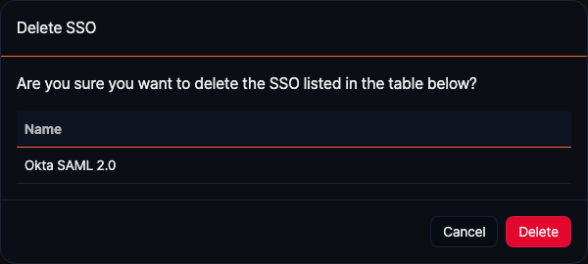
You cannot delete an enabled SSO configuration. Disable it before deleting.

