Ticket tags

Overview
A ticket tag is a label that you use to visually classify and manage tickets. Each tag has a unique name and a background color, and when you attach a tag to a ticket, the tag appears as a colored badge in the ticket list. Tags let you recognize the type, priority, and processing state of tickets at a glance.

Viewing and searching ticket tags
Go to Response > Ticket Tags to view or search the ticket tag list.
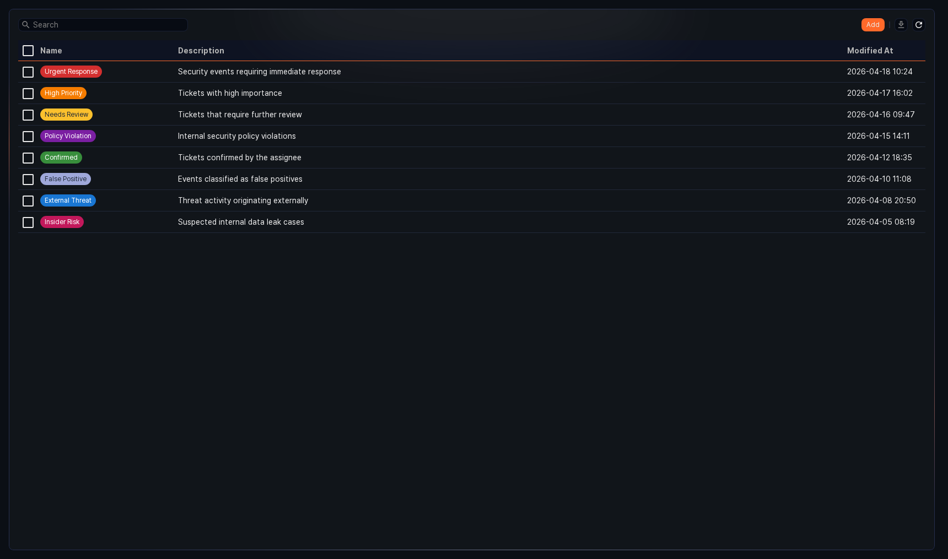
- Name: The name of the tag. The name appears as a badge with the configured background color.
- Description: The description of the tag.
- Modified At: The date and time when the tag was last modified.
To find a specific tag in the list, use the search box in the toolbar. The search is case-insensitive.
Downloading the list
To download the ticket tag list to your local PC as a file, click Download in the toolbar. The downloaded file contains the Name, Description, Created At, and Modified At fields.
Refreshing
To reload the ticket tag list with the latest information, click Refresh in the toolbar.

Adding a ticket tag
To add a ticket tag:
In Response > Ticket Tags, click Add Tag in the toolbar.
In the side panel, enter the required values and click Save.
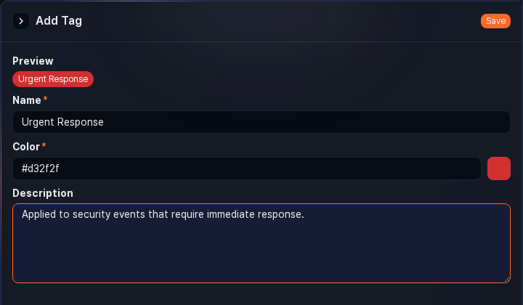
- Preview: Preview of the tag with the configured name and color applied.
- Name: The name of the tag (required, up to 20 characters). A name consisting only of whitespace is not allowed, and you cannot add two tags with the same name.
- Color: The background color of the tag (required). Select a color from the preset palette or specify a color value directly.
- Description: The description of the tag (up to 2,000 characters).

Editing a ticket tag
To edit a ticket tag:
In the ticket tag list, click the name of the tag you want to edit.
In the side panel, update the information and click Save.

Deleting a ticket tag
To delete a ticket tag:
In the ticket tag list, select the checkbox to the left of the tag you want to delete.
Click Delete in the toolbar.
In the Delete Tag dialog, review the tag information and click Delete.

