Widgets

Overview
Widgets are the building blocks of dashboards. Security operations analysts combine widgets to visualize collected logs in real time and build dashboards that surface anomalies at a glance. The Widgets screen lets you create, edit, and delete the widgets placed on dashboards.
Sonar supports three widget types:
Widget type | Description
Query Widget | Runs a Logpresso query or dataset and visualizes the results as a grid or chart.
External Site Widget | Displays an external URL inside a dashboard as an inline frame.
Input Control | Provides a date, text, or list input that controls user-defined variables in other query widgets.
Accessing this screen requires the dashboard management, widget editing, or widget viewing permission. To add, modify, or delete widgets you need the dashboard management or widget editing permission. An account with only the widget viewing permission can browse the list but cannot make changes.

Viewing the widget list
Navigate to > Widgets on the Dashboard screen to display the widget list.
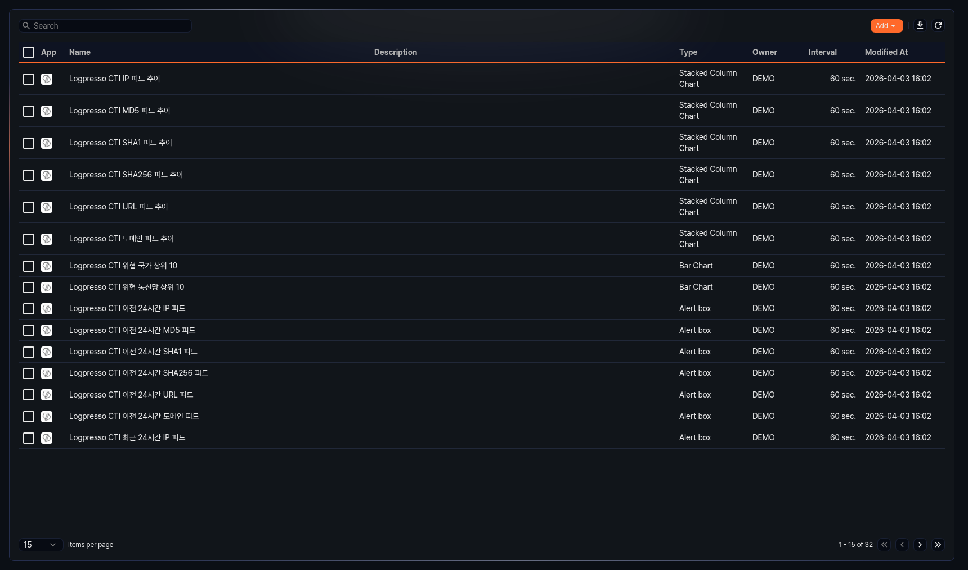
The list shows the following columns:
- App: Icon of the app to which the widget belongs. Default widgets display the Logpresso icon; app widgets display their respective app icon.
- Name: Widget name
- Description: Widget description
- Type: Chart type of the widget (Grid, Line, Spline, Area, Bar, Column, Scatterplot, Pie, Treemap, Alert Box, World Map, External Site, Date Input Control, Text Input Control, List Input Control, etc.)
- Owner: Account that created the widget
- Interval: Widget data refresh interval (in seconds)
- Modified At: Date and time the widget was last modified (yyyy-MM-dd HH:mm format)
You can search by name or description keywords.
Downloading the list
Click to download the widget list as a file.
Refreshing the list
Click to refresh the list with the latest data.

Adding a widget
Click Add in the widget list to open a dropdown menu for selecting the widget type.
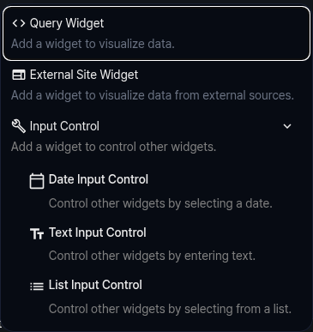
Query Widget
Click Query Widget to open the pivot-table-based query widget editor. Create a widget that runs a query or dataset and visualizes the results as a grid or chart. For details, see Query widget.
External Site Widget
Click External Site Widget to open a settings panel on the right side of the screen. Create a widget that displays an external URL inside a dashboard as an inline frame. For details, see External site widget.
Input Control
Click Input Control to expand the sub-type list. Create a widget that controls user-defined variables in other query widgets. For details, see Input control.
- Date Input Control: Select a date or date range to control other widgets.
- Text Input Control: Enter text to control other widgets.
- List Input Control: Select an item from a predefined list to control other widgets.

Editing a widget
Click a widget row in the widget list to open the editing screen. For query widgets, the pivot-table-based widget editor opens. For external site widgets and input controls, a settings panel opens on the right side of the screen.
After making changes, click Save to save them.

Deleting a widget
Select the checkbox of the widget to delete in the widget list.
Click the Delete button.
Click Delete in the confirmation dialog.
If you delete a widget that is in use on a dashboard, that widget will no longer display data and the dashboard layout will need to be adjusted.

