External site widget

Overview
An external site widget displays a web page at a specified URL as an inline frame (iframe) inside a dashboard cell. Use it to integrate external monitoring tools, internal portals, or dashboard systems outside Sonar into a single Sonar dashboard view.
The web page displayed by an external site widget must allow rendering inside an iframe through its X-Frame-Options or Content-Security-Policy header settings. If the target site blocks iframe embedding, a "This content is blocked" message appears in the widget area and the page does not load. In this case, you must change the target site's security policy or replace the URL with one that allows iframe embedding. Sonar cannot bypass this restriction.
Only accounts with the dashboard management or widget editing permission can add or modify external site widgets. An account with only the widget viewing permission can view settings but cannot make changes.

Adding a widget
Navigate to > Widgets on the dashboard.
Click the Add button and select External Site Widget.
A settings panel opens on the right side of the screen.
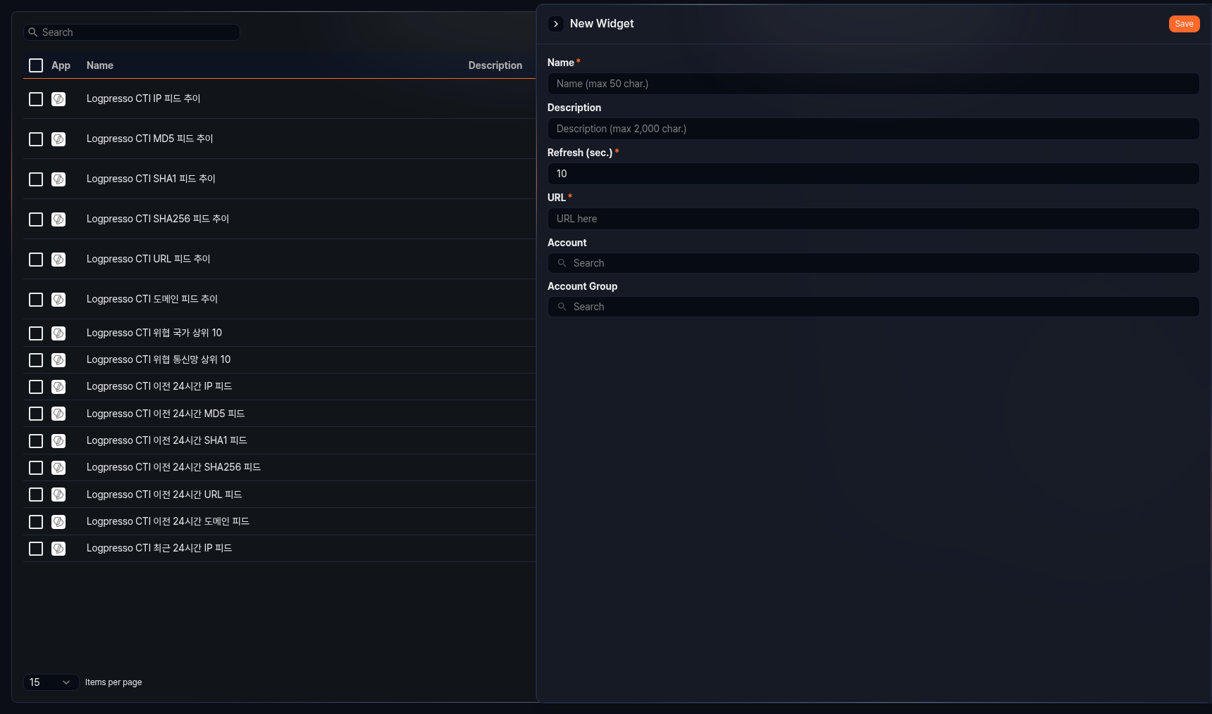
Configure the following fields:
- Name: Widget name (required, up to 50 characters)
- Description: Widget description (up to 2,000 characters)
- Refresh (sec.): Interval at which the widget is automatically refreshed (in seconds, required, range: 0–2,147,483)
- URL: Address of the external site to display (required)
- Granted Users: Select the accounts to share this widget with.
- Granted Groups: Select the account groups to share this widget with.
Click Save to save the widget.

Editing a widget
Click an external site widget in the widget list to open a settings panel on the right side of the screen. The settings fields are the same as those described in Adding a widget.

