Branch
This task executes different tasks depending on the evaluation result (true/false) of a comparison operation or comparison expression. The evaluation result is returned as the output parameter result. This task type appears as Decision in the Task Type field.
Branch tasks are categorized as Comparison branch, Null check branch, or Expression branch based on the selected Command.
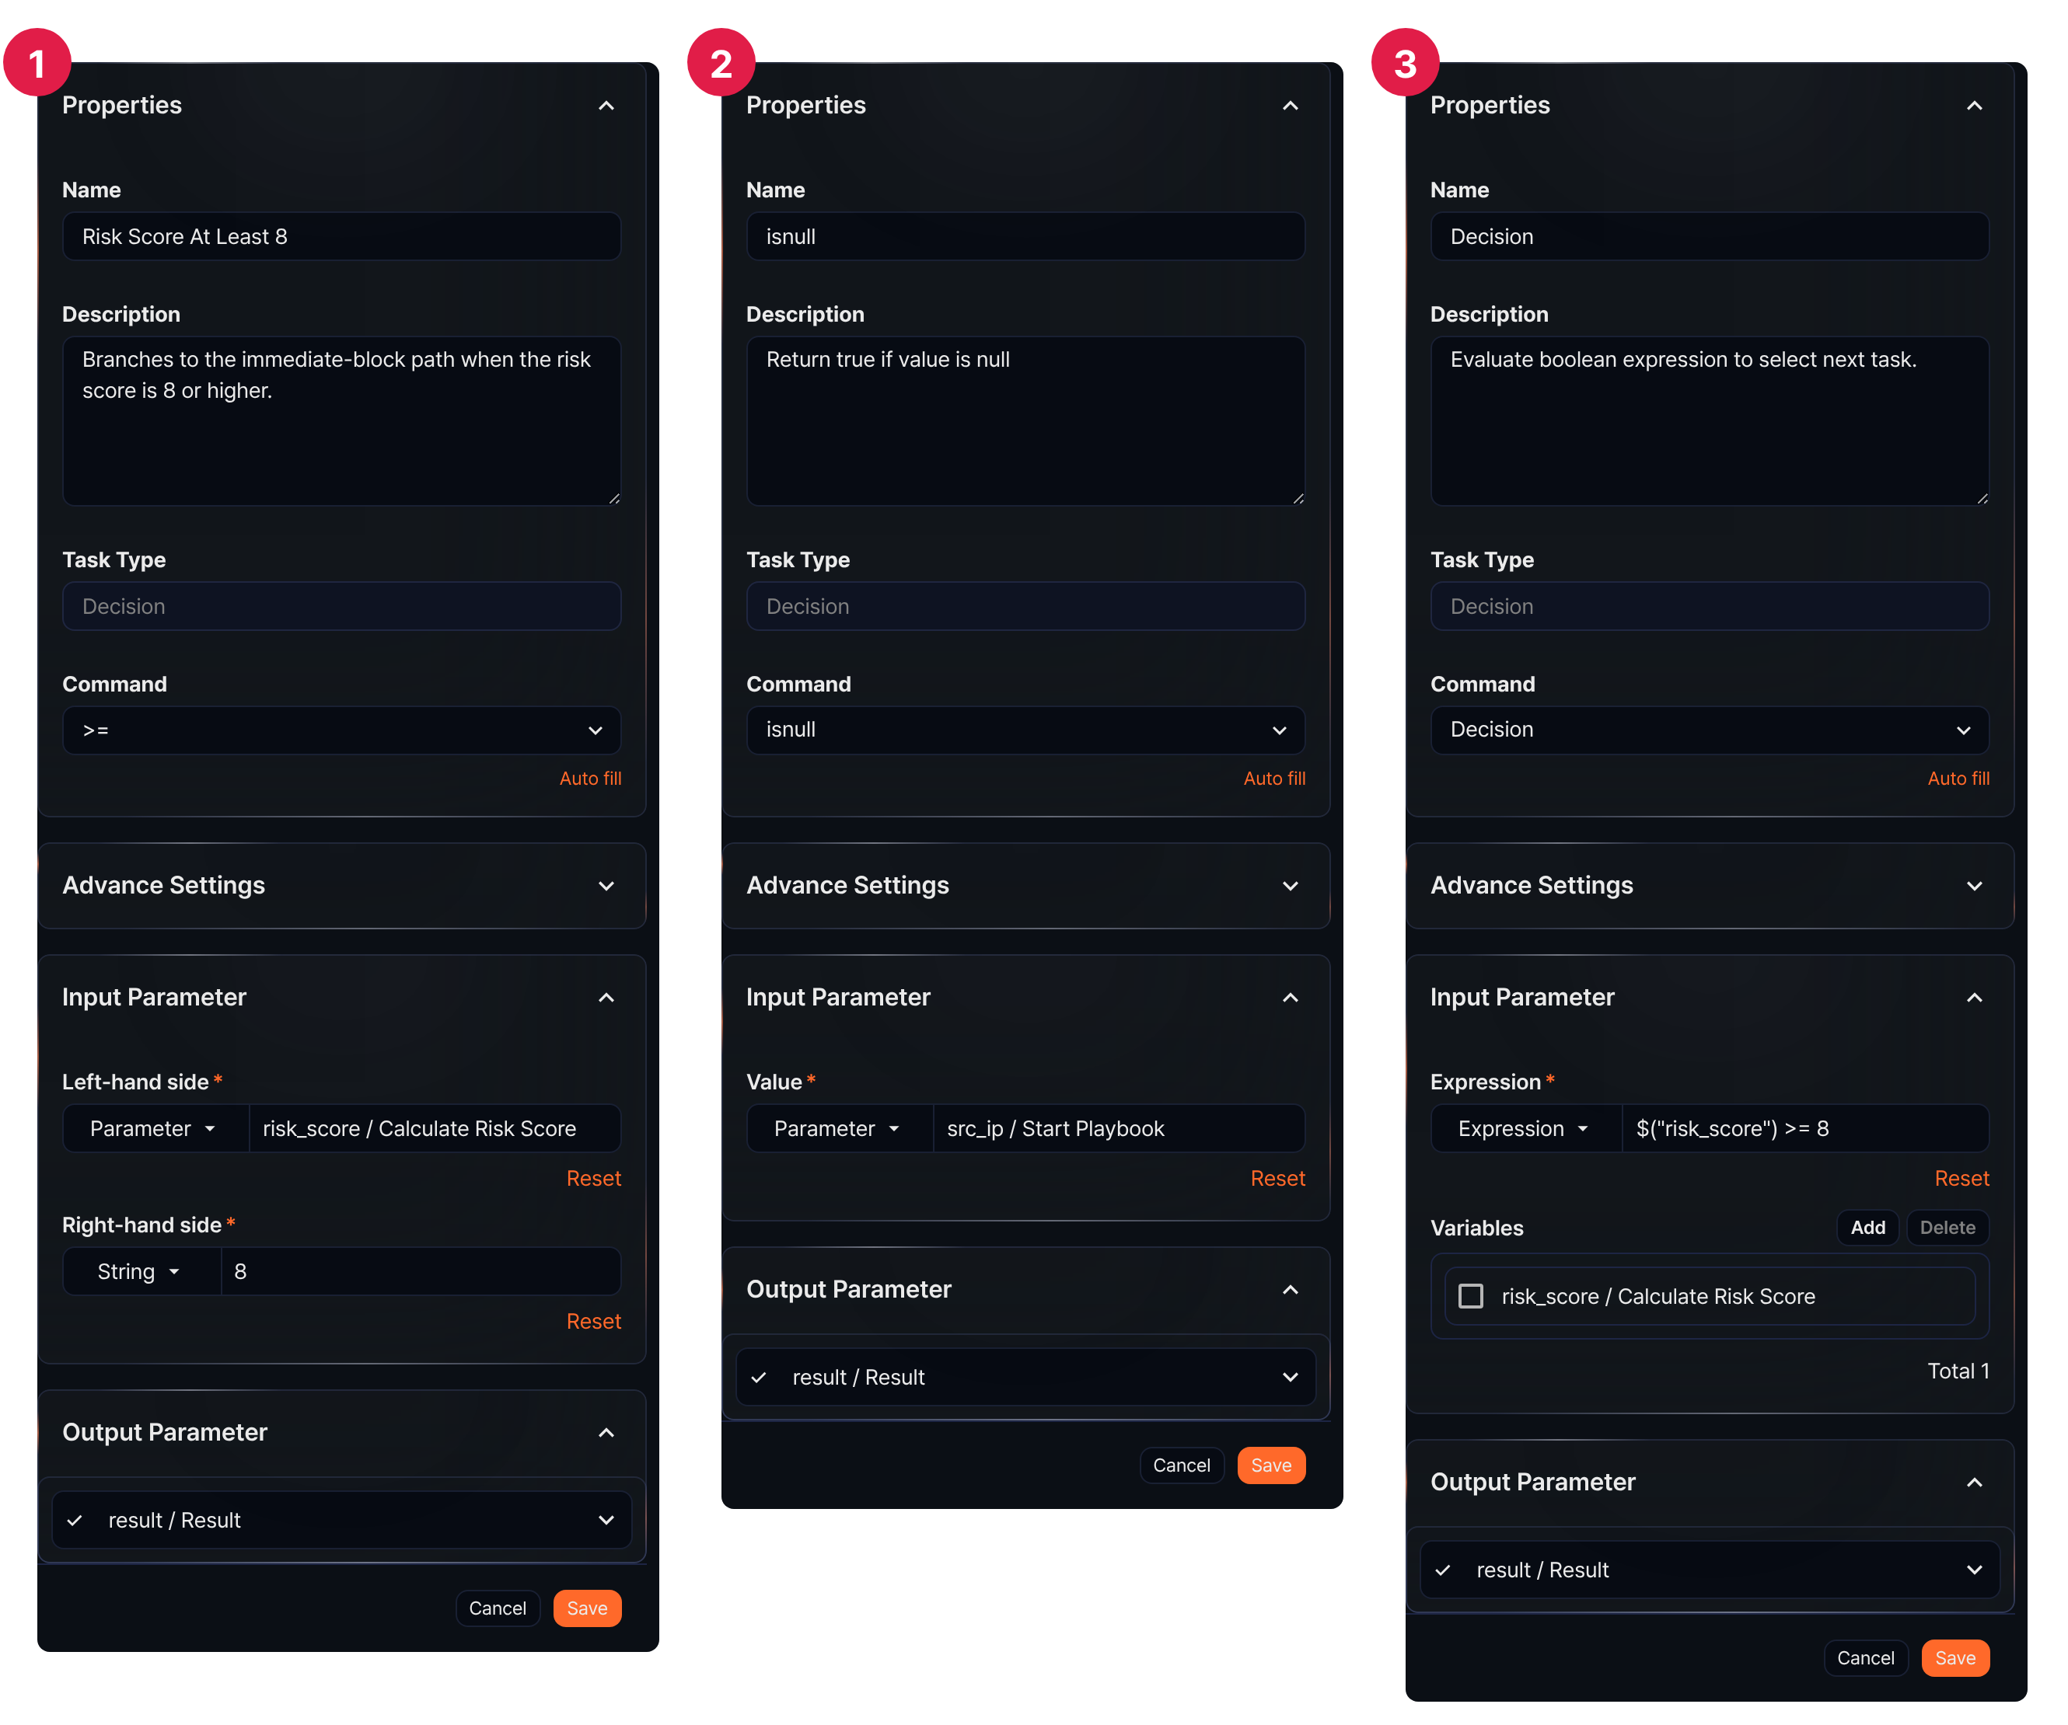
The figure above shows how the input parameters change depending on the selected command (① comparison branch, ② null check branch, ③ expression branch).

Comparison branch
Compares input parameters or strings on the Left-hand side and Right-hand side, then branches the task flow based on the result.
Command
Select the comparison operator to apply to the input parameters (left and right sides).
Comparison operator | Description
>= | Returns true when the left value is greater than or equal to the right
> | Returns true when the left value is greater than the right
<= | Returns true when the left value is less than or equal to the right
< | Returns true when the left value is less than the right
== | Returns true when the left value equals the right
!= | Returns true when the left value does not equal the right
Input parameters
Define the Left-hand side and Right-hand side.
Input parameter | Description
Left-hand side* | Left operand of the comparison. Select Parameter or String.
Right-hand side* | Right operand of the comparison. Select Parameter or String.
- Selecting Parameter shows the list of parameters received from preceding tasks. Choose a parameter to assign to the left or right side.
- Selecting String lets you enter the value to compare directly. The characters you enter are saved and compared as-is; if you type quotes, they become part of the value.

Null check branch
Evaluates an input parameter value using the isnull() or isnotnull() function and branches the task flow based on the result.
Command
Select the function to use for the branch.
Command | Description
isnull | Returns true when the value is null
isnotnull | Returns true when the value is not null
Input parameters
Select a parameter to pass a value to the function.
Value*
The parameter that passes its value to the function.

Expression branch
Branches the task flow based on the evaluation result (true/false) of an expression.
Command
Select Decision.
Input parameters
In an expression branch, input parameters are used in the Expression. To use a parameter inherited from a preceding task in the expression, add it to the Variables.
Expression*
Enter the comparison expression to evaluate. To use parameters from the Variables in the expression, use the $("variable") format.
The expression can include not only comparison operations but also additional logical operations or function calls.
You can also specify a Parameter in the expression. In that case, the parameter's value must be boolean (true/false).
Variables
Click Add and select variables from the parameter list to use in the expression. The parameter list shows parameters passed by preceding tasks or playbook input parameters.
To delete a variable from the variable list, select the checkbox in the variable row and click Delete.
Branch task example
A branch task routes the flow through the T connection point when the result is true, and through the F connection point when the result is false. The following figure shows the Risk Score At Least 8 branch task selected: its T connection point leads to Request Account Block Approval, and its F connection point leads to Continue Monitoring?.
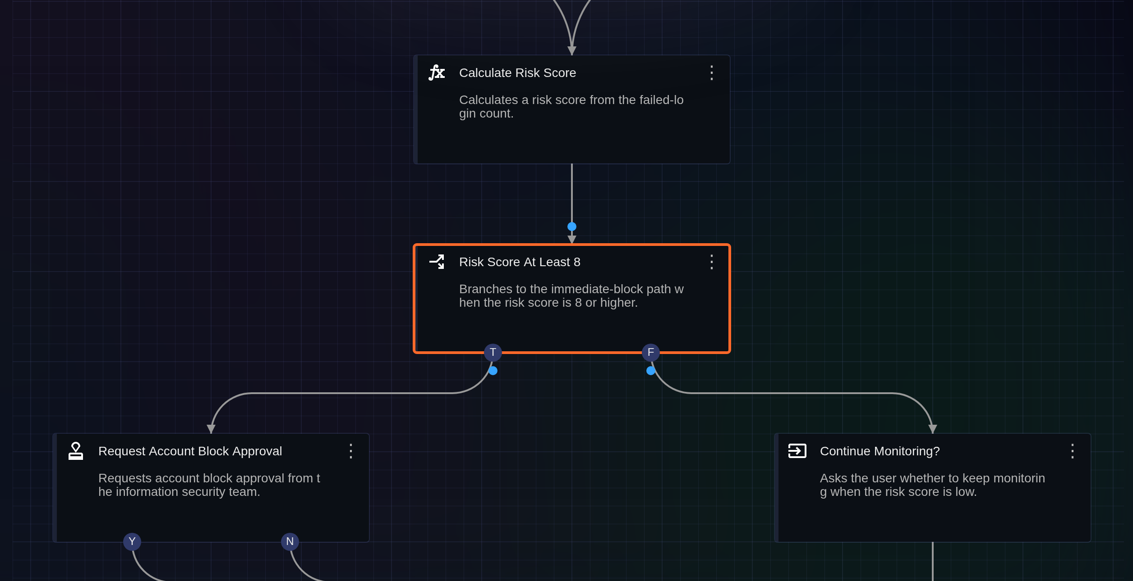
The following example shows the flow branching when a comparison operation or expression evaluates to true.
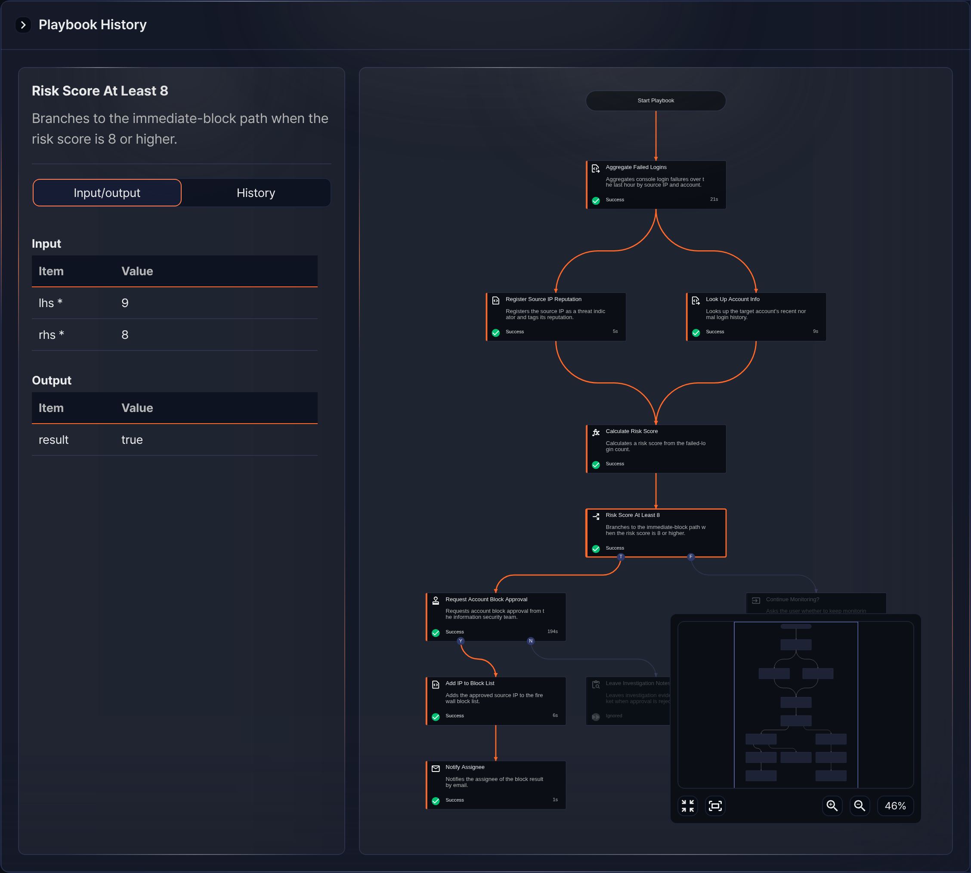
The following example shows the flow branching when a comparison operation or expression evaluates to false.
