Send email
This task sends an email according to the specified format. This task type appears as Email in the Task Type field.
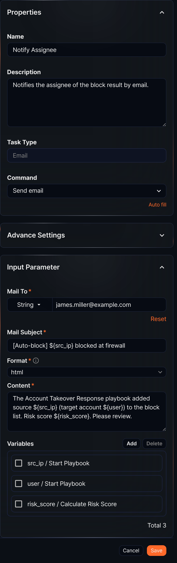
Command
The only Command available is Send email.
Input parameters
The input parameters are as follows:
Mail To*
The email recipient address. Select from Parameter or enter the recipient's address as a String.
Mail Subject*
Enter the email subject.
Format*
Select the format for the body (options: plain, markdown, html).
Content*
Enter the email body.
Variables
Click Add and select variables to use in the Mail Subject or Content. Both Mail Subject and Content are strings. To substitute a variable value into the string, use the ${variable} format.
$("variable") is a function used to reference variable values in Logpresso queries and cannot be used inside strings.
To use the Send email task, configure the mail server information first under Settings > Mail Server.

