Execute
This task lets you automate various actions using command groups. Installing a Logpresso app adds the command groups provided by that app to the playbook.
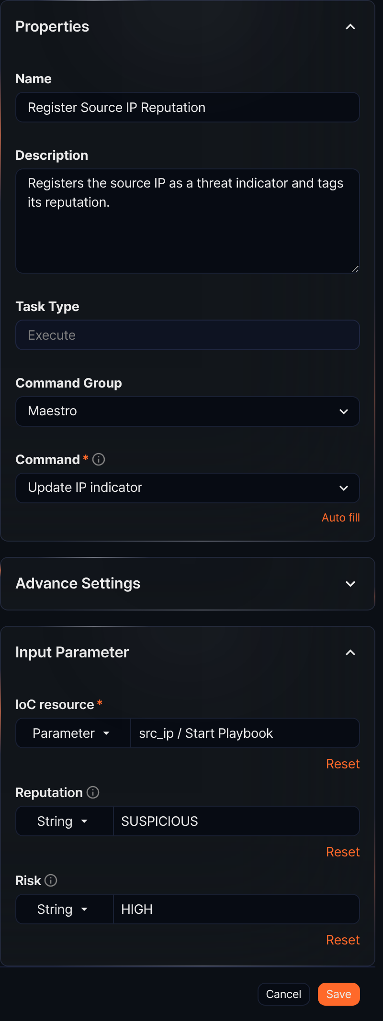
Command Group
A command group is a collection of commands the task can execute. In addition to the built-in command group, installing a Logpresso app that supports playbooks extends the available command groups.
Command
Select the command to execute from the command list. After selecting a Command, you can specify the required input parameters and view the output parameters.
The commands provided by the Maestro command group are as follows:
Command | Description
Create article | Creates an article-type ticket and returns its GUID as an output parameter
Validate directory | Checks whether a local directory exists on the Logpresso Sonar system
Remove blacklist | Removes a specific IP address from a specified address list
Add blacklist | Adds a specific IP address to a specified address list
Create ticket from event | Creates a ticket based on an input event and returns the ticket GUID
Get Investigate Result | Retrieves an investigation result of a ticket
Add Investigate Result | Adds a query result as an investigation result and returns its GUID as an output parameter
Validate file attachment | Validates the local file path and size on the Logpresso Sonar system
Add file attachment | Attaches a file to a ticket and returns the file GUID, size, and name
Update IP indicator | Creates or updates an indicator (IP address)
Update MD5 indicator | Creates or updates an indicator (MD5)
Update URL indicator | Creates or updates an indicator (URL)
Update Domain indicator | Creates or updates an indicator (domain)
Update Email indicator | Creates or updates an indicator (email)
Set ticket indicent | Changes the incident status of a ticket
Set ticket status | Changes the status of a ticket
Create ticket | Creates a new ticket and returns its GUID as an output parameter
Set ticket attack | Changes the true/false positive status of a ticket
Set ticket priority | Changes the priority of a ticket
Add ticket comment | Adds a comment to a ticket
Set ticket tags | Sets tags on a ticket
Add ticket tags | Adds tags to a ticket
Set ticket assignee | Sets the assignee and approver of a ticket
Add pattern | Adds a pattern to a pattern group
The commands provided by the Sonar command group are as follows:
Command | Description
Send report | Generates a report for a specified date range using a registered report template and sends it by email
Export report | Generates a report for a specified date range using a registered report template and saves it

Create article
When the Command is Create Article, this task creates an article-type ticket and returns the ticket's GUID as an output parameter.
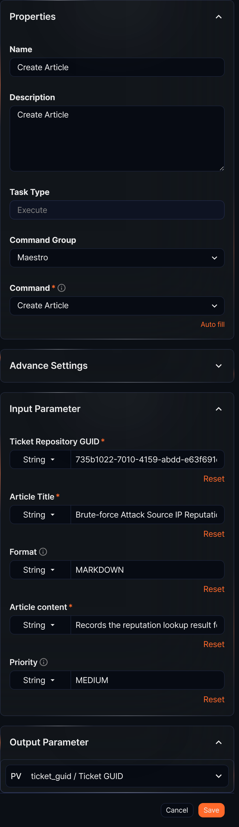
Input parameters
The input parameters are as follows:
Input parameter | Description
Ticket repository GUID* | The GUID of the ticket repository where the ticket will be created
Article title* | The title of the ticket to create
Format | Input format for the article content (PLAIN or MARKDOWN; defaults to MARKDOWN)
Article content* | The article content
Priority | One of LOW, MEDIUM, or HIGH. Defaults to LOW if not specified.
- All input parameters can be set by selecting from the Parameter list or by selecting String and entering a value.
- The parameter list only includes values defined in preceding task output parameters or playbook input parameters.
Output parameters
The output parameters are as follows:
Parameter | Name | Description
ticket_guid | Ticket GUID | The GUID of the created ticket

Validate directory
When the Command is Validate Directory, this task checks whether a directory exists on the local file system of the server running the playbook. The task fails if the directory does not exist.
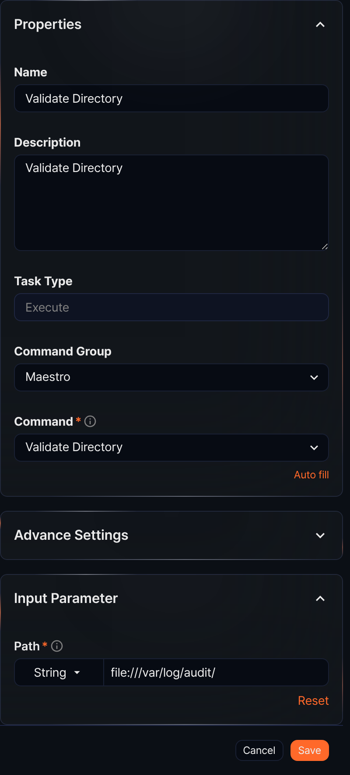
Input parameters
The input parameters are as follows:
Input parameter | Description
Path* | Directory path starting with file://

Remove blacklist
When the Command is Remove blacklist, this task removes a specific IP address from a specified address list.
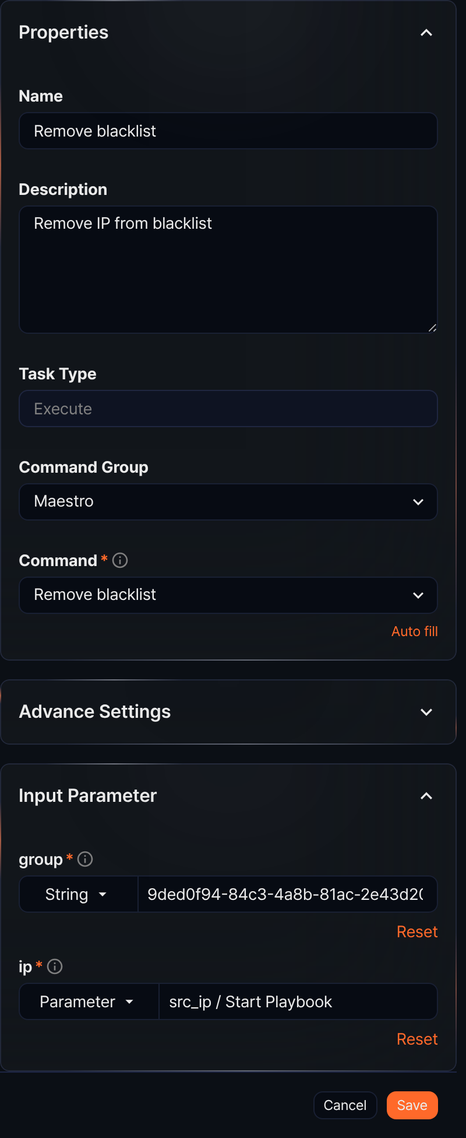
Input parameters
The input parameters are as follows:
Input parameter | Description
group* | The GUID of the address group
ip* | The IP address to remove from the group

Add blacklist
When the Command is Add blacklist, this task adds an IP address to be managed as a blocklist entry in the specified address group.
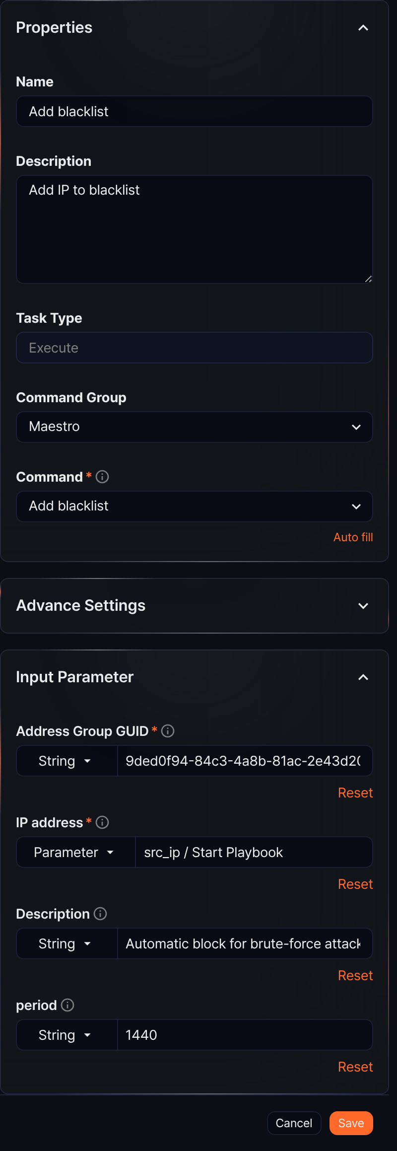
Input parameters
The input parameters are as follows:
Input parameter | Description
Address group GUID* | The GUID of the address group
IP address* | The IP address to add to the group
Description | A detailed description of the IP address
period | The duration to maintain the IP address, in minutes

Create ticket from event
When the Command is Create Ticket from Event, this task creates a new ticket based on a specified event and returns the ticket GUID as an output parameter.
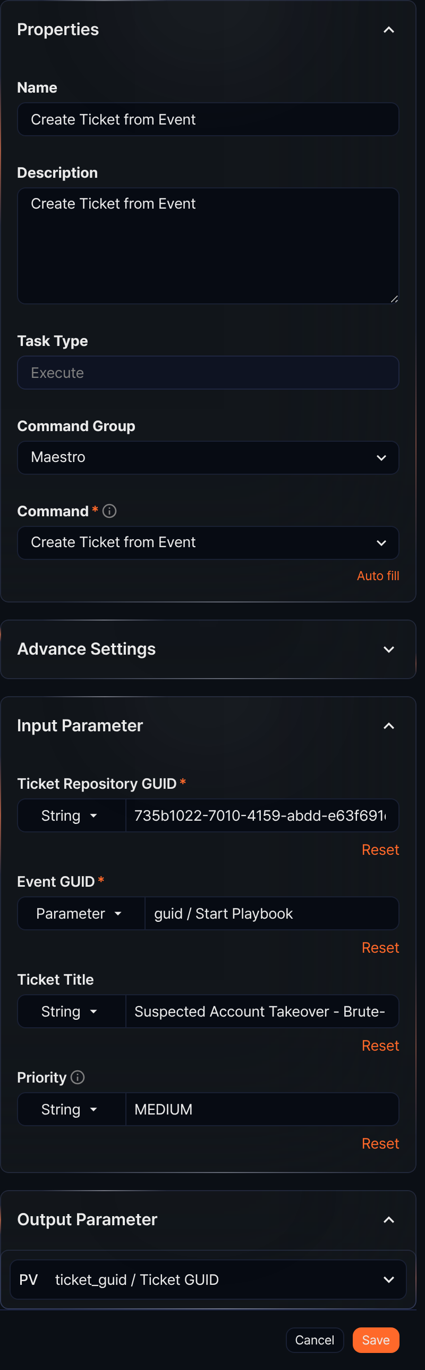
Input parameters
The input parameters are as follows:
Input parameter | Description
Ticket repository GUID* | The GUID of the ticket repository
Event GUID* | The GUID of the event the ticket references
Ticket title | The title of the ticket
Priority | One of LOW, MEDIUM, or HIGH. Defaults to LOW if not specified.
Output parameters
The output parameters are as follows:
Parameter | Name | Description
ticket_guid | Ticket GUID | The GUID of the created ticket

Get Investigate Result
When the Command is Get Investigate Result, this task retrieves an investigation result of a ticket.
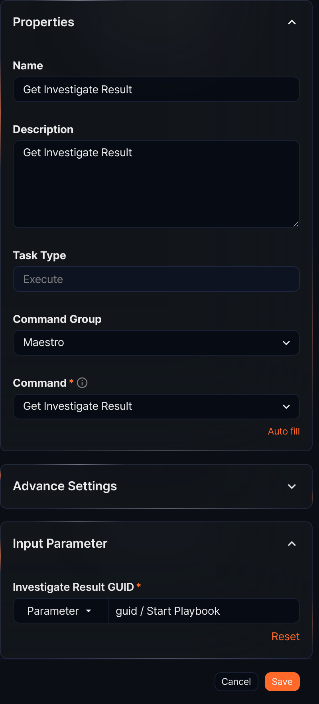
Input parameters
The input parameters are as follows:
Input parameter | Description
Investigate Result GUID* | The GUID of the investigation result to retrieve

Add Investigate Result
When the Command is Add Investigate Result, this task adds a query result as an investigation result to a ticket and returns its GUID as an output parameter.
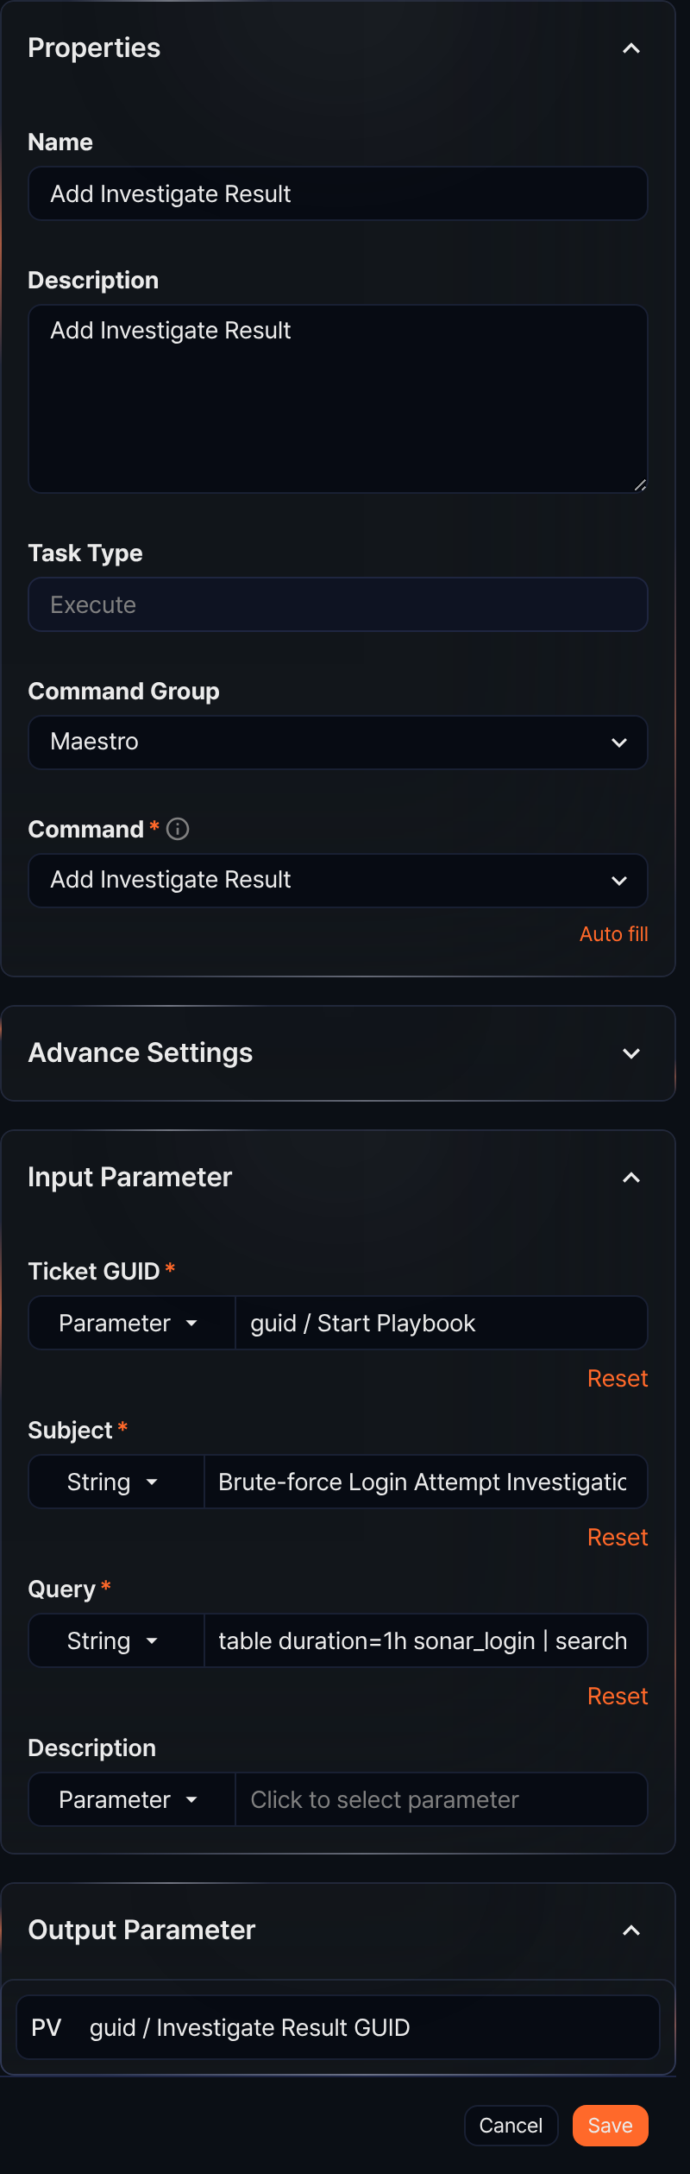
Input parameters
The input parameters are as follows:
Input parameter | Description
Ticket GUID* | The GUID of the ticket to add the investigation result to
Subject* | The subject of the investigation result to add
Query* | The query used to generate the investigation result
Description | A description of the investigation result
Enter the query in string mode. The entered value is saved as-is, and quotes are applied automatically when the command runs.
Output parameters
The output parameters are as follows:
Parameter | Name | Description
guid | Investigate Result GUID | The GUID of the created investigation result

Validate file attachment
When the Command is Validate File Attachment, this task validates the size of a file on the local file system of the server running the playbook.
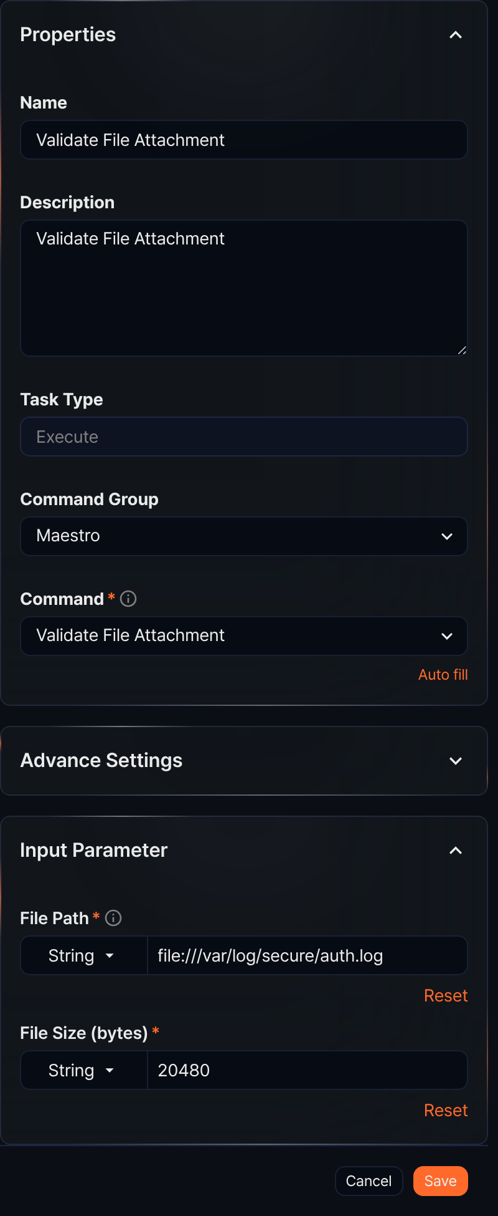
Input parameters
The input parameters are as follows:
Input parameter | Description
File path* | File path starting with file://
File size (bytes)* | File size in bytes
This task checks whether the file at the specified path matches the specified size.

Add file attachment
When the Command is Add File Attachment, this task attaches a file to an existing ticket and returns the file's GUID, size, and name as output parameters.
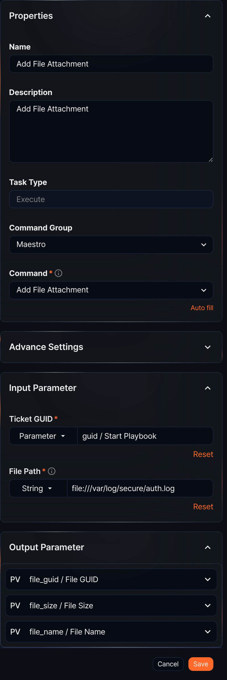
Input parameters
The input parameters are as follows:
Input parameter | Description
Ticket GUID* | The GUID of the ticket to attach the file to
File path* | File path starting with file://, https://, or http://
Output parameters
The output parameters are as follows:
Parameter | Name | Description
file_guid | File GUID | The GUID of the attached file
file_size | File size | Size in bytes
file_name | File name | The name of the file

Update IP/MD5/URL/Domain/Email indicator
When the Command is Update IP indicator, Update MD5 indicator, Update URL indicator, Update Domain indicator, or Update Email indicator, this task creates or updates an indicator (IP address, MD5, URL, domain, or email address).
The properties panel for this command looks like the figure in the Execute section above (the Register Source IP Reputation task).
Input parameters
The input parameters are as follows:
Input parameter | Description
IoC resource* | The type-specific identifier of the indicator (IP address, MD5, URL, domain, or email address)
Reputation | One of UNKNOWN, BENIGN, SUSPICIOUS, or MALICIOUS
Risk | One of HIGH, MEDIUM, LOW, or BENIGN

Set ticket indicent
When the Command is Set Ticket Indicent, this task changes the incident status of a specified ticket.
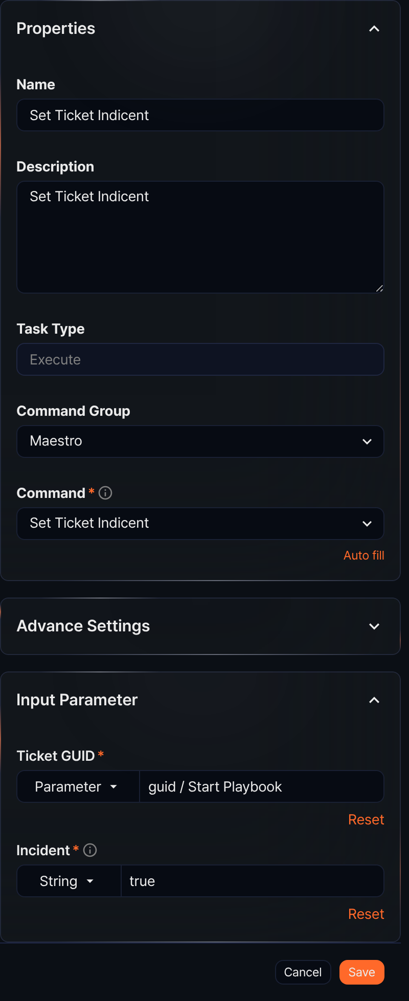
Input parameters
The input parameters are as follows:
Input parameter | Description
Ticket GUID* | The GUID of the ticket
Incident* | The incident status: true (incident) or false (normal)

Set ticket status
When the Command is Set Ticket Status, this task changes the status of a ticket.
Input parameters
The input parameters are as follows:
Input parameter | Description
Ticket GUID* | The GUID of the ticket
Ticket status* | The status of the ticket. One of APPROVED, SUBMITTED, REJECTED, or CLOSED.

Create ticket
Creates a new ticket and returns the ticket GUID as an output parameter.
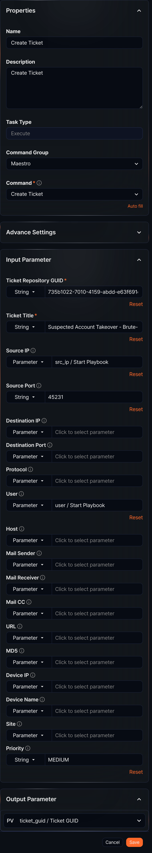
Input parameters
The input parameters are as follows:
Input parameter | Description
Ticket repository GUID* | The GUID of the ticket repository
Ticket title* | The title of the ticket
Source IP | The source IP address of the ticket
Source port | The source port of the ticket
Destination IP | The destination IP address of the ticket
Destination port | The destination port of the ticket
Protocol | The protocol of the ticket
User | The user associated with the ticket
Host | The host associated with the ticket
Mail sender | The mail sender of the ticket
Mail receiver | The mail receiver of the ticket
Mail CC | The mail CC of the ticket
URL | The URL of the ticket
MD5 | The MD5 of the ticket
Device IP | The asset IP of the ticket
Device name | The device name (hostname) of the asset IP
Site | The site of the ticket
Priority | One of LOW, MEDIUM, or HIGH. Defaults to LOW if not specified.
Output parameters
The output parameters are as follows:
Parameter | Name | Description
ticket_guid | Ticket GUID | The GUID of the created ticket

Set ticket attack
When the Command is Set Ticket Attack, this task changes the true/false positive status of an existing ticket.
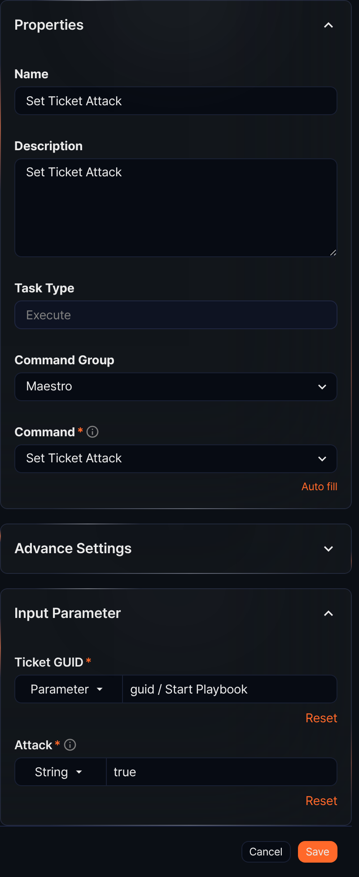
Input parameters
The input parameters are as follows:
Input parameter | Description
Ticket GUID* | The GUID of the ticket
Attack* | The true/false positive status: true (true positive) or false (false positive)

Set ticket priority
When the Command is Set Ticket Priority, this task changes the priority of an existing ticket.
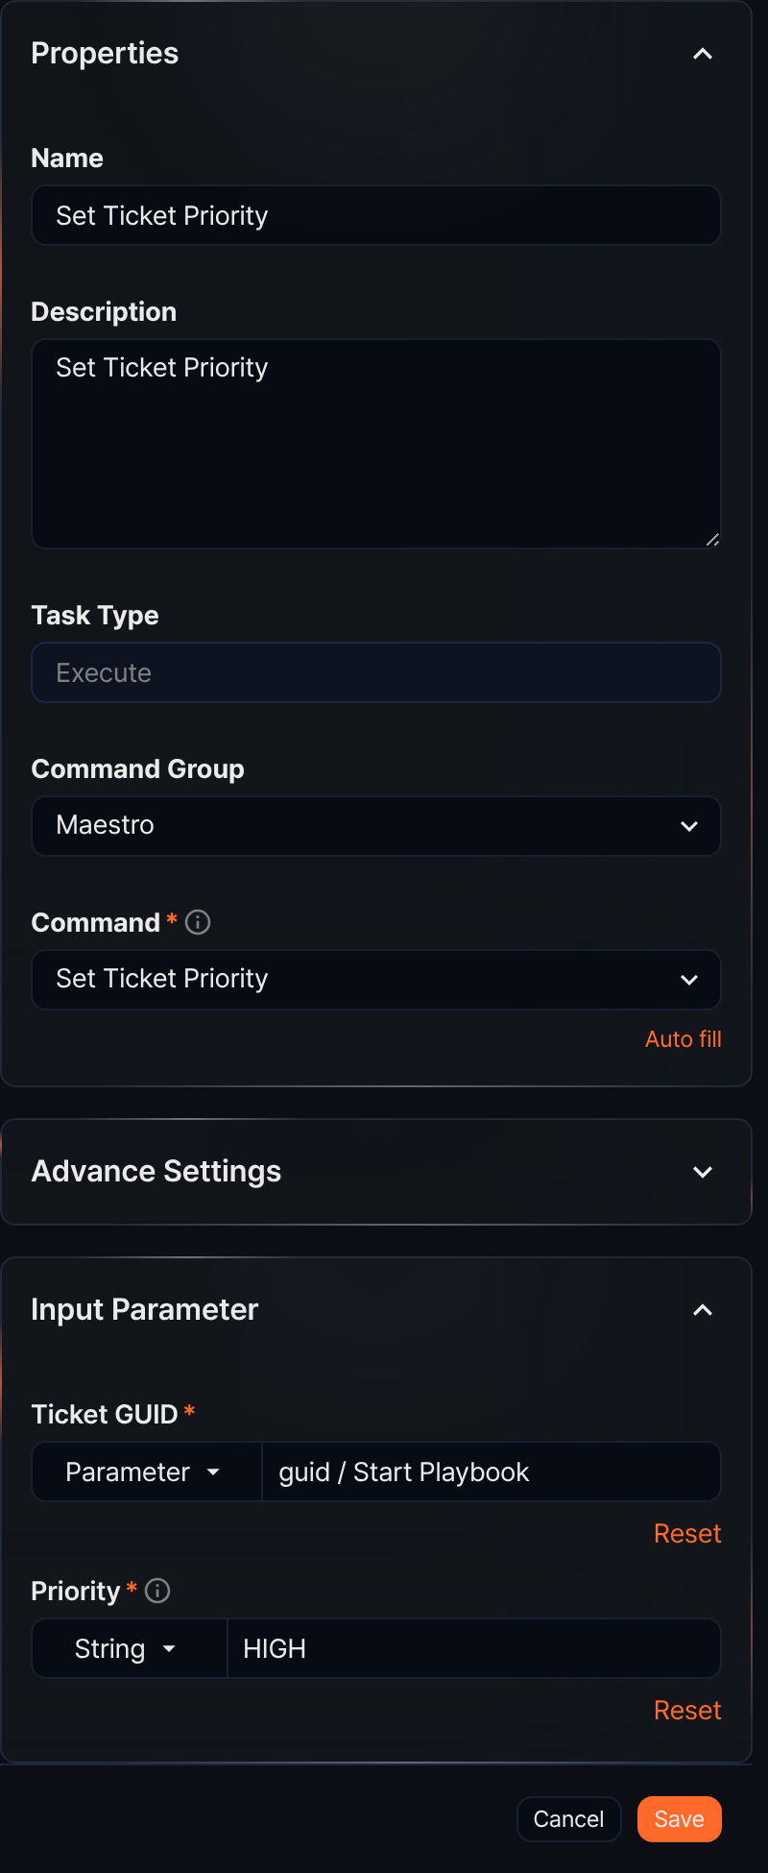
Input parameters
The input parameters are as follows:
Input parameter | Description
Ticket GUID* | The GUID of the ticket
Priority* | One of LOW, MEDIUM, or HIGH

Add ticket comment
When the Command is Add Ticket Comment, this task adds a comment to a ticket.
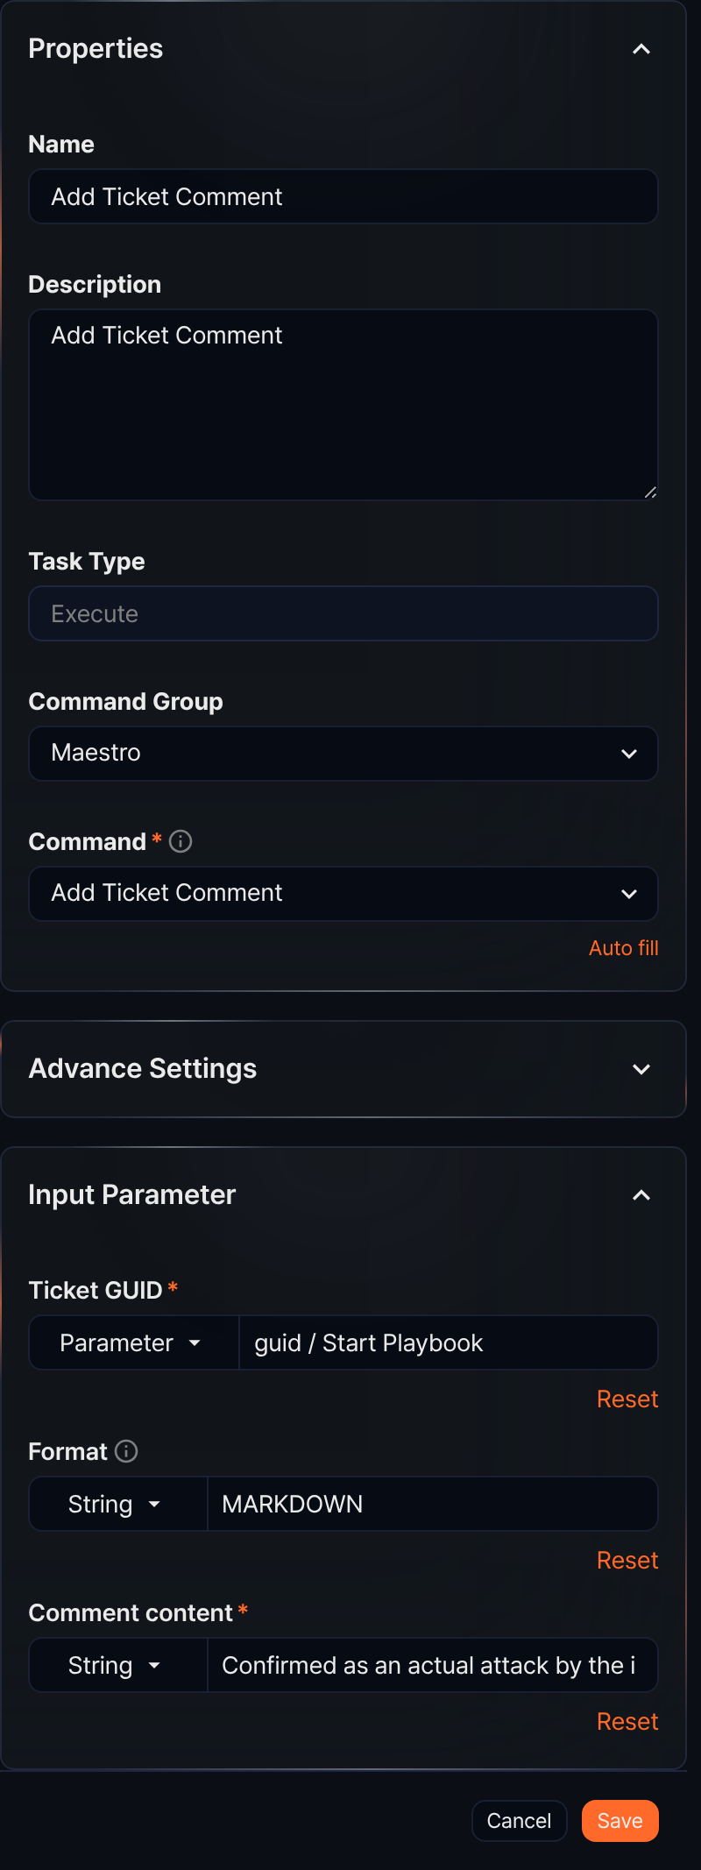
Input parameters
The input parameters are as follows:
Input parameter | Description
Ticket GUID* | The GUID of the ticket
Format | One of PLAIN, JSON, or MARKDOWN. Defaults to MARKDOWN if not specified.
Comment content* | The comment text

Set ticket tags
When the Command is Set Ticket Tags, this task sets tags on a ticket.
Input parameters
The input parameters are as follows:
Input parameter | Description
Ticket GUID* | The GUID of the ticket
Tag GUID* | A comma-separated list of tag GUIDs
When entering multiple tag GUIDs, separate them with commas without spaces after the comma (e.g., 339ee35f-91c0-4eb9-a04e-9d614d295546,cc70f5cf-d9ad-4d6e-8e6d-17297904cea9).
Running the Set Ticket Tags command removes all existing tags from the ticket and applies the new tags.

Add ticket tags
When the Command is Add Ticket Tags, this task adds tags to a ticket.
Input parameters
The input parameters are as follows:
Input parameter | Description
Ticket GUID* | The GUID of the ticket
Tag GUID* | A comma-separated list of tag GUIDs
When entering multiple tag GUIDs, separate them with commas without spaces after the comma (e.g., 339ee35f-91c0-4eb9-a04e-9d614d295546,cc70f5cf-d9ad-4d6e-8e6d-17297904cea9).
Running the Add Ticket Tags command keeps any existing tags and adds the new tags, excluding duplicates.

Set ticket assignee
When the Command is Set Ticket Assignee, this task sets the assignee and approver of a ticket.
Input parameters
The input parameters are as follows:
Input parameter | Description
Ticket GUID* | The GUID of the ticket
User GUID* | The account GUID. Accepts array input.
Ticket Assign Type* | APPROVER or ASSIGNEE

Add pattern
When the Command is Add pattern, this task adds a pattern to a pattern group.
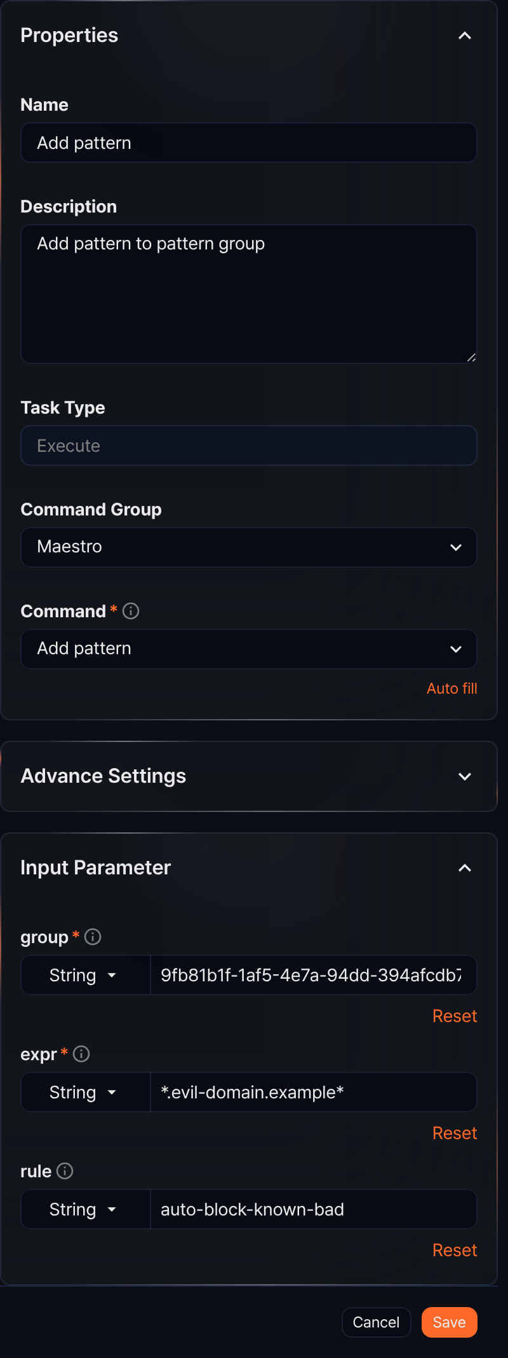
Input parameters
The input parameters are as follows:
Input parameter | Description
group* | The GUID of the pattern group
expr* | The pattern string
rule | The name of the pattern rule

Send report
When the Command is Send report, this task generates a report for a specified date range using a report template and sends it by email.
Input parameters
The input parameters are as follows:
Input parameter | Description
Template GUID* | The GUID of the report template
File format* | Report file format: one of docx, html, pdf, or hwpx
From* | Start of the reporting period in yyyyMMddHHmmss format
To* | End of the reporting period in yyyyMMddHHmmss format
Recipient* | The email address to send the report to
To receive emails at the specified address, configure the SMTP server for sending mail under Settings > Mail Server.

Export report
When the Command is Export report, this task generates a report for a specified date range using a report template and saves it.
Input parameters
The input parameters are as follows:
Input parameter | Description
Template GUID* | The GUID of the report template
File format* | Report file format: one of docx, html, pdf, or hwpx
From* | Start of the reporting period in yyyyMMddHHmmss format
To* | End of the reporting period in yyyyMMddHHmmss format
Path* | The path to save the generated file (e.g., /opt/logpresso/report.pdf)

