Query
This task executes a query and returns the results as output parameters. Use query tasks to detect anomalies in specific events or logs, analyze incident timelines by querying relevant logs when a security incident occurs, or regularly monitor specific systems.
Query tasks are categorized as Query result, Integer scalar query result, String scalar query result, or Date scalar query result based on the selected Command. The properties panel looks like the figure in the Query result section below.

Query result
Executes a query and assigns the results to output parameters.
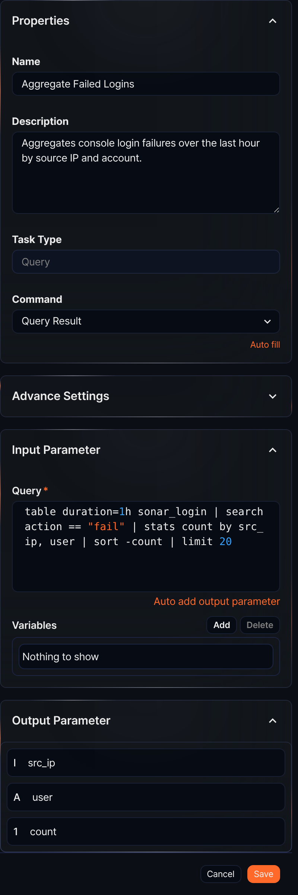
Command
Select Query Result.
Input parameters
When the Command is Query Result, the input parameters are as follows:
Query*
Enter the query to execute. To use parameters from the Variables in the query, use the $("variable") format.
Click Auto add output parameter to automatically add the output fields of the query to the Output Parameter list.
Variables
Click Add and select variables from the parameter list to use in the query. The parameter list shows parameters passed by preceding tasks or playbook input parameters.
To delete a variable from the variable list, select the checkbox in the variable row and click Delete.

Integer scalar query result
Executes a query that returns an integer value. The result is returned in the output parameter result.
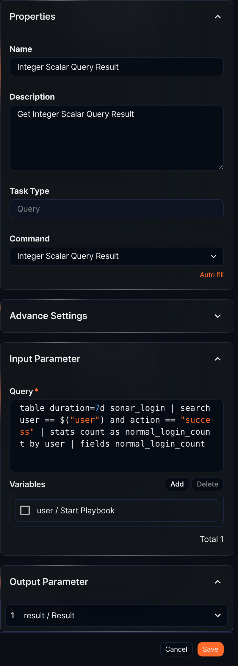
Command
Select Integer Scalar Query Result.
Input parameters
When the Command is Integer Scalar Query Result, the input parameters are as follows:
Query*
Enter the query that returns an integer value. To use parameters from the Variables in the query, use the $("variable") format.
Variables
Click Add and select variables from the parameter list to use in the query. The parameter list shows parameters passed by preceding tasks or playbook input parameters.
To delete a variable from the variable list, select the checkbox in the variable row and click Delete.

String scalar query result
Executes a query that returns a string value. The result is returned in the output parameter result.
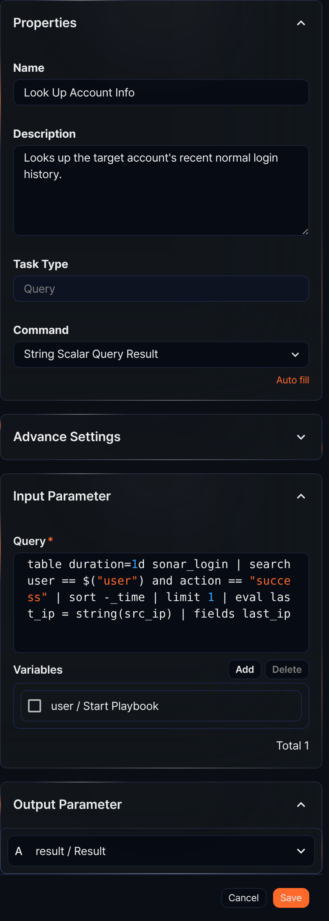
Command
Select String Scalar Query Result.
Input parameters
When the Command is String Scalar Query Result, the input parameters are as follows:
Query*
Enter the query that returns a string value. To use parameters from the Variables in the query, use the $("variable") format.
Variables
Click Add and select variables from the parameter list to use in the query. The parameter list shows parameters passed by preceding tasks or playbook input parameters.
To delete a variable from the variable list, select the checkbox in the variable row and click Delete.

Date scalar query result
Retrieves a date query result.
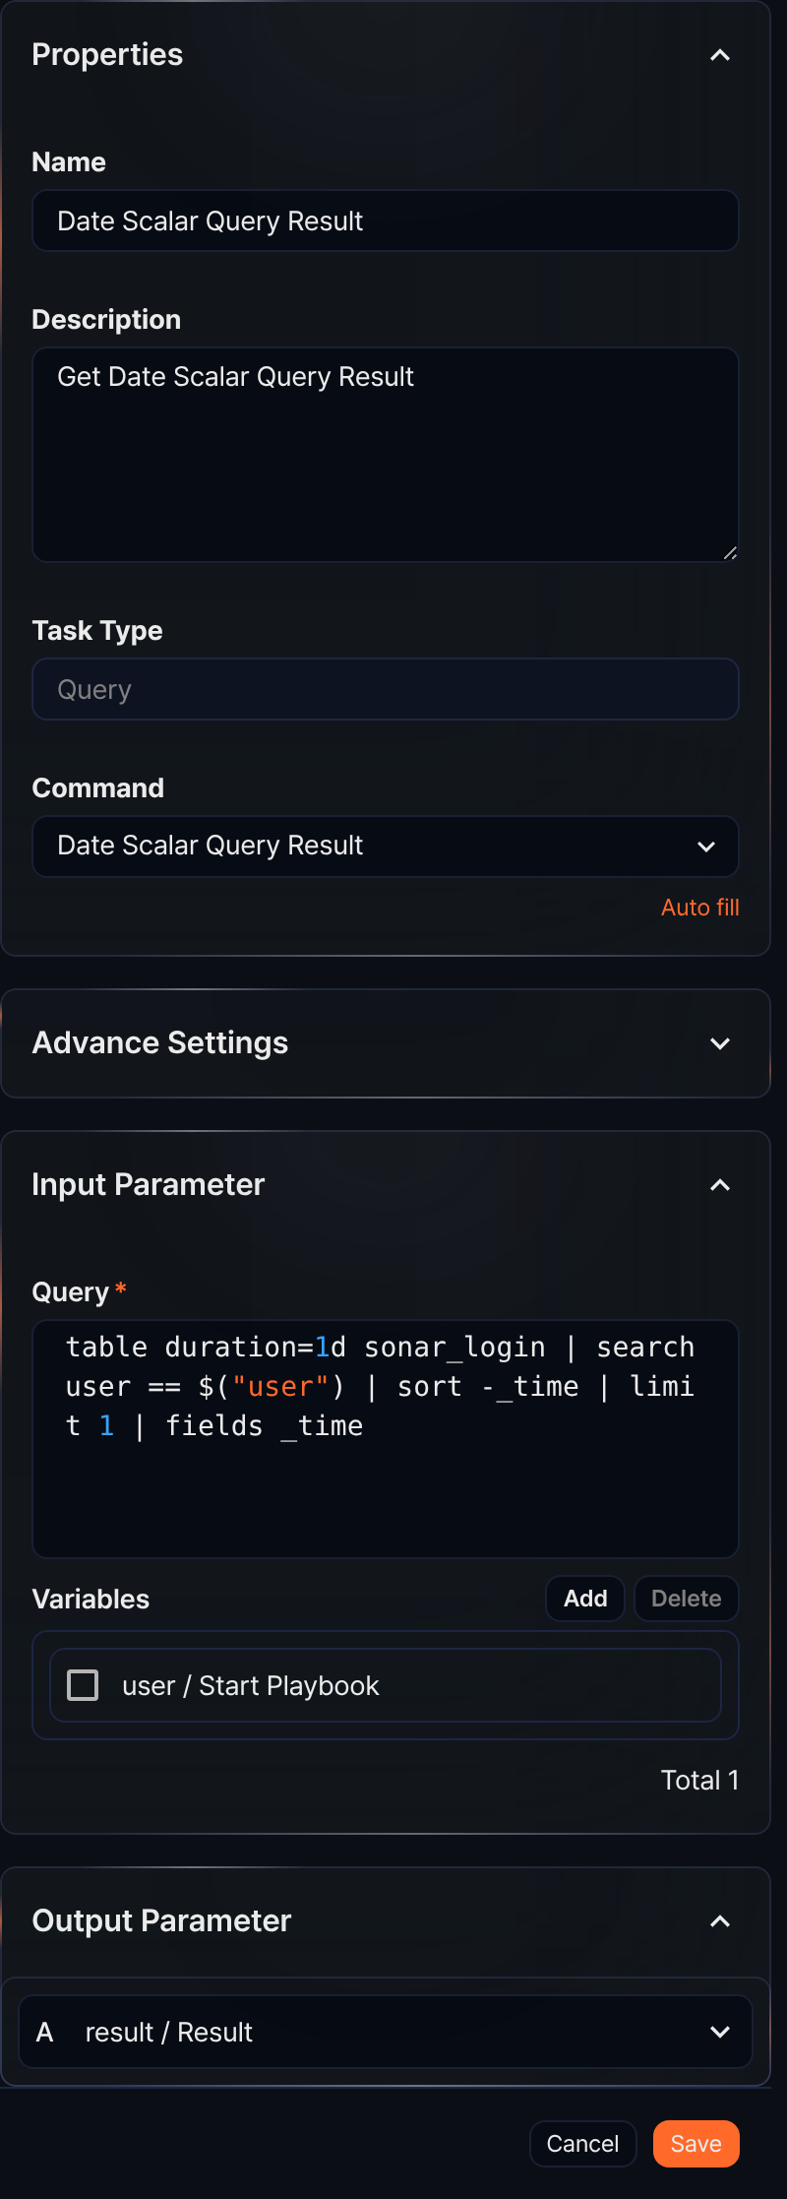
Command
Select Date Scalar Query Result.
Input parameters
When the Command is Date Scalar Query Result, the input parameters are as follows:
Query*
Enter the query that returns date information. To use parameters from the Variables in the query, use the $("variable") format.
Variables
Click Add and select variables from the parameter list to use in the query. The parameter list shows parameters passed by preceding tasks or playbook input parameters.
To delete a variable from the variable list, select the checkbox in the variable row and click Delete.
Query task example
A query task retrieves data using the entered query and returns the results as output parameters. The following describes the Query Result command as an example.
In the playbook, add a task and configure the Query Result command.
The settings panel looks like the figure in the Query result section above (the Aggregate Failed Logins task).
Enter the query in the Query field, then click Auto add output parameter. An Auto Set Output Variable popup appears showing the output variables and their values.
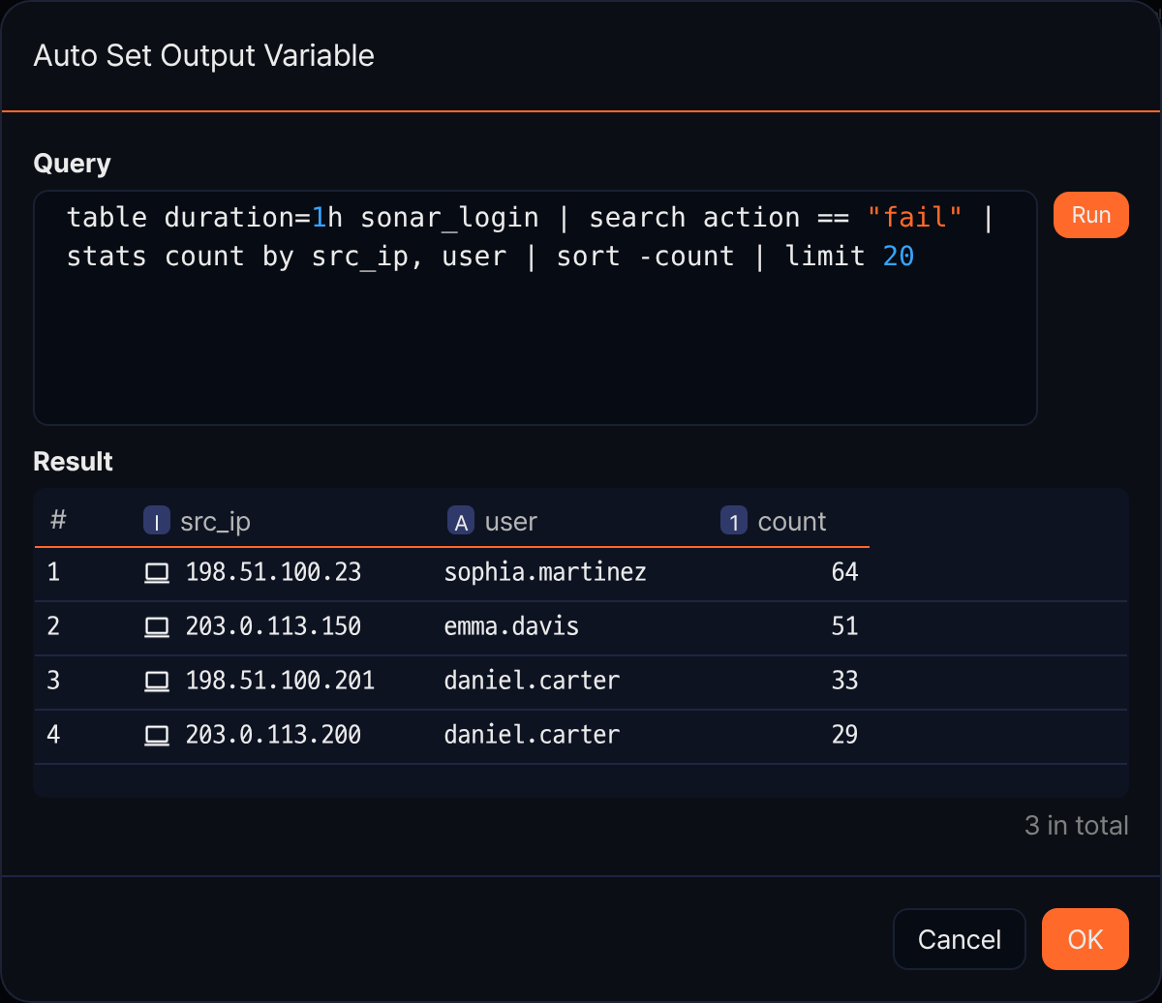
Click OK in the Auto Set Output Variable popup. The Output Parameter list of the task is automatically configured, as shown in the figure in the Query result section above.
Run the playbook to confirm that the query result values are returned as output parameters.
