Task properties

Common properties
Every task has the following properties. All task properties can be viewed and changed in the properties panel.
Property | Description
Name | The name of the task shown in the flowchart
Description | A description of the task
Task type | The type that categorizes the task by the function it performs
Command | The command the task executes. Most tasks execute a single command. Varies by task type.
Command Group | (When task type is Execute) The list of available commands
Playbook | (When task type is Call playbook) The sub-playbook to execute
Advance Settings | Timeout, retry interval, retry count, and action on task failure (not available for Call playbook tasks)
Input parameters | Local parameters that receive values from a preceding task or the playbook's input parameters. Varies by task type.
Output parameters | Output variables to assign values that are passed to the following task. Varies by task type.
- Command Group is divided into the default command group and command groups provided by apps.
- Required input parameters are marked with an asterisk (*).
Name and description
Every task has a Name and a Description. Tasks are displayed as boxes in the flowchart, and their name and description are used to identify them. In the following figure, the red box marks the Name and Description fields in the edit panel; the same name and description appear on the task box in the flowchart.
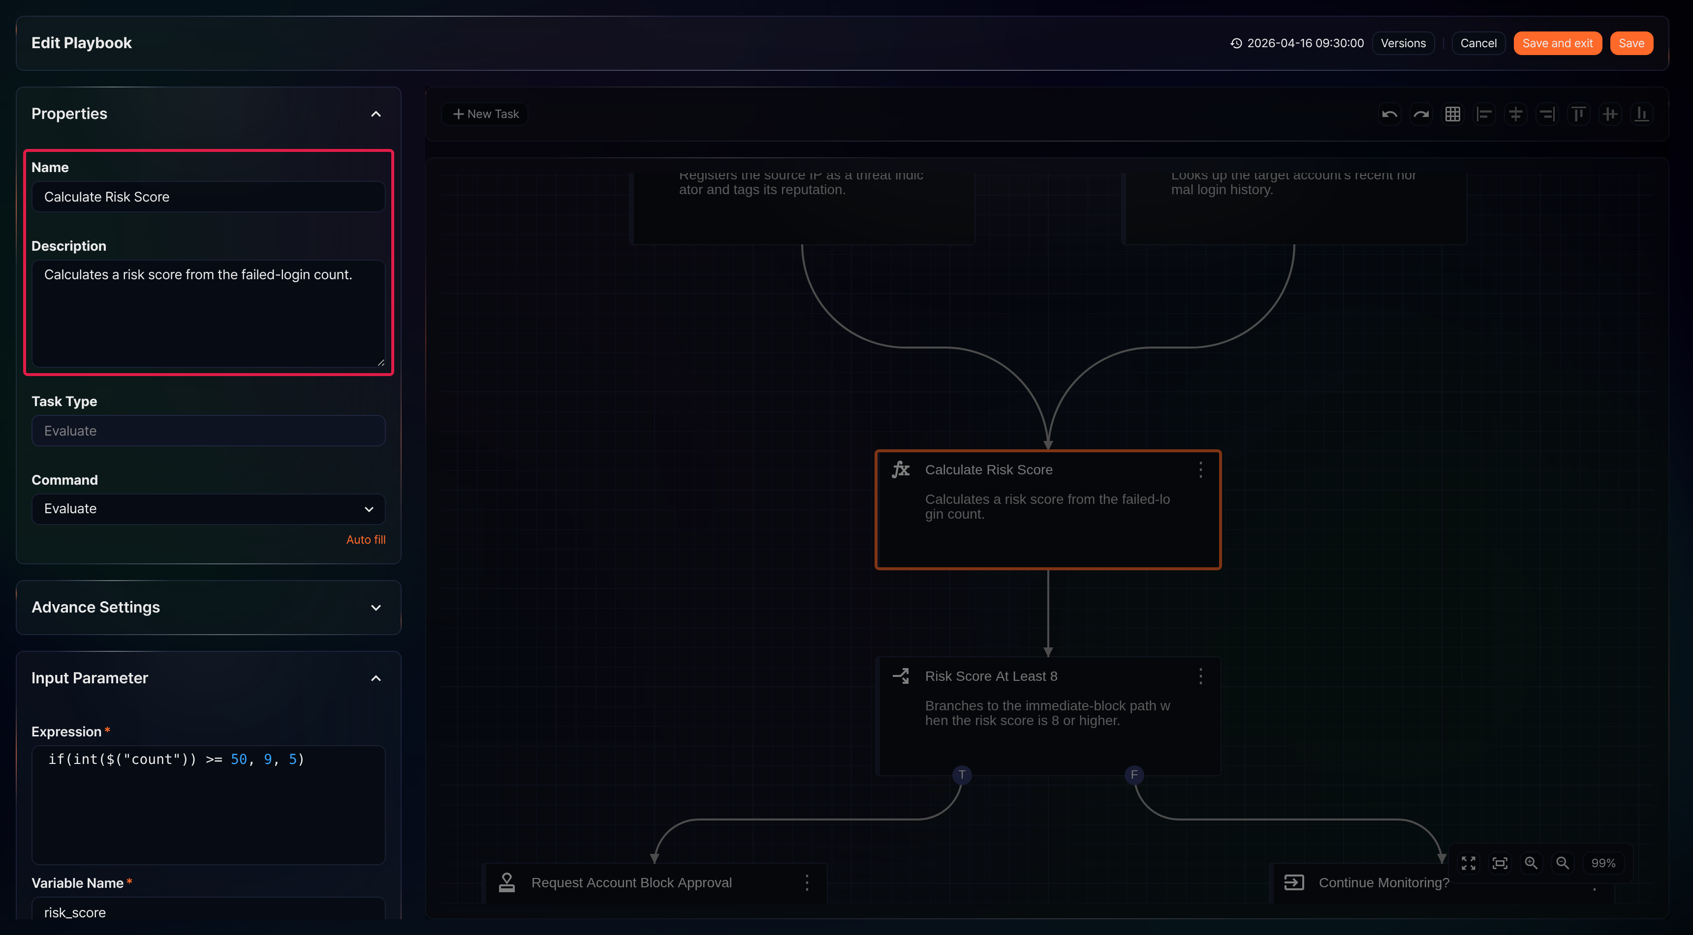
Click Auto fill below the command in the properties panel to populate the Name and Description with the selected command's display name and description. Edit them as needed.
Advance Settings
The Advance Settings section provides options to control task behavior.
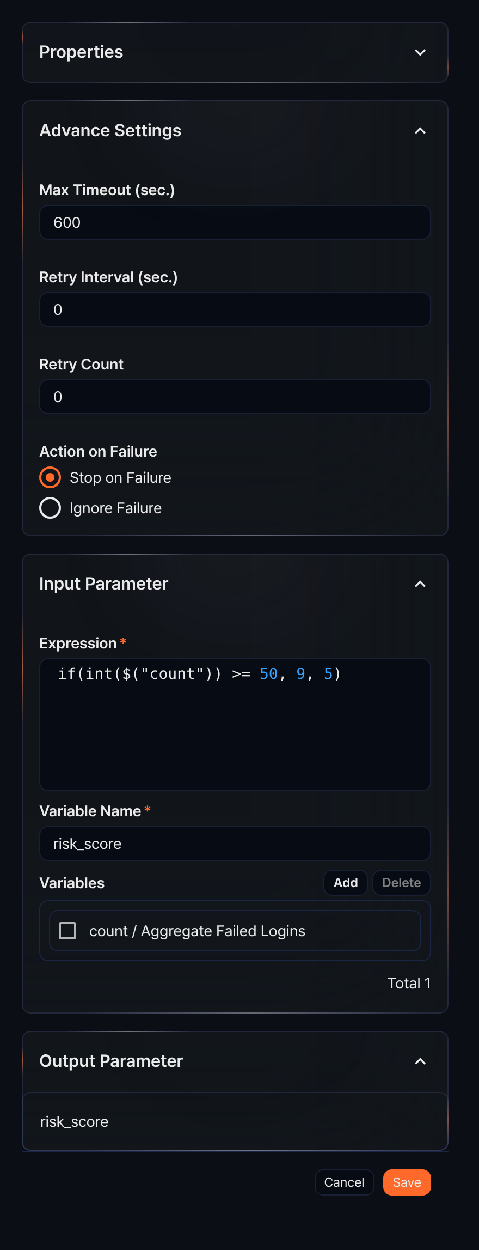
- Max Timeout (sec.): Maximum wait time for task completion (default: 600 seconds)
- Retry Interval (sec.): Interval between retries for a failed task (default: 0 seconds)
- Retry Count: Number of retries (default: 0). If the task completes within the retry count, it is considered successful.
- Action on Failure: Action to take when a task fails (options: Stop on Failure, Ignore Failure; default: Stop on Failure)

Properties by type
A task is the smallest building block of a playbook. Each task type performs a different function. The following table summarizes the task types:
Task type | Description
Execute | Executes a command defined in a command group
Branch (Decision) | Branches the task flow based on the evaluation of a comparison expression (true/false)
Expression (Evaluate) | Assigns the result of an expression to a variable
User input | Receives user input and assigns it to an output parameter
Approval request (Approval) | Branches the task flow based on the user's approval result
Wait (Delay) | Waits for a specified duration before proceeding to the next task
Send email (Email) | Sends an email according to the format specified in the input parameters
Call playbook (Playbook) | Calls and runs another playbook
Query | Executes a query and retrieves the results
Investigate Result | Executes a query and adds the results as an investigation result to a ticket

