Wait
This task waits for a specified duration. Use it when multiple flows are running in parallel, when one flow depends on another, or when you need to wait for another flow to complete. This task type appears as Delay in the Task Type field.
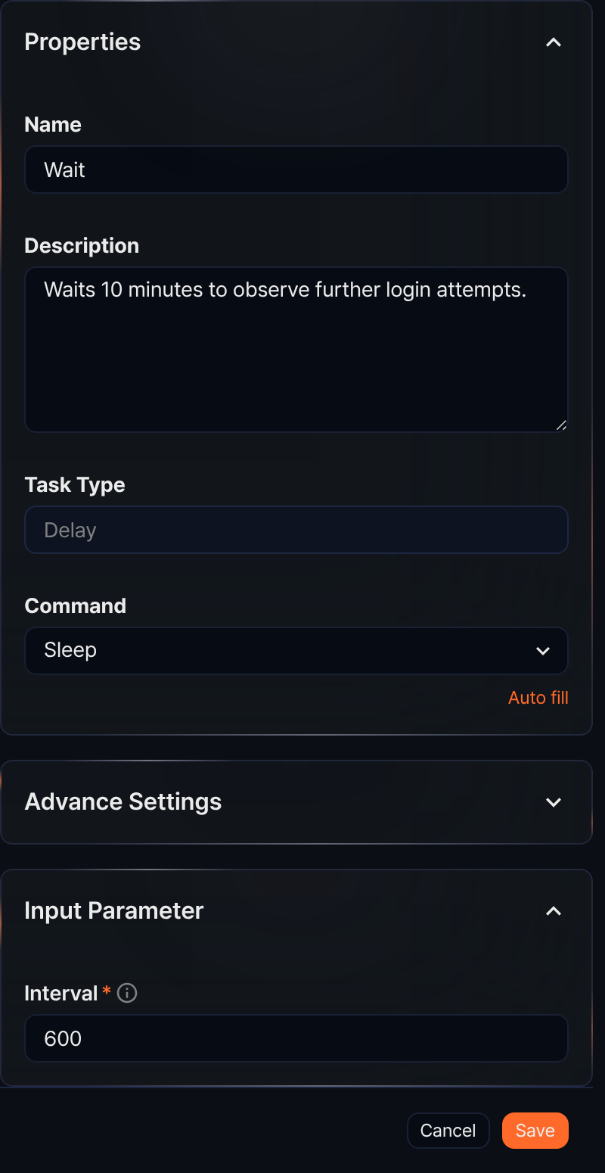
Command
The only Command available is Sleep.
Input parameters
The input parameters are as follows:
Interval*
Enter the wait time in seconds.

