SNR#3314 일부 머신러닝 쿼리 명령어 수행시 실행 오류 개선 (rforest, anomalies)
버전: [4.0.2511.2](../../4.0/releases/4.0.2511.2)
4.0.2511.0 이후 버전에서 rforest, anomalies와 같이 서브쿼리가 선택사항인 쿼리 명령어를 서브쿼리 없이 실행할 때(예: 모델을 지정하는 경우) 쿼리 실행에 실패하던 문제를 해결했습니다.
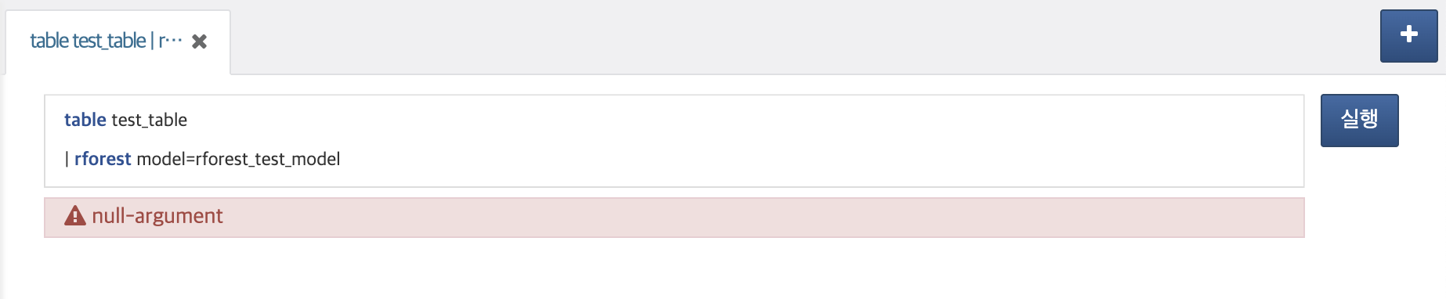
[2025-12-16 19:28:08,660] ERROR (LogQueryPlugin) - araqne logdb: cannot create query
java.lang.NullPointerException
at com.logpresso.sonar.core.query.LocalFileAccessPlanner.__M_hasOnlyNonLocalFileAccessCommands(LocalFileAccessPlanner.java:102)
at com.logpresso.sonar.core.query.LocalFileAccessPlanner.hasOnlyNonLocalFileAccessCommands(LocalFileAccessPlanner.java)
at com.logpresso.sonar.core.query.LocalFileAccessPlanner.__M_plan(LocalFileAccessPlanner.java:60)
at com.logpresso.sonar.core.query.LocalFileAccessPlanner.plan(LocalFileAccessPlanner.java)
at org.araqne.logdb.query.engine.QueryServiceImpl.__M_createQuery(QueryServiceImpl.java:516)
at org.araqne.logdb.query.engine.QueryServiceImpl.createQuery(QueryServiceImpl.java)
at org.araqne.logdb.msgbus.LogQueryPlugin.__M_createQuery(LogQueryPlugin.java:343)
at org.araqne.logdb.msgbus.LogQueryPlugin.createQuery(LogQueryPlugin.java)
at jdk.internal.reflect.GeneratedMethodAccessor14.invoke(Unknown Source)
at java.base/jdk.internal.reflect.DelegatingMethodAccessorImpl.invoke(DelegatingMethodAccessorImpl.java:43)
at java.base/java.lang.reflect.Method.invoke(Method.java:566)
at org.araqne.msgbus.handler.MsgbusPluginHandler.__M_handleMessage(MsgbusPluginHandler.java:197)
at org.araqne.msgbus.handler.MsgbusPluginHandler.handleMessage(MsgbusPluginHandler.java)
at org.araqne.msgbus.impl.MessageBusImpl$TaskRunner.__M_invokeMessageHandler(MessageBusImpl.java:591)
at org.araqne.msgbus.impl.MessageBusImpl$TaskRunner.invokeMessageHandler(MessageBusImpl.java)
at org.araqne.msgbus.impl.MessageBusImpl$TaskRunner.__M_run(MessageBusImpl.java:580)
at org.araqne.msgbus.impl.MessageBusImpl$TaskRunner.run(MessageBusImpl.java)
at java.base/java.util.concurrent.ThreadPoolExecutor.runWorker(ThreadPoolExecutor.java:1128)
at java.base/java.util.concurrent.ThreadPoolExecutor$Worker.run(ThreadPoolExecutor.java:628)
at java.base/java.lang.Thread.run(Thread.java:829)

